Pneumatosis Intestinalis in a patient with trichobezoar – Rare association –
V.B. Pathiranaª, R.V. Paranamannaª, R.M.G. Rathnayakaª, M. Gunasekaraª.
ª National Hospital – Colombo, Sri Lanka.
Corresponding author –
V.B. Pathirana. ORCID: http://orcid.org/0000-0002-8764-142X.
Email – varunapath@gmail.com.
Phone - +094 0772207680.

Keywords –
Trichobezoar, epigastric pain, pneumatosis intestinalis, trichotillomania, Pneumoperitoneum.

Abstract -
This case report is on a young girl who presented with chronic epigastric pain and abdominal mass without noticeable psychiatric illness or trichotillomania and subsequently trichobezoar was found to be the reason for her symptoms. She underwent laparotomy to retrieve the bezoar. During laparotomy extensive pneumatosis of small bowel was noted where this association was not previously reported in literature. Since pneumatosis was not symptomatic no bowel resection was carried out. She made uneventful recovery. This illustrates that trichobezoar is an important cause to consider in young females with chronic abdominal pain even in the absence of clear evidence for trichotillomania. Rarely this can be associated with intestinal pneumatosis. Intestinal pneumatosis does not warrant treatment unless it causes symptoms.

Introduction –
Trichobezoar is a mass of ingested hair within gastrointestinal tract¹. This rare cause was found to be the reason for chronic epigastric pain of a young girl in this case report without apparent psychiatric illness. She was incidentally found to have pneumatosis intestinalis [PI] which may be or may not be related to trichobezoar⁵.

Case report –
17 year old girl presented with epigastric pain for one year duration associated with nausea, post prandial abdominal fullness, early satiety and episodic vomiting occurring 3-4 times a month. Her bowel habits were normal and there was no per rectal bleeding or melena. She was admitted to hospital due to worsening of symptoms over a period of two weeks with more frequent vomiting. She denies trichotillomania and there was no history of psychiatric illness or behavioral abnormality and her school performances were average.
She was not pale, anicteric, BMI was 17.18Kg/m² and no abnormality was noted in her hair. Abdominal examination revealed firm lump involving epigastric and right hypochondria extending 6cm from the costal margin. Rest of the abdominal examination was unremarkable. Her hemoglobin was 12.7g/dl, serum albumin was 4.0g/dl and rest of the laboratory investigations including bilirubin levels, serum amylase and serum electrolytes were within the normal range.
Gastroduodenoscopy revealed large trichobezoar where scope was not negotiable beyond the body of stomach [Fig1]. CECT showed grossly distended stomach with non-enhancing intra luminal mass extending up to the first part of duodenum suggestive of a bezoar [Fig2] and intramural gas in the small and large intestine suggestive of pneumatosis.
She underwent laparotomy and the bezoar was retrieved via gastrotomy [Fig3]. A gastric wall thickening was observed with average thickness of 5-6mm. Distal jejunum and entire ileum showed gaseous outpouchings of variable size ranging from few millimeters to 1cm indicating extensive intestinal Pneumatosis [Fig4] and was left unattended since patient was asymptomatic. She made uneventful postoperative recovery.
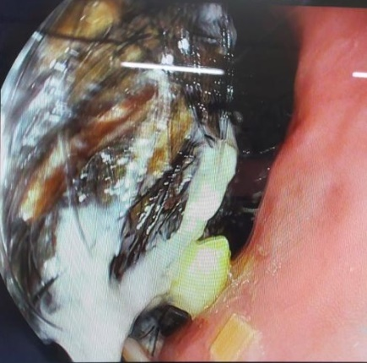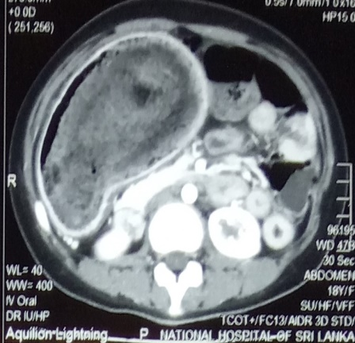
Fig2 : Heterogeneous mass with in the stomach [Arrow].
Fig 1: Trichobezoar.

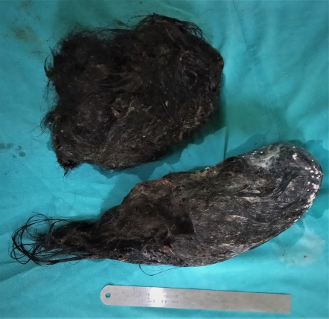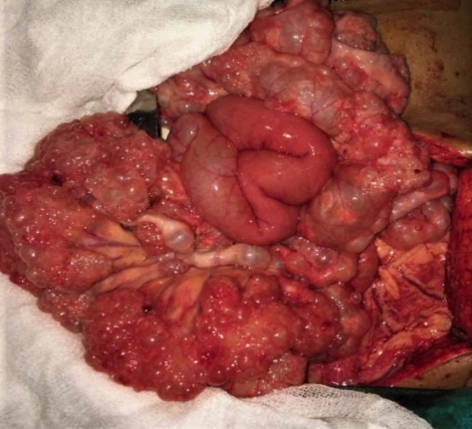
Fig 4: Distal jejunum and Ileum showing Pneumatosis Intestinalis [Arrow].
Fig 3: Retrieved trichobezoar

Discussion –
Bezoars are masses formed from ingested foreign material and identified in less than 5% of all upper gastrointestinal endoscopy¹. They are most commonly found in the stomach. Trichobezoar are the rarest of them accounting for 6% of all bezoars and invariably related to trichotillomania and trichophagia¹ which can be a part of a psychiatric illness though this patient denies any of these habits.
Bezoars can be asymptomatic particularly when they are small and symptomatic patients have epigastric pain, nausea and vomiting, early satiety which are non-specific and can be overlooked as young patients may not undergo routine endoscopy leading to delay of diagnosis. Considering the fact that around 90% of these patients are young females^{1,3} this case illustrates the importance of considering trichobezoar as a cause for unexplained abdominal pain in a young female even with the absence of clear psychiatric illness or evidence for trichotillomania.
Trichobezoar need early intervention since it is known for many complications such as gastric erosion and bleeding, perforation and gastric outlet obstruction. The extension of trichobezoar in to the small bowel which is known as Rapunzel Syndrome can lead to small bowel obstruction, pancreatitis and cholangitis ^{1, 2, 4}. Open surgery is considered the best method since it is technically easy and have high success rate of complete removal of the bezoar with low complication rates^{1,2,4}. Laparoscopic and endoscopic interventions are shown to be less effective ^{1, 2, 4}. Most patients will only need gastrotomy and/or enterotomy for retrieval of bezoar, but complicated cases may require subtotal gastrectomy or intestinal resection¹. Following successful removal of trichobezoar patients will need surveillance endoscopy for few years to confirm patient has come out of trichotillomania².
Pneumatosis Intestinalis [PI] is a rare condition which has a wide range of clinical presentations from benign asymptomatic condition to a life threatening surgical emergency due to adhesion obstruction or spontaneous bowel perforation^{5, 6}. Morphologically PI is seen in “bubble like” type [cystoides] which was noted in this patient or continuous band like type⁵. It may be idiopathic [primary], occasionally identified in asymptomatic patients or secondary to various gastrointestinal or pulmonary diseases^{5, 7}. Inflammatory bowel disease, chronic bowel infections and infestations, bowel obstruction and pyloric obstruction, diverticulitis, bowel ischaemia, toxic mega colon are some of common gastrointestinal conditions related to PI^{7,8}. Some of the non-gastrointestinal conditions related to PI are pulmonary disease like asthma, and emphysema, collagen vascular diseases, immunosuppression, organ transplantation ect^{7,8}. Direct association with trichobezoar and PI is not documented in literature. Chronic inflammation of bowel wall secondary to hair, partial pyloric and small bowel obstruction may have contributed to pneumatosis in this patient since these causes are known to associate with PI⁷. Most of the time PI will present with symptoms related to its underlying disease. However vomiting, abdominal distention, weight loss with involvement of small bowel and diarrhea, hematochezia with involvement of large bowel is reported as the symptoms related to PI⁸.
Plain abdominal x ray may reveal pneumatosis but contrast enhanced CT scan of abdomen is more sensitive in detecting PI and particularly in acute presentation it can help in identifying intra luminal gas from intra mural gas, air within biliary system, ischemic bowel, pneumoperitoneum, ascites which will help in decision to operate^{5, 6, 7}.
Pneumatosis Intestinalis is treated according to underlying cause and surgery is usually reserved for patients presenting with acute abdomen due to perforation or obstruction. Patients with clinical and laboratory evidence of abdominal sepsis, elevated serum amylase and presence of portal venous gas need urgent surgery where asymptomatic cases are managed non operatively^{5,6,8.} Pneumoperitoneum along should not be considered as an indication for surgery since it was noted in 50% of patients with PI⁶. In this patient resection of involved segment was not necessary as it is uncomplicated and neither feasible considering the extensive involvement of small bowel.

Conclusion –
Trichobezoar can be a cause for chronic unexplained abdominal pain in young females, where it may be not suspected in the absence of trichotillomania and hair loss. Trichobezoar and intestinal pneumatosis are rare clinical entities where this association was not documented previously. Pneumatosis intestinalis needs individualized treatment based on clinical presentation.

Declarations
Authors’ contributions
All authors made substantial contributions to merit inclusion as co-authors. All authors approved the final manuscript.
Conflicts of interest
The author declares that there is no conflict of interest.
Ethical approval
Not applicable.
Consent for publication
Patient consent obtained for publication without personal details.

References –
- Bertha E. García-Ramíreza, Carlos M. Nuño-Guzmána, Ricardo E. Zaragoza-Carrilloa, Hugo Salado-Renteríaa, Audrey Gómez-Abarcaa Jorge L. Corona. Small-Bowel Obstruction Secondary to Ileal Trichobezoar in a Patient with Rapunzel Syndrome. Case Reports in Gastroenterol 2018;12:559–565 DOI: 10.1159/000492810.

- Marek Wolski, Marta Gawłowska-Sawosz, Michał Gogolewski, Tomasz Wolańczyk, Piotr Albrecht, Andrzej Kamiński. Trichotillomania, trichophagia, trichobezoar – summary of three cases, Endoscopic follow up scheme in trichotillomania. Psychiatr. Pol. 2016; 50(1): 145–152 DOI: http://dx.doi.org/10.12740/PP/43636

- S Dindyal, NJ Bhuva, MJ Ramdass and V Narayansingh. Trichobezoar presenting with the 'comma sign' in Rapunzel Syndrome - A case report and literature review. Cases Journal 2008, 1:286 doi:10.1186/1757-1626-1-286.

- R. R. Gorter, C. M. F. Kneepkens, E. C. J. L. Mattens, D. C. Aronson and H. A. Heijcor. Management of trichobezoar: case report and literature review. Pediatric Surgery International 2010 May; 26(5): 457–463. doi: 10.1007/s00383-010-2570-0.

- Daniela Berritto, Raffaello Crincoli, Francesca Iacobellis, Francesca Iasiello, Nunzia Luisa Pizza, Francesco Lassandro, Lanfranco Musto and Roberto Grassi. Primary Pneumatosis Intestinalis of Small Bowel: A Case of a Rare Disease. Case Reports in Surgery Volume 2014, Article ID 350312, 4 pages http://dx.doi.org/10.1155/2014/350312.

- Mehdi Tahiri, Jordan Levya, Saud Alzaida, Dawn Andersona. An approach to pneumatosis intestinalis: Factors affecting your management. International Journal of Surgery Case Reports 6 (2015) 133–137 http://dx.doi.org/10.1016/j.ijscr.2014.12.007.

- Lisa M. Ho, Erik K. Paulson, William M. Thompson. Pneumatosis Intestinalis in the Adult: Benign to Life-Threatening Causes. AJR 2007; 188:1604–1613 DOI:10.2214/AJR.06.1309.

- Haijing Zhang, Stephanie L, Jun and Todd V. Brennan. Pneumatosis Intestinalis: Not Always a Surgical Indication. Case Reports in Surgery Volume 2012, Article ID 719713, 3 pages doi:10.1155/2012/719713.

