Bone metastases of urothelial carcinoma
Modeste Mayele- Kenfuni, Mohamed Amirifou, Adil Kbirou, Rachid Yassine, Reda Safwate, Deogracias Nzambimana, Nedjim Saleh, Mohamed Dakir, Adil Debbagh, Rachid Aboutaieb
Department of Urology, Ibn Rochd University Hospital
and Faculty of Medicine and Pharmacy, Casablanca, Morocco.
Abstract
Introduction
Bone metastases of urothelial carcinoma are the third most common metastasis after the lungs and liver. Bone complications adversely affect quality of life. They are also associated with increased mortality. The objective of this study is to describe the epidemiological, clinical and prognostic aspects of bone metastases of urothelial carcinoma.
Material and methods
This is a retrospective, monocentric study of 8 cases of bone metastases of urothelial carcinoma, collected from January 2018 to September 2020 at the Ibn Rochd University Hospital in Casablanca, Morocco. The analyzed data were collected on an exploitation sheet. Incomplete records were excluded from the study.
Results
The average age of our patients was 61.37 years. All patients were male and smokers. Pain was the main calling sign and was found in seven patients. Four patients had anemia and 50% of the patients had acute obstructive kidney disease.
All patients had undergone a CT scan that confirmed bone metastases in seven patients with predominantly osteolytic lesions. Treatment was palliative and consisted of chemotherapy, radiotherapy or combination thereof. Three patients died, two progressed with new lesions. Three had stabilized lesions.
Conclusion
The presence of bone metastases of urothelial carcinoma constitutes an unfavorable moment in the evolution of this cancer. These metastases are responsible for numerous complications that require multidisciplinary management.

Introduction
Urothelial cancer is the second most common cancer in urology, consisting of bladder tumors and tumors of the upper excretory tract. These lesions are known for their seriousness with a high metastasizing power and a high mortality rate, directly related to the systemic spread of the disease. When urothelial cancer becomes metastatic, metastases may be synchronous with the discovery of the disease or may occur during post-treatment surveillance of the primary lesion [1]. Numerous metastatic sites have been described in the literature, but the most common secondary sites of urothelial carcinomas are drainage nodes (90%) [2], lung (52%), liver (33%) and bone (26%) [3]. The prevalence of bone metastases in patients with advanced or metastatic urothelial cancer is 30-40% [4].
The objective of this study is to describe the epidemiological, clinical and prognostic aspects of bone metastases of urothelial carcinoma.
Materials and methods
This is a retrospective, descriptive study conducted at the Ibn Rochd University Hospital of Casablanca over a period of 2 years and 8 months (32 months) from January 2018 to September 2020. In our study, we selected patients with urothelial cancer with bone metastases at the onset or during the course of the disease. Data were collected from medical records retrieved from the annual registries of the Urology and Oncology Department. Patient information was collected on an operating sheet. This included epidemiological, clinical, biological, radiological (imaging), prognostic and therapeutic data.
Results
Our series includes 8 cases, all male, exclusive male and all smokers. The mean age of our patients is 61.37 years with extremes of 46 to 74 years. No occupation at risk.
Table1: Epidemiology data.
 | Age (years) | Sex | Profession | Smoking
1st case | 54 | Male | Employee | Positive
2nd case | 54 | Male | Hitchhiker | Positive
3rd case | 60 | Male | Tourism Agent | Positive
4th case | 68 | Male | Peasant | Positive
5th case | 74 | Male | No occupation | Positive
6th case | 66 | Male | No occupation | Positive
7th case | 69 | Male | No occupation | Positive
8th case | 46 | Male | No occupation | positive

All eight cases presented with stony hematuria and lower urinary tract symptoms of the irritative type (urinary frequency and urinary burns). All patients had undergone endoscopic tumor resection (RTUV). The pathology study confirmed urothelial carcinoma (UC) infiltrating the muscle in seven patients. One patient had urothelial carcinoma infiltrating the chorion with vascular emboli. Patients were subsequently evaluated for extension using thoracoabdominal pelvic tomography (TAP CT), which did not reveal any visceral or bone metastases. Three patients had pelvic adenopathies.
A radical treatment (cystoprostatectomy) decided during the multidisciplinary consultation meeting (RCP) was proposed to all patients. Four patients (50% of cases) accepted the procedure, two of whom had received neoadjuvant chemotherapy. For the remaining patients, they were lost to follow-up after refusal of the proposed treatment. Of the 50% of cases operated on (cystoprostatectomy), three patients were derived by tranileal cutaneous ureterostomy (Bricker) and one case by enterocystoplasty (neovessia).
Table 2: Endoscopic aspect, operative procedure and anatomopathological study
 | Endoscopic aspect | Endoscopic gesture | Anatomo-pathological study
Case 1 | Left posterolateral wall tumor and intra diverticular | incomplete RTUV | incomplete C U high grade papillary infiltrating chorion (pT1 high grade), vascular emboli, detrusor shown uninfiltrated
Case 2 | bladder papillomatosis | Incomplete RTUV | C U infiltrating bladder muscle (pT2)
Case 3 | Left trigonal and posterolateral tumor | Complete RTUV | C U infiltrating the muscularis (pT2)
Case 4 | Large tumor of the left side wall | Complete RTUV | CU with infiltrated muscle (pT2)
Case 5 | Tumour occupying almost the entire bladder | Incomplete RTUV1  RTUV2 (Second look) | pTa high grade, muscle not shown  CU pT2
Case 6 | Large tumor occupying almost all the bladder lumen | Incomplete RTUV | CU pT2
Case7 | Right posterolateral wall tumor, right meatus not seen | Complete RTUV | CU pT2
Case 8 | Retro trigonal and right lateral tumor | Complete RTUV | CU pT2

Clinically, the time to diagnosis of bone metastases ranged from 6 months to 3 years after the initial diagnosis of urothelial carcinoma.
The circumstances of discovery were dominated by pain, which was present in seven of our patients (87.5% of cases). The pain was pelvic (pelvis) in 6 patients, one patient had pelvic and spinal back pain. One patient had no pain. Signs associated with pain were: altered general condition and functional impotence of one or two lower limbs. These signs were present in a variable manner.
Table 3: Clinical presentation
 | Pain |  |  |  |  |  | Alteration of the general condition | Functional impotence of one or 2 lower limbs
 | Basin |  |  |  |  | Lumbar and Pelvis
1st Case | + |  |  |  |  |  | + | +
2nd Case | + |  |  |  |  |  | + | +
3rd Case |  |  |  |  | + |  | + | +
4th Case |  |  |  |  |  |  | +
5th Case | +
6th Case | + |  |  |  |  |  |  | +
7th Case | + |  |  |  |  |  | +
8th Case | + |  |  |  |  |  | + | +

Biologically, 4 patients (i.e. 50% of cases) had a poorly tolerated anemia. In 3 cases it was a microcytic hypochromic anemia and only one patient had a normochromic microcytic anemia. The cytobacteriological examination of urine (ECBU) was positive in 3 patients and the isolated germ was multi-sensitive E.Coli.
Renal function was normal in 50% of the cases (4 patients) and acute obstructive renal failure in 4 of our patients (50% of the cases), one of whom had died. The hydroelectrolyte balance showed variable results.
Thoracoabdominopelvic CT scan (TAP CT) was performed in all our patients (100% of the cases). Bone metastases were found in 7 patients (87.5% of cases). The pelvic bones were the most affected with 87.5% of cases, lumbar and dorsal vertebrae in 37.5% of cases, costal lesions in 25% of cases and cranial lesions in one case.

Table 4: Bones affected in CT scan
Type of bone affected | Number of cases (%)
Pelvic bone | 7 cases (87.5%)
Lumbar and dorsal vertebrae | 3 cases (37.5%)
Ribs | 2 cases (25%)
Skull bone | 1 case (12.5%)
One patient (12.5% of cases) had not shown bone metastases on CT scan and the diagnosis was confirmed by bone scan. On CT scan, lesions were osteolytic in 6 patients (75% of cases), osteocondensate in one patient (12.5% of cases) and mixed in one patient (12.5% of cases).
Table 5: Radiological appearance (CT scan) of bone metastases
Type of bone metastases | Number of cases (%)
Osteolytic | 6 Cases (75%)
Osteocondensing | 1Case (12.5%)
Mixed (osteolytic and osteocondensing) | 1Case (12.5%)

In addition to bone lesions, for patients who had not undergone cystectomy, CT scan had shown bladder lesions in all cases, but no upper excretory tract lesions (UET) had been objectified. The TAP CT scan had also shown ureterohydronephrosis in 4 patients (50% of cases) (bilateral in 3 patients and right-sided unilateral in 1 patient), lung lesions in 4 patients (50% of cases), liver lesions in 2 patients (25% of cases), splenic lesions in 1 case (12.5% of cases) and retroperitoneal adenopathies in 50% of cases (4 patients).
Three of our patients (37.5% of the cases) had performed bone scans that showed bone metastases. One patient (12.5% of the cases) had benefited from magnetic resonance imaging (MRI) which showed bone lesions and pedicular damage. One patient underwent a CT-guided bone biopsy and pathological examination confirmed metastases of a carcinoma whose histological appearance was compatible with a carcinoma urothelial with squamous inflection sector.
Treatment of these bone metastases was palliative. Two patients (25% of cases) had received chemotherapy alone, another patient (12.5% of cases) had received radiotherapy alone. Four patients (50% of cases) had received palliative chemotherapy and analgesic and haemostatic radiotherapy. One patient had received zoledronic acid for threatening bone metastases, two patients had received percutaneous nephrostomy, and one patient had received urinary diversion catheterization to improve renal function for ureterohydronephrosis with renal failure.
Four patients had received a red blood cell transfusion for poorly tolerated anemia, and three patients had been treated for multi-sensitive E.Coli urinary tract infection. All patients had received analgesics.
Table 6: Treatment
Type of treatment | Number of cases
Chemotherapy | 2 cases
Radiotherapy | 1 case
Chemotherapy and radiotherapy | 4 cases

Table 7 Associated treatment
Associated treatment | Number of cases
Zoledronic acid | 1 case
nephrostomy | 2 cases
ureteral probe ascent | 1 case
blood transfusion | 4 cases
Treatment of urinary tract infection | 3 cases
Antalgic | 8 cases

Three patients (37.5% of cases) had stabilized lesions after chemotherapy and radiotherapy. They still continue palliative care, two patients (25% of cases) had progressed to worsening with the appearance of pulmonary, liver and splenic metastases, in addition to the bone adenopathies and metastases that existed before treatment. They received immunotherapy, three patients (37.5% of cases) had died, two of them before starting treatment and one after treatment.

Figure 1 Bladder ultrasound: tissue processes of the left posterolateral and intradiverticular bladder wall.
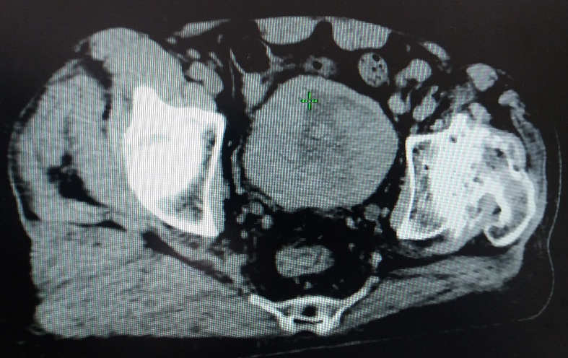
Figure 2 : (CT scan): Large intravesical tumor.
Figures 3, 4, 5, 6 : The most common metastatic sites (CT scans): Node involvement (Figure 3), lung metastases (Figure 4), liver metastases (Figure 5), bone metastases (Figure 6).
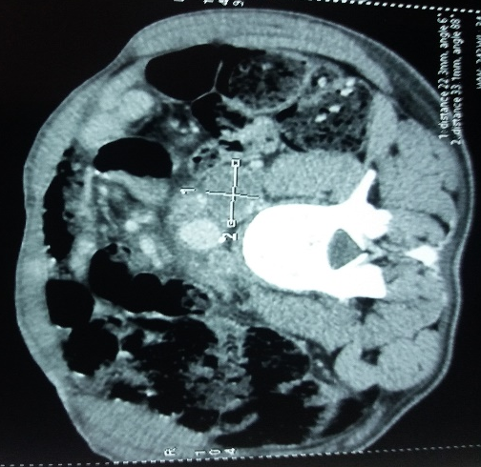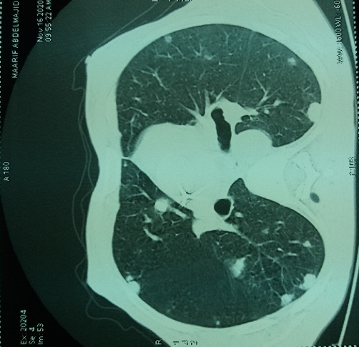
Figure 3: Left lateroaortic adenopathy Figure 4: Pulmonary metastases

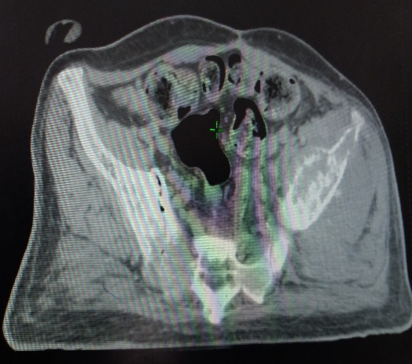
Figure 5: Liver metastasis Figure 6: Bone metastasis (pelvis)

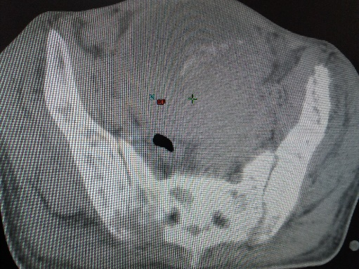
Figure 7: Osteolytic bone metastasis (orange arrow), osteocondensation (Black arrow) in the pelvis.
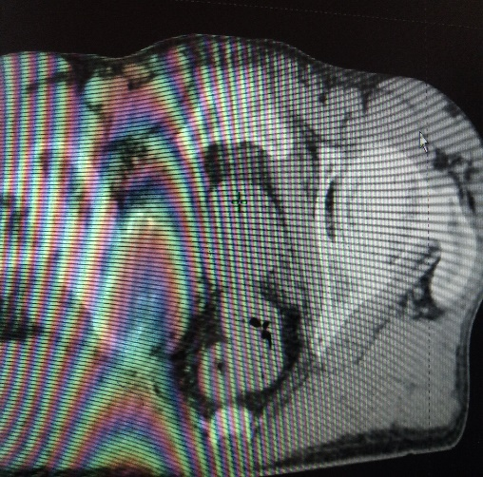
Figure 8: Osteolytic metastasis of the right ischio-pubic ramus
Discussion
Urothelial carcinoma is a major public health problem [5]. Secondary bone tumors, or bone metastases, are the localization and development of tumor lesions in bone tissue from cells that have migrated by blood or lymphatic route from a primary tumor. These are the most common bone tumors (60%) [6].
Tumors of the bladder appear after the age of 60 in the majority of cases [7,8]. In France, with an estimated 12,305 new cases in 2015, 80% of which will be in men, bladder cancer ranks fourth in incidence and seventh in deaths from all cancers and is the second most common urological cancer after prostate cancer [7].
Transitional cell carcinoma is the most predominant histological type, found in more than 90% of cases [9,10].
Tumors of the upper excretory tract (TUET) account for 5% of urothelial carcinomas [3,11]. The peak incidence is between 70 and 90 years of age with a male/female ratio close to 2:1 [3].
For our study focused on bone metastases of urothelial carcinoma, our data are consistent with the literature where most tumors appear after the age of 60 years and where urothelial carcinomas of the bladder are more common than tumors of the upper excretory tract (TUET).
These cancers occur more frequently in men than in women, but women have a poorer prognosis [5].
Our series of eight patients consisted exclusively of males with no female cases. This is consistent with most of the data in the literature where the male sex is predominant.
At the initial diagnosis of urothelial tumors, 5% of tumors are metastatic from the outset [12,13]. The majority of metastases occur in the course of progression after treatment of urothelial carcinoma [1,4]. The most frequent secondary sites of urothelial carcinoma are the lung (52%), liver (33%), and bone (26%) [3].
Bone metastases are the main cause of pain at the time of cancer. They are responsible for many serious complications in addition to pain: pathological fracture, spinal cord compression, ponytail compression, paralysis of cranial nerves, hypercalcemia, bone marrow infiltration with deficit of one or more blood lines. These complications lead to a significant reduction in quality of life [14].
Bone metastases (BM) can be asymptomatic [6].
Our data are consistent with those of most authors where pain is the main and revealing manifestation of bone metastases. It was present in seven of our patients and absent in only one.
The renal insufficiency in half of our patients was due to tumor obstruction or compression of the excretory pathways by adenopathy.
The recommended extension workup for urothelial carcinoma is uroscanning coupled with chest CT [3,7]. The CT scan is necessary to confirm the malignancy of a bone lesion. MRI is complementary to CT, especially for the examination of the spinal cord and tumor extensions [15]. Bone scans are not routinely indicated in muscle-invasive bladder tumors (MITT), but remain the first-line examination when there is a clinical point of care [7,16]. A guided puncture biopsy under CT scan should be considered as a last resort if there is still doubt [16].
Our results are consistent with those in the literature because bone scans were not systematically requested, and were performed in only 3 patients in our series. Also for the bone biopsy, which was performed only in one patient. It was the TAP CT scan that had already objectified bone metastases.
Secondary bone lesions may be: most often diffuse (predominantly in the axial skeleton: mainly lumbar spine, pelvis, upper extremities of femurs, scapular belt, skull), sometimes isolated or associated with other visceral metastases. Lytic or condensing, depending on whether osteoclasia or osteoblastic reconstruction processes predominate [6].
Radiologically, there are three types of bone reactions: lytic, condensing or mixed [15]. Osteolytic metastases are the most common [14].
The results of our series were consistent with those in the literature because osteolytic lesions were predominant. In addition to the CT scan, one patient received an MRI scan that confirmed pedicular damage, but the patient died before the start of treatment.
The reference treatment for metastatic urothelial cancers is based on Cisplatin-based chemotherapy.
The combination of M-VAC (methotrexate, vinblastine, adriamycin, cis-platin) is the reference treatment for patients eligible for this chemotherapy with a median survival of 14 to 15 months [1,7]. The initial standard first-line treatment protocol is MVAC, MVAC HD (intensified) or gemcitabine-carboplatin (GC). Pembrolizumab (anti-PDL-1) is recommended for second-line therapy [7]. Prior to the development of effective chemotherapy, patients with metastatic cancer rarely had a median survival of more than 3-6 months [17].
In the literature, Karnofsky's performance status (PS) less than or equal to 80% and the presence of visceral metastases were independent prognostic factors of low survival after MVAC treatment [18]. In the case of visceral metastases, mean survival is 4 months. Creatinine clearance of less than 60 ml/min is also a prognostic factor as it would contraindicate the use of cisplatin, which has been shown to be the most effective protocol. Thus, patients are classified into two groups according to their performance status and creatinine clearance: patients eligible for platinum-based combination chemotherapy (FIT) and those not eligible (UNFIT).
Whether at the time of diagnosis or in the follow-up of tumors already known and treated, the management of urothelial metastases is essentially based on chemotherapy [1].
. Local irradiation (radiotherapy) of the metastasis, in addition to its direct antitumor effect, reduces pain by reducing edema and peritumoral inflammation. It is the most effective and quickest treatment, especially in terms of analgesia. Surgery is useful for treating pathologic fractures, although simple immobilization does not allow for any bone consolidation, and additional radiotherapy must be administered in all cases [14]. Bone complications have a negative effect on pain and therefore on quality of life. They are also associated with increased mortality [19].
Biphosphonates reduce the risk of vertebral or non-vertebral pathologic fractures, spinal cord compression, malignant hypercalcemia, and reduce the need for surgery or radiation [14].
Bisphosphonates limit and delay these events by inhibiting bone resorption. Denosumab is a monoclonal antibody that binds to and neutralizes RANKL (nuclear factor-KB ligand receptor activator), thereby inhibiting osteoclast function and thus generalized bone resorption and local bone destruction. Thus, RANKL is as good as zoledronic acid at preventing or delaying bone complications [20]. Denosumab has fewer kidney complications than bisphoshonates.
Our series joins the data in the literature because our patients (FIT) had received Cisplatin-based chemotherapy, those who were UNFIT had received carboplatin with gemcitabine. They had also received analgesic and haemostatic radiotherapy. One patient had received zoledronic acid (biphosphonate) to prevent bone events. No patients had received Denosumab or had undergone bone surgery.
The prognosis is generally unfavorable with limited life expectancy and significant morbidity and mortality, as evidenced by our series. While the small number of cases is the limitation of our study, we have nevertheless achieved our goal of describing the epidemiological, clinical and prognostic aspects of bone metastases of urothelial carcinoma.
Conclusion
Bone involvement in urothelial carcinoma is common and represents a turning point in the evolution of this cancer. With a very poor prognosis, they are responsible for many serious complications that significantly affect the quality of life. The therapeutic management of these problems requires a multidisciplinary approach (often decided in a multidisciplinary consultation meeting) in order to stabilize these lesions, improve quality of life and prolong the survival of these patients.

REFERENCES
[1] T. Lebret, A. Méjean, Metastasis of urothelial cancers: place of chemotherapy, Progress in Urology (2008), Suppl. 7, S261-S276
2] Lebret T, Méjean A. Rare locations of metastases from urothelial carcinoma. Prog En Urol J Assoc Fr Urol Société Fr Urol. 2008;18 Suppl 7:289-97.
3] M. Rouprêt, F. Audenet, M. Roumiguié,G. Pignot, A. Masson-Lecomte, E. Compérat, N. Houédé, S. Larré, S. Brunelle, E. Xylinas,Y. Neuzillet, A. Méjean: French recommendations of the AFU Cancer Committee - update 2020-2022: tumors of the upper urinary excretory tract.
4] Hachimi Mohamed, Koutani Abdellatif, Marzouk Mohamed, El Kadiri el Hassani Bedreddine El Ghazi El Abbès, Albouzidi Abderrahmane, Elfakir Youssef, Slaoui Amine, Recommendations of good medical practice in onco-urology: tumors of bladder, Moroccan Urological Association (AMU) 2016
5] Loïc Julita ; Patrice Jichlinski ; Ilaria Lucca : Urothelial carcinoma of the bladder and upper urinary tract, Forum Med Switzerland 2017;17(35):744-749
6] Professor Jean-Philippe Vuillez: Secondary bone tumors, Corpus Médical- Faculté de Médecine de Grenoble, October 2003.
7] M.Rouprêt, G.Pignot, A.Masson-Lecomte, E.Compérat, F.Audenet, M.Roumiguié, N.Houédé, S.Larré, S.Brunelle, E.Xylinas, Y.Neuzillet, A. Méjean: French recommendations of the cancer committee of the French association of urology (AFU) - Update 2020-2022 : bladder tumors
8] Siegel RL, Miller KD, Jemal A, Cancer statistics, Cancer J Clin 2018 ;68 :7-30, http://dx.doi.org / 10.3322/caac.21442
9] Ismaili N., Arifi S., Flechon A., El Mesbahi O., Blay J.Y., Droz J.P., et al. Small cell cancer of the bladder: pathology, diagnosis, treatment and prognosis Bull Cancer 2009 ; 96 (6) : E30-E44
10] N. Ismaili, M. Amzerin, S. Elmajjaoui, J.-P. Droz, A. Flechon, H. Errihani: Role of chemotherapy in the management of bladder cancer, Prog Urol, 2011, 6, 21, 369-382
11] Visser O, Adolfsson J, Rossi S, Verne J, Gatta G, Maffezzini M, et al, Incidence and survival of rare urogenital cancers in Europe. Eur J Cancer 2012;48(4):456-64.
12] Jemal A, Siegel R, Ward E, Hao Y, Xu J, Thun MJ. Cancer statistics, 2009. Cancer J Clin 2009;59:225-49.
13] Jacques IRANI, Stéphane BERNARDINI, Jean-Louis BONNAL, Bruno CHAUVET, Marc COLOMBEL, Jean-Louis DAVIN, Guy LAURENT, Thierry LEBRET, Marc MAIDENBERG, Catherine MAZEROLLES, Christian PFISTER, Morgan ROUPRET, Catherine ROY, François ROZET, Fabien SAINT, Christine THEODORE : Urothelial Tumors, Advances in Urology (2007), 17, 1065-1098.
14] M. Gremaud D. Delouche C. Monnerat: Treatment of bone metastases with bisphosphonates, Rev Med Switzerland 2006; volume 2. 31127
15] Nicolas Amoretti, Juliette Thariat, Yasir Nouri, Pauline Foti, Olivier Hericord, Sandy Stolear, Lucia Coco, Olivier Hauger, Laurent Huwart, Pascal Boileau : Semiology of bone metastases in conventional radiology, Cancer Bulletin, French Cancer Society, Volume 100 N◦ November 11, 2013, John Libbey Eurotext
[16] M. Rouprêt : Tumeurs de la vessie : Bladder Tumors: What does the urologist expect from imaging? Journal of Diagnostic and Interventional Radiology (2012) 93, 314-320 Elsevier Masson
17] Pfister C., Roupret M., Neuzillet Y., Larré S., Pignot G., et al. CCAFU Oncologic Urology Recommendations 2013: Bladder Tumours. Prog Urol, 2013, 23, S105-S125, suppl. 2
[18] Ploeg M, Aben KK, Kiemeney LA. The current and future burden of bladder cancer worldwide. World J Urol 2009; 27:289-93.
[19]. Aapro M, Abrahamsson PA, Body JJ, et al. Guidance on the use of bisphosphonates in solid tumours : recommendations of an international expert panel. Ann Oncol 2008 Mar;19(3):420-32.
[20]. Henry DH, Costa L, Goldwasser F, et al. Randomized, double-blind study of denosumab versus zoledronic acid in the treatment of bone metastases in patients with advanced cancer (excluding breast and prostate cancer) or multiple myeloma. J Clin Oncol 2011 Mar;29(9):1125-32.

