Case report
Genital auto-mutilation, the second attempt was dramatic.
Ghannam Youssef¹, Nedjim Abdelkerim Saleh^{1*}, Abdi El Mostapha¹, Hagguir Hissein¹, Moataz Amine¹, Dakir Mohamed¹, Debbagh Adil¹, Aboutaieb Rachid¹
¹Department of Urology, CHU Ibn Rochd / Faculty of Medicine and Pharmacy, Casablanca/Maorc

* Correspondence: Dr Nedjim Abdelkerim Saleh, Department of Urology, CHU Ibn Rochd, Email: nedjimsaleh@gmail.com; ORCID: https://orcid.org/0000-0002-3494-6350

Abstract
Genital auto-mutilation is a urological emergency rarely encountered in practice. It constitutes a drama by it’s manner of occurrence and clinical presentation. In case of heavy bleeding, a state of hemorrhagic shock may occur and require resuscitation. the treatment is based on surgery and psychiatric advice. a regular follow-up with an antentive intention is needed to avoid the recurrency. We are reporting a 29-year-old patient followed for schizophrenia with poor compliance who is attempting genital auto-mutilation for the second time . The first attempt resulted in shallow wounds, but the second attempt was dramatic: it resulted in genital amputation.
Key words: penis, external genital organes, , mutilation, amputation, schizophrenia

INTRODUCTION
Self-injury is defined as an intentional act on one’s own organs without a suicidal intention (1). Genital auto-mutilation is one of the rare and more complex forms, both psychopathologically and symbolically (2). It constitutes a serious urological emergency (3). The prognosis is marked by the repercussions on the psycho-social level, then those on the urinary and sexual functions of the organ (4). The authors report a new observation of self-mutilation in a schizophrenic patient with a history of attempted genital auto-mutilation.

CASE REPORT
A 29 years old patient , followed for schizophrenia for 2 years on neuroleptics traitements with poor compliance who has attempted to amputate his testicles a week earlier brought once again to the emergency department by his family following auto--amputation of his penis in the toilet approximately some hours before the admission . The clinical examination revealed a a calm patient in hemorrhagic shock with an amputated penis at its base ,active bleeding and a scrotal wound in the process of healing (Figure 1). Hemostatic measurements were taken in the emergency room and the patient was taken the intensive care unit for resuscitation . After stabilization, he was referred to the operating room. After thorough washing with saline and antiseptic, a perfect control of the hemostasis was ensured with identification of the urethra and the corpus cavernosum. A bladder catheterization was easy performed with a foley catheter 18 (Figure2). The final gesture consisted of a urethrostomy, placement of a drain and suturing of the different planes (Figure 3). The postoperative follow-up was simple. The patient is regularly followed up with his psychiatrist.
DISCUSSION
Genital self-mutilation is a urological emergency rarely encountered in practice. It constitutes a drama by its manner of occurrence and its clinical presentation. In case of heavy bleeding, a state of hemorrhagic shock may set in and require resuscitation. The mainstay of treatment is emergency surgery and psychiatric advice. This follow-up must be regular and assess an intention of recurrence. Beyond the functional prognosis (micturition and sexual), there is a problem of body image.
Penile amputation has been classified into three groups: self-mutilation, criminal amputation and traumatic accident (5). Self-mutilation, an unusual situation in daily urological practice, is a rare phenomenon. It occurs in the majority of cases in a psychotic setting, but can be secondary to drug or alcohol abuse. Treatment and management varies according to the severity of the lesions, the time required for consultation and the mental state of the patient (6).
The man has an ambivalent relationship with his body. As an object of care, revered, the body can also be the site of mutilating practices. Men have always marked their bodies in ritual practices (7). Self-mutilation would be reported in mythology, ethnology and some religious and contemporary rituals (2). The first self-castration in history is reported by Lucien of Samosate who relates the legendary story of Combatus. He is a young Syrian of great beauty who had received from his king the important mission to accompany Queen Stratonice on her journey to Hierapolis in Phrygia. He decided to emasculate himself before the departure and to lock his genitals in a box which he entrusted to the king. This sacrifice enabled him to confound his slanderers on his return and was worth to him to be filled with honors by the king (8).
The incidence of this disease is not well known, the majority of cases do not seem to be reported by the patient or the family (9). Blacket et al identified three particular groups at risk for genital self-harm: schizophrenics, transvestites and men with religious or cultural conflicts (10).
The current standard of treatment for this infrequent injury is replanting with approximation of the urethra, corpus cavernosum and microsurgical anastomosis of the dorsal vein, arteries and nerves. This technique is considered to reduce immediate and long-term postoperative complications (11). Certain conditions are necessary to replant the amputated penis and predict the success of the surgery: state of viability of the organ, state of the graft bed or stump of the penis at the time of injury. The amputated part must be wrapped in gauze soaked in saline solution and placed in a sterile bag (12). If re-implantation is not possible, hemostasis with skin ureterostomy is performed (13).
In our context, given the contexts in which the procedure occurred and the time of presentation, we were unable to attempt reimplantation. Our attitude was first of all to stabilize the patient and transport him to the operating room with perfect control of hemostasis, regularization of the stump and urethrostomy.
CONCLUSION
Self-mutilation of the penis is a rare situation in urological practice. It frequently occurs in schizophrenia. The management is multidisciplinary and may involve the resuscitator, the urologist and the psychiatrist. The surgical attitude in emergency depends on the severity of the lesions and the time of consultation. It must be done with the intention of preserving the functions of the penis as much as possible.
DECLARATIONS
Contributions of the authors
All the authors contributed substantially to the design and production of this article.
Availability of data and materials
Not applicable.
Financial support and sponsorship
None.
Conflicts of Interest
All the authors have declared that there is no conflict of interest.
Ethical Approval and Consent to Participate
Not applicable.
Consent to publication
Not applicable.

REFERENCES
- Favazza A. The coming of age of self-mutilation. J Nerv Mental Dis 1998 ; 186 : 259-68.
- Outarahout, Mouna, et Fatima-Zahra Sekkat. « Automutilation de la verge ou le suicide de genre. Trois cas de schizophrènes », L'information psychiatrique, vol. volume 90, no. 3, 2014, pp. 207-211.
- CAYGILL, Phillippa L., FLOYD JR, Michael S., NEW, Francesca J., et al. A successful microsurgical approach to treating penile amputation following genital self mutilation. Journal of surgical case reports, 2018, vol. 2018, no 10, p. rjy271.
- Patial T, Sharma G, Raina P. Traumatic penile amputation: a case report. BMC Urol 2017; 17 (1): 93.
- Jezior JR, Brady JD, Schlossberg SM. Management of penile amputation injuries. World J Surg. 2001;25:1602–9.
- Moufid, K., Joual, A., Debbagh, A., Bennani, S., & El Mrini, M. (2004). Genital self-mutilation. Report of 3 cases [L'automutilation génitale: À propos de 3 cas].
- Morelle C. Le corps blessé, automutilation, psychiatrie et psychanalyse. Paris : Masson, 1995.
- Androutsos G, Geroulanos S. L’eunuchisme à Byzance. Prog Urol 2001 ; 11 : 757-60.
- Hendershot E, Stutson AC, Adair TW. A case of extreme sexual self-mutilation. Journal of forensic sciences Y 2010 ; 55 : 245-7.
- Blacker KH, Wong N. Four cases of autocastration. Arch Gen Psychiatry. 1963;8:169–76.
- El Harrech Y, Abaka N, Ghoundale O, Touiti D. Genital self-amputation or the Klingsor syndrome: Successful non-microsurgical penile replantation. Urol Ann. 2013;5(4):305-308.
- Hayhurst JW, O›Brien BM, Ishida H, Baxter TJ. Experimental digital replantation after prolonged cooling. Hand. 1974;6:134–41.
- A. Sarr, Y. Sow, B. Ndiaye, M. Koldimadji, B. Ouedraogo, B. Diao et al. Automutilation génitale masculine: à propos de 2 observations. Sexol, 2014 ; 479 : 4.

Figure 1: Traumatic section of the penis with a healing wound at the bursae level.

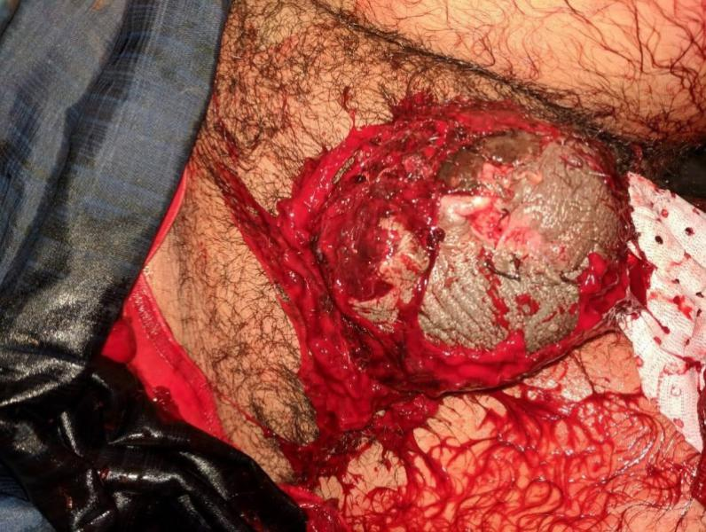

Figure 2: Intraoperative appearance: correct hemostasis, identification of the urethra and corpus cavernosum with catheterisation of the urethra

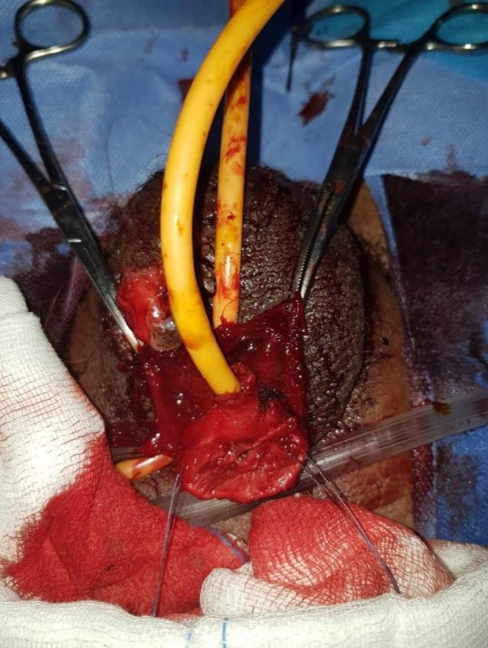

Figure 3: aspect at the end of the operation

