TOPIC
Management of Acute Sigmoid Volvulus in a Tertiary Hospital North Central Nigeria: The Place of Advanced Radiodiagnostics
Authors
*Edwin OSENI-MOMODU¹
¹Department of Surgery, Bingham University/Bingham University Teaching Hospital, Jos campus
Hassan SHEHU¹
¹Department of Surgery, Bingham University/Bingham University Teaching Hospital, Jos campus
Jaejeok LEE¹
¹Department of Surgery, Bingham University/Bingham University Teaching Hospital, Jos campus

Correspondence to: Associate Professor Edwin OSENI-MOMODU Department of Surgery, College of Medicine and Health Sciences, Jos campus, Bingham University Teaching Hospital,
Bingham University, Zaria Bypass, PMB 2238, City Postcode 930241
Jos. Plateau State. Nigeria. TEL: +234 703 321 6336, EMAIL: eosenimomodu@yahoo.com

,

ABSTRACT
Background: Volvulus involves the twisting of air-liquid stool filled thin-walled segment of an intestine around its necessarily narrow mesenterial base, thereby strangulating the blood vessels, which often causes necrosis of this redundant intestinal segment.
Objective: To find out its presentation patterns and build a decision algorithm for diagnostic and therapeutic, determine best management outcomes of acute sigmoid volvulus, report our experience with its disease markers, if any, it is etiology and measures which reduce surgical mortality and morbidity.
- Hypothesis: Null hypothesis, Ho; Scout film radiographic studies of the abdomen without use of more advanced computer topographies, CT, or magnetic resonce imaging, MRI, are not sufficient to diagnose acute volvulus and as such presumptive diagnosis of acute sigmoid volvulus must be refereed to specialized centres with CT and MRI facilities.
- Alternate Hypothesis; Ha: Good history taking, exact structured physical longitudinal examination of patients inclusive of abdominal radiography are sufficient to clinch the diagnosis of acute sigmoid volvulus in a resource limited hospital thereby mitigating cost of management.
Design: This study is a retrospective study over five years from 2015-2020, at BHUTH, Jos, Plateau State North-Central, Nigeria.
Methods:
All patients with acute abdomen with the presumptive diagnosis of acute or sub-subacute colonic volvulus admitted to surgical management were studied retrospectively.
Results: The Hospital admitted 41 patients: 31 males and 10 females, in the ratio of 3:1 for the management of acute sigmoid volvulus.
Conclusion: We did not find any benefit in preoperative decompression or detorsion of the volvulus; the only case so managed had a recrudescence within three months and died shortly after the Hartmann operation. The diagnosis was easy, requiring focused history taking and adequate structured physical examination, laboratory workup, and the study of only a scout film radiograph of the abdomen. (Word count 291)

Keywords: endemicity, dolichol-sigmoid, absolute wind stoppage, Hartmann's procedure,
Abbreviations: Bingham University Teaching Hospital (BHUTH), length of hospital stay (LOS), multi-organ failures (MOF), quality of life (QOL).

INTRODUCTION
Volvulus occurs when an air-filled thin-walled segment of the intestine twists about its narrow mesentery ⁽¹⁾ Colonic volvulus occurs up to 90% at the volvulus and 20% at the caecum. ⁽¹⁾ Any redundant portion of the colon can be affected by volvulus. Most patients are males. ^{(2, 3, 4, 5, 6, 7)} A volvulus may reduce spontaneously but more commonly causes bowel obstruction, which can progress to strangulation, gangrene, and perforation. Chronic constipation may lead to a large, redundant colon that predisposes to volvulus, especially if the mesenteric base is narrow .^{(3, 4, 5, 6)} Anatomical studies suggest that Black Africans have a predisposition to sigmoid volvulus, with a male gender bias due to an elongated narrow mesenterial base of the sigmoid colon segment. ^{1,2} Madiba TE, Haffajee MR, found that the elongated sigmoid colon in Black-Africans is already present in utero more frequently in Black-African males.^{(2, 3)} For instance, a narrow-shaped mesentery and dolichol-sigmoid segment, with increased splanchnic pressure, commonly leads to necrosis and perforation in male foetoses while broadly shaped sigmoid occurs more in females. ⁽⁶⁾ This anatomy explains the preponderance of volvulus cases amongst males when compared with its occurrence in females^{.(6,7,8)} Delayed patients' referral causes necrosis of the intestinal segment and its twisted knots until increased splanchnic pressure provokes the perforations. ⁽⁶⁾
The non-resection procedures viz sigmoidopexy and recto-sigmoidoplasty do not require bowel preparation with lower morbidity and mortality rates at first incidence, but there is a high frequency of recurrence afterward varying from 45% to 71%.⁽⁹⁾
Where a detorsion fails and there are signs of colonic gangrene, sigmoid resection and Hartmann's procedure with a temporary colostomy and mucus spout would be done to avoid the high mortality associated with primary anastomosis in this situation^{.(10)}
An 180⁰ twisting of the rectosigmoid while considered physiological and reduces spontaneously in 2%, torsion of more than 180o causes ischaemia and necrosis. The preferential anticlockwise direction of twisting in circa 70% as reported in the literature remains still unexplained. ^{(6, 11)}

(4). METHODOLOGY
Lead symptoms were abdominal pain (100%), abdominal tenderness (100%), vomiting and gross abdominal distensions (100%age), and constipation, and absolute wind stoppage^{. (5)} These usual acute sigmoid volvulus features were not difficult to recognize, particularly when gross abdominal gaseous distention of the upper left abdominal quadrant with an emptiness of the left iliac depression were present. ⁽⁶⁾
This diagnosis was already clinched at the surgical outpatient because of these specific signs and symptoms, namely, easily identifiable massively distended large colon with various peculiar radiological findings of the plain abdomen such as bird's beak coffee bean signs. (FIGURES 1, 3 & 4) There was hardly a need to do a CT-scan nor MRI. Only three (3) of all operated for acute volvulus were false-positive.
Vigorous resuscitation with an initial 1 litre of crystalloid fluids in the first 45 minutes and continued at a rate of 1 litre 6 hourly during surgery preparation went along the lines of designed
Twenty-four surgeries (60%) were performed as emergencies on the same night of admission, mostly when the American Society of Anesthesiologists' (ASA) Physical Status Classification System was already about III. Only 40% of surgeries were done the following mornings12 with ASA Physical Status Classification System much less than III. The average time of resuscitation and preparation for surgery was 2-3 hours. Informed consent forms were made available to all who agreed to the operation and willing to join a retrospective study that would help master the treatment modus, which would help manage future patients. The need for a colostomy, which would be reversed after about 3-6 months of stay at home, was explained. Those who agreed were included in the study.
Inclusion criteria:
- All patients who were admitted as surgical inpatients management who consented to the study.
- A consecutive selection process was done as eligible patients who consented to the study were seen.
- All patients were assured anonymity and the freedom to quit the study group at any time if they so wished.
- Guardians of minors signed for their wards after sufficient explanations were offered.
Forty-four (44) Patients were initially taken into the study, as shown in Table 1.
Only three patients did not show evidence for volvulus of the sigmoid colon but of midgut and so
were eliminated from the study.
Patients were vigorously hydrated, bladder catheterized, and given preoperative broad-spectrum antibiotics. They also received intra-venous Cephalosporines, aminoglycosides, and infusions of metronidazole before and during surgeries beyond 3 hours. Blood specimens were collected, and 2 – 3 pints of whole blood were grouped and crossed matched before taking the patients to the theatre. Infusion of one pint of whole blood was begun at the start of surgery even if PCV was normal since there could have been haemo-concentration. Check-lists were regularly done on patients before and immediately post-surgery.
All the 41 patients in the male to female ratio of 31:10 had laparotomies. One male patient (2.4%) had a reduction and colopexy since there was no necrosis. 40 Patients (97.6%) underwent the Hartmann's procedure in the male to female ratio of 27:13. The mean operation time was 3 hours. The median duration of the procedures was 180 minutes. The time-lag between admission and surgery was a median of 8 hours.
Our house-developed Surgeon's operative protocol, a decisional algorithm of clinical or radiologic severity, was used. See Figure 2.
Twisted mesenterial knots were identified in all patients (100%); 23 patients (57.1%) had frank necrotic segments with varied sizes of perforations and soilage of the peritoneal cavity. The enlarged necrotic colonic segments were removed after clamping about 2cm into its healthy proximal colon and 2 cm distal from the necrotic end of the segment, which was then carefully unwound held between abdominal packs, resected and lifted out of the abdomen care taken not to allow more leakage and increase of intra-peritoneal soilage and postoperative infection. (Figures 3 and 4)
This picture shows one of our acute volvuli without necrosis; the volvulus segment is elongated but shows a narrow mesenterial base, which is the essential contributory factor for the twist; in this case, the torsion is twice. ^{(3, 4, 5)}
If the remaining proximal piece of the descending colon was long enough, a colostomy position was chosen at a site below the waist's expected beltline; otherwise, it was chosen higher. A colostomy with a spout was now fashioned such that a brook would not develop, which process required proficiency.
Statistical data analysis.
Statistical analysis was done with Excel and Statistical Package for the Social Sciences (SPSS) 22nd Edition.

(5). Results:
Forty-one patients, 41 (100%) who made our inclusion criteria for this study were admitted for management in the Surgery Department. All 41 patients (100%)) underwent explorative laparotomies. Thirty-seven 37 patients (90.2%) had amputations of the necrotic colon segment and Hartmann's procedure. One male patient (2.4%) had a reduction and colopexy since there was no necrosis. 40 Patients (97.6%) underwent the Hartmann's procedure in the male to female ratio of 27:13. Three males (3.75%) had resection of the necrotic segment and an immediate end to end anastomosis without washout.
The average age of all patients was 65 years with a median age of 38 years, median sex distribution of 1.00 with a standard deviation of 0.454. The median length of hospital stay (LOS) was 7.0 days, and a standard deviation of 24.5 days. There were hardly intra-operative complications since the surgery was straight forward as preplanned.
Severe abdominal soilage from leakage of stool from perforations of necrosis of the twisted colon segment negatively affected morbidity and mortality values. ^{(1, 6)}
Mortality showed one death (2.4%) for the patient that had a reduction and colopexy but had a recurrence of volvulus three months later; he died after a Hartmann's procedure. Thirty-eight 38 (92.7%) patients had Hartmann's procedure. All colostomies for primary Hartmann's procedure were reverted after three months of recuperation at home. All such 15 male patients (48.4%) were alive all the period of this study.
The immediate survival rate of the operated cases was 28 (70%). The mortality rate was twelve 12 (30%) from various postoperative morbidities, especially peritonitis, septicemia, respiratory failure; Table 2. The rest died of sepsis and multi-organ failures (MOF).
Discussion
We had a high mortality rate of 19% for Hartmann's procedure alone. This 2-digit percentage, which is similar to a mortality rate of 16.7% by Udueze NO in Kaduna, Nigeria (19), is higher than rates of 10.5% found by Nuhu A, Jah A in the Gambia(1) and 12% at the University Hospital of Cocody, Abidjan by Kassi AB, Lebeau R, Yenon KS, Katche E, Diane B, Kouassi JC ⁽¹²⁾ ; 12% by T R Mokoena and T E Madiba ⁽²¹⁾ in South Africa.
All 3 cases who had immediate continuity anastomosis after resection of volvulus died; they posted high mortality of 7.3%, similar to that Traoré D, Sanogo Z, Bengaly B, Sissoko F, Coulibaly B, Togola B, et al. in Bamako. 20 This 100% (3 cases) of mortality was discouraging and could not continue the management of acute volvulus until such operations' skill has been honed.
The average occurrence per year of 8.8% sigmoid volvulus in our study appears low, despite being in the endemic subregion compared with results found in similar studies. ⁽¹²⁾ Acute volvulus occurred highest in the age group of 30 – 39 years with 20.5% and male to female ratio of 7:2 in keeping with higher male prevalence as shown in all the age subset.6 (Table 1)
Male to female ratio was 31 to 13 (2.3:1), less than that of Kassi AB, Lebeau R, Yenon KS, Katche E, Diane B, Kouassi JC.12 Mean age was 65 years with a median 38 years tallied with studies of Nuhu A, Jah A. and Kassi AB1, Lebeau R, YenonKS, Katche E, Diane B, Kouassi JC respectively. ^{(1, 12)} Male to female ratio of volvulus in the age group of 0-19 years was 7:4. The male preponderance is in keeping with trends of the works of Perrot L, Fohlen A, Alves A, Lubrano J ⁽⁶⁾ , and others in the endemic areas by Kassi AB, Lebeau R, YenonKS, Katche E, Diane B, Kouassi JC. ^{(9, 12)} All cases of sigmoid volvulus in this study occurred at just above the iliac crest, where the descending colon becomes sigmoid colon without sex difference in conformity with the works of Mnguni M N, Islam J, Manzini V, Govindasamy V, Zulu B M W, Clarke D et al. ⁽⁹⁾
Most patients were in a good state of nourishment despite a history of chronic recurrences of constipations. Their vital signs were not alarming, nor were their laboratory findings deranged. ⁽⁶⁾
We did not practice the sigmoidoscopic detorsion, nor excision and anastomosis on the same admission as prevalent in Scandinavian Countries. ^{(2, 18)} The few attempts were aborted mid-way because of the scarcity of functional sigmoidoscopes and expertise. There was often intraluminal bleeding indicative of beginning or frank necrosis of the twisted knots, which were invariably confirmed at laparotomy.
Excision and continuity anastomosis was done when there was no intestinal necrosis and the remaining colon's length sufficient for the anastomosis without tension. Three such cases (7.3%) had a mortality of 100% in this subgroup. ⁽⁶⁾
The high rate of recurrence of volvulus by successful endoscopic detorsion in literature at about 60% within a short time did not lend a drive to pursue the procedure^{. (5)}
Our total morbidity and mortality rates of twelve (29.3%) were higher than the 10.5% found by Nuhu A, Jah A in the Gambia. (1) The mortality rate of 12% at the University Hospital of Cocody, Abidjan Kassab, Lebeau R, Yenon KS, Katche E, Diane B, Kouassi JC. ⁽¹²⁾
Our Hartmann's procedure had significant mortality initially due to postoperative infections of the operative site. ⁽⁹⁾ However, the intestinal continuity's easy restoration made it the gold standard despite the temporary postoperative disabilities and immediate worsening of quality of life (QOL).
Our experience with primary anastomosis following resection of the gangrenous bowel segment was not satisfactory as would be in experienced hands. Junior surgeons should not do Hartmann's procedure. In the absence of an accurate and valid method to ascertain bowel viability and strict clinical criteria to select primary anastomosis cases, Hartmann's procedure should not occur. ⁽¹¹⁾

CONCLUSION
Our study suggests that the management of uncomplicated acute sigmoid volvulus with excision and continuity anastomosis in the same sitting was fraught with high mortality. A Hartmann's procedure, where feasible, should be carried out, especially when the sigmoid segment is gangrenous. Morbidity is mainly from infections of the operative site, anastomotic breakdowns, and peritonitis. The timing of surgery, the type of anastomosis, and the bowel's viability influenced the outcome significantly. There were no distinct disease markers in our experience. We did not find it necessary to recourse to advanced radio-diagnostics (CT-scans nor MRI- studies), which hospitals with limited resources could not afford.

Acknowledgments: Statistical reviews were done by Mr. Henry Job of the ICT Department of BHUTH.
Authors' Contributions
Oseni-Momodu, EO Conception, design, drafting and writing and revisions of the manuscript,
Shehu, H Administrative and critical revisions of the manuscript,
Lee, A J Lead Surgeon in most cases and literature search and photography
There was no financial support nor sponsorship. All authors agreed to pay for the cost of publication if the need arises
Conflicts of interest: All authors declared that there are no conflicts of interest
ETHICS
Approval to undertake this study was applied for and received from the Human Research and Ethics Committee of Bingham University Teaching Hospital (BHUTH).
Approval number: NHREC/21/05/2005/00710
All authors consented to publish this Paper.
REFERENCES ACUTE VOLVULUS
- Nuhu A, Jah A. Acute sigmoid volvulus in a West African population. Annals of African Medicine Vol.9, No. 2; 2010:86-90
- Madiba TE, Aldous C, Haffajee MR. The morphology of the fetal sigmoid colon in the African population: a possible predisposition to sigmoid volvulus. Colorectal Disease © 2015 The Association of Coloproctology of Great Britain and Ireland 17, 1114-1120
- Madiba TE, Haffajee MR. Sigmoid colon morphology in the population of Durban, South Africa, with special reference to sigmoid volvulus, Clin Anat 2011; 24: 441-53.
- Madiba TE, Haffajee MR. Anatomical variations in the level of origin of the sigmoid colon from the descending colon and the attachment of the sigmoid mesocolon. Clin Anat 2010; 23; 179-85
- Niels van der Naald N, Prins MI, Otten K, Kumwenda D, Bleichrodt RP. Novel Approach to Treat Uncomplicated Sigmoid Volvulus Combining Minimally Invasive Surgery with Enhanced Recovery, in a Rural Hospital in Zambia. World J Surg. 2018 Jun;42(6):1590-1596
- Perrot L, Fohlen A, Alves A, Lubrano J. Management of the colonic volvulus in 2016. J Visc Surg. 2016 Jun;153(3):183-192
- Maddah G, Kazemzadeh GH, Abdollahi A, Maddah G, Kazemzadeh GH, Abdollahi A, Bahar MM, Tavassoli A, Shabahang et al. Management of sigmoid volvulus: options and prognosis. J Coll Physicians. Surg Pak 2014; 24(1): 13-1
- Samuel JC, Akinkuotu A, Msiska N, Bruce A Cairns, Arturo P Muyco, and Anthony G Charles et al. (2010) Re-examining treatment strategies for sigmoid volvulus: an analysis of treatment and outcomes in Lilongwe, Malawi. Glob j Surg. 2010 Oct; 1(2): 149–153
- Mnguni M N, Islam J, Manzini V, Govindasamy V, Zulu B M W, Clarke DL, Madiba T E. How far has the pendulum swung in the surgical management of sigmoid volvulus? Experience from the KwaZulu-Natal Teaching Hospitals and review of the literature. Colorectal Dis. 2012 Dec;14(12):1531-7.
- Liang JT, Lai HS, Lee PH, Elective laparoscopically assisted sigmoidoscopy for the sigmoid volvulus. Surg Endosc 2006;20: 1772-3.
- Shepherd JJ. The epidemiology and clinical presentation of sigmoid volvulus. Br J Surg 1969; 56:353-359.11
- Kassi AB1, Lebeau R, YenonKS, Katche E, Diane B, Kouassi JC. Morbidity and mortality of Hartmann's procedure for sigmoid volvulus at the University Hospital of Cocody, Abidjan. West Afr J Med. 2011 May-Jun;30(3):169-72.
- Mulas C, Bruna M, Garcia-Armengol J, Roig JV. Management of colonic volvulus. Experience in 75 patients. Rev Esp Enferm Dig 2010; 102: 239–48
- van der Naald N, Prins MI, Otten K I, Kumwenda D, Bleichrodt RP. Novel Approach to Treat Uncomplicated Sigmoid Volvulus Combining Minimally Invasive Surgery with Enhanced Recovery, in a Rural Hospital in Zambia. World J Surg. 2018 Jun;42(6):1590-1596
- Ifversen AK, Kjaer DW. More patients should undergo surgery after sigmoid volvulus. World J Gastroenterol. 2014; 20(48): 18384-18389
- Maddah G, Kazemzadeh GH, Abdolahi A, Bahar MM, Tavassoli A, Shabahang H. Management of Sigmoid Volvulus: Options and Prognosis. J Coll Physicians Surg Pak. 2014 Jan;24(1):13-7.
- Atamanalp SS. Treatment of sigmoid volvulus: A single-center experience of 952 patients over 46.5 years. Tech Coloproctol. 2013; 17(5): 561-569
- Oren D, Atamanaalp SS, Aydinli B, Ilhan M, Yildirgan, M B, Yalçin K, et al. An algorithm for the management of sigmoid colon volvulus and the safety of primary resection: experience with 827 cases. Dis Colon Rectum 2007; 50: 489-97
- Udezue N O. Sigmoid volvulus in Kaduna, Nigeria. Comparative Study. Dis Colon Rectum Aug 1990; 33(8): 647-9. doi: 10.1007/BF02150738. T R Mokoena, T E Madiba Sigmoid volvulus among Africans in Durban. Trop Geogr Med. 1995;47(5):216-7
- Traoré D, Sanogo Z, Bengaly B, Sissoko F, Coulibaly B, Togola B, et al. Acute sigmoid volvulus: Results of surgical treatment in the teaching hospitals of Bamako. Journal of visceral surgery 2014; 151: 97 – 101
- Mokoena TR, Madiba T E Sigmoid volvulus among Africans in Durban
Trop Geogr Med 1995; 47(5):216-7.

Figure Legend

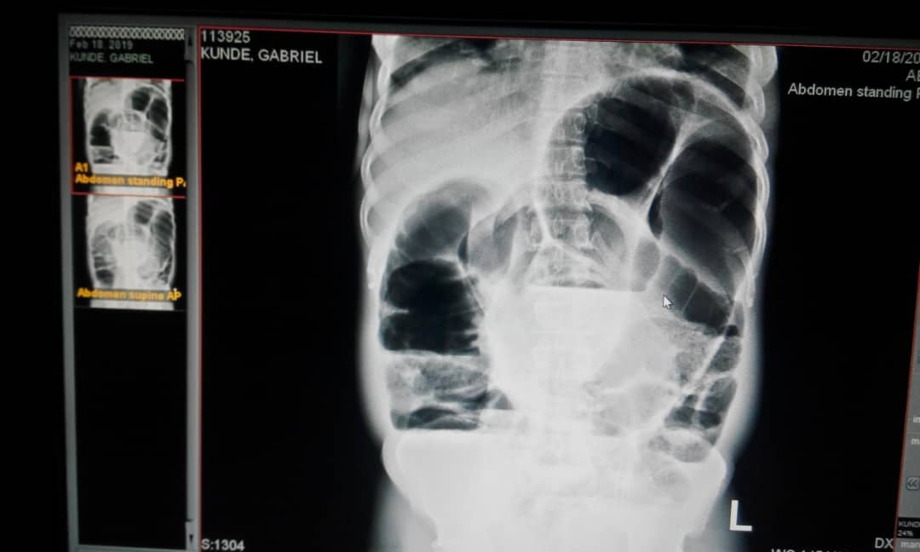
Figure 1: Plain x-ray of abdomen; bird's beak and coffee bean signs

NO VOVULUS
INTESTINAL OBSTRUCTION,
dd SIGMOID VOVULUS
VIGOROUS RESUSCITATION
WIND PASSAGE AND BO AFTER RESUSCITATION
NO IMPROVEMENT, CONTINUOUS ABDOMINAL EXTENSION AND ABSOLUTE WIND STOPPAGE
NO RADIOGRAPH SIGNS FOR VOVULUS
NO VOVULUS
CONTINUE CONSERVATIVE MANAGEMENT
HIGH Suspicion FOR VOVULUS
EXPLORATIVE LAPAROTOMY
ENDOSCOPIC DETORSION MANEUVER
POSITIVE BIRD’S BEAK AND COFFEE BEAN SIGNS
NEGATIVE/FAILURE
POSITIVE/SUCCESSFUL
DEFINITIVE SURGERY(HARTMANN’S)
Figure 2: decisional algorithm for clinical diagnostics and management.

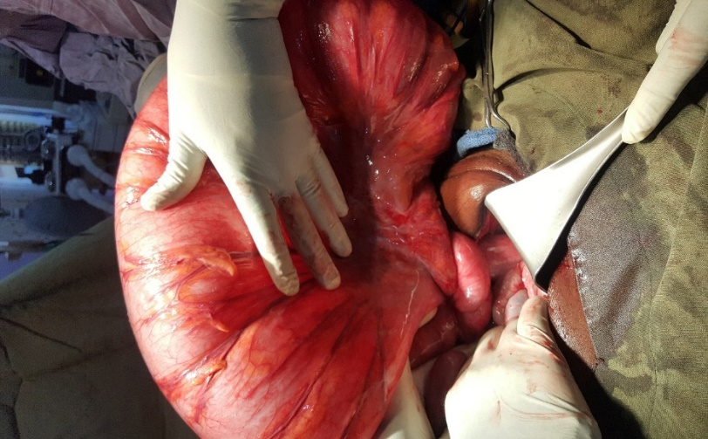
FIGURE. 3: ACUTE VOLVULUS WITHOUT NECROSIS;
A KNOT OF NARROW ELONGATED MESENTERIAL
BASE IN ANTICLOCKWISE ROTATION

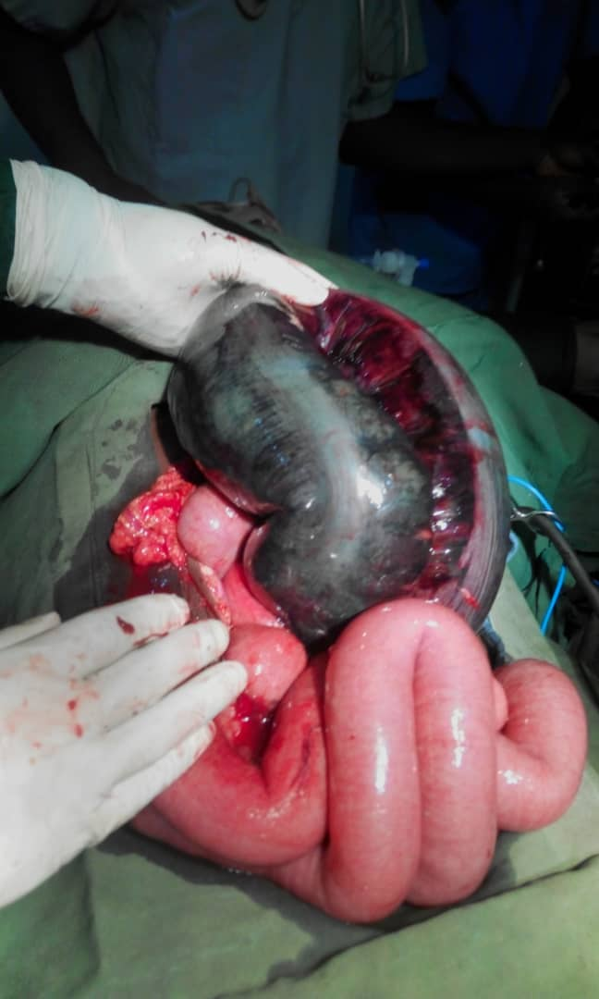
Figure 4: One of our patients with a coffee-bean
necrosis of sigmoid colon

Number of Patients (41) 100%
Reduction and Colopexy 1 (2.4%)
Recurrence After 3 Mons & Re-Operation Hartmann 1
Died 1 (2.4%)
Laparotomy 40,( 97.6%)

37 (92.5%) Hartmann’s Procedure
Died 8 (19%)
Resection + Immediate Anastomosis 3 (7.3%)
Temporary Colostomy
stoma closure 3 Months later
Died 3 (7.5%)⁶
FIGURE. 5: OUTCOME OF SURGICAL MANAGEMENT

TABLE LEGEND
Table 1: Demographic Distribution of Patients with Acute Volvulus by Age and Sex
Age(years) | Frequency and percentage (%)
 | Male | Female | Total (%)
0-9  10 – 19  20 – 29  30 – 39  40 – 49  50 – 59  60 – 69  70 – 79 | 2(4.5)  4(9.1)  5(11.4)  7(15.9)  3(6.8)  3(6.8)  4(9.1)  3(6.8) | 5(11.4)  2(4.5)  0(0)  2(4.5)  1(2.3)  1(2.3)  2(4.5)  0(0) | 7(15.9)  6(13.6)  5(11.4)  9(20.5)  4(9.1)  4(9.1)  6(13.6)  3(6.8)
Total | 31(70.5) | 13(29.5) | 44(100.0)

Table 2. Causes of postoperative deaths
CASE OF MORTALITY | HARTMANN’S PROCEDURE
 | Male | % | Female | %
Peritonitis due to Anastomotic Leak  Respiratory Failure  Septicaemia  MOF | 4 40 1 10  2 20 1 10  1 10 0 0  1 10 0 0
TOTAL | 8 80 2 20

The table above shows the demographic distribution of mortality based on gender and percentage.

