Aneurysmal bone cyst arising in iliopubic chondromyxoid fibroma – A case report

João Vale *, Sara Diniz *, Filipe Rodrigues *, Ana Ribau *, André Coelho**, Vânia Oliveira *, Pedro Cardoso *

* Orthopaedics Deparment, Centro Hospitalar e Universitário do Porto, EPE – Centro Hospitalar e Universitário do Porto, Porto, Portugal
** Pathologic anatomy, Centro Hospitalar e Universitário do Porto, EPE – Centro Hospitalar e Universitário do Porto, Porto, Portugal

Corresponding author:
João Vale
e-mail: jsoaresvale@gmail.com
telephone: +351 913383869
ORCID: 000-0002-5937-0837
Address: Rua Padre Cruz, 148 1º, 4050-219 Porto, Portugal

Running Title: Association between aneurysmal bone cyst and chondromyxoid fibroma in a location never described before

Abstract:
Chondromyxoid fibroma is rare cartilaginous tumor, accounting for 0.5% of all primary bone tumors and 2% of benign bone tumors. Areas of aneurysmal bone cysts (ABC) may be found within CMF in 8.6% of cases. A 20-year-old man presents pain due to a mass on iliopubic ramus that was diagnosed as an aneurysmal bone cyst arising from a chondromyxoid fibroma. This case confirms the rare association between aneurysmal bone cyst and chondromyxoid fibroma. Although aneurysmal bone cyst is more frequently associated with highly vascularized tumors, it is important to consider the diagnosis in the presence of a chondromyxoid fibroma.

Key-words
Chondromyxoid fibroma; Secondary aneurysmal bone cyst; Iliopubic ramus

Introduction
Chondromyxoid fibroma (CMF) was described by Jaffe and Lichtenstein as a distinctive entity in 1948.¹ The definition given by the World Health Organization (WHO) is benign cartilaginous neoplasm, composed of lobules formed by spindle-shaped cells with myofibroblastic features at the periphery, and stellate and chondrocyte-like cells towards the center, the extracellular matrix of the lobules is fibrous at the periphery and myxoid and chondroid towards the center. ²
This rare cartilaginous tumor, accounting for 0.5% of all primary bone tumors and 2% of benign bone tumors, occurs predominantly in adolescents and young adults and more commonly in males.²³ This tumor can occur at almost any osseous site, with predilection for bones of the lower extremities, usually the proximal tibia.^{2,3} Flat-bones account 25 to 30.3% of cases, with ilium been the most affected.^{2,4,5}
Areas of aneurysmal bone cysts (ABC) may be found within CMF in 8.6% of cases. ⁴
ABCs is result of specific pathologic change, which is probably the result of trauma or a tumor-induced anomalous vascular process.⁶ The most common as giant cell tumor, but other like osteoblastoma, angioma, chondroblastoma, telangiectatic osteosarcoma are common to. ⁶
To the best of our knowledge, there is not any case of aneurysmal bone cyst arising from an iliopubic chondromyxoid fibroma.

Case Report
A 20-year-old man with no relevant medical history presents mechanical pain in the left inguinal region with 6 months of evolution. Physical examination revealed a 4cmx2cmx2cm palpable mass in groin.
The conventional radiography (figure 1) revealed an osteolytic tumour in the left ilio-pubic ramus, with cortical thinning and a fracture line in the central region. MRI presents a well defined lesion with lobulated contour and internal septation (figure 2) suggesting an aneurysmal bone cyst or an telangiectatic osteosarcoma. Ultrasonography-guided percutaneous biopsy diagnosed a chondromyxoid fibroma.
The tumour excision was performed through an anterior approach. A Pfannenstiel incision was extended to the proximal region of the left thigh, in order to isolate and protect the femoral neuro-vascular bundle. The spermatic cord was recognized and protected. Bladder was protected as well. Pubic symphysis and the anterior rim of acetabulum were identified and used as anatomical reference to osteotomies. An en-bloc resection of iliopubic ramus and the soft tissues that surrounded it was made (figure 3). No pelvic ring reconstruction was considered for mechanical purpose. Abdominal wall was reinforced with Gore-Tex® mesh, that was attached to symphysis, anterior acetabular rim and abdominal wall muscle fascia to prevent intra-pelvic herniation.
The patient was discharged home 2 days after surgery, with partial-weight bearing and no evidence of complications.
Microscopic examination showed complete excision of the lesion, with free margins.
Histological analysis revealed a benign mesenchymal neoplasm, well delimitated and organized in chondromyxoid lobes of variable cellularity, with stellate cells in myxoid areas and lacunar cells in chondroid areas, features consistent with chondromyxoid fibroma (fig. 4.1 and 4.2). There were also abundant hemorrhagic cavitated areas developing within the tumor, with septa rich in osteoclastic-type multinucleated giant cells and with deposition of linear immature osteoid, typical of aneurysmal bone cyst transformation (fig. 4.3 and 4.4), explaining the images seen in MRI. The neoplasm occupied and expanded the ischio-pubic ramus, reaching the subcartilaginous area of the pubic symphysis, but it didn’t invade the adjacent soft tissue, as it was surrounded by a thin layer of woven bone, consequence of cortical bone remodeling.
After 1 year of follow-up, the patient is pain-free, without functional impairment or complications. There is no recurrence until present.

Discussion
This case represents an unusual localization for this type of tumor. A literature review of 278 cases of CMF of bone, reported that 30.3% of cases occurred in flat bones. Of these only 1 case (1.2%) was located on pubis and 2 on ischium (2.4%). ⁴
As the name indicates, chondromyxoid fibromas show a variety of histological features. The classic histological feature is stellate or spindle-shaped cells arranged in lobules in a myxoid background. ⁴ However, a lobulated pattern was seen in only 86.7% of cases, and can present a macro or microlobular pattern isolated or a mixture. ⁴
In our case, the tumor was accompanied by area of ABC. The origin of term ABC comes from an article by Jaffe and Lichtenstein in 1942.⁷ They postulated that ABC might be a secondary phenomenon due to hemorrhagic “blow-out” in a preexisting lesion, which may be destroyed in the process. ⁷ A preexisting lesion was identified in approximately one third. ⁶
ABCs conventional treatment has been the surgical removal of the entire lesion, or of as much as possible, with recurrence seen in 10-70% of cases.^{2,6} Spontaneous regression following incomplete removal is very unusual.² More recently, non-surgical polidocanol sclerotherapy demonstrates to be a safe and effective option even for aggressive ABCs, depending on location and surgical risks.⁸ Appropriate treatment requires realizing that it has a specific pathophysiologic origin, and identifying the preexisting lesion. If no coexisting lesion is identified, lesion are usually treated with curettage and bone grafting. ⁶
The typical treatment of CMF by curettage has a 20% to 25% recurrence rate, lowering to 7% with addition of bone grafting.^{9,10} Resection provides lower recurrence rates but is not always feasible.
Based on the system proposed by Enneking WF and Dunham WK, this case of CMF involves zone III (involvement of pubis and ischium bones). ¹¹ A review of 8 cases describing surgical management of CMF of pelvis, reported two cases of involvement of superior ramus of pubis. One was treated with resection without grafting and complicated with pelvic internal organs herniation. On second case reconstruction was done using fibular strut allograft, with none complication on follow-up. ¹² Another case of CMF of iliopubic ramus presented good results with aggressive curettage and chip bone grafting. Author reclaims this procedure as safe, easy, and less morbid for this anatomic site. ¹³
In our case, we resected iliopubic ramus and used a Gore-tex® surgical mesh to prevent intra-pelvic herniation. Resection should be performed for large lesions or in anatomic sites such as the complex pelvis where such procedure does not increase the risk of fracture and reduce the likelihood of recurrence or a second surgery.
The secondary ABC arising from CMF was verified histologically. It is associated to a significant recurrence rate and the surgical strategy adopted was then confirmed the most appropriate.
This case represents a rare tumor, in an uncommon location, with an atypical histological transformation. This case shows the rare association between ABC and CMF. Although secondary ABCs are more frequently associated with highly vascularized tumors, it is important to consider the diagnosis of CMF in the presence of an ABC, as it may alter the clinical approach to minimize the risk of recurrence.

Authors' Contributions
João Vale: Wrote the manuscript, Performed the literature review.
Sara Diniz: Edited the paper
Filipe Rodrigues: Edited the manuscript
Ana Ribau: Edited the paper
André Coelho: Edited the manuscript
Vânia Oliveira: Edited the manuscript
Pedro Cardoso: Edited the manuscript

Financial Support and Sponsorship
None.

Conflicts of Interest
None.

Consent for Publication
Written informed consent was obtained from the patient for publication of this case report and any accompanying images.

References
1. Jaffe HL LL. Chondromyxoid fibroma of bone; a distinctive benign tumor likely to be mistaken especially for chondrosarcoma. Arch Pathol. 1948.
2. Spieler P, Rössle M. Soft Tissue and Bone. 2012:1053-1105. doi:10.1007/978-3-642-24719-4_17
3. Greenspan A, Jundt G, Remagen W. Differential Diagnosis in Orthopaedic Oncology.; 2007. http://www.loc.gov/catdir/toc/ecip0616/2006020800.html%5Cnhttp://www.loc.gov/catdir/enhancements/fy0712/2006020800-d.html.
4. Wu CT, Inwards CY, O’Laughlin S, Rock MG, Beabout JW, Unni KK. Chondromyxoid fibroma of bone: A clinicopathologic review of 278 cases. Hum Pathol. 1998;29(5):438-446. doi:10.1016/S0046-8177(98)90058-2
5. Zillmer DA, Dorfman HD. Chondromyxoid fibroma of bone: Thirty-six cases with clinicopathologic correlation. Hum Pathol. 1989;20(10):952-964. doi:10.1016/0046-8177(89)90267-0
6. Kransdorf MJ, Sweet DE. Aneurysmal bone cyst: Concept, controversy, clinical presentation, and imaging. Am J Roentgenol. 1995;164(3):573-580. doi:10.2214/ajr.164.3.7863874
7. Henry L. Jaffe; Louis Lichtenstein. Solitary unicameral bone cyst with emphasis on the roentgen picture, the pathologic apperance and the pathogenesis. Arch Surg. 1942;44(6):1004-1025.
8. Brosjö O, Tsagozis P. Treatment of an aggressive aneurysmal bone cyst with percutaneous injection of polidocanol: A case report. J Med Case Rep. 2014;8(1):8-11. doi:10.1186/1752-1947-8-450
9. Subach BR, Copay AG, Martin MM, Schuler TC, Romero-Gutierrez M. An unusual occurrence of chondromyxoid fibroma with secondary aneurysmal bone cyst in the cervical spine. Spine J. 2010;10(2):e5-e9. doi:10.1016/j.spinee.2009.11.016
10. Gherlinzoni, F*; Rock, M†; Picci P. Chondromyxoid fibroma. The experience at the Istituto Ortopedico Rizzoli. JBJS. 1983;65(2):198-204.
11. Dunham; WE. Resection and reconstruction for primary neoplasms involving the innominate bone. J Bone Jt Surg. 1978;60(6):731–746.
12. Jamshidi K, Mazhar FN, Jafari D. Chondromyxoid fibroma of pelvis, surgical management of 8 cases. Arch Iran Med. 2015;18(6):367-370.
13. Arikan M, Togral G, Yildirim A, Aktas E. Chondromyxoid fibroma of the pubic ramus: A case report and literature review. Acta Orthop Traumatol Turc. 2016;50(1):115-119. doi:10.3944/AOTT.2016.14.0232

Figures

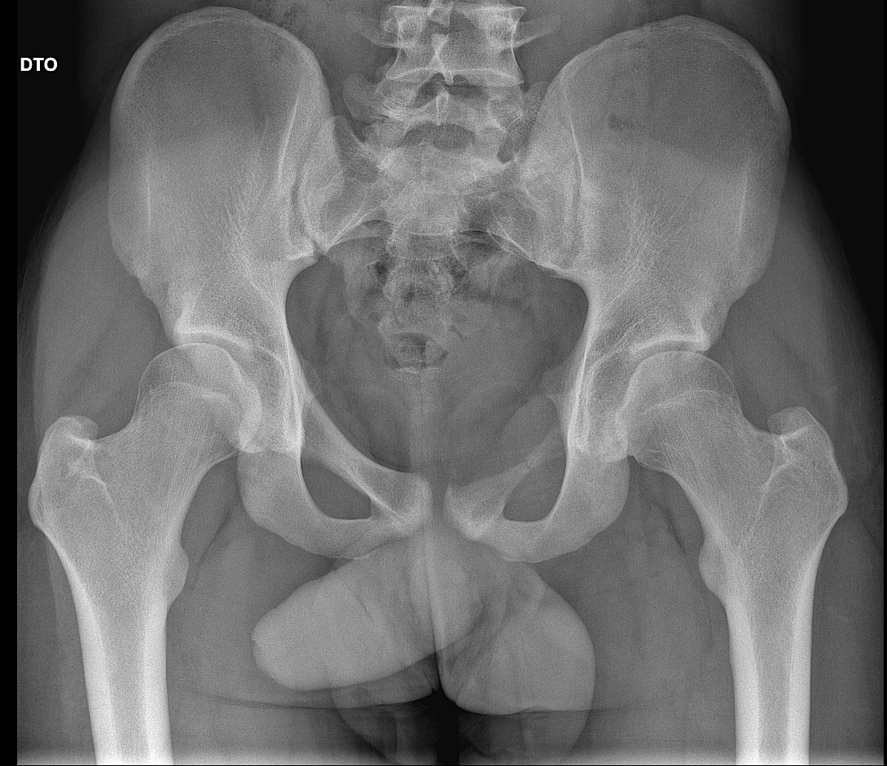
Figure 1 – Preoperative radiographic image shows thinning of the iliopubic ramus and a fracture line in the central region.

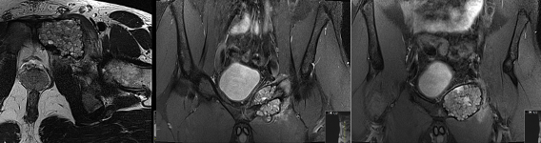

Figure 2 - Preoperative MRI: weel defined lesion with lobulated contour and internal septation
Figure 3 – En-bloc resection of iliopubic ramus and the soft tissues that surrounded it

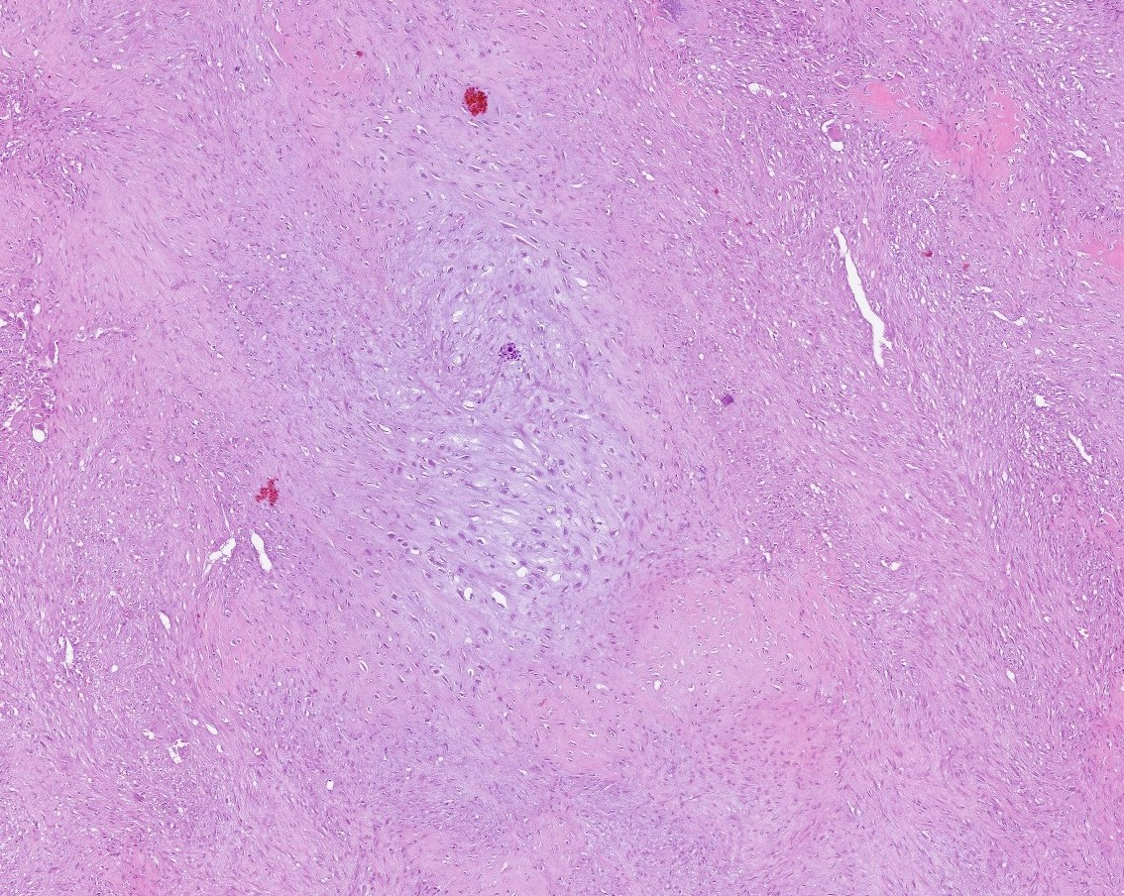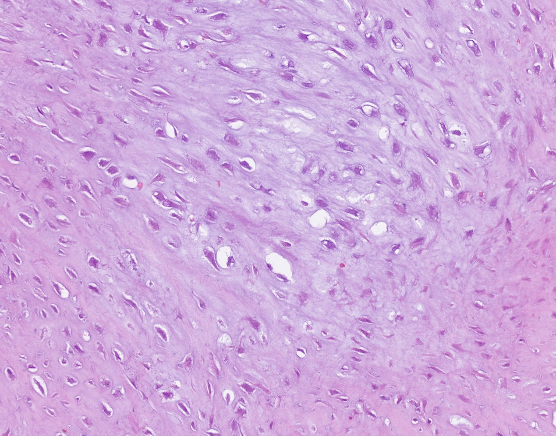
*
*
2
1
2
1
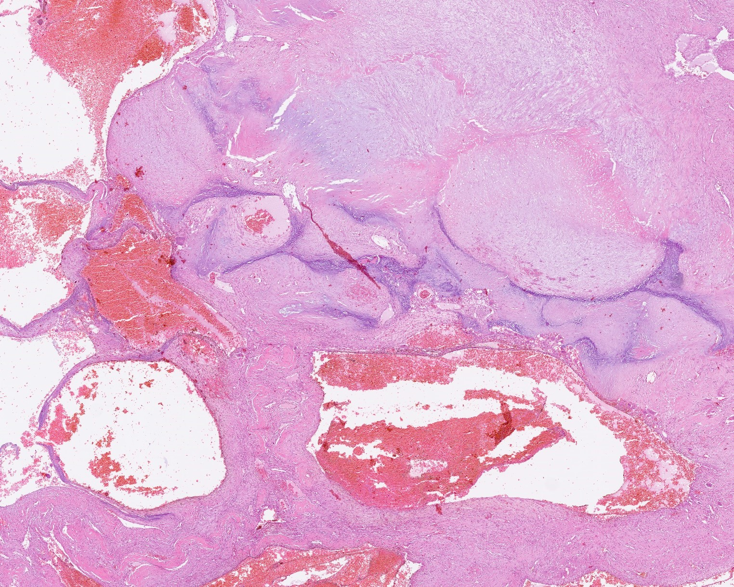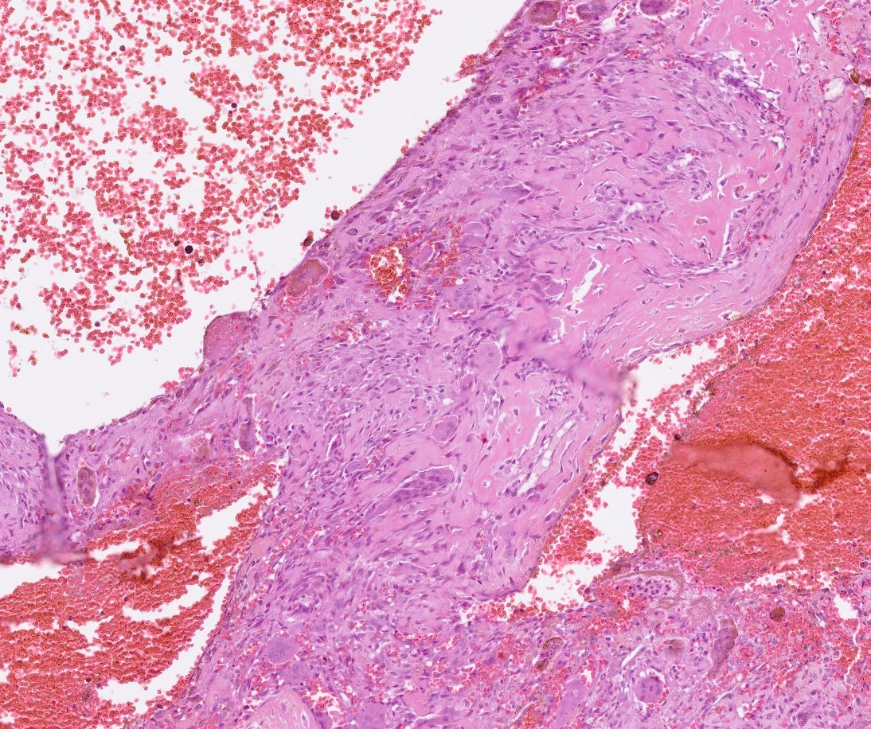
3
4

Figure 4 – 1) The tumor has a zonal, vaguely lobulated architecture, with hypocellular chondromyxoid matrix at the center and a more cellular spindled-cell component at the periphery; 2) The chondroid central areas have oval to stellate cells (*), some of them residing within lacunae (arrow) surrounded by cartilage-like matrix; 3) Secondary aneurysmal bone cyst-like areas are seen throughout the neoplasm, with hemorrhagic spaces; 4) In these areas, the septa contain numerous osteoclastic-type multinucleated giant cells, abundant hemosiderin and linear deposition of osteoid matrix.
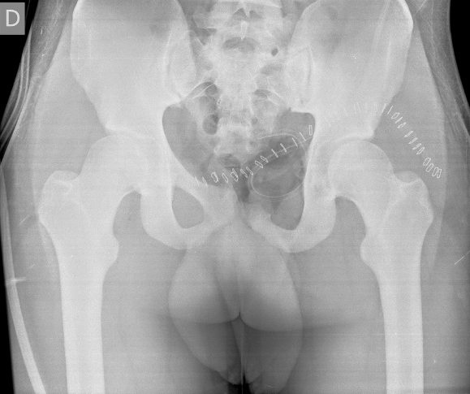
Figure 5 - Postoperative x-ray, after the ressection of iliopubic rami

