Title

Self-induced laparoscopic adjustable gastric band obstruction.

Author
Dr Sajad Ahmad Salati
Associate Professor of Surgery
Unaizah College of Medicine,
Qassim University, KSA.

Address for Correspondence
Dr Sajad Ahmad Salati
Associate Professor of Surgery,
Unaizah College of Medicine,
Qassim University, KSA.
Email: docsajad@yahoo.co.in

Laparoscopic adjustable gastric banding (LAGB) is an effective approach for management of morbid obesity. However, despite favourable mortality and weight loss outcomes, there have been reports of a wide range of associated early and late complications (1, 2). A 29-year-old patient was seen on out-patient basis, fourteen months post LAGB. LAGB has been undertaken elsewhere for management of morbid obesity (BMI 41.7). At one-month post operation, the band had been filled by the operating surgeon through injection into the palpable subcutaneous port with 2 cc fluid after he had tolerated solids followed by another 2 cc and 1 cc after each month of follow up. The patient had lost about 7% of his weight over one year but he had not achieved satisfaction and hence had stopped attending the follow-up clinics. He had then, on the basis of information gathered on internet, self-filled the band twice with unspecified volume, against medical advice. The patient had started losing weight to his satisfaction but had also experienced chest discomfort, difficulty in swallowing and episodes of vomiting. The complaints had increased in intensity over the preceding two weeks. On examination, the patient was conscious, cooperative and well oriented. Vitals signs showed tachycardia and there were features of dehydration. Weight was 79 kg and BMI was 27.6. Abdomen was soft and non-tender with no clinical evidence of port infection. Patient was resuscitated and upper gastrointestinal contrast study was done. The contrast film (Fig 1A) revealed gastric stomal obstruction with dilated pouch and esophagus.
The fluid (9.5 ml) was released from the bank by suction at the port site and the gastric band was deflated. The patient attained symptomatic relief and at three-week follow-up, contrast study was repeated which demonstrated reversal of changes in the previous study and free outflow of contrast from the stomach (Fig 1B).
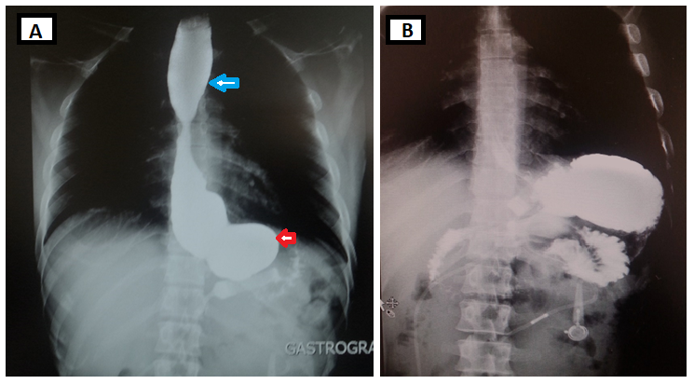
Figure 1: A – Pre-deflation : Stomal obstruction with dilated gastric pouch (red arrow) and dilated esophagus (blue arrow) ; B – Post-deflation: Free out flow of contrast from the stomach .

The patient was attached to the services of board-certified bariatric surgeon where the option of removal of band with subsequent laparoscopic sleeve gastrectomy was offered to the patient.
Laparoscopic adjustable gastric banding (LAGB) procedures have a favourable risk-benefit profile and have been widely used for management of morbid obesity. But in recent years, laparoscopic sleeve gastrectomy has becoming increasingly popular due to wide range of complications associated with LAGB which include gastric band slippage, port or tubing malfunction, stomal obstruction, band erosion, pouch dilation, and port infection (1-3).
Approximately 50% of patients after LAGB may require reoperation (4), including 25% who experience major late complications. Lanthaler et al. conducted a study on weight loss and quality of life after gastric band removal or deflation and found that up to 73% of patients would not choose to have LAGB again (5).
Upper gastrointestinal tract contrast imaging is often required to diagnose these complications. Some complications can be managed in the primary care setting through behavioural diet modification or removal of fluid from the band (band deflation) as was done in our case; however, many complications require surgical repair or removal of the band (2,3).

Our case also stresses upon the fact that proper education of patients is a must when option for such sophisticated procedures, particularly in the present era of internet, where patient may access and misinterpret the available information.

Acknowledgement
The author would like to thank the patient for allowing the usage of case history and personal images for academic purposes. This project did not receive any sort of grant from any funding agency in the public, commercial or not-for-profit sector nor is there any conflict of interests.

References
1. Snow JM, Severson PA. Complications of adjustable gastric banding. Surg Clin North Am. 2011;91(6):1249-64.
2. Kodner C, Hartman DR. Complications of adjustable gastric banding surgery for obesity. Am Fam Physician. 2014 ;89(10):813-8.
3. Carucci LR, Turner MA, Szucs RA. Adjustable laparoscopic gastric banding for morbid obesity: imaging assessment and complications. Radiol Clin North Am. 2007;45(2):261-74.
4. Matlach J, Adolf D, Benedix F, Wolff S. Small-diameter bands lead to high complication rates in patients after laparoscopic adjustable gastric banding. Obes Surg. 2011;21(4):448-56.
5. Lanthaler M, Strasser S, Aigner F, Margreiter R, Nehoda H. Weight loss and quality of life after gastric band removal or deflation. Obes Surg. 2009;19(10):1401-08.

