Research Article
Study of Surgical Site Infection- An Obstetrical Surgical Morbidity at a Tertiary Level Hospital.

Dr Deepika Panwar¹ , Dr BS Jodha², Dr Prabhu Prakash³
¹2nd year resident, Department of Obstetrics and Gynecology, Umaid Hospital, Dr S.N. Medical college and hospital, Jodhpur, India
²Sr.Professor and Unit Head, Department of Obstetrics and Gynecology, Umaid Hospital, Dr S.N. Medical college and hospital, Jodhpur, India
³Professor, Department of Microbiology, Umaid Hospital, Dr S.N. Medical college and hospital, Jodhpur, India
Correspondence to: Dr Deepika Panwar, 2nd year resident, Department of Obstetrics and Gynecology, Umaid Hospital, Dr S.N. Medical college and hospital, Jodhpur, India.
Email: panwardeepika19@gmail.com.

Abstract: Background: Surgical site infection (SSI) is amongst the most common sufferings following caesarean section. It contributes to increased morbidity and negative impact on the mental, social and economic condition of patient. Aim: To determine the incidence, risk factors and therefore the bacteriological profile following caesarean section at Umaid Hospital Jodhpur. Methods: This was a hospital based prospective observational study of 1600 patients who had caesarean section over 3 months duration. Out of which 50 patients developed post caesarean surgical site infection. Wound swabs were collected from these patient, culture and antibiotic sensitivity were done for aerobic pyogenic organisms. Results: Out of the 1600 participants who had a caesarean section, 50 patients had surgical site infection, giving an incidence of 3.12 of 100 caesarean sections. The common isolates were CONS (Coagulase Negative Staphylococcus aureus) (57%), Staphylococcus aureus (14%), followed by E.coli (17 %), Acinetobactor (7%) and Klebsiella (3%). Common known risk factors present in this study were emergency caesarean section , obesity, rupture of membranes, lack of intra operative antibiotic coverage, previous caesarean section etc. Most isolates were resistant to Ofloxacin and sensitive to Vancomycin, Linezolid and Amikacin. Conclusion: The post-caesarean wound infection rate in our centre was 3.12 of 100 caesarean sections. Linezolid , Cefazoline antibiotics were sensitive for commonest isolates from SSIs and may be used prophylactically till the final report of culture and sensitivity is obtained. This may reduce the complications associated with SSI.

Keywords: Caesarean section, surgical site infection, Wound infections, Antibiotic sensitivity.

INTRODUCTION:
Surgical site infection (SSI) is defined as an infection occurring within 30 days after a surgery and affecting superficial/deep tissues at the operation site¹. Surgical site infection (SSI) is one of the most common causes of nosocomial infections, with a reported incidence rate of 2-20%². Postoperative SSI following caesarean section is related with increased morbidity, mortality, prolonged hospital stay and socio-economic loss to the patient ³.
Among risk factors patient related factors are old age, nutritional status, pre existing infection, co-morbid illness and procedure related factors like poor surgical technique, prolonged duration of surgery, pre operative part preparation, improper aseptic precautions. These factors can influence SSIs significantly⁴.
In addition to these risk factors, the virulence and the invasive power of the organism involved, physiological state of the wound tissue and the immunological integrity of the host are also the important. Surgical site infections delays recovery of patient, prolongs hospital stay or outpatient treatment, may necessitate readmission and can lead to significant morbidity and mortality⁵. The rate of surgical site infection after caesarean section range from 3% to 15% in different settings⁶⁻⁸ .
The underlying predisposing factors for surgical site infection following caesarean include intrinsic factors like age, obesity, underlying medical conditions like diabetes mellitus, hypertension, and immune-compromised states like HIV infection, anemia⁹⁻¹². Extrinsic factors identified in previous studies include preoperative parts preparation, type of procedure carried out (emergency), type of skin incision given (horizontal/vertical), prophylactic antibiotic coverage, chorioamnionitis, number of vaginal examinations carried out before surgery, duration of operation and environment of the operating room¹³⁻¹⁴ . Knowledge of risk factors may help to reduce the incidence and severity of surgical site infections.
The CDC describes three levels of surgical site infection; Superficial incisional SSI Infection occurs within 30days after the operation and infection involves only skin or subcutaneous tissue of the incision and at least one of the following: 1. Purulent drainage, with or without laboratory confirmation, from the superficial incision. 2. Organisms isolated from an aseptically obtained culture of fluid or tissue from the superficial incision. 3. At least one of the following signs or symptoms of infection: pain or tenderness, localized swelling, redness, or heat and superficial incision is deliberately opened by surgeon, unless incision is culture-negative. 4. Diagnosis of superficial incisional SSI by the surgeon or attending physician. Deep incisional SSI Operation related infection involving deep soft tissues which occurs within 30 days after the operation and at least one of the following: 1. Purulent drainage from the deep incision but not from the organ/space component of the surgical site. 2. A deep incision spontaneously dehisces or is deliberately opened by a surgeon when the patient has at least one of the following signs or symptoms: fever (>38°C), localized pain, or tenderness, unless site is culture-negative. 3. An abscess or other evidence of infection involving the deep incision is found on direct examination, during reoperation, or by histo-pathologic or radiologic examination. 4. Diagnosis of a deep incisional SSI by a surgeon or attending physician ¹⁵.

MATERIAL AND METHODS:
This hospital based prospective observational study was carried out in Department of Obstetrics and Gynecology at one of the largest tertiary care level, Mother and Child Hospital, of western India. The study population comprised of 1600 women who delivered by caesarean section over a 3 months period. Structured questionnaire was used to collect information from study subjects. Information was collected about demographic data, existing chronic disease (such as diabetes mellitus, hypertension) and wound related characteristics. All females were examined post operatively for SSI features like purulent drainage from incision site till discharge from the hospital. Females who were readmitted with clinical features of SSI within 30 days of Caesarean section were also included for calculation of SSI incidence. Two swabs were collected from the infection site using standard aseptic precautions and sent to the microbiology laboratory for further testing. In laboratory one swab was used for direct microscopy and Gram’s staining, from another swab aerobic pyogenic culture and sensitivity testing was done. Identification of organism and Culture sensitivity reporting were done according to CLSI guidelines ¹⁶. For detection of sepsis markers i.e. CRP and PCT, 3 ml of blood sample were collected in plain vial and testing was done using Expedia Latex Agglutination and Dx insta check kits respectively.
Due clearance was obtained from Institute, Ethics Committee (IEC no. SNMC/IEC/2021/plan/387). Written informed consent was taken from all subjects prior to inclusion into the study.
Statistical analysis: Qualitative variables will be expressed as numbers and percentage and analysed using chi square test.

RESULTS:
The study was performed over a period of 3 months. Out of the 1600 women delivered by caesarean section, 50 (3.12%) women developed surgical site infection (Figure 1).
Figure 1: Proportion of participants developing surgical site infection following caesarean section.

SSI = surgical site infection.

Proportion of SSI was highest among teenage (8.1%), among those with ≥4 children (4%) and those who had secondary education (3.3%). (Table 1)
Table1: Demographic characteristics of women undergoing Caesarean section.
VARIABLE | TOTAL PATIENT | SSI PRESENT (%) | SSI ABSENT (%) | p value
Age  <19  20-29  >30 | 49  1277  274 | 04(8.1)  40(3.1)  06(2.1) | 45(91.8)  1237(96.8)  268(97.8) | X² = 4.9  Df = 2  P = 0.086
Parity  1  2  3  =/>4 | 915  455  132  98 | 36(3.9)  08(1.7)  02(1.5)  04(4.0) | 879(96.0)  447(98.2)  130(98.4)  94(95.9) | X² = 5.8  Df = 3  P = 0.134
Education level  Illiterate  Primary  Secondary | 326  915  359 | 08(2.4)  30(3.2)  12(3.3) | 318(97.5)  885(96.7)  347(96.6) | X² = 0.612  Df = 2  P = 0.736
Estimated gestational age  <37Weeks  >37 Weeks | 160  1440 | 05(3.1)  45(3.1) | 155(96.8)  1395(96.8) | X² = 0.06  Df = 1  P = 0.811
Booking status  Unbooked  Booked | 958  620 | 26(2.7)  24(3.8) | 932(97.2)  596(96.1) | X² = 1.74  Df = 1  P = 0.224
SSI – surgical site infection
SSI was significantly higher among emergency caesarean section (6%) than elective caesarean section (0.8%) (p= <0.0001). Also obese women (BMI>30) were having more SSI (4.5%) than BMI <30 (3.2%) (p=0.014). The most common indication of caesarean section developing SSI was fetal distress (5%) followed by previous LSCS. Rupture of membranes before caesarean section (2.8%) was associated with higher risk of developing surgical site infection than intact membranes (2.2%). Other factors associated with increased risk of post-caesarean wound infection were intra-operative blood loss greater than 500 ml (p <0.001) and lack of intra-operative antibiotic prophylaxis (p<0.001). Hospital stay was found to be higher in women developing SSI (100%). (Table 2)
Table 2: Risk factors associated with post-caesarean wound infection.
RISK FACTOR | TOTAL  (%) | SSI present  (%) | SSI  Absent (%) | p VALUE
BMI  <30  >30 | 1490  110 | 45(3.2)  05(4.5) | 1345(96.7)  105(95.4) | X² = 4.72  Df = 1  P = 0.014
Type of surgery  Emergency  Elective | 700  900 | 42(6)  08(0.8) | 658(94)  892(99.1) | X² = 32.31  Df = 1  P <0.001
Indication of C-sec  Fetal distress (FD)  Previous 1 LSCS  Prev 2 /Prev 3 LSCS  NPOL  Primary breech  DTA  CPD  Pre eclampsia  Placenta previa  Others | 300  500  159  168  130  50  37  41  24  191 | 15(5.0)  08(1.6)  03(1.8)  03(1.7)  03(2.3)  03(6.0)  03(8.1)  01(2.4)  01(4.1)  10(5.2) | 285(95)  492(98.4)  156(98.1)  165(98.2)  127(97.6)  47(94.0)  34(91.8)  40(97.5)  23(95.8)  181(94.7) | X² = 16.77  Df = 9  P = 0.052
Past illness – Diabetes  Yes  No | 20  1580 | 05  45 | 15  1535 | X² = 32.01  Df = 1  P<0.001
Antibiotic prophylaxis  Yes  No | 900  700 | 08(0.8)  42(6) | 892(99.1)  658(94) | X² = 32.31  Df = 1  P<0.001
Time of administration of antibiotic  Immediately before surgery  Post operative | 900  700 | 08(0.8)  42(6) | 892(99.1)  658(94) | X² = 32.31  Df =1  P<0.001
Duration of surgery  <1/2 hour  >1/2 hour | 200  1400 | 00  05(0.35) | 200(100)  1395(99.64) | X² = 0.03  Df = 1  P=0.866
Amount of blood loss  <500 ml  >500 ml | 1560  40 | 00  02(5) | 1560(100)  38(95) | X² = 43.7  Df = 1  P<0.001
Length of hospital stay  <7 days  >7days | 1554  46 | 04(0.25)  46(100) | 1550(99.74)  00 | X² = 1435  Df = 1  P<0.001
[(Others = abruption, severe oligohydraminos, twin pregnancy, bad obstetric history, cord prolapsed) FD=fetal distress, NPOL= non progression of labour, DTA=deep transverse arrest, CPD= cephalopelvic disproportion]

Figure 2: Shows number of bacterial isolates from culture. A total of 50 wound swabs were collected from patients developing post caesarean SSI. Among these 28 (56%) had bacterial growth while 22 (44%) showed no growth.

Percentage of culture with growth
Table 3: Frequency of pathogenic bacteria isolates from post-operative wound infection.
Type of organism | Pus culture | Vaginal culture
CONS | 16 | 02
E.coli | 05 | 17
Staph aureus | 04 | 03
Klebsiella | 01 | 05
Acinatobactor | 02 | 00
(CONS= coagulase-negative staphylococcus, E.coli= Escherichia coli)

Figure 3: Frequecy of bacterial isolates from SSI.
CONS= Coagulase negative staphylococcus aureus, E.coli= Escherichia coli

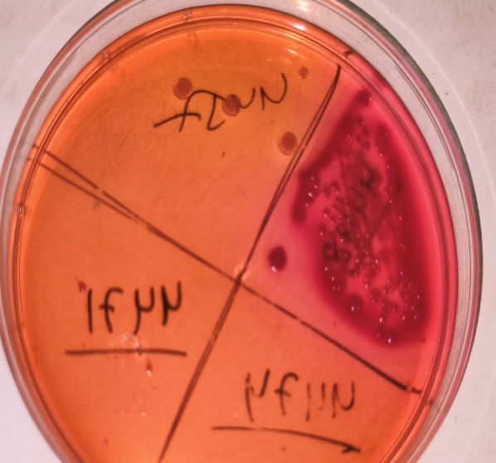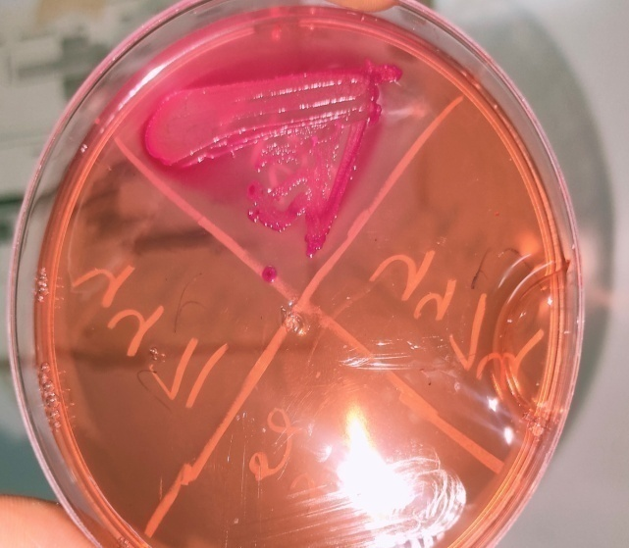
Figure:4(a) E.coli, LF colonies on MacConkey Agar (b) S.aureus LF colonies on MacConkey Agar

Figure 5: Shows type of wound infection: About 76% were superficial and 24% were deep wound infections

Figure 6: Shows management of patient with SSI. About 39 patients (78%) were managed by dressing alone while 11(22%) required resuturing.

Among the organisms isolated from wound culture, most of the CONS (coagualse negative staph aureus) were highly sensitive to Linezolid (100%) and Amikacin (100%), while highly resistant to Ofloxacin. E coli was highly sensitive to Meropenam (100%), Cefepime (100%), Tobramycin (10 0%) (Table 5)
Table 5: Antibiotic Sensitivity profile of various organisms from surgical site wound infection.
Antibiotic name | CONS | E.coli | Staphylococcus aureus
Linezolid | 100% | - | 100%
Amikacin | 100% | 50% | 100%
Cefazoline | 96.66% | - | 100%
Vancomycin | 91.66% | - | 100%
Ampicillin+sulbactum | 85.71% | - | -
Tobramycin | 60% | 100% | 100%
Ampicillin | 50% | - | -
Piperacillin | 0% | - | -
Ofloxacin | 0% | 0% | 0%
Meropenam | - | 100% | -
Cefepime | - | 100% | -
Aztronem | - | 80% | -
Ciprofloxacin | - | - | 100%
Piperacillin +Tazobactam | - | - | 100%

DISCUSSION:
The study aimed to determine the incidence of post caesarean section wound infection and the causative pathogens with their sensitivity profiles. The incidence of post-caesarean wound infection in present study was 3.12 per 100 caesarean sections. Similar past studies had reported an incidence ranging from 7.8% to 8.5%¹⁸. The possible reason for variation in these studies could be due to differences in the population under study and diversity of indications for caesarean sections performed in different centers. The low incidence of SSI in present study could also be due to proper aseptic precautions being followed at our institute.
In present study, teenagers (<19 years) were found to have higher proportion of SSI (8.1%). In a similar study, Cunningham et al reported that many obstetrical complications such as prolonged labour, PIH, and post partum sepsis were more frequently observed among teenagers in ¹⁹.
In present study SSI was observed more among booked women compared to unbooked. This could be due to extended hospital stay, nosocomial, iatrogenic infection due to multiple per vaginal examinations and obstetric interventions in these patients as compared to un-booked patient, who were referred either delivered or operated relatively early due to emergent indication.
In this study SSI was more common educated women, which is contrary to findings of Charles Obinna Njoku et al where SSI was seen more in uneducated women¹⁷. This may be due to the reason that educated women were booked and were admitted for extended duration in the ward and had frequent obstetric examinations by various strata of healthcare services.
The findings of this study demonstrate a significant association between SSI with BMI, obese women having (BMI>30 Kg/m²) developed more SSI (4.5%) than those with BMI <30 Kg/m² (3.2%) (p=0.014). This finding was similar to other studies²⁰. It is because of relatively poor perfusion of adipose tissue which may impair wound healing and decrease the local immune response, enabling infection to occur. The incision for obese women may also need to be longer and therefore involve more tissue becoming exposed to contamination.
Generally patients undergoing emergency Caesarean section are at higher risk of infections. In this study elective surgeries developing SSI were 6% while 0.8% were emergencies. This is probably due to inadequate preparation time owing to maternal/fetal distress, reduced attention to infection preventing procedure like prophylactic antibiotic and increased urgency of procedure. Similar results were found in Study done by Charles Obinna Njoku et al with SSI developing more in emergency caesarean sections as compared to elective ones ¹⁷.
Most common indication of caesarean section developing SSI in our study was fetal distress (5%) followed by previous LSCS. Study done by Tsehaynesh Aslake Wendmagegn et al in 2018 also showed Fetal distress to be the most common indication²¹. In our study 76 % wound infection were superficial while 24% were deep wounds. While a study done by Ghirmay et al in 2015 showed superficial incidence as 25% and deep 75% ²².
Prolong duration of surgery results in increased exposure of operation site to air, prolonged trauma, prolonged anesthesia and more blood loss. In our study 0.35% of patient operated for >1/2 hour developed SSI. Shapiro et al reported that with each hour of surgery the infection rate almost doubles²³. This finding was not significant since caesarean section being routine obstetric surgery is completed in short duration (< half hour).
In our study blood loss more than 500 ml was seen in 5% of cases developing SSI. Risk of SSI rises by 30% for every 100ml of blood loss. A high volume of blood loss is usually associated with poor control of bleeding, increased tissue damage and more sutures²⁴.
In this study, type of suture material used in surgery was not found to be significant as all the surgeries were done using delayed absorbable suture material (chromic catgut and polygalactin 910).
In this study out of 50 patients developing SSI, 28 patients (56%) had microbial culture growth where Gram positive cocci (Staphylococcus aureus and CONS ) was isolated in 72% cases, followed by E.coli (17%), Acinetobacter sp. (7%) and Klebsiella sp. (3%). Similar results were found in other studies done by Charles Obinna Njoku et al where Staphylococcus aureus was most common organism associated with SSI¹⁷.
In this study vaginal swab of patient developing surgical site infection was also sent, where E.coli (62%) was most common following Klebsiella sp. (18%). The results were not found to be significant as Ecoli is natural commensal of vagina. Blood sample for CRP (C-reactive protein) and PCT (procalcitonin) were also collected but results were not significant as out of 50 patient developing Surgical site infection, 45 (90%) were CRP positive and PCT was in normal range in all 50 patient.
In this study, CONS isolates were sensitive to Amikacin, Linezolid, Cefazoline and Vancomycin (table 9). Another study done by Njoku et.al reported CONS to be sensitive to Amikacin and Imipenem, and resistant to Cephalosporins, Amoxicillin/Clavulanate, Gentamicin and Meropenem, and Fluoroquinolones¹⁷. In spite of availability of antibiotics SSI are still responsible for much morbidity and socio economic loss for both patient as well as health care systems. Reduction in SSI while minimizing antibiotic resistance still remains a challenge for many health care institutions.
Secondary resuturing rate was less at our centre (22% underwent resuturing while 78% of cases were managed on conservative basis i.e. dressing alone) which shows that proper aseptic precautions were taken while managing these patients and secondary resuturing rate was less.
SSI is known to cause prolonged hospital stay thus bringing financial burden to patient. In our study all patient with SSI had a hospital stay of >7 days (100%) compared to others who were discharged within 7 days of surgery.
Limitation of this study was lack of follow up of patient who developed SSI after discharge from hospital within 30 days of surgery and went to other institutes for management.

CONCLUSION:
- The incidence of SSI in this study was 3.12 per 100 caesarean sections.
- Presence of wound sepsis was associated with longer duration of hospital stay which further led to economic loss to the patient.

RECOMMENDATIONS:
- Hand hygiene and Infection prevention practice by health care providers to be followed in order to reduce the risk of wound sepsis.
- To evaluate and improve pre and post operative care, there is need of continuous training and supervision of infection control practices.
- Intra operative antibiotics can be given to all patient scheduled for any obstetric intervention and caesarean section whether emergency / elective. Every institute should follow their antibiotic use protocols.
- If a patient is diabetic, frequent and regular blood sugar monitoring along with low glycemic index diet and appropriate exercise.
- A vigilent infection control committee should be established which should monitor SSI through surveillance studies with feedback data to healthcare workers, labour room, operation theatre and post operative staff and residents and surgeons has been shown to be an important component of strategies to reduce risk of SSI to minimum acceptable level.
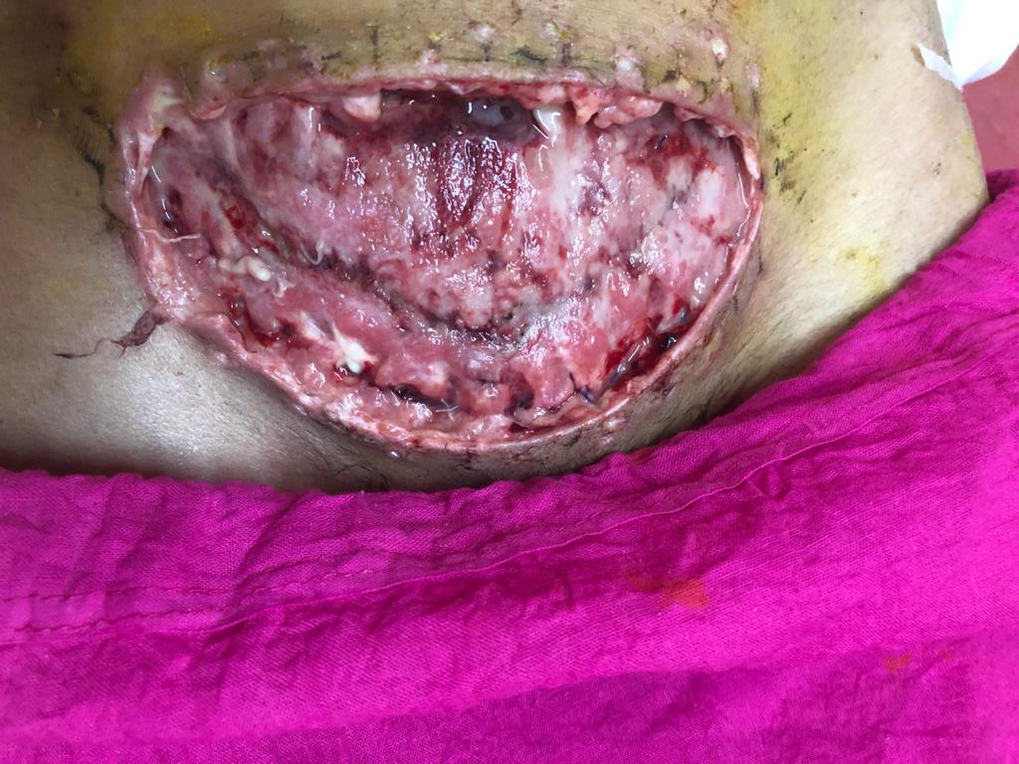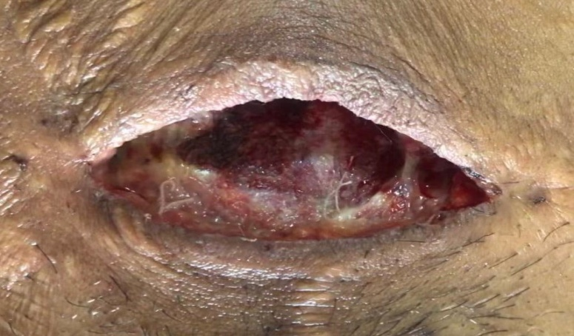
Figure 7: SURGICAL SITE WOUND DEHISCENCE
Figure 8: SURGICAL SITE INFECTION
DECLARATIONS

Availability of Data and Materials: Not applicable.
Financial support and sponsorship: None
Conflicts of interest: None
Ethical approval and consent to participate: Approved by Institutional Ethical Committee Dr. Sampurnanand Medical College Jodhpur. Certificate reference number: SNMC/IEC/2021/plan/387 Consent for publication: Not applicable
REFRENCES:
- Mangram AJ, Horan TC, Pearson ML, Silver LC, Jarvis WR. Guideline for Prevention of Surgical Site Infection, 1999. Centres for Disease Control and Prevention (CDC) Hospital Infection Control Practices Advisory Committee. Am J Infect Control. 1999;27:97–132. https://doi.org/10.1016/S0196-6553(99)70088-X.
- Owens CD, Stoessel K. Surgical site infections: epidemiology, microbiology and [2] prevention. J Hosp Infect. 2008; 70 (Suppl 2)
- Weigelt JA, Lipsky BA, Tabak YP, Derby KG, Kim M, Gupta V. Surgical site infections:Causative pathogens and associated outcomes. Am J Infect Control. 2010;38:112–20. https://doi.org/10.1016/j.ajic.2009.06.010 PMid:19889474.
- Owens CD, Stoessel K. Surgical site infections: epidemiology, microbiology and prevention. J Hosp Infect. 2008; 70 (Suppl 2)
- Ezechi, OC., Fasuba, OB., Dare, FO. Socioeconomic barrier to safe motherhood among booked patients in rural Nigerian communities. J Obstet Gynaec 2000; 20
- Chaim, W., Bashiri, A, Bar-David, J., Shoham-Vardi, I., Mazor, M. Prevalence and clinical significance of postpartum endometritis and wound infection. Infect Dis Obstet Gynecol 2000; 8: 77- 82.
- Killian, CA., Graffunder, EM., Vinciguerra, TJ., Venezia, RA. Risk factors for surgical-site infections following cesarean section. Infect Control Hosp Epidemiol 2001; 22: 613- 617.
- Johnson, A., Young, D., Reilly, J. Caesarean section surgical site infection surveillance. J Hosp Infect 2006; 64: 1-6.
- Webster, J. Post Caesarean wound infection: a review of the risk factors. Aust N Z J Obstet Gynaecol 1988; 28: 201-207.
- Mitt, P., Lang, K., Peri, A., Marimets, M. Surgical-site infections following Caesarean section in an Estonian University hospital: post discharge surveillance and analysis of risk factors. Infect Control Hosp Epidemiol 2005; 26: 449-454.
- Litta, P., Vita, P., Konshi, de Toffoli, J., Omnis, GL. Risk factors for complicating infections after Caesarean section. Clin Exp Obstet Gynaecol 1995; 22: 71-75.
- Beattie, PG., Rings, TR., Hunter, MF., Lake, Y. Risk factors for wound infection following Caesarean section. Aust N Z J Obstet Gynaecol 1994; 34: 398-402.
- Gorbach, S., Bartlett, J., Blacklow, N. Surgical Site Infections. Infectious Diseases (3rdedtn). Lippincott Williams and Wilkins 2004; 823-829.
- Lilani, SP., Jangale, N., Chowdhury, A. Surgical Site Infections in clean and clean-contaminated cases. Ind J of Med Microbiol 2005; 23: 249-252.
- Centers for Disease Control and Prevention (CDC). Surgical site infection (SSI) event: procedure-associated module, vol. 2017; 2016.
- Clinical and Laboratory Standards Institute (CLSI). Performance standards for antimicrobial susceptibility testing, 16th informational supplements. CLSI Document M2-A9 , Wayne PA:2006
- Charles Obinna Njoku 1 , Amarachi Nnaemezie Njoku (2019) Microbiological Pattern of Surgical Site Infection Following Caesarean Section at the University of Calabar Teaching Hospital, Available at:https://www.ncbi.nlm.nih.gov/pmc/articles/PMC4625239/ (Accessed: ).
- Vikrant Negi,1 Shekhar Pal,2 Deepak Juyal,corresponding author3 Munesh Kumar Sharma,4 and Neelam Sharma5 (2015) Bacteriological Profile of Surgical Site Infections and Their Antibiogram: A Study From Resource Constrained Rural Setting of Uttarakhand State, India, Available at:https://www.ncbi.nlm.nih.gov/pmc/articles/PMC4625239/ (Accessed: ).
- Cunningham F. G. Williams Obstetrics. McGRAW Hill: New York, 23, 2009
- Ward VP, Charlett A, Fagan J, Crawshaw SC. Enhanced surgical site infection surveillance following caesarean section: experience of a multicentre collaborative post-discharge system. J Hosp Infect. 2008;70:166–173
- Tsehaynesh Aslake Wendmagegn,corresponding author Gerezgiher Buruh Abera, eyzer Tilahun Tsehaye, Kibrom Brhanu Gebresslasie, and Berhe Girmay Tella (2018) Magnitude and determinants of surgical site infecion among women underwent cesarean section in Ayder comprehensive specialized hospital Mekelle City, Tigray region, Northern Ethiopia, 2016, Available at:https://www.ncbi.nlm.nih.gov/pmc/articles/PMC6291995/ (Accessed: )
- Ghirmay G et al (2015) Incidence of Post Cesarean Section Wound Infection and its AssociatedRisk Factors in Orrota National Referral Maternity Hospital , Available at:Ghirmay G et al / Int. J. of Allied Med. Sci. and Clin. Research Vol-4(3) 2016 [495-506(Accesed: ).
- Shapiro M, Muñoz A, Tager IB, Schoenbaum SC, Polk BF. Risk factors for infection at the operative site after abdominal or vaginal hysterectomy. N Engl J Med. 1982;307(27):1661-6.
- Trans TS, Jamulitrat S, chongsuvivatwong V, Geater A. Risk factors for post cesarean surgical site infection. Obstet Gynaecol. 2000;95(3):367-71

