Study of Surgical Site Infection: An Obstetrical Surgical Morbidity at a Tertiary Level Hospital

Deepika Panwar¹, BS Jodha¹, Prabhu Prakash²

¹ Department of Obstetrics and Gynecology, Umaid Hospital, Dr. S.N. Medical College and Hospital, Jodhpur, India
² Department of Microbiology, Umaid Hospital, Dr. S.N. Medical College and Hospital, Jodhpur, India

Correspondence to: Deepika Panwar, Department of Obstetrics and Gynecology, Umaid Hospital, Dr. S.N. Medical College and Hospital, Jodhpur, India.
Email: panwardeepika19@gmail.com

Abstract
Background: Surgical site infection (SSI) is amongst the most common sufferings following cesarean section. It contributes to increased morbidity and negative impact on the mental, social and economic condition of patients. This study aimed to determine the incidence, risk factors, and therefore the bacteriological profile following cesarean section at Umaid Hospital Jodhpur.
Methods: This was a hospital-based prospective observational study of 1600 patients who had cesarean section over 3 months duration. Among them, 50 patients developed post-cesarean SSI. Wound swabs were collected from these patients. Culture and antibiotic sensitivity were done for aerobic pyogenic organisms.
Results: Out of the 1600 participants who had a cesarean section, 50 patients had SSI, giving an incidence of 3.12 of 100 cesarean sections. The common isolates were coagulase-negative Staphylococcus Aureus (57%), Staphylococcus Aureus (14%), E.coli (17%), Acinetobacter (7%), and Klebsiella (3%). The risk factors were emergency cesarean section, obesity, rupture of membranes, lack of intraoperative antibiotic coverage, previous cesarean section, etc. The common isolates were resistant to Ofloxacin and sensitive to Vancomycin, Linezolid, and Amikacin.
Conclusion: The post-cesarean wound infection rate in our center was 3.12 of 100 cesarean sections. Linezolid, Cefazoline antibiotics were sensitive for the common isolates from SSI and may be used prophylactically till the final report of culture and sensitivity is obtained. This may reduce the complications associated with SSI.
Keywords: cesarean section, surgical site infection, wound infections, antibiotic sensitivity.

INTRODUCTION:
Surgical site infection (SSI) is defined as an infection occurring within 30 days after surgery and affecting superficial/deep tissues at the operation site ^{[1]}. SSI is one of the most common causes of nosocomial infections, with a reported incidence rate of 2-20% ^{[2]}. Postoperative SSI following cesarean section is related to increased morbidity, mortality, prolonged hospital stays, and socio-economic loss to the patients ^{[3]}.
Among risk factors, patient-related factors are old age, nutritional status, pre-existing infection, co-morbid illness, and procedure-related factors like poor surgical technique, prolonged duration of surgery, pre-operative part preparation, and improper aseptic precautions. These factors can influence SSI significantly ^{[2]}.
In addition to these risk factors, the virulence and the invasive power of the organism involved, the physiological state of the wound tissue, and the immunological integrity of the host are also important. SSI may delay the recovery of patients, prolong hospital stay or outpatient treatment, necessitate readmission, and lead to significant morbidity and mortality ^{[4]}. The rate of SSI after cesarean section ranges from 3% to 15% in different settings ^{[5-7]}.
The underlying predisposing factors for SSI following cesarean include intrinsic factors like age, obesity, medical conditions like diabetes mellitus and hypertension, and immune-compromised status like HIV infection and anemia ^{[8-11]}. Extrinsic factors identified in previous studies include preoperative part preparation, type of procedure carried out (emergency), type of skin incision given (horizontal/vertical), prophylactic antibiotic coverage, chorioamnionitis, number of vaginal examinations carried out before surgery, duration of operation, and environment of the operating room ^{[12, 13]}. The knowledge of risk factors may help to reduce the incidence and severity of SSI.
The CDC describes three levels of SSI; Superficial incisional SSI occurs within 30 days after the operation, and the infection involves only skin or subcutaneous tissue of the incision and at least one of the following: 1. Purulent drainage, with or without laboratory confirmation, from the superficial incision. 2. Organisms isolated from an aseptically obtained culture of fluid or tissue from the superficial incision. 3. At least one of the following signs or symptoms of infection: pain or tenderness, localized swelling, redness or heat, and the superficial incision is deliberately opened by the surgeon unless the incision is culture-negative. 4. Diagnosis of superficial incisional SSI by the surgeon or attending physician. Deep incisional SSI Operation-related infection involving deep soft tissues which occurs within 30 days after the operation and at least one of the following: 1. Purulent drainage from the deep incision but not from the organ/space component of the surgical site. 2. A deep incision spontaneously dehisces or is deliberately opened by a surgeon when the patient has at least one of the following signs or symptoms: fever (> 38 °C), localized pain or tenderness unless the site is culture-negative. 3. An abscess or other evidence of infection involving the deep incision is found on direct examination, during reoperation, or by histopathologic or radiologic examination. 4. Diagnosis of a deep incisional SSI by a surgeon or attending physician ^{[14]}.
MATERIAL AND METHODS
This hospital-based prospective observational study was carried out in the Department of Obstetrics and Gynecology at one of the largest tertiary care levels, Mother and Child Hospital, of western India. The study population comprised 1600 women who delivered by cesarean section over 3 months. A structured questionnaire was used to collect information from study subjects. Information was collected about demographic data, existing chronic diseases (such as diabetes mellitus and hypertension), and wound-related characteristics. All females were examined post-operatively for SSI features like purulent drainage from incision site till discharge from the hospital. Females who were readmitted with clinical features of SSI within 30 days of cesarean section were also included for calculation of SSI incidence. Two swabs were collected from the infection site using standard aseptic precautions and sent to the microbiology laboratory for further testing. In the laboratory, one swab was used for direct microscopy and Gram’s staining, from another swab aerobic pyogenic culture and sensitivity testing was done. Identification of organism and culture sensitivity reporting was done according to CLSI guidelines ^{[15]}. For detection of sepsis markers i.e., CRP and PCT, 3 mL of blood samples were collected in the plain vial, and the testing was done using Expedia Latex Agglutination and Dx instant check kits, respectively. Due clearance was obtained from Institute, Ethics Committee (IEC No. SNMC/IEC/2021/plan/387). Written informed consent was taken from all subjects before inclusion into the study. Qualitative variables will be expressed as numbers and percentages and analyzed using the chi-square test.
RESULTS:
The study was performed for 3 months. Out of the 1600 women delivered by cesarean section, 50 (3.12%) women developed SSI (Figure 1). The proportion of SSI was the highest among teenagers (8.1%), among those with ≥ 4 children (4%), and those who had secondary education (3.3%) (Table 1).

Figure 1. The proportion of participants developing surgical site infection following cesarean section. SSI: surgical site infection.

Table1. Demographic characteristics of women undergoing cesarean section.
VARIABLE | TOTAL PATIENT | SSI PRESENT (%) | SSI ABSENT (%) | P-value
Age  < 19  20-29  > 30 | 49  1277  274 | 4 (8.1)  40 (3.1)  6 (2.1) | 45 (91.8)  1237 (96.8)  268 (97.8) | X² = 4.9  Df = 2  P = 0.086
Parity  1  2  3  ≥ 4 | 915  455  132  98 | 36 (3.9)  8 (1.7)  2 (1.5)  4 (4.0) | 879 (96.0)  447 (98.2)  130 (98.4)  94 (95.9) | X² = 5.8  Df = 3  P = 0.134
Education level  Illiterate  Primary  Secondary | 326  915  359 | 8 (2.4)  30 (3.2)  12 (3.3) | 318 (97.5)  885 (96.7)  347 (96.6) | X² = 0.612  Df = 2  P = 0.736
Estimated gestational age  < 37 Weeks  > 37 Weeks | 160  1440 | 5 (3.1)  45 (3.1) | 155 (96.8)  1395 (96.8) | X² = 0.06  Df = 1  P = 0.811
Booking status  Un-booked  Booked | 958  620 | 26 (2.7)  24 (3.8) | 932 (97.2)  596 (96.1) | X² = 1.74  Df = 1  P = 0.224
SSI: surgical site infection.

SSI was significantly higher among emergency cesarean section (6%) than elective cesarean section (0.8%) (P < 0.0001). Also, obese women (BMI > 30) were having more SSI (4.5%) than BMI < 30 (3.2%) (P = 0.014). The most common indication of cesarean section developing SSI was fetal distress (5%) followed by previous LSCS. Rupture of membranes before cesarean section (2.8%) was associated with a higher risk of developing SSI than intact membranes (2.2%). Other factors associated with increased risk of post-cesarean wound infection were intra-operative blood loss greater than 500 mL (P < 0.001) and lack of intra-operative antibiotic prophylaxis (P < 0.001). Hospital stay was found to be higher in women developing SSI (100%) (Table 2).

Table 2. Risk factors associated with post-cesarean wound infection.
RISK FACTOR | TOTAL  (%) | SSI present  (%) | SSI  Absent (%) | P VALUE
BMI  < 30  > 30 | 1490  110 | 45 (3.2)  5 (4.5) | 1345 (96.7)  105 (95.4) | X² = 4.72  Df = 1  P = 0.014
Type of surgery  Emergency  Elective | 700  900 | 42 (6.0)  8 (0.8) | 658 (94.0)  892 (99.1) | X² = 32.31  Df = 1  P < 0.001
Indication of cesarean  FD  Previous 1 LSCS  Previous 2/3 LSCS  NPOL  Primary breech  DTA  CPD  Pre-eclampsia  Placenta previa  Others | 300  500  159  168  130  50  37  41  24  191 | 15 (5.0)  8 (1.6)  3 (1.8)  3 (1.7)  3 (2.3)  3 (6.0)  3 (8.1)  1 (2.4)  1 (4.1)  10 (5.2) | 285 (95.0)  492 (98.4)  156 (98.1)  165 (98.2)  127 (97.6)  47 (94.0)  34 (91.8)  40 (97.5)  23 (95.8)  181 (94.7) | X² = 16.77  Df = 9  P = 0.052
Past illness – Diabetes  Yes  No | 20  1580 | 5  45 | 15  1535 | X² = 32.01  Df = 1  P < 0.001
Antibiotic prophylaxis  Yes  No | 900  700 | 8 (0.8)  42 (6.0) | 892 (99.1)  658 (94.0) | X² = 32.31  Df = 1  P < 0.001
Time of administration of antibiotic  Immediately before surgery  Post-operative | 900  700 | 8 (0.8)  42 (6.0) | 892 (99.1)  658 (94.0) | X² = 32.31  Df = 1  P < 0.001
Duration of surgery  < 1/2 hour  > 1/2 hour | 200  1400 | 0 (0.0)  5 (0.4) | 200 (100.0)  1395 (99.6) | X² = 0.03  Df = 1  P = 0.866
Amount of blood loss  < 500 mL  > 500 mL | 1560  40 | 0 (0.0)  2 (5.0) | 1560 (100.0)  38 (95.0) | X² = 43.7  Df = 1  P < 0.001
Length of hospital stay  < 7 day  > 7day | 1554  46 | 4 (0.3)  46 (100.0) | 1550 (99.7)  0 (0.0) | X² = 1435  Df = 1  P < 0.001
Others: abruption, severe oligohydramnios, twin pregnancy, bad obstetric history, cord prolapsed, FD: fetal distress, NPOL: non-progression of labor, DTA: deep transverse arrest, CPD: cephalopelvic disproportion.

A total of 50 wound swabs were collected from patients developing post-cesarean SSI. Among these 28 (56%) had bacterial growth while 22 (44%) showed no growth (Figure 2).

Figure 2. The number of bacterial isolates from culture.

Table 3. The frequency of pathogenic bacteria isolates from post-operative wound infection.
Type of organism | Pus culture | Vaginal culture
CONS | 16 | 2
E.coli | 5 | 17
Staph aureus | 4 | 3
Klebsiella | 1 | 5
Acinetobacter | 2 | 0
CONS: coagulase-negative staphylococcus, E.coli: Escherichia coli.

Figure 3. The frequency of bacterial isolates from SSI. CONS: coagulase-negative staphylococcus aureus, E.coli: Escherichia coli.

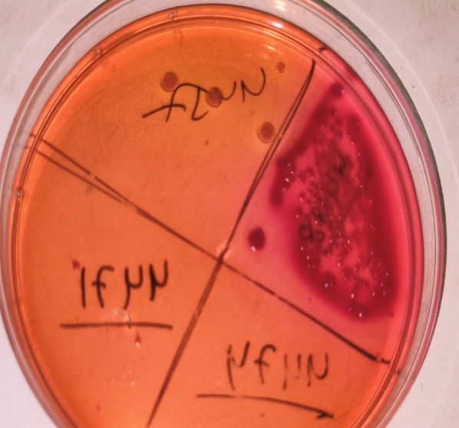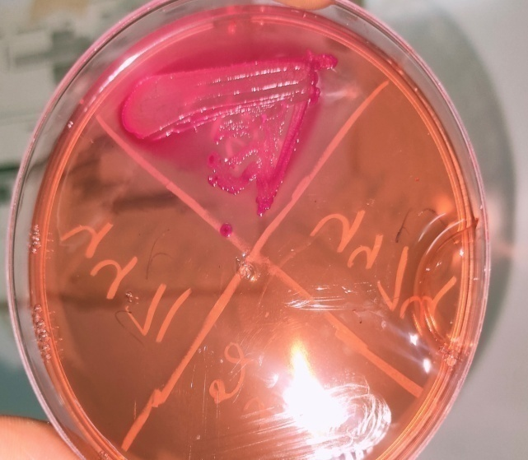
Figure 4. (A) E.coli LF colonies on MacConkey Agar. (B) S.aureus LF colonies on MacConkey Agar.

About 76% were superficial and 24% were deep wound infections (Figure 5). About 39 patients (78%) were managed by dressing alone while 11 (22%) required re-suturing (Figure 6).

Figure 5. The type of wound infection.

Figure 6. The management of patients with SSI. SSI: surgical site infection.

Among the organisms isolated from wound culture, most of the CONS (coagulase-negative staph aureus) were highly sensitive to Linezolid (100%) and Amikacin (100%), while highly resistant to Ofloxacin. E.coli was highly sensitive to Meropenem (100%), Cefepime (100%), and Tobramycin (100%) (Table 4).

Table 4. Antibiotic Sensitivity profile of various organisms from surgical site infection.
Antibiotic name | CONS | E.coli | Staphylococcus aureus
Linezolid | 100% | - | 100%
Amikacin | 100% | 50% | 100%
Cefazoline | 96.66% | - | 100%
Vancomycin | 91.66% | - | 100%
Ampicillin + sulbactam | 85.71% | - | -
Tobramycin | 60% | 100% | 100%
Ampicillin | 50% | - | -
Piperacillin | 0% | - | -
Ofloxacin | 0% | 0% | 0%
Meropenem | - | 100% | -
Cefepime | - | 100% | -
Aztreonam | - | 80% | -
Ciprofloxacin | - | - | 100%
Piperacillin + Tazobactam | - | - | 100%

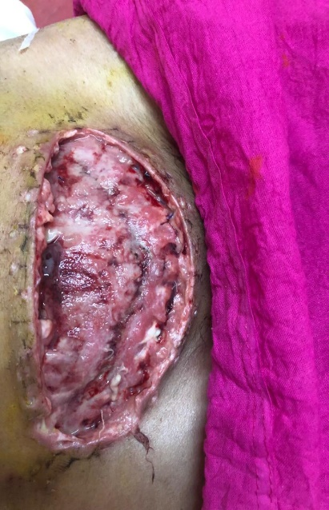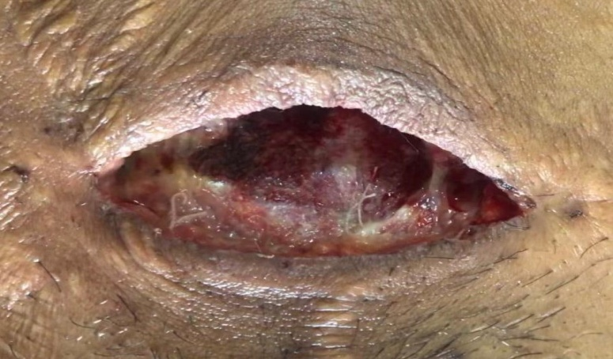
Figure 7. (A) Surgical site wound dehiscence. (B) surgical site infection.

DISCUSSION
The study aimed to determine the incidence of post-cesarean section wound infection and the causative pathogens with their sensitivity profiles. The incidence of post-cesarean wound infection in the present study was 3.12 per 100 cesarean sections. Similar past studies had reported an incidence ranging from 7.8% to 8.5% ^{[16]}. The possible reason for variation in these studies could be due to differences in the population under study and the diversity of indications for cesarean sections performed in different centers. The low incidence of SSI in the present study could also be due to proper aseptic precautions being followed at our institute.
In the present study, teenagers (< 19 years) were found to have a higher proportion of SSI (8.1%). In a similar study, Cunningham et al. reported that many obstetrical complications such as prolonged labor, PIH, and postpartum sepsis were more frequently observed among teenagers ^{[17]}.
In the present study, SSI was observed more among booked women compared to un-booked. This could be due to extended hospital stay, nosocomial, iatrogenic infection due to multiple per vaginal examinations, and obstetric interventions in these patients as compared to the un-booked patients, who were referred either delivered or operated relatively early due to emergent indication.
In this study, SSI was more common in educated women, which is contrary to findings of Charles Obinna Njoku et al. where SSI was seen more in uneducated women ^{[18]}. This may be due to the reason that educated women were booked and were admitted for an extended duration in the ward and had frequent obstetric examinations by various strata of healthcare services.
The findings of this study demonstrate a significant association between SSI and BMI. Obese women (BMI > 30 Kg/m²) developed more SSI (4.5%) than those with BMI < 30 Kg/m² (3.2%) (P = 0.014). This finding was similar to other studies ^{[19]}. It is because of relatively poor perfusion of adipose tissue which may impair wound healing and decrease the local immune response, enabling infection to occur. The incision for obese women may also need to be longer and therefore involve more tissue becoming exposed to contamination.
Generally, patients undergoing emergency cesarean section are at higher risk of infections. In this study, elective surgeries developing SSI were 6% while 0.8% were emergencies. This is probably due to inadequate preparation time owing to maternal/fetal distress, reduced attention to infection-preventing procedures like prophylactic antibiotics, and increased urgency of the procedure. Similar results were found in a study done by Charles Obinna Njoku et al. with SSI developing more in emergency cesarean sections as compared to elective ones ^{[18]}.
The common indication of cesarean section developing SSI in our study was fetal distress (5%) followed by previous LSCS. A study done by Wendmagegn et al. in 2018 also showed fetal distress to be the most common indication ^{[20]}. In our study, 76% of wound infections were superficial while 24% were deep wounds. While a study done by Ghirmay et al. in 2015 showed superficial incidence as 25% and deep 75% ^{[21]}.
Prolong duration of surgery results in increased exposure of operation site to air, prolonged trauma, prolonged anesthesia, and more blood loss. In our study, 0.35% of patients operated on for > 1/2 hour developed SSI. Shapiro et al. reported that with each hour of surgery the infection rate almost doubles ^{[22]}. This finding was not significant since cesarean section being routine obstetric surgery is completed in a short duration (< half hour).
In our study, blood loss of more than 500 mL was seen in 5% of cases developing SSI. The risk of SSI rises by 30% for every 100 mL of blood loss. A high volume of blood loss is usually associated with poor control of bleeding, increased tissue damage, and more sutures ^{[23]}.
In this study, the type of suture material used in surgery was not found to be significant as all the surgeries were done using delayed absorbable suture material (chromic catgut and polyglactin 910).
In this study, out of 50 patients developing SSI, 28 patients (56%) had microbial culture growth where Gram-positive cocci (Staphylococcus aureus and CONS) was isolated in 72% cases, followed by E.coli (17%), Acinetobacter sp. (7%) and Klebsiella sp. (3%). Similar results were found in other studies done by Njoku et al. where Staphylococcus aureus was the most common organism associated with SSI ^{[18]}.
In this study, the vaginal swab of patients developing SSI was also sent, in which E.coli (62%) was the most common bacteria following Klebsiella sp. (18%). The results were not found to be significant as E.coli is a natural commensal of the vagina. Blood samples for CRP (C-reactive protein) and PCT (procalcitonin) were also collected but results were not significant as out of 50 patients developing SSI, 45 (90%) were CRP positive and PCT was in the normal range in all 50 patients.
In this study, CONS isolates were sensitive to Amikacin, Linezolid, Cefazoline, and Vancomycin (Table 4). Another study done by Njoku et al. reported CONS to be sensitive to Amikacin and Imipenem, and resistant to Cephalosporins, Amoxicillin/Clavulanate, Gentamicin and Meropenem, and Fluoroquinolones ^{[18]}. Despite the availability of antibiotics, SSI is still responsible for much morbidity and socio-economic loss for both patients as well as health care systems. Reduction in SSI while minimizing antibiotic resistance remains a challenge for many health care institutions.
The secondary resuturing rate was less at our center (22% underwent resuturing while 78% of cases were managed on a conservative basis i.e., dressing alone) which shows that proper aseptic precautions were taken while managing these patients and the secondary resuturing rate was less.
SSI is known to cause prolonged hospital stay thus bringing financial burden to the patient. In our study, all patients with SSI had a hospital stay of > 7 days (100%) compared to others who were discharged within 7 days of surgery.
The limitation of this study was the lack of follow-up of patients who developed SSI after discharge from the hospital within 30 days of surgery and went to other institutes for management.
CONCLUSION
- The incidence of SSI in this study was 3.12 per 100 cesarean sections.
- The presence of wound sepsis was associated with a longer duration of hospital stay which further led to economic loss to the patient.
RECOMMENDATIONS
- Hand hygiene and Infection prevention practice by health care providers have to be followed to reduce the risk of wound sepsis.
- To evaluate and improve pre- and post-operative care, there is a need for continuous training and supervision of infection control practices.
- Intraoperative antibiotics can be given to all patients scheduled for any obstetric intervention and cesarean section whether emergency/elective. Every institute should follow its antibiotic use protocols.
- If a patient is diabetic, frequent and regular blood sugar monitoring along with a low glycemic index diet and appropriate exercise.
- A vigilant infection control committee should be established which should monitor SSI through surveillance studies with feedback data to healthcare workers, labor room, operation theatre, and post-operative staff, and surgeons are an important component of strategies to reduce the risk of SSI to a minimum acceptable level.
Figure 8: SURGICAL SITE INFECTION
DECLARATIONS
Availability of Data and Materials: Not applicable.
Financial support and sponsorship: None.
Conflicts of interest: None.
Ethical approval and consent to participate: Approved by Institutional Ethical Committee Dr. Sampurnanand Medical College Jodhpur. Certificate reference number: SNMC/IEC/2021/plan/387.
Consent for publication: Not applicable.

REFRENCES
1. AJ Mangram, TC Horan, ML Pearson, LC Silver, & WR Jarvis. (1999) Guideline for Prevention of Surgical Site Infection, 1999. Centres for Disease Control and Prevention (CDC) Hospital Infection Control Practices Advisory Committee. American Journal of Infection Control.27:97–132.
2. Owens C. D., & Stoessel K. (2008) Surgical site infections: epidemiology, microbiology and prevention. Journal of Hospital Infection.70 (Suppl 2):3-10.
3. Weigelt J. A., Lipsky B. A., Tabak Y. P., Derby K. G., Kim M., & Gupta V. (2010) Surgical site infections: Causative pathogens and associated outcomes. American Journal of Infection Control.38(2):112-120.
4. Ezechi O. C., Fasubaa O. B., & Dare F. O. (2000) Socioeconomic barriers to safe motherhood among booked patients in rural Nigerian communities. Journal of Obstetrics and Gynaecology Research.20(1):32-34.
5. Chaim W., Bashiri A., Bar-David J., Shoham-Vardi I., & Mazor M. (2000) Prevalence and clinical significance of postpartum endometritis and wound infection. Infect Dis Obstet Gynecol.8(2):77-82.
6. Killian C. A., Graffunder E. M., Vinciguerra T. J., & Venezia R. A. (2001) Risk factors for surgical-site infections following cesarean section. Infect Control Hosp Epidemiol.22(10):613-617.
7. Johnson A., Young D., & Reilly J. (2006) Caesarean section surgical site infection surveillance. J Hosp Infect.64(1):30-35.
8. Webster J. (1988) Post-caesarean wound infection: a review of the risk factors. Aust N Z J Obstet Gynaecol.28(3):201-207.
9. Mitt P., Lang K., Peri A., & Maimets M. (2005) Surgical-site infections following cesarean section in an Estonian university hospital: postdischarge surveillance and analysis of risk factors. Infect Control Hosp Epidemiol.26(5):449-454.
10. Litta P., Vita P., Konshi de Toffoli, J., & Omnis GL. (1995) Risk factors for complicating infections after Caesarean section. Clinical and Experimental Obstetrics & Gynecology.22:71-75.
11. Beattie P. G., Rings T. R., Hunter M. F., & Lake Y. (1994) Risk factors for wound infection following caesarean section. Aust N Z J Obstet Gynaecol.34(4):398-402.
12. Gorbach S., Bartlett J., & Blacklow N. (2004) Surgical Site Infections. Infectious Diseases.3rd edition:823-829.
13. Lilani SP., Jangale N., & Chowdhury A. (2005) Surgical Site Infections in clean and clean-contaminated cases. Indian Journal of Medical Microbiology ;23:249-252.
14. Prevention Centers for Disease Control and. (2017) Surgical site infection (SSI) event: procedure-associated module.
15. (CLSI) Clinical and Laboratory Standards Institute. (2006) Performance standards for antimicrobial susceptibility testing. 16th informational supplements.CLSI Document M2-A9.
16. Negi V., Pal S., Juyal D., Sharma M. K., & Sharma N. (2015) Bacteriological Profile of Surgical Site Infections and Their Antibiogram: A Study From Resource Constrained Rural Setting of Uttarakhand State, India. Journal of clinical and diagnostic research.9(10):Dc17-20.
17. Cunningham F.G., Levero K.J., & Bloom S.L. (2018) Williams Obstetrics. 25th Edition, McGraw-Hill, New York.819-822.
18. Njoku C. O., & Njoku A. N. (2019) Microbiological Pattern of Surgical Site Infection Following Caesarean Section at the University of Calabar Teaching Hospital. Open Access Maced J Med Sci.7(9):1430-1435.
19. Ward V. P., Charlett A., Fagan J., & Crawshaw S. C. (2008) Enhanced surgical site infection surveillance following caesarean section: experience of a multicentre collaborative post-discharge system. J Hosp Infect.70(2):166-173.
20. Wendmagegn T. A., Abera G. B., Tsehaye W. T., Gebresslasie K. B., & Tella B. G. (2018) Magnitude and determinants of surgical site infecion among women underwent cesarean section in Ayder comprehensive specialized hospital Mekelle City, Tigray region, Northern Ethiopia, 2016. Bmc Pregnancy and Childbirth.18(1):489.
21. G. Ghebreigziabher, & H Z. (2016) Incidence of Post Cesarean Section Wound Infection and its Associated Risk Factors in Orrota National Referral Maternity Hospital. International Journal of Allied Medical Sciences and Clinical Research.4(3).
22. Shapiro M., Muñoz A., Tager I. B., Schoenbaum S. C., & Polk B. F. (1982) Risk factors for infection at the operative site after abdominal or vaginal hysterectomy. N Engl J Med.307(27):1661-1666.
23. Tran T. S., Jamulitrat S., Chongsuvivatwong V., & Geater A. (2000) Risk factors for postcesarean surgical site infection. Obstet Gynecol.95(3):367-371.

