Hypopigmentation with muscular and subcutaneous atrophy as a complication of Intralesional Steroid injection in Ganglion
¹Sandip Kumar Rahul, ²Digamber Chaubey, ³Rupesh Keshri, ⁴Pallavi Suman

Corresponding author: Sandip Kumar Rahul
Address: Room No. 125, ward block, Department of Paediatric surgery, Indira Gandhi Institute of Medical Sciences, Patna
Phone number: 09554464173
E-mail address: sandeep.rahul65@gmail.com
Email id of each author
sandeep.rahul65@gmail.com
drdigamber04@gmail.com
keshri23rupesh@gmail.com
jhnvii.24@gmail.com

Details of all authors
Author 1 (Corresponding author)
Sandip Kumar Rahul
Assistant professor
Paediatric surgery, IGIMS, Patna
Contact no. - +91-9554464173
Email id: sandeep.rahul65@gmail.com
https://orcid.org/0000-0002-9620-9305

Author 2
Digamber Chaubey
Assistant Professor
Paediatric surgery, IGIMS, Patna
Contact no. - +91-9455896827
Email id: drdigamber04@gmail.com
Orcid id : https://orcid.org/0000-0002-2754-5241

Author 3
Rupesh Keshri
Consultant, Paediatric Surgery
ESI hospital, Bihta, Patna
Contact no. - +91-9934634943
Email id: keshri23rupesh@gmail.com

Author 4
Pallavi Suman
VIMS, Pawapuri, Bihar
Contact no. - +91-9608540007
jhnvii.24@gmail.com

Conflict of interest: None
Source of support: None
Declaration of consent: Consent was taken from both parents and the child before submitting the case and clinical pictures

Dear Sir,
Although ganglion cysts are commonly encountered in surgical practice, recurrences have been reported with almost all modalities used in its management. We report an unusual complication following Intralesional steroid injection.
A ten- year-old-male presented with a ganglion cyst over the dorsum of the right hand which was treated with aspiration and intralesional Triamcinolone injection. Lesion disappeared when he came for follow-up after one month. He, however, developed hypopigmentation at the site of injection of steroid along with atrophy of the dorsal forearm muscles and subcutaneous tissue which became more obvious after five months of the procedure (Figure 1). There was no deficiency in the movements or sensation of the hand or forearm. What could have caused this complication?
Local spillage of steroid, over-dosage, effect of the medication (more than anticipated) and nerve injury could all be the cause. Lymphatic channels have an important role of returning macromolecules from the interstitial fluid into the venous circulation. Triamcinolone, being a macromolecule takes the lymphatic pathway but it also finds its way out due to its lipophilic property by the virtue of acetonide group between carbon-15 and 16 in its structure. ^{[1, 2]} So, Injected Triamcinolone takes the lymphatic pathway and may come out at places to cause hypopigmentation and localised atrophy as seen in our case. It has been found that the number of melanocytes is normal in such cases of steroid induced hypopigmentation but it appears that their functioning is suboptimal. ^{[3]}

Ganjoo et. al. reported a linear streak of depigmentation following a single intralesional Triamcinolone injection in a ganglion over the anterior aspect of wrist. ^{[4]} Similar pattern of hypopigmentation has been described by several investigators. ^{[1, 5]} Venkatesan et. al. reported linear hypopigmentation and cutaneous atrophy following intra-articular steroids for deQuervain’s tendonitis. ^{[3]}
Ganglion cysts are notorious for recurrences. Recurrences have been reported after surgery, simple aspiration, intralesional injection of steroids or sclerosants and closed rupture of these cysts. ^{[6]} In a study by Chatterji et. al., comparison between aspiration with intralesional injection of Triamcinolone, Hyaluronidase and sclerosant (Sodium tetradecyl sulphate) revealed recurrence rates of 20%, 31.67% and 35% respectively. ^{[6]} There was hypopigmentation in 8.33% patients and wrist stiffness in 51.67% patients who had Intralesional Triamcinolone injection. ^{[6]}
We have had recurrences with all these modalities of treatment at our centre and we choose the appropriate intervention after discussing with the relatives all these options including their complications. We have used aspiration with intralesional steroid injection using single dart technique after appropriate counselling in a few of our patients who have not chosen an invasive procedure like surgery for management.
In this case, Parents refused to get the involved site biopsied. This patient was then managed by the combined efforts of the dermatologists and Physiotherapists. For hypopigmentation, he received 0.1% tacrolimus and 8- methoxy Psoralen topically after consulting a dermatologist. After 20 months of intralesional injection, the wasted muscles regained their original shape with regular physiotherapy but hypopigmentation persisted.

We concluded that intra-lesional steroid injection may result in significant hypopigmentation, atrophy of subcutaneous tissue and fat and muscular wasting and these complications along with high recurrence rate must be taken into consideration while planning management of a Ganglion cyst.

Conflict of interest: None declared Source of support: Nil

Authorship contribution: All the authors were involved in the management of the patients; Authors 1 and 2 also did framing of the manuscript; all the authors have read and approved the manuscript before submission.

References
- Prasad K, Madke B, Kar S, Sinha AK, Yadav N. Linear rays of depigmentation along lymphatics after intralesional corticosteroid therapy. Indian Dermatology Online Journal. 2015; 6:456-7. DOI: 10.4103/2229-5178.169728
- Chembolli L, Rai R, Srinivas CR. Depigmentation along lymphatic channels following intralesional corticosteroid injection. Indian Journal of Dermatology. 2008;53:210-1. DOI: 10.4103/0019-5154.44805
- Venkatesan P, Fangman WL. Linear hypopigmentation and cutaneous atrophy following intra-articular steroid injections for de Quervain's tendonitis. J Drugs Dermatol. 2009 May;8(5):492-3. PMID: 19537375.
- Shikhar Ganjoo, Vinita Gupta. Perilymphatic Linear Depigmentation in a Child following intralesional Steroid for Ganglion. Archives of Dermatology and Skin Care. 2018; 1: 1-2
- Dhawan AK, Bisherwal K, Grover C, Tanveer N. Linear Leucoderma Following Intralesional Steroid: A Report of Three Cases. Journal of Cutaneous and Aesthetic Surgery. 2015;8:117-9. DOI: 10.4103/0974-2077.158453
- Chatterjee S, Basu A, Gupta S, Biswas S. Comparative Study of Recurrence and Complications Using Various Sclerosants by Single Dart Technique in Treatment of Ganglion Cysts. Indian J Surg. 2014; 76(5):350-3. DOI: 10.1007/s12262-012-0711-5
Figure legends
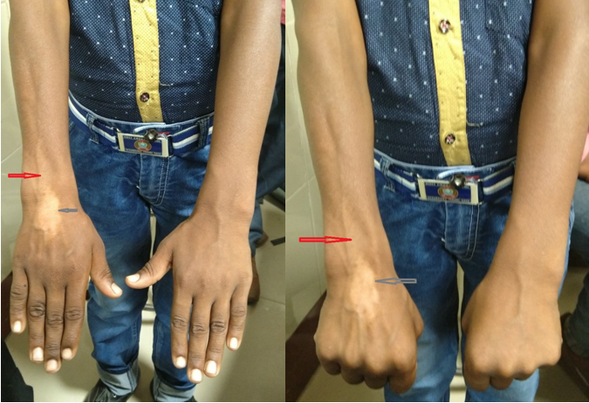
Figure 1: Wasting of forearm muscles with atrophy (red arrow) and hypopigmentation (grey arrow) at the site of injection, after intralesional injection of Triamcinolone in a Ganglion cyst

