PENETRATING TRAUMA OF THE EXTERNAL GENITAL ORGANS WITH EXTENSIVE URETHRAL INVOLVEMENT

elmehdi wichou, hissein hagguir , bencherki Youssef ,dakir Mohamed ,debbagh adil ,aboutaieb rachid.
SUMMARY

Penetrating trauma to the external genitalia is rare and it’s commonly encountered in young people. We are reporting a case of external genital trauma by a stab wound with an extensive urethral injury in a 29 year old subject. The evolution after the surgical intervention was highly favourable upon the functional level (micturition and erection ).
Keywords: penetrating trauma of the external genitalia;luxation ,urethral injury , urethrorrhaphy .

INTRODUCTION
Penetrating trauma to the external genitalia is rare and generally occurs in young people (1). Approximately 60% of the penetrating genitourinary injuries involve the external genitalia, which include the penis and scrotum (2). These traumas have a particular anatomo-clinical formes and are frequently accompanied by cavernous and urethral wounds (3). Urethral trauma can occur as a result of blunt or penetrating wounds, but most oftenly seen in men after traumatic catheterisation or repetitive endoscopic manipulation . In the case of penetrating trauma to the external genitalia, an urgent surgical exploration is the rule(4) . We are reporting a case of penetrating trauma to the external genitalia with extensive urethral involvement and discussing it with different datas from the literature.

Clinical case
It’s about a 29 years old man , without any known past medical history , was received at the emergency departement for a stabbing wound to the external genitals following a physical assault . Physical examination revealed a large wound of the left peno-scrotal angle with a tense, painful scrotum and urethrorrhagia. A scrotal ultrasound was carried out as an emergency and showed a large scrotal hematoma without testicular lesion. An emergency surgical exploration found a large wound of the external genital organs with extensive rupture of more than 90% of the penile urethra (image 1) and luxation of the right testicle (image 2)

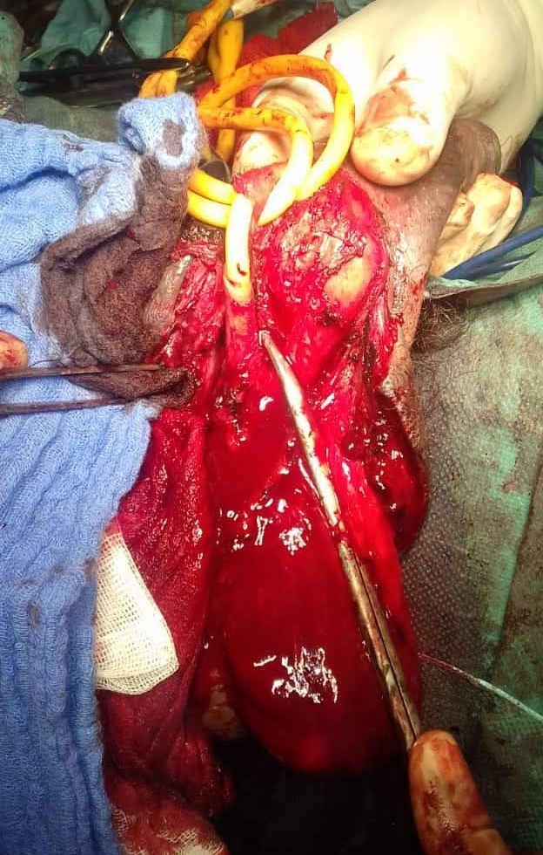 Extensive rupture penile urethra( image1) luxation of the right testicle image(2)

Our surgical attitude was urethrorrphay on a catheterised urethra by separated points wit a resorbable thread,reintegration of the testicles into the scrotum with orchidopexy of the luxated right testicle (image 3) and closure of the wound in two planes.

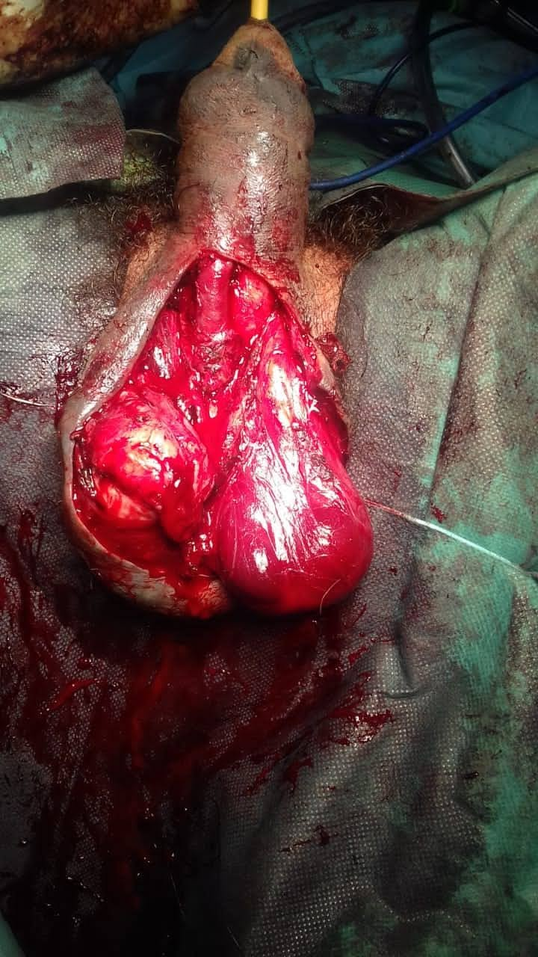
Reintegration of the testicles with orchidopexy of the
luxated right testicle image(3)

The urinary catheter was removed after 15 days and the patient has regained a normal spontaneous urination after removal of the catheter and did not complain of any voiding or erectile dysfunction. One month later, a retrograde urethrocystography was performed showing no obstructive anomalies (image 4).

Retrograde urethrocystography showing no obstructive anomalies (image 4).

discussion
Trauma of the external genital organs in males can lead to damages to the scrotum, testicle and testicular appendages. Associated lesions should be carefully searched for because they are present in 20 to 30% of cases (5). These are mainly traumas of the penis or urethra, skin lesions on the perineum or thighs, and/or abdominal visceral lesions. Trauma to the anterior urethra accounts for about 10% of urogenital traumas (6). In our case, the trauma also concerned the external genital organs with significant damage to the anterior urethra.

If the management of simple contusions poses few problems, it is not the same for the partial ruptures and especially total ruptures, which can be treated immediately as an emergency, or remotely at the stage of stenosis (7). For our patient, the urethral damage was partial but extensive and The repair was immediate as an emergency .

In any stabbing trauma of the male external genitalia , an urgent Surgical exploration is the rule . In an open trauma, severe testicular injuries as well as bilateral trauma are more frequent. Testicular preservation rates are quite low, ranging from 35 to 50%(8). We have carried out an emergency exploration. The procedure consisted of urethrorrhaphy, reintegration of the testicules and orchidopexy of the luxated right testicle.
The evolution was highly favourable marked by normal urination and good erection.

CONCLUSION
penetrating trauma of the external genitalia can cause urethral strictures, sexual and psychosocial problems. A good anatomical knowledge and experienced practice are essential for a good evolution and to avoid the possible complications as well.

references :
1. agga hs, tassian ge, fiser pb, mcculloh ce, mcaninch jw, brever bn. Product related adult genitourinary injuries treated at emergency department in the United States from 2002 to 2010.J Urol.2013 Apr ; 189(4) : 1362-8.
2. Brandes SB, Buckman RF, Chelsky MJ et al. External genitalia gunshot wounds : a ten-year experience with fifty-six cases. J Trauma. 1995 ; 39:266Y271.

3. Kpatcha T M, Tengue K, Tchangai et al. an external genitalia injuries by firearm: about one case 2014, (1):2; 129-132a
4. Cline KJ, Mata JA,Venable DD, Eastham JA. Penetrating trauma to the male external genitalia. J Trauma 1998;44:492-4
5. Kleinclauss F, Martin M, Chabannes E, Bernardini S, Della Negra E, Bittard H. testicular trauma Traumatisme testiculaire : rapport of 56 cases. Prog Urol 2001;11 : 486-91.
6. FentonAS, MoreyAF,Aviles R, Garcia CR.Anterior urethral stricture, etiology and characteristics. Urology 2005;65:1055-8.
7. Biserte J., Nivet J. Traumatisme de l'urètre antérieur : diagnostic et traitement. EMC (Elsevier SAS, Paris),
Urologie, 18-330-A-11, 2006.
8. Gordon LM, Stein SM, Ralls PW. Traumatic epididymitis: evaluation with color Doppler sonography. AJR Am J Roentgenol 1996;166: 1323-5.

