Point-by-point response to comments
The authors are very grateful for the comments. We have incorporated our response accordingly
Reviewer #1:
Wandering spleen is indeed a rare disease in clinic, and acute abdomen with torsion and necrosis is less. As a rare disease are welcome for our journal. But as a modern medical condition, abdominal enhanced CT is still very necessary. Because for patients with acute abdomen, abdominal distension is very common, ultrasound in the case of abdominal distension is difficult to see the real situation inside.
If the case has enhanced CT, the whole specimen after resection and the pedicle torsion picture before resection, it will be more intuitive and vivid.
Author’s Response: Thank you for the comments. Unfortunately, we did not have CT images but we included abdominal sonography and radiograph images along with intra-operative taken pictures.
Reviewer #2:
In this paper, the authors report a rare case of wandering spleen complicated with torsion of its pedicle. The paper would be very interesting, but it remains some improvement. Specifically, the clinical data would be more readable if it was presented in table. Moreover, I noticed that some examinations, such as ultrasound and radiography, were carried out on the the patient. If the results had been shown in figures, the record would be more comprehensive and reliable.

Authors Response: Thank you for the comments. We have included the comments accordingly.

TORSION OF A WANDERING SPLEEN: A CASE REPORT
Solomon B.¹ Yonas A.¹ Henok T.S¹

¹Department of Surgery, Addis Ababa University, College of Health Sciences, Addis Ababa, Ethiopia.
*Correspondence address. Tel: +251911602326; E-mail: solbekeleabebe@gmail.com

Abstract
Wandering spleen is a rare clinical occurrence characterized by absence of spleen in its normal anatomic place. Patients may present with acute abdomen, abdominal mass, chronic abdominal pain. Prompt diagnosis and intervention is necessary. Here, we report a case of a woman who presented with acute abdominal pain secondary to a wandering spleen complicated by torsion of its vascular pedicle.
Key words: Wandering Spleen, Torsion, Splenectomy

Introduction
The spleen develops from the mesoderm in the dorsal mesogastrium. It lies in the left hypochondrium behind the stomach, and is approximately 12 cm long and 7 cm wide. The spleen is fixed in position by the lienorenal and gastrosplenic ligaments; the phrenicocolic ligament provides additional support. The ligaments are embryological condensations that take place in the peritoneum, and congenital peritoneal anomalies may result in splenic displacement (1,2)
Wandering spleen, also known as displaced, ectopic, drifting, floating spleen or splenoptosis is a rare condition defined as a huge, single spleen in an abdominal position rather than its anatomical site, owing to laxity of its pedicles and absence of ligamentous attachments (2).
Acquired anomalies have been described and are attributed to laxity of the ligaments due to weakness of the abdominal wall, multiple pregnancies, hormonal changes or increase in size in the spleen. Both congenital and acquired conditions result in a long pedicle, which is predisposed to torsion. The splenic vessels course within the pedicle, and therefore, torsion of the pedicle results in partial or complete infarct of the spleen (2,3).
We report a case of torsion of a wandering spleen in a 40 years old multiparous women who presented to our emergency with acute abdomen.

Case Report
A 40 years old female patient who presented to our emergency room with abdominal pain and progressive abdominal distention of two-week duration which got worsen over the past 24 hrs. She claims to have 3 episodes of vomiting of ingested matter. She had no prior similar illness nor chronic medical conditions. She is para 8 mother from rural Ethiopia. Physical examination revealed tachycardia of 100/min. Abdominal examination showed a huge, firm, tender periumbilical mass measuring 12*8 cm extending to right lower quadrant area, with positive signs of fluid collection. Abdominal radiography showed an important colon distention especially at the upper left quadrant without air fluid levels (Figure 1). Abdominal ultrasound done showed a midline pelvic region solid mass, measuring 12.8*6.3*14.9cm in size (Figure 2). There were multiple internal echogenic foci with no distal shadowing, likely micro hemorrhage and spleen not visualized in its normal anatomic location.

Index | Result
WBC | 12,300/mm³
Hemoglobin | 9.5g/dl
Hematocrit | 30.1%
Platelet Count | 514,000/mm³
Urea | 13ng/dl
Creatinine | 0.8ng/dl
Abbreviations: WBC, White Blood Count;
Table 1: Laboratory findings of the patient

Figure 1: Erect abdominal film. Absence of splenic shadow in the left upper quadrant and hypogastric mass of soft tissue density

Figure 2: Abdominal sonography showing huge spleen in ectopic position

The patient underwent emergency exploratory laparotomy revealed a significantly enlarged, infarcted wandering spleen, located in ectopic location (Figure 1). Suspended with only its pedicle which was twisted 360° in counterclockwise direction dragging tail of pancreas (Figure 2). There were few peritoneal and omental adhesions.

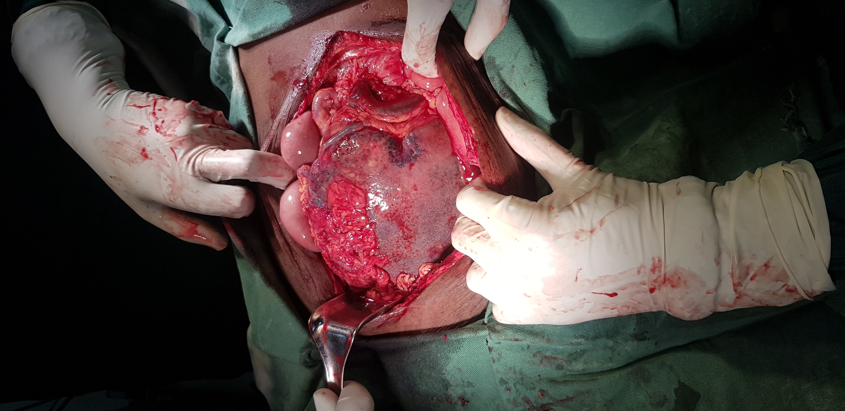

Figure 3: Huge spleen located in the mid abdomen extending to the pelvis

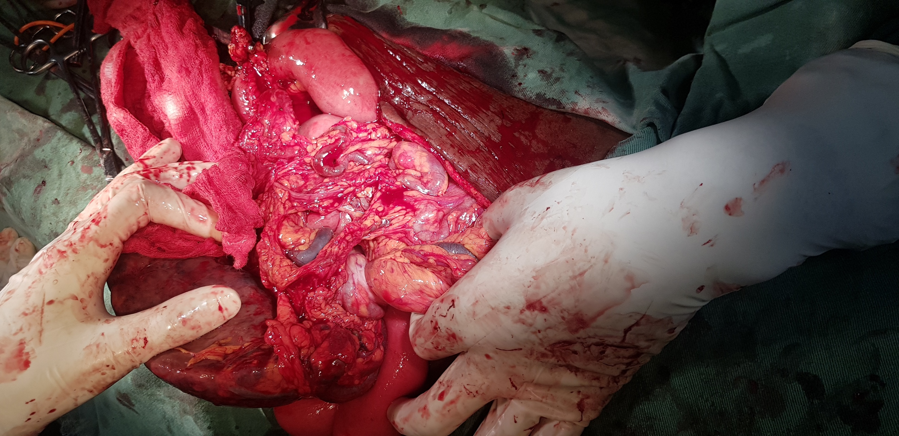

Figure 4: Twisting of the splenic hilum indicating torsion (arrow).

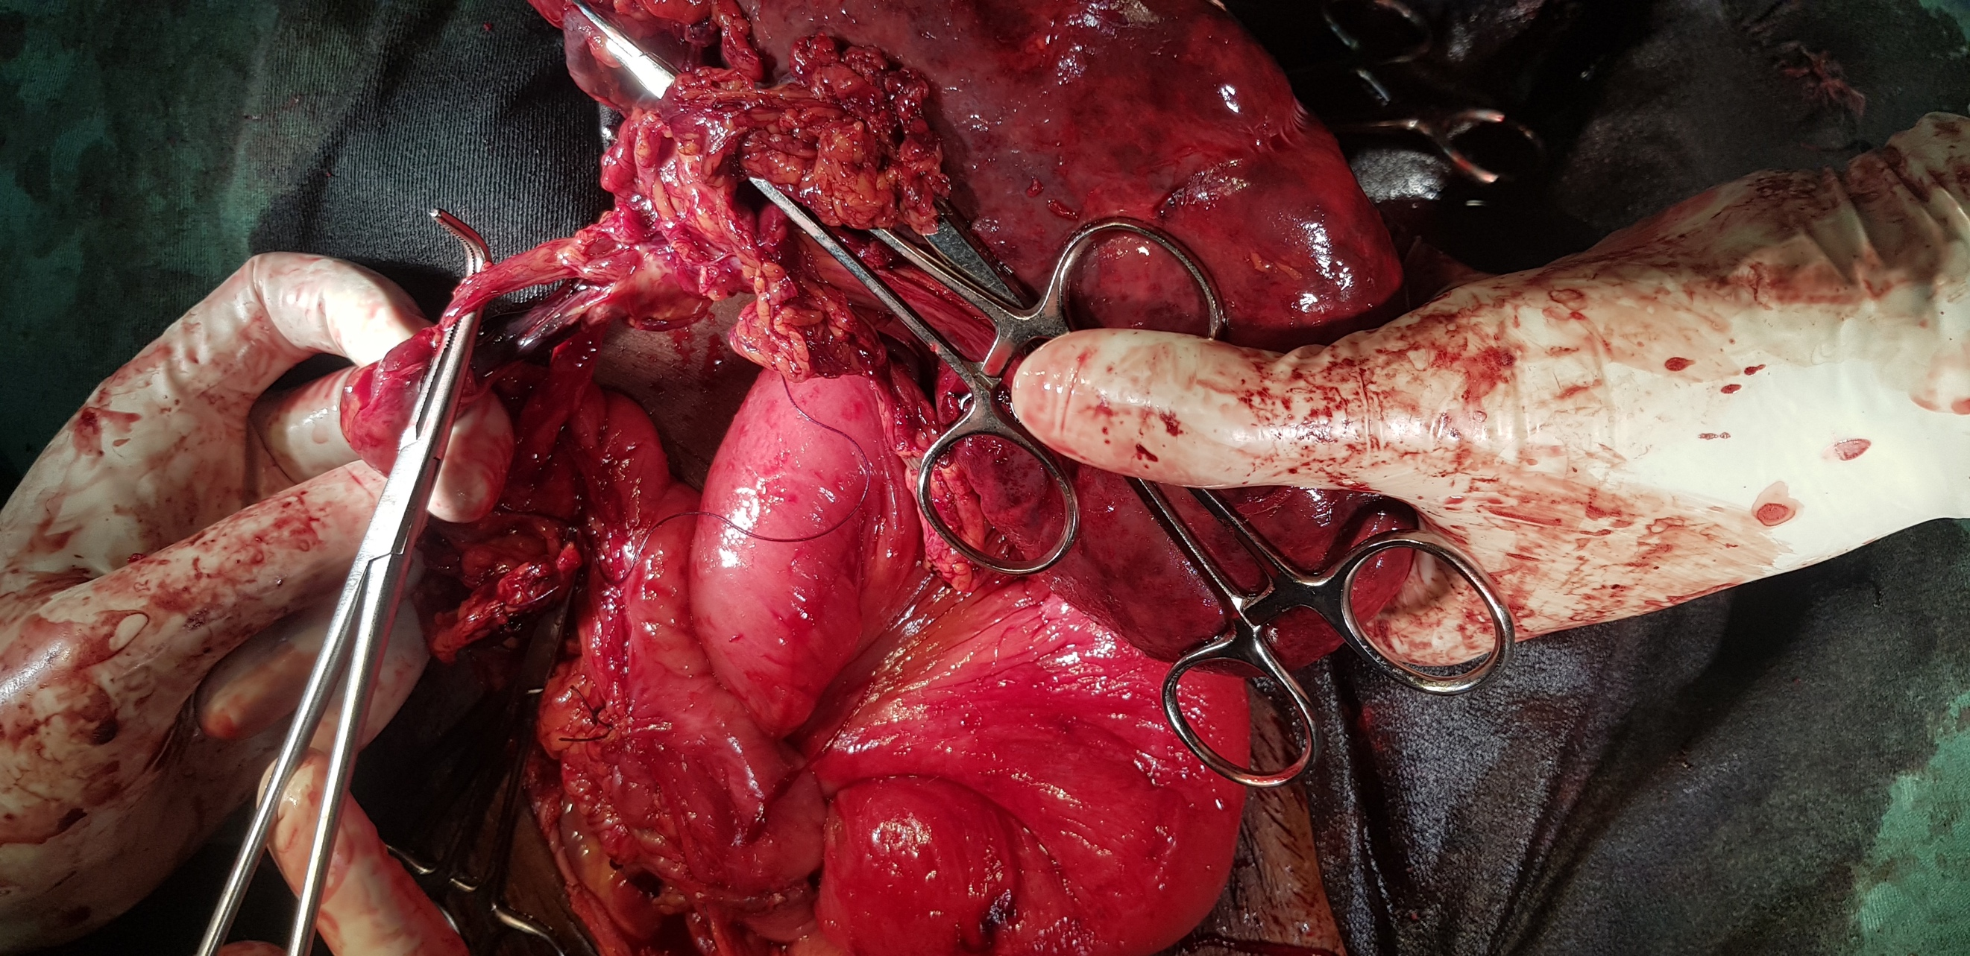

Figure 5: Splenic vessels dissected separately at the hilum.

Splenectomy was performed avoiding injury to pancreatic tail (Figure 4). Histology section showed tissue mainly composed of hemorrhage, congested blood vessels with lymphocyte, plasma cells and neutrophils. The features were consistent with splenic infarction of ischemic origin. The postoperative period was uneventful. The patient was discharged on the fourth postoperative day, to come back for vaccination two weeks later.

Discussion
Wandering spleen is a rare clinical finding where the spleen is found suspended by only its mesentery. It is usually found in young children and women aged between 20 and 40 years of age. Most cases are attributed to be congenital in origin but acquired conditions like multiple pregnancies have also been incriminated. The splenic vessels course within the pedicle, and therefore, torsion of the pedicle results in a partial or complete infarct of the spleen (4). Torsion of a wandering spleen is diagnosed in about 0.2 - 0.3% of patients who require splenectomy. The clinical presentation of wandering spleen may be variable, from an asymptomatic patient to one with mild abdominal pain, signs of acute abdomen with or without peritonitis (1,4). Ultrasound imaging with duplex scanning can be used as an initial mode of imaging which can show the position of the wandering spleen with concomitant replacement of bowel in the left upper quadrant. CT contrast imaging is the preferred mode of investigation, with the contrast helping to elucidate the viability of the spleen. An early diagnosis and surgical care are the best guarantee for preserving the spleen (5).
The spleen in our patient was hugely enlarged with absence of all splenic ligamentous attachments and short gastric vessels with a consequent dislocation of a bigger, congested and infarcted spleen in the pelvis.
Splenic preservation is preferred choice in the case of non-infarcted spleen, especially in young patients. But a splenectomy proceeding detorsion is necessary if there is any sign of infarction. Anti-Pneumococcal, Hemophilus influenza and meningococcal vaccines are indicated before elective splenectomy and shortly after non-elective splenectomy (4,6).

Conclusion
A wandering spleen must be suspected in patients who present with acute abdomen and palpable mass. Diagnosis requires high index of clinical suspicion. Abdominal ultrasound and CT are important adjuncts to diagnosis. Splenopexy or splenectomy are options of management depending on whether or not there is infarction.

Declaration

Acknowledgement
Not Applicable

Authors’ Contribution
Solomon involved in pre-operative preparation, operation, post op follow-up and wrote this article. Henok supervised the surgery and checked the article. Yonas assisted in the surgery and followed patient postoperatively.

Conflict of Interest
The authors declared that there are no conflicts of interest to disclose.

Financial support and sponsorship
Not Applicable

Consent for Publication
Written consent was obtained from the individual patient.

References
- Sharma and Salerno: A torted wandering spleen: a case report. Journal of Medical Case Reports 2014 8:133.
- Chawla S, Boal DK, Dillon PW, Grenko RT. Splenic torsion. Radiographics. 2003 Mar-Apr;23(2):305-8.
- Stringel G, Soucy P, Mercer S. Torsion of the wandering spleen: splenectomy or splenopexy. J Pediatr Surg. 1982 Aug;17(4):373-5.
- El Bouhaddouti H, Lamrani J, Louchi A, El Yousfi M. Torsion of a Wandering Spleen. Saudi J Gastroenterol. 2010 Oct-Dec;16(4):288-91.
- Kapan M, Gumus M‚ Onder A, Gumus H. A wandering spleen presenting as an acute abdomen Case report.J Emerg Med. 2010 Sep 18.
- Misawa T, Yoshida K, Shiba H, Kobayashi S, Yanaga K. Wandering spleen with chronic torsion. Am J Surg. 2008 Apr;195(4):504-5.

