I INTRODUCTION

Ethiopia is a developing country with a current estimated population of more than 115,000,000 ([WWW.Worldmeters.info](http://WWW.Worldmeters.info)) and has a lot of chronic rheumatic valvular heart disease patients(1,2). This is not surprising as more than 80% of them are found in middle and low income countries(3). Many of these patients need open heart surgery services(4). Without surgery 1 to 5 % of patients with severe valve disease will die annually(3).

Modern open heart surgery in its current form started in the 1950s, however the situation in Africa is still challenging with a limited number of health facilities providing routine open heart surgery services(3,5,6 ). In Ethiopia open heart surgery on routine basis has been introduced recently(7). One such center is Elouzeir cardiac Hospital, a private cardiac hospital located at Addis Ababa, Bole sub city. The hospital provides interventional cardiology and open heart surgery services. This study reviews the first hundred heart valve surgeries of the hospital done starting from 20 June, 2017 to 19 June, 2019 .

Data of patients operated is analyzed to see the outcomes of heart valve surgery of the hospital as compared to the rest of the world. Another specific research question in this study is , do we need to use routinely inotropic support postoperatively in all heart valve surgery cases or in only selected cases? Routine use of inotropic support can cause a lot of side effects and higher cost whereas selective use might decrease these disadvantages(8). On the other hand, patients who undergo open heart surgery will have myocardial stunning which might cause low cardiac output state for which proper inotropic support will be mandatory.(10,11). Though there are several studies done that confirm routine use of inotropic support is not necessary in coronary artery bypass grafting surgery, there is only one study done on inotropic support after heart valve surgery according to a search we conducted of the English literature in various search engines(Pub med, Google scholar, Cochrane library).(9,10,12).

II MATERIALS AND METHODS

The first 100 heart valve surgery patients operated in Elouzeir cardiac hospital were included in the study as recorded in the operation theatre registry . A retrospective chart review of the patient records were made after the patients charts were retrieved from the chart archive room. A structured questionnaire was used to extract the necessary information from the charts. The questionnaires were filed by a trained nurse of the hospital.

Demographic data including age, sex and address were included. Diagnosis as recorded from echocardiography done by the hospital’s cardiologist was recorded with significant regurgitation registered as 2+ or more whereas stenosis a significant gradient across the valve.

Data on length of Intensive care unit and ward stays, postoperative follow up of the first month after operation, type and size of valve, and whether inotropic support was needed or not were included in the questionnaire. The data were coded and put in to an SPSS version 25 analysis software and outcomes analyzed.

*Description of operative procedure*

The operative procedure was done under general anesthesia using total intravenous anesthesia and endotracheal intubation and routine arterial and central venous line monitoring and a Foley catheter to measure urine output. Median sternotomy , thymus dissection, opening of pericardial cavity with dissection of pericardium whenever there was adhesion and pericardial tenting were followed by full heparinization and determination of activated clotting time. Ascending aortic cannulation was done when activated clotting time was above 200 seconds. Bicaval cannulation was done for mitral and tricuspid surgeries whereas single double stage right atrial cannulation was used for isolated aortic valve surgeries. Once activating clotting time exceeded 380 seconds cardiopulmonary bypass was commenced. Cooling was done to 32 degrees . Aortic cross clamp was applied and aortic root ante grade cold crystalloid del Nido cardioplegia was given and half doses repeated in double valve replacement and Bentall cases. Ostial cardioplegias given in aortic regurgitation cases. No retrograde or warm cardioplegia (hot shot) used.

Mitral valve was approached through right atrium and interatrial septum only when tricuspid repair is needed otherwise it was approached directly by left atrial atriotomy between the right pulmonary veins in the interatrial groove. Superior and inferior vena cavae snuggers were used in those with right atrial approaches. The anterior mitral leaflet was excised and the posterior leaflet saved with it’s chordae .Mitral replacement was done using figure of eight non pledgeted Ticron 2/0 sutures and mechanical valves were used ; St. Jude and On-x valves.

Aortic surgeries were done through a transverse ascending aorta aortotomy, removal of the aortic cusps and any calcification and suturing using pledgeted Ticron 2/0 horizontal mattress sutures. Except one tissue valve used on the aorta for an old woman by her choice, all others were mechanical valves ; St. Jude and On-x valves.

Tricuspid valve repairs were commissurotomies for stenosis and De Vega annuloplasties for regurgitation as tricuspid annuloplasty rings were not available .

Aortic repairs were removal of sinus of valsalva calcifications causing isolated aortic stenosis in the presence of normal looking cusps.

Length of cross clamp time, arterial blood gas and electrolyte findings, temperature and electrocardiogram findings dictated the length of reperfusion time to wean off cardiopulmonary bypass and subsequent decannulations. Pacing wires were used when a rhythm disturbance appeared after release of aortic cross clamp, otherwise pacing wires were not placed routinely. Inotropic support was started if there were signs of hemodynamic compromise. Chest was closed after inserting two chest tubes using sternal wires; and soft tissue and subcuticular skin closures. Patients were transferred to the intensive care unit intubated.

*Ethical issues* **–** This study was conducted after the hospital medical director has given permission to access data of patients from the archive room, otherwise there was no formal institutional board review in this hospital. But as this was a retrospective study involving only chart reviews, there were no other ethical issues discussed.

III RESULTS

Out of the100 cases, 40 were males and 60 females . The patients age ranged from 15 to 76 with a calculated mean of 35.83 years. More than half (52%) were from Addis Ababa. Nearly half(46%) of patients had isolated mitral stenosis while 18 had isolated aortic stenosis.

81 were single valve replacements (60 mitral and 21 aortic) and 11 were double valve replacements. There were 3 mitral replacements with tricuspid repairs and 1 double valve replacement with tricuspid repair. There was one Bentall procedure.



1 – mitral stenosis 2 – mitral regurgitation 3 – Aortic stenosis 4 – Aortic regurgitation 5 – mitral stenosis and aortic regurgitation 6 – mitral and aortic stenosis 7 – mitral, aortic and tricuspid regurgitation 8 – mitral stenosis and regurgitation 9 - mitral stenosis plus tricuspid regurgitation 10 – mitral and tricuspid regurgitation 11 – mitral and tricuspid stenosis 12 – aortic stenosis and regurgitation 13 – mitral and aortic regurgitation

Figure 1 - Diagnosis of heart valve surgeries done at Elouzeir Hospital from June 20, 2017 to June 19, 2019.

There were three aortic stenosis cases due solely to calcium at the sinuses of valsalva with pliable normal looking cusps and removal of the calcifications resulted in relief of the stenosis and there was no need to replace the valves. This was proven later by absence of a gradient in the postoperative echocardiography.

Postoperative stay in the Intensive care unit was for a mean of 5.79 days. Sixty percent of patients did not need any inotropic or vasodilating agent.. An additional five percent needed nitroglycerin, a vasodilating agent. When inotropes were used, adrenaline and dobutamine were the commonest agents used.

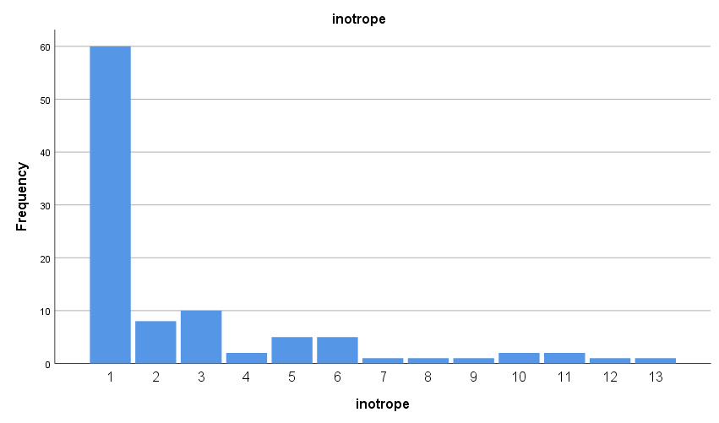

1 – no inotrope used 8 – Nitroglycerin and Noradrenalin

2 – Dobutamine used 9 – Nitroglycerin and dopamine

3 – Adrenaline used 10 - Dopamine

4 – Noradrenalin used 11 – Dobutamine, adrenaline and dopamine

5 – Nitroglycerine used 12 – Adrenaline, Noradrenalin, and dopamine

6 – Dobutamine and adrenaline 13 – Adrenaline and Noradrenalin

7 – Dobutamine plus Noradrenalin

Figure 2 - Inotrope use in heart valve surgeries done at Elouzeir Cardiac Hospital from June 20, 2017 to June 19, 2019.

Total cardiopulmonary bypass time ranged from 39 to 344 minutes (mean – 118) whereas aortic cross clamp time ranged from 23 to 260 minutes (mean – 83).

Thirty days mortality was 8%, 6 patients died in the intensive care unit, one patient died on the operating table due to failure to wean from cardiopulmonary bypass and 1 patient developed bleeding 17 days after discharge from the hospital and died immediately after readmission from massive gastrointestinal bleeding. The average aortic cross clamp time of the mortalities was 118 minutes while the cross clamp time average of the survivors was 83 minutes . The average cardiopulmonary bypass time of mortalities was 185 minutes while that of survivors was 118 minutes. Of the eight deaths, five were mitral valve replacements, one aortic valve replacement, one double valve replacement and one was the Bentall patient. Otherwise there was no stroke or any other complication recorded in the survivors in the first thirty days of postoperative follow up.

IV DISCUSSION

Though some patients from country side might have registered through their families in Addis Ababa, it is surprising that 52% of patients were from Addis Ababa because rheumatic heart disease is expected more in the regions with a lower socioeconomic standard than in Addis Ababa. The other factor could be economic, though a lot of patients are there in the regions, they may not afford the private hospital payment compared to Addis Ababa patients.

The fact that mitral stenosis was the commonest (46%) diagnosis is not surprising as the most common etiology of valve disease in Ethiopia is rheumatic(1,2). The same is true as to why most patients are young(mean of 35.83 years) and females(60%). This is in contrast to many developed nations where patients are older and degenerative causes are commonest indications for heart valve surgeries(13).However, in Brazil where rheumatic heart disease is common, the commonest valve replacement surgery was isolated aortic valve replacement(34%), followed by isolated mitral valve replacement(24.9%) whereas in this study isolated mitral replacement was commonest(60%) probably due to a different patient population(14).

Aortic stenosis due to sinus of valsalva calcifications in an otherwise normal looking aortic valve cusps was a unique observation in this study and deserves further studies(15).

The use of del Nido cardioplegia has been proven(16) by double blind studies already to be one of the best cardioplegic solutions. Besides, it is available widely as it is prepared locally(17).

Also, saving the posterior leaflet of mitral valve has been proven in several studies to be superior to removing both leaflets of the mitral valve in mitral valve replacement surgeries (18, 19).

Valve repair and use of a bioprosthetic in rheumatic valve disease is debatable especially in low and middle income countries where the chance of having a second surgery for deteriorated repaired valve or bioprosthesis is low. The fact that patients are young also adds to the logic behind using mechanical valves as these young patients have a longer life expectancy compared to older individuals. On the other hand, repair or use of bioprosthesis might make it easier to have children for women who wish to have children compared to those with a mechanical valve and long term anticoagulation especially in low and middle income countries where laboratory facilities for lifelong follow up of level of anticoagulation might be challenging. Availability of drugs used for anticoagulation might also be a challenge. Long term survival is similar in both repair and replacement.(20,21).

Among mechanical valves, the St. Jude valve is one of the time tested valves with excellent function (22), and were commonly used. When the St. Jude valves were not available, On-x valves were used.

The mean intensive care unit stay was 5.79 days which is longer than many other centers but our patients stayed longer in the intensive care because of lack of proper monitoring and close follow up in the wards(23).

Sixty five percent of our patients did not need inotropic support. This shows that like coronary artery bypass graft surgeries, Valve surgeries also may not require routine use of inotropic agents ; though this might require further wider scale studies(10). Among inotropic agents , levosimendan (which is not available in this country) has been shown to be the best agent in several studies followed by dobutamine and adrenaline (27).

Mortality is higher than many excellent centers (24) but is comparable to rheumatic valvular surgeries (25, 26) probably due to the late presentation of patients (26) and could also be due to lack of more advanced facilities like Extracorporeal membrane oxygenation and ventricular assist devices for patients who have a complicated course(10). Not surprisingly, those who died had a significantly longer cardiopulmonary bypass and aortic cross clamp times compared to the survivors. Whether the surgery was double or single valve replacement was not associated with mortality. A study done in Australia on surgery for rheumatic valvular heart disease has shown that adverse outcome in short term survival is associated with presence of associated kidney disease, length of intensive care unit stay and anticoagulant complication but was not associated with the left ventricular ejection fraction or whether the procedure was a double or a single valve(3). The length of Intensive care unit stay was not longer in the mortalities of our study as many patients died in the intensive care unit.

*The limitations of this study* includes a small study population, a retrospective study, a hospital based study especially of a private hospital which might not be representative of the whole population and therefore these limitations have to be taken in to account in interpreting the results and conclusions.

V CONCLUSION

Mitral stenosis is the commonest valve lesion diagnosed and isolated mitral valve replacement is the commonest valve surgery performed in Elouzeir cardiac hospital. Routine use of inotropic support may not be needed for valve surgery patients.