ADDIS ABABA UNIVERSITY, COLLEGE OF HEALTH SCIENCE, SCHOOL OF MEDICINE
DEPARTMENT OF SURGERY

Predictors Of Relaparotomy For Persisting Intra Abdominal Infection In Secondary Peritonitis
Name of investigators | Abel Shiferaw,M.D. , Henock T/Selase, M.D.
Full title of the research project | Predictors of relaparotomy for persisting intra abdominal infection in secondary peritonitis
Study Area | Yekatit 12 referral hospital, Minilik II referral Hospital
Address of the investigators | Cell phone: +251913921385, +251911684562
 | Email: abelshiferaw3417@gmail.com zelekehenok8@gmail.com

June 04, 2021 G.C
Table of Contents
Abstract: 3
Introduction: 4
Background 4
Literature Review 5
Rationale of the study 8
Objectives 9
General Objective 9
Specific Objectives 9
Methodology 10
Study design: 10
Study Setting: 10
Study population: 10
Source of data: 10
Data collection: 11
Data analysis: 11
Study Variables: 11
Ethical Consideration 12
Operational definitions 12
Result 13
Discussion 19
Conclusion 20
Dissemination and utilization of results 21
References 22
Annex 25

Abstract:
Introduction: Peritonitis is one of the commonest causes of acute abdomen in Ethiopia with a high mortality and morbidity. One of the causes of high morbidity and mortality is persistent intraabdominal infection. Persistent intraabdominal infection is usually managed by relaparotomy in our setup. The two essential approaches for managing post op collection are RL on-demand (“wait and see” approach) and planned RL. Despite multiple studies, both have comparative mortality. These makes management of persistent intraabdominal infection challenging. This study aimed to identify Preoperative and intra operative clinical variables that are predictive of persistent intraabdominal infection..

Objectives: The aim of this study is to identify preoperative and intraoperative clinical factors that may predict the need for relaparotomy in patients with complex intra-abdominal sepsis, in order to assist clinicians to decide timely intervention.

Methods: A retrospective cross-sectional study was conducted on 172 cases of patients who were operated from Sept, 2018 to April, 2020 at two affiliated referral hospital of AAU, collage of Medicine, Addis Ababa; Yekatit 12 referral hospital and Minilik II referral Hospital. All of patients were cases of secondary peritonitis. Clinical progress of the patients from admission to discharge/death was documented. More than 20 preoperatve and intraoperative variables were analyzed to identify predictive model using logistic regression analysis.
Results: Out of 172 patients with peritonitis included in this study, 70.9% were males. The Median age group of patients was 25 yrs. 82% of patients were referred from Addis Ababa (within the city). The median length of time from the onset of symptoms to seeking medical care was 3 days. The most common cause of secondary peritonitis was complicated appendicitis (52.9%), followed by perforated PUD (33.1%). Out of 172 laparotomy cases for secondary peritonitis, 40 (23.3%) required relaparotomy for postop collection. From Patients who developed postop collection, 45% of them were diagnosed after pus/Gi content leaked through the surgical wound. In Our study, the mortality rate of patients who develop postop collection and undergone relaparotomy was 27.5 % and 4.5% for those without postop collection. Logistic regression identified the following 4 variables as having strong predictive value: Duration of illness more than 5 days, Systolic BP </= 90 mmHg, Amount of peritoneal fluid > 1000 ml and small bowel as source of contamination
Conclusion: Management of persistent intra-abdominal infection is challenging. Sign and symptoms of persistent intra-abdominal infection are subtle, resulting late diagnosis after onset of MODS. Delay in diagnosis results in high mortality and morbidity. We have identified 4 preoperative and intraoperative variables available at first laparotomy to predict persistant intraabdominal infection requiring relaparotomy. These sets of variables can be a mile stone for future validation study before inserted into day to day clinical practice.

Introduction:

Background
Peritonitis is one of the commonest causes of acute abdomen with a high mortality rate ranging from 10-60% depending on the study in western countries(1) and it is one of the commonest cause of acute abdomen in Ethiopia(2–6).
Secondary Peritonitis accounts for approximately 90% of all peritonitis cases in western countries (7). The three most common causes of secondary peritonitis in low income countries are appendicitis, perforated duodenal ulcer and typhoid perforation, in no particular order(8). In the west, appendicitis remains the most common cause of peritonitis, followed by colonic perforation, usually as a result of diverticulitis(9).
Irrespective of the cause, successful management of peritonitis include early administration of antibiotics, timely and effective surgical intervention, and supportive care to maintain organ function and limit the development of multiple organ failure(10,11).
The surgical treatment of secondary peritonitis is usually three fold, consisting of laparatomy to eliminate source of infection, preoperative peritoneal lavage to reduce bacterial load and prevention of persistent or recurrent infection.
One of the main causes of death is failure to control the initial infection and persistence of bacterial peritonitis. To minimize these risks, the concept of “relaparotomy” was introduced.
Incidence of relaparotomy ranges from 0.5 -15% in various reported studies(12,13). Highest incidence was seen in gastrointestinal surgeries, while lowest in vascular surgeries(12). Incidence of relaparotomy is also found to be higher in hospital setup associated training facility.
The aim of RL in abdominal sepsis is to do a peritoneal lavage to drain abscesses and fluid collections, debride necrotic tissues, and reduce the amount of microorganisms(14). Surgery in intraabdominal sepsis improves survival. The studies suggest early intervention reduce mortality by decreasing multi organ failure(15).
Despite the development of antibiotics and significant improvement in intensive care support, mortality after relaparotomy ranges from 24 to 71 %. Factors associated with high mortality are elderly patients, peritonitis at the initial surgery and multi organ failure(12,13,16).
There are different classifications of relaparatomy. The two essential approaches for managing post op collection are RL on-demand (“wait and see” approach) and planned RL(17). RLs are called on demand if the relaparotomy is performed only when there is clinical deterioration or lack of improvement and called planned if relaparotomy is planned every 48 hours unless findings at relaparotomy are negative and decided on during the first surgery. The main advantages of planned relaparotomy are early detection of persistent infection or infectious complications (potentially beneficial to patient outcome) and limited adhesion formation during early relaparotomy (possibly reducing the risk of surgical complications). The drawback of planned relaparotomy is unnecessary re-explorations in critically ill patients and increased cost. The advantage of relaparotomy on demand is that the procedure is limited to patients who do in fact need such treatment, preventing unnecessary operations when infection has resolved during conventional postoperative treatment. Furthermore, the on-demand strategy provides a time lapse that may allow the development of a contained infection accessible to percutaneous interventional techniques(18). The drawback of on-demand relaparatomy is vigilant monitoring of the patient is a requirement. Round the clock decision making is required in order to perform a timely reoperation. Even after close follow up, there is lack of standardized criteria to define when to perform a relaparotomy during the course of disease.

Both strategies have advantages and disadvantages and are still used side-by-side in clinical practice despite growing support for on demand strategy. The studies conducted in the past few years does not seem to suggest that either approaches confers a superior advantage in terms of mortality(18–21).
The objective of this study was to identify preoperative and intraoperative clinical factors that may predict ongoing abdominal infection and the need for relaparotomy in order to construct a clinical model to assist clinicians in predicting the need for relaparotomy in patients with persisting intra abdominal infection in secondary peritonitis.
There are very few data on this specific problem from the developing world, where the spectrum of disease is markedly different from that in the developed world(21–27).

Literature Review
Multiple researches have been done on the strategies of relaparotomy, but still there is no universal consensus on which one to implement. Some of them are as follows
A met analysis was conducted by Lamme et al. in Netherland sought to compare planned and on demand relaparatomy strategies in adult patients with secondary peritonitis in 2002(18). Eight observational studies with a total of 1266 patients (planned relaparotomy, 286; relaparotomy on demand, 980) were included, No randomized studies were found. Studies were noted to be heterogeneous from both a clinical and a statistical standpoint. Using a random-effects approach, the combined odds ratio for in-hospital mortality was 0.70 (95 % confidence interval 0.27 to 1.80) in favor of the on-demand strategy, but it was not statistically significant.
Rakic et al analyzed the outcomes of 65 patients with severe peritonitis surgically treated in two Croatian hospitals(19). In one hospital, 34 patients were treated on-demand, and in another hospital 31 patients were treated by planned relaparotomy. The mortality rate was higher in patients operated on-demand (59% vs 29%,P=0.024) at first go. However, after the adjustment for individual patient’s sex and APACHE II scores, the difference in the relative risk became non-significant (P=0.178). In conclusion although planned laparotomy seemed to have lower mortality rate, there was no significant difference after adjustments.
In 2004 Lamme et al conducted a retrospective study on 278 patients with secondary peritonitis and compared the 81 treated with planned laparotomy and the 197 treated with on-demand laparotomy; and obtained a different conclusion(20). He found a significantly lower hospital mortality rate for on-demand laparotomy (21.8% vs. 36%; p = 0.016) and a better two-year survival rate (65.8% vs. 55.5%; p = 0.031). In this study, treatment choice was an independent predictor of survival. In secondary outcomes, the ICU stay was longer for planned laparotomy patients, but mechanical ventilation days and total hospital stay were similar. In this study, the overall average APACHE II scores were lower than in the prior study (10.8 for on-demand and 11.7 for planned). This suggests that some of the benefit of the on-demand strategy may have been in patients with lower APACHE II scores, as would be expected.
Randomized, nonblinded clinical trial was conducted by van Ruller et al. in 7 teaching hospitals in the Netherlands to compare planned and on-demand laparotomy strategies. A total of 232 patients (116 on-demand and 116 planned) were randomized(21). The primary outcomes of the study, death and major morbidity, were similar in the two groups at 12 months (mortality 29% on-demand and 36% planned; p = 0.23; morbidity 40% on-demand and 44% planned; p = 0.58). However, there were significant differences in the secondary outcomes, with the on-demand group having significantly shorter ICU stays (7 vs. 11 days), fewer hospital days (27 vs 35), and lower cost (23% less). Although this study does not answer the question of which is a better strategy, it does suggest the on-demand strategy has benefits (less health care utilization and cost) and that mandatory laparotomy is not helpful unless indicated for specific purpose.
There are two views of explaining this dilemma. Some might argue that the surgeon’s choice for an individual patient, based on ability to predict disease severity or disease outcome, rather than the treatment strategy itself, correlated with outcome. However, there are several arguments against this line of reasoning: disease severity was comparable between the groups; both treatment strategies were equally represented in disease subgroups; it is questionable whether the group of more severely ill patients would indeed benefit only from a planned strategy as opposed to an on-demand strategy; and treatment strategy was an independent prognostic factor for survival.
As already mentioned both strategies have comparable mortality, but there is still ongoing researches being done to find out some specifications that helps to address specific strategie, specifically planned relaparatomy. But at the end all concluded rather than specifying to single strategy, they prefer to give extra care and attention to patients with specific factors so as to have low clinical threshold for early relaparatomy in this patients. Some are as follows.
A systemic review was done on” Clinical Predictors of Ongoing Infection in Secondary Peritonitis” by Lamme et al on 2006(28). A total of 37 articles were included in the study. 76 individual variables (patient, peritonitis, surgery, clinical, and laboratory variables) were tested from which 10 were eventually selected. These variables were age, concomitant disease, upper gastrointestinal source of peritonitis, generalized peritonitis, elimination of the focus, bilirubin, creatinine, lactate, PaO2/FiO2 ratio, and albumin. This set of variables proved to be moderately predictive for positive findings during relaparotomy in a retrospective cohort of 219 patients operated on for secondary peritonitis (receiver operator curve 0.75, with 95% confidence interval 0.68–0.82). This finding is considered promising results in the discrimination between patients having a positive and negative relaparotomy.
A retrospective chart review conducted in Houston, USA by Kim et al. was aimed at identifying the predictors of relaparotomy after nontrauma emergency general surgery with initial fascial closure(29). A total of 129 patients underwent NTIAC surgery with fascial closure. Twenty-nine patients (22%) required relaparotomy and 100 patients (78%) did not. Kim et al analyzed several factors such as demographics, comorbidities, intraoperative findings, morbidity, and mortality. Five independent predictors, peripheral vascular disease (P = 0.04), alcohol abuse (P = 0.02), body mass index of 29 kg/m2 or greater (P = 0.04), the finding of any ischemic bowel (P = 0.02), and operating room latency of 60 hours or longer (P = 0.01) were found to be significant. Patients with 2 or more of these predictors had a 55% risk of relaparotomy whereas those with fewer than 2 had a 9% risk (P < 0.001). At last the author concluded high risk patients with 2 or more risk factors should have a higher level of postoperative surveillance with early post-imaging and lower clinical threshold for early relaparotomy.
A retrospectively study was conducted by Sileikis et al on 195 patients with secondary peritonitis who had undergone planned relaparotomy from 2005 to 2009 at Vilnius University Hospital, Lithuania(11). The patients were divided into two groups: ‘relaparatomy unnecessary’ group A and ‘relaparotomy necessary’ group B, according to the operation`s findings. 6 factors (age, sex, leukocyte count, C reactive protein, time of symptoms to index operation, Mannheim Peritonitis Index) were analyzed in the study.4 variables, mean age (54 v. 63 years, p=0,002), mean CRP level (133,2 v. 182,8 mg/L, p=0,025), mean time of symptoms to index operation (38,1 v. 67,1 hours, p=0,006) and mean MPI value (22,4 v. 29,4, p<0,0001) were found to be significant. A scoring system was developed using those variables to assist in determining the necessity of the planned relaparotomy.
The prominent study done from Africa, a developing nation was conducted in the College of Health Sciences, University of KwaZulu-Natal, South Africa titled “Developing a clinical model to predict the need for relaparotomy in severe intra-abdominal sepsis secondary to complicated appendicitis”(30). 1000 patients were included in the study with 406 relaparotomies( 227, planned and 179, on demand). Logistic regression analysis showed that the following four factors predicted the need for subsequent relaparotomy: patients referred from any rural centre, duration of illness >5 days, heart rate >120 bpm, and perforation associated with generalized intraabdominal sepsis. A model developed using this variables had a predictive value of >90% for the need of subsequent relaparotomy.

Rationale of the study
Persistent intra abdominal infection following laparotomy is the main reason for relaparotomy. Patients who developed persistent intra abdominal infection requiring relparotomy have increased morbidity (surgical site infection, wound dehiscence, hospital acquired infections…), increased mortality and increased health care cost (long hospital stay, increase ICU bed occupancy…). This is more profound on patients that are detected late and taken to OR after SIRS developed. The rationale of this study is to identify preoperative and intra operative factors that will predict increased chance of persistent intra abdominal infection requiring relaparotomy, so that this patients will be given extra care and detect post op collection early(early laboratory investigation, early imaging).

Objectives

General Objective
- To identify predictors of relaparotomy for persistent intraabdominal infection

Specific Objectives
- To identify preoperative and intraoperative clinical factors that predicts the need for relaparotomy
- To determine the commonest causes of secondary peritonitis in the two affiliated hospitals of AAU, College of Health Science, School of Medicine
- To determine the incidence of relaparotomy among patients with secondary peritonitis in two affiliated hospitals of AAU, College of Health Science, School of Medicine

Methodology

Study design:
A retrospective cross-sectional quantitative design was used to conducted, with analytical approach adopted to determine the predictors of relaparotomy for persistent intraabdominal infection.

Study Setting:
This study was conducted in the two affiliated referral hospital of AAU, collage of Medicine, Addis Ababa. These hospitals are Yekatit 12 referral hospital and Minilik II referral Hospital.
Yekatit 12 hospital is a regional hospital in Addis Ababa. It has 57 surgical beds and provides definitive surgical care to 3 sub cities, as well as the surrounding rural areas. Minilik 11 hospital is one of the biggest hospitals, sitting in the center of Addis Ababa. It has 96 surgical beds and is responsible for giving surgical care for 2 sub cities and the surrounding rural countryside. The surgical departments of these hospitals are the training sites for surgical residents of postgraduate program of Collage of Health Science, AAU.

Study population:
A total of 172 cases of patients with secondary peritonitis who had undergone laparatomy from Sept 1, 2019 to April 08, 2020 were included in this study.
- Inclusion criteria:
All patients admitted and operated for secondary peritonitis in the department in the two affiliated hospitals of AAU, collage of Medicine within this time-frame were included.
- Exclusion criteria:
Patient with initial laparatomy done in other hospitals
Patients with negative relaparatomy
Patients with acute pancreatitis
Patients with mesentric Ischemia
Patient with already planned relaparatomy
Patient with TB peritonitis
Patient who under gone relaparatomy for other cause(bleeding, wound dehiscence…)
Patients with peritonitis following trauma

Source of data:
Patients’ medical chart was main source data. Basic demographic data (age, sex, place of referral) were collected. The clinical symptoms, findings on physical examination, post resuscitation vital signs and laboratory results were recorded. Intraoperative details were extracted from operation note.
Additional information was extracted from emergency room triage paper, operation logbook and HMIS.

Data collection:
Data was collected using structured questionnaire and it was collected by the primary investigator.

Data analysis:
The patients were divided into two groups, relaparotomy and non-relaparotomy group. More than 20 preop and intraop factors were evaluated with respect to their significance in predicting the need for relaparotomy for postop collection.
Student’s t-test for continuous variables and the chi-squared test for nominal variables were run to identify any significant differences between the two groups. Logistic multiple regression was then performed using all factors found significant on this univariate analysis. Those variables with p-value less than 0.05 were considered significant and were inserted in the predictive model.

All data analysis was performed using IBM SPSS Statistics (version 23).

Study Variables:
Dependent variable: Relaparatomy
Independent variables:
Socio-demographic characters:
- Age
- Sex
Pre op
- Duration of illness(hrs)
- ASA class
- Heart rate (BPM)
- Blood Pressure
- Place of Referral
- White cell count (× 10 ⁶/L)
- Neutrophil (%)
- Platelet count (× 10 ⁶/L)
- Hemoglobin ( g/dl)
- Antibiotic intake before Surgery
- Previous abdominal surgery
- Comorbidities – Hypertension, Diabetes, RVI, Tobacco use
Intraop
- Finding of any ischemic bowel
- Source of contamination
- Type of peritoneal fluid – Turbid, pus, GI content
- Amount of peritoneal fluid(L)
- Extent of peritonitis(localized vs Generalized)
- Surgical access – local or laparatomy
- Malignancy
- inotropic / Vasopresive Agents requirement
- Duration of Surgery
- Drain placement
- Intraop Change in diagnosis
- Intraop bowel injury
- Admission to the ICU

Ethical Consideration
Ethical clearance for the study was obtained from Addis Ababa University, College of Health Science Institutional Review Board. Data collection was undertaken after permission is obtained from the administration. The identities of the study participants will not disclosed. The collected questionnaires were not transferred to third party.

Operational definitions
- Relaparotomy : - Abdominal operations that have to be redone within 60 days in association with the initial surgery
Positive findings - turbid or purulent intra-abdominal fluid with/out Gi content. Negative findings - minimal amounts of serous fluid with no other new findings in the abdomen.

- Referred from any rural center :- being referred from outside of Addis Ababa
- Antibiotic intake before Surgery :- any antibiotic taken(PO or IV) for more than 24 hr with an intention of treatment, before surgery
- Localized Peritonitis :- peritoneal inflammation localized to a specific quadrant
- Generalized peritonitis :- inflammation involving all or most of the peritoneal surface
- Pervious abdominal surgery :- any open abdominal surgery that breach the peritoneum

Result
During the study period, 172 eligible cases were admitted and operated for secondary peritonitis in the two hospitals. 102 patients were operated at Minilik II hospital and 70 patients were operated at Yekatit hospital.

Out of 172 patients, 70.9% of the patients were males and 29.1% were females. The Median age group of patients was 25 yrs, with 53.5 % of them lie between 15 yrs and 34 yrs. 82% of patients were referred from Addis Ababa, while 18% were from outside of addis ababa( mostly Oromia region). The commonest co morbid disease that was found was hypertension (4.1%), followed by HIV (2.3%) and DM (1.7%). The median length of time from the onset of symptoms to seeking medical care was 3 days. In our study, 93% of our patients fall in to ASA 1 and 2 score. In physical examination, the median systolic BP was 110 and diastolic BP was 70. The median pulse rate was 110.

Off all cases of peritonitis, 72.7 cases had generalized peritonitis, while 27.3% had localized peritonitis. To access the peritoneum, limited incision was used in 24.4% of patient, while full laparotomy was used in 75.6% of patients. While assessing the intraop factors, the most common cause of secondary peritonitis was complicated appendicitis (52.9%), followed by perforated PUD (33.1%), small bowel pathology (4.7 %) and colonic pathology (4.7%). During exploration, pus was found in 68.8 % of the time, while GI content mixed with pus was found in 28.5% of the time. The mean amount of peritoneal fluid was 673.4 ml, more than 1000ml of peritoneal fluid was found in 22.5 % of patients.

During exploration, ischemic bowel and underlying malignancy was found in 4.7 % and 1.7% of patients respectively. Drainage tube was left in 64 % of patients after exploration. Intraoperatively, inotrops and/or vasopresors were required in 2.3% of patients. Intraop bowel injury was observed in 3.5% of cases. In 18.6% of cases, diagnosis was changed after exploration and intraop finding. 4.1% of patients had previous abdominal surgery. The median duration of surgery was 110 min.

Out of 172 laparotomy cases for secondary peritonitis, 40 (23.3%) required relaparotomy for postop collection. From Patients who developed postop collection, 45% of them were diagnosed after pus/Gi content leaked through the surgical wound, while the rest were diagnosed with clinical sign augmented with imaging. Of the 40 patient who developed postop collection, 33(82.5%) of them only require 1 relaparatomy, 6(15%) of them under done 2 relaparotomy and 1(2.5%) was reoperated 3 times.

The median duration between laparotomy for peritonitis and first relaparotomy for postop collection was 7.5 days, with 30% of the cases, it is beyond 10 days.The mean duration of hospital stay for all peritonitis cases with no postop collection was 7 days, while those with postop collection requiring re laparotomy was 21.9 days. In Our study, the mortality rate of patients who develop postop collection and undergone relaparotomy was 27.5 % and 4.5% for those without postop collection.
Based on the differences between the relaparotomy and non relaparotomy groups, a number of parameters were found to be significant on Chi-square and student-t correlation tests. These variables were included in a logistic regression model to predict the need for relaparotomy. Duration of illness more than 5 days, Systolic BP </= 90 mmHg, Amount of peritoneal fluid > 1000 ml and small bowel as source of contamination were found to be significant on logistic regression. Over all prediction successes of the above model is 88.4%(sensitivity 53.3%%,specificity 96.8%).

Table 1.Comparison between Relaparotomy and Non-relaparotomy group
 | Relaparotomy | Non-relaparotomy | P-value
Gender (%) |  |  | 0.082
Male | 60 % | 74.2%
Female | 40 % | 25.8%
Age(yrs) Median | 26 | 25 | 0.062
Place of Referral |  |  | 0.007
From Addis Ababa | 67.5% | 86.4%
From Rural Center | 32.5% | 13.6%
Comorbidities
Hypertension | 5 % | 3.8% | 0.734
Diabetes | 5 % | 0.8 % | 0.073
HIV | 2.5 % | 2.3% | 0.933
Duration of illness(hrs) Mean | 65.7 | 107.8 | <0.001
Antibiotic treatment before Surgery | 22.5%0 | 16.7% | 0.400
Preop Systolic BP, Mean | 104.4 | 112.2 | 0.005
Preop Diastolic BP, Mean | 66.5 | 68.6 | 0.277
Preop Heart rate, Mean | 114.2 | 109.3 | 0.092
Investigation
WBC Count, Mean | 13474.25 | 13582.65 | 0.922
Hemoglobin Level, Mean | 14.13 | 14.9 | 0.101
Platelet Count, Mean | 299700 | 291523 | 0.742
Presence Of Ischemic bowel | 10 % | 3% | 0.067
Use of Inotropic /Vasopressive Agents | 0 % | 3% | 0.265
Presence of underlying malignancy | 5 % | 0.8% | 0.073
Extent of Peritonitis |  |  | 0.977
Generalized Peritonitis | 72.5 % | 72.7 %
Localized Peritonitis | 27.5 % | 27.3 %
Source of intraabdominal Contamination |  |  | < 0.001
Appendix | 44.7% | 56.1 %
Stomach and Duodenum | 26.3% | 35.6%
Jejunum and Ileum | 15.8% | 1.5%
Colon | 13.2% | 2.3%
Tubo-ovarian | 0 % | 2.3%
Gall Bladder | 0 % | 2.3%
Type of peritoneal fluid |  |  | < 0.001
Turbid | 12.5% | 0 %
Pus | 57.5 % | 72 %
GI±Pus | 30 % | 28 %
Amount of peritoneal fluid |  |  | <0.001
< 1000 ml | 51.5% | 84.3%
≥ 1000 ml | 48.5% | 15.7%
Surgical access to peritoneum |  |  | 0.747
Laparotomy | 22.5 % | 25 %
Limited Incision | 77.5 % | 75 %
Drainage tube placement | 52.5% | 67.4% | 0.085
Intra op change in diagnosis | 35 % | 13.6% | 0.002
Intraop bowel injury | 5 % | 3 % | 0.552
Duration of Surgery (min) | 145.6 | 109.8 | <0.001
Previous abdominal surgery | 5 % | 3.8 % | 0.734
Admitted to ICU in immediate Postop | 7.5 % | 4.5 % | 0.462

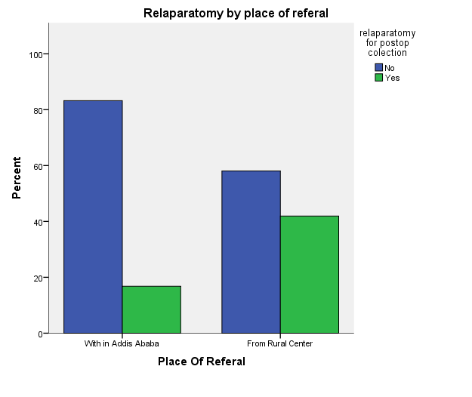

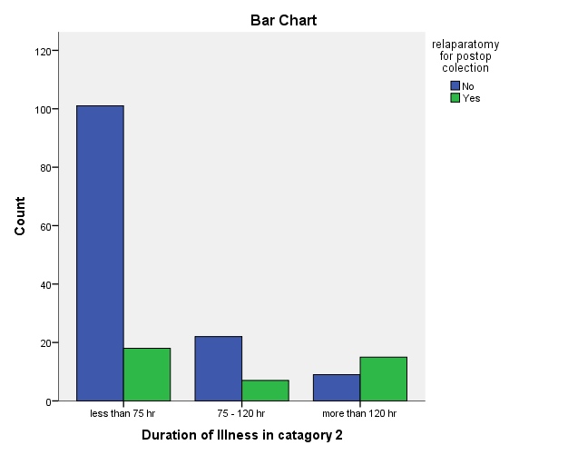

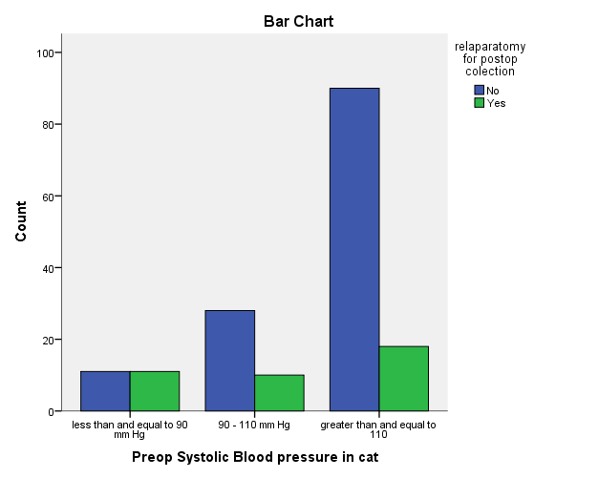

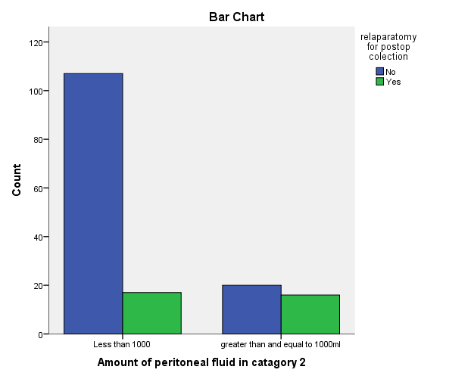

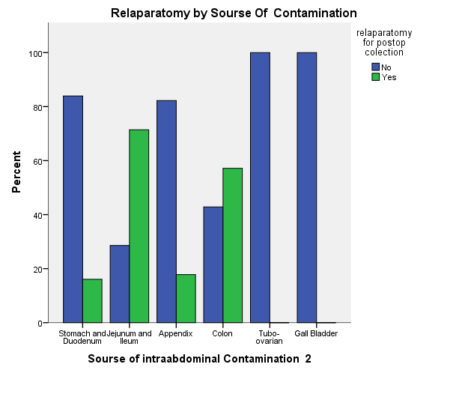

Discussion
In Developing country like ours, peritonitis is one of the causes of acute abdomen that is associated with high mortality and morbidity.
In this study, appendicitis was the commonest cause of peritonitis, which is consistent with most studies in Ethiopia(2,3,5,6) and in Western countries(31). The overall mortality of patients with secondary peritonitis is reported to be between 12% and 79% (19,31–35), while in our study, it is 9.9%. In our study, the incidence of relaparatomy for postop collection was 23.3 %, which is in higher range than most of western literatures (0.5 -15%)(11,12). The mortality we observed after relaparotomy was 27.8%, comparable to most studies(24 to 71 %)(12,13,16).
The median interval to relaparotomy was 8 days(3 – 58 days) in our studies, which more than most studies(Hutchins et al. – 5 days)(15). The median duration of hospital stay in our study was 21 days, which was comparable to Randomized study done in Netherlands in teaching hospitals(27 days).
We have identified 4 independent predictors of subsequent relaparotomy with multivariate analysis: Duration of illness > 5 days, Systolic BP </= 90 mmHg, Source of cont.(small bowel) and amount of peritoneal fluid.
A South African study done by V Y Kong, on complicated appendicitis found referral from a rural centre; duration of illness >5 days; heart rate >120 bpm; and perforation with associated GC as independent predictor(30). When comparing to our study, duration of illness was also a strong predictor, while place of referral had shown correlation on chi-square test, but did notshow significant correlation on logistic regression.
Another study done in Houston, Texas by Jerry J. Kim, showed peripheral vascular disease, alcohol abuse, BMI of 29 kg/m2 or higher, the finding of any ischemic bowel at initial laparotomy, and OR latency of 60 hours or longer were good predictors of relaparotomy(29). In our study, we could not include peripheral vascular disease and BMI as variables b/c of retrospective nature of our study, while presence of ischemic bowel did not show correlation.
Another study done in Lithuania by A. Sileikis showed age, CRP,MPI and duration to surgery as an independent predictor for positive relaparatomy(11). In our study duration of surgery showed correlation on univariate analysis, but not in logistic regression. We did not included CRP and MPI b/c retrospective nature of our study.
A systemic review done by lamme showed age, concomitant disease, upper gastrointestinal source of peritonitis, generalized peritonitis, elimination of the focus, bilirubin, creatinine, lactate, PaO2/FiO2 ratio, and albumin showed significant association(28).
From all above mentioned studies, we can observe there is no universal model for all; it is depend on disease pattern, population distribution and the resources that are available. As we can see, 45% of our patients were diagnosed after infectious fluid has leaked through surgical wound. This signifies, sign and symptoms of persistent infection were subtle enough to be missed. So we can use this model to find patients who are at increased risk of post op collection requiring relaparotomy and intervene early before MODS occurs. Multiple studies have been done to confirm whether planned or ondemand relaparotomy is superior, but still none of them show significant difference on mortality(18–21). So we can use this model, to give extra care for patients that are at higher risk of post op collection.

Conclusion
Prevention is the best strategy. The first surgery in peritonitis must be complete to prevent post op collection. To achieve this, early administration of antibiotics; timely and effective surgical intervention and Supportive are paramount. Despite maximum effort, some patients develop persistent intraabdominal infection. The two main approaches to deal with postop intraabominal infection are planned and on-demand relaparotomy. Multiple studies has been done to confirm whether planned or ondemand relaparotomy is superior, but still none of them show significant difference on mortality(18-21).

Planned relaparotomy detect persistent infection early, before occurrence of MODS; while high negative relaparotmy is the drawback. In Ondemand relaparotomy, exploration is limited to patients who developed sign and symptoms of persistant intraabominal infection. The disadvantage of this strategy is late detection of postop collection after SIRS develops. These partly because of lack of standardized criteria to define when to perform a relaparotomy during the course of disease. The variables found in our study can be used as one of the criteria to find patients at increased risk of post op collection, so we can plan relaparotomy or work up the patients so as to detect persistent intraabdominal infection before the development of SIRS. This will decrease negative relaparotomy, while detecting persistent infection early before development of MODS. The low sensitivity of the model require further studies before wide spread use of our predictive model.

Dissemination and utilization of results
The findings of the study primarily will be presented to the surgical department, College of Medicine, AAU. The findings will be disseminated to different organizations, including the involved hospitals through different means such using Ethiopia Medical journal or any global once if possible.

References
1. Farthmann EH, Schöffel U. Principles and limitations of operative management of intraabdominal infections. World J Surg. 1990 Mar 1;14(2):210–7.
2. Wossen MT. Pattern of Emergency Surgical Operations Performed for Non-Traumatic Acute Abdomen at Ayder Referral Hospital, Mekelle University, Tigrai, Ethiopia by the Year 2000-2003 Ec. 2019;9(5):4.
3. Gebrie TA, Handiso TB, Hagisso SN. Management Outcome and Associated Factors of Surgically Treated Non Traumatic Acute Abdomen at Attat Hospital, Gurage Zone, Ethiopia. Int J Surg Res Pract 6:099
4. Negash M, Teklewold B, Pawulos W. Assessment of Non-Traumatic Acute Abdominal Cases Treated Operatively at Wolaita Sodo Teaching and Referral Hospital, Southern Ethiopia. 2017 Jan 1;
5. Ayenew Z, Gizaw AT, Workneh D, Fentahun N. Outcome of Non-Traumatic Surgical Acute Abdomen in Nekemte Referral Hospital Southwest Ethiopia: A Retrospective Cross-Sectional Study. Surg Curr Res 7: 282.
6. Outcome of emergency surgical operations performed for non-traumatic acute abdomen among adults in Mekele Hospital, Tigray, Ethiopia, 2013. European Journal of Pharmaceutical and Medical Research 3: 106-111.
7. Kujath P, Rodloff A: Peritonitis. Second edition, page 36-41. ed Second edition Bremen, London, Boston, UNIMED, 2005.
8. Gupta S, Kaushik R. Peritonitis - the Eastern experience. World J Emerg Surg WJES. 2006 Apr 26;1:13.
9. Malangoni MA, Inui T. Peritonitis – the Western experience. World J Emerg Surg. 2006 Sep 5;1(1):25.
10. Mandell K, Arbabi S. Re-laparotomy for severe intra-abdominal infections. Surg Infect. 2010 Jun;11(3):307–10.
11. Sileikis A, Kazanavičius D, Skrebunas A, Ostapenko A, Strupas K. Prediction for a planned relaparotomy in secondary peritonitis. Cent Eur J Med. 2013 Aug 1;8.
12. Unalp HR, Kamer E, Kar H, Bal A, Peskersoy M, Ali Onal M. Urgent Abdominal Re-Explorations. World J Emerg Surg. 2006 Apr 4;1:10.
13. Koirala R, Mehta N, Varma V, Kapoor S, Kumaran V, Nundy S. Urgent Redo-Laparotomies: Patterns and Outcome-A Single Centre Experience. Indian J Surg. 2015 Jun;77(3):195–9.
14. Agalar F, Eroglu E, Bulbul M, Agalar C, Tarhan OR, Sari M. Staged Abdominal Repair for Treatment of Moderate to Severe Secondary Peritonitis. World J Surg. 29(2):240–4.
15. Hutchins RR, Gunning MP, Lucas DN, Allen-Mersh TG, Soni NC. Relaparotomy for suspected intraperitoneal sepsis after abdominal surgery. World J Surg. 2004 Feb;28(2):137–41.
16. Krivitskiĭ DI, Shuliarenko VA, Babin IA. [Indications for relaparotomy]. Klin Khirurgiia. 1990;(1):18–21.
17. Mayberry JC, Goldman RK, Mullins RJ, Brand DM, Crass RA, Trunkey DD, et al. Surveyed opinion of American trauma surgeons on the prevention of the abdominal compartment syndrome. J Trauma 1999;47:509‑13.
18. Lamme B, Boermeester MA, Reitsma JB, Mahler CW, Obertop H, Gouma DJ. Meta-analysis of relaparotomy for secondary peritonitis. Br J Surg. 2002 Dec;89(12):1516–24.
19. Rakić M, Popović D, Rakić M, Druzijanić N, Lojpur M, Hall BA, et al. Comparison of on-demand vs planned relaparotomy for treatment of severe intra-abdominal infections. Croat Med J. 2005 Dec;46(6):957–63.
20. Lamme B, Boermeester MA, Belt EJT, van Till JWO, Gouma DJ, Obertop H. Mortality and morbidity of planned relaparotomy versus relaparotomy on demand for secondary peritonitis. Br J Surg. 2004 Aug;91(8):1046–54.
21. van Ruler O, Mahler CW, Boer KR, Reuland EA, Gooszen HG, Opmeer BC, et al. Comparison of on-demand vs planned relaparotomy strategy in patients with severe peritonitis: a randomized trial. JAMA. 2007 Aug 22;298(8):865–72.
22. Kong VY, Bulajic B, Allorto NL, Handley J, Clarke DL. Acute appendicitis in a developing country. World J Surg. 2012 Sep;36(9):2068–73.
23. Kong V, Aldous C, Handley J, Clarke D. The cost effectiveness of early management of acute appendicitis underlies the importance of curative surgical services to a primary healthcare programme. Ann R Coll Surg Engl. 2013 May;95(4):280–4.
24. Kong VY, Van der Linde S, Aldous C, Handley JJ, Clarke DL. Quantifying the disparity in outcome between urban and rural patients with acute appendicitis in South Africa. South Afr Med J Suid-Afr Tydskr Vir Geneeskd. 2013 Jul 29;103(10):742–5.
25. Kong V, Aldous C, Clarke D. Understanding the reasons for delay to definitive surgical care of patients with acute appendicitis in rural South Africa. S Afr J Surg. 2014 Feb 1;52:2–5.
26. Kong VY, Van Der Linde S, Aldous C, Handley JJ, Clarke DL. The accuracy of the Alvarado score in predicting acute appendicitis in the black South African population needs to be validated. Can J Surg. 2014 Aug;57(4):E121–5.
27. Clarke DL, Thomson SR, Bissetty T, Madiba TE, Buccimazza I, Anderson F. A single surgical unit’s experience with abdominal tuberculosis in the HIV/AIDS era. World J Surg. 2007 May;31(5):1087–96; discussion 1097-1098.
28. Lamme B, Mahler CW, van Ruler O, Gouma DJ, Reitsma JB, Boermeester MA. Clinical predictors of ongoing infection in secondary peritonitis: systematic review. World J Surg. 2006 Dec;30(12):2170–81.
29. Kim JJ, Liang MK, Subramanian A, Balentine CJ, Sansgiry S, Awad SS. Predictors of relaparotomy after nontrauma emergency general surgery with initial fascial closure. Am J Surg. 2011 Nov;202(5):549–52.
30. Kong V, Linde S, Aldous C, Handley J, Clarke D. Developing a clinical model to predict the need for relaparotomy in severe intra-abdominal sepsis secondary to complicated appendicitis. S Afr J Surg. 2014 Dec 18;52:2014–91.
31. Merlino JI, Malangoni MA, Smith CM, Lange RL. Prospective randomized trials affect the outcomes of intraabdominal infection. Ann Surg. 2001 Jun;233(6):859–66.
32. Christou NV, Barie PS, Dellinger EP, Waymack JP, Stone HH. Surgical Infection Society intra-abdominal infection study. Prospective evaluation of management techniques and outcome. Arch Surg Chic Ill 1960. 1993 Feb;128(2):193–8; discussion 198-199.
33. Koperna T, Schulz F. Prognosis and treatment of peritonitis. Do we need new scoring systems? Arch Surg Chic Ill 1960. 1996 Feb;131(2):180–6.
34. Wittmann DH, Schein M, Condon RE. Management of secondary peritonitis. Ann Surg. 1996 Jul;224(1):10–8.
35. Mulier S, Penninckx F, Verwaest C, Filez L, Aerts R, Fieuws S, et al. Factors Affecting Mortality in Generalized Postoperative Peritonitis: Multivariate Analysis in 96 Patients. World J Surg. 2003 May 1;27:379–84.
36. Open management of the septic abdomen: therapeutic and prognostic considerations based on APACHE II. - Abstract - Europe PMC [Internet]. [cited 2020 Oct 22]. Available from: https://europepmc.org/article/med/2721209

Annex
Questionnaire
This questionnaire is prepared to identify preoperative and intraoperative clinical factors that predicts the need for relaparotomy in the four affiliated referral hospital of AAU, College of Health Science, School of Medicine, Addis Ababa
Socio-demographic data
Card Number _____________
Telephone No ___________________________
1. Age ___________ 2. Sex _____
3. Date of admission _________6. Date of discharge_________
6. Date of surgery __________ 7. Duration of post-op stay_____________

Preoperative Factors
1. Duration of presenting illness | ________Hrs
2. ASA class of the patient | ________ Class
3. Heart rate at time of admission | ________ bpm
4. Blood Pressure(Systolic/Diastolic) | ____/____ mm Hg
5. Place of referral | 1. With in Addis Ababa  2. From Rural center
6. White cell count | ________ cells/ L
7. Platelet count | ________ cells/ L
8. Hemoglobin level | ________ g/dl
9. Hypertension | 1. Yes 2. No
10. Diabetes Mellitus | 1. Yes 2. No
11. RVI | 1. Yes 2. No
12. Tobacco use | 1. Yes 2. No
13. Antibiotic treatment before surgery | 1. Yes 2. No
Intraoperative Factors
14. Presence of Ischemic bowl | 1. Yes 2. No
15. Administration of inotropic / Vasopresive Agents | 1. Yes 2. No
16. Extent of peritonitis | 1. Localized peritonitis  2.Generalized peritonitis
17. Presence of Malignancy | 1. Yes 2. No
18. Source of contamination | 1.Stomach and duodenum  2. Jejunum and ileum  3. Appendix  4. Colon  5. Tubo-ovarian  6. Others
19. Type of peritoneal Fluid | 1. Turbid  2. Pus  3. GI content
20. Amount of peritoneal fluid | ________ L.
21. Surgical access | 1.limited incision  2. Laparatomy
22.Duration of Surgery | ________ Hrs
23. Level of the surgeon who perform the procedure | 1.Consultant  2. resident
24. Previous abdominal surgery | 1. Yes 2. No
25. No of relaparotomies | ________
26. Outcome of the patient | 1. Dead 2. Discharged improved

