ADDIS ABABA UNIVERSITY, COLLEGE OF HEALTH SCIENCE, SCHOOL OF MEDICINE
DEPARTMENT OF SURGERY
Addis Ababa, Ethiopia

Predictors Of Relaparotomy For Persisting Intra Abdominal Infection In Secondary Peritonitis

PI- Dr Abel Shiferaw (M.D., General Surgeon, Assistant Professor) – Corresponding Author
Address- Yeka Sub city, Addis Ababa, Ethiopia
Phone Number - 0913921385
Email – abelshiferaw3417@gmail.com
CoI- Dr Henock T/Selase (M.D., General Surgeon, Vascular Surgeon, Assistant Professor)
Address- Bole Sub city, Addis Ababa, Ethiopia
Phone Number - 0911684562
Email – zelekehenok8@gmail.com

Abstract:

Background: Peritonitis is one of the commonest causes of acute abdomen in Ethiopia. One of the causes of high morbidity and mortality is persistent intraabdominal infection. The two essential approaches for managing post op collection are laprotomy on-demand and planned Relaparotomy. Despite multiple studies, both have comparative mortality. This study aimed to identify clinical variables that are predictive of persistent intraabdominal infection.

Methods: A retrospective study was conducted on patients who were operated from Sept, 2018 to April, 2020 at two affiliated referral hospital of AAU, collage of Medicine; Yekatit 12 hospital Medical College and Minilik II referral Hospital. All of the patients were cases of secondary peritonitis. Clinical progress of the patients from admission to discharge/death was documented. Multiple preoperatve and intraoperative variables were analyzed to develop predictive clinical model.
Results: Out of 172 laparotomy cases for secondary peritonitis, 40 (23.3%) required relaparotomy for postop collection. From Patients who developed postop collection, 45% of them were diagnosed after pus/Gi content leaked through the surgical wound. The mortality rate of patients who develop postop collection and undergone relaparotomy was 27.5 % and 4.5% for those without postop collection. Logistic regression identified 4 variables as having significant predictive value: Duration of illness more than 5 days, Systolic BP </= 90 mmHg, Amount of peritoneal fluid > 1000 ml and small bowel as source of contamination. Over all prediction successes of the above model is 88.4% (sensitivity 53.3%, specificity 96.8%).
Conclusion: Management of persistent intra-abdominal infection is challenging. We have identified 4 clinical variables that predict persistent intraabdominal infection requiring relaparotomy. These sets of variables can be a mile stone for future validation study before inserted in today to day clinical practice.

Keywords: Relaparotomy, Predictors, Laparotomy, Secondary peritonitis, Intra-abdominal infection

Introduction:

Background
Peritonitis is one of the commonest causes of acute abdomen with a high mortality rate ranging from 10-60% depending on the study in western countries(1) and it is one of the commonest cause of acute abdomen in Ethiopia(2–6). Secondary Peritonitis accounts for approximately 90% of all peritonitis cases in western countries (7,8).
Irrespective of the cause, successful management of peritonitis include early administration of antibiotics, timely and effective surgical intervention, and supportive care to maintain organ function and limit the development of multiple organ failure(9,10,11). One of the main causes of death is failure to control the initial infection and persistence of bacterial peritonitis. To minimize these risks, the concept of “relaparotomy” was introduced.
Incidence of relaparotomy ranges from 0.5 -15% in various reported studies(12,13,14). The studies suggest early intervention reduce mortality by decreasing multi organ failure(15).
Despite the development of antibiotics and significant improvement in intensive care support, mortality after relaparotomy ranges from 24 to 71 % (12,13,16).
The two essential approaches for managing post op collection are RL on-demand (“wait and see” approach) and planned RL(17). Planned relaparotomy detect persistent infection early, before occurrence of MODS; while high negative relaparotmy is the drawback. In Ondemand relaparotomy, exploration is limited to patients who developed sign and symptoms of persistant intraabominal infection. The disadvantage of this strategy is late detection of postop collection after SIRS develops.

Both strategies have advantages and disadvantages and are still used side-by-side in clinical practice despite growing support for on demand strategy. The studies conducted in the past few years does not seem to suggest that either approaches confers a superior advantage in terms of mortality(18–21).

A meta analysis conducted by Lamme et al. in 2002 comparing planned vs on demand relaparatomy strategies showed in-hospital mortality was 0.70 (95 % confidence interval 0.27 to 1.80) in favor of the on-demand strategy, but it was not statistically significant(18).
Rakic et al analyzing the outcomes of 65 patients with severe peritonitis and concluded although planned laparotomy seemed to have lower mortality rate, there was no significant difference after adjustments(19).

In 2004 Lamme et al conducted a retrospective study on 278 patients with secondary peritonitis and found a significantly lower hospital mortality rate for on-demand laparotomy (21.8% vs. 36%; p = 0.016) and a better two-year survival rate (65.8% vs. 55.5%; p = 0.031)(20).
The only Randomized clinical trial was conducted by van Ruller et al. in 7 teaching hospitals in the Netherlands including a total of 232 patients(21). The study showed death and major morbidity, were similar in the two groups at 12 months (mortality 29% on-demand and 36% planned; p = 0.23; morbidity 40% on-demand and 44% planned; p = 0.58). However, there were significant differences in the secondary outcomes, with the on-demand group having significantly shorter ICU stays (7 vs. 11 days), fewer hospital days (27 vs 35), and lower cost (23% less).
As already mentioned both strategies have comparable mortality, but there is still ongoing researches being done to find out some specifications that helps to address specific strategy, specifically planned relaparatomy. But at the end, all concluded rather than specifying to single strategy, they prefer to give extra care and attention to patients with specific factors so as to have low clinical threshold for early relaparatomy in this patients.

The objective of this study was to identify preoperative and intraoperative clinical factors that may predict ongoing abdominal infection and the need for relaparotomy in order to construct a clinical model to assist clinicians in predicting the need for relaparotomy in patients with persisting intra abdominal infection in secondary peritonitis.
There are very few data on this specific problem from the developing world, where the spectrum of disease is markedly different from that in the developed world(21–27).

Methodology

Study design:
A retrospective cross-sectional quantitative design was used to conduct the study, with analytical approach adopted to determine the predictors of relaparotomy for persistent intraabdominal infection.

Study Setting:
This study was conducted in the two affiliated referral hospital of AAU, collage of Medicine, Addis Ababa. These hospitals are Yekatit 12 teaching hospital and Minilik II referral Hospital. The surgical departments of these hospitals are the training sites for surgical residents of postgraduate program of Collage of Health Science, AAU.

Study population:
A total of 172 consecutive patients with secondary peritonitis who had undergone laparatomy from Sept 1, 2019 to April 08, 2020 were included in this study.
- Inclusion criteria:
All patients admitted and operated for secondary peritonitis in the department in the two affiliated hospitals of AAU, collage of Medicine within this time-frame were included.
- Exclusion criteria:
Patient with initial laparatomy done in other hospitals
Patients with negative relaparatomy
Patients with acute pancreatitis
Patients with mesentric Ischemia
Patient with already planned relaparatomy
Patient with TB peritonitis
Patient who under gone relaparatomy for other cause (bleeding, wound dehiscence…)
Patients with peritonitis following trauma

Source of data:
Patients’ medical chart was main source data. Basic demographic data (age, sex, place of referral) were collected. The clinical symptoms, findings on physical examination, post resuscitation vital signs and laboratory results were recorded. Intraoperative details were extracted from operation note.
Additional information was extracted from emergency room triage paper, operation logbook and HMIS.
Data was collected using structured questionnaire and it was collected by the primary investigator.

Statistical analysis:
The patients were divided into two groups, relaparotomy and non-relaparotomy group. More than 20 preop and intraop factors were evaluated with respect to their significance in predicting the need for relaparotomy for postop collection.
Student’s t-test for continuous variables and the chi-squared test for nominal variables were run to identify any significant differences between the two groups. Logistic multiple regression was then performed using all factors found significant on this univariate analysis. Those variables with p-value less than 0.05 were considered significant and were inserted in the predictive model.

All data analysis was performed using IBM SPSS Statistics (version 23).

Ethical Consideration
Ethical clearance for the study was obtained from Addis Ababa University, College of Health Science Institutional Review Board. Data collection was undertaken after permission is obtained from the administration. The identities of the study participants will not disclosed. The collected questionnaires were not transferred to third party.

Operational definitions
- Relaparotomy : - Abdominal operations that have to be redone within 60 days in association with the initial surgery
Positive findings - turbid or purulent intra-abdominal fluid with/out Gi content. Negative findings - minimal amounts of serous fluid with no other new findings in the abdomen.

- Referred from any rural center :- being referred from outside of Addis Ababa
- Antibiotic intake before Surgery :- any antibiotic taken(PO or IV) for more than 24 hr with an intention of treatment, before surgery
- Localized Peritonitis :- peritoneal inflammation localized to a specific quadrant
- Generalized peritonitis :- inflammation involving all or most of the peritoneal surface
- Pervious abdominal surgery :- any open abdominal surgery that breach the peritoneum

Result
During the study period, 172 eligible cases were admitted and operated for secondary peritonitis in the two hospitals. 102 patients were operated at Minilik II hospital and 70 patients were operated at Yekatit hospital.

Out of 172 patients, 70.9% of the patients were males and 29.1% were females. The Median age group of patients was 25 yrs, with 53.5 % of them lie between 15 yrs and 34 yrs. 82% of patients were referred from Addis Ababa, while 18% were from outside of Addis Ababa (Table 1). The commonest co morbid disease that was found was hypertension (4.1%), followed by HIV (2.3%) and DM (1.7%).

Table 1 . Demographic characteristics of patients
 | Relaparotomy | Non-relaparotomy | P-value
Gender (%) |  |  | 0.082
Male | 60 % | 74.2%
Female | 40 % | 25.8%
Age(yrs) Median | 26 | 25 | 0.062
Place of Referral |  |  | 0.007
From Addis Ababa | 67.5% | 86.4%
From Rural Center | 32.5% | 13.6%
Comorbidities
Hypertension | 5 % | 3.8% | 0.734
Diabetes | 5 % | 0.8 % | 0.073
HIV | 2.5 % | 2.3% | 0.933

The median length of time from the onset of symptoms to seeking medical care was 3 days. In our study, 93% of our patients fall in to ASA 1 and 2 score. In physical examination, the median systolic BP was 110 and diastolic BP was 70. The median pulse rate was 110. Information about preoperative factors is also summarized in Table 2.

Table 2. Preoperative Data for each Group
 | Relaparotomy | Non-relaparotomy | P-value
Duration of illness(hrs) Mean | 65.7 | 107.8 | <0.001
Antibiotic treatment before Surgery | 22.5% | 16.7% | 0.400
Preop Systolic BP, Mean | 104.4 | 112.2 | 0.005
Preop Diastolic BP, Mean | 66.5 | 68.6 | 0.277
Preop Heart rate, Mean | 114.2 | 109.3 | 0.092
Investigation
WBC Count, Mean | 13474.25 | 13582.65 | 0.922
Hemoglobin Level, Mean | 14.13 | 14.9 | 0.101
Platelet Count, Mean | 299700 | 291523 | 0.742
Previous abdominal surgery | 5 % | 3.8 % | 0.734

Off all cases of peritonitis, 72.7 cases had generalized peritonitis, while 27.3% had localized peritonitis. To access the peritoneum, limited incision was used in 24.4% of patient, while full laparotomy was used in 75.6% of patients. While assessing the intraop factors, the most common cause of secondary peritonitis was complicated appendicitis (52.9%), followed by perforated PUD (33.1%), small bowel pathology (4.7 %) and colonic pathology (4.7%). During exploration, pus was found in 68.8 % of the time, while GI content mixed with pus was found in 28.5% of the time. The mean amount of peritoneal fluid was 673.4 ml, more than 1000ml of peritoneal fluid was found in 22.5 % of patients.

During exploration, ischemic bowel and underlying malignancy was found in 4.7 % and 1.7% of patients respectively. Drainage tube was left in 64 % of patients after exploration. Intraoperatively, inotrops and/or vasopresors were required in 2.3% of patients. Intraop bowel injury was observed in 3.5% of cases. In 18.6% of cases, diagnosis was changed after exploration and intraop finding. 4.1% of patients had previous abdominal surgery. The median duration of surgery was 110 min. All intraoperative data are shown in Table 3.

Out of 172 laparotomy cases for secondary peritonitis, 40 (23.3%) required relaparotomy for postop collection. From Patients who developed postop collection, 45% of them were diagnosed after pus/Gi content leaked through the surgical wound, while the rest were diagnosed with clinical sign augmented with imaging. Of the 40 patient who developed postop collection, 33(82.5%) of them only require 1 relaparatomy, 6(15%) of them under done 2 relaparotomy and 1(2.5%) was reoperated 3 times.

The median duration between laparotomy for peritonitis and first relaparotomy for postop collection was 7.5 days, with 30% of the cases, it is beyond 10 days.The mean duration of hospital stay for all peritonitis cases with no postop collection was 7 days, while those with postop collection requiring re laparotomy was 21.9 days. In Our study, the mortality rate of patients who develop postop collection and undergone relaparotomy was 27.5 % and 4.5% for those without postop collection.

Table 3. Intraoperative data for each Group
 | Relaparotomy | Non-relaparotomy | P-value
Presence Of Ischemic bowel | 10 % | 3% | 0.067
Use of Inotropic /Vasopressive Agents | 0 % | 3% | 0.265
Presence of underlying malignancy | 5 % | 0.8% | 0.073
Extent of Peritonitis |  |  | 0.977
Generalized Peritonitis | 72.5 % | 72.7 %
Localized Peritonitis | 27.5 % | 27.3 %
Source of intraabdominal Contamination |  |  | < 0.001
Appendix | 44.7% | 56.1 %
Stomach and Duodenum | 26.3% | 35.6%
Jejunum and Ileum | 15.8% | 1.5%
Colon | 13.2% | 2.3%
Tubo-ovarian | 0 % | 2.3%
Gall Bladder | 0 % | 2.3%
Type of peritoneal fluid |  |  | < 0.001
Turbid | 12.5% | 0 %
Pus | 57.5 % | 72 %
GI±Pus | 30 % | 28 %
Amount of peritoneal fluid |  |  | <0.001
< 1000 ml | 51.5% | 84.3%
≥ 1000 ml | 48.5% | 15.7%
Surgical access to peritoneum |  |  | 0.747
Laparotomy | 22.5 % | 25 %
Limited Incision | 77.5 % | 75 %
Drainage tube placement | 52.5% | 67.4% | 0.085
Intra op change in diagnosis | 35 % | 13.6% | 0.002
Intraop bowel injury | 5 % | 3 % | 0.552
Duration of Surgery (min) | 145.6 | 109.8 | <0.001
Admitted to ICU in immediate Postop | 7.5 % | 4.5 % | 0.462

Based on the differences between the relaparotomy and non relaparotomy groups, a number of parameters were found to be significant on Chi-square and student-t correlation tests. These variables were included in a logistic regression model to predict the need for relaparotomy. Duration of illness more than 5 days, Systolic BP </= 90 mmHg, Amount of peritoneal fluid > 1000 ml and small bowel as source of contamination were found to be significant on logistic regression (Figure 1-4). Over all prediction successes of the above model is 88.4% (sensitivity 53.3%, specificity 96.8%).

Figure 1. Comparison between Relaparotomy and Duration of Illness
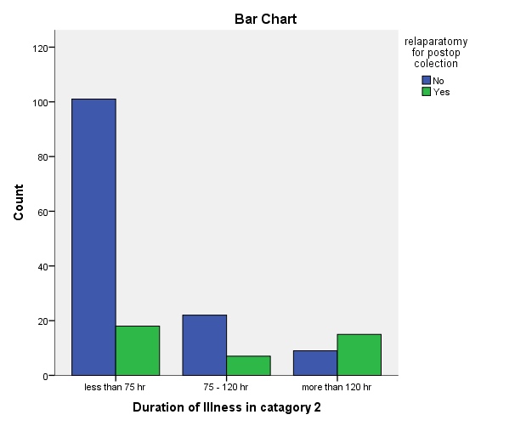

Figure 2. Comparison between Relaparotomy and Preop systolic Blood pressure
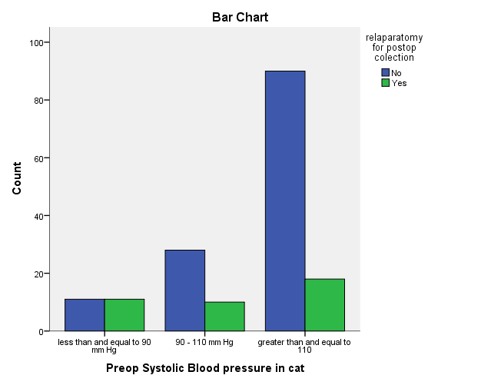

Figure 3. Comparison between Relaparotomy and Amount of peritoneal fluid

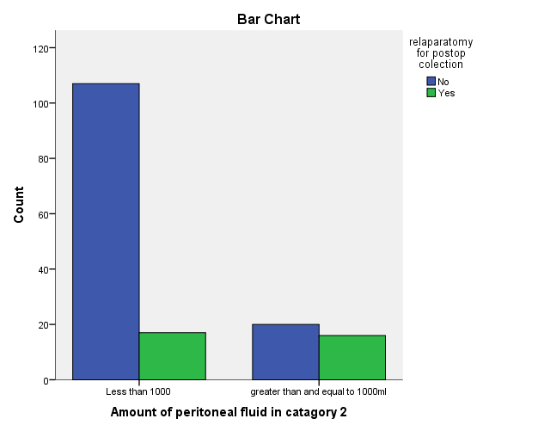
Figure 4. Comparison between Relaparotomy and Source of Intraabdominal contamination
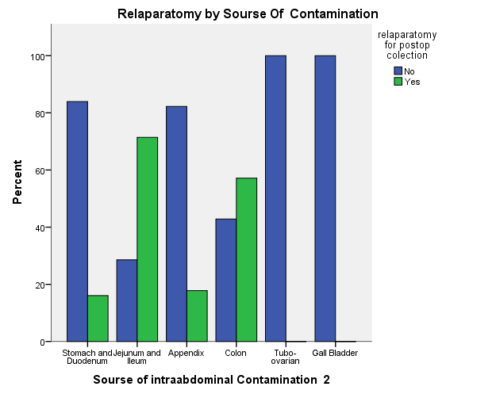

Discussion
In Developing country like ours, peritonitis is one of the causes of acute abdomen that is associated with high mortality and morbidity.
In this study, appendicitis was the commonest cause of peritonitis, which is consistent with most studies in Ethiopia(2,3,5,6) and in Western countries(31). The overall mortality of patients with secondary peritonitis is reported to be between 12% and 79% (19,31–35), while in our study, it is 9.9%. In our study, the incidence of relaparatomy for postop collection was 23.3 %, which is in higher range than most of western literatures (0.5 -15%)(11,12). The mortality we observed after relaparotomy was 27.8%, comparable to most studies(24 to 71 %)(12,13,16).
The median interval to relaparotomy was 8 days(3 – 58 days) in our studies, which more than most studies(Hutchins et al. – 5 days)(15). The median duration of hospital stay in our study was 21 days, which was comparable to Randomized study done in Netherlands in teaching hospitals (27 days).
We have identified 4 independent predictors of subsequent relaparotomy with multivariate analysis: Duration of illness > 5 days, Systolic BP </= 90 mmHg, Source of cont.(small bowel) and amount of peritoneal fluid.
A systemic review done by lamme showed age, concomitant disease, upper gastrointestinal source of peritonitis, generalized peritonitis, elimination of the focus, bilirubin, creatinine, lactate, PaO2/FiO2 ratio, and albumin showed significant association(28).
Another study done in Lithuania by A. Sileikis showed age, CRP,MPI and duration to surgery as an independent predictor for positive relaparatomy(11). In our study duration of surgery showed correlation on univariate analysis, but not in logistic regression. We did not included CRP and MPI b/c retrospective nature of our study.
A study done in Houston, Texas by Jerry J. Kim, showed peripheral vascular disease, alcohol abuse, BMI of 29 kg/m2 or higher, the finding of any ischemic bowel at initial laparotomy, and OR latency of 60 hours or longer were good predictors of relaparotomy(29). In our study, we could not include peripheral vascular disease and BMI as variables b/c of retrospective nature of our study, while presence of ischemic bowel did not show correlation.
A South African study done by V Y Kong, on complicated appendicitis found referral from a rural centre; duration of illness >5 days; heart rate >120 bpm; and perforation with associated GC as independent predictor(30). When comparing to our study, duration of illness was also a strong predictor, while place of referral had shown correlation on chi-square test, but did not show significant correlation on logistic regression.
From all above mentioned studies, we can observe there is no universal model for all; it depends on disease pattern, population distribution and the resources that are available. As we can see, 45% of our patients were diagnosed after infectious fluid has leaked through surgical wound. This signifies sign and symptoms of persistent infection were subtle enough to be missed. So we can use this model to find patients who are at increased risk of post op collection requiring relaparotomy and intervene early before MODS occurs.
This study has some limitation. The retrospective nature of study is the main one. Prospective study would have given us a chance to analyze more variables and make follow up of patients complete. Smaller sample size makes generalizability of the study limited. Further prospective validation studies are required before widespread adoption of this predictive mode in clinical practice.

Conclusion
Prevention is the best strategy in management of persistent intrabdominal infection. The first surgery in peritonitis must be complete to prevent post op collection. To achieve this, early administration of antibiotics; timely and effective surgical intervention and Supportive are paramount. Despite maximum effort, some patients develop persistent intraabdominal infection. The two main approaches to deal with postop intraabominal infection are planned and on-demand relaparotomy. Multiple studies has been done to confirm whether planned or ondemand relaparotomy is superior, but still none of them show significant difference on mortality(30-33).These partly because of lack of standardized criteria to define when to perform a relaparotomy during the course of disease.
The variables found in our study can be used as one of the criteria to find patients at increased risk of post op collection, so we can plan relaparotomy or work up the patients so as to detect persistent intraabdominal infection before the development of SIRS. This will decrease negative relaparotomy, while detecting persistent infection early before development of MODS. The low sensitivity of the model require further studies before wide spread use of our predictive model.

Authors' Contributions
Conceived the project, carried out to acquisition and analysis of data, contributed to drafting and approval of the final manuscript: Abel Shiferaw
Made substantial contributions to conception and design of the study and provided technical support: Henock T/Selase

Availability of Data and Materials
The patients’ data was collected using Hard copy questionnaires that are available as compiled file. The Data entered into SPSS version 23 is available and will be sent when requested by review committee

Financial Support and Sponsorship
Financial support for this article is from Addis Ababa University, College of Health science. The funding is for covering material cost during conduction of the study.
Conflicts of Interest
All authors declared that there are no conflicts of interest
Ethical Approval and Informed consent
Ethical clearance for the study was obtained from Addis Ababa University, College of Health Science Institutional Review Board.
Consent for Publication
Not applicable

References
1. Farthmann EH, Schöffel U. Principles and limitations of operative management of intraabdominal infections. World J Surg. 1990 Mar 1;14(2):210–7.
2. Wossen MT. Pattern of Emergency Surgical Operations Performed for Non-Traumatic Acute Abdomen at Ayder Referral Hospital, Mekelle University, Tigrai, Ethiopia by the Year 2000-2003 Ec. 2019;9(5):4.
3. Gebrie TA, Handiso TB, Hagisso SN. Management Outcome and Associated Factors of Surgically Treated Non Traumatic Acute Abdomen at Attat Hospital, Gurage Zone, Ethiopia. Int J Surg Res Pract 6:099
4. Negash M, Teklewold B, Pawulos W. Assessment of Non-Traumatic Acute Abdominal Cases Treated Operatively at Wolaita Sodo Teaching and Referral Hospital, Southern Ethiopia. 2017 Jan 1;
5. Ayenew Z, Gizaw AT, Workneh D, Fentahun N. Outcome of Non-Traumatic Surgical Acute Abdomen in Nekemte Referral Hospital Southwest Ethiopia: A Retrospective Cross-Sectional Study. Surg Curr Res 7: 282.
6. Outcome of emergency surgical operations performed for non-traumatic acute abdomen among adults in Mekele Hospital, Tigray, Ethiopia, 2013. European Journal of Pharmaceutical and Medical Research 3: 106-111.
7. Kujath P, Rodloff A: Peritonitis. Second edition, page 36-41. ed Second edition Bremen, London, Boston, UNIMED, 2005.
8. Gupta S, Kaushik R. Peritonitis - the Eastern experience. World J Emerg Surg WJES. 2006 Apr 26;1:13.
9. Malangoni MA, Inui T. Peritonitis – the Western experience. World J Emerg Surg. 2006 Sep 5;1(1):25.
10. Mandell K, Arbabi S. Re-laparotomy for severe intra-abdominal infections. Surg Infect. 2010 Jun;11(3):307–10.
11. Sileikis A, Kazanavičius D, Skrebunas A, Ostapenko A, Strupas K. Prediction for a planned relaparotomy in secondary peritonitis. Cent Eur J Med. 2013 Aug 1;8.
12. Unalp HR, Kamer E, Kar H, Bal A, Peskersoy M, Ali Onal M. Urgent Abdominal Re-Explorations. World J Emerg Surg. 2006 Apr 4;1:10.
13. Koirala R, Mehta N, Varma V, Kapoor S, Kumaran V, Nundy S. Urgent Redo-Laparotomies: Patterns and Outcome-A Single Centre Experience. Indian J Surg. 2015 Jun;77(3):195–9.
14. Agalar F, Eroglu E, Bulbul M, Agalar C, Tarhan OR, Sari M. Staged Abdominal Repair for Treatment of Moderate to Severe Secondary Peritonitis. World J Surg. 29(2):240–4.
15. Hutchins RR, Gunning MP, Lucas DN, Allen-Mersh TG, Soni NC. Relaparotomy for suspected intraperitoneal sepsis after abdominal surgery. World J Surg. 2004 Feb;28(2):137–41.
16. Krivitskiĭ DI, Shuliarenko VA, Babin IA. [Indications for relaparotomy]. Klin Khirurgiia. 1990;(1):18–21.
17. Mayberry JC, Goldman RK, Mullins RJ, Brand DM, Crass RA, Trunkey DD, et al. Surveyed opinion of American trauma surgeons on the prevention of the abdominal compartment syndrome. J Trauma 1999;47:509‑13.
18. Lamme B, Boermeester MA, Reitsma JB, Mahler CW, Obertop H, Gouma DJ. Meta-analysis of relaparotomy for secondary peritonitis. Br J Surg. 2002 Dec;89(12):1516–24.
19. Rakić M, Popović D, Rakić M, Druzijanić N, Lojpur M, Hall BA, et al. Comparison of on-demand vs planned relaparotomy for treatment of severe intra-abdominal infections. Croat Med J. 2005 Dec;46(6):957–63.
20. Lamme B, Boermeester MA, Belt EJT, van Till JWO, Gouma DJ, Obertop H. Mortality and morbidity of planned relaparotomy versus relaparotomy on demand for secondary peritonitis. Br J Surg. 2004 Aug;91(8):1046–54.
21. van Ruler O, Mahler CW, Boer KR, Reuland EA, Gooszen HG, Opmeer BC, et al. Comparison of on-demand vs planned relaparotomy strategy in patients with severe peritonitis: a randomized trial. JAMA. 2007 Aug 22;298(8):865–72.
22. Kong VY, Bulajic B, Allorto NL, Handley J, Clarke DL. Acute appendicitis in a developing country. World J Surg. 2012 Sep;36(9):2068–73.
23. Kong V, Aldous C, Handley J, Clarke D. The cost effectiveness of early management of acute appendicitis underlies the importance of curative surgical services to a primary healthcare programme. Ann R Coll Surg Engl. 2013 May;95(4):280–4.
24. Kong VY, Van der Linde S, Aldous C, Handley JJ, Clarke DL. Quantifying the disparity in outcome between urban and rural patients with acute appendicitis in South Africa. South Afr Med J Suid-Afr Tydskr Vir Geneeskd. 2013 Jul 29;103(10):742–5.
25. Kong V, Aldous C, Clarke D. Understanding the reasons for delay to definitive surgical care of patients with acute appendicitis in rural South Africa. S Afr J Surg. 2014 Feb 1;52:2–5.
26. Kong VY, Van Der Linde S, Aldous C, Handley JJ, Clarke DL. The accuracy of the Alvarado score in predicting acute appendicitis in the black South African population needs to be validated. Can J Surg. 2014 Aug;57(4):E121–5.
27. Clarke DL, Thomson SR, Bissetty T, Madiba TE, Buccimazza I, Anderson F. A single surgical unit’s experience with abdominal tuberculosis in the HIV/AIDS era. World J Surg. 2007 May;31(5):1087–96; discussion 1097-1098.
28. Lamme B, Mahler CW, van Ruler O, Gouma DJ, Reitsma JB, Boermeester MA. Clinical predictors of ongoing infection in secondary peritonitis: systematic review. World J Surg. 2006 Dec;30(12):2170–81.
29. Kim JJ, Liang MK, Subramanian A, Balentine CJ, Sansgiry S, Awad SS. Predictors of relaparotomy after nontrauma emergency general surgery with initial fascial closure. Am J Surg. 2011 Nov;202(5):549–52.
30. Kong V, Linde S, Aldous C, Handley J, Clarke D. Developing a clinical model to predict the need for relaparotomy in severe intra-abdominal sepsis secondary to complicated appendicitis. S Afr J Surg. 2014 Dec 18;52:2014–91.
31. Merlino JI, Malangoni MA, Smith CM, Lange RL. Prospective randomized trials affect the outcomes of intraabdominal infection. Ann Surg. 2001 Jun;233(6):859–66.
32. Christou NV, Barie PS, Dellinger EP, Waymack JP, Stone HH. Surgical Infection Society intra-abdominal infection study. Prospective evaluation of management techniques and outcome. Arch Surg Chic Ill 1960. 1993 Feb;128(2):193–8; discussion 198-199.
33. Koperna T, Schulz F. Prognosis and treatment of peritonitis. Do we need new scoring systems? Arch Surg Chic Ill 1960. 1996 Feb;131(2):180–6.
34. Wittmann DH, Schein M, Condon RE. Management of secondary peritonitis. Ann Surg. 1996 Jul;224(1):10–8.
35. Mulier S, Penninckx F, Verwaest C, Filez L, Aerts R, Fieuws S, et al. Factors Affecting Mortality in Generalized Postoperative Peritonitis: Multivariate Analysis in 96 Patients. World J Surg. 2003 May 1;27:379–84.
36. Open management of the septic abdomen: therapeutic and prognostic considerations based on APACHE II. - Abstract - Europe PMC [Internet]. [cited 2020 Oct 22]. Available from: https://europepmc.org/article/med/2721209

