Running Head: Value of Hounsfield unit in RIRS and PCNL - Li et al.

The Value Of Hounsfield Unit In Retrograde Intrarenal Surgery Versus Percutaneous Nephrolithotomy For The Treatment Of Renal Stone Of 2-3 cm: A Single-center Prospective Pilot Study
Yuzhuo Li,^{1*} Qiqi He,^{1*} Fei wang,² Teng Ma,¹ Junsheng Bao,¹ Li Yang, ¹
Zhiping Wang¹, Gupta Sanjay³
- Department of Urology, Key laboratory of disease of Urological systems, Gansu Nepho-Urological clinical Center, Second hospital of Lanzhou University, Lanzhou, Gansu, China
- Department of pediatrics, Second hospital of Lanzhou University, Lanzhou, Gansu, China
- Department of Urology, University Hospitals Case Medicine Center, Case Western Reserve University, Cleveland, OH, United States

Correspondence: Qiqi He, Department of Urology, Key laboratory of disease of Urological systems, Gansu Nepho-Urological clinical Center, Second hospital of Lanzhou University, Lanzhou, Gansu, China
Email: hqq86-92@163.com

Key words: Hounsfield unit, retrograde intrarenal surgery, Percutaneous nephrolithotomy, renal stones
* These two authors contribute equally to the work as co-first authors.
ABSTRACT
Purpose: To determine whether the Hounsfield Unit (HU) value of no-contrast computer computed tomography (NCCT) might offer better guidance in the selection of RIRS or PCNL in renal stones of 2-3 cm.
Materials and Methods:A total of 158 patients with kidney stones (2-3 cm) who underwent PCNL/RIRS from March 2016 to January 2019 were enrolled in this study. Gender, stone sizes, locations, average HU value of stone, surgery time, hospital stay time, stone free rate and complications at the time of hospitalization and 3 month follow-up were measured to identify the surgery efficiency.
Results: Upon consideration of HU value, the mean surgery time were significantly decreased in RIRS comparing to control RIRS(cRIRS) group (47.73 ± 15.52 versus 72.41 ± 27.71 min, P<.05). Statistically, the surgery time was strong influenced by the HU values both in RIRS (OR: 93.8, P<.01) and PCNL (OR, 8.21, P<.05). HU values proved to have a strong positive relation with surgery time in RIRS while a low positive related in PCNL (P<.05).
Conclusion:Overall, for renal stones of 2-3 cm, RIRS might be a safe and efficacious treatment option if HU value and other parameters could be comprehensively accounted. Individual precision surgery might provide ideal treatment and prognosis for patients requiring long-term continuous clinical procedures.

INTRODUCTION
Renal stone disease is proved as one of most frequently diseases in the urology clinical practice worldwide. Extracorporeal shock wave lithotripsy (ESWL) has been introduced as an efficient alternative approach to disintegrate stones < 1cm. However, for the large stone with Hounsfield Unit (HU) >1000 HU, the efficiency of this intervene is low. Percutaneous nephrolithotomy (PCNL) has been increasingly utilized in the treatment of large stone nearing to 80 percent success rates⁽²⁾. Nowadays, retrograde intrarenal surgery (RIRS) has been efficiently used in the clinic ⁽³⁻⁵⁾. However, some stone disease in borderline are open to several surgery options determined by the size, stone burden, locations, etc., are not been all well standardized yet⁽⁴⁾. For instance, 2-3 cm kidney stone, PCNL or RIRS with auxiliary ESWL are both feasible. However, PCNL might cause invasive complications and even lead a slow loss of renal function in long run, while the RIRS could not resolve the problems in a single session and repeat session might raise the risk of ureteral stricture and other complications. Therefore, further individual precision surgery design is necessary.
HU value calculated by Non-contrast computed tomography (NCCT) usually been underestimated in surgery procedures⁽⁶⁾. This small prospective, single-center pilot study was therefore conducted to figure whether HU value could be used as a decision aid in guiding RIRS and PCNL as optimal procedure for patients with 2-3 cm renal stones.

PATIENTS AND METHODS
Study population:
A prospective, double blind study was undertaken from March 2016 to January 2019, which enrolled 98 patients and 60 control patients with renal calculi of 2-3 cm undergoing RIRS or PCNL. The study protocol was approved by the ethics committee of Lanzhou University Second Hospital（2018A-019）. The inform consent was fully explained and signed by all patients.
Study design and surgical techniques:
Inclusion criteria were presence of renal stones 2-3 cm in diameter for all patients, surgery decisions (without HU value evaluated) were initially evaluated and made by a more than 20 years urology experienced chief doctors (ZP, Wang) based on the guideline and center clinical discussion(Campbell-Walsh Urology. 11th ed. Philadelphia, PA: Elsevier). All surgery were performed or supervised by another experienced urolithiasis surgeon (JS, Bao). After surgery, cases of HU<1000 and performed RIRS were enrolled into RIRS group, HU≥1000 and performed PCNL into PCNL group, meantime, randomization of two control groups viz. cRIRS and cPCNL were determined by the sequences of patients’ discharge time and surgery options. The appropriate cases met criterion were double-blind sorted into certain groups. Exclusion criteria of all cases were uncontrolled coagulopathy, anatomic abnormality, solitary kidney, pregnancy and some challenge cases (huge BMI, long lower pole calyx, steep infundibular-pelvic angle and narrow infundibulum) might affect prognosis. Hemoglobin, platelet, coagulation tests, serum creatinine levels and urine culture tests of patients were performed preoperatively, and treatment was provided according to the findings if necessary. Information was recorded on the patients’ age, gender, HU value, stone sizes and stone locations. Patients' enrollment algorithm is illustrated in Figure 1. The patients’ data and groups’ settings were gathered and developed by a resident (YZ, Li). Preoperative consultation and follow-up was performed by another trained surgeon (T, Ma). The detailed surgery procedures were as follows:
RIRS:
After general anesthesia, a safety guide wire was placed using rigid ureteroscopy (9.5 / 11.5F), examined the ureter and possible pathologies as well as facilitate the placement of the ureteral access sheath. Stones were fragmented using a 270 micrometer laser fiber(Lumenis, San Jose, CA) with the help of a 7.5-F fiber optic flexible ureterorenoscope (Storz FLEX-X2, Tuttlingen, Germany) after the placement of ureteral access sheaths (9.5 / 11.5 F) (COOK, Indiana，US). Stone fragmentation was then dusting accomplished using a laser energy of 0.8-1.2 J and a rate of 20-25 Hz (Lumenis, San Jose, CA), which was adjusted based on stone situations. Stones smaller than 2 mm were left to pass spontaneously while the larger ones were removed with a basket catheter. A 4.8F Double-J stent was routinely placed at the end of the operation because of possible edema and other problems that might be caused by the access sheath. For the patients who could not place the access sheaths rightly due to the small diameter of their ureters, and a D-J stent was placed for 2-4 weeks and then perform the surgery^{(7,8)}.
PCNL:
Solo ultrasonography (US)-guided PCNL were performed on the patients considered not fit for RIRS. Solo ultrasonography (US)-guided PCNL technique was described previously^{(9,10)}. After general anesthesia accomplished, an externalized F5 ureteral catheter were placed into the ureter via a cystoscope and dilate the kidney by retrograde instillation of saline if needed. A prone position was then performed. We used a 3.5-MHz convex abdominal transducer (Hitachi Aloka Medical America, Wallingford, CT) to localize the stone position as well as the collecting system anatomy. Renal puncture was performed with an 18-gauge EchoTip needle (Cook Medical) under real-time ultrasonographic monitoring freehand without the aid of a needle guide. A safety guidewire were placed into aim calyx to confirm the working tract via needle. A F10 to F18-20 dilated sheath (BARD X-Force, Bard Medical) was used for working tract dilation via guidewire. Lithotripter device thus could be used for stone fragmentation and removal via working tract (F18 or F20). The F5 externalized ureteral catheter was removed after stone dusting, a F5 D-J tube stent,F12 catheter and a F16-18 drainage tube (depends on working tract diameter) were indwelling in ureter (4 weeks), urethral(3 days) and renal calyx(1 week), respectively.
Outcome assessment:
The primary outcome was stone-free rate (SFR). The final SFR was determined by NCCT taken in the third postoperative month. The procedure was considered successful if there were no residual stones.
The Secondary outcomes included the relationships between SFR and stone density (HU value) , locations, hospitalization time, operative time, also complications. Surgical times were calculated from the beginning of cystoscopy to the end of the procedure carried out by placing a urinary catheter. The mean length of hospital stay was calculated from the day of surgery to the day of discharged. Clavien classifications was used for the postoperative and follow-up complications assessment.
Statistical analysis:
Data obtained from this study was analyzed using the SPSS 20.0 statistics software. While investigating whether the variables were normally distributed, Shapiro Wilk's was used due to the number of units. The Mann-Whitney U test was used for analyzing the differences between the groups due to the non-normal distribution of the variables. The relationship between the categorical variables was analyzed by Chi-square or fisher exact tests. Regression analysis was used to evaluate the correlation of the data. The HU value was considered as a dependent variable whereas all other significant potential parameters were taken as independent variables. Univariate analysis was performed to obtain the odds ratio, 95% confidence interval and P- value. The results were interpreted using a significance level of 0.05.

RESULTS
Patients and stone characteristics
The study was completed with a total of 158 patients, divided into 4 groups: RIRS group (n=62), PCNL group (n=36), control RIRS group (cRIRS, n=30) and control PCNL group (cPCNL, n=30). The preoperative characteristics of the patients and the stones are shown in Table 1.
When we set a paired match between surgery and control groups, the age, stone sizes did not show a significant differences between RIRS and cRIRS group (P>.05).The PCNL and cPCNL group were similar in terms of these aspects (P>.05); however, the HU value of RIRS group were significantly lower than values of cRIRS (P<.05). When we set a match of the RIRS and PCNL group, the PCNL stone sizes were significantly larger than RIRS, more upper and middle stones were treated by RIRS while more lower pole stones and multiple stones were treated by PCNL(P<.05). The HU value of PCNL group was apparently higher than that of RIRS group (P<.05) (details showed in Table 1).
The outcomes and follow-up
In terms of mean surgery time, RIRS group demonstrated shorter surgery time than cRIRS. While the PCNL patients need to puncture solo hole to perform the surgery and retrograde ureteral catheterization before the procedure, which might take more time than RIRS group (P<.05). In all RIRS and cRIRS group patients (n=92), 18 patients suffered temporary fever after surgery, a slight abdominal or flank pain/blood urine were recorded as Clavien grade 1 complications, and were overcome by symptomatic treatment(alternating antibiotics, antipyretics, etc.). None of these two groups suffer Clavien grade 2-3 complications in short term postoperation. However, the PCNL and cPCNL groups exhibited more complications than RIRS post-op (P<.05). A total of 38 out of 66 patients performed PCNL exhibited post-op symptoms. 34 patients were recorded as Clavien grade 1 complications (17 in each PCNL group ), 2 patients (each in two PCNL groups) had to receive the blood transfusion as result of the hemorrhage of renal cortex and a second session PCNL was performed after 2 weeks, which was record as Clavien grade 2 and 3 complications. For mean hospital stay time, patients in the RIRS group had a shorter duration compared with the PCNL group as the less severe post-op reactions and complications. No differences were found between RIRS versus cRIRS or PCNL versus cPCNL in Table 2.
Three month post-operation, the SFR of PCNL groups demonstrated a significant higher compared to RIRS (P<.05). However, no significant differences found intergroup comparison of RIRS versus cRIRS and PCNL versus cPCNL. Two patients of cRIRS group were readmitted after 3 month post-op, one of them appeared ureter stone-street treated by ESWL failed, then by rigid ureteroscopic lithotripsy, and the other patient suffered from continuous fever 4 month post-op, a ultrasonic guild nephrostomy was performed and second session PCNL was performed 2 weeks later, then recovered and discharged 6 days post-op. No Clavien grade 1-2 complications were noted in 3-month follow-up, the ESWL were enrolled as an adjuvant therapy for all patients of residual stones. (Table 2）
Factors analysis of HU value towards total outcomes
After the evaluations mentioned above, and in order to explore the role of HU value predicting outcomes, an univariate analysis was carried out for a threshold of 1000 HU on all 158 cases. Considering different procedures and difficulties in respect, RIRS and PCNL were analyzed respectively. It proved that only surgery time might be strongly influenced by the HU values both in RIRS (OR: 93.8, P<.01) and PCNL (OR, 8.21, P<.05). No significant differences were noted in terms of the SFR, hospital stay and complications (P>.05). （Table 3）
Correlation analysis
Correlation analysis revealed that the HU values were significant and positively related to the surgery time if RIRS were adopted (Figure 2), whereas slight positive if PCNL was applied. (Figure 3). However, other outcome indexes did not prove a significant relation to HU values (data not shown)

DISCUSSION
PCNL has been recommend as the first-line treatment for intrarenal stones larger than 2 cm according to European Association of Urology Guidelines⁽¹¹⁾. Although the advantage of high stone clearance rates has been widely proved in reports, the invasive method with serious complications might also worry urologists inevitably. At the same time, RIRS has been recommend as the first-line treatment targeting intrarenal stones between 1-2 cm, in particular, for patients of obesity, anticoagulation, skeletal deformity and renal anomalies, the indications of RIRS could be broaden⁽¹¹⁻¹⁴⁾.
Several studies have already attempted to employ the RIRS to treat the stone>2 cm and exhibiting some positive effects. However, in spite of these positive results, RIRS is still considered escalating the treatment cost and requires multiple sessions to clear large stone >2 cm in current strategy, long surgery time and several sessions also might lead serious complications such as stricture and fibrosis of ureter⁽¹⁵⁾, it has been proved that the elevated levels of renal injury biomarker increase further according to stone size and surgery time，which means larger stone and longer surgery time would raise the risk of renal injury positively ^{(16,17)}, whereas PCNL provides a SFR around 95% but with potential invasive complications after the first treatment ⁽¹⁸⁻²⁰⁾. The optimal surgery decisions for 2-3 cm stone become a topic worth pondering and need to be elucidated.
HU value of NNCT for kidney stone usually used for ESWL preparing. The stone density has been reported to relate to ESWL outcome, Stones ≥ 1000 HU are less likely to be disintegrated^{(21,22)}. However, urologists usually focus on this indicator in ESWL but likely to neglect it before lithotripsy. No studies focused on the outcomes of large stones (>2 cm) performed by RIRS with HU value evaluated so far to our knowledge. In our clinical experiences, the stone density < 1000HU could be easily fragmenting initially and then dusting to suitable size particles by adjust holmium laser settings using RIRS, except the stone of low calyx or severe hydronephrosis, which might be more suitable to perform PCNL or mPCNL. For the stones >1000HU, some cases might need a long time and not easy to dusting. some studies confirmed our experiences and presented that the lower efficiency of holmium laser in some stone cases ⁽²³⁾. Moreover, lasers in undeveloped area might not work well in all stones, especially for large stones, which need a long surgery time and easily cause complications. Even with high-tech laser, residual stone could not be avoided in all cases probably. Due to existed controversy and limited literature, we reasoned that it would be meaningful to conduct this small prospective single-center pilot studies to define the potential decision aid of screening the HU value on 2-3 cm renal calculus to perform RIRS or PCNL and following outcomes.
The highlight of our present study, is that we firstly proposed HU value should be taken as a routine consideration in 2-3 cm stone diseases requiring RIRS or PCNL surgery which might change the surgery decision in some cases. The threshold of 1000 HU is widely accepted in ESWL procedure. It might not be accurate but really effective in preparation of RIRS. Larger renal stones needed a significantly longer operation time, which essentially increased the risk of sepsis, especially in RIRS. Without prompt management, sepsis would be dangerous and even life-threatening⁽²⁴⁾. Stiff stones > 2 cm with high density might not fit for RIRS and could be easily performed by PCNL. Fragile stones (postulate HU<1000HU) might be the optimal candidate for RIRS and might benefit patients. Adjuvant ESWL would be also meaningful and efficacious to the residual stones less than 1000 HU if necessary. The second session RIRS or PCNL might be omitted. During our preliminary study, some cases of easily disintegrated stones were noticed and marked, which mostly proved HU<1000 HU. Therefore, we organized four groups to assess if 1000 HU value might be useful in RIRS or PCNL. The results exhibited that with consideration of HU value, no severe complications and repeat session were noted in RIRS group and adjuvant ESWL were all efficiency. The surgery time, hospital stay and complications of RIRS after HU value evaluated were superior to cRIRS and two PCNL groups.
Our results confirmed that PCNL offered a higher SFR than RIRS as well, which was consistent with most published studies ^{(2,8,20)}. Zewu et al supposed that the potential reasons for RIRS with a relatively lower SFR may be due to residual fragments that are more likely to represent a cluster of clinically insignificant fragments and small working channel according literatures⁽²⁵⁾, as well as a call for the vacuum aspiration stone system for RIRS. However, RIRS with HU value evaluated could provide a comparable final SFR and shorter recovery time with fewer overall complications for intermediate-size renal stones (2-3 cm) in one session with help of adjuvant ESWL in many cases. During our follow-up, best overcomes raised from patients of RIRS with HU value evaluated, none received a second session RIRS and ureteral stricture or other severe complications.

LIMITATIONS AND RECOMMEDATION
There were several limitations need to be taken into account when considering the present work. Firstly, timing of the outcome evaluation and follow-up might not long enough. Some residual stone fragments may pass away in 6-12 months after surgery, the 3 months’ endpoint seems not enough and may overestimate our failure rate⁽²⁶⁾. Secondly, among the present patients, all RIRS group with a stone density of < 1000 HU and had no complications in 3 month follow-up. This result indicated that 1000 HU value played a critical role in predicting the successful of RIRS and exclude those might suffer a poor outcome or complications. The fact we need to know, is that these patients initially decided to perform RIRS properly and then following set groups by HU value were evaluated. Some cases of cRIRS group were still >1000 HU and proved that RIRS were remain an efficacious management. The threshold, comprehensive indicators and networks approach may need further investigated. Third limitation is the consistency of stone fragility and HU value. For most cases, HU value could offer a predictive and corresponding information before surgery. However, as to pure cystine stones with HU<1000 and account for less than 2% of all cases of lithiasis, might not be easily fragmented and dusted by employing RIRS if stones are larger than 2 cm. Therefore, for the small group of patients with family calculus history, young age and metabolic abnormality, more attention before surgery is needed. Lastly but foremost, participant size and study design is limited, we tried to identify and enroll as many patients into this study to draw a more accurate results. However, it might not easy for a single-center to conduct an ideal participants’ size of particular range stones (2-3 cm) for analysis though the total number of stones’ surgery at our center was high (>800 cases/year). Given the large sample numbers and long follow-up periods, it seems likely study of this magnitude might probably miss follow-up data and generate bias. Only control cases of our study were randomized, so it could not avoiding the potential bias which similar as an observation study, and could not raise some evidences as strong as a standard random control trail(RCT). The conclusions should be careful considered upon these limited contribution. Therefore, a large sample size and multi-center study remain calling for.
After all, it is important to balance benefits and risks according to the characteristics of individuals and select an ideal treatment for patients. Our study further indicated that RIRS might be a safe and efficacious treatment option for renal stones of 2-3 cm in size if HU value has been considered for evaluation. A number of patients thus might not have to suffer the potential severe complications of PCNL. Although both the EAU and AUA guidelines do not currently recommend RIRS as the first-line treatment of 2-3cm stones, we indeed have confidence to utilize as primary modality if patients are properly selected. Nevertheless, further prospective randomized multi-center trials are required to confirm these results.

CONCLUSION
RIRS might be a safe and efficacious treatment option for renal stones of 2-3 cm if HU value<1000HU. Take the sight of HU value before RIRS in 2-3cm kidney stone cases, several sessions of RIRS might be prevented and decrease the risk of complications. Some patients might receive better outcomes only in single session of RIRS if patients could be properly selected and well prepared. Individual precision surgery might provide ideal treatment and prognosis for patients requiring long-term continuous clinical procedures.

SPONSORSHIP AND AUTHOR CONTRIBUTIONS
This work was supported by National Natural Science Foundation of China (81800671), Industry Program of Gansu and Cuiyin Talent Program (CY-QN06),the author contributions were as following:
Yuzhuo Li : Paper writing, collected the data
Qiqi He: Paper writing, analysis the final data, study design
Fei Wang and Teng Ma: Collected the data
Junsheng Bao and Li Yang: Surgery performances
Zhiping Wang: Surgery method design
Sanjay Gupta: Analysis the final data,review and revise the paper

ACKNOWLEDGEMENT
The authors thank all the medical stuffs who take part into this work.

CONFLICT OF INTEREST
All authors disclose no financial or commercial conflict of interest.

REFERENCES
1. Massoud AM, Abdelbary AM, Al-Dessoukey AA, Moussa AS, Zayed AS, Mahmmoud O. The success of extracorporeal shock-wave lithotripsy based on the stone-attenuation value from non-contrast computed tomography. Arab Journal of Urology. 2014;12:155-61.
2. Bai Y, Wang X, Yang Y, Han P, Wang J. Percutaneous nephrolithotomy versus retrograde intrarenal surgery for the treatment of kidney stones up to 2 cm in patients with solitary kidney: a single centre experience. Bmc Urology. 2017;17:9.
3. Kim TJ, Lee IJ, Lee JK, et al. Analysis of factors affecting re-admission after retrograde intrarenal surgery for renal stone. World Journal of Urology. 2018.
4. Sabnis RB, Ganesamoni R, Doshi A, Ganpule AP, Jagtap J, Desai MR. Micropercutaneous nephrolithotomy (microperc) vs retrograde intrarenal surgery for the management of small renal calculi: a randomized controlled trial. Journal of Urology. 2013;112:355-61.
5. Aydemir H, Budak S, Kumsar S, Kose O, Saglam HS, Adsan O. Efficacy of surgical techniques and factors affecting residual stone rate in the treatment of kidney stones. Turkish Journal of Urology. 2014;40:144.
6. Gok A, Polat H, Cift A, et al. The hounsfield unit value calculated with the aid of non-contrast computed tomography and its effect on the outcome of percutaneous nephrolithotomy. Urolithiasis. 2015;43:277-81.
7. Hamed AMAE, Elmoghazy H, Aldahshoury M, et al. Single session vs two sessions of flexible ureterosopy (FURS) for dusting of renal pelvic stones 2–3 cm in diameter: Does stone size or hardness play a role in number of sessions to be applied?”. Turkish Journal of Urology. 2017;43:158.
8. Li M-M, Yang H-M, Liu X-M, Qi H-G, Weng G-B. Retrograde intrarenal surgery vs miniaturized percutaneous nephrolithotomy to treat lower pole renal stones 1.5-2.5 cm in diameter. World journal of clinical cases. 2018;6:931.
9. Usawachintachit M, Tzou DT, Hu W, Li J, Chi T. X-ray–free Ultrasound-guided Percutaneous Nephrolithotomy: How to Select the Right Patient? Urology. 2017;100:38-44.
10. Zhou T, Chen G, Gao X, et al. ‘X-ray’-free balloon dilation for totally ultrasound-guided percutaneous nephrolithotomy. Urolithiasis. 2015;43:189-95.
11. Türk C, Petřík A, Sarica K, et al. EAU guidelines on interventional treatment for urolithiasis. European urology. 2016;69:475-82.
12. Zanetti SP, Boeri L, Catellani M, et al. Retrograde intrarenal surgery (RIRS), regular and small sized percutaneous nephrolithotomy (PCNL) in daily practice: European Association of Urology Section of Urolithiasis (EULIS) Survey. Archivio Italiano di Urologia e Andrologia. 2016;88:212-6.
13. Ruhayel Y, Tepeler A, Dabestani S, et al. Tract sizes in miniaturized percutaneous nephrolithotomy: a systematic review from the european association of urology urolithiasis guidelines panel. European urology. 2017;72:220-35.
14. Javanmard B, Razaghi MR, Jafari AA, Mazloomfard MM. Flexible ureterorenoscopy versus extracorporeal shock wave lithotripsy for the treatment of renal pelvis stones of 10–20 mm in obese patients. Journal of lasers in medical sciences. 2015;6:162.
15. Dong H, Peng Y, Li L, Gao X. Prevention strategies for ureteral stricture following ureteroscopic lithotripsy. Asian Journal of Urology. 2018;5:94-100.
16. Balasar M, Pi?kin MM, Topcu C, et al. Urinary kidney injury molecule-1 levels in renal stone patients. World Journal of Urology. 2016;34:1-6.
17. Dede O, Dağguli M, Utanğaç M, et al. Urinary expression of acute kidney injury biomarkers in patients after RIRS: it is a prospective, controlled study. International Journal of Clinical & Experimental Medicine. 2015;8:8147-52.
18. Guo J. Clinical effects of Poly-Flexible Ureteroscopy combined with ultrasound guided all seeing needle Microperc to treatment of Lower Pole Renal Calculi larger than 2cm with infundibulopelvic angle less than 60 degrees. Journal of Current Medical Research and Opinion. 2018;1.
19. Kucukdurmaz F, Sahinkanat T, Olmez C, Temizer M, Resim S. Comparison of ureteroscopy and percutaneous nephrolithotomy for renal pelvic stones over 2 cm. JOURNAL OF CLINICAL AND ANALYTICAL MEDICINE. 2018;9:42-6.
20. Çakıcı MÇ, Sarı S, Özok HU, et al. Comparison of Retrograde Intrarenal Surgery and Percutaneous Nephrolithotomy in the Treatment of 2-3 cm Multicalyceal Kidney Stones. Journal of Urological Surgery. 2018;5:143-8.
21. Waqas M, Imran Jamil M, Ayaz Khan M, Akhter S. Evaluating the importance of different computed tomography scan-based factors in predicting the outcome of extracorporeal shock wave lithotripsy for renal stones. Investigative and clinical urology. 2018;59:25-31.
22. Celik S, Sefik E, Basmacı I, et al. A novel method for prediction of stone composition: the average and difference of Hounsfield units and their cut-off values. International urology and nephrology. 2018;50:1397-405.
23. Ito H, Kawahara T, Terao H, et al. Predictive value of attenuation coefficients measured as Hounsfield units on noncontrast computed tomography during flexible ureteroscopy with holmium laser lithotripsy: a single-center experience. Journal of Endourology. 2012;26:1125-30.
24. Cindolo L, Berardinelli F, Castellan P, Castellucci R, Pellegrini F, Schips L. A fatal mycotic sepsis after retrograde intrarenal surgery: a case report and literature review. Urologia Journal. 2017;84:106-8.
25. Zewu Z, Cui Y, Feng Z, Yang L, Chen H. Comparison of retrograde flexible ureteroscopy and percutaneous nephrolithotomy in treating intermediate-size renal stones (2-3cm): a meta-analysis and systematic review. International braz j urol. 2019;45:10-22.
26. Ouzaid I, Al-Qahtani S, Dominique S, et al. A 970 Hounsfield units (HU) threshold of kidney stone density on non-contrast computed tomography (NCCT) improves patients' selection for extracorporeal shockwave lithotripsy (ESWL): evidence from a prospective study. Bju International. 2013;110:E438-E42.

Corresponding Author
Qiqi He, MD.PHD.
Department of Urology, Key laboratory of disease of Urological systems,
Gansu Nepho-Urological clinical Center,
Lanzhou University Second Hospital ,
80 Cui YinMen street, Lanzhou, Gansu, China, 730030,
Tel：+86 0931 8942561
- mail: ery_heqq@lzu.edu.cn;

Tables:

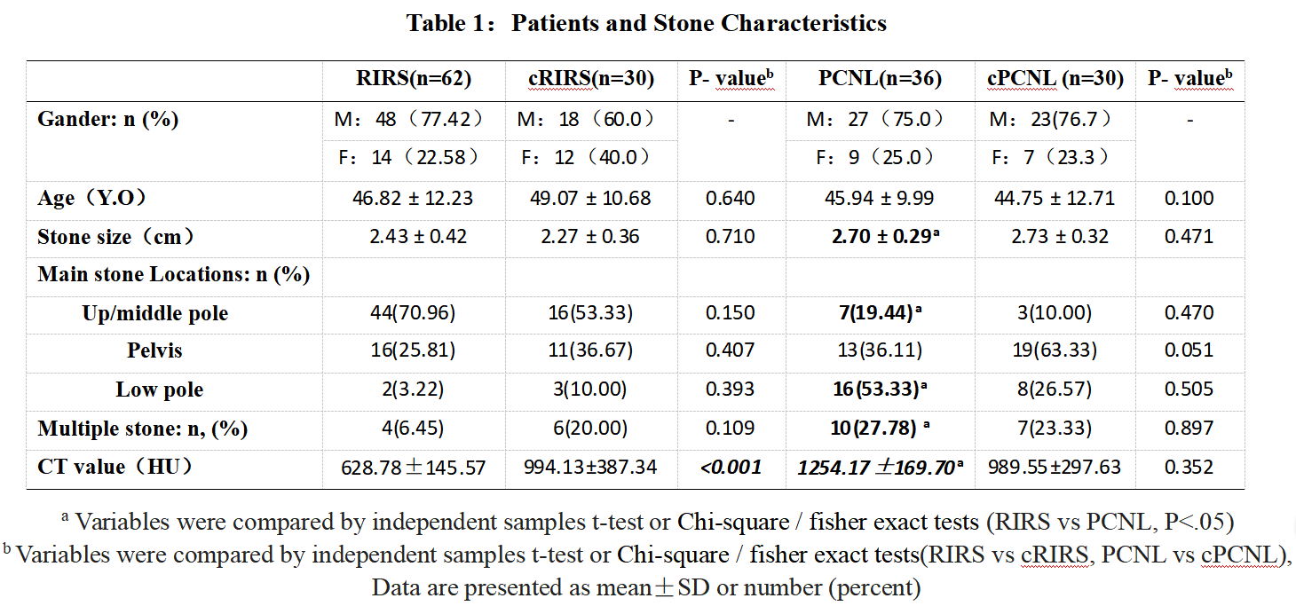

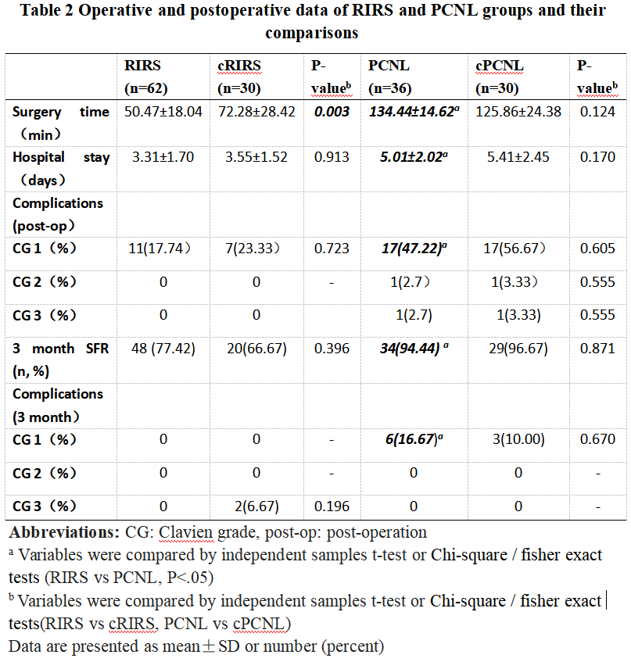

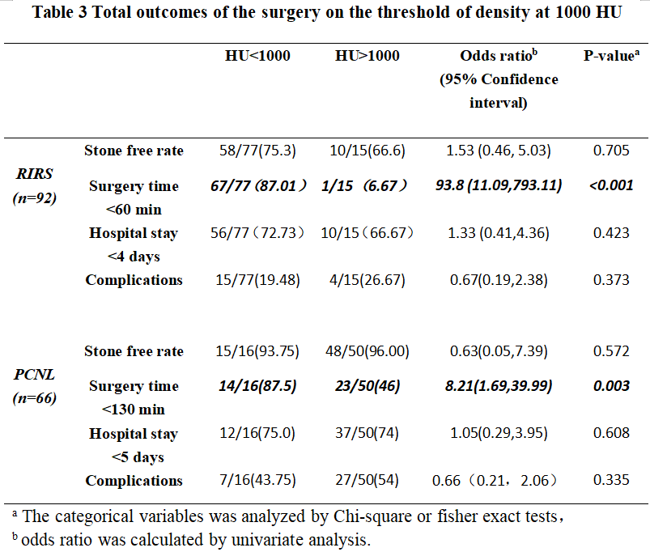

Figures:
Figure 1: Patients' enrollment algorithm
Analysis
Data analysis (n=158) and exclude cases (n=0)
HU value evaluated after surgery and match our prospective treatment strategy (n=98)
Randomize control after surgery included (without HU value evaluated) (n=60)
3 month follow up (n=158),
Lost to follow up (n=0)
Assessed for eligibility
FOLLOW-UP
cPCNL group
(n=30)
cRIRS group
(n=30)
RIRS group
(HU<1000, n=62)
PCNL group, (HU≥1000, n=36)
ALLOCATION
Surgery patients (n=158)
Patients met Inclusion criteria (n=158)

Enrollment
Exclude (Not meeting inclusion criteria, declined to participate, potential surgical contraindication and other reasons)

Fig 2 Correlation analysis between the HU values to surgery time in RIRS
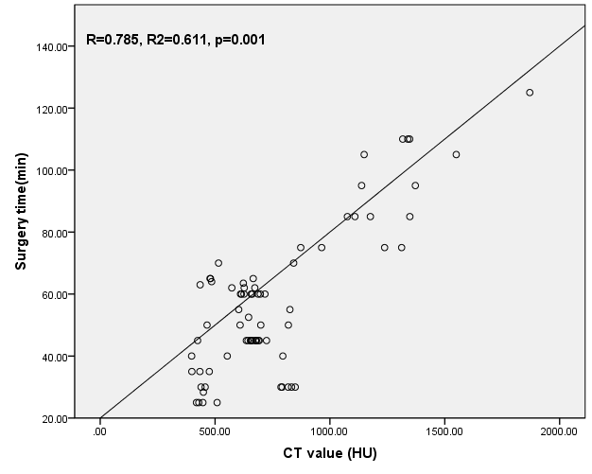

Fig 3 Correlation analysis between the HU values to surgery time in PCNL
