Proximal epithelioid sarcoma of the vulva: A case report and review of the literature

Mercedes Bravo-Taxaª, Luis Taxa-Rojasª, Aldo López-Blanco^{b}
ª Pathology Department, Instituto Nacional de Enfermedades Neoplásicas (INEN), Lima, Peru
^{b} Surgical Gynecology Department, Instituto Nacional de Enfermedades Neoplásicas (INEN), Lima, Peru

CORRESPONDING AUTHOR:
Dr. Mercedes Bravo-Taxa
Postal address: Calle Las Dalias 351, La Molina, Lima 12, Perú
Telephone: +51 980701186
Workplace: National Institute of Neoplastic Diseases (INEN)
Address: Av. Angamos 2520, Surquillo, Lima 15038, Perú
Email: mercedes.bravo.t@upch.pe
ORCID: 0000-0002-6965-4841

ABSTRACT
Primary sarcomas of the vulva are rare, with an incidence of 1.5% to 5% of all vulvar malignancies. There are only 41 cases described in the English literature of proximal epithelioid sarcoma of the vulva, which also constitutes a highly aggressive neoplasm with a high rate of recurrence and metastasis. We are reporting the first case of vulvar epithelioid sarcoma reported in our country, Peru, and Latin America.
We present the case of a 53-year-old woman with no significant history who presented a large tumor mass of 25 cm in the left hemi-vulva of 2 years of evolution, associated with intense pain. She underwent a radical surgical resection with left inguinopelvic lymphadenectomy and reconstruction with myocutaneous flap.

Keywords: Epithelioid sarcoma; Vulva; Sarcoma.

INTRODUCTION
Vulvar sarcoma constitutes 1.5–5% of all malignancies in this gynecologic region. Types of sarcoma commonly present in the vulva include leiomyosarcomas, malignant fibrous histiocytoma, malignant rhabdoid tumor, angiosarcoma, rhabdomyosarcoma, and epithelioid sarcomas.¹⁻³ Epithelioid Sarcoma is subclassified into distal or proximal type in relation to the involvement of upper and lower extremities or the pubic region and trunk, respectively. Proximal type epithelioid sarcoma of the vulva is an exceedingly rare soft tissue tumor, with only 41 cases described in the English literature, and extremely aggressive with a high rate of local recurrence and distant metastasis.^{2,4} The following publication provides the first case of vulvar epithelioid sarcoma reported in our country, Peru and Latin America; and reviews its clinical, histomorphological, treatment and prognosis of this unusual pathology.

CASE PRESENTATION
A 53-year-old woman reported a 2-year illness characterized by a progressive growth tumor in left hemi-vulva, which became more abrupt in the last 6 months and generated permanent intense pain. Upon examination, an 18 cm-sized tumor was seen on the right labia majora of left hemi-vulva, without infiltration of the urethral meatus or vaginal introitus; however, it compromised the adjacent skin and presented a 2-3 cm-sized left inguinal lymphadenopathy. Imaging of the lower abdomen revealed the presence of a 17.5 x 15 x 15.3 cm extensive solid lesion with polylobulated margins and necrotic component located in the left vulvar region, infiltrating fatty planes and conditioning effect of mass on the adductor muscles fascia of the left thigh. In addition, lymphadenopathy was identified in the left inguinal region, external iliac chain and left obturator group (Figure 1 A, B). Chest and brain CT were negative for metastases.
The multidisciplinary team decided to perform radical vulvar resection plus selective left inguinal and pelvic lymphadenectomy, as well as reconstruction with an abdominal myocutaneous flap. Macroscopically, a 33 x 30 x 14 cm-sized multilobed indurated tumor in left hemi-vulva was corroborated, extending to the vaginal introitus, suprapubic region and bilateral inguinal region, predominantly on the left side (Figure 2 A, B, C, D). The sectional surface was solid, heterogeneous with intermingled tan-whitish, myxoid, necrotic, hemorrhagic, and cystic degeneration areas.
Microscopically, the tumor was composed of long polygonal spindle cells with abundant eosinophilic cytoplasm, pleomorphic vesicular nucleus, prominent nucleolus, and high mitotic activity, 22 mitoses per 10 high-power fields. Likewise, lymphovascular and lymph node invasion was identified. The surgical margins were free of injury (Figure 3). The immunophenotype of the neoplastic cells showed immunoexpression for Pankeratin, EMA, Vimentin, Actin; while they were negative for Desmin, CD10, CD34, CD138, Melan A, HMB45, SOX-10, S100, Estrogen receptor and CDX2. And the most relevant immunohistochemical finding, that determined the diagnosis, was the loss of INI-1 expression, concluding that the tumor corresponded to a Proximal Epithelioid Sarcoma of the vulva (Figure 4).
With this result, the patient was tributary and keep receiving adjuvant treatment with radiotherapy and chemotherapy. Currently, she remains without evidence of recurrence after 3 months of follow-up.

DISCUSSION
Vulvar cancer is the fourth most common cause of gynecological malignancy, constituting 5% of all cancers of the female genital tract^{1,2} Among the various histological types of vulvar cancer, squamous cell carcinoma is the most common type and represents 95% of all malignant neoplasms in this gynecological area, followed by melanoma, sarcoma, and basal cell carcinoma.¹ Primary vulvar sarcomas are rare, reaching an incidence of 1.5 to 5% of cancers in this topographic region.^{2,3}

Epithelioid sarcoma (ES) is a malignant soft tissue neoplasm of uncertain histogenesis, which was established as a distinctive disease by Ezinger in 1970.³ ES are classified into distal, conventional or classic type and proximal type according to site of occurrence; then, when the upper or lower extremities are affected, it is called distal ES; while ES in the trunk or pubic region are classified as proximal.²⁻⁴ The proximal ES of the vulva are rare entities, with only 41 cases published in the English literature, and the first of them described by Piver et al. in 1972.^{2,4} (Table 1)

It occurs more frequently in women of reproductive age with a mean age of 37.8 years and mainly affects the labia majora, followed by the Bartholin gland, clitoris and labia minora. The most common initial clinical symptom is the presence of a slow-growing painless mass on the labia majora, which makes the diagnosis more difficult and delayed, since they are often confused with Bartholin cysts, lipomas or genital warts.²⁻⁴

The microscopic appearance of ES shows plump spindle cells to large polygonal cells with abundant eosinophilic or amphophilic cytoplasm and vesicular chromatin nucleus with prominent nucleolus. The growth pattern can be multinodular and/or in sheets; moreover, it is common to find areas of necrosis and high mitotic activity.²⁻⁵ As an unusual pattern, it is recognized that the proximal ES of the vulva may present myxoid changes.³
The diagnosis requires the support of the immunohistochemical profile. ES reveals cytoplasmic immunoreactivity for keratin, vimentin and EMA, while neoplastic cells are negative for S-100 and CD31. On the other hand, an essential marker to confirm the diagnosis of ES is the absence of INI1 expression. This immunophenotypic expression pattern allows us to differentiate ES from other soft tissue malignancies with epithelioid appearance such as synovial sarcoma, extrarenal malignant rhabdoid tumor, malignant epithelioid peripheral nerve sheath tumor, melanoma, rhabdomyosarcoma and undifferentiated carcinoma.³⁻⁶

The SMARCB1 gene located on chromosome 22q11 acts as a tumor suppressor gene. However, recent studies have shown the loss of expression of this protein in more than 80% of cases of ES, which plays a crucial role in its tumorigenesis.^{3,4,7} Therefore, the development of a therapy aimed to repair the function of the SMARCB1 gene could provide a treatment option probably with better results.

The ideal treatment remains uncertain; however, the mainstay of initial management is surgical resection with wide negative margins of more than 2 cm.²⁻⁴
Loco-regional lymph node dissection is controversial, Kim et al. propose the dissection of enlarged nodes, even though, there is no evidence that it has a significant impact on local or distant relapse.⁵ In contrast, Kasumatsu et al. suggest that radical resection and inguinal dissection is the best choice, since it offers better control of disease and could postpone adjuvant treatment.⁸
The role of adjuvant radiotherapy and/or chemotherapy is not clear. Some reports advocate the use of radiotherapy in high-grade tumors or those with inadequate surgical margins, and there have even been cases of a decrease in the rate of recurrence in patients who received this type of adjuvant.^{9,10} Meanwhile, chemotherapy effectiveness is not clear, there is literature with very varied results and rates of recurrence, with minimal benefits from its use; however, due to the low number of cases available, chemotherapy still remains as an alternative treatment.^{3,4,9}

The prognosis of ES is not favorable, the lack of symptoms added to its aggressive nature with a rapid tendency to metastasis and high recurrence rate, despite the presence of wide negative margins, cause a not very long survival in these patients. The overall survival rate is 21 months for initial stages and 6 months for advanced stages of disease. ²⁻⁴ Locoregional lymph node involvement, vascular invasion, tumor size greater than 2 cm, depth of involvement, presence of necrosis and high mitotic index, exceeding 2 mitoses per 10 high-power fields, are considered as poor prognostic factors.^{3,5}
According to reports in the literature, 38 to 69% of patients develop recurrence, which usually occurs within the first 6 months of the initial treatment, the most common sites of involvement being the lungs and lymph nodes. Furthermore, 62.5% of patients who develop a recurrence will die from the disease. ²⁻⁴

CONCLUSION
Proximal epithelioid sarcomas of the vulva are a rare, extremely aggressive condition with a high tendency to recurrence and metastasis, so a timely diagnosis with surgical resection and wide negative margins is necessary.
Data related to the tumour is limited; therefore, it is particularly important to encourage prospective and randomised clinical trials that are focused on treatment of the tumour, and to determine the efficacy of possible adjunctive therapies.

AUTHOR’S CONTRIBUTIONS
Dr Bravo analyzed the clinical data and drafted the manuscript. Dr Taxa provided the pathological results and provided professional guidance on this. Dr López provided imaging studies and conducted follow-up on the patient in the outpatient clinic. Dr Taxa and Dr López contributed to critical review and supervised the entire study. All the authors have read and approved the final version of this manuscript.

AVAILABILITY OF DATA AND MATERIALS
Not applicable.

FINANCIAL SUPPORT AND SPONSORSHIP
None.

CONFLICTS OF INTEREST
The authors declare that there are no conflicts of interests.

REFERENCES
- Siegel R, Naishadham D, Jemal A. Cancer statistics, 2013. CA Cancer J Clin 2013;63:11-30.
- Jeon SE, Lee J, Jung HJ et al. An extremely rare elderly case of proximal epithelioid sarcoma of the vulva: case report with a review of literatures. Obstetrics & gynecology science, 2020;63(5), 670–674.
- Rego JL, Cintra GF, Netto AK et al. Extremely rare case of vulvar myxoid epithelioid sarcoma. Case reports in obstetrics and gynecology, 2015;971217.
- Han CH, Li X, Khanna N. Epithelioid sarcoma of the vulva and its clinical implication: A case report and review of the literature. Gynecologic oncology reports, 2016;15, 31–33.
- Kim JH, Choi YS, Lee TS. A case of epithelioid sarcoma arising in the vulva. J Gynecol Oncol 2008;19:202-4.
- Kim JH, Kim HM, Kwon J et al. Proximal-type epithelioid sarcoma of the vulva with INI1 diagnostic utility. Ann. Diagn. Pathol. 2012;16, 411–415.
- Noujaim J, Thway K, Bajwa Z et al. Epithelioid sarcoma: opportunities for biology-driven targeted therapy. Front. Oncol. 2015;5, 186.
- Kasamatsu T, Hasegawa T, Tsuda H et al. Primary epithelioid sarcoma of the vulva. Int J Gynecol Cancer 2001;11:316–20.
- Argenta PA, Thomas S, Chura JC. Proximal-type epithelioid sarcoma vs. malignant rhabdoid tumor of the vulva: a case report, review of the literature, and an argument for consolidation. Gynecol. Oncol. 2007;107, 130–135.
- Hasegawa T, Matsuno Y, Shimoda T et al. “Proximal-type epithelioid sarcoma: a clinicopathologic study of 20 cases,” Modern Pathology, vol. 14, no. 7, pp. 655–663, 2001.

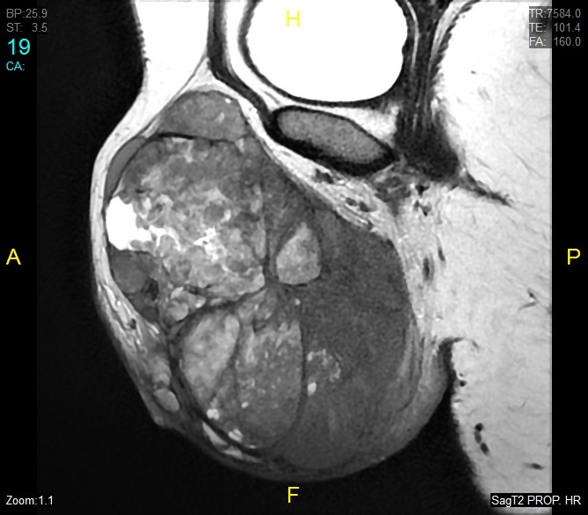
FIGURES:
A
B

Figure 1 A and B: Extensive solid lesion with polyobulated margins and necrotic component located in left vulvar region and infiltrating fatty planes.

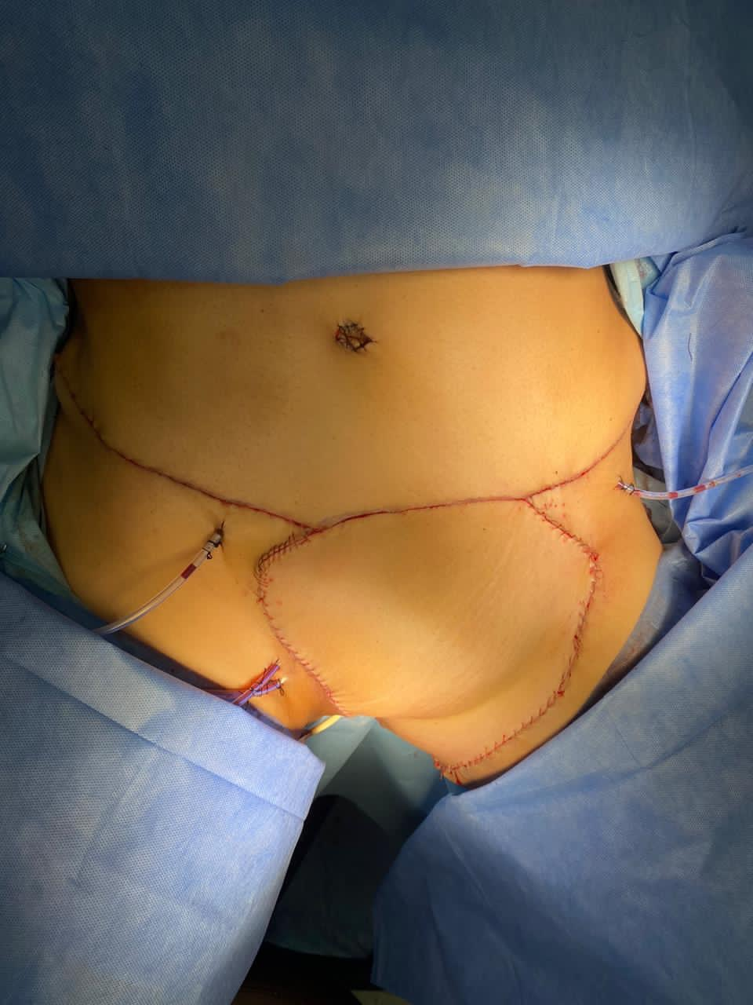
A
C
D
B

Figure 2 A-B: Extensive solid lesion in left hemi-vulva, which extends to the vaginal introitus, suprapubic region and bilateral inguinal region. C: Radical resection plus left inguino-pelvic lymphadenectomy. D: Simultaneously, reconstruction was performed with an abdominal myocutaneous flap.

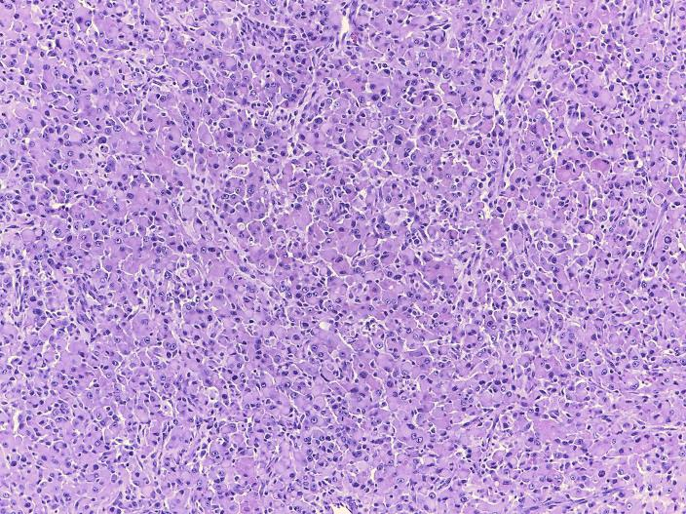
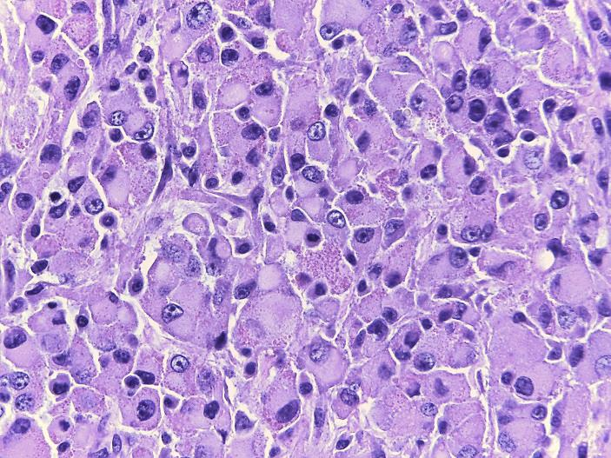
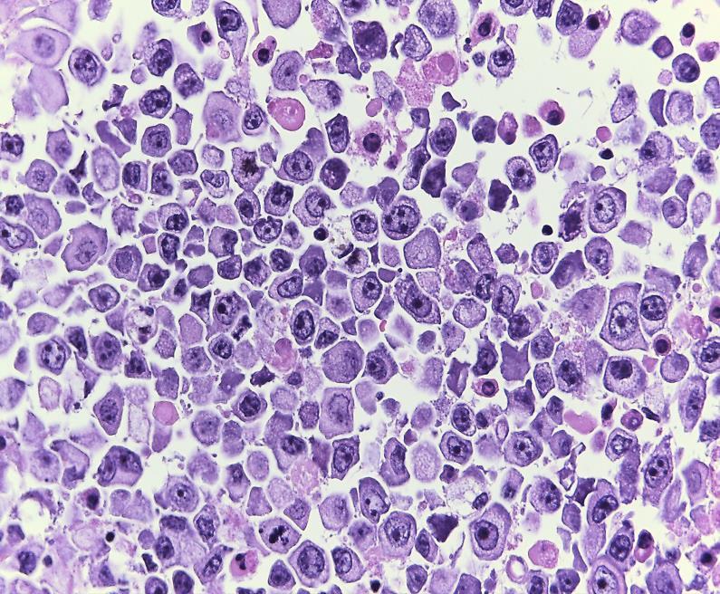
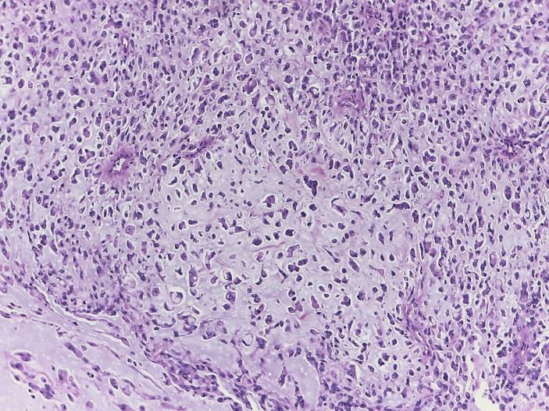
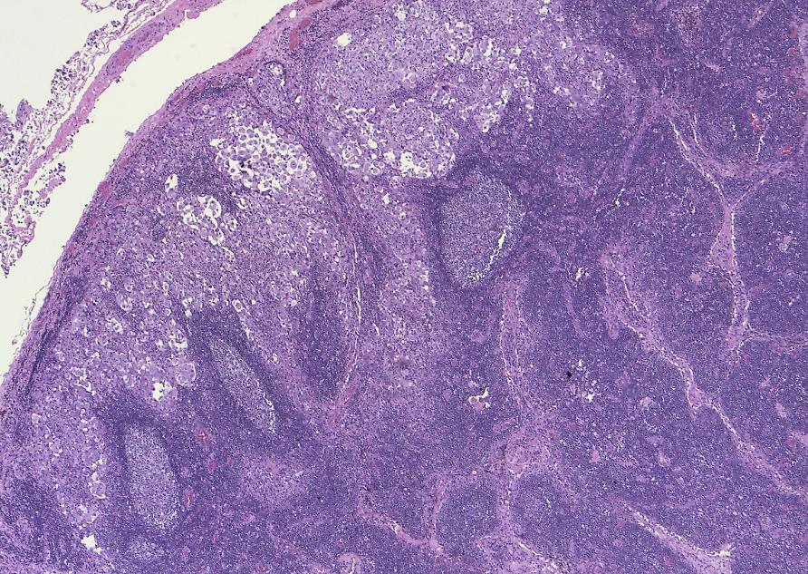
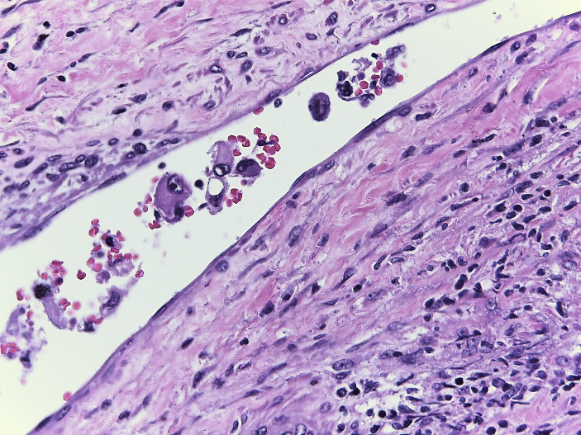
**
A
B
C
D
E
F

Figure 3 A: Sheet-like proliferation of spindle cells to polygonal cells. HE 50X B: Tumor cells have pleomorphic vesicular nucleus, prominent nucleolus, and abundant eosinophilic or amphophilic cytoplasm. HE 400X C: High mitotic activity, with atypical forms (arrows) HE 400X D: Striking myxoid stroma HE 200X E: Macrometastases of epithelioid sarcoma (asterisks). HE 100X F: Lymphovascular embolism. HE 400X.

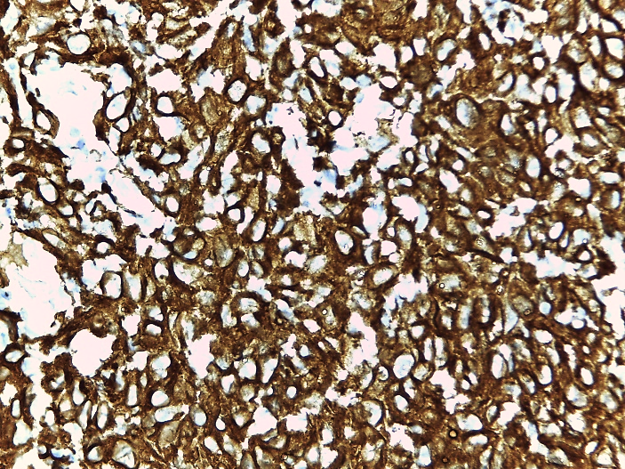
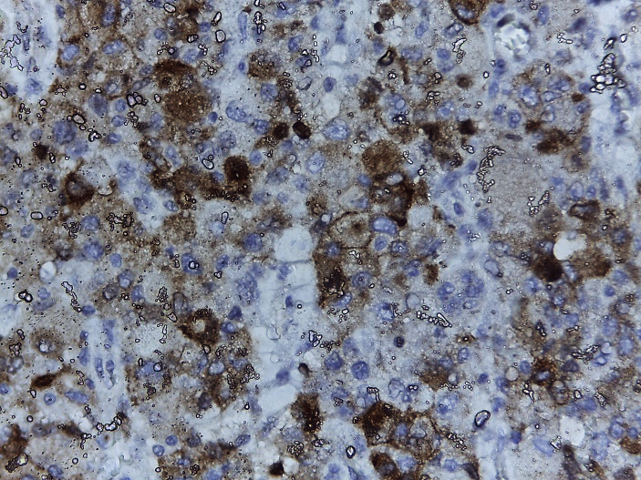
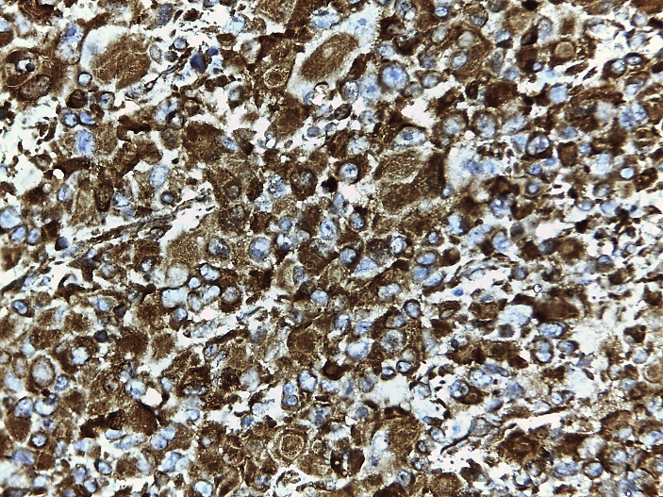
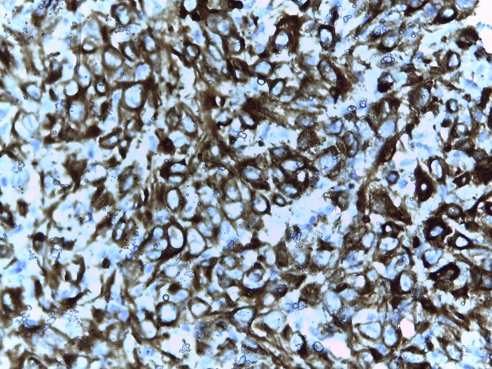
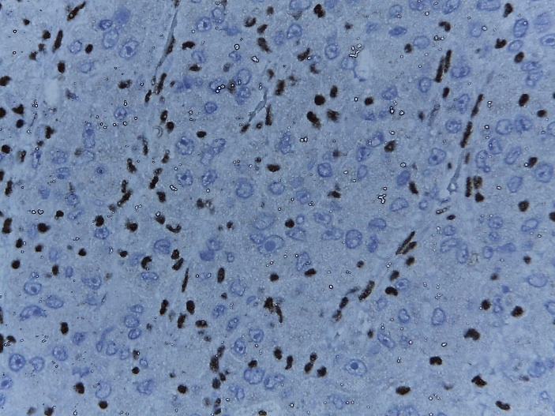
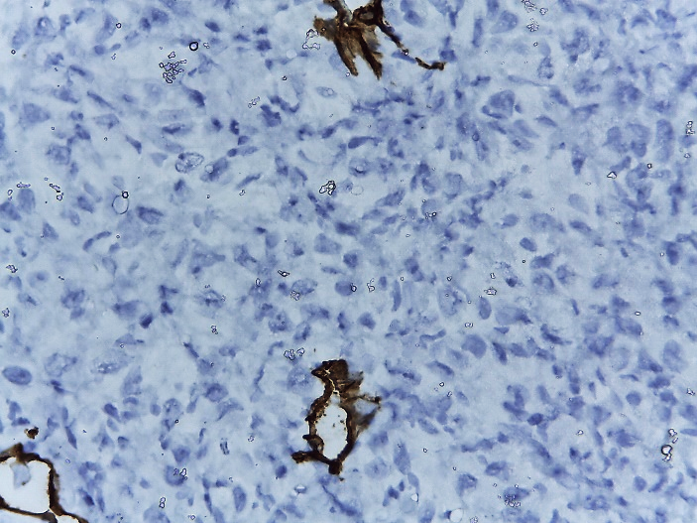
EMA
VIMENTINA
ACTIN
PANKERATIN
INI-1
CD 34

Figure 4: Neoplastic cells showed immunoexpression for EMA, Vimentin, Actin, Pankeratin; while they were negative for CD34 and presented loss of expression of INI-1.

TABLE:
Table 1. Published cases with vulval epithelioid sarcoma
First autor, country | Year | Age | Surgery | LND | ADJ | DFS  (months) | OS  (months) | Outcome
Bravo, Perú | 2021 | 53 | Wide local excision | B | RT | 2 | 2 | NED
Jeon, Korea | 2020 | 77 | Wide local excision | B | RT | - | 36 | DOD
Yue, China | 2018 | 41 | Wide local excision | - | - | 9 | 9 | NED
Chan Hee Han, USA | 2016 | 32 | Wide local excision | - | - | 9 | 9 | NED
Rego, Brazil | 2015 | 34 | Wide local excision | - | - | - | 18 | NED
Patrizi, Italy | 2013 | 63 | Radical vulvectomy | B | RT | - | 14 | NED
Kim, Korea | 2012 | 41 | Local excision | - | RT | - | 10 | NED
Ong, Sigapore | 2012 | 51 | Hemivulvectomy | Y | - | - | 8 | NED
Andrisani, Italy | 2011 | 46 | Radical vulvectomy | B | RT, CT | 1 | 12 | DOD
Chiyoda, Japan | 2011 | 33 | Radical vulvectomy | B | - | - | 36 | NED
Manzanares-Campillo, Spain | 2011 | 57 | Local excision | - | - | 48 | 96 | NED
Tholpady, USA | 2010 | 17 | Local excision | - | - | - | 12 | NED
Rai, USA | 2009 | 17 | Local excision | B | RT | 2 | 2 | AWD
Mas-Morey, Spain | 2008 | 30 | Wide Local excision | B | RT | - | 12 | NED
Eroglu, Turkey | 2008 | 25 | Wide local excision | Y | RT | - | 16 | NED
Kim, Korea | 2008 | 24 | Wide local excision | - | - | - | 8 | NED
Argenta, USA | 2007 | 35 | Radical excision | Y | RT | - | 40 | NED
Dainese | 2005 | 34 | Radical hemivulvectomy | Y | - | - | 12 | NED
Altundag, Turkey | 2004 | 51 | Hemivulvectomy | B | RT, CT | 4 | 6 | DOD
Ulutin, USA | 2003 | 42 | Radical vulvectomy | - | - | - | 146 | NED
Moore, USA | 2002 | 29 | Radical vulvectomy | - | CT | 6 | 6.5 | DOD
Gonzalez-Peramato, Spain | 2001 | 84 | Local excision | - | CT | 1 | 1 | AWD
Kasamatsu, Japan | 2001 | 23 | Local excision | - | - | 30 | 96 | NED
Hasegawa | 2001 | 37 | Local excision | - | CT | - | 11 | NED
 |  | 30 | Local excision | - | - | 96 | 104 | NED
 |  | 80 | Wide local excision | - | - | 10 | 23 | DOD
Tjalma, Belgium | 1999 | 23 | Hemivulvectomy | Y | - | - | 48 | NED
Guillou, Switzerland | 1997 | 57 | Local excision | - | RT | - | 52 | DOID
 |  | 49 | Radical vulvectomy | - | RT | - | 22 | NED
 |  | 45 | Wide local excision | - | RT, CT | - | 21 | NED
Ross, USA | 1997 | 20.5 | Local excision | - | - | - | 105 | NED
Hernandez-Ortiz, Spain | 1995 | 51 | Radical vulvectomy | - | - | 11 | 12 | DOD
Konefka, Poland | 1994 | 49 | Radical vulvectomy | B | CT | 5 | 8 | DOD
Weissmann, USA | 1990 | 26 | Local excision | - | - | 14 | 78 | AWD
Perrone, USA | 1989 | 21 | Local excision | Y | - | - | 56 | NED
Tan, Singapore | 1989 | 21 | Local excision | - | - | - | 36 | NED
Wevers, Netherland | 1989 | 37 | Local excision | Y | - | 2 | 5 | DOD
Ulbright, USA | 1983 | 55 | Local excision | - | - | 8 | 15 | DOD
 |  | 30 | Wide local excision | - | - | 1.5 | 8 | DOD
Hall, USA | 1980 | 31 | Wide local excision | Y | - | 35 | 70 | DOD
Gallup, USA | 1976 | 31 | Radical vulvectomy | - | - | - | 16 | NED
Piver, USA | 1972 | 27 | Local excision | - | - | - | 108 | NED
LND, lymph node dissection; Y, yes; B, bilateral; RT, radiation therapy; CT, chemotherapy; NED, no evidence of disease; DOD, die of disease; AWD, alive with disease; DOID, die of interurrent disease; DFS, disease free survival; OS, overall survival

