A RARE CASE OF ISOLATED HYDATID CYST OF BREAST

Abstract

Introduction
Hydatid cyst of the breast is very rare. It is very difficult to differentiate from other tumours of the breast on radiology. So it requires cytology/histopathology for final confirmation. Till now very few reports are published in literature. Majority of the reported cases have been diagnosed postoperatively.

Presentation of case
52 year old women presented with screening mammography abnormality of the right breast. On clinical examination no palpable lump was found. Sono-Mammography reported well defined hypoechoic lesion with wall calcification in right breast? Complex cyst, likely benign
Our pre-operative D/D :- ? hydatid cyst
FNAC (after all precaution to prevent hypersensitivity reactions):- Shows degenerated proctoscolices are found. Detached hooklets with refractile structure are seen , favours Hydatid cyst
Serology was normal (Anit-Echinococcal antibody )

Discussion
In Sheep rearing countries like Australia, Argentina, Uruguay, Chile hydatid disease is an endemic disease, sporadic cases are detected throughout the world. It is a parasitic infection caused by the larval form of Echinococcus granulosu. The breast can be a primary site or part of a disseminated hydatidosis. It’s difficult to differentiate from fibroadenoma, phyllodes tumors, chronic abscesses, or even carcinoma. Preoperative diagnosis can be made by fine needle aspiration cytology after all precaution to prevent hypersensitivity reactions. It also can be diagnosed by radiological or serologic means. But final histopathology is the confirmative. Surgery is the treatment of choice.

Conclusion
Hydatid cyst of the breast is very uncommon but it should be included in differential diagnosis of breast lumps if mannography/sonography shows wall calcification.

Keywords: Hydatid cyst, Very rare, Painless Breast lump, Incidentally, Endemic

Presentation of case
52 year old women presented with screening mammography abnormality. There was no history of injury, discharge from the nipple and family history of breast cancer. .She stayed for sometime in a sheep rearing country – Australia. Examination revealed no abnormality in the breast nipple or areola. The mammogram revealed a well defined round opaque lesion with peripheral calcification in lower/outer quadrant of right breast. Collaborative USG study of the breasts revealed a 17 mm * 14 mm sixe well defined hypoechoie lesion at 6-7 o clock position with wall calcification seen in right breast. D/D was ?complex cyst ? chronic abscess ? Hydatid cyst FNAC (after all precaution to prevent hypersensitivity reactions) reported degenerated proctoscolices , detached hooklets with refractile structure, favours Hydatid cyst. Anit-Echinococcal antibody was normal. Other screening test for hydatid cyst-chest X-ray and USG abdomen of the patient were normal. Patient was given albendazole therapy for 8 wks as prophylactic measure. Complete excision of the cyst was done after USG guided wire localisation of the non palpable lesion. USG of the specimen was done at the same time to check its complete removal. Preoperative prophylactic hydrocortisone was given to prevent hypersensitivity reaction. Histopathology of the specimen confirmed hydatid cyst.
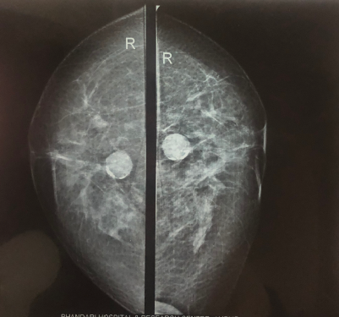
Pre-operative mammogram showing SOL

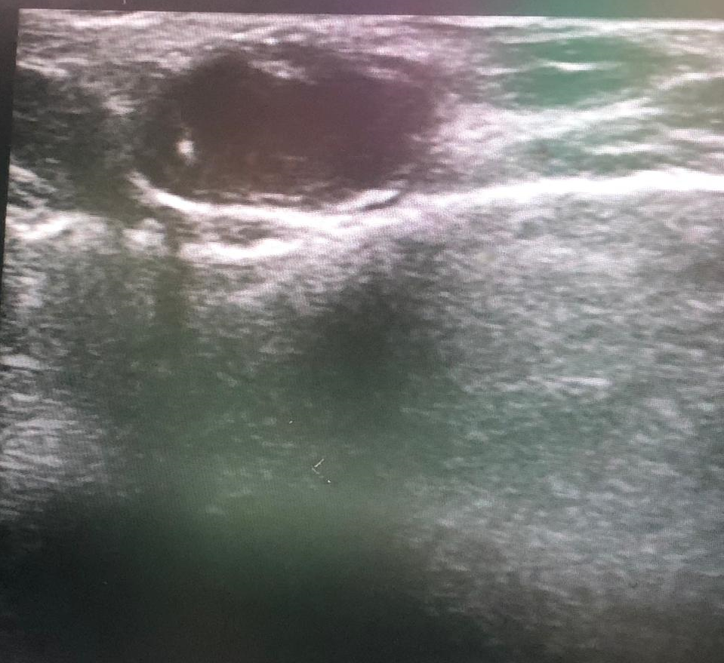
USG guided wire localisation
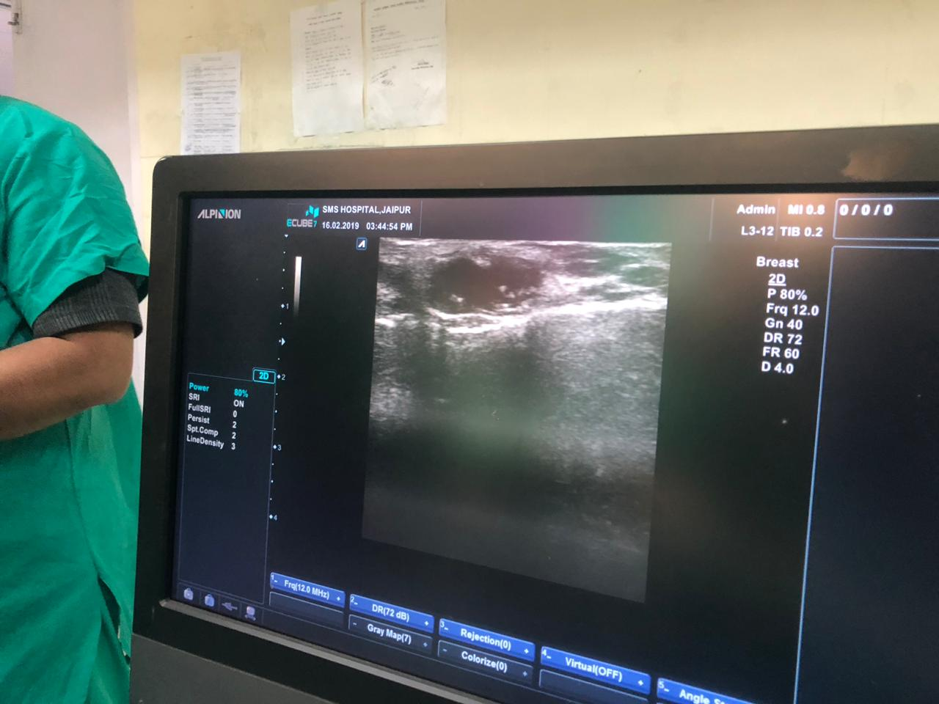
Intra-operative USG
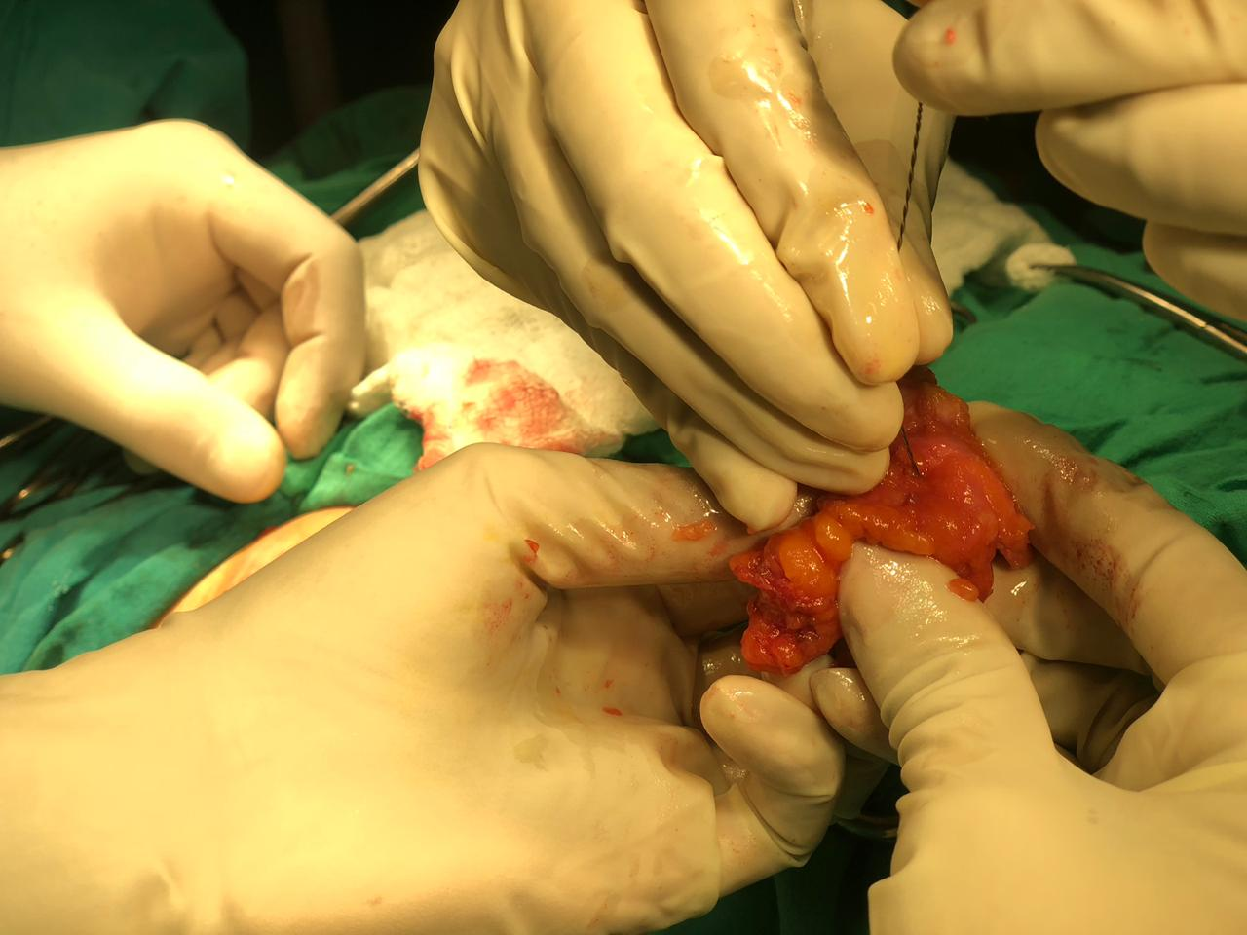
Specimen
Wire
Specimen with wire removed

Discussion

Introduction
Incidence of hydatid disease in India is 1-200 in 1 lakh population. 60% of the cysts are found in the liver, 30% in lungs, 2.5% in kidneys, 2.5% in heart and pericardium, 2% in bone, 1.5% in spleen, 1% in muscle, and 0.5% in brain and very rarely in breast. Hydatid disease of breast accounts for only 0.27% of all cases in endemic areas but hydatid disease of breast is very very rare where it if found sporadically and that’s why very few cases had been reported in the literature and till now the largest series is of 20 cases (Tunisia).
Hydatid disease is a parasitic infection caused by the larval form of Echinococcus granulosus. This disease is widespread and occurs in all continents, including circumpolar, temperate, subtropical, and tropical zones. Human cystic echinococcosis remains highly endemic in pastoral communities, particularly in regions of South America (Argentina, Uruguay, Chile), the Mediterranean littoral (Spain, France, Italy), Eastern Europe, the near and Middle East (Turkey), East Africa (Maghreb countries), Central Asia, China, and Russia.¹
Very few cases of hydatid cysts of the breast have been reported in the literature. The largest series of 20 hydatid cyst of the breast was reported in Tunisia.² Patients usually present to the hospital with a palpable and painless lump in the breast. It is challenging to differentiate it from other tumoral lesions of the breast. Only few reports are published and majority of the reported cases have been diagnosed postoperatively. Very few of the reported cases have been diagnosed preoperatively.³ It is not possible to reach definitive diagnosis with only radiological investigations.
Hydatid disease is a cyclozoonosis caused by the larval (metacestode) stages of cestodes (flat worms) belonging to the genus Echinococcus and the family Taeniidae. The disease exists in two forms: the larval stage (metacestode) and the adult stage (tinea). The carnivorus ( dog and wild canine) are definitive host. Humans are the accidental intermediate host (dead end) and animals (herbivores and omnivores) are both intermediate and definitive hosts.¹
The adult E. granulosus is a worm, found in the infected definitive host, produces eggs that are passed in stool. Eggs ingested by intermediate hosts like cows, sheep, and humans, liberate an embryo in the duodenum, which penetrates intestinal mucosa and enters the portal circulation.^{4,5} The liver acts as a first filter and stops about 75%, while lungs, the second filter, stop about 10% and only 15% embryos are free to develop cysts in other organs of the body.⁶ According to Barret and Thomas, 60% of the cysts are found in the liver, 30% in lungs, 2.5% in kidneys, 2.5% in heart and pericardium, 2% in bone, 1.5% in spleen, 1% in muscle, and 0.5% in brain and very very rarely in breast.^{6,7} The embryo usually develops into a unilocular cyst- Hydatid cyst.⁸
Hydatid disease of breast is rare and accounts for only 0.27% of all cases. The breast can be a primary site or part of a disseminated hydatidosis.^{9,14} Typically, the patient presents with painless breast lump, which increases slowly in size without regional lymph node involvement. It generally affects women between 30 and 50 years of age. It’s difficult to differentiate from fibroadenoma, phyllodes tumors, chronic abscesses, or even carcinoma. Final confirmation is by cytology/histopathology. So breast hydatid cyst should be included in differential diagnosis of breast lumps.^{6,9,14} Preoperative diagnosis can be made by fine needle aspiration cytology where scoleces, hooklets or laminated membrane can be identified.¹⁰ It is a safe procedure as long as precautions to prevent hypersensitivity reactions are taken, till now no complications after FNAC were mentioned in the literature.^{6,11,14} The disease can be diagnosed by radiologic or serologic means, both of which are not definitive.¹¹ Mammogram may show a circumscribed mass, the characteristic ring shaped structures inside the mass in over penetrated view along with calcification, strongly suggests breast hydatid cyst.¹² The ultrasound and Magnetic Resonance Imaging are helpful diagnostic tools.^{6,13} Hemagglutination tests may be helpful in diagnosis.¹⁵
Complete excision is the treatment of choice. However, recurrent cysts have been reported postoperatively in 10% of patients. To prevent recurrence albendazole therapy is recommended.²

Conclusion
Hydatid cyst of the breast is very uncommon and it should be included in the differential diagnosis of breast lump. So before doing FNAC or core biopsy it is must to exclude hydatid disease of breast as these procedures may lead to hypersensitivity reaction. Complete excision of the cyst is the treatment of choice. Recurrence after surgical removal have been reported but postoperative Albendazole may decrease its recurrence rate.

References
1. Josef E.F. Echinococcal cyst-open approach. In: Milicevic Miroslav., editor. 6th ed. Vol. 1. Lipincott Williams & Wilkins, Wolters Kluwer Health; New Delhi: 2012. p. 1189. (Fischer's mastery of surgery).
2. Ouedrago E.G. Hydatid cyst of the breast: 20 cases. J Gynecol Obstet Biol Reprod. 1986;15:187–194.
3. Ali A., Aldhilan A., Makanjuola D., Abdulmohsen A. Preoperative diagnosis of hydatid cyst of the breast: a case report. Pan Afr Med J. 2013;14:99. [PubMed]
4. Garcia G., Shimizu R., Bruckner D. Sinus tract extension of liver hydatid cyst and recovery of diagnostic hooklets in sputum. Am J Clin Pathol. 1986;85:519–521. [PubMed]
5. Langer J.C., Rose D.B., Keystone J.S., Taylor B.R., Langer B. Diagnosis and management of hydatid disease of the liver. Ann Surg. 1983;199(4):412–417. [PubMed]
6. Das D.K., Choudhury U. An unusual breast lump. JIMA. 2002;100(5):327–328. [PubMed]
7. Günag K., Müslümanoglu M., Taviloglu K. Hydatid cyst of the breast – avery rare form of hydatid disease. Breast Dis. 1996;9:295–298.
8. Khatib I., Kharouf T., Khrais M., Khasawneh A. Primary hydatid cyst of the breast: report of two cases. Jordan Med J. 2003;37(2):192–194.
9. Farrokh D. Hydatid cysts of the breast: a report of three cases. Irn J Med Sci. 2000;25(1&2):72–75.
10. Sagin H.B., Kiroglu Y., Aksoy F. Hydatid cyst of the breast diagnosed by fine needle aspiration biopsy. A case report. Acta Cytol. 1994;38(6):965–967. [PubMed]
11. Mirdha B., Biswas A. Echinococcosis: presenting as palpable lumps of breast. Indian J Chest Allied Sci. 2001;43(4):220–226.
12. Vega A., Ortega E., Cavada A., Garjo F. Hydatid cyst of the breast: mammographic findings. Am J Roentgenol. 1994;162:825–826. [PubMed]
13. Tukel S., Erden I., Kocak S.M., Ciftci E. Hydatid cyst of breast: MR imaging findings. Am J Roentgenol. 1997;168:1386–1387. [PubMed]
14. Acar T., Gömcel Y., Güzel K., Yazgan A., Aydyn R. Isolated hydatid cyst of the breast. SMJ. 2003;48(2):52–53.
15. Radhi J.M., Thavanathan M.J. Hydatid cyst presenting as a breast lump. Can J Surg. 1990;33:29–30.[PubMed]

