Manuscript
Pyosalpinx presenting as intestinal obstruction in a patient of OHVIRA syndrome-a case report.
Abstract
Obstructed hemivagina and ipsilateral renal anomaly (OHVIRA), or Herlyn-Werner-Wunderlich syndrome, is a rare Mullerian duct anomaly with uterus didelphys, unilateral obstructed hemivagina, and ipsilateral renal agenesis. Usually these cases present after menarche with pelvic pain and/or a mass and rarely, in later years, with primary infertility. Strong suspicion and knowledge of this anomaly are essential for a precise diagnosis. A 20 year old patient presented with acute abdomen & features of sepsis, USG & CT abdomen showed left pyosalpinx, uterus didelphys, intestinal obstruction (dilated bowel loops), ipsilateral renal agenesis & collection as noted in pelvis, RIF. Patient underwent emergency surgery for drainage of pyosalpinx & pus contaminated collection. Sloughed off ovary was sent for HPE & biopsy report confirmed present of acute inflammatory cells. OHVIRA syndrome may present with acute abdomen and is usually treated with vaginal septum resection and drainage of the hematometrocolpos
Keywords: OHVIRA syndrome, Herlyn-Werner-Wunderlich syndrome, Pyosalpinx, Uterus didelphys, Renal agenesis
Introduction
Didelphys uterus with obstructed hemivagina and ipsilateral renal agenesis is named as Herlyn–Werner Wunderlich (HWW) syndrome or OHVIRA syndrome [1]. In 1971the association of renal agenesis with ipsilateral blind hemivagina was reported as Herlyn–Werner syndrome, and the association of renal aplasia, bicornuate uterus with isolated hematocervix, and a normal vagina were reported by Wunderlich in 1976 [2]. The incidence of uterus didelphys, related to OHVIRA syndrome, is approximately 1/2,000 to 1/28,000, and it is associated with ipsilateral renal agenesis in 43% of cases [3].
An obstructing longitudinal vaginal septum, which was also present in this case, is associated with 75% of these anomalies[4].

Case report
Patient aged 20years presented to the emergency department with chief complaints of pain abdomen since 20days, burning micturition since 8 days and fever since 5 days. She was married with no history of pregnancy. She had a regular menstrual cycle , was febrile (101.5° F) with a tender abdomen with maximum tenderness in right iliac fossa, on further questioning it was found that patient also had complaints of constipation & had not passed stools since 1 day, she was advised USG abdomen and other routine investigations. Her WBC counts at admission were 40, 000, pregnancy test was negative and urinalaysis were normal. USG abdomen examination revealed a bicornuate uterus, collection in right lower half of abdomen & left kidney was not visualized; findings of CT scan were
- left kidney was absent,
- Multiple dilated small bowel loops were seen with maximum diameter 3.7 cm, no transition point was seen.
- Approximately 15x10x7 cm (500-600cc) peripherally enhancing collection was seen in pelvis with extension to right iliac fossa and pouch of douglas. Additionally Minimal fluid seen along liver surface.
- Uterine didelphys with widely separated horns, distended left half of vagina
- Tubular structure was noted in left adnexa with high attenuation consistent with pyosalpinx. Left ovary was not identified separately
Hence considering the clinical feature and constellation of CT & USG findings final diagnosis of SAIO, pyoperitoneum secondary to pyosalpinx with features of OHVIRA syndrome (as patient had ipsilateral renal agenesis & obstructed hemivagina).
Under general anesthesia after painting & draping, a classical vertical midline incision was made, wound developed in layers. Approximately 500 cc pus contaminated fluid was drained. Complete small & large bowel loops were examined, they were found dilated due to adhesions; adhesiolysis was done. Left fallopian tube was found dilated & filled with pus, left ovary was found partially sloughed out. The sloughed ovarian tissue was sent for HP examination. Peritoneal lavage was done with peritoneal drain placed in pelvic cavity. Early postoperative period was uncomplicated. There was significant decrease in the WBC counts. On post-operative day 5, patient was afebrile; clinical condition was satisfactory with normal WBC counts on discharge. She was advised to attend gynecology OPD for further definitive management. Biopsy report confirmed the presence acute inflammatory infiltrate with no granuloma.

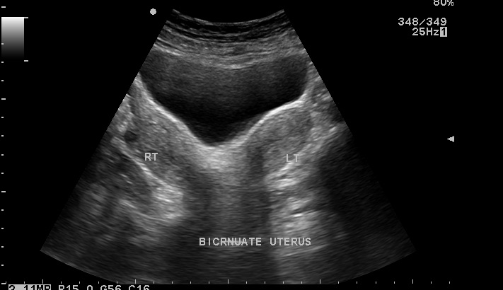
Fig 1: USG images demonstrate two separate uterine horns, additional findings noted on USG were absent left kidney and collection in pelvis & RIF

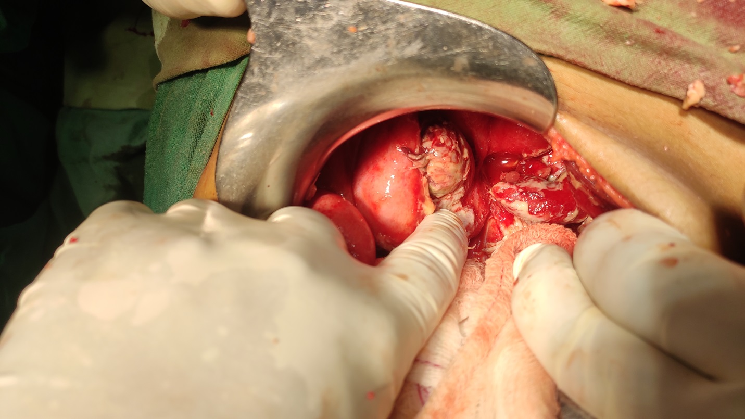
Fig 4: Intra OP images shows left pyosalpinx with partially sloughed off left ovary.

Discussion
There are only a few reported cases presenting with acute abdominal pain as in our case or abnormal vaginal discharge, or even acute retention of urine [5,6,7]. Our case attained menarache at the age of 13 but was never diagnosed until she presented as acute abdomen, possibly she had superadded infection which led to pyosalpinx &tubal rupture and ultimately led to the development of Pyoperitoneum. Early diagnosis and surgery are imperative to relieve the presenting symptoms and prevent complications such as endometriosis and infertility. The management of choice for OHVIRA syndrome is resection of the vaginal septum in order to relieve the obstructed hemivagina to prevent complications such as hematocolpos. As our case had developed septicemic shock it was imperative to drain the septic foci so the drainage of pus contaminated fluid was done and sloughed off ovary was sent for HPE. Most patients with OHVIRA syndrome can be treated solely with single-stage vaginoplasty and routine laparoscopy is not essential for management. In order to preserve the hymenal integrity hysteroscopic resection of the septum under Transabdominal guidance has also been reported as a treatment option.
In conclusion, OHVIRA or HWW syndrome is a rare congenital urogenital anomaly that may present with acute abdominal pain. Diagnosis of OHVIRA requires high clinical suspicion as patients usually have normal menstrual cycle but should be kept as a differential diagnosis in patients complaining of recurrent severe dysmenorrhea. We would like to highlight that although rarely encountered, uterus didelphys with obstructed hemivagina should be in the differential diagnosis of adolescent girls/young adults presenting with acute abdomen.

References

[1] Orazi C, Lucchetti MC, Schingo PM, Marchetti P, Ferro F. Herlyn-Werner Wunderlich syndrome: uterus didelphys, blind hemivagina and ipsilateral renal agenesis. Sonographic and MR findings in 11 cases. Pediatr Radiol 2007;37: 657–65.
[2] Park NH, Park HJ, Park CS, Park SI. Herlyn-Werner-Wunderlich Syndrome with unilateral hemivaginal obstruction, ipsilateral renal agenesis, and contralateral renal thin GBM disease: a case report with radiological follow up. J Korean Soc Radiol 2010;62:383–8.
[3] Del Vescovo R, Battisti S, Di Paola V, Piccolo CL, Cazzato RL, Sansoni I, Grasso RF, Zobel BB. Herlyn-Werner-Wunderlich syndrome: MRI findings, radiological guide (two cases and literature review) and differential diagnosis. BMC Med Imaging 2012;12:4.
[4] Troiano RN, McCarthy SM: Mullerian duct anomalies: imaging and clinical issues. State of the art. Radiology 2004; 233:19e34
[5] Mandava A, Prabhakar RR, Smitha S. OHVIRA syndrome (obstructed hemivagina and ipsilateral renal anomaly) with uterus didelphys, an unusual presentation. J Pediatr Adolesc Gynecol 2012;25:e23–5.
[6] Broseta E, Boronat F, Ruiz JL, Alonso M, Osca JM, Jiménez-Cruz JF. Urological complications associated to uterus didelphys with unilateral hematocolpos. A case report and review of the literature. Eur Urol 1991;20:85–8.
[7] Adams Jr GW, Wilson CE, Holloway JH, Williamson HF. Uterus didelphys with unilateral imperforate vagina: a rare cause of acute urinary retention. J Urol 1979;121:131–2

