Case Report
Giant Cell Tumors at the distal radius: en-bloc excision and arthrodesis of the translocated ipsilateral ulna
Eva Campos Pereira^{1*}, João Vale², Tiago Amorim-Barbosa², Filipe Rodrigues², Arnaldo Sousa², Pedro Teixeira Mota², Vânia Oliveira², Alexandre Pereira², Pedro Cardoso²

1. Orthopaedics Department, Hospital Central do Funchal, Funchal, Portugal
2. Orthopaedics Department, Centro Hospitalar e Universitário do Porto, Porto, Portugal

Correspondence to:
Eva Campos Pereira
Orthopaedics Department, Hospital Central do Funchal, Funchal, Portugal
E-mail: eva.campos.pereira@gmail.com

Abstract
Distal radius is the third most common site of giant cell tumor of bone (GCTB). The local aggressive invasion of this rare neoplasm requires reconstructive solutions after wide excision.
Authors present two cases of patients diagnosed with Campanacci grade III GCTB of the distal radius successfully treated with en-bloc excision and translocation of the ipsilateral ulna. Pre-operative application of denosumab was given for one year to both patients. At one-year follow-up, both patients are disease free and reported satisfactory results on Quick - Disabilities of the Arm, Shoulder and Hand (Quick-DASH) questionnaire and modified Musculoskeletal Tumor Society (MSTS) score. Although a challenge, this treatment for GCTB of the distal radius shows a successful oncological and functional outcome.

Keywords: Giant cell tumor of bone, distal radius, en-bloc excision, translocation, ipsilateral ulna, wrist arthrodesis

INTRODUCTION
Giant cell tumor of bone (GCTB) is a benign but locally aggressive intramedullary bone tumor that was first described in 1818 by Cooper and Travers.¹⁻³ Distal radius is the third most common site of GCTB after distal femur and proximal tibia.^{1,4-7} Local recurrences occur in 70% of the cases within 24 months after excision and lung metastasis in 2% of the patients.⁷⁻¹⁰
Typically, local pain with an increased swelling is reported and a pathological fracture occurs in 10% of the patients because of its osteolytic nature.^{3,11}
The radiological system of 3 stages described by Campanacci et al. demonstrates a clinical-radiological correlation. In stage I, latent lesions have a well-marginated border and do not perforate the cortical bone. Stage II lesions are active, without a radiopaque rim or soft tissue involvement. Stage III tumors are aggressive, without well-defined limits, with rapid and permeated growth, with involvement of the surrounding soft tissue. For both stage I and stage II lesions, intralesional curettage and acrylic bone cement (or other substitutes) are the most reported treatment.^{3-8,10,12-14} Nevertheless, more aggressive treatment protocols are required to prevent recurrence of lesions at stage III. Although adjuvant agents decrease the recurrence rates of intralesional curettage, this primary option have higher recurrence rates (up to 27%) than wide resection (0 to 12%).^{6,8,15,16}
Denosumab, a human monoclonal antibody against RANKL (receptor activator of nuclear factor-kB ligand), contains tumor growth and makes surgery viable or facilitates resection without contamination when used as neoadjuvant therapy in large and aggressive lesions of complex locations.^{1,10}
After resection of aggressive lesions of distal radius, surgeons must consider the pros and cons of the different reconstructive options already described. Despite the consensus in radical tumor excision the best wrist reconstructive option is not well defined.
Authors describe two cases of patients diagnosed with Campanacci grade III GCTB of the distal radius treated with en-bloc resection and reconstruction with ulnar autograft and wrist fusion with good functional results.

CASE REPORT

Case 1
A 35-year-old right hand-dominant male presented with a painful and enlarging mass on his left wrist, with six months evolution. The patient referred that, two months before mass detection, a pathological fracture was diagnosed after a minor trauma (Figure 1). On physical examination the distal forearm was tender and hypoesthesia in the ulnar nerve territory was present. Pre-operative anteroposterior and lateral radiographs, computed tomography (CT scan) and magnetic resonance imaging (MRI) revealed an expansible lesion located within the epiphysis of the distal radius, compatible with a Campanacci grade III GCTB (Figure 2). He underwent a CT scan guided core biopsy, and the histological report confirmed GCTB. The staging imaging verified no other lesions. The patient completed one year of neoadjuvant therapy with denosumab (120mg SC per 28 days, during 12 months) (Figure 2). The patient underwent an 8 centimeters dorsal en-bloc resection of the distal radius and an ulnar osteotomy at the same level of the radius osteotomy, retaining muscular attachments. The lunate was removed and the joint surface of the ulna as well as the remaining carpal bones were decorticated. Distal ulna was transposed and aligned with the remaining radius and the third metacarpal bone. An uneventful fixation was performed with a dorsal 3.5 mm locking compression plate (LCP) with a slight dorsiflexion and ulnar deviation (Figure 3). The histology report confirmed wide resection (R0).
The patient was immobilized with an above-elbow cast for three weeks and a below-elbow splint for two more weeks. The patient underwent an intensive program of physiotherapy during eight months. One year after surgery, there was no clinical or imaging signs of local recurrence and radiographs showed bone fusion at both ends of the ulna (Figure 4). The patient presented full flexion/extension of the fingers and full supination/pronation (SN/PN) (Figure 5). The modified Musculoskeletal Tumor Society score (MSTS) was 21 (compared to the pre-operative value of 9) and the Quick - Disabilities of the Arm, Shoulder and Hand questionnaire (Quick-DASH) was 22,7 (compared to the pre-operative value of 88,6). The mean hand grip value, evaluated with a Jamar dynamometer, for the operated side was 51,8 libras (lbs) compared to 93,9 lbs for the contralateral side. The patient is pain free.

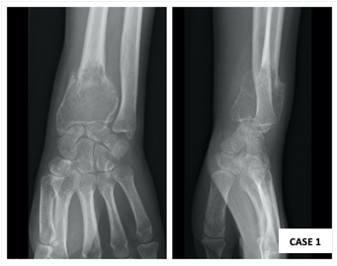
Figure 1 – Anteroposterior (AP) and lateral radiographs revealing pathological fracture after minor trauma.

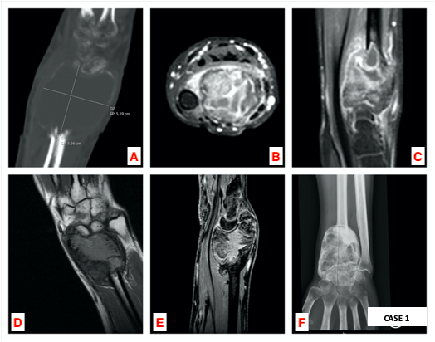
Figure 2 – a) Sagittal computed tomography (CT scan); b-c) axial and sagittal magnetic resonance imaging (MRI) on initial imaging evaluation of the left wrist; d-e) Coronal and sagittal MRI; f) AP radiograph after one year of denosumab therapy.
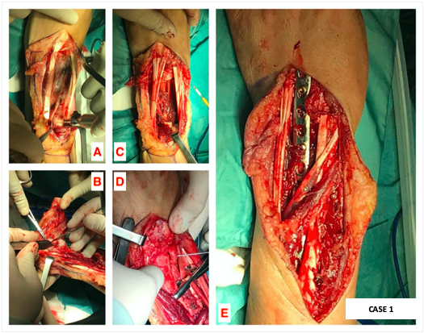
Figure 3 – a-b) Dorsal approach of the left wrist: 8 centimeters distal radius osteotomy and en-bloc resection; c-d) after lunate removal and osteotomy of the distal ulna, translocation of the ulnar fragment; e) wrist arthrodesis using a 3.5 mm locking compression plate (LCP).
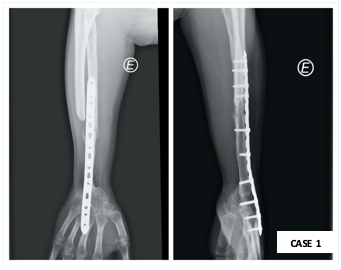
Figure 4 –AP and lateral radiographs show signs of union, without local recurrence, at one year of follow-up.
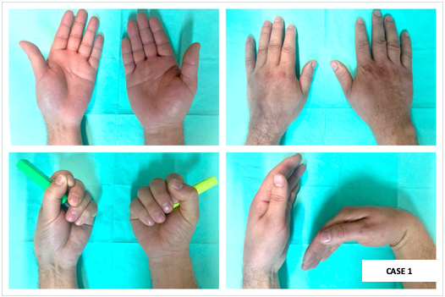
Figure 5 – Postoperative clinical evaluation of the left operated wrist at one year of follow-up, compared with the contralateral side.

CASE 2
A 25-year-old right hand-dominant female presented with right wrist pain over an enlarging mass for one year. The patient reported a gradual increase in size over the last two months. On physical examination, the dorsal distal radius was tender and wrist motion was painful. The X-ray and CT scan revealed an expanded osteolytic lesion. MRI detected a huge osteolytic lesion and soft tissue extension with 4 x 3,3 x 2,3 cm, compatible with a Campanacci grade III GCTB (Figure 6). Staging imaging revealed no other lesions. The histology report of the imaging-guided core biopsy showed a GCTB. After one year of with denosumab therapy (120mg SC per 28 days, during 12 months) (Figure 6) the patient underwent the same surgery as Case 1. A 6 cm dorsal en-bloc resection of the distal radius and wrist arthrodesis with a 3.5 mm LCP plate were performed (Figure 7). There were no major complications related to the procedure. Histological report confirmed complete resection with free margins. An above-elbow cast was applied for three weeks, after which a below-elbow was used for two more weeks. After two months she had a full SN/PN. After six months the patient was able to perform the daily activities without restrictions (Figure 8). At six months the MSTS score was 24 (compared to the pre-operative value of 19), the mean handgrip strength value for the operated side was 33,1 lbs compared to 49,8 lbs for the non-operated side, and scored 27,3 in Quick-DASH questionnaire (the same value as in the pre-operative assessment). At one year of follow-up the patient has no clinical or imaging signs of local recurrence (Figure 9). The patient is pain free.
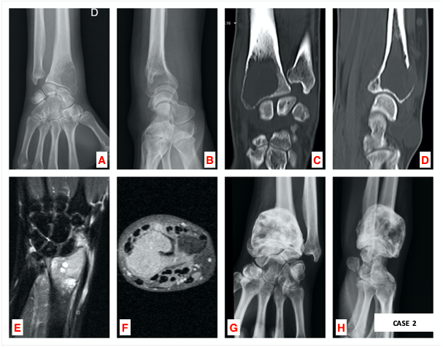
Figure 6 – a-b) AP and lateral radiographs, coronal and sagittal CT scans (c-d) and coronal and axial MRI (e-f) of the right wrist during primary imaging evaluation; g-h) Pre-operative radiographs of the distal right wrist after one year of denosumab therapy.

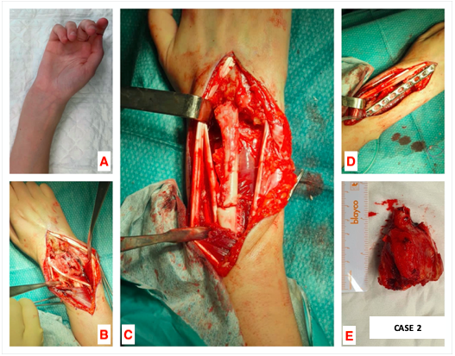
Figure 7 – Cosmetic appearance of the distal right wrist before surgery (a) and dorsal approach (b); translocation of the distal ulna after distal radius osteotomy (c) and dorsal wrist arthrodesis with a 3.5 mm LCP plate (d); en-bloc resection of 6 cm distal radius (e).

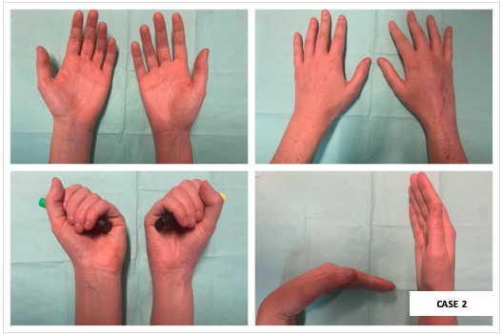
Figure 8 – Postoperative clinical evaluation of the right wrist at one year of follow-up, compared with the contralateral side.
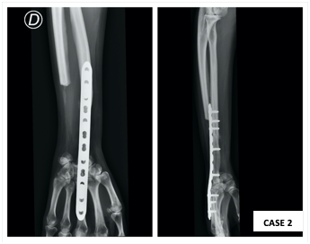
Figure 9 – There is no clinical or imaging signs of local recurrence. AP and lateral radiographs at one year of follow-up.

DISCUSSION
GCTB of the distal radius is the third most common site of this relative rare neoplasm, corresponding to 10%.^{2,4-7,17,18} Despite its benign label, distal radius is the most common primary site responsible for metastases and high focus on ruling out pulmonary metastasis is mandatory in the pre-operative assessment.^{9,10,12,19}
In well-marginated cortical borders, curettage with bone grafting/cement packing is acceptable despite the recurrence rates up to 50%.^{4,5,7,17,19} Campanacci grade, pathological fractures, tumor site and adjuvant therapy are recognized predictors of local recurrence.^{1,19} Studies have correlated the incidence of metastases with aggressive growth and local recurrence.^{20,21}
The treatment of the rare Campanacci III lesions is a much more arduous task. To avoid recurrence a wide resection should be performed, and surgeons should consider reconstructive options that preserve wrist function. The en-bloc resection is widely acceptable in expansive lesions, recurrent tumors and when the articular surface is largely damaged or collapsed.^{17,18,22} Due to the proximity with other bones (ulna and carpal bones) and other soft tissue structures, intralesional excisions, even when adjuvant therapies are used, have poor local control when compared to en-bloc resection.^{1,2} Reconstruction of the wrist by ulnar translocation after total resection was first described in 1982 by Seradge^{5,6,19,22} and several techniques to fixate the transposed ulna were described: Steinmann pins, T-shape plates, dynamic compression plates, clover leaf plates and K-wires.¹⁹ The ipsilateral ulnar translocation technique is a surgical procedure that avoids donor site morbidity and allows an adequate muscular cover with improved vascularity.^{5,7,9,17} Furthermore, the option of a single bone in the forearm avoids the complication of ulnar variants when other reconstruction techniques – fibular, iliac crest, allografts – are considered.⁶ Comparing all the fixation methods of the translocated ulna, Chobpenthai et al.¹⁹ concluded that distal radius plate technique is the less traumatic and achieves the best functional and cosmetic results.
Despite the flaws pointed out to this technique (poor vascularity, proximal and distal nonunion and lack of motion), arthrodesis result in less post-operative pain and good to excellent results in grip strength.^{15,19} The most accepted wrist position after fusion is 10º dorsiflexion and 5-10º ulnar deviation.⁹
Another possibility for reconstruction could be a custom-made mega prosthesis to preserve some motion in the sagittal e coronal planes. However, the literature is scarce and these patients were too young and with some functional demand, so the arthroplasty would be quickly condemned to fail.²³
Not less important, a great ally on dissection and resection is denosumab used as neoajuvant therapy. The massive cortical destruction and friable nature of GCTB benefit from this chemotherapeutic agent in reducing pain and suppressing the tumor.^{1,10}
In conclusion, treatment of Campanacci grade III GCTB of the distal radius remains a challenge, however neoadjuvant denosumab therapy and tumor en-bloc resection have good prognosis. The reported cases show a good functional and oncological outcome and patients are satisfied.

DECLARATIONS
Acknowledgments
Work performed at Orthopaedics Department of Centro Hospitalar e Universitário do Porto, Porto, Portugal.

REFERENCES

1. Zou C, Lin T, Wang B, Zhao Z, Li B, Xie X, Huang G, Yin J, Shen J. Managements of giant cell tumor within the distal radius: A retrospective study of 58 cases from a single center. J Bone Oncol 2019:14:100211

2. Liu Y, Li K, Sun B. Which Treatment is the Best for Giant Cell Tumors of the Distal Radius? A Meta-analysis. Clin Orthop Relat Res 2012;470:2886-2894

3. Sánchez-Torres LJ, de la Parra-Márquez ML, Cruz-Escalante AM, Ramírez-Barroso R, Espinoza-Velazco A. Microsurgical reconstruction in limb salvage due to a giant cell tumor of the distal radius. Case report. Acta Orthop Mex 2017;31(2):98-102

4. Wang Y, Lu M, Zhou Y, Wang J, Zhang Y, Yu X, Tang F, Luo Y, Duan H, Tu C. The functional outcomes and complications of different reconstruction methods for Giant cell tumor of the distal radius: comparison of Osteoarticular allograft and three-dimensional-printed prosthesis. BMC Musculoskelet Disord 2020;21:69

5. Salunke AA, Shah J, Warikoo V, Chakraborty A, Pokharkar H, Chen Y, Pruthi M, Pandit J. Giant cell tumor of distal radius treated with ulnar translocation and wrist arthrodesis: What are the functional outcomes? Orthop Surg 2017; 25(1): 1-6

6. Puri A, Gulia A, Agarwal MG, Reddy K. Ulnar translocation after excision of a Campanacci grade-3 giant -cell tumour of the distal radius. An effective method of reconstruction. J Bone Joint Surg 2010;92-B:875-879

7. Ververidis AN, Drosos GI, Tilkeridis KE, Kazakos KI. Carpus translocation into the ipsilateral ulna for distal radius recurrence giant cell tumour: A case report and literature review. J Orthop 2015;12:S125-S129

8. Xu L, Jin J, Hu A, Xiong J, Wang D, Sun Q, Wang S. Soft tissue recurrence of giant cell tumor of the bone: Prevalence and radiographic features. J Bone Oncol 2017;9:10-14

9. Vyas A, Patni P, Saini N, Sharma R, Arora V, Gupta SP. Retrospective Analysis of Giant Cell Tumor Lower End Radius Treated with En bloc Excision and Translocation of Ulna. Indian J Orthop 2018;52:10-14

10. Handel AC, Galvez MG, Brogan DM, Boyer MI, Cipriano CA, Hirbe AC, Pet MA. Vascularized Ulnar Transposition and Radioulnoscapholunate Fusion With Volar Locking Plate in a Dorsal Position Following Resection of Giant Cell Tumor of the Distal Radius. Tech Hand Up Extrem Surg 2020;24(3):142-150

11. Lieberman JR, ed. AAOS Comprehensive Orthopaedic Review. Wolters Kluwer 2020; 3rd ed.

12. Chalidis BE, Dimitrou CG. Modified Ulnar Translocation Technique For the Reconstruction of Giant Cell Tumor of the Distal Radius: Case Report and Literature Review. Orthopedics 2008;31(6):1-4

13. Palacios AO, Ambite JCM, Zbigniew. Giant Cell Tumors on the Fourth Metacarpal: about a case. Rev Iberam Cir Mano 2018;46:40-45

14. Cheng C, Shih H, Hsu K, Hsu RW. Treatment of Giant Cell Tumor of the Distal Radius. Clin Orthop 2000;383:221-228

15. Zhang J, Li Y, Li D, Xia J, Li S, Yu S, Liao Y, Li X, Li H, Yang Z. Clinical effects of three surgical approaches for a giant cell tumor of the distal radius and ulna. Mol Clin Oncol 2016; 5:613-617

16. Saikia KC, Bhattacharyya TD, Bhuyan SK, Bordoloi B, Durgia B, Ahmed F. Local recurrences after curettage and cementing in long bone giant cell tumor. Indian J Orthop 2011;45(2):168-173

17. Meena DK, Thalanki S, Sharma SB. Wrist fusion through centralization of the ulna for recurrent giant cell tumour of the distal radius. Orthop Surg 2016;24(1):84-87

18. Saini R, Bali K, Bachhal V, Mootha AK, Dhillon MS, Gill SS. En bloc excision and autogenous fibular reconstruction for aggressive giant cell tumor of distal radius: a report of 12 cases and review of literature. J Orthop Surg Res 2011;6:14

19. Chobpenthai T, Thanindratarn P, Phorkhar T, Ingviya T. The reconstruction after en-bloc resection of giant cell tumors at the distal radius: A systematic review and meta-analysis of the ulnar transposition reconstruction technique. Surg Oncol 2020;34:147-153

20. Bertoni F, Present D, Sudanese A, Baldini N, Bacchini P, Campanacci M. Giant-cell tumor of bone with pulmonary metastases. Six case reports and a review of the literature. Clin Orthop Relat Res1988;237(2):275–85

21. Siebenrock KA, Unni KK, Rock MG. Giant-cell tumour of bone metastasising to the lungs. A long-term follow-up. J Bone Joint Surg Br 1998;80(1):43–7

22. McLean JM, Clayer M, Stevenson AW, Samson AJ. A Modified Ulnar Translocation Reconstruction Technique for Campanacci Grade 3 Giant Cell Tumors of the Distal Radius Using a Clover Leaf Plate. Tech Hand Up Extrem Surg 2014;18(3):135-142

23. Hariri A, Facca S, Di Marco A, Liverneaux P. Massive wrist prosthesis for giant cell tumour of the distal radius: a case report with a 3-year follow-up. Orthop Traumatol Surg Res 2013;99(5):635-8

