Figures
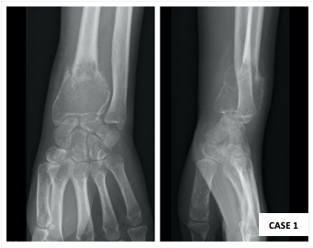
Figure 1 – Anteroposterior (AP) and lateral radiographs revealing pathological fracture after minor trauma.

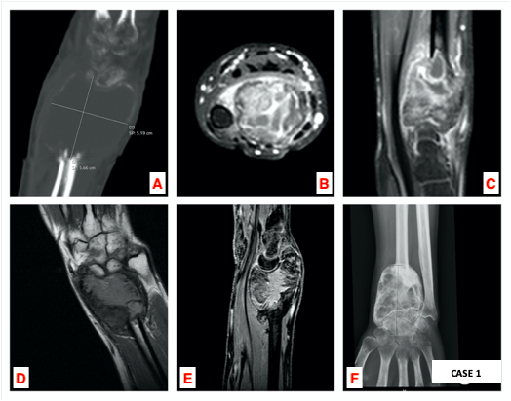
Figure 2 – a) Sagittal computed tomography (CT scan); b-c) axial and sagittal magnetic resonance imaging (MRI) on initial imaging evaluation of the left wrist; d-e) Coronal and sagittal MRI; f) AP radiograph after one year of denosumab therapy.

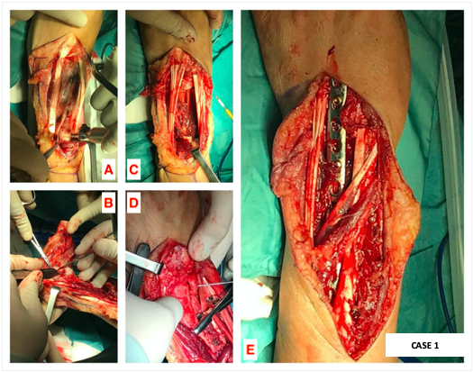
Figure 3 – a-b) Dorsal approach of the left wrist: 8 centimeters distal radius osteotomy and en-bloc resection; c-d) after lunate removal and osteotomy of the distal ulna, translocation of the ulnar fragment; e) wrist arthrodesis using a 3.5 mm locking compression plate (LCP).

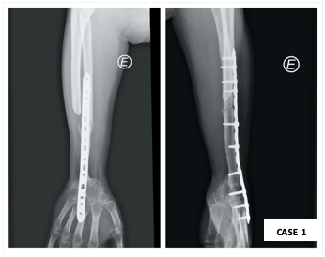
Figure 4 –AP and lateral radiographs show signs of union, without local recurrence, at one year of follow-up.

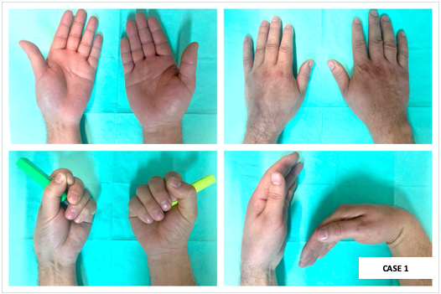
Figure 5 – Postoperative clinical evaluation of the left operated wrist at one year of follow-up, compared with the contralateral side.

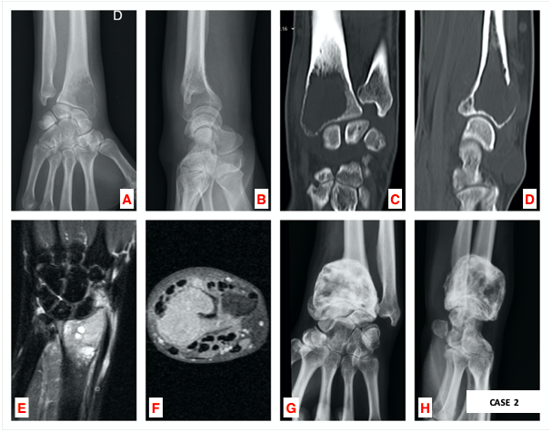

Figure 6 – a-b) AP and lateral radiographs, coronal and sagittal CT scans (c-d) and coronal and axial MRI (e-f) of the right wrist during primary imaging evaluation; g-h) Pre-operative radiographs of the distal right wrist after one year of denosumab therapy.

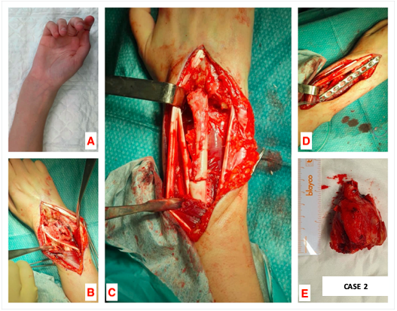

Figure 7 – Cosmetic appearance of the distal right wrist before surgery (a) and dorsal approach (b); translocation of the distal ulna after distal radius osteotomy (c) and dorsal wrist arthrodesis with a 3.5 mm LCP plate (d); en-bloc resection of 6 cm distal radius (e).

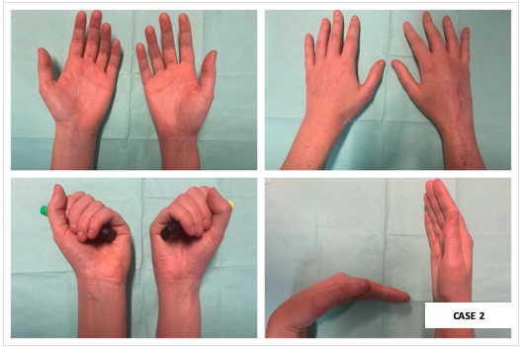
Figure 8 – Postoperative clinical evaluation of the right wrist at one year of follow-up, compared with the contralateral side.

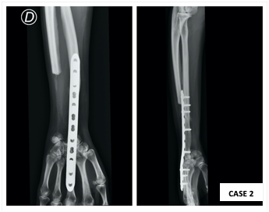
Figure 9 – There is no clinical or imaging signs of local recurrence. AP and lateral radiographs at one year of follow-up.

