SPONTANEOUS PNEUMOMEDIASTINUM WITH SUBCUTANEOUS EMPHYSEMA IN A COVID-19 PATIENT

Mohamed Hajri*, Mehdi Mbarek, Hafedh Mestiri, Rached Bayar.

Department of General Surgery, Mongi Slim University Hospital, La Marsa, Tunis, Tunisia.
*Corresponding author: Mohamed Hajri; 26, Rue Essamaouel, Mutuelle Ville, Tunis, Tunisia. Email : hajrimed2013@gmail.com.

A 39-year-old man presented to the emergency room with complaints of fever, shortness of breath and pronounced dry cough for 1 week. He had no history of chronic obstructive pulmonary disease and asthma. He denied tobacco, alcohol or drug use. On physical examination, he was conscious, febrile (temperature: 38.4 °C), with a pulse rate of 105 beats/min and blood pressure of 130/80 mm Hg. His respiratory rate was 28 breaths/min and his oxygen saturation was 87 % on room air, improving to 96% on 8L/min oxygen via a non-rebreathing mask. He also had palpable crepitus around the neck and the upper thoracic region. Chest auscultation revealed bilateral rhonchi and fine crackles. Reverse transcription (RT)-PCR analysis of COVID-19 was positive. Blood investigations revealed a normal white blood cell count of 7.45 × 10⁹ /L (normal range, 3.50–9.50 × 10⁹ /L), elevated blood levels for C-reactive protein (76 mg/L; normal range, 0–10 mg/L) and normal kidney and liver tests. He was started on methylprednisolone, prophylactic enoxaparin and vitamins, and remained stable on non-invasive supplemental oxygen. Chest computed tomography showed typical findings of COVID-19 pneumonia, affecting 60% of lung parenchyma. CT scan was also remarkable for severe pneumomediastinum with extensive subcutaneous emphysema extending into the neck, the thorax and the upper limbs. There was no evidence of pneumothorax (Fig. 1). An esophageal rupture was ruled out by esophagram. As the vital signs were stable, the patient was treated conservatively. During the hospital stay, his respiratory status progressively improved and his oxygen requirements gradually decreased, maintaining oxygen saturation > 96%. A repeat CT scan was performed at day 7 and showed significant regression of the pneumomediastinum (Fig. 2). He was discharged home on 13th day of admission.
Spontaneous pneumomediastinum (SPM) is an uncommon clinical occurrence which is usually caused by medical conditions such as chronic obstructive pulmonary disease, asthma and pulmonary infections [1]. It has been reported as single cases in COVID-19 patients since the pandemic started. While most of the cases were managed conservatively, it can be life-threatening and does require close monitoring. The underlying mechanism of SPM in COVID-19 patients may relate to increased alveolar pressure and extensive alveolar membrane damage causing alveolar rupture. This rupture might lead to air dissection along the bronchovascular sheaths, causing pulmonary interstitial emphysema that spreads toward the mediastinum [2]. Although our patient had no history of chronic lung disease and had never required mechanical ventilation during his hospital stay, his pronounced cough would have been a major factor in the occurrence of SPM. Through this case, we aim to highlight that pneumomediastinum in COVID-19 patients could be a possible indicator of worsening disease and should be monitored carefully, although our patient had a favorable course.

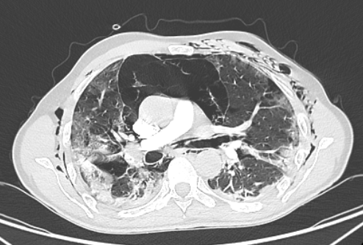
Fig. 1: Chest CT scan showing severe pneumomediastinum with extensive subcutaneous emphysema, typical findings of COVID-19 pneumonia.
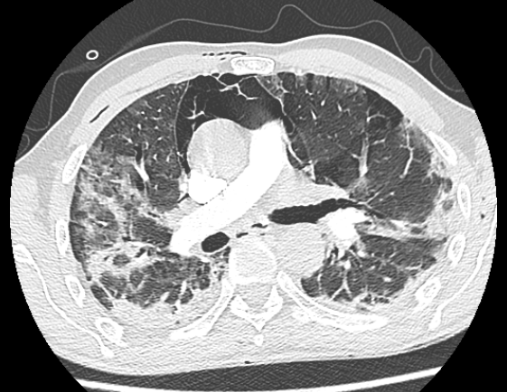
Fig. 2: Repeat chest CT scan showing significant regression of the pneumomediastinum.

References:
[1] Sahni S, Verma S, Grullon J, et al. Spontaneous pneumomediastinum: time for consensus. North Am J Med Sci 2013; 5: 460.
[2] Machiraju PK, Alex NM, Safinaaz, et al. Pneumomediastinum in COVID-19: A series of three cases and review of literature. SAGE Open Med Case Rep 2021; 9: 2050313X211011807.

