SPONTANEOUS PNEUMOMEDIASTINUM WITH SUBCUTANEOUS EMPHYSEMA IN A COVID-19 PATIENT

Mohamed Hajri*, Mehdi Mbarek, Hafedh Mestiri, Rached Bayar.

Department of General Surgery, Mongi Slim University Hospital, La Marsa, Tunis, Tunisia.
*Correspondence to: Dr. Mohamed Hajri; Department of General Surgery, Mongi Slim University Hospital, La Marsa. 26, Rue Essamaouel, Mutuelle Ville, 1082, Tunis, Tunisia. E-mail : hajrimed2013@gmail.com.

Abstract
A 39-year-old man presented to the emergency room with complaints of fever, shortness of breath and pronounced dry cough for 1 week. On physical examination, his respiratory rate was 28 breaths/min and his oxygen saturation was 87 % on room air, improving to 96% on 8L/min oxygen via a non-rebreathing mask. He also had palpable crepitus around the neck and the upper thoracic region. Reverse transcription (RT)-PCR analysis of COVID-19 was positive. Chest computed tomography showed typical findings of COVID-19 pneumonia, affecting 60% of lung parenchyma. CT scan was also remarkable for severe pneumomediastinum with extensive subcutaneous emphysema extending into the neck, the thorax and the upper limbs. There was no evidence of pneumothorax. An esophageal rupture was ruled out by esophagram. During the hospital stay, his respiratory status progressively improved and his oxygen requirements gradually decreased, maintaining oxygen saturation > 96%. A repeat CT scan was performed at day 7 and showed significant regression of the pneumomediastinum. He was discharged home on 13th day of admission.
Keywords: Pneumomediastinum, emphysema, COVID-19.

INTRODUCTION
Since it’s discovery in late 2019, Coronavirus disease (COVID-19) has emerged worldwide and become a major global health problem. It primarily involves the respiratory system. Pneumomediastinum is a known complication in COVID 19 [1]. It is mostly observed in mechanically ventilated patients [2]. Herein, we report a rare case of spontaneous pneumomediastinum with subcutaneous emphysema in a non-intubated COVID-19 patient.
CASE REPORT
A 39-year-old man presented to the emergency department with complaints of fever, myalgia, shortness of breath and pronounced dry cough for 1 week. He had no history of chronic obstructive pulmonary disease and asthma. He denied alcohol consumption and tobacco or drug use. On examination, he was conscious, febrile (temperature: 38.4 °C), with a pulse rate of 105 beats/min and blood pressure of 130/80 mm Hg. Respiratory rate was 26 breaths/min and oxygen saturation was 87 % on room air, improving to 95% on 8L/min oxygen via a non-rebreathing mask. He also had palpable crepitus around the neck and the upper thoracic region. Chest auscultation revealed bilateral rhonchi and fine crackles. Nasopharyngeal RT-PCR analysis was positive for SARS-CoV-2 infection. Blood investigations revealed a normal white blood cell count of 7.45 × 10⁹ /L (normal range, 3.50–9.50 × 10⁹ /L), elevated blood levels for C-reactive protein (76 mg/L; normal range, 0–10 mg/L) and normal kidney and liver tests. He was started on methylprednisolone, prophylactic enoxaparin and vitamins, and remained stable on non-invasive supplemental oxygen. Chest computed tomography showed typical findings of COVID-19 pneumonia, affecting 60% of lung parenchyma. CT scan was also remarkable for severe pneumomediastinum with extensive subcutaneous emphysema extending into the neck, the thorax and the upper limbs. There was no evidence of pneumothorax (Figure 1). An esophageal rupture was ruled out by esophagram. As the vital signs were stable, the patient was treated conservatively. During the hospital stay, his respiratory status progressively improved and his oxygen requirements gradually decreased, maintaining oxygen saturation > 96%. A repeat CT scan was performed at day 7 and showed significant regression of the pneumomediastinum (Figure 2). He was discharged home on 13th day of admission.

Figure 1. Chest CT scan showing severe pneumomediastinum with extensive subcutaneous emphysema, typical findings of COVID-19 pneumonia.
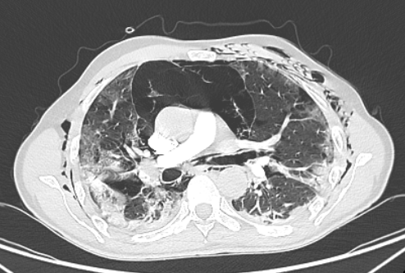
Figure 2. Repeat chest CT scan showing significant regression of the pneumomediastinum.
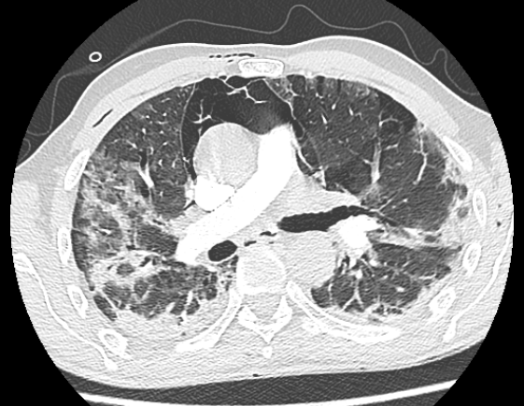

DISCUSSION
Spontaneous pneumomediastinum (SPM) is an uncommon clinical occurrence which is usually caused by medical conditions such as chronic obstructive pulmonary disease, asthma and pulmonary infections [3]. It has been reported as single cases in COVID-19 patients since the pandemic started [4]. While most of the cases were managed conservatively, it can be life-threatening and does require close monitoring [5, 6]. The underlying mechanism of SPM in COVID-19 patients may relate to increased alveolar pressure and extensive alveolar membrane damage causing alveolar rupture [7]. This rupture might lead to air dissection along the bronchovascular sheaths, causing pulmonary interstitial emphysema that spreads toward the mediastinum [8]. Although our patient had no history of chronic lung disease and had never required mechanical ventilation during his hospital stay, his pronounced cough would have been a major factor in the occurrence of SPM. Through this case, we aim to highlight that pneumomediastinum in COVID-19 patients could be a possible indicator of worsening disease and should be monitored carefully, although our patient had a favorable course.

DECLARATIONS
Authors’ contributions
Manuscript writing and data collection: Hajri M, Mbarek M.
Data interpretation and critical revision: Mestiri H, Bayar R.
Availability of Data and Materials
All available data are reported in the present manuscript.
Financial support and sponsorship
None.
Conflicts of interest
All authors declared that there are no conflicts of interest.
Ethical approval and consent to participate
Not applicable.
Consent for publication
Informed consent was obtained for publication of this case and accompanying images.

REFERENCES
[1] Palumbo D, Campochiaro C, Belletti A, et al. Pneumothorax/pneumomediastinum in non-intubated COVID-19 patients: differences between first and second Italian pandemic wave. Eur J Intern Med 2021; 88: 144–146.
[2] Belletti A, Palumbo D, Zangrillo A, et al. Predictors of pneumothorax/pneumomediastinum in mechanically ventilated COVID-19 patients. J Cardiothorac Vasc Anesth.
[3] Sahni S, Verma S, Grullon J, et al. Spontaneous pneumomediastinum: time for consensus. North Am J Med Sci 2013; 5: 460.
[4] Mohan V, Tauseen RA. Spontaneous pneumomediastinum in COVID-19. BMJ Case Rep CP 2020; 13: e236519.
[5] Kangas-Dick A, Gazivoda V, Ibrahim M, et al. Clinical characteristics and outcome of pneumomediastinum in patients with COVID-19 pneumonia. J Laparoendosc Adv Surg Tech 2021; 31: 273–278.
[6] Wang J, Su X, Zhang T, et al. Spontaneous pneumomediastinum: a probable unusual complication of coronavirus disease 2019 (COVID-19) pneumonia. Korean J Radiol 2020; 21: 627.
[7] Lei P, Mao J, Wang P. Spontaneous pneumomediastinum in a patient with coronavirus disease 2019 pneumonia and the possible underlying mechanism. Korean J Radiol 2020; 21: 929.
[8] Machiraju PK, Alex NM, Safinaaz, et al. Pneumomediastinum in COVID-19: A series of three cases and review of literature. SAGE Open Med Case Rep 2021; 9: 2050313X211011807.

