CLEAR CELL SARCOMA:
20 YEARS OF EXPERIENCE AT THE INSTITUTO NACIONAL DE ENFERMEDADES NEOPLÁSICAS

Martín Falla-Jimenez, MD*, Luis Aguilar-Villena, MD*, Lourdes Huanca-Amesquita, MD**, Mercedes Bravo-Taxa, MSc**, Victor Castro-Oliden, MD***, Juan Haro-Varas, MD***, Marco Velarde-Mendez, MD*, Julio Abugattas-Saba, PhD*, José Cotrina-Concha, MD*.

* Department of Breast Surgery and Soft Tissue, Instituto Nacional de Enfermedades Neoplásicas (INEN), Lima, Peru

** Department of Oncology Pathology, Instituto Nacional de Enfermedades Neoplásicas (INEN), Lima, Peru

*** Department of Medical Oncology, Instituto Nacional de Enfermedades Neoplásicas (INEN), Lima, Peru

CORRESPONDING AUTHOR:
Dr. Mercedes Bravo-Taxa
Postal address: Calle Las Dalias 351, La Molina, Lima 12, Perú
Telephone: +51 980701186
Workplace: National Institute of Neoplastic Diseases (INEN)
Address: Av. Angamos 2520, Surquillo, Lima 15038, Perú
Email: mercedes.bravo.t@upch.pe
ORCID: 0000-0002-6965-4841

ABSTRACT

Objectives: Clear cell sarcoma is a rare subtype of tumor with a propensity to metastasize regional lymph node and distant organs with a poor prognosis in the short and medium term. The objective of this study is to determine the frequency of lymph node involvement, the effectiveness of loco and regional treatment, the risk of recurrence and progression after surgery.
Methods: Twenty patients were analyzed. All those cases were confirmed with pathology and immunohistochemistry for clear cell sarcoma at our institute, who also received treatment between 1998 and 2018. Subsequenty, survival rates were determined according to local, regional and distant involvement, as well as the prognostic factors.
Results: Twenty patients were included: 11 men and 9 women with a mean age of 36 years. The mean tumor size was 6.87cm. and most of them were located in the extremities (85%). At onset, 4 patients had local disease, 10 had lymph node metastatic disease, and 6 had distant metastases. On the other hand, 9 patients had previous surgery in another institution, of which 4 cases were re-operated by our surgical department. A total of 11 patients were treated surgically at our institution: 8 cases had negative margins and 3 positive margins. Finally, a disease-free survival rate at 2 and 5 years was 20 and 5%, respectively.
Conclusions: The initial management of this entity is important for the prognosis of the disease, with surgery being the mainstay of treatment. A high rate of lymph node metastasis is observed, so regional lymph node dissection should be considered when possible. An important role in survival regarding the use of chemotherapeutic agents and/or the use of radiotherapy has not yet been demonstrated.

Key words: sarcoma, clear cell sarcoma, soft tissue tumors
INTRODUCTION
Clear cell sarcoma (CCS), formerly known as malignant melanoma of soft parts, is an unusual neoplasm of tendons and aponeuroses, which was first described by Enzinger in 1965¹ as a tumor with melanocytic differentiation, reason for its confusion with malignant melanoma². Nowadays, its histogenesis is still uncertain; however, thanks to advances in molecular analysis, it is known that CCSs has a translocation in the t(12;22) (q13;q12), which results in the chimeric EWSR1/ATF1 gene in 90% of cases, ending the previous association^{3,4}.
This neoplasm mainly affects young adults between 20 and 40 years of age and usually metastasizes to the regional lymphatic nodes and lungs⁵. Patients with metastatic disease have a poor prognosis, and those with lymph node involvement have an overall survival rate of 40% at 2 years^{6,7}. However, other literature reports 5-year overall survival rates of 40-68%^{6,8}.
The aim of the present study was to analyze the clinical characteristics of 20 patients, with pathology and immunohistochemistry confirmed for clear cell sarcoma in our institution and who also received treatment between 1998 and 2018. Subsequently, survival rates according to local, regional, and distant involvement, effectiveness of loco-regional surgical treatment, risk of recurrence and post-treatment disease progression were determined.

MATERIALS AND METHODS
Thirty-seven cases diagnosed as Clear Cell Sarcomas at the National Institute of Neoplastic Diseases (INEN), during the period 1998 and 2018, were analyzed. These were identified from the database of the statistics department of the institution. Data on affiliation, surgical procedure, pathology report, complications and follow-up were obtained from the medical records of the selected patients and were recorded in a predetermined collection format. Subsequently, the pathology slides were submitted for review by a medical oncologist pathologist with expertise in sarcomas, determining the exclusion of 17 cases, due to: incompatibility of the result (n=15) and loss of material for review (n=2).
Confirmation of the histologic diagnosis was performed by immunohistochemistry techniques (immunoreactivity for S-100 and HMB-45 protein markers). Other factors examined, given their prognostic significance were age (≤30 years, > 30 years), sex, lesion size (≤ 5cm, >5cm), lesion location (extremities, trunk and head), regional lymph node involvement and treatment.
The treatment received was multimodal, with surgery, chemotherapy, and radiotherapy, with wide local resection at beginning whenever possible, or amputation and disarticulation of the extremity. The status of the surgical margin was determined histologically and was classified as negative (without tumor cells in the stained margin) and positive (with tumor cells in the stained margin).
Patients with risk of local recurrence or positive surgical margins were treated with complementary radiotherapy. Additionally, those with nodal and distant metastatic disease received chemotherapy treatment.
Survival curves were estimated using the Kaplan-Meier method, and the overall survival rate was estimated at the second, fifth and tenth year. Numerical variables were analyzed using measures of central tendency and dispersion, while categorical variables were presented as proportions and absolute numbers; the information was analyzed in the IBM SPSS Statistics v. 25 statistical program.

RESULTS

The clinical characteristics at the first evaluation of the patients are as shown in Table 1.

Table 1: Clinical features at the first clinical assessment
 | All patients | Patients with localized tumor
N° | 20 | 4
Gender (M:F) | 11:9 | 1:3
Average age (range) | 36 years old (19-65) | 45 years (28-59)
Tumor size (range) | 6.87 cm (1-19.5) | 3.3 cm (1-5.5)
Time of illness at diagnosis (range) | 20 months (1-120) | 21 months (3-48)
Location of the lesion
Upper extremities | 7 | 3
Lower extremities | 10 | 1
Trunk | 2 | 0
Head | 1 | 0
Stage
Located | 4 | 4
Regional | 11 | 0
Remote | 5 | 0
Local recurrence
Yes | 6 | 0
No | 5 | 3*
*One case was not intervened

Of the twenty (N=20) patients identified with a diagnosis of clear cell sarcoma, the following clinical characteristics were determined: 11 were men and 9 were women, the mean age at presentation was 36 years, with a range between 19 and 65 years. The mean tumor size was 6.87 cm (range: 1cm-19.5cm). The mean time of disease at diagnosis was 20.20 months (range: 1 month-120 months). The most frequent location was the lower extremities (10 cases), followed by the upper extremities (7 cases), trunk (2 cases) and head and neck (1 case).
At time of diagnosis, 4 patients had local disease, 11 nodal metastatic disease, and 5 distant metastases.
In addition, 9 cases had surgery prior to admission to our institution, of which 3 presented positive margins and 3 negative margins. Another 3 cases had no report of the status of the margins in the anatomic-pathologic report. Finally, of the 9 cases operated on in other hospitals, 4 required reinterventions at INEN.
A total of 11 cases were treated surgically in our institution: 4 with wide local resection, 5 with wide local resection and regional lymph node dissection and 2 with amputation of the limb. The margins in these cases were: negative in 8 cases and 3 positives.
The overall survival rate was 10% at 2 years, 5% at 5 years and 5% at 10 years. (Table 2)

Table 2: Estimated cause-specific survival (CSS) in 2, 5 and 10 years
 | No. of patients | 2 years - SCE (%) | 5 years - SCE (%) | 10 years - SCE (%)
All patients | 20 | 10 | 5 | 5
Patients with localized tumor | 4 | 25 | 25 | 25
Patients with lymph node involvement | 11 | 9 | 0 | 0
Patients with distant metastases | 5 | 0 | 0 | 0

Patients with localized lesion
4 patients presented localized lesions at the time of diagnosis, 3 of which were treated surgically at our institute, 75% presented lesions smaller than 5 cm. In addition, 75% were positive for S-100 and HMB-45. On the other hand, the status of the margins of the 3 surgically treated cases: 2 presented negative and 1 positive margins. Subsequently, 3 patients were treated with adjuvant chemotherapy (QT) and/or radiotherapy (RT): combined therapy (adriamycin + RT or cyclophosphamide + RT) (n=2) and radiotherapy alone (n=1). The survival rate in this group was 25% at 2 years; the median survival time for the 3 cases was 12 months (range: 7 months-20 months). One of the 4 cases in this group presented negativity for both immunohistochemical markers, underwent wide local resection with negative margins and adjuvant treatment (adriamycin + RT), and continued with active controls, all without evidence of recurrence, until the end of the study.

Patients with lymph node involvement
Of the 20 cases that made up our population, 11 presented lymph node involvement at the time of diagnosis, with 63% of the lesions measuring more than 5 cm. Likewise, 100% were positive for S-100 and 60% for HMB-45. On the other hand, 8 cases underwent surgery and 7 had recurrence with a mean of 7 months after surgery. Only 2 cases were reoperated with amputation and emergency surgery, respectively. 6 patients received adjuvant treatment with chemotherapy (QT) and/or radiotherapy (RT); chemotherapeutic treatment was with dacarbazine (n=2), carboplatin (n=1) and interferon (n=1). Two patients received only RT, 2 others only QT and finally the other 2 received combined treatment (interferon + RT and Carboplatin + RT). The 2-year survival rate was 9%.

Patients with distant metastases
5 cases presented distant metastases at diagnosis, all of them with multiple presentations, mainly involving the lung (n=3), and with dimensions greater than 5 cm in 60% of them. Eighty percent of the cases were positive for S-100, while 60% were positive for HMB-45. None of these cases underwent surgery. However, 4 patients were treated with adjuvant chemotherapy (QT) and/or radiotherapy (RT). Dacarbazine (n=2), carboplatin (n=1) and combined therapy (dacarbazine +RT) (n=1) were administered. The survival rate in this group was 0% at 2 years; median survival time was 3 months (range: 0.8 months-7 months).

Table 3: Prognostic factors
 | Nª | 5 years - SCE (%) | P - value
Gender |  |  | 0,824
Male | 11 | 0
Female | 9 | 11
Age |  |  | 0,042
≤ 30 | 9 | 0
> 30 | 11 | 9
Tumor size in cm |  |  | 0,200
≤ 5 | 9 | 11
> 5 | 11 | 0
Location of the lesion |  |  | 0,013
Extremities | 17 | 6
Trunk and head | 3 | 0
Surgical technique* |  |  | 0,022
Wide local resection | 9 | 11
Amputation | 2 | 0
Surgical margins* |  |  | 0,212
Positives | 3 | 0
Negatives | 8 | 13
Local recurrence
Yes | 6 | 0
No | 5 | 0
*Operated in INEN
Local recurrence of the lesion
6 cases had recurrence, all of them with positive lymph node. Two of them were previously operated and 2 others were reoperated in our institution with limb amputation. On the other hand, 4 patients received treatment with chemotherapy and/or adjuvant radiotherapy: only one received dacabarzine, another one received combined therapy (interferon + RT), and 2 only radiotherapy. The median time to recurrence was 7.5 months (range: 2-19 months). The 2-year survival rate was 16%, with a median survival of 12 months.

DISCUSSION
Soft tissue sarcomas represent 1.2% of the cases reported annually in our institution⁹, and 0.4% correspond to clear cell sarcoma (CCS)¹⁰.

This entity was first described by Enzinger in 1965, where he presented clinical and epidemiological characteristics of 21 cases¹. In 1994, our institution carried out a review of 11 cases of CCS, which are not part of the group analyzed in the present publication¹¹. Currently, the most extensive study on CCS includes 175 cases¹².

Despite the lack of clarity of its histogenesis, the theory of the apparent origin in the migration of some cells from the neural crest to the developmental zone is accepted. Advances in molecular analysis have revealed the presence of the translocation t(12;22) (q13;q12), which results in the chimeric gene EWSR1/ATF1 in 90% of cases^{3,4,13,14,15}. However, this translocation is not specific to this entity since it is also detected in Angiomatoid Fibrohistiocytoma and in hyalinizing clear cell carcinoma of the salivary gland; therefore the results of its detection should be used within the appropriate¹⁴ clinical presentation and morphology. Also, six different types of EWS-ATF1 fusion genes have been found to be involved in this pathology⁵ and a less frequent translocation variant, t(12;22)(q32.3;q12) resulting in the EWSR1-CREB1 fusion¹³⁻¹⁵.

CCS tends to occur more frequently in young adult patients between 20 and 40 years and has a greater predilection for the female sex; in addition, it is located mainly in the extremities, deep in the fasciae, generating a slow and painless growth, so they are usually diagnosed as benign nodules, and resected with inadequate margins^{6,7,12,16,17}. Our study, in contrast to what is reported in the literature, found a higher percentage of involvement in male patients (55%), while the predominant location was the extremities (85%).

At INEN, Abugattas et al.¹¹ analized 11 cases of CCS, finding the most frequent location at foot or ankle (73% between both). They also described a mortality rate of 91% with a mean fllow-up pf 18.9 months.
According to its location, it has been described that survival decreases when the lesion is in the trunk⁶; however, since we only obtained 2 cases in this location, it was not significant for the global comparison.

Macroscopically, most of these tumors are small (<5 cm), but lesions larger than 10 cm have been described. CCS is solid, lobulated or multinodular, firm, grayish-white, intimately associated with tendons, fascia or aponeurosis¹³⁻¹⁵. Size has been considered a prognostic factor in this entity. A-Bing Li et al.¹² determined that a tumor size of less than 3 cm corresponded to a favorable prognostic factor, with a specific survival rate for this group of 86.2%, while for tumors larger than 3 cm it was 42.8%. Likewise, Kawai et al.¹⁶ described tumors larger than 5 cm had a poor prognosis and an increased incidence of local recurrence.

Histologically, the tumor shows a uniform arrangement in nests, bundles, and short fascicles of epithelioid (Figure A) to spindle-shaped (Figure B) cells, separated by dense fibro-collagenous bands (Figure C). The tumor cells show abundant cytoplasm that can be amphophilic to eosinophilic. The nuclei are vesicular with a large reddish central nucleolus. Scattered multinucleated giant cells (Figure D) and melanocytic pigment may also be seen. Pleomorphism and elevated mitotic activity are usually absent; features that can be seen in metastases and/or recurrences¹³⁻¹⁵.
Immunophenotypically, tumor cells show strong and diffuse expression of melanocytic markers such as S-100 protein, SOX10, HMB-45, Melan A and Microphthalmia Transcription Factor (MITF). They may also present variable expression for neuroectodermal markers such as neuronal specific enolase (NSE), synaptophysin and CD57¹³⁻¹⁵.

The main differential diagnosis is with malignant melanoma, since immunophenotypically they are indistinguishable. The clinical presentation (tumor of deep location in distal extremity), the absence of junctional component and the uniform cytomorphology are key for the diagnosis of CCS, but in some cases the use of molecular tests such as fluorescence in situ hybridization (FISH) or real-time polymerase chain reaction (RT-PCR) will be necessary for the detection of translocations associated with CCS¹³⁻¹⁵.

The gold standard treatment for localized CCS is surgical resection with wide margins, as these determine the patient’s prognosis^{2,611,12}. Huang J. et al.¹⁸ determined as poor prognostic factors a tumor size greater than 5 cm, the presence of positive margins, neutrophil-to-lymphocyte ratio (NLR) higher than 2.73, the platelet-to-lymphocyte ratio (PLR) higher than 103.89 and the lymphocyte-to-monocyte ratio (LMR) lower than 4.2.

Rosenthal et al¹⁹, performed a meta-analysis on the risk of lymph node involvement in different soft tissue sarcomas, finding that regional lymph node involvement in CCS is 18% (range: 4-50%), higher than the risk compared to the other histologic types. For this reason, he recommends for high-risk sarcomas (CCS, angiosarcoma and epithelioid sarcoma) clinical evaluation of regional lymph nodes by means of PET/CT or PET/MRI for staging, US of locoregional lymph node basins with biopsy of suspicious lymph nodes, and sentinel lymph node biopsy (SLNB).

Lewis JJ et al. concluded that mortality in extremity soft tissue sarcoma results from metastasis rather than local recurrence²⁰, which is consistent with the findings of our study, where survival rates in patients with distant metastases were 0%.
Other authors, such as Bianchi et al.⁶ report a 5-year survival rate of 56%, similar to that found by Hocar et al.²¹ with a 5-year survival rate of 59%.

Finally, Bianchi et al. suggest that follow-up should be by annual radiographic screening with chest CT, PET SCAN or plain radiography in the first 5 years⁶.

CONCLUSIONS
CCS is an entity where the initial management is crucial for the prognosis of the disease, with surgery being the mainstay of treatment.
The high rate of lymph node metastasis in this disease has been observed, so regional lymph node study should be considered to include lymph node dissection in the primary surgery when possible.
A significant role in survival has not yet been demonstrated with respect to the use of chemotherapeutic agents and/or use of RT.

AUTHOR’S CONTRIBUTIONS
Dr Falla, Aguilar, Huanca and Bravo analyzed the clinical data and drafted the manuscript. Dr Huanca provided the pathological results and provided professional guidance on this. Dr Falla, Dr. Castro, Dr. Haro and Dr. Velarde conducted follow-up on the patient in the outpatient clinic. Dr Abugattas and Dr Cotrina contributed to critical review and supervised the entire study. All the authors have read and approved the final version of this manuscript.

AVAILABILITY OF DATA AND MATERIALS
Not applicable.

CONFLICTS OF INTEREST
The authors state that there are no conflicts of interest with respect to the research, authorship and publication of this article.

FUNDING STATEMENT
This research did not receive any specific grant from funding agencies in the public, commercial, or not-for-profit sectors

BIBLIOGRAPHY

- Enzinger F. M. (1965). Clear-cell sarcoma of tendons and aponeuroses. An analysis of 21 cases. Cancer, 18, 1163–1174. https://doi.org/10.1002/1097-0142(196509)18:9<1163::aid-cncr2820180916>3.0.co;2-0
- Ibrahim, R. M., Steenstrup Jensen, S., & Juel, J. (2018). Clear cell sarcoma-A review. Journal of orthopaedics, 15(4), 963–966. https://doi.org/10.1016/j.jor.2018.08.039
- Yang, L., Chen, Y., Cui, T., Knösel, T., Zhang, Q., Geier, C., Katenkamp, D., & Petersen, I. (2012). Identification of biomarkers to distinguish clear cell sarcoma from malignant melanoma. Human pathology, 43(9), 1463–1470. https://doi.org/10.1016/j.humpath.2011.10.022
- Yoon, J. H., Baek, Y. S., Jeon, J., Oh, C. H., & Song, H. J. (2014). Dual-color, break-apart fluorescence in situ hybridization probe for distinguishing clear cell sarcoma of soft tissue from malignant melanoma. International journal of dermatology, 53(12), 1464–1467. https://doi.org/10.1111/j.1365-4632.2011.05009.x
- Dim, D. C., Cooley, L. D., & Miranda, R. N. (2007). Clear cell sarcoma of tendons and aponeuroses: a review. Archives of pathology & laboratory medicine, 131(1), 152–156. https://doi.org/10.5858/2007-131-152-CCSOTA
- Bianchi, G., Charoenlap, C., Cocchi, S., Rani, N., Campagnoni, S., Righi, A., Frisoni, T., & Donati, D. M. (2014). Clear cell sarcoma of soft tissue: a retrospective review and analysis of 31 cases treated at Istituto Ortopedico Rizzoli. European journal of surgical oncology: the journal of the European Society of Surgical Oncology and the British Association of Surgical Oncology, 40(5), 505–510. https://doi.org/10.1016/j.ejso.2014.01.016
- Clark, M. A., Johnson, M. B., Thway, K., Fisher, C., Thomas, J. M., & Hayes, A. J. (2008). Clear cell sarcoma (melanoma of soft parts): The Royal Marsden Hospital experience. European journal of surgical oncology: the journal of the European Society of Surgical Oncology and the British Association of Surgical Oncology, 34(7), 800–804. https://doi.org/10.1016/j.ejso.2007.10.006
- Hocar, O., Le Cesne, A., Berissi, S., Terrier, P., Bonvalot, S., Vanel, D., Auperin, A., Le Pechoux, C., Bui, B., Coindre, J. M., & Robert, C. (2012). Clear cell sarcoma (malignant melanoma) of soft parts: a clinicopathologic study of 52 cases. Dermatology research and practice, 2012, 984096. https://doi.org/10.1155/2012/984096
- E. Payet Meza, M. Ubillús Trujillo, M. Olivera Hurtado de Mendoza, et all (2016). Registro de cancer de Lima Metropolitana 2010-2012 Volumen 5. 173-175
- Chávez, M., Ziegler, G., Cotrina, J., Galarreta, J., de la Cruz, M., & Mantilla, R. (2019). Current situation of soft tissue sarcomas: Registry of a Latin American cancer institute. Situación actual de los sarcomas de partes blandas: registro de un instituto oncológico de Latinoamérica. Cirugia espanola, 97(4), 203–212. https://doi.org/10.1016/j.ciresp.2019.01.005
- Abugattas J, Garcia J, Cotrina M, et all (1994) Melanoma Maligno de Partes Blandas. Acta Cancerológica N°2.
- Li, A. B., Jiang, B. J., Wang, H. H., Yang, Y. S., Zhang, X. B., Lan, G. H., & Shu, W. B. (2019). Prognostic Factors for Survival in Patients with Clear Cell Sarcoma: An Analysis of the Surveillance, Epidemiology, and End Results (SEER) Database. Medical science monitor: international medical journal of experimental and clinical research, 25, 6950–6956. https://doi.org/10.12659/MSM.916705
- Antonescu C.R. Clear Cell Sarcoma of Soft Tissue. WHO Classification of Tumors of Soft Tissue and Bone.4ta Ed. Lyon: IARC; 2013:221-222
- Doyle L y Hornick J. Epithelioid and Epithelial-Like Tumors. Practical Soft Tissue Pathology. 2nd Ed. Philadelphia: Elsevier; 2019: 87-89.
- Goldblum J; Folpe A y Weiss S. Soft Tissue Tumors Showing Melanocytic Differentiation. Enzinger & Weiss Soft Tissue Tumors. 6ta Ed. Philadelphia: Elsevier; 2014: 880-916.
- Kawai, A., Hosono, A., Nakayama, R., Matsumine, A., Matsumoto, S., Ueda, T., Tsuchiya, H., Beppu, Y., Morioka, H., Yabe, H., & Japanese Musculoskeletal Oncology Group (2007). Clear cell sarcoma of tendons and aponeuroses: a study of 75 patients. Cancer, 109(1), 109–116. https://doi.org/10.1002/cncr.22380
- Blazer, D. G., 3rd, Lazar, A. J., Xing, Y., Askew, R. L., Feig, B. W., Pisters, P. W., Pollock, R. E., Lev, D., Hunt, K. K., & Cormier, J. N. (2009). Clinical outcomes of molecularly confirmed clear cell sarcoma from a single institution and in comparison with data from the Surveillance, Epidemiology, and End Results registry. Cancer, 115(13), 2971–2979. https://doi.org/10.1002/cncr.24322
- Huang, J., Luo, R. K., Du, M., Zeng, H. Y., Chen, L. L., & Ji, Y. (2015). Clear cell sarcoma of the pancreas: a case report and review of literature. International journal of clinical and experimental pathology, 8(2), 2171–2175. PMCID: PMC4396256.
- Rosenthal, J., Cardona, K., Sayyid, S.K. et al. Nodal metastases of soft tissue sarcomas: risk factors, imaging findings, and implications. Skeletal Radiol 49, 221–229 (2020). https://doi.org/10.1007/s00256-019-03299-6
- Lewis, J. J., Leung, D., Heslin, M., Woodruff, J. M., & Brennan, M. F. (1997). Association of local recurrence with subsequent survival in extremity soft tissue sarcoma. Journal of clinical oncology: official journal of the American Society of Clinical Oncology, 15(2), 646–652. https://doi.org/10.1200/JCO.1997.15.2.646
- Hocar O, Le Cesne A, Berissi S, et al. Clear cell sarcoma (malignant melanoma) of soft parts: a clinicopathologic study of 52 cases. Dermatol Res Pract. 2012;2012:984096. doi:10.1155/2012/984096

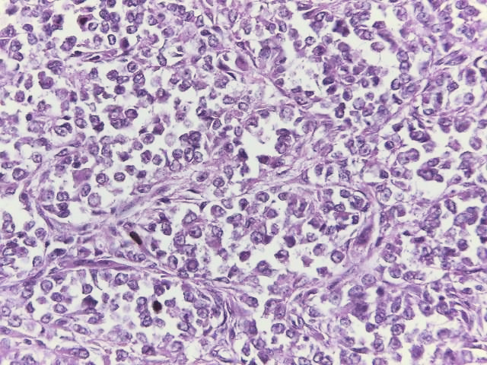
A

Figure A: The tumor shows short fascicles of epithelioid cells. (HE 400X)

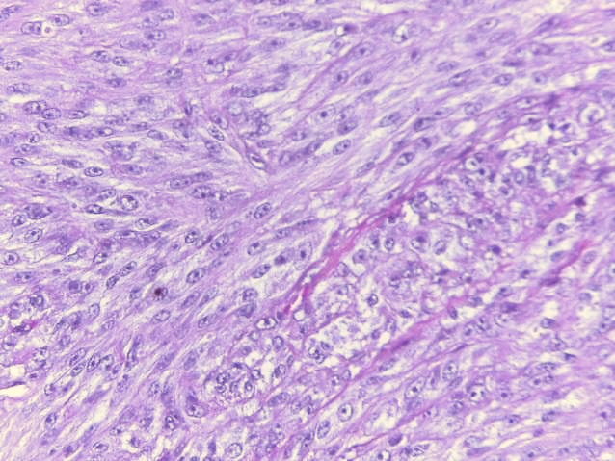
B

Figure B: The tumor shows spindle-shaped cells. (HE 400X)

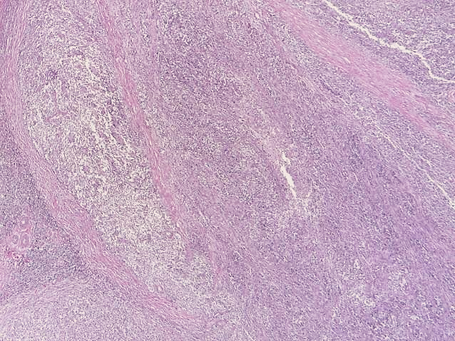
C

Figure C: Nests of tumor cells are separated by dense fibro-collagenous bands. (HE 100X)

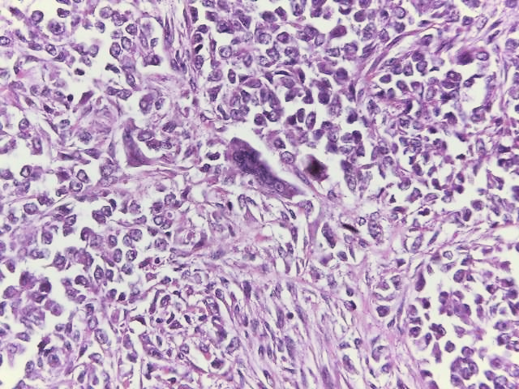
D

Figure D: Scattered multinucleated giant cells may be seen. (HE 400X)

