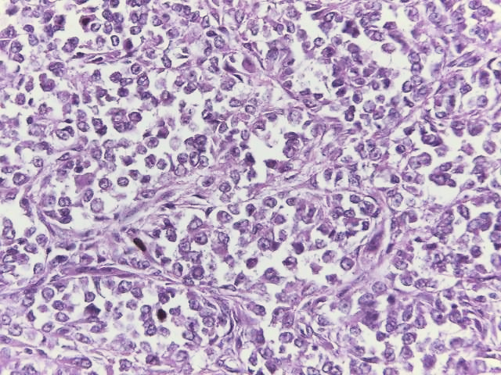

**A**

Figure A: The tumor shows short fascicles of epithelioid cells. (HE 400X)