Figure B: The tumor shows spindle-shaped cells. (HE 400X)

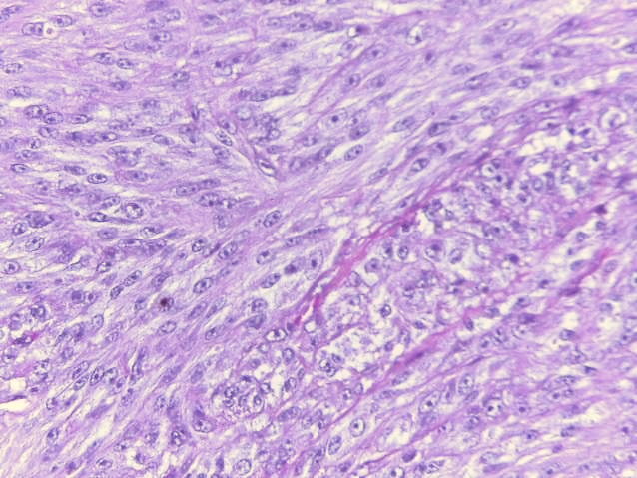

**B**