Figure C: Nests of tumor cells are separated by dense fibro-collagenous bands. (HE 100X)

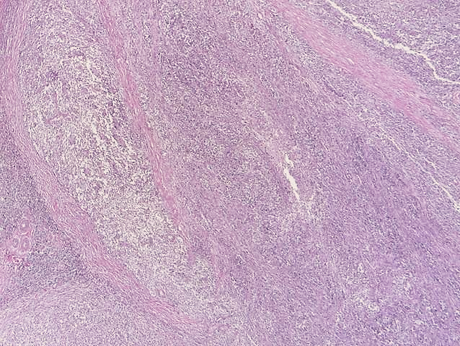

**C**