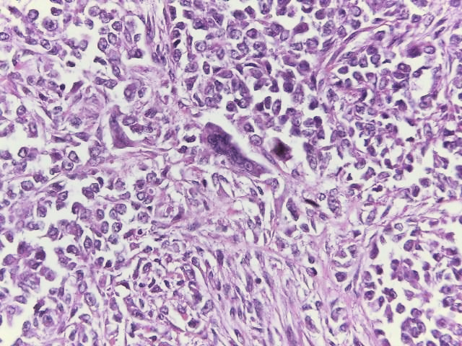

**D**

Figure D: Scattered multinucleated giant cells may be seen. (HE 400X)