Manuscript Title:

**CLEAR CELL SARCOMA: 20 YEARS OF EXPERIENCE AT THE INSTITUTO NACIONAL DE ENFERMEDADES NEOPLÁSICAS**

Author(s): (print all the names in full)

* **Martín Falla-Jimenez**
* **Luis Aguilar-Villena**
* **Lourdes Huanca-Amesquita**
* **Mercedes Bravo-Taxa**
* **Victor Castro-Oliden**
* **Juan Haro-Varas**
* **Marco Velarde-Mendez**
* **Julio Abugattas-Saba**
* **José Cotrina-Concha**

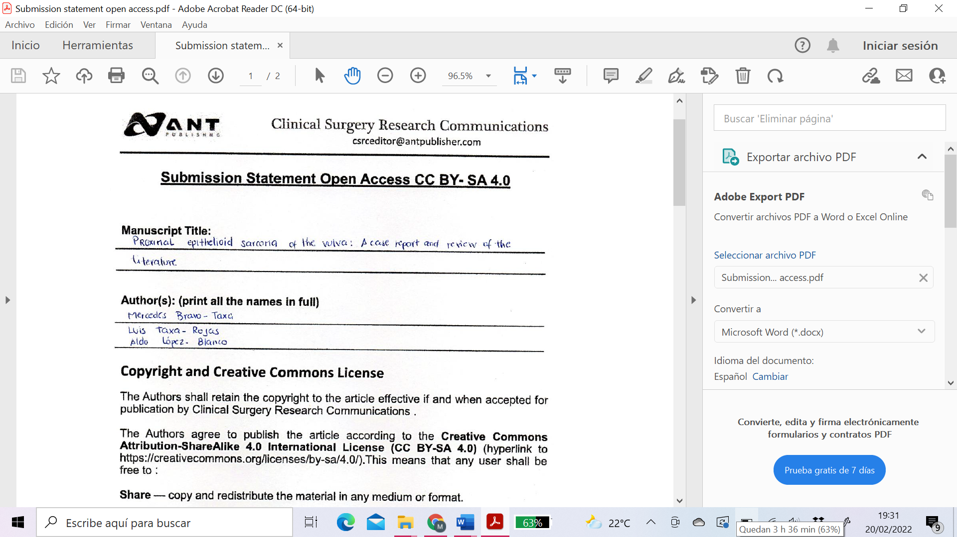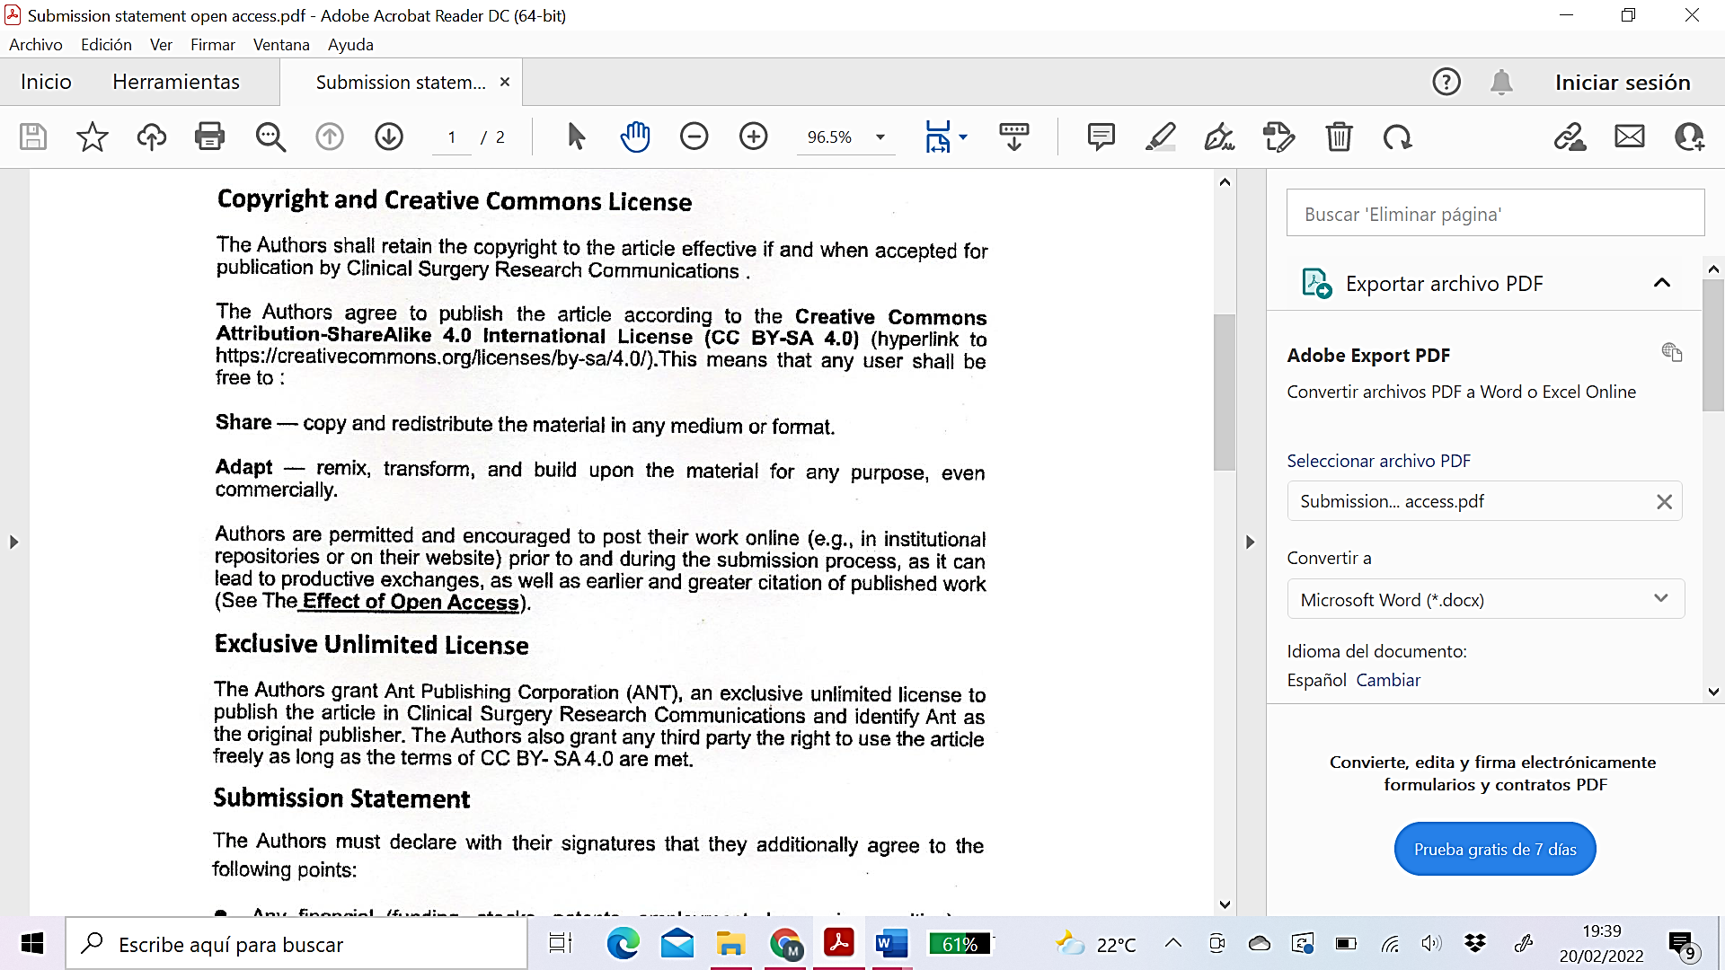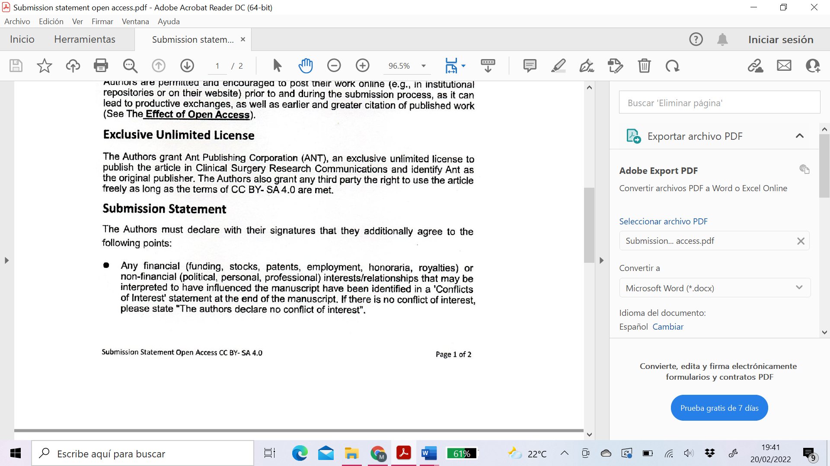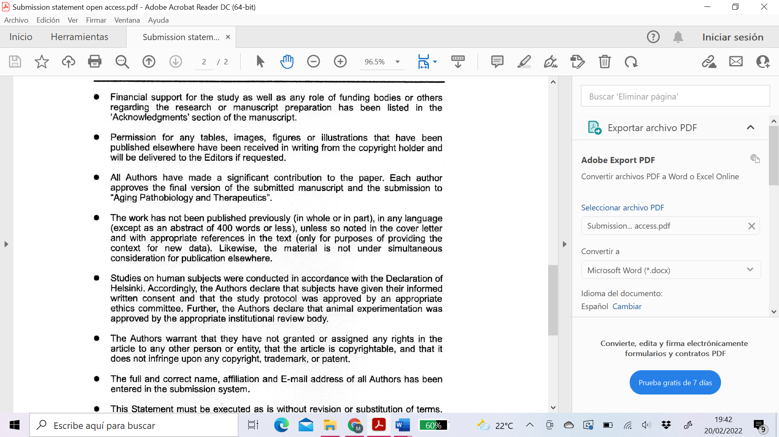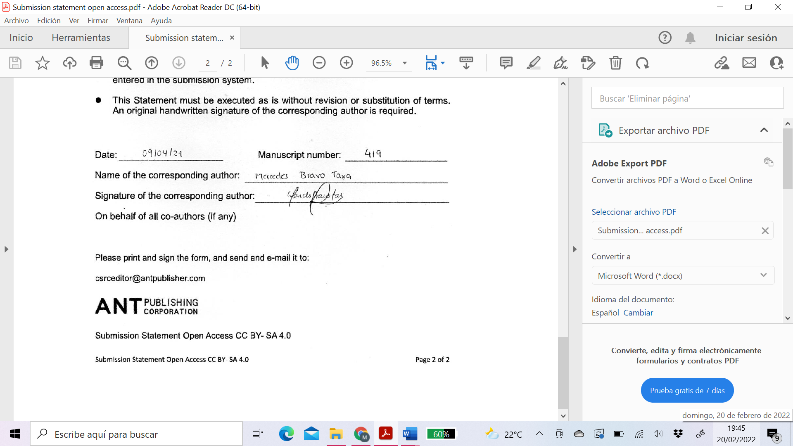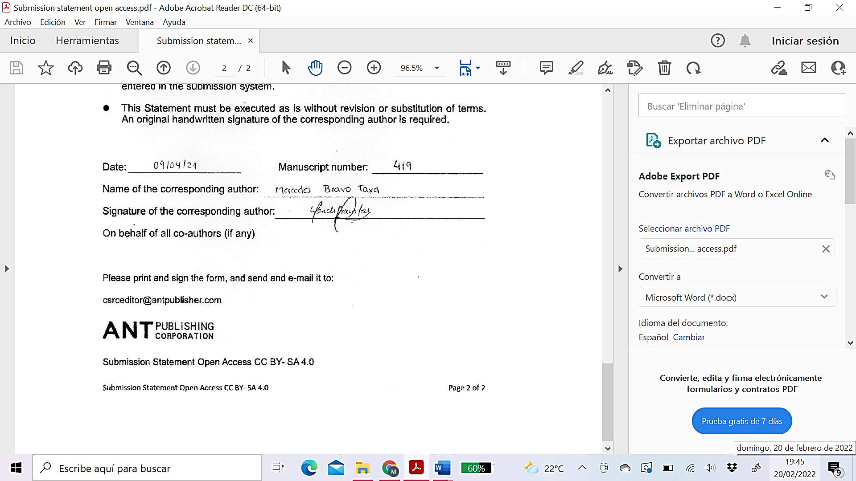

04/03/2022