Leucine Metabolite β-hydroxy-β-methylbutyrate (HMB) Supplementation on Muscle Mass during Resistance Training in Older Subjects- A Meta-analysis
Guang-Qin Zou, MD^{1 ,†}，Quan Wang, MD^{2 ,†}，Xiang Lu MD, PHD ^{2 ,*},Wei Gao, MD, PHD，^{2,*}
¹Department of Geriatrics, The Second Affiliated Hospital of Nanjing Medical University, Nanjing, China
²Department of Geriatrics, Sir Run Run Hospital, Nanjing Medical University, Nanjing, China
† these authors contributed equally to this work
*Correspondence to: Xiang Lu, MD, PhD, Department of Geriatrics, Sir Run Run Hospital, Nanjing Medical University, 211166, Nanjing, Jiangsu Province, China. Email: luxiang66@njmu.edu.cn.Wei Gao, MD, PhD, Department of Geriatrics, Sir Run Run Hospital, Nanjing Medical University, 211166, Nanjing, Jiangsu Province, China. Email: gaowei84@njmu.edu.cn.

Running Title: leucine Metabolite β-hydroxy-β-methylbutyrate (HMB) supplementation during resistance exercise training(RET) and muscle

Funding Sources
This work was supported by grants from the National Key Research and Development Plan of China (No. 2020YFC2008505 to Xiang Lu), the National Natural Science Foundation of China (No. 81970218 to Xiang Lu and No. 81970217 to Wei Gao), the Six Talent Peaks Project of Jiangsu Province (No. WSN‐ 175 to Wei Gao), and Jiangsu Geriatrics Society (JGS2019ZXYY06 to Xiang Lu).

graphics count: 4 tables and 8 figure

Abstract:
Background: Aging accompanied by loss of muscle mass, strength and function, may contribute to the development of frailty and fracture in older people. Inventions such as β-hydroxy-β-methylbutyrate (HMB)treatment and resistance exercise training (RET) have been well established alone in pro-researches to attenuate muscle loss. Nevertheless, there is no consensus whether combination of HMB intervention and RET could obtain an additional benefit to older population.
Objective: Our aim was to systematically and quantify whether HMB supplementation combined with RET could bring a synergistic effect in muscle mass, strength and function in older adults.
Methods：A systematic search was performed using the electronic databases MEDLINE, EMBASE, Cochrane library and Web of Science from inception to Oct 30,2021. The articles were all randomized controlled trials and met the inclusion and exclusion criteria. A fixed or randomized (if data were heterogeneous) effects meta-analysis was performed using the STATA.
Results：Total of the 256 articles screened ,8 studies matched our eligibility criteria which enrolled 333 subjects (≥65 years). Meta-analysis were conducted and the results showed no significant difference between groups in lean mass, fat mass, or physical performance. In the subgroup analysis regarding the differences of muscle strength between appendicular, HMB supplementation combined with RET contributed to improve muscle strength of the lower limbs significantly [n= 6, SMD 0.55, 95% confidence interval(CI),0.06 to 1.04].
Conclusion: Combination of HMB supplementation and RET in older people has an additional benefit for muscle strength especially in lower limbs, instead of muscle function and physical performance. Further studies are needed to demonstrate the mechanism.
KeyWords: β-hydroxy-β-methylbutyrate, HMB, muscle, resistance exercise training

Introduction
Age-related loss of muscle mass is an important clinical problem in old people followed by decreasing in muscle strength and function which leads to multiple adverse consequences including disability, frailty, morbidity, and mortality[1]. The prevalence of sarcopenia which charactered of muscle loss and disfunction reported by EWSDOP2 is up to 9.9%~40.4% in old adults[2]. It is estimated that the number of old people should be 2 billion by 2050. So, interventions that can ameliorate, or even prevent, loss of muscle mass and improve physical function are a key clinical priority.
The loss of muscle mass is mainly due to a dynamic imbalance between muscle protein synthesis (MPS) and muscle protein breakdown(MPB).It is well known that both resistance exercise and nutrition therapy are two promising ways to maintain the protein balance[3][4]. However, it is difficult for some elderly people to implement and persist resistance exercise particular during acute illness and disability. In addition, aiming to reduce the risk of sports injuries and falls, the elderly need professional guidance to carry out resistance training. On the other hand, nutritional supports including protein and amino acid supplements are considered to be safe and convenient, but the efficient depends on the appetite and digestive functions of the elderly. For this reason, investigating novel nutritional supplement programs more available and efficient such as amino acids and their metabolites are wanted.
β-Hydroxy-β-methylbutyrate (HMB) is a metabolite of the amino acid leucine, and its effects on skeletal muscle mass and strength have been investigated[5][6]. HMB is thought to be metabolized to β-Hydroxy-β-methylglutaryl -CoA, which participates cholesterol synthesis, and then provides material for muscle cell growth[7]. Also, HMB may enhance stability of cell membrane by undergoing polymerization. In clinical studies, the role of HMB combined with RET treatment has not yet reached consensus due to study-specific characteristics. Researchers have found both gains and no change in strength with HMB supplementation. Weather HMB supplementation combined with RET is effective than RET alone which focus on muscle mass, strength and function is unclear in older adults[8][9]
Hence, we conducted a meta-analysis to assess the influence of HMB supplementation combing with RET in older people on lean mass, body fat mass (FM), muscle strength, and muscle function.

Methods
Study inclusion/exclusion criteria
Studies that met the following criteria were eligible for inclusion according to the PICOS (Participant, Intervention, Control, Outcome Measures and Study Design) strategy. The following Table 1：
Inclusion criterion | Description
Participants | Aged 65 or older.
Intervention | HMB oral supplementation in addition to Resistance Training
Control | Participants not provided with HMB supplementation (controls or placebo).
Outcome | body composition、muscle strength、muscle function
Study design | Randomized controlled trial
Table 1：Inclusion and exclusion criteria used to evaluate studies for the meta-analysis

Data sources and searches
A literature search was conducted by searching relevant databases to investigate the effects of HMB combined with resistance exercise on body composition, muscle strength and function in older adults. Relevant articles from the earliest year to 2000 were searched. Search terms were used including (HMB or beta-hydroxy-beta-methylbutyrate or β-hydroxy-β-methylbutyrate) and (exercise or training or "resistance exercise") and ("older adults" or elderly or elder) and (“muscle mass” or “muscle strength”or sarcopenia). Search electronic libraries included PubMed (http://www.ncbi.nlm.nih.gov/pubmed/),Web of Science (http://apps.webofknowledge.com/), Cochrane library (www.cochranelibrary.com) and Embase (http://www.embase.com/), with keywords used in various combinations, and maximum search results have been reached (last search date Oct 30, 2021). Trials were conducted in humans.
Data extraction and Outcome Measures
The data in the papers were extracted by 2 independent and parallel investigators using a predefined data sheet independently. Firstly, all papers were downloaded by two researchers. Secondly, removing the duplicates, screening the titles and abstracts to identify the studies which met the eligibility criteria. And after that, assessment of full text was performed subsequently. Furthermore, we hand-searched the references meeting the inclusion criteria for further analysis. The following data were extracted for each study: authors, years, sample size, gender, mean age, RET intervention, placebo/control information, body composition results, information on muscle strength and muscle function, and any other noteworthy information (e.g., source of bias/conflict of interest).
Assessment of the methodological quality of include studies and risk of bias
The methodological quality of the included articles was assessed by two investigators according to the Cochrane Collaboration risk-of-bias tool[10], including seven separate areas:(1) random sequence generation; (2) allocation concealment; (3) blinding of participants and personnel; (4) blinding of outcome assessments; (5) incomplete outcome data; (6) selective reporting; and (7) other sources of bias. When 2 researchers have a disagreement on study eligibility, data extraction, and risk-of-bias assessment, a third investigator was available to arbitrate.
Data analysis
The outcome of interest in this paper included the effect on body composition, strength, physical function. If the dependent variable had multiple time points, only pre-intervention and post-intervention values were selected. Meta-analysis was performed on extracted data with stata-SE. For included studies, given the different ways used to measure muscle mass and strength, effect sizes were expressed as Standardized mean differences (SMDs) with 95% confidence interval (CI). SMD values of 0.2, 0.5, and 0.8 were defined as small, medium, and large effect sizes, respectively[11].The heterogeneity of included studies was determined by I2(<50% was considered low, 50-74.9% was considered moderate, and 75-100% was considered high heterogeneity). Fixed-effects model were used when I2 was less than 50%，otherwise random-effects model were used.

Results
Study selection
A total of 256 studies were identified from the search strategy and other searches, and after eliminating duplicates, 215 records were available for title and abstract screening. 37 articles were screened for full text, and after further screening based on our selection criteria, 10 of these articles were reviewed for inclusion. After further exclusion based on our selection criteria, 8 randomized controlled trials met the inclusion criteria and underwent final analysis, Figure 1 shows the PRISMA flow diagram.
Study characteristics
The 8 eligible randomized controlled trials involved a total of 333 older adults: 159 received the experience group and 174 were assigned to the control group. Due to the unavailable data of 2 studies [16][19], the authors were contacted to provide additional data and did not receive any response. The studies were conducted in healthy older adults which average age over 65 years. No studies mentioned the race of the subjects. The duration of the intervention varied widely, from 6 weeks to 12 months, and the frequency was 2 to 3 times per week. the HMB dose varied between 1.5 g/d (n = 2) and 3.0 g/d (n = 6). Table 2-4 provides basic data on the included trials.

Table 2. Study characteristics of included trials
Author,  Year | Subjects | No.PL HMB | Age,  PL HMB |  | Training Regimen |  |  |  |  |  |  |  |  | HMB Supplementation
 |  |  |  |  | Length |  | Frequency |  | Intensity (Reps） | Sets |  |  |  | Loading | Daily dose | Control
Stout,  2013 | man，woman，  healthy， | n_{p} =20  n_{h} =16 |  | 73.0±1.0；73.0±1.0 |  | 21(wk) | 3/wk |  | 8-12 at 80% 1-RM |  |  |  | 3 | mixture | 3 g HMB/d |  |  | Placebo
Stout,  2015 | man,  healthy | n_{p} =12  n_{h} =12 |  | 72.1±5.7；72.1±5.7 |  | 12(wk) | 3/wk |  | N.R |  |  |  | N.R | mixture | 3 g HMB/d |  |  | Placebo
Din,  2019 | man,  healthy, | n_{p} =8  n_{h} =8 |  | 68.5±1.0；67.8±1.15 |  | 6(wk) | 3/wk |  | 6-8 at 75% 1-RM |  |  |  | N.R | mixture | 3 g HMB/d |  | Placebo
Vukovich,  2000 | man，woman，  healthy， | n_{p} =17  n_{h} =14 |  | 70.0±1.0；70.0±1.0 |  | 8(wk) | 2/wk |  | 10-12 at 70% 1-RM |  |  |  | 2 | capsules | 3 g HMB/d |  | Placebo
Berton L,  2016 | women,  healthy | n_{p} =33  n_{h} =32 |  | 69.5±5.3；69.5±5.3 |  | 8(wk) | 2/wk |  | mild fitness |  |  |  | N.R | drink | 1.5 g ca- HMB/d |  | Standard diet
Deutz,  2013 | men,women  ,healthy | n_{p} =11  n_{h} =8 |  | 67.1±1.7；67.4±1.4 |  | 8(wk) | 3/wk |  | 8-10 at 80% 1-RM |  |  |  | 3 | sachet | 3 g HMB/d |  | Placebo
Rathmacher,2020 | men,women,  healthy | n_{p}=34  n_{h}=30 |  | 67.7±0.7；67.2±0.7 |  | 12(mon) |  | 3/wk | 60 minutes of supervised resistance |  |  |  | 3 | capsules | 3 g ca-HMB/d  plus vitamin D3 (2,000 IU/day) |  | Placebo
Osuka，2021 | Woman | n_{p}=39  n_{h} =39 |  | 71.8±4.1；73.5±4.2 |  | 12(wk) | 2/wk |  | 50 min resistance training |  |  | N.R |  | Powder | 1.5g ca--HMB/d |  | Placebo
Table 2：No: number; PL: Placebo , ca-HMB: calcium beta-hydroxy-beta-methylbutyrate; N.R.: not reported.; 1-RM：one repetition maximum
Table 3 Individual study results included in the meta-analysis
Author,  Year | Measurement  of body  composition |  | Body composition change,  mean (SE), (C;T) | Measurement of muscle  strength | Muscle strength change,  mean (SE), (C;T) | Measurement of  physical function |  | Physical function  change, mean (SE),  (C;T)
Stout,2013 | DXA | Total lean mass, kg | 21.9±0.94；23.7 ±0.94 | Extensor 180°·s−1 | 53.9±4.82; 64.5±5.09 | Get up and go, s |  | 5±0.24;5.5±0.55
 |  | Leg lean mass, kg | 14.6± 0.94;15.5±0.89 | Flexor 180°·s−1 | 37.9±2.26; 41.3±2.88
 |  | Total fat mass , kg | 21.5±0.85;23.1±0.85 | Extensor 60°·s−1 | 73.8±6.95;91.7±7.45
 |  |  |  | Flexor 60°·s−1 | 40.5±2.5; 47.4±3.32
 |  |  |  | Hand grip strength, kg | 26.6±2.6; 29.02±2.56
Stout,2015 | DXA | abdominal fat mass ,kg | 2.59 ± 0.62; 2.34 ± 0.61
Din, 2019 | DXA | Thigh lean muscle mass, kg 644 ± 323 g； 5734 ± 245g MVC，Nm 217 ± 11；203±12  Thigh fat free mass, g 531 1 ± 274；5470 ± 237 1-RM：Nm 510±44；499±31
Vukovich,2000 | DXA | Body fat,% | 34.4±1.3 ;32.9±1.4 | upper body strength，h% | 1.5±3.2；11.5±3.5
 |  | Fat-free mass, kg | 48.9±1.6; 51.1±1.6 | lower body strength，% | 18.1±3.4;21.8±3.6
Berton L,2016 | DXA | ASMMI 6.33±0.77 ;6.42±0.80  Abdominal fat mass, kg 11.60±3.43;10.89±3.93 |  | PT isokinetic Nm: 76.35±22.79; 83.07±26.95 |  | Chair stand times, s |  | 9.44±1.84 ;9.29±2.21
 |  |  |  | PT isokinetic ext, Nm: 50.94±16.44; 55.77±16.06 |  | 6MWT, m |  | 524.11±61.8；518.40±63.93
 | pQCT | Fat-free mass ,kg | 38.57±5.68;38.96±5.13 | PT isokinetic flex, Nm: | 26.10±9.06; 27.57±9.06 | Walking time, s |  | 2.66±0.33；2.66±0.40
 | Radial pQCT | Muscle area,mm² | 2642.02±367.99；2632.47±413.36 | handgrip strength，kg | 21.36±4.88;19.35±4.57 | Balance test,score |  | 3.86±0.43；3.90±0.31
 |  | Fat area,mm2 | 1514.63±649.30；1395.07±708.00 | Handgrip endurance, s | 82.95±66.42;89.66±57.24 |  | SPPB | 11.49±0.78；11.47±0.82
 | Tibial pQCT | Muscle area | 6169.35±728.08；5759.62±850.77
 |  | Fat area,mm2 | 3290.46±2071.02；3592.97±2182.15
Deutz, 2013 | DXA | Leg Lean ,Kg | 11.79±1.09;11.29±0.62 | knee extensor (60°) strength Nm | 22.24±8.16；23.64±9.61
 |  | Total body fat mass,kg | 26.45±2.66; 22.58±2.01 | knee extensor (180°) strength | 15.90±8.06；11.15±8.49
 |  | Total lean Mass ,Kg | 40.18±3.26；39.50±2.06

Table 4 Individual study results included in the meta-analysis（continue）
Rathmacher,2020 | DXA | Lean Mass ,kg | 51.6±2.0；50.4±2.2 | Hand grip strength, kg | 26.7±1.8;24.5±2.0 | Get up and go, s | 6.1±0.1; 6.4±0.2
 |  | Body fat（%） | 37.9±1.1；39.4±1.2 |  |  | Get up（reps） | 18.6±0.9；17.7±0.9
Osuka，2021 | DXA | Appendicular lean mass, kg | 12.6±1.21; 12.1±0.83 | Knee extensor strength, N | 220.3±49.78；212.7±56.37 | Usual gait speedm/s | 1.55±0.27；1.55±0.20
 |  | Fat-free mass, kg | 33.2±2.11; 32.6±1.76 | Hip adductor strength, N | 179.7±40.2；166.3±37.98 | Maximal gait speed，m/s | 2.23±0.31；2.14±0.31
 |  | Skeletal muscle index, kg/m2 | 5.48±0.29; 5.37±0.29 | Handgrip strength ,kg | 21.5±3.42；20.1±4.03 | Timed up-and-go，s | 5.2±1.11；5.5±1.32
 |  | Fat mass, kg | 14.2±3.68；15.2±4.10 |  |  | Five-repetition sit-to-stand，s | 4.3±1.24；4.4±2.27
 |  | Upper-extremity lean mass, kg | 2.82±0.27;2.77±0.29
 |  | Lower-extremity lean mass, kg | 9.7±1.01;9.4±0.64
Table 3.4 DXA: dual X-ray absorptiometry; SPPB: short physical performance battery. MVC：maximal voluntary contraction。1-RM：one repetition maximum

Quality of included studies and risk of bias
No study was considered low risk of bias in all categories. Scout’ research showed the high risk in selective reporting because of the difference with the pre-registered trial [16]. The smallest biases were found in allocation concealment and blinding of outcome assessments. Figure 2-3 contained the risk of bias assessment.
Main outcomes
All studies included reported measurements of body composition, including fat mass, fat-free mass, which based on DXA or computed tomography (CT), with measurement cycle ranging from 6 weeks to 12 months. 5 studies reported the effects of HMB on lower-body strength, including knee flexion/extension by isokinetic, isometric, one maximum repetition (1RM), maximal voluntary contraction (MVC), peak torque (PT) isometric and isokinetic strength of the lower limbs, and Hip adductor strength, etc. 4 studies reported the effects on upper-body strength muscle strength, including handgrip strength and handgrip endurance[12][13][18][19], 1 study reported percentage change in upper and lower body strength[14]. Four studies reported the effects on muscle function, including SPPB, get-up and go, and 4-meter walk time and 6-second walk distance, usual gait speed, five-repetition sit-to-stand[12][13][18][19]. Mean standard difference (MSD) at the end of the intervention period between HMB groups and placebo combined with resistance exercise was used for analysis.
All included studies were tested for heterogeneity: fat mass，fat free mass，lower-body strength，upper-body strength and muscle function，which were high heterogeneous. Therefore, random effects models were applied to the meta-analysis.
8 studies were included in the meta-analysis, revealing evidence that HMB or supplements containing HMB improved lower-body strength compared with controls, but with a moderate to large effect size (SMD = 0.55; 95% CI: 0.06, 1.04; P = 0.000; I2= 86.9%, Figure 4). The effect of HMB was not significantly effect to upper-body strength (SMD = 0.27; 95% CI: -0.55, 1.09; P = 0.000; I2= 92.0%, Figure 5). Almost no effect was found in fat mass (SMD = 0.25; 95% CI: -0.18, 0.75; P = 0.001; I2= 82.1%, Figure 6), and fat-free mass (SMD = 0.04; 95% CI: -0.26, 0.33; P = 0.000; I2= 76.3%, Figure 7), and muscle function (SMD = 0.15; 95% CI: -0.21, 0.51; P = 0.000; I2= 83.7%, Figure 8).
Sensitivity analyses and publication bias
Recording to recommendations of the Cochrane Handbook for Systematic Reviews of Interventions, statistical tests to build funnel plot asymmetry were not undertaken owing to the use of standard mean difference (SMD) in the meta-analysis.

Discussion
This study was conducted to compare the effect on the muscle mass, strength and function intervened by HMB supplementation in addition to RET and RET alone in healthy community-dwelling elder adults. The synergy effects of the two intervention methods mentioned above had been evaluated before[20][21]. But there is no unanimous conclusion, which may be related to the status of the study population and intervention methods. Josephine S. Jakubowski concluded that HMB produces a small effect on total body mass(TBM) gain, but this effect did not translate into significantly greater increases in free fat mass(FFM), strength or decreases in fat mass (FM) during periods of RET[22]. DAVID S. ROWLANDS AND JASMINE S. THOMSON showed that supplementation with HMB during resistance training incurs small but clear overall and leg strength gains in previously untrained men, but effects in trained lifters are trivial[23]. Although these studies have shown that HMB combined with RET has limit effect, it is unwise to draw conclusions too early. The HMB effect on body composition is inconsequential. As a promising intervention, more updated researches should be included to evaluate. Our analysis including the latest clinical studies in recent years showed that HMB supplementation combined with RET may significantly enhance muscle strength of low limbs in the elderly, but no positive effect was noted for muscle strength of up strength, lean mass, fat mass and muscle function during the entire study. An explanation for strength gains in previously untrained lifters requires further research. To our knowledge, we first found that in the elderly population, supplementing HMB on the basis of resistance training could achieve additional positive effects on muscle strength. This conclusion is similar to previous study conducted among young athletes.
With the aging of the population intensifying, we conducted this study mainly for the elderly, who often suffered multiple chronic diseases. It is well known that physical inactivity and malnutrition which interacts each other are common conditions in older adults. Nutritional interventions are important to promote physical activity. Exercise, in turn, also helps to improve appetite and promote nutrient absorption. HMB, as a metabolite of leucine, is considered to be an important nutritional supplement used to increase muscle synthesis, especially in athletes and elderly people in a weakened state. Previous reviews have elaborated that the supplementation of HMB is an effective nutritional therapy to alleviate the decline in muscle mass and preserve muscle function in older adults and frail people. However, it is not clear whether supplementing HMB combined with RET has a definite synergistic effect in combating sarcopenia. A recent meta-analysis has suggested that the addition of HMB supplementation in addition to physical exercise has no or fairly low impact in improving body composition, muscle strength, or physical performance in adults aged 50 to 80 years, compared to exercise alone[24]. conducted a systematic review and meta-analysis showing that there were no additional effects of nutritional interventions when combined with resistance training on muscle mass, strength, or physical function. Our study has contradicting results with the systematic review conducted by Javier Courel-Ibáñez regarding no or fairly low impact of HMB combined with RET in improving muscle mass, muscle strength, or physical performance, where we found that preserved muscle strength in the intervention group compared to the gradual loss experienced in the control group. Subgroup analysis showed that HMB combined with resistance training mainly improved upper limb muscle strength rather than lower limbs. Obviously, the strength of the lower limb muscles is more important to improve the self-care ability and stability of the elderly. This is a novel result which may provide insight into resource optimization and strategies to prevent frailty and sarcopenia.
The findings of our meta-analysis were mainly studied in older adults who were untrained or lightly exercised. Although studies have shown that resistance training alone is an effectively way to prevent weakness and sarcopenia in older people, nutritional supplementation is still safer, simpler and more feasible. However, to date, the optimal type of nutritional intervention or supplementation for the prevention of frailty and sarcopenia is unclear. MoonKi Choi analysis of the types of nutrients, including protein and some multinutrient supplements, only creatine showed significant effects on lean body mass[25].
HMB, a metabolite of leucine, activates the major signaling pathways leading to protein synthesis[26][27]. In several preclinical models, HMB has been shown to stimulate muscle protein synthesis by activating the mammalian target of rapamycin (mTOR). Berton et al. concluded that in older women with regular light fitness, supplementation with HMB combined with a small amount of RET had no significant effect on total SPPB scores or individual SPPB scores, but it did significantly improve several muscle strength and fitness parameters[14] suggested that ingestion of HMB during impedance increased lean body mass as well as muscle strength[28][29], however, this study was excluded due to the apparent asymmetry of inclusion. Kraemer et al. reported a 9.3 kg increase in FFM, as well as Wilson et al. a 7.4 kg increase in FFM during 12 weeks of resistance exercise and HMB supplementation. However, this magnitude of FFM gain is similar to the results reported by subjects receiving resistance exercise and those using androgenic anabolic steroids[30]. Therefore, these two studies were excluded. Three recent meta-analyses indicated that ingestion of HMB combined with RT training, regardless of training, had no substantial effect on body composition, muscle function, and muscle strength[31] [32][33] that HMB is not an effective anabolic supplement. However, these studies were conducted in young adults. The findings of our analysis showed blunted effects of HMB supplement additionally in muscle mass. This result may due to four reasons. Firstly, the analysis included studies of healthy older adults who might not suffered by malnutrition. The effects of HMB interventions might be blunted among older adults who habitually consume sufficient nutrients. Second, compared with the young, the elderly, due to the degradation of digestion and absorption function, the conventional dose of HMB may not achieve the expected effects. One study focused on athletes, Holland et al. have reported that >1.6 g/kg/d habitual protein intake could potentially limit the increase in muscle mass after RET in individuals who received HMB supplements[35]. In addition, due to the imbalance of muscle protein metabolism in the elderly, long-term nutritional supplementation is needed, while short-term supplementation may not show obvious effects. Moreover, inflammation, immobilization and other acute clinical conditions, could further contribute to skeletal muscle wasting. Thus, the different results may indicate that different populations respond differently to HMB supplementation combined with RET. As intervention of HMB has the advantages of low costs and high availability and accessibility, additional studies are necessary to determine whether they can be effective in preventing frailty and sarcopenia. Our findings may have important clinical implications given the well-documented detrimental effects of low muscle mass and skeletal muscle wasting in a number of clinical conditions. HMB combined with RET treatment is a potent stimulus for muscle improvement. Further studies are needed to investigate the combination of HMB and exercise for improving muscle mass and physical performance.

Limitations
Because the high heterogeneity in this meta-analysis was the result of including trials of different genders, it is unclear whether older men and women respond similarly to HMB supplementation during RET because the main limitation of this meta-analysis was the small number of included studies and the exclusion of subgroup analyses. Also the sample size was relatively small and Different RET protocols (training length, training volume and number of exercises performed), different intervention doses, measurement modalities and choice of outcome indicators can influence the final conclusions.
Conclusion
Combination of HMB supplementation and RET in older people has an additional benefit for muscle strength especially in lower limbs, instead of muscle function and physical performance. Further studies are needed to demonstrate the mechanism.

Conflicts of interest
The authors declare no conflict of interest.

References
- Cruz-Jentoft AJ, Sayer AA. Sarcopenia. Lancet. 2019 Jun 29;393(10191):2636-2646.
- Mayhew AJ, Amog K, Phillips S, Parise G, McNicholas PD, de Souza RJ, Thabane L, Raina P. The prevalence of sarcopenia in community-dwelling older adults, an exploration of differences between studies and within definitions: a systematic review and meta-analyses. Age Ageing. 2019 Jan 1;48(1):48-56.
- Bischoff-Ferrari HA, Vellas B, Rizzoli R, Kressig RW, da Silva JAP, Blauth M, Felson DT, McCloskey EV, Watzl B, Hofbauer LC, Felsenberg D, Willett WC, Dawson-Hughes B, Manson JE, Siebert U, Theiler R, Staehelin HB, de Godoi Rezende Costa Molino C, Chocano-Bedoya PO, Abderhalden LA, Egli A, Kanis JA, Orav EJ; DO-HEALTH Research Group. Effect of Vitamin D Supplementation, Omega-3 Fatty Acid Supplementation, or a Strength-Training Exercise Program on Clinical Outcomes in Older Adults: The DO-HEALTH Randomized Clinical Trial. JAMA. 2020 Nov 10;324(18):1855-1868.
- Nilsson MI, Mikhail A, Lan L, Di Carlo A, Hamilton B, Barnard K, Hettinga BP, Hatcher E, Tarnopolsky MG, Nederveen JP, Bujak AL, May L, Tarnopolsky MA. A Five-Ingredient Nutritional Supplement and Home-Based Resistance Exercise Improve Lean Mass and Strength in Free-Living Elderly. Nutrients. 2020 Aug 10;12(8):2391.
- Gepner Y, Varanoske AN, Boffey D, Hoffman JR. Benefits of β-hydroxy-β-methylbutyrate supplementation in trained and untrained individuals. Res Sports Med. 2019 Apr-Jun;27(2):204-218.
- He X, Duan Y, Yao K, Li F, Hou Y, Wu G, Yin Y. β-Hydroxy-β-methylbutyrate, mitochondrial biogenesis, and skeletal muscle health. Amino Acids. 2016 Mar;48(3):653-664.
- Duan Y, Li F, Li Y, Tang Y, Kong X, Feng Z, Anthony TG, Watford M, Hou Y, Wu G, Yin Y. The role of leucine and its metabolites in protein and energy metabolism. Amino Acids. 2016 Jan;48(1):41-51.
- Weihrauch M, Handschin C. Pharmacological targeting of exercise adaptations in skeletal muscle: Benefits and pitfalls. Biochem Pharmacol. 2018 Jan;147:211-220. Durkalec-Michalski K, Jeszka J, Podgórski T. The Effect of a 12-Week Beta-hydroxy-beta-methylbutyrate (HMB) Supplementation on Highly-Trained Combat Sports Athletes: A Randomised, Double-Blind, Placebo-Controlled Crossover Study. Nutrients. 2017 Jul 14;9(7):753.
- Teixeira FJ, Matias CN, Monteiro CP, Valamatos MJ, Reis JF, Tavares F, Batista A, Domingos C, Alves F, Sardinha LB, Phillips SM. Leucine Metabolites Do Not Enhance Training-induced Performance or Muscle Thickness. Med Sci Sports Exerc. 2019 Jan;51(1):56-64.
- Cochrane Handbook for Systematic Reviews of Interventions, V ersion5.1.0 [updated March 2011]. The Cochrane Collaboration; 2011.
- Cohen J. Statistical Power Analysis for the Behavioural Sciences. Hillsdale, NJ: Lawrence Erlbaum; 1988
- Berton L, Bano G, Carraro S, Veronese N, Pizzato S, Bolzetta F, De Rui M, Valmorbida E, De Ronch I, Perissinotto E, Coin A, Manzato E, Sergi G. Effect of Oral Beta-Hydroxy-Beta-Methylbutyrate (HMB) Supplementation on Physical Performance in Healthy Old Women Over 65 Years: An Open Label Randomized Controlled Trial. PLoS One. 2015 Nov 3;10(11):e0141757.
- Stout JR, Smith-Ryan AE, Fukuda DH, Kendall KL, Moon JR, Hoffman JR, Wilson JM, Oliver JS, Mustad VA. Effect of calcium β-hydroxy-β-methylbutyrate (CaHMB) with and without resistance training in men and women 65+yrs: a randomized, double-blind pilot trial. Exp Gerontol. 2013 Nov;48(11):1303-10.
- Vukovich MD, Stubbs NB, Bohlken RM. Body composition in 70-year-old adults responds to dietary beta-hydroxy-beta-methylbutyrate similarly to that of young adults. J Nutr. 2001 Jul;131(7):2049-52.
- Din USU, Brook MS, Selby A, Quinlan J, Boereboom C, Abdulla H, Franchi M, Narici MV, Phillips BE, Williams JW, Rathmacher JA, Wilkinson DJ, Atherton PJ, Smith K. A double-blind placebo controlled trial into the impacts of HMB supplementation and exercise on free-living muscle protein synthesis, muscle mass and function, in older adults. Clin Nutr. 2019 Oct;38(5):2071-2078.
- Stout JR, Fukuda DH, Kendall KL, Smith-Ryan AE, Moon JR, Hoffman JR. β-Hydroxy-β-methylbutyrate (HMB) supplementation and resistance exercise significantly reduce abdominal adiposity in healthy elderly men. Exp Gerontol. 2015 Apr;64:33-4.
- Deutz NE, Pereira SL, Hays NP, Oliver JS, Edens NK, Evans CM, Wolfe RR. Effect of β-hydroxy-β-methylbutyrate (HMB) on lean body mass during 10 days of bed rest in older adults. Clin Nutr. 2013 Oct;32(5):704-12.
- Rathmacher JA, Pitchford LM, Khoo P, Angus H, Lang J, Lowry K, Ruby C, Krajek AC, Fuller JC, Sharp RL. Long-term Effects of Calcium β-Hydroxy-β-Methylbutyrate and Vitamin D3 Supplementation on Muscular Function in Older Adults With and Without Resistance Training: A Randomized, Double-blind, Controlled Study. J Gerontol A Biol Sci Med Sci. 2020 Oct 15;75(11):2089-2097.
- Osuka Y, Kojima N, Sasai H, Wakaba K, Miyauchi D, Tanaka K, Kim H. Effects of exercise and/or β-hydroxy-β-methylbutyrate supplementation on muscle mass, muscle strength, and physical performance in older women with low muscle mass: a randomized, double-blind, placebo-controlled trial. Am J Clin Nutr. 2021 Oct 4;114(4):1371-1385.
- Rowlands DS, Thomson JS. Effects of beta-hydroxy-beta-methylbutyrate supplementation during resistance training on strength, body composition, and muscle damage in trained and untrained young men: a meta-analysis. J Strength Cond Res. 2009 May;23(3):836-46.
- Bear DE, Langan A, Dimidi E, Wandrag L, Harridge SDR, Hart N, Connolly B, Whelan K. β-Hydroxy-β-methylbutyrate and its impact on skeletal muscle mass and physical function in clinical practice: a systematic review and meta-analysis. Am J Clin Nutr. 2019 Apr 1;109(4):1119-1132.
- Jakubowski JS, Nunes EA, Teixeira FJ, Vescio V, Morton RW, Banfield L, Phillips SM. Supplementation with the Leucine Metabolite β-hydroxy-β-methylbutyrate (HMB) does not Improve Resistance Exercise-Induced Changes in Body Composition or Strength in Young Subjects: A Systematic Review and Meta-Analysis. Nutrients. 2020 May 23;12(5):1523.
- Rowlands DS, Thomson JS. Effects of beta-hydroxy-beta-methylbutyrate supplementation during resistance training on strength, body composition, and muscle damage in trained and untrained young men: a meta-analysis. J Strength Cond Res. 2009 May;23(3):836-46.
- Courel-Ibáñez J, Vetrovsky T, Dadova K, Pallarés JG, Steffl M. Health Benefits of β-Hydroxy-β-Methylbutyrate (HMB) Supplementation in Addition to Physical Exercise in Older Adults: A Systematic Review with Meta-Analysis. Nutrients. 2019 Sep 3;11(9):2082.
- Choi M, Kim H, Bae J. Does the combination of resistance training and a nutritional intervention have a synergic effect on muscle mass, strength, and physical function in older adults? A systematic review and meta-analysis. BMC Geriatr. 2021 Nov 12;21(1):639.
- Duncan, N.; Fuller, J.C.;Baier, S.M.; Naimo, M.A.; et al. The effects of 12 weeks of beta-hydroxy-beta-methylbutyrate free acid supplementation on muscle mass, strength, and power in resistance-trained individuals: A randomized, double-blind, placebo-controlled study . Eur. J. Appl. Physiol. 2014, 114, 1217–1227.
- Kraemer, W.J.; Hatfield, D.L.; Volek, J.S.; Fragala, M.S.; Vingren, J.L.; Anderson, J.M.; Spiering, B.A.; Thomas, G.A.; Ho, J.Y .; Quann, E.E.; et al. Effects of amino acids supplement on physiological adaptations to resistance training. Med. Sci. Sports Exerc. 2009, 41, 1111–1121.
- Bhasin, S.; Storer, T.W.; Berman, N.; Callegari, C.; Clevenger, B.; Phillips, J.; Bunnell, T.J.; Tricker, R.; Shirazi, A.;Casaburi, R. The effects of supraphysiologic doses of testosterone on muscle size and strength in normal men. N. Engl. J. Med. 1996, 335, 1–7.
- Sanchez-Martinez, J.; Santos-Lozano, A. Garcia-Hermoso, A; Sadarangani, K.P; Cristi-Montero, C. Effects of beta-hydroxy-beta-methylbutyrate supplementation on strength and body composition in trained and competitive athletes: A meta-analysis of randomized controlled trials. J. Sci. Med. Sport 2018, 21, 727–735.30
- Holland, B.M.; Roberts, B.M.; Krieger, J.W.; Schoenfeld, B.J. Does HMB Enhance Body Composition in Athletes? A Systematic Review and Meta-analysis. J. Strength Cond. Res. 2019, 20, 1–8.
- Jakubowski JS, Nunes EA, Teixeira FJ, Vescio V, Morton RW, Banfield L, Phillips SM. Supplementation with the Leucine Metabolite β-hydroxy-β-methylbutyrate (HMB) does not Improve Resistance Exercise-Induced Changes in Body Composition or Strength in Young Subjects: A Systematic Review and Meta-Analysis. Nutrients. 2020 May 23;12(5):1523.
- Wu H, Xia Y, Jiang J, Du H, Guo X, Liu X, Li C, Huang G, Niu K. Effect of beta-hydroxy-beta-methylbutyrate supplementation on muscle loss in older adults: a systematic review and meta-analysis. Arch Gerontol Geriatr. 2015 Sep-Oct;61(2):168-75.
- Bruckbauer A, Zemel MB, Thorpe T, Akula MR, Stuckey AC, Osborne D, Martin EB, Kennel S, Wall JS. Synergistic effects of leucine and resveratrol on insulin sensitivity and fat metabolism in adipocytes and mice. Nutr Metab (Lond). 2012 Aug 22;9(1):77.
- Bruckbauer A, Zemel MB, Thorpe T, Akula MR, Stuckey AC, Osborne D, Martin EB, Kennel S, Wall JS. Synergistic effects of leucine and resveratrol on insulin sensitivity and fat metabolism in adipocytes and mice. Nutr Metab (Lond). 2012 Aug 22;9(1):77.
- Holland BM, Roberts BM, Krieger JW, Schoenfeld BJ. Does HMB Enhance Body Composition in Athletes? A Systematic Review and Meta-analysis. J Strength Cond Res. 2019 Dec 20.

Figure legends
Figure 1 Flow through of articles through the search and review process.
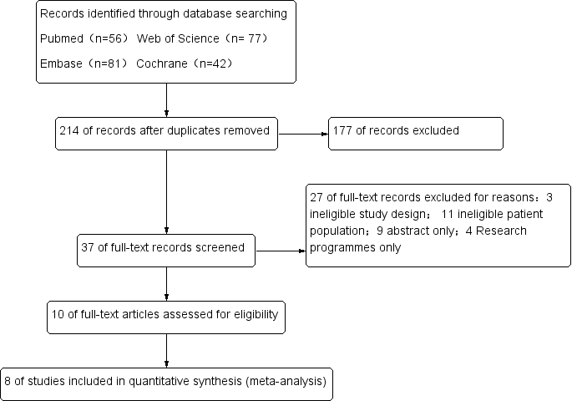

Figure 2, Figure3 Risk-of-bias summary for all studies and outcomes.
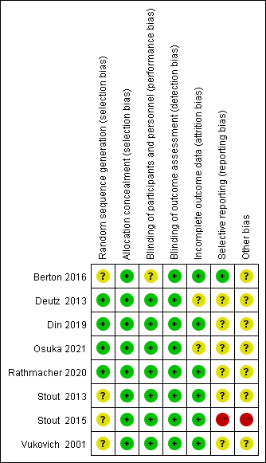

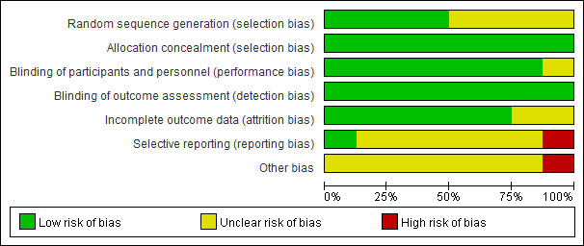

Figure 4 Effects meta-analysis of HMB on lower-body strength.
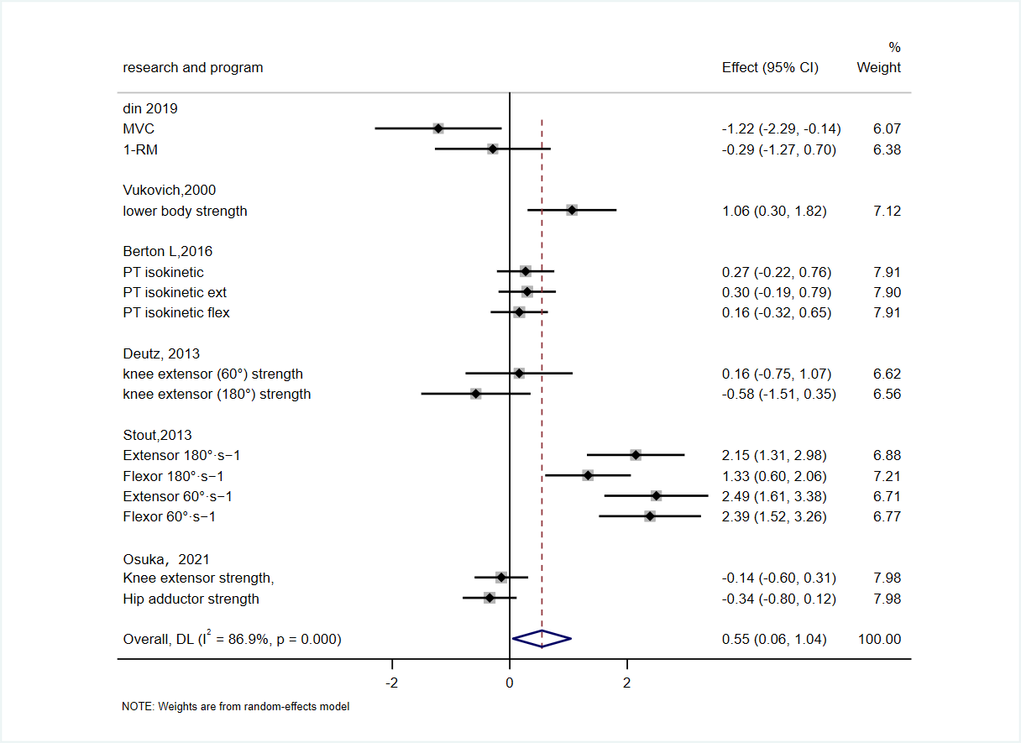

Figure 5 Effects meta-analysis of HMB on upper-body strength.
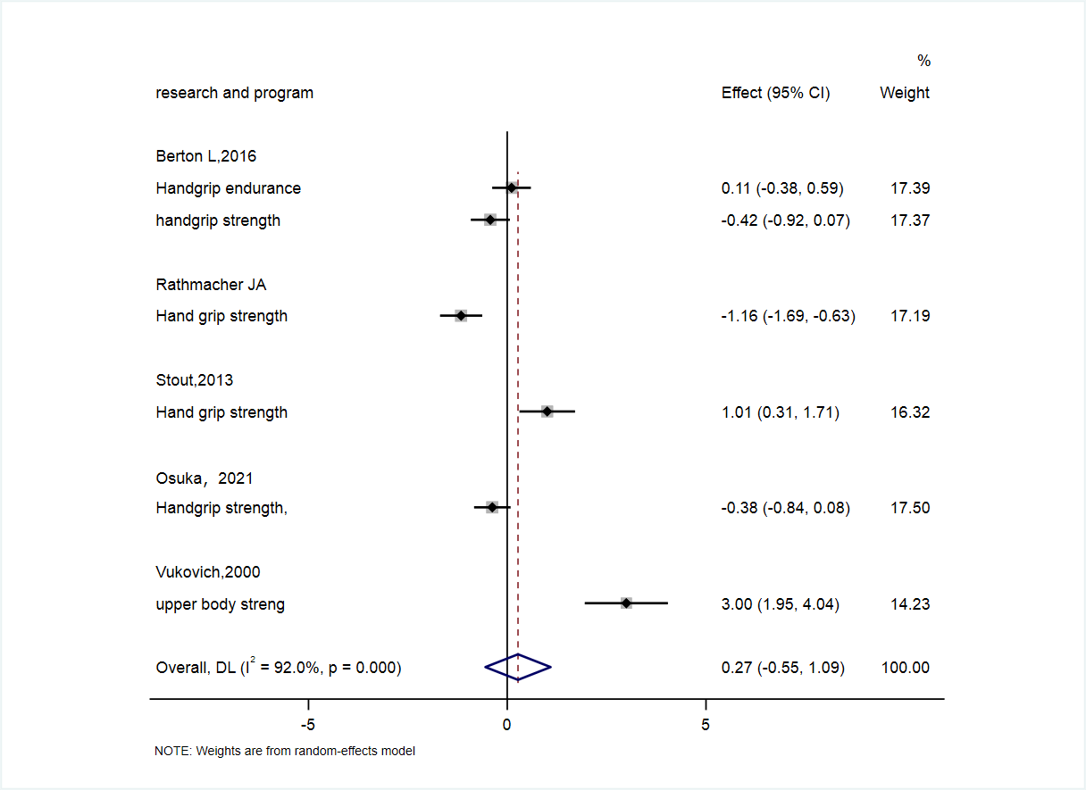
Figure 6 Effects meta-analysis of HMB on fat mass.

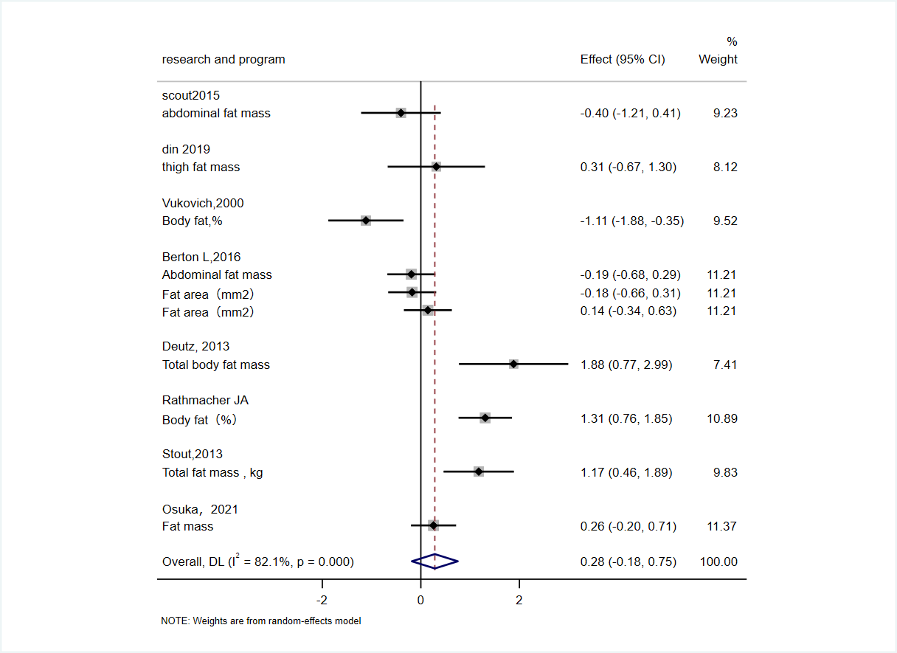

Figure 7 Effects meta-analysis of HMB on fat-free mass. Squares are effect sizes.
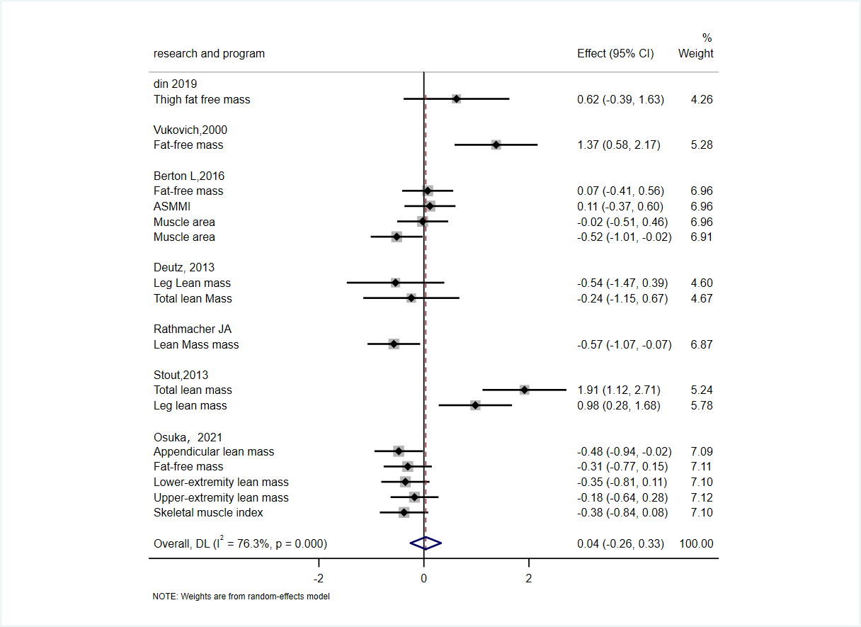

Figure 8 Effects meta-analysis of HMB on muscle function.
