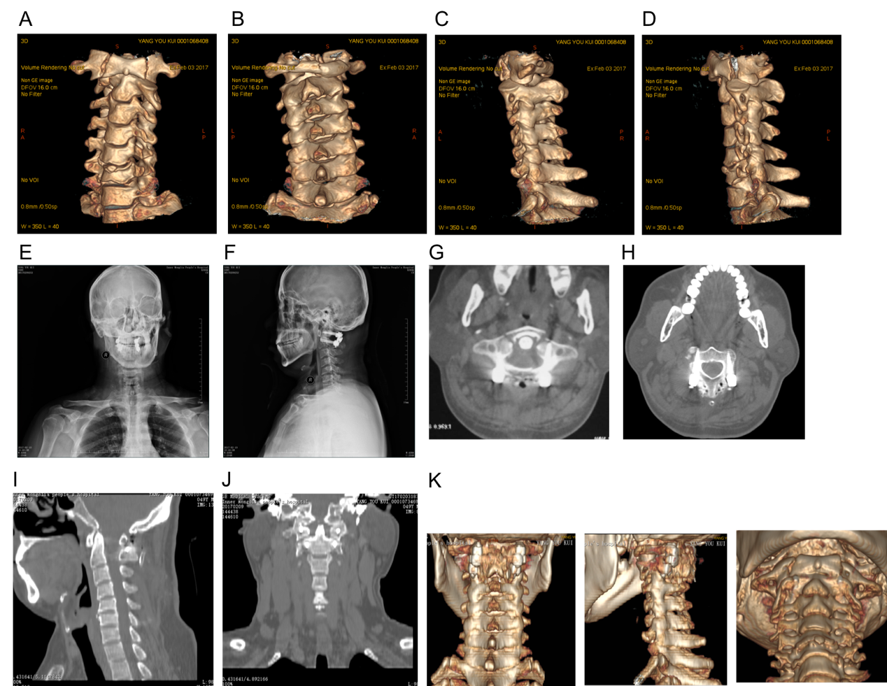

Supplementary Fig. 1. Typical case: a 39-year-old male with trauma caused by neck injury and limited activity. A. Anterior arch fracture of the atlas showed by CT. B. Posterior arch fracture of the atlas showed by CT. C. Anterior arch double fracture of the atlas showed by CT. D. Atlantoaxial dislocation showed by CT. E. Internal fixation in place showed by postoperative X-ray. F. Good reset of fracture dislocation. G. Accurate atlantoaxial fixation showed by postoperative CT plain scan. H. Reset of fracture dislocation showed by postoperative CT plain scan. I. Postoperative CT reconstruction of the sagittal site showed good reset of atlantoaxial dislocation. J. Postoperative CT reconstruction of the coronal site showed good reset of atlantoaxial dislocation. K. Postoperative CT 3D reconstruction showed reliable internal fixation and good reset of atlantoaxial fracture dislocation.

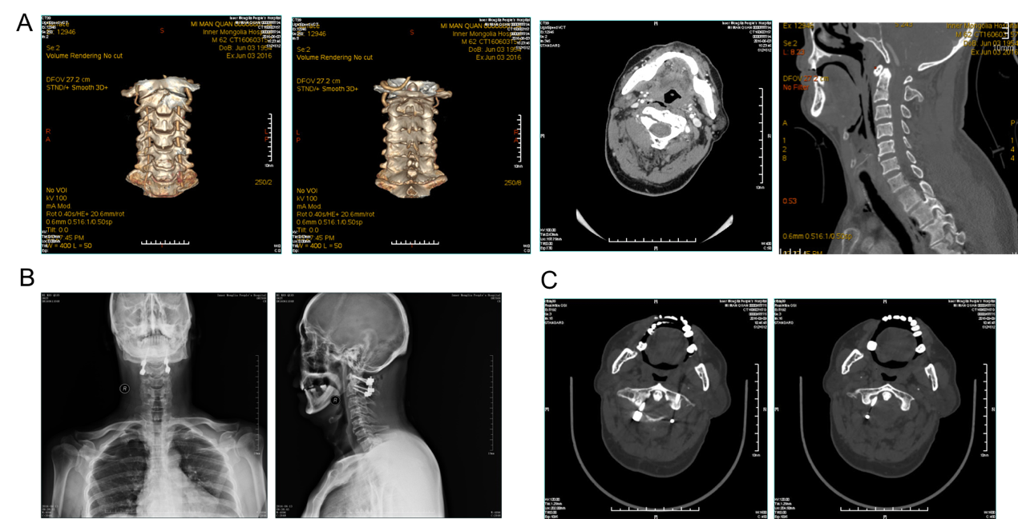
Supplementary Fig. 2. Special case 1: a 62-year-old male suffering from neck pain and limited mobility was diagnosed with pivotal fracture. The navigation template was used, but the bilateral fixation was performed by different doctors, and the screw offset occurred on the side completed by the doctor who was not particularly familiar with the atlantoaxial fixation. This case was excluded from this study.
A. Axial fracture showed by preoperative CT. B. Offset of atlantoaxial pedicle screw showed by postoperative X-ray. C. Offset of the right pedicle screw of the atlas showed by postoperative CT.

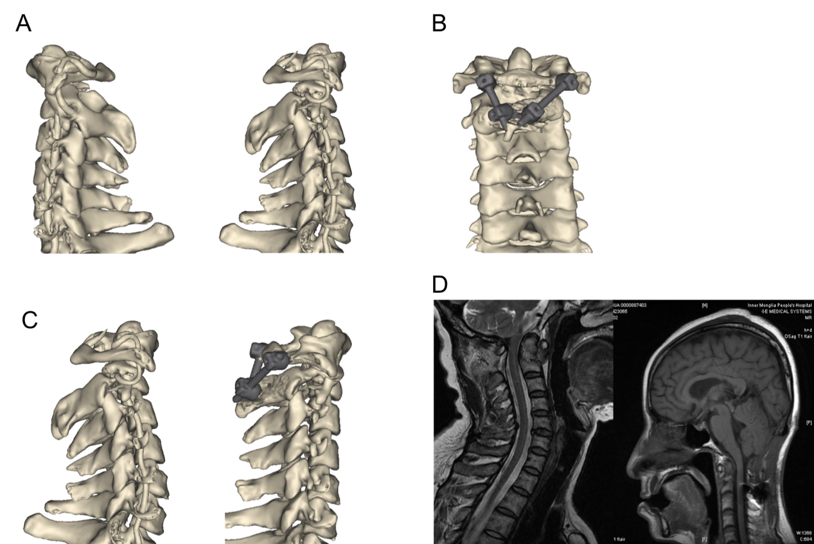
Supplementary Fig.3. Special case 2: a 39-year-old female admitted to the hospital with a "falling from a height and causing weakness in her limbs with numbness for 1 day." CT and MRI of the neck were retrospectively examined: the base fracture of the atlas was accompanied by degeneration of the spinal canal stenosis. The diagnosis was: atlantoaxial instability (AAI). Posterior atlantoaxial pedicle screw fixation was planned. However, the patient's CTA and cervical CT 3D reconstruction showed that the patient's vertebral artery was parasitic and the left pedicle of the pivot was too thin to be nailed, and the right pedicle was fractured. Considering the advantages of the 3D navigation module to preset the surgical plan and predict the risk of surgery, it was decided to use the 3D navigation template to assist the placement of pedicle screw and the lateral side block screw. Although this patient did not meet the inclusion criteria but she benefited from the 3D navigation template, which fully highlighted the advantages of 3D navigation templates from another angle.
A. Preoperative CTA and cervical 3D reconstruction. B. Schematic diagram of the surgical plan. C. Preoperative and postoperative results comparison. D. Preoperative and postoperative MRI comparison.

