LINC00271 inhibits epithelial-mesenchymal transition of papillary thyroid cancer cells via down-regulating trefoil factor 3 expression
Running title: the role of LINC00271 in papillary thyroid cancer

Pihong Li^{1#}, Xiaoyu Pan^{1#}, Zhouci Zheng¹, Yihan Sun¹, Yifan Han¹, Jianda Dong^{1*}

¹Department of General Surgery, The Second Affiliated Hospital of Wenzhou Medical University, Wenzhou 325027, China.

# These authors contributed equally.

Corresponding author: Jianda Dong, dongjianda1973@126.com
Department of General Surgery, The Second Affiliated Hospital of Wenzhou Medical University, Wenzhou 325027, China.

Abstract
Objective As an essential promoter of papillary thyroid cancer (PTC) metastasis, epithelial-mesenchymal transition (EMT) plays an important role in PTC progression while its upstream regulation mechanism is unknown. This study aims to clarify the specific regulation mechanism of LINC00271 on EMT of PTC cells.
MethodsThe invasive and migratory capabilities of TPC-1 cells were determined by transwell invasion assays and wound-healing assays, respectively. The interplay between LINC00271 and trefoil factor 3 (TFF3) was confirmed with RNA pull-down and RNA immunoprecipitation (RIP) assay. The stability of TFF3 was measured by cycloheximide-chase assay and ubiquitination assay.
Results LINC00271 was down-regulated both in tumor tissues of PTC patients and PTC cell line (TPC-1) and its expression was inversely correlated with the expressions of TFF3. Functionally, LINC00271 overexpression inhibited EMT of TPC-1 cells and reduced the tumor volumes of xenograft model mice. Further investigation confirmed that LINC00271 bound to TFF3 and suppressed TFF3 expression by enhancing its ubiquitination level. In addition, the TFF3 overexpression abrogated the inhibitory effect of LINC00271 on EMT of TPC-1 cells.
Conclusion LINC00271 inhibited EMT of TPC-1 cells via down-regulating TFF3 expression.
Keywords LINC00271, trefoil factor 3, epithelial-mesenchymal transition, papillary thyroid cancer.

Introduction
Papillary thyroid cancer (PTC) is the most common type of thyroid cancer, accounting for about 85% of all types of thyroid cancer [1]. Although the majority of patients with PTC tend to have good prognoses after clinical treatment, 30% of patients are diagnosed with metastasis and die from it in a short time [2]. Epithelial-mesenchymal transition (EMT) is considered to play an essential role in tumor metastasis [3]. During EMT progression, thyroid epithelial cells gradually change to mesenchymal cells, losing differentiation capacity, and enhancing the invasion and migration ability, thus given rise to the metastasis in PTC patients [3]. Therefore, exploring the upstream regulation mechanism of EMT is quite meaningful for the clinical prevention of PTC metastasis.
Trefoil factor 3 (TFF3), a member of the trefoil factor family, is well known as an oncogene [4-6]. Krause et al. [7] measured TFF3 in 150 thyroid specimens and found that the TFF3 expression was significantly higher in thyroid malignancy in comparison with benign thyroid nodules. Besides, in PTC cell line TPC-1, TFF3 promotes the EMT process via the MAPK/ERK signaling pathway [8]. TFF3 knockdown could effectively inhibit the EMT process and repress cell migration and invasion [9]. Thus it can be seen that TFF3 is a promoter of EMT in PTC while its upstream regulation mechanism remains unclear.
Long non-coding RNA (lncRNA) is a class of non-coding RNA that has longer than 200 nucleotides and its dysregulation has been reported to be closely related to the development of various cancers [10]. Nowadays, increasing attention has been paid to the role of lncRNA in TPC. Ma et al. [11] screened out 220 lncRNAs which were dysregulated in PTC patients using the TCGA dataset. Among them, LINC00271 was down-regulated in PTC specimens and the low LINC00271 expression was an independent risk factor for metastasis and recurrence of PTC, indicating that LINC00271 may take part in the EMT process of PTC. Based on the previous studies, the present study set out to explore the modulatory effects of LINC00271 on the EMT in PTC and to provide an intervention target for the clinical prevention and treatment of PTC metastasis.
Materials and methods
Sample collection
Forty fresh PTC and paired adjacent tissues were collected from patients with PTC through surgery at the Second Affiliated Hospital of Wenzhou Medical University. All samples were frozen immediately after lesion resection and then stored for the following experiments. All procedures of this study were approved by the Second Affiliated Hospital of Wenzhou Medical University and each subject signed informed consent forms.
Cell culture and transfection
The human normal thyroid epithelial cell line Nthy-ori 3-1 and the PTC cell line TPC-1 were all purchased from Cell Bank of Type Culture Collection of the Chinese Academy of Science (China). Both cell lines were cultured with Dulbecco's Modified Eagle Medium (DMEM; Gibco; USA) containing 10% fetal bovine serum (FBS; Gibco, USA) at 37℃ with 5% CO₂.
TPC-1 cells were cultured in 6-well plates with a concentration of 4×10⁵ cells/well. When the cells were cultured to 75% confluence, cells were transfected with RNAi-vector (si-LINC00271) or over-expression vectors (pcDNA-LINC00271 and pIRES2-TFF3) or relative negative controls (si-control, pcDNA, and pIRES2-EGFP) using Lipofectamine 2000 (Invitrogen, USA).
Quantitative RT-PCR
TRIzol Reagent (Invitrogen, USA) was used to isolate total RNAs from tumor tissues or cells. The quality of total RNA samples was evaluated by spectrophotometer and the high-quality RNAs (1.8 < OD260/280 < 2.0) were transcribed into cDNA using the One-step RNA Reverse Transcription kit (Hai Gene, China). Quantitative RT-PCR was performed in triplicate using the SYBR Green PCR kit (QIAGEN, Germany). Gene expressions were calculated by the 2^{-∆∆CT} method and the relative expression of LINC00271 and TFF3was normalized to β-actin. The sequences of the primers used in the experiments were shown in Table 1.
Western blot analysis
Total proteins from tumor tissues or cells or subcutaneous xenografts of mice were isolated using Radio Immunoprecipitation Assay (RIPA) buffer (Cwbio, China). Protein was electrophoresed by 10% SDS-PAGE and transferred to polyvinylidene fluoride membranes (ThermoFisher Scientific, USA). The membranes were treated with 5% skim milk for 30 min and incubated with primary antibodies anti-TFF3 (1:1000; Abcam, USA), anti-E-cadherin (1:300; Abcam), anti-zonula occluden-1 (1:500; Abcam), anti-N-cadherin (1:1000; Abcam), anti-Fibronection (1:1000; Abcam), and anti-β-actin (1:5000; Abcam) overnight at 4℃. The next day, membranes were incubated with Goat Anti-Rabbit IgG H&L (1:2000; Abcam) for another 2 h. Bands were visualized in IBright FL1500 Intelligent Imaging System (ThermoFisher, USA) and the protein levels were quantified using Image J software.
Transwell invasion assays
Before assays, the membranes of transwell chambers (Corning, USA) were pre-coated using matrigel (Corning, USA). The upper chamber was added with serum-free DMEM containing 1$\text{×}$10³ TPC-1 cells and the lower chamber was added with DMEM containing 10% FBS. Chambers were then cultured in a 5% CO₂ incubator at 37℃. Forty-eight hours later, invading cells on the lower side of the filter were stained using 0.5% crystal violet and counted using the microscope.
Wound healing assays
TPC-1 cells were seeded into six-well plates. When the cells were grown to 90%-95% confluence, the monolayer of cells was scratched with a micropipette tip [12]. The wound areas were photographed at 2-time points (0 and 24 h). The distance between each group was calculated.
RNA immunoprecipitation (RIP) assay
RIP assay was performed basing on the instruction of Magna RIPTM RNA-Binding Protein Immunoprecipitation Kit (Merck Millipore, MO, USA). TPC-1 cells were collected at 80%-90% confluence and lysed using 100 μl specific lysis buffer. Magnetic beads conjugated with human anti-TFF3 antibody were added into the lysate. The protein in samples was removed with Proteinase K and the precipitated RNA was obtained. After purification, RNA was used to detect LINC00271 by qRT-PCR. IgG was used as a negative control.
RNA pull-down assay
The biotin-labeled LINC00271 was constructed with the Biotin RNA Labeling Mix (Roche, Basel, Switzerland) and T7 RNA polymerase (Roche, Basel, Switzerland). TPC-1 cells were collected at 80%-90% confluence and lysed using 100 μl RIPA lysis buffer. The lysate was then incubated with biotin-labeled LINC00271 and streptavidin agarose magnetic beads for 1 h at 4℃. Western blot was conducted to determine the TFF3 expression in the LINC00271 pull-down complex.
Cycloheximide (CHX)-chase assay
TPC-1 cells were transfected with pcDNA-LINC00271 or pcDNA. Forty-eight hours after transfection, the original medium of TPC-1 cells was replaced with the fresh medium containing CHX (125 μg/mL). Then, the expression of TFF3 was determined using western blot at 0, 1, 2, 3 h after CHX treatment.
Ubiquitination assay
Flag-TFF3, HA-ubiquitin (Ub), and pcDNA-LINC00271 (or pcDNA) were co-transfected into TPC-1 cells. Forty-eight hours later after transfection, TPC-1 cells were incubated with MG132 (10 nM). Six hours later, total protein was isolated from TPC-1 cells using RIPA. Then, the cell lysates were incubated with protein A/G magnetic beads conjugated with the anti-FLAG antibody overnight. Anti-Ubiquitin antibody was used to determine the ubiquitination levels of TFF3.
Mouse xenograft models
BALB/c nude mice (4-6 weeks old, female) were purchased from Laboratory Animal Resources, Chinese Academy of Sciences (Beijing, China). The lentiviral vector (LV)-LINC00271 and its negative control (LV-control) were produced by Ribobio (China). For the establishment of the xenograft model, twelve mice were randomly divided into two groups. In the LV-LINC00271 group (n=6), 1×10⁶ TPC-1 cells transfected with LV-LINC00271 were diluted in 100 μl of DMEM and injected subcutaneously into the right flank of nude mice. In the LV-control group (n=6), 1×10⁶ TPC-1 cells transfected with LV-control were diluted in 100 μl of DMEM and injected subcutaneously in the same position of nude mice. The tumor volumes of mice were measured every 7 days. After 28 days, mice were sacrificed and the tumor xenografts were collected for follow-up experiments. All procedures during the experiments were approved by the Ethical Committee of The Second Affiliated Hospital of Wenzhou Medical University.
Statistical analysis
Experimental results were expressed as mean ± standard deviation (SD) and analyzed using GraphPad 7.0 Prism. The differences were analyzed by Student t-test or one-way analysis of variance (ANOVA) with the Newman-Keuls post hoc test. The correlation between the expression of LINC00271 and TFF3 in PTC tissue samples was analyzed by the Pearson correlation analysis. Results were considered statistically significant when P<0.05.
Results
LINC00271 was down-regulated in PTC tissues and PTC cell line
Firstly, we detected the expression of LINC00271 in 40 paired PTC tissues and the corresponding adjacent tissues. The results shown in Figure 1A displayed that LINC00271 expression was visibly lower in PTC tissues than in adjacent tissues, indicating LINC00271 may take part in PTC progression. Using online bioinformatics software, we found four proteins [DiGeorge syndrome critical region 8 (DGCR8), forkhead box A1 (FOXA1), E2F transcription factor 4 (E2F4), and TFF3] that may interact with LINC00271 and have been reported to be related to EMT [13-16]. Next, we overexpressed LINC00271 in PTC cell line TPC-1 and found that only TFF3 significantly reduced in response to LINC00271 overexpression (Supplemental Figure 1). Therefore, we selected TFF3 for further experiments. Then, the expression level of TFF3, measured by qRT-PCR and western blot (Figure 1B), showed a significant increase in PTC tissues than in adjacent tissues. The correlation plot further showed that the expression of LINC00271 was inversely correlated with the expressions of TFF3 in PTC tissues (Figure 1C). Besides, consistent with Figure 1A and B, compared with normal thyroid epithelial cell line Nthy-ori 3-1, the LINC00271 expression in PTC cell line TPC-1 was declined (Figure 1D) and the TFF3 expression in TPC-1 was increased (Figure 1E and F)
LINC00271 overexpression suppressed EMT of PTC cells in vitro and in vivo
To define the role of LINC00271 in PTC, we overexpressed LINC00271 in PTC cell line TPC-1 using pcDNA-LINC00271 (Figure 2A). As shown in Figure 2B, after LINC00271 overexpression, the protein levels of TFF3 and mesenchymal markers (N-cadherin and Fibronectin) [17] were decreased while the protein levels of epithelial markers [E-cadherin and zonula occluden-1 (ZO-1)] [18] were increased. Then, transwell invasion assays (Figure 2C) and wound-healing assays (Figure 2D) showed that pcDNA-LINC00271 down-regulated the invasive and migratory capabilities of TPC-1 cells. These above data indicating that LINC00271 upregulation could suppress EMT of TPC-1 cells. Next, we validated our in vitro foundings in BALB/c nude mice. From Figure 2E, we found that compared with LV-control, the LV-LINC00271 could slow the growth of tumor cells and visibly reduce the tumor volumes. Meanwhile, similar to the in vitro study, LINC00271 overexpression inhibited TFF3 expression and EMT of tumor cells (Figure 2F).
LINC00271 reduced TFF3 expression via weakening its stability
In the previous experiments, we found that LINC00271 expression was inversely correlated with the TFF3 expressions in PTC tissues (Figure 1C), and LINC00271 overexpression clearly suppressed TFF3 protein level in TPC-1 cells (Figure 2B). To verify whether there was an endogenous interaction between LINC00271 and TFF3 protein, RNA pull-down assay and RIP were performed. As shown in Figure 3A, a great amount of TFF3 was detected in the complex pulled down by biotinylated LINC00271. Moreover, compared with IgG, a great quantity of LINC00271 was detected in the anti-TFF3 antibody precipitation complex (Figure 3B). Furthermore, the TFF3 protein level was down-regulated in TPC-1 cells which were transfected with pcDNA-LINC00271 and up-regulated in TPC-1 cells which were transfected with si-LINC00271 (Figure 3C). While neither pcDNA-LINC00271 nor si-LINC00271 could affect the mRNA level of TFF3 (Figure 3D). To further explore whether LINC00271 declined TFF3 expression via affecting its stability, we blocked protein synthesis in TPC-1 cells using CHX (125μg/mL, a protein synthesis inhibitor) and determined TFF3 protein levels at 0, 1, 2 and 3 h after CHX treatment. From Figure 3E, pcDNA-LINC00271 could continuously decrease the TFF3 expression in comparison with pcDNA. The further ubiquitination assay revealed that LINC00271 suppressed TFF3 expression by enhancing its ubiquitination level (Figure 3F).
LINC00271 inhibited EMT of PTC cells through targeting TFF3
To further investigate whether TFF3 is the functional target of LINC00271 for inhibiting EMT of PTC cells, a series of follow-up experiments were carried out. We overexpressed LINC00271 in TPC-1 cells by pcDNA-LINC00271 transfection and overexpressed LINC00271 and TFF3 in TPC-1 cells by pcDNA-LINC00271+pIRES2-TFF3 co-transfection. As shown in Figure 4A, LINC00271 overexpression reduced the expression levels of mesenchymal markers (N-cadherin and Fibronectin) and increased the expression levels of epithelial markers (E-cadherin and ZO-1), while this trend could be reversed by up-regulation of TFF3. In addition, transwell invasion assays (Figure 4B) and wound-healing assays (Figure 4C) revealed that the decreased invasive and migratory capabilities of TPC-1 cells which were associated with LINC00271 overexpression were attenuated by TFF3 overexpressing. The above data suggested that LINC00271 exerted its inhibitory effect on EMT of TPC-1 cells via inhibiting TFF3 expression.
Discussion
The metastasis of PTC is the most important factor hindering the favorable prognosis of PTC. As an essential promotor of invasion and migration of cancer cells, the significance of EMT in PTC metastasis is undoubted[3]. In this study, we investigated the role of LINC00271 in PTC and found that LINC00271 could prevent EMT of PTC cells via down-regulating TFF3.
Previous studies revealed that the down-regulation of LINC00271 was observed in several cancers such as oral squamous cell carcinoma, adrenocortical carcinoma, thyroid cancer, and so on [19-21] and adrenocortical tumors [20], and its low expression was associated with the poor prognosis of cancer, indicating LINC00271 may serve as a tumor suppressor gene. In our study, we found the expression levels of LINC00271 was down-regulated in both tumor tissues of PTC patients and PTC cell line. LINC00271 overexpression significantly reduced the expression of N-cadherin and Fibronectin while increased the expressions of E-cadherin and ZO-1. N-cadherin and Fibronectin are mesenchymal markers while E-cadherin and ZO-1 are the markers of epithelial cells [22]. It has been reported that the decreased level of the epithelial markers and increased levels of the mesenchymal markers are the distinctive events of EMT and contribute to the cancer metastasis [23]. In view of this, the above data showed LINC00271 overexpression could prevent the EMT of PTC cells. Then, the further in vivo study showed the overexpressed LINC00271 reduced the tumor volume of xenograft model mice, confirming the antitumor effect of LINC00271 in PTC.
It’s worth noting that, in tumor tissues of PTC patients, the TFF3 expression was inversely correlated with the expressions of LINC00271. The LINC00271 overexpression reduced the TFF3 protein level and the interference of LINC00271 increased the TFF3 protein level. While neither pcDNA-LINC00271 nor si-LINC00271 could affect the mRNA level of TFF3. Previous studies revealed that lncRNAs could regulate the expression level of protein by affecting its stability [24]. In view of this, we explored whether LINC00271 reducing TFF3 expression under this mechanism. As we speculated, the CHX-chase assay and ubiquitination assay showed that LINC00271 overexpression elevated the ubiquitination level of TFF3, thus accelerating its degradation and declining its protein level.
The high expression of TFF3 has been reported to promote the EMT process in PTC progression. Moreover, Batlle E et al. reported that TFF3 could reduce E-cadherin (an epithelial cell marker) expression by repressing its transcription [25]. In parallel with previous reports, in our study, the TFF3 overexpression reduced the expressions of epithelial cell markers and elevated the expressions of mesenchymal markers in TPC-1 cells transfected with pcDNA- LINC00271. These data indicated that TFF3 mediated the regulatory effect of LINC00271 on EMT of PTC cells.
In conclusion, our study revealed the antitumor effect of LINC00271 on PTC, elaborated the regulatory mechanism of LINC00271 on EMT of PTC cells, providing a new perspective for the prevention of PTC metastasis.
Conflict of interest
The authors declare no conflict of interest.
Authors’ contributions
Jianda Dong: Conceptualization.
Pihong Li and Xiaoyu Pan: Data curation, Writing- Original draft preparation.
Zhouci Zheng: Partial animal experiments.
Yihan Sun: Data analysis.
Yifan Han: Complete examination of the manuscript.
References
1. Fagin, J.A. and S.A. Wells, Jr., Biologic and Clinical Perspectives on Thyroid Cancer. The New England journal of medicine, 2016. 375(11): p. 1054-1067.
2. Grubbs, E.G. and D.B. Evans, Role of lymph node dissection in primary surgery for thyroid cancer. J Natl Compr Canc Netw, 2007. 5(6): p. 623-30.
3. Shakib, H., et al., Epithelial-to-mesenchymal transition in thyroid cancer: a comprehensive review. Endocrine, 2019. 66(3): p. 435-455.
4. May, F.E. and B.R. Westley, TFF3 is a valuable predictive biomarker of endocrine response in metastatic breast cancer. Endocr Relat Cancer, 2015. 22(3): p. 465-79.
5. Kannan, N., et al., Trefoil factor 3 is oncogenic and mediates anti-estrogen resistance in human mammary carcinoma. Neoplasia, 2010. 12(12): p. 1041-53.
6. Pandey, V., et al., Expression of two non-mutated genetic elements is sufficient to stimulate oncogenic transformation of human mammary epithelial cells. Cell Death Dis, 2018. 9(12): p. 1147.
7. Krause, K., et al., TFF3-based candidate gene discrimination of benign and malignant thyroid tumors in a region with borderline iodine deficiency. J Clin Endocrinol Metab, 2008. 93(4): p. 1390-3.
8. Lin, X., et al., TFF3 Contributes to Epithelial-Mesenchymal Transition (EMT) in Papillary Thyroid Carcinoma Cells via the MAPK/ERK Signaling Pathway. Journal of Cancer, 2018. 9(23): p. 4430-4439.
9. Wu, J., et al., Lentivirus-mediated shRNA interference of trefoil factor 3 blocks cell viability, migration and invasion in the papillary thyroid carcinoma cells. Neoplasma, 2018. 65(2): p. 169-177.
10. Xiong, X.D., et al., Long non-coding RNAs: An emerging powerhouse in the battle between life and death of tumor cells. Drug Resist Updat, 2016. 26: p. 28-42.
11. Ma, B., et al., Long intergenic non-coding RNA 271 is predictive of a poorer prognosis of papillary thyroid cancer. Scientific reports, 2016. 6: p. 36973-36973.
12. Yang, Z., et al., SIRT6/HIF-1α axis promotes papillary thyroid cancer progression by inducing epithelial-mesenchymal transition. Cancer cell international, 2019. 19: p. 17-17.
13. Shi, M., et al., Functional Dissection of pri-miR-290~295 in Dgcr8 Knockout Mouse Embryonic Stem Cells. Int J Mol Sci, 2019. 20(18).
14. Huang, J.Z., et al., Down-regulation of TRPS1 stimulates epithelial-mesenchymal transition and metastasis through repression of FOXA1. J Pathol, 2016. 239(2): p. 186-96.
15. Baiz, D., et al., Bortezomib effect on E2F and cyclin family members in human hepatocellular carcinoma cell lines. World J Gastroenterol, 2014. 20(3): p. 795-803.
16. Lin, X., et al., TFF3 Contributes to Epithelial-Mesenchymal Transition (EMT) in Papillary Thyroid Carcinoma Cells via the MAPK/ERK Signaling Pathway. J Cancer, 2018. 9(23): p. 4430-4439.
17. Kong, G., et al., Irisin reverses the IL-6 induced epithelial-mesenchymal transition in osteosarcoma cell migration and invasion through the STAT3/Snail signaling pathway. Oncology reports, 2017. 38(5): p. 2647-2656.
18. Zhu, Y., et al., HIF-1α regulates EMT via the Snail and β-catenin pathways in paraquat poisoning-induced early pulmonary fibrosis. Journal of cellular and molecular medicine, 2016. 20(4): p. 688-697.
19. Zhou, S., et al., Long Non-Coding RNA Expression Profile Associated with Malignant Progression of Oral Submucous Fibrosis. Journal of oncology, 2019. 2019: p. 6835176-6835176.
20. Buishand, F.O., et al., Adrenocortical tumors have a distinct, long, non-coding RNA expression profile and LINC00271 is downregulated in malignancy. Surgery, 2020. 167(1): p. 224-232.
21. Murugan, A.K., A.K. Munirajan, and A.S. Alzahrani, Long noncoding RNAs: emerging players in thyroid cancer pathogenesis. Endocr Relat Cancer, 2018. 25(2): p. R59-r82.
22. Paolillo, M. and S. Schinelli, Extracellular Matrix Alterations in Metastatic Processes. International journal of molecular sciences, 2019. 20(19): p. 4947.
23. Lu, W. and Y. Kang, Epithelial-Mesenchymal Plasticity in Cancer Progression and Metastasis. Dev Cell, 2019. 49(3): p. 361-374.
24. Yang, F., et al., Repression of the long noncoding RNA-LET by histone deacetylase 3 contributes to hypoxia-mediated metastasis. Mol Cell, 2013. 49(6): p. 1083-96.
25. Meyer zum Büschenfelde, D., et al., Molecular mechanisms involved in TFF3 peptide-mediated modulation of the E-cadherin/catenin cell adhesion complex. Peptides, 2004. 25(5): p. 873-83.
Figure legends

Figure 1 LINC00271 was down-regulated in PTC tissues and PTC cell line
Forty paired PTC tissues and the corresponding adjacent tissues were collected through surgery. A: LINC00271 expression was measured by qRT-PCR. B: Trefoil factor 3 (TFF3) expression was measured by western blot and qRT-PCR. C: The correlation plot of LINC00271 expression and TFF3 protein level. The higher TFF3 protein level (x-axis) was correlated with the lower LINC00271 expression (y-axis). In normal thyroid epithelial cell line Nthy-ori 3-1 and PTC cell line TPC-1, D: LINC00271 expression was measured by qRT-PCR, E: mRNA level of TFF3 was measured by qRT-PCR, F: protein level of TFF3 was measured by western blot.
**P<0.01, ***P<0.01 vs adjacent tissues or Nthy-ori 3-1.

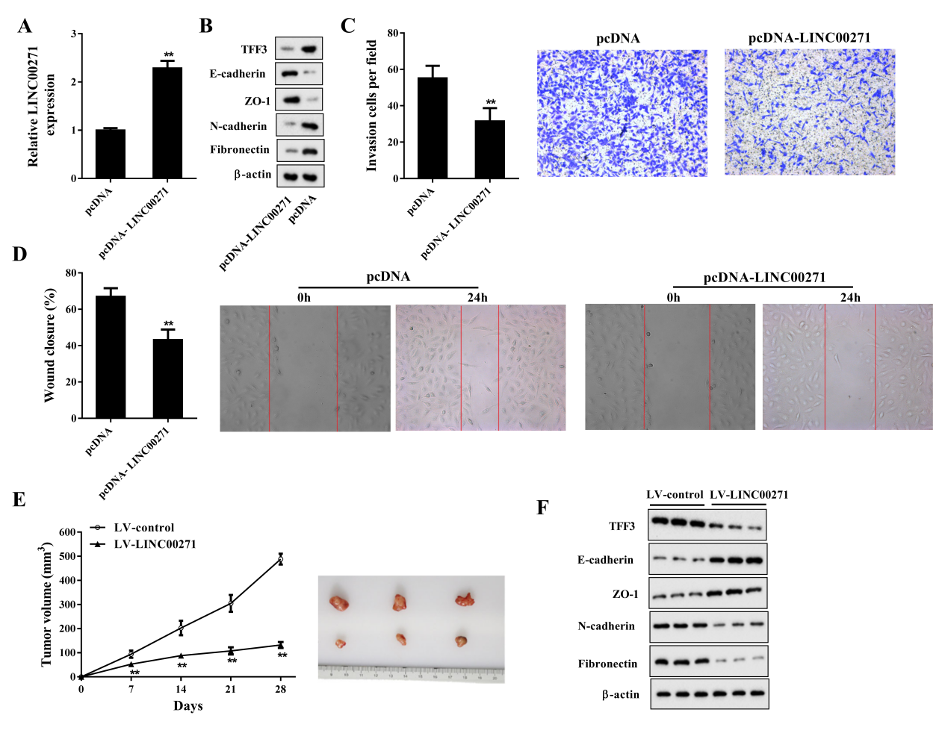

Figure 2 LINC00271 overexpression suppressed EMT of PTC cells in vitro and in vivo
TPC-1 cells were transfected with pcDNA-LINC00271 or its negative control (pcDNA). Forty-eight hours later, cells were harvested for the following experiments. A: LINC00271 expression was measured by qRT-PCR. B: The protein levels of TFF3, E-cadherin, zonula occluden-1 (ZO-1), N-cadherin, and Fibronection were measured by western blot. β-actin was used as an internal control. C: The invasive capability of TPC-1 cells was determined by the transwell invasion assay. D: The migratory capability of TPC-1 cells was determined by the wound-healing assay. Xenograft model mice were divided into 2 groups: lentiviral vector (LV)-LINC00271 (n=6) and LV-control (n=6). E: The tumor volumes of subcutaneous xenografts were calculated at four-time points (7, 14, 21, and 28 days) after injection. F: The protein levels of TFF3, E-cadherin, ZO-1, N-cadherin, and Fibronection of subcutaneous xenografts were measured by western blot. β-actin was used as an internal control.
**P<0.01 vs pcDNA or LV-control.
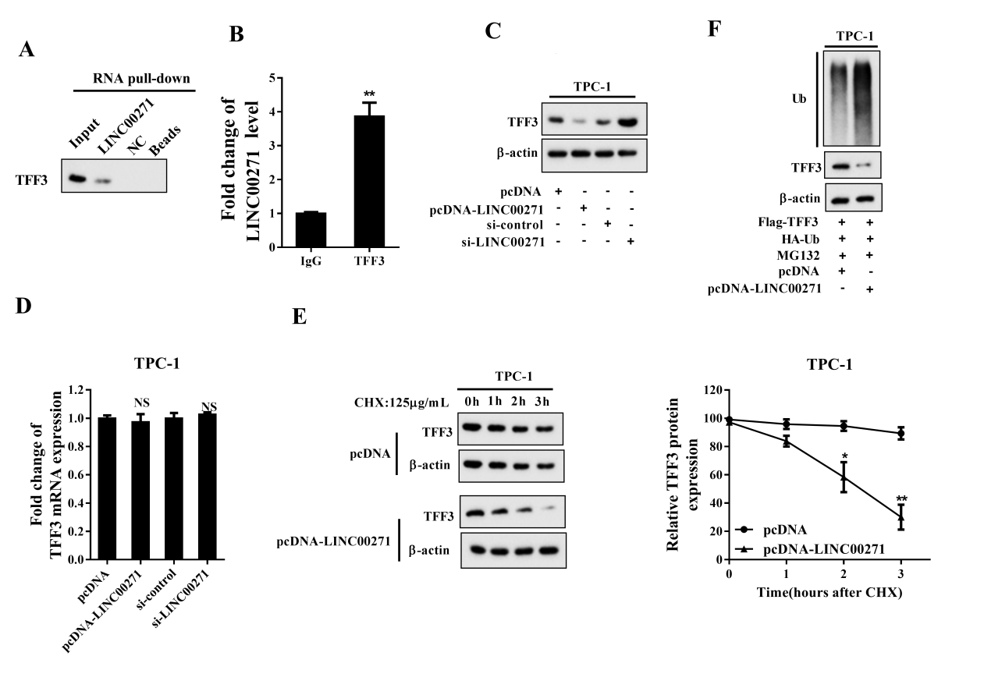

Figure 3 LINC00271 reduced TFF3 expression via enhancing its ubiquitination
A: Detection of TFF3 using western blot in the samples pulled down by the biotinylated LINC00271 or its negative control (NC Beads). B: RNA-binding protein immunoprecipitation (RIP) followed by qRT-PCR was performed to measure the combination of LINC00271 and TFF3. C: After overexpressing or silencing LINC00271 in TPC-1 cells, the protein level of TFF3 was measured by western blot. D: After overexpressing or silencing LINC00271 in TPC-1 cells, the mRNA level of TFF3 was measured by qRT-PCR. E: After overexpressing LINC00271, TPC-1 cells were incubated with CHX (125 μg/ml), and the expression of TFF3 was measured by western blot at four-time points (0, 1, 2 and 3 h) after CHX treatment. β-actin was used as an internal control and ImageJ was used to quantify TFF3 band densitometry. F: After overexpressing LINC00271, TPC-1 cells were treated with MG132 (10 nM) for 8 h. Immunoprecipitation followed by western blot was performed to assess the ubiquitination level of TFF3.
*P<0.05 vs pcDNA, **P<0.01 vs IgG or pcDNA.

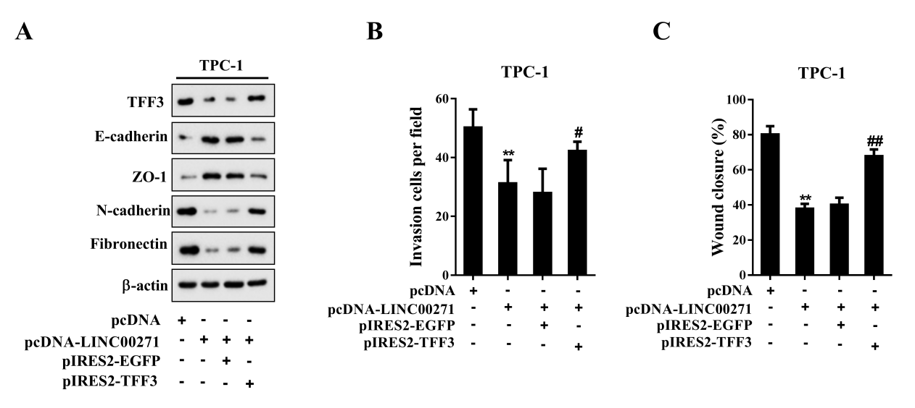

Figure 4 LINC00271 inhibited EMT of PTC cells through targeting TFF3
TPC-1 cells were divided into 4 groups: pcDNA, pcDNA-LINC00271, pcDNA-LINC00271+pIRES2-EGFP, pcDNA-LINC00271+ pIRES2-TFF3. A: The protein levels of TFF3, E-cadherin, ZO-1, N-cadherin, and Fibronection were measured by western blot. β-actin was used as an internal control. B: The invasive capability of TPC-1 cells was determined by the transwell invasion assay. C: The migratory capability of TPC-1 cells was determined by the wound-healing assay.
**P<0.01 vs pcDNA, #P<0.05 vs pcDNA-LINC00271+pIRES2-EGFP, ##P<0.01 vs pcDNA-LINC00271+pIRES2-EGFP.

Supplemental Figure 1 TPC-1 cells were transfected with pcDNA-LINC00271 or pcDNA. Then, the expression levels of DiGeorge syndrome critical region 8 (DGCR8), forkhead box A1 (FOXA1), E2F transcription factor 4 (E2F4), and TFF3 were measured by qRT-PCR and western blot. **P<0.01 vs pcDNA.
Table 1 Sequences of the primers used in the experiments
qRT-PCR Primers Sequences
LINC00271 | F 5’-GCTATTGGTGGGAGGCTTCAG-3’  R 5’-TGGGCTGGACTTAATGACTTGC-3’
TFF3 | F 5’- CTTGCTGTCCTCCAGCTCT-3’  R 5’- CCGGTTGTTGCACTCCTT-3’
β-actin | F 5’- GCACTCTTCCAGCCTTCCTT-3’  R 5’-TGGGCTGGACTTAATGACTTGC-3’

