MiR-20b and miR-106a synergistically suppress inflammatory factors secretion and mitigates sepsis-induced acute kidney injury via targeting TLR4
Ling Zhou^{1*}, Yiying Tao¹ ,Yue Yue¹
¹Department of Nephrology, The First Affiliated Hospital of Soochow University, Suzhou; 215000, China
Corresponding author: *Corresponding author: Ling Zhou, MD. Mailing address: Department of Nephrology, The First Affiliated Hospital of Soochow University. Address: 899 Pinhai Rd., Suzhou 215000, People’s Republic of China. TEL: +86-0512-67972438 E-mail:zl66060@163.com

Abstract
Background Inflammatory response plays a key role in the pathogenesis of sepsis-induced acute kidney injury (AKI). MiR-20b and miR-106a are found to be related to kidney diseases; hence their impact on inflammatory factors secretion and sepsis-induced AKI was investigated.
Methods Septic AKI model was established in rats with lipopolysaccharide (LPS) treatment. The levels of interleukin-1β (IL-1β), interleukin-6 (IL-6), and tumor necrosis factor-α (TNF-α) were determined by enzyme-linked immune-sorbent assay (ELISA). The expression of miR-20b and miR-106a was quantified with qRT-PCR, and TLR4 protein level was analyzed by western blot. The interactional between TLR4 mRNA and miR-20b or miR-106a were identified with a dual-luciferase reporter assay.
Results MiR-20b and miR-106a was down-regulated in kidney tissues of septic AKI mice (n=7), and the serum creatinine (SCr) level and blood urea nitrogen (BUN) level were also increased. In human renal proximal tubule cells (HK-2), miR-20b and miR-106a collectively suppressed inflammatory factors production including IL-1β, IL-6, and TNF-α. MiR-20b and miR-106a worked together in targeting TLR4. MiR-20b and miR-106a suppressed inflammatory factors secretion in HK-2 cells via collectively controlling TLR4.
Conclusion MiR-20b and miR-106a exhibit synergistic effects on suppressing inflammatory factors secretion by targeting TLR4, and thus mitigating sepsis-induced AKI.
Keywords sepsis-induced AKI, miR-20b, miR-106a, TLR4, HK-2 cells, inflammatory factors

Introduction
Sepsis refers to a serious systemic inflammatory response syndrome caused by infection, featured with end-organ dysfunction and multi-organ failure[1]. Acute kidney injury (AKI) is a common and severe complication of sepsis, resulting in high mortality in critically ill patients[2]. The pathogenesis of sepsis-induced AKI involves complicated cytokines and inflammatory mediators, that is, inflammatory reaction plays an essential role in this process. Therefore, anti-inflammation therapy is likely to be a promising approach in ameliorating AKI induced by sepsis[3]. However, the inflammatory mediators and the regulatory mechanism remained incompletely understood.
Toll-like receptor 4 (TLR4) is a prototypical sensor of infection or injury that widely implicated in inflammation and immune response[4]. By recruiting inflammatory factors, activation of TLR4 appears to be responsible for kidney injury[5, 6], and TLR4 activation following sepsis is considered to contribute to disease progression[7]. It is well known that endotoxin lipopolysaccharide (LPS) is a typical ligand of TLR4 and mediates TLR4-dependent pro-inflammatory cytokines expression including interleukin-1β (IL-1β), interleukin-6 (IL-6), and tumor necrosis factor-α (TNF-α)[8]. Hence LPS-induce experimental model was used in research concerning sepsis-related AKI[9].
However, the factors affecting TLR4 expression in sepsis-induced AKI are still far from resolved. MicroRNAs (miRNAs) have emerged as critical regulators of gene expression and possess diverse abilities in human disorders. MiR-20b has been identified to be aberrantly expressed and play a role in tumors such as gastric cancer and breast cancer[10, 11]. Through targeting NLRP3, miR-20b exhibited inhibitory effect on mycobacterium tuberculosis induced inflammation[12]. Moreover, the polycystic kidney disease gene Pkd1 has been proven to be a target of miR-20, implying its potential function in kidney development[13]. Besides, miR-106a also has been revealed to be involved in cancer oncogenesis, growth, and metastasis via modulating cell function[14, 15]. Recently, significant down-regulation of miR-106a has been observed in the plasma of focal segmental glomerulosclerosis, and miR-106a overexpression suppressed podocyte apoptosis in vitro[16].
In addition, with bioinformatics method (TargetScan), we predicted that TLR4 may be a target of miR-20b and miR-106a, suggesting a putative functional interaction between them. Actually, miR-20b and miR-106a has been claimed to regulate neuronal genes expression during the neural differentiation[17]. Taken together, we speculated that miR-20b and miR-106a may have an impact on inflammatory reaction in sepsis-induced AKI via targeting TLR4. Therefore, this study was initiated to clarify the interaction between miR-20b and TLR4, as well as miR-106a and TLR4, and their influence on inflammatory factors secretion and on sepsis-induced AKI pathogenesis.

Materials and methods
Septic AKI model
Approval to conduct this study was obtained from the ethics committee of The First Affiliated Hospital of Soochow University and performed according to the guidelines of Laboratory Animal Science Association. 2-8-week-old male BALB/c mice (20-22 g) provided by the Laboratory Animal center of Soochow University were used to induce the septic AKI model[18]. Briefly, mice were intraperitoneally injected with LPS (10 mg/kg, Sigma-Aldrich, USA) and fasted overnight. Mice in the sham group were intraperitoneally injected with an equivalent of saline solution. 24 h following LPS injection, the mice were euthanized for samples collection.
Kidney function evaluation in septic AKI mouse
The blood and renal tissues of mice were collected for serum creatinine (SCr) and blood urea nitrogen (BUN) levels measurement. In this study, a Hitachi 7060 automated Chemistry Analyzer (Diamond Diagnostics, USA) was employed to determine the levels of SCr and BUN, conforming to the protocol of the instrument.
Quantitative real-time PCR (qRT-PCR)
QRT-PCR was carried out to exam the expression level of miR-20b and miR-106a in the kidney tissue of septic AKI mice. Total RNA was extracted from the tissues using TRIzol reagent (Invitrogen, USA) complying by its instructions. 2 μg of total RNA was taken for cDNA synthesis with a Prime-Script RT reagent kit (TaKaRa Biotechnology, China). QRT-PCR was conducted with the fast qPCR kit (Kapa Biosystems, USA) on a CFX Connect PCR system (Bio-rad, USA). Relative miRNAs expression was normalized with U6 and calculated using the 2^{-ΔΔCt} method.
Western blot
For protein extraction, kidney tissues were solubilized in ice-cold RIPA lysis buffer (Thermo Fisher Scientific, USA) and protein concentrations were assessed with a bicinchoninic acid (BCA) assay kit (Thermo Fisher Scientific, USA). The total protein was loaded onto 10% sodium dodecylsulfate-polyacrylamide gel electrophoresis (SDS-PAGE) and transferred onto polyvinylidene difluoride (PVDF) membranes (Bio-Rad, USA). The PVDF membrane was blocked in the Tris-buffered saline (TBS) containing 5% non-fat milk and 0.1% Tween-20 for 1 hour at room temperature. Anti-β-actin and anti-TLR4 at 1:1500 dilutions were used as the primary antibodies, and were incubated at 4°C overnight. Then membrane was incubated with HRP-conjugated secondary antibody for 2 h at room temperature. Proteins were imaged by Tanon Chemiluminescence Imaging system with an ECL regent (Thermo Fisher, USA).
HK-2 cells culture and LPS treatment
Human renal proximal tubule cells (HK-2) were commercially obtained from American Type Culture Collection (ATCC, USA) and grown in phenol red-free Dubecco's Modified Eagle's Medium (DMEM/F12, Gibco, USA) supplemented with 10% fetal bovine serum (FBS, Gibco, USA). HK-2 cells were maintained at 37°C with 5% CO₂ and then incubated with 1 μg/ml LPS in serum-free DMEM for 24 h.
Enzyme-linked immune-sorbent assay (ELISA)
After 24 h following LPS treatment, the supernatant was collected to determine the expression of IL-1β, IL-6, and TNF-α. The levels of inflammatory cytokines were measured using human ELISA kits (Abcam, UK) according to the manufacturer’s instructions.
Dual-luciferase reporter assay
The luciferase reporter vector was constructed with oligonucleotides designed according to the predicted binding site of TLR4 3’-untranslated region (3’UTR). The WT TLR4 3’-UTR or MUT TLR4 3’-UTR were inserted into pmirGLO vector (Promega, USA), and the recombinant vectors were obtained. 293T cells at 70% confluence were co-transfected with the recombinant vector and miR-20b mimic, or miR-106a mimic (or their negative control miRNA) using Lipofectamine 2000 (Invitrogen, USA). After 24 h, the cells were assayed for luciferase activity detection with the dual luciferase reporter assay system (Promega, USA) according to the manufacturer’s instructions.
Overexpression of miR-20b mimic and miR-106a in septic AKI model
2-8-week-old male BALB/c mice (20-22 g) were used to construct the septic AKI model by intraperitoneal injection of LPS (10 mg/kg, Sigma-Aldrich, USA). Subsequently, the septic AKI were injected with pre-NC (the negative control of miRNA mimic, n=7) or miR-20b+miR-106a mimic (n=7) through tail intravenous[19]. After 24 h, the mice were euthanized for blood and kidney tissues collection.
Statistical analysis
SPSS 21.0 software (SPSS Inc., USA) was used in statistical analyses, and all the data were expressed as mean ± standard deviation. Comparative analysis between groups was performed with Student’s t test, and a value of P< 0.05 was considered significant. Comparison among more than two groups was completed using ANOVA followed by the Newman-Keuls post hoc test.

Results
Down-regulation of miR-20b and miR-106a in sepsis-induced AKI mice
The acute kidney injury (AKI) mouse model was successfully established (Figure 1A). The blood sample and kidney tissue were taken from the AKI mice (AKI, n=7) for kidney function analysis and gene expression analysis. Compared with the sham group (n=7), the SCr level and BUN level were all notably higher in AKI mice (n=7) (Figure 1B). In kidney tissue of AKI mice, the expression of miR-20b and miR-106a was clearly reduced when compared with that in sham group (Figure 1C). On the contrary, the TLR4 protein level was markedly up-regulated in the kidney tissues of AKI mice as compared with that in sham group (Figure 1D). Collectively, our data demonstrated the declined renal function and significant variation in expression of miR-20b, miR-106a, and TLR4 protein in sepsis-induced AKI mice.
MiR-20b and miR-106a collectively suppress inflammatory factors secretion in human renal proximal tubule cells
To induce inflammatory reaction, HK-2 cells were treated with lipopolysaccharide (LPS). Level of IL-1β, IL-6, and TNF-α detected by ELISA were remarkably higher in LPS-treated HK-2 cells than that in control group (Figure 2A). Compared with the control cells, the expression of miR-20b and miR-106a was observably repressed in LPS-treated HK-2 cells (Figure 2B), while the TLR4 protein level was notably elevated in HK-2 cells induced by LPS (Figure 2C). As shown in Figure 2D, with miR-20b or miR-106a mimic transfected, miR-20b and miR-106a were over-expressed in HK-2 cells. Subsequently, HK-2 cells were divided into several groups: control, LPS, LPS+pre-NC, LPS+miR-20b mimic, LPS+miR-106a mimic, and LPS+miR-20b mimic+miR-106a mimic. The results illustrated that transfection of miR-20b mimic in HK-2 cells clearly reduced inflammatory factors secretion that induced by LPS, such as IL-1β, IL-6, and TNF-α (Figure 2E); the level of IL-1β, IL-6, and TNF-α was also augmented with miR-106a mimic transfected (Figure 2E). In addition, the concentration of IL-1β, IL-6, and TNF-α was further dropped after co-transfection of miR-20b mimic and miR-106a mimic in HK-2 cells, when comparing with individual transfection of miR-20b mimic or miR-106a mimic (Figure 2E). Taken together, it could be seen that miR-20b and miR-106a collectively suppressed LPS-induced inflammatory factors secretion by HK-2 cells.
MiR-20b and miR-106a work together in targeting TLR4
The potential targets of miR-20b and miR-106a were then explored. As shown in Figure 3A, miR-20b and miR-106a were located in the X-chromosome of the mouse. TargetScan was used and it demonstrated that miR-20b and miR-106a were well complementary with TLR4 3’UTR, and the binding site was conserved (Figure 3B). Then the interactional binding sites between the wild type (WT) 3’UTR of TLR4 were identified with the dual-luciferase assay, with the mutants (MUT1, MUT2, and double MUT) 3’UTR of TLR4 designed as control. It was indicated that transfection of miR-20b mimic or miR-106a mimic significantly restrained the relative luciferase activity in WT-TLR4 3’UTR, MUT1-TLR4 3’UTR, and MUT2-TLR4 3’UTR, and co-transfection of the both exhibited the same effect (Figure 3C). However, the miR-20b mimic or miR-106a mimic did not affected the relative luciferase activity in double MUT-TLR4 3’UTR (Figure 3C). In addition, TLR4 protein level was inhibited by miR-20b mimic or miR-106a mimic, but it was enhanced after miR-20b inhibitor or miR-106a inhibitor transfection (Figure 3D). Herein, we illuminated that miR-20b and miR-106a worked together to negatively regulated TLR4 by targeting its 3’UTR.
MiR-20b and miR-106a suppress inflammatory factors secretion via collectively controlling TLR4
To explore the mechanism of miR-20b and miR-106a in affecting inflammatory response, HK-2 cells were allocated into 4 groups: pre-NC, miR-20b mimic+miR-106a mimic, miR-20b mimic+miR-106a mimic+pcDNA, and miR-20b mimic+miR-106a mimic+pcDNA-TLR4. The results revealed that TLR4 protein expression was largely inhibited by over-expression of miR-20b and miR-106a, but pcDNA-TLR4 inverted this effect (Figure 4A). Moreover, the secretion of inflammatory factors including IL-1β, IL-6, and TNF-α was dramatically reduced when miR-20b mimic and miR-106a mimic were transfected into HK-2 cells, which was further elevated by TLR4 overexpression (Figure 4B). It was proven that expression of miR-20b and miR-106a repressed inflammatory factors secretion through collectively controlling TLR4.
Overexpression of miR-20b and miR-106a ameliorates sepsis-induced AKI through targeting TLR4
To validate the effect of miR-20b and miR-106a expression on development of sepsis-induced AKI, the septic AKI mice were injected with pre-NC (n=7) or miR-20b+miR-106a mimic (n=7). It was found that the level of SCr and BUN was clearly reduced in septic AKI mice with overexpression of miR-20b and miR-106a when comparing to the pre-NC group (Figure 5A). Compared with the pre-NC group, miR-20b and miR-106a were up-regulated in kidney tissues of mice with miR-20b+miR-106a mimic transfected (Figure 5B); but the TLR4 protein expression was notably attenuated with miR-20b and miR-106a overexpressed (Figure 5C). Meanwhile, the levels of serum inflammatory factors including IL-1β, IL-6, and TNF-α were remarkably come down by miR-20b and miR-106a overexpression in septic AKI mice (Figure 5D). We hereto illustrated that overexpression of miR-20b and miR-106a ameliorates sepsis-induced AKI and inflammatory factors release through targeting TLR4.

Discussion
In the current study, the synergistic effects of miR-20b and miR-106a on controlling inflammatory factors secretion were clarified, and their role in affecting sepsis-induced AKI was also highlighted. With septic model experiment and LPS-induced inflammatory reaction in vitro performed, it can be concluded that miR-20b and miR-106a exhibit synergistic effects on suppressing inflammatory factors secretion by targeting TLR4, and thus mitigating sepsis-induced AKI. Findings in this study not only elucidate the inflammatory mechanism mediated by TLR4, but also illuminated the pivotal function of miR-20b and miR-106a in sepsis-induced AKI, providing effective potential targets for this disease treatment.
Due to the diversity of the target mRNAs, miRNAs widely participate in many kinds of physiological and pathological processes, such as innate and adaptive immune, inflammatory reaction, cancer metastasis and progression, and neurological disorders[20-22]. As to sepsis, miRNAs have been validated to be closely associated with inflammatory response by targeting sepsis-related genes, which may serve as promising biomarkers in sepsis diagnosis, prognosis, and treatment[23]. It has been reported that significantly elevated miR-133a levels were observed in mice after puncture-induced sepsis and in critically ill patients with sepsis, which was predictive for an unfavorable prognosis and represented a predictor for long-term mortality[24]. Besides, miR-27a up-regulation has been noted in lungs of septic mice, and it promoted inflammatory reaction in sepsis[25]. In the present study, the roles of miR-20b and miR-106a in controlling inflammatory response and influencing sepsis pathogenesis were interpreted for the first time, offering new potential biomarkers and targets for sepsis diagnosis and treatment.
Apart from its role in repressing inflammation induced by mycobacterium tuberculosis[12], miR-20b has been claimed to inhibit airway inflammation in asthmatic mice[26]. In addition, the crucial influences of miR-20b on osteoarthritis and viral myocarditis pathogenesis have also been identified, through respectively targeting NLRP3 and ZFP-148[27, 28]. These findings concerning the regulatory relationship between miR-20b and inflammation were in accordance with our study. In colon cancer[15], non-small cell lung cancer[14], and glioblastoma [29] the oncogenic role of miR-106a has been validated, while its involvement in inflammation has been seldom focused on. Upon Th17 differentiation, miR-106a was markedly up-regulated, implying its feasible capability in participating in Th17-mediated inflammation[30]. Furthermore, it has been manifested that miR-106a targets interleukin-10 (IL-10), a crucial modulator of inflammatory diseases[31], but the relevance of this regulatory mechanism to human disease are not warranted. Our study further confirmed the effects of miR-20b and miR-106a on inflammatory factors production and on septic AKI progression, as well as the synergistic effect of the both on negatively regulating TLR4, a recruit of inflammatory cytokines.
TLR4 is activated by LPS, a component of Gram-negative bacteria to induce secretion of pro-inflammatory mediators, but aberrant regulation of the host response to LPS usually leads to sepsis, a systemic inflammatory status[32]. In the current study, activation of TLR4 by LPS in HK-2 cells results in a sharp increase in expression of IL-1β, IL-6, and TNF-α, and these essential pro-inflammatory cytokines contribute to aggravating inflammatory reaction. Considering that TLR4 occupies a central point in sepsis-induced AKI, the exploration on its regulatory mechanism may benefit a lot in developing novel therapy for septic AKI and other inflammation-related disorders.
In conclusion, miR-20b and miR-106a synergistically suppress inflammatory factors secretion by targeting TLR4, and thus mitigating sepsis-induced AKI. This study emphasized the influence of miR-20b and miR-106a on inflammatory response in septic AKI, providing important theoretical foundation for improving the outcome in sepsis-induced AKI treatment.

Conflict of interest
The authors declare no conflict of interest.
Financial Support and Sponsorship
This research was supported by Jiangsu Natural Science Foundation Project (BK 20190052).

References
[1] A. Zarjou, A. Agarwal, Sepsis and acute kidney injury, J Am Soc Nephrol, 22 (2011) 999-1006.
[2] Y.M. Hu, M.H. Pai, C.L. Yeh, Y.C. Hou, S.L. Yeh, Glutamine administration ameliorates sepsis-induced kidney injury by downregulating the high-mobility group box protein-1-mediated pathway in mice, Am J Physiol Renal Physiol, 302 (2012) F150-158.
[3] A.C. Souza, R.A. Volpini, M.H. Shimizu, T.R. Sanches, N.O. Camara, P. Semedo, C.E. Rodrigues, A.C. Seguro, L. Andrade, Erythropoietin prevents sepsis-related acute kidney injury in rats by inhibiting NF-kappaB and upregulating endothelial nitric oxide synthase, Am J Physiol Renal Physiol, 302 (2012) F1045-1054.
[4] M. Ghosh, J. Subramani, M.M. Rahman, L.H. Shapiro, CD13 restricts TLR4 endocytic signal transduction in inflammation, J Immunol, 194 (2015) 4466-4476.
[5] A. Akcay, Q. Nguyen, C.L. Edelstein, Mediators of inflammation in acute kidney injury, Mediators Inflamm, 2009 (2009) 137072.
[6] L. Zhang, D. Sun, Y. Bao, Y. Shi, Y. Cui, M. Guo, Nerolidol Protects Against LPS-induced Acute Kidney Injury via Inhibiting TLR4/NF-kappaB Signaling, Phytother Res, 31 (2017) 459-465.
[7] C.X. Lima, D.G. Souza, F.A. Amaral, C.T. Fagundes, I.P. Rodrigues, J.C. Alves-Filho, M. Kosco-Vilbois, W. Ferlin, L. Shang, G. Elson, M.M. Teixeira, Therapeutic Effects of Treatment with Anti-TLR2 and Anti-TLR4 Monoclonal Antibodies in Polymicrobial Sepsis, PLoS One, 10 (2015) e0132336.
[8] H.Y. Ye, J. Jin, L.W. Jin, Y. Chen, Z.H. Zhou, Z.Y. Li, Chlorogenic Acid Attenuates Lipopolysaccharide-Induced Acute Kidney Injury by Inhibiting TLR4/NF-kappaB Signal Pathway, Inflammation, 40 (2017) 523-529.
[9] M. Shi, X. Zeng, F. Guo, R. Huang, Y. Feng, L. Ma, L. Zhou, P. Fu, Anti-Inflammatory Pyranochalcone Derivative Attenuates LPS-Induced Acute Kidney Injury via Inhibiting TLR4/NF-kappaB Pathway, Molecules, 22 (2017).
[10] T.M. Xue, L.D. Tao, M. Zhang, G.C. Xu, J. Zhang, P.J. Zhang, miR-20b overexpression is predictive of poor prognosis in gastric cancer, Onco Targets Ther, 8 (2015) 1871-1876.
[11] A. Ahmad, K.R. Ginnebaugh, S. Sethi, W. Chen, R. Ali, S. Mittal, F.H. Sarkar, miR-20b is up-regulated in brain metastases from primary breast cancers, Oncotarget, 6 (2015) 12188-12195.
[12] J. Lou, Y. Wang, Z. Zhang, W. Qiu, MiR-20b inhibits mycobacterium tuberculosis induced inflammation in the lung of mice through targeting NLRP3, Exp Cell Res, 358 (2017) 120-128.
[13] M.P. Bartram, M. Hohne, C. Dafinger, L.A. Volker, M. Albersmeyer, J. Heiss, H. Gobel, H. Bronneke, V. Burst, M.C. Liebau, T. Benzing, B. Schermer, R.U. Muller, Conditional loss of kidney microRNAs results in congenital anomalies of the kidney and urinary tract (CAKUT), J Mol Med (Berl), 91 (2013) 739-748.
[14] X. Xie, H.T. Liu, J. Mei, F.B. Ding, H.B. Xiao, F.Q. Hu, R. Hu, M.S. Wang, miR-106a promotes growth and metastasis of non-small cell lung cancer by targeting PTEN, Int J Clin Exp Pathol, 8 (2015) 3827-3834.
[15] B. Yue, B. Sun, C. Liu, S. Zhao, D. Zhang, F. Yu, D. Yan, Long non-coding RNA Fer-1-like protein 4 suppresses oncogenesis and exhibits prognostic value by associating with miR-106a-5p in colon cancer, Cancer Sci, 106 (2015) 1323-1332.
[16] B. Xiao, L.N. Wang, W. Li, L. Gong, T. Yu, Q.F. Zuo, H.W. Zhao, Q.M. Zou, Plasma microRNA panel is a novel biomarker for focal segmental glomerulosclerosis and associated with podocyte apoptosis, Cell Death Dis, 9 (2018) 533.
[17] H. Wang, W. Ban, T. Wang, Z. Li, X. Dang, miR-20b/106a modulate Ngn2 gene expression during neural differentiation of human umbilical cord mesenchymal stem cells, Neuroreport, 28 (2017) 1225-1231.
[18] Y. Peng, X. Zhang, Y. Wang, S. Li, J. Wang, L. Liu, Overexpression of toll-like receptor 2 in glomerular endothelial cells and podocytes in septic acute kidney injury mouse model, Ren Fail, 37 (2015) 694-698.
[19] Y. Yao, F. Sun, M. Lei, miR-25 inhibits sepsis-induced cardiomyocyte apoptosis by targetting PTEN, Biosci Rep, 38 (2018).
[20] M. Bhaskaran, M. Mohan, MicroRNAs: history, biogenesis, and their evolving role in animal development and disease, Vet Pathol, 51 (2014) 759-774.
[21] J.T. Mendell, E.N. Olson, MicroRNAs in stress signaling and human disease, Cell, 148 (2012) 1172-1187.
[22] L.M. Bekris, J.B. Leverenz, The biomarker and therapeutic potential of miRNA in Alzheimer's disease, Neurodegener Dis Manag, 5 (2015) 61-74.
[23] J. Huang, Z. Sun, W. Yan, Y. Zhu, Y. Lin, J. Chen, B. Shen, J. Wang, Identification of microRNA as sepsis biomarker based on miRNAs regulatory network analysis, Biomed Res Int, 2014 (2014) 594350.
[24] F. Tacke, C. Roderburg, F. Benz, D.V. Cardenas, M. Luedde, H.J. Hippe, N. Frey, M. Vucur, J. Gautheron, A. Koch, C. Trautwein, T. Luedde, Levels of circulating miR-133a are elevated in sepsis and predict mortality in critically ill patients, Crit Care Med, 42 (2014) 1096-1104.
[25] Z. Wang, Z. Ruan, Y. Mao, W. Dong, Y. Zhang, N. Yin, L. Jiang, miR-27a is up regulated and promotes inflammatory response in sepsis, Cell Immunol, 290 (2014) 190-195.
[26] H. Ma, H. Wang, Y. Luo, S. Guo, C. Song, Mir-20b-Induced Increase in Myeloid-Derived Suppressor Cells in the Lungs of Mice with Chronic Asthma, Ann Clin Lab Sci, 47 (2017) 76-82.
[27] K. Qian, L. Zhang, K. Shi, Triptolide prevents osteoarthritis via inhibiting hsa-miR-20b, Inflammopharmacology, (2018).
[28] H.F. Xu, X.T. Gao, J.Y. Lin, X.H. Xu, J. Hu, Y.J. Ding, S.H. Zhu, MicroRNA-20b suppresses the expression of ZFP-148 in viral myocarditis, Mol Cell Biochem, 429 (2017) 199-210.
[29] P. Li, Q. Xu, D. Zhang, X. Li, L. Han, J. Lei, W. Duan, Q. Ma, Z. Wu, Z. Wang, Upregulated miR-106a plays an oncogenic role in pancreatic cancer, FEBS Lett, 588 (2014) 705-712.
[30] M. Kastle, S. Bartel, K. Geillinger-Kastle, M. Irmler, J. Beckers, B. Ryffel, O. Eickelberg, S. Krauss-Etschmann, microRNA cluster 106a~363 is involved in T helper 17 cell differentiation, Immunology, 152 (2017) 402-413.
[31] A. Sharma, M. Kumar, J. Aich, M. Hariharan, S.K. Brahmachari, A. Agrawal, B. Ghosh, Posttranscriptional regulation of interleukin-10 expression by hsa-miR-106a, Proc Natl Acad Sci U S A, 106 (2009) 5761-5766.
[32] A. Plociennikowska, A. Hromada-Judycka, K. Borzecka, K. Kwiatkowska, Co-operation of TLR4 and raft proteins in LPS-induced pro-inflammatory signaling, Cell Mol Life Sci, 72 (2015) 557-581.

Figure legends
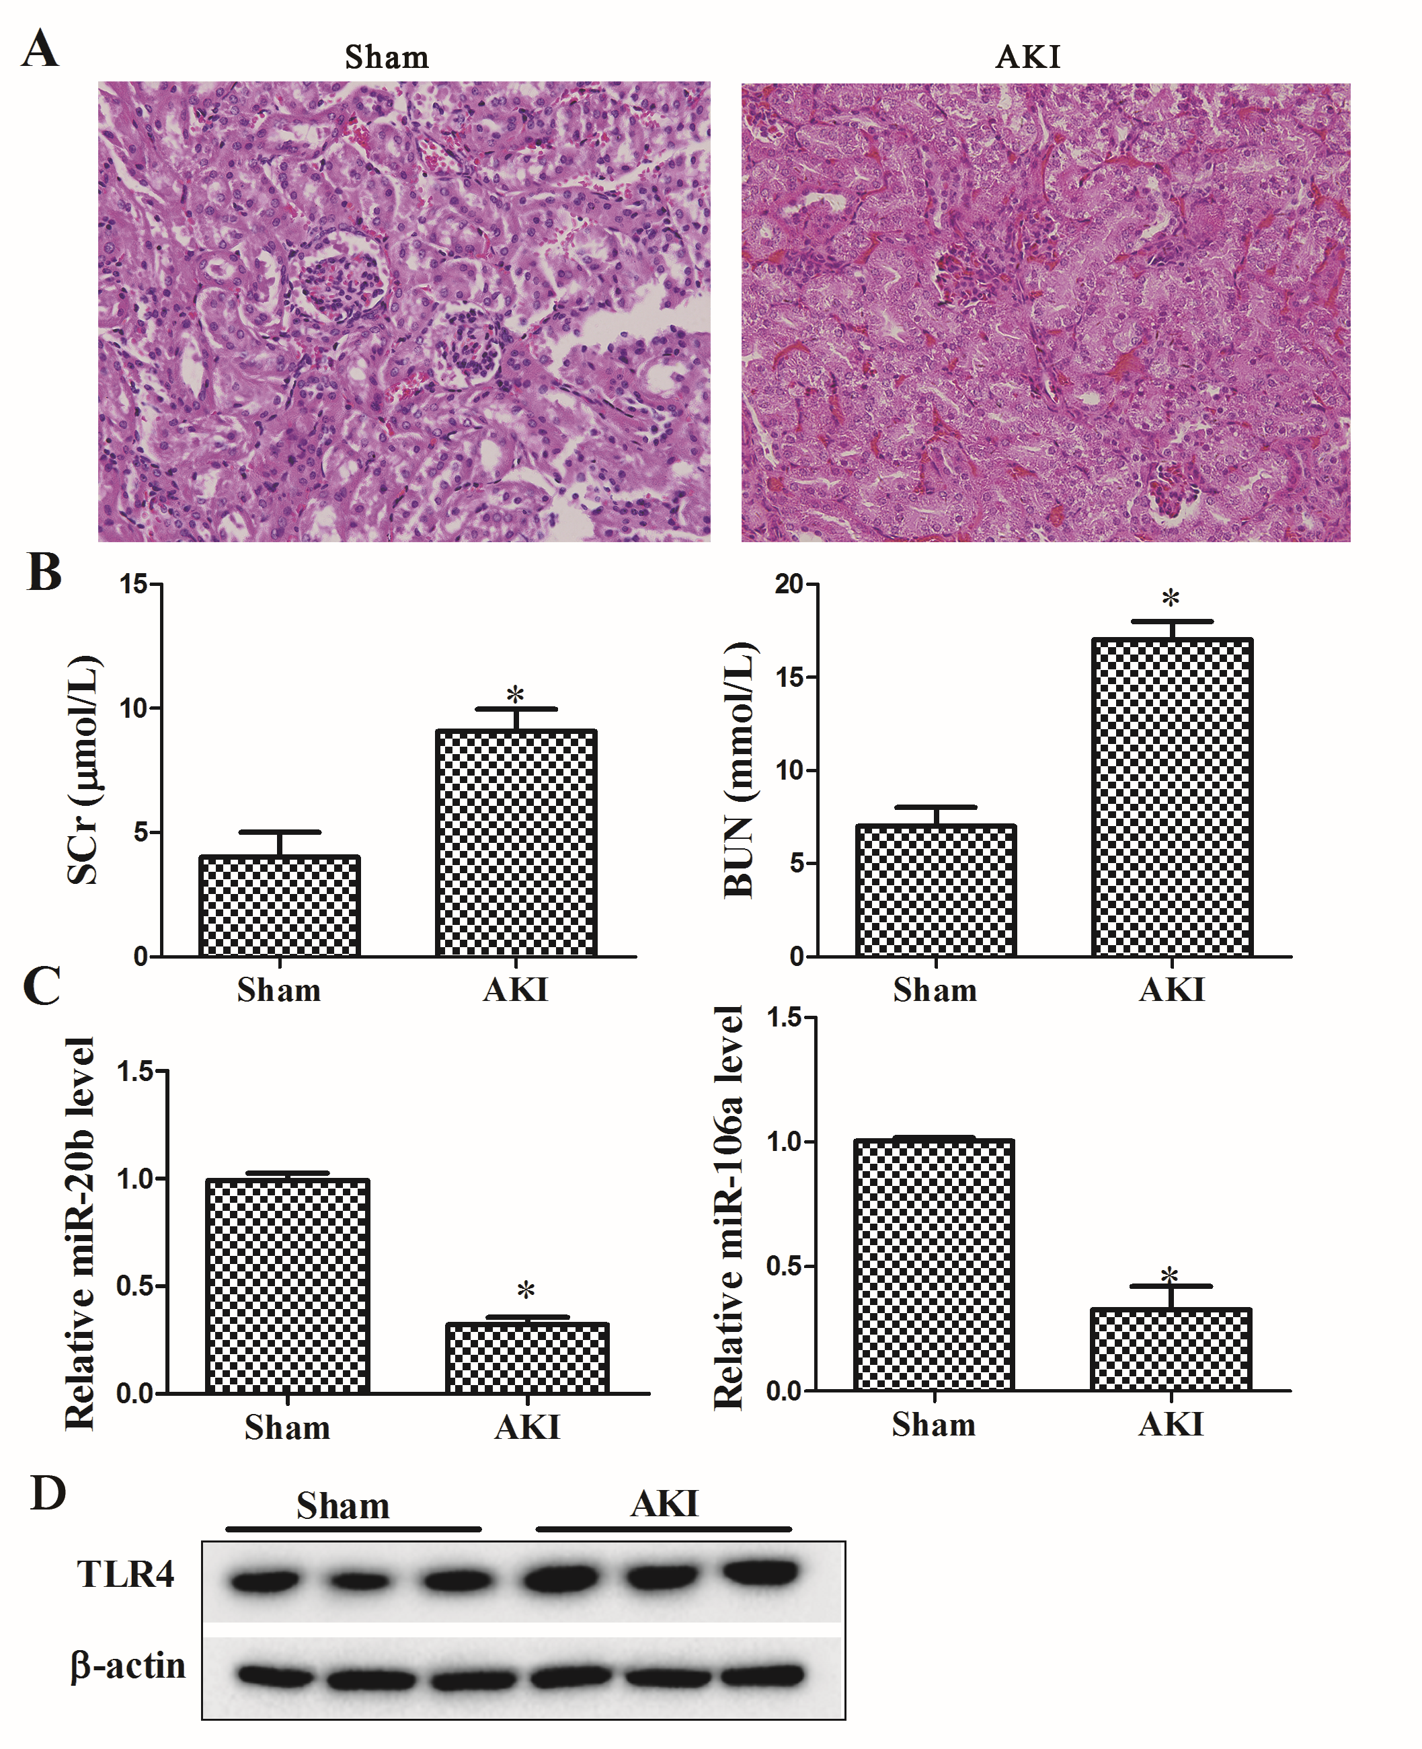
Figure 1 Down-regulation of miR-20b and miR-106a in sepsis-induced AKI mice. The blood sample and kidney tissue were taken from the acute kidney injury mice model (AKI, n=7) and the sham group (n=7). (A) Kidney tissues were stained using HE. (B) The SCr level and BUN level of mice in the two groups were determined to assess the kidney function of septic AKI mice. (C) The expression of miR-20b and miR-106a in kidney tissues was determined by qRT-PCR. (D) The TLR4 protein level in kidney tissues was estimated with western blot. *P<0.05 compared with sham.
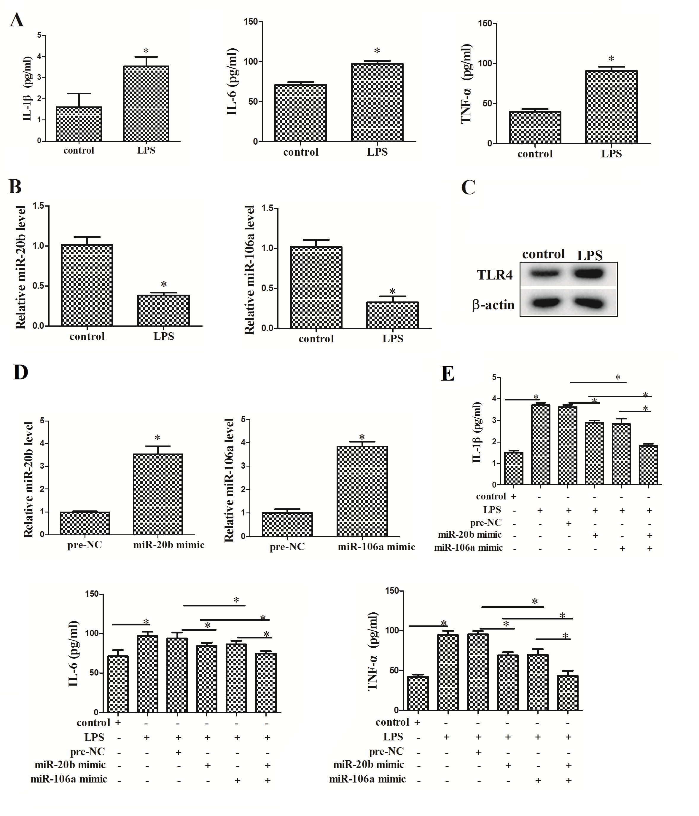
Figure 2 MiR-20b and miR-106a collectively suppressed inflammatory factors secretion in human renal proximal tubule cells. HK-2 cells were treated with lipopolysaccharide (LPS). (A) Level of IL-1β, IL-6, and TNF-α were detected by enzyme-linked immune-sorbent assay (ELISA). (B) The expression of miR-20b and miR-106a in HK-2 cells was measured by qRT-PCR; the TLR4 protein level in HK-2 cells was analyzed with western blot. (D) The expression of miR-20b and miR-106a in HK-2 cells was measured by qRT-PCR. (E) Level of IL-1β, IL-6, and TNF-α were detected by ELISA. *P<0.05 compared with control.

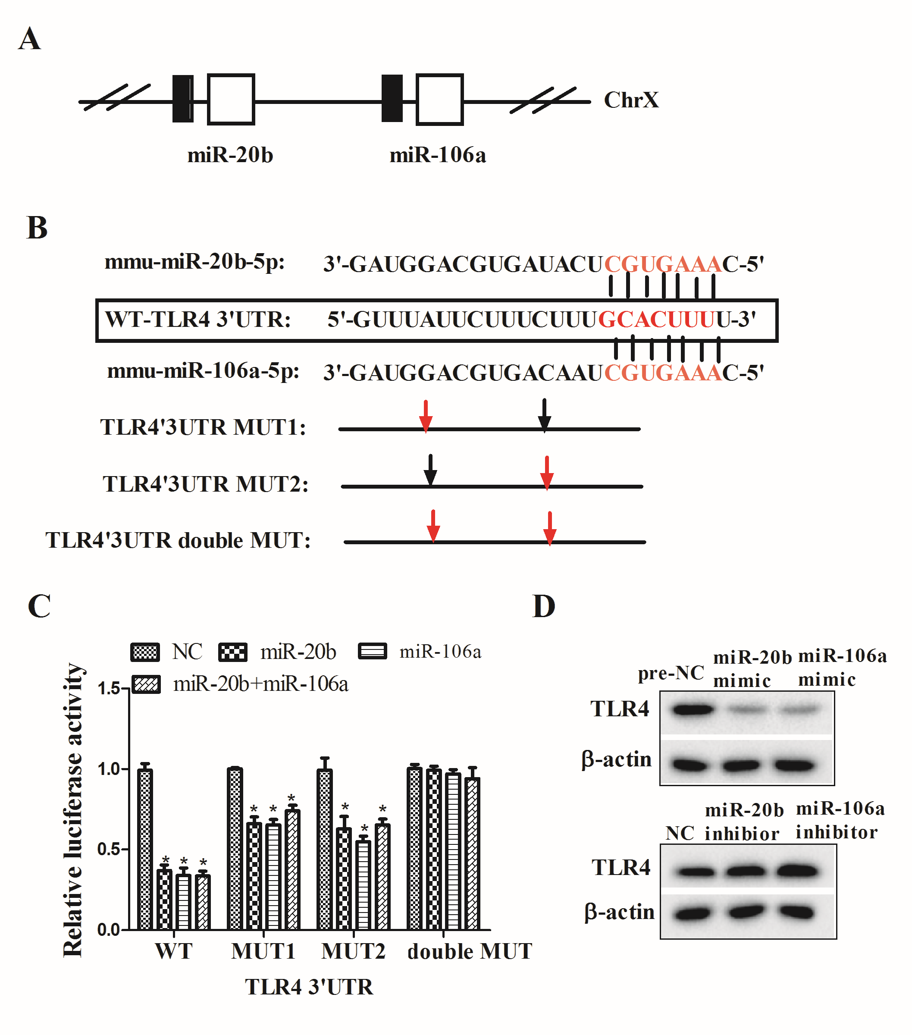
Figure 3 MiR-20b and miR-106a work together to target TLR4. Dual luciferase reporter assay was used to exam the interplay between miR-20b and TLR4, and between miR-106a and TLR4. (A) The location of miR-20b and miR-106a on the X-chromosome. (B) The predicted miR-20b and miR-106a-binding sites on 3’UTR region of TLR4. (C) The luciferase activity was assessed after cell transfection. (D) The TLR4 protein level in HK-2 cells was analyzed with western blot. *P<0.05 compared with the negative control of miRNA mimic.
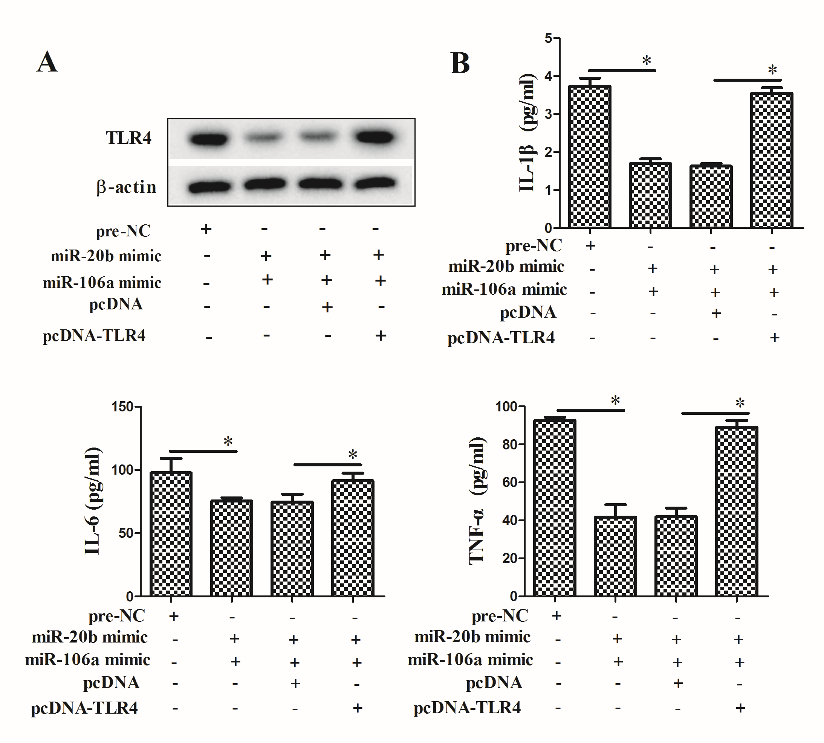
Figure 4 MiR-20b and miR-106a suppressed inflammatory factors secretion via collectively controlling TLR4. HK-2 cells were allocated into 4 groups: pre-NC, miR-20b mimic+miR-106a mimic, miR-20b mimic+miR-106a mimic+pcDNA, and miR-20b mimic+miR-106a mimic+pcDNA-TLR4. (A) The TLR4 protein level in HK-2 cells was analyzed using western blot. (B) Level of IL-1β, IL-6, and TNF-α were detected by ELISA. *P<0.05 compared with the negative control of miRNA mimic.

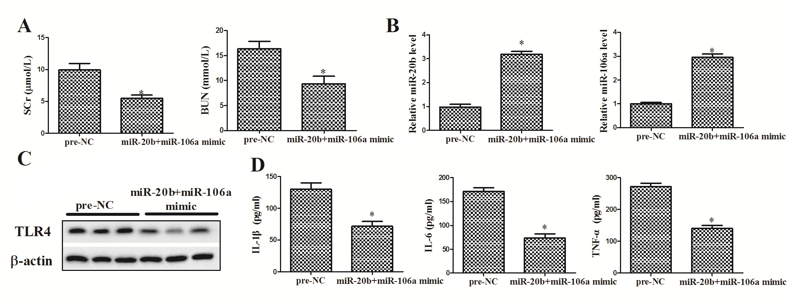
Figure 5 Overexpression of miR-20b and miR-106a ameliorates sepsis-induced AKI through targeting TLR4. The septic AKI mice were injected with pre-NC (n=7) or miR-20b+miR-106a mimic (n=7). (A) The SCr level and BUN level of mice in the two groups were determined to assess the kidney function of septic AKI mice. (B) Relative expression of miR-20b and miR-106a in kidney tissues was evaluated with qRT-PCR. (C) The TLR4 protein level in kidney tissues was estimated by western blot. (D) Concentration of IL-1β, IL-6, and TNF-α in serum of mice was detected by ELISA. *P<0.05 compared with pre-NC.

