Therapeutic Brief
Gastrointestinal disasters of Cetuximab in the treatment of metastatic colorectal cancer：Mechanism and its effect on Prognosis
Yue Wu¹, Haowei Jia¹, Xinqi Bao¹, Tianyu Zhu¹, Ruixin Li¹, Hongchao Zhao¹, Junfeng Sun^{1*}

¹ Department of Gastrointestinal Surgery, The first affiliated hospital of Zhengzhou university, Zhengzhou, China

Corresponding author: Junfeng Sun
E-mail: sunjunfenger@126.com

ABSTRCT
Colorectal cancer (CRC) is responsible for one of the top three cancers in incidence and mortality worldwide. It causes more than 880,000 deaths every year and the number of new cases is increasing , which is a serious threat to human health.Surgery and chemotherapy are always the first choices for cancer patients. However, the majority patients are diagnosed at an advanced stage, because at early stage , symptoms are usually not apparent and difficult to diagnose. The prognosis of CRC has never been satisfactory, especially in patients with metastatic CRC(mCRC). Targeted therapy is a new available treatment method. Because of its clear target, strong specificity, reliable security, small side effects and sustainable prolongation of OS(overall survival) , it has become a research focus for the integrated therapy of advanced tumors including mCRC. Cetuximab, a monoclonal antibody production, is one of the most wide studied targeted drugs.
By competitively binds to EGFR (epithelial growth factor receptor, EGFR), cetuximab inhibits EGF (epithelial growth factor, EGF) and its ligand binding to EGFR, thereby inhibits tumor cells growth, invasion, metastasis and induces tumor cells apoptosis. In addition, cetuximab also exerts an anti-tumor role through many other paths, such as inhibiting of tumor angiogenesis, regulating the host anti-tumor immunity. Its curative effect has been affirmed in the treatment of many kinds of tumors, especially colorectal cancer. Cetuximab combined with chemotherapy or monotherapy is used as the first-line treatment in patients with RAS wild type mCRCs. However, with the development of clinical application, the adverse drug reactions have attracted more and more attention.Numbers of studies have found that gastrointestinal disasters play a significant role in all adverse drug reactions of cetuximab and have multiple effects on the prognosis of colorectal cancer.

This paper mainly focuses on the mechanism of gastrointestinal disasters(GDs) in the treatment of metastatic colorectal cancer and its influence on the prognosis from three aspects:IMB(intestinal mucosal barrier) , GM(gut microbiota)-host immune balance and bacterial metabolites:short chain fatty acids(SCFAs) .Moreover, we will provide promising suggestions that we collect to help ncologist make full use of cetuximab in the treatment of mCRC.

Keywords: Cetuximab, colorectal cancer, gut microbiota-host immune balance, bacterial metabolites, Gastrointestinal disasters

INTRODUCTION
Cetuximab is a IgG1 human / mouse chimeric monoclonal antibody targeting the extracellular region of EGFR. It can specifically bind to EGFR related domains on the surface of a variety of cancer cells, competitively block the corresponding ligands and inhibit the activation of RAS-RAF. RAS-RAF can induce the phosphorylation and activation of receptor related kinases (MAPK, MEK, ERK) and regulate the expression of transcription factors. It also can activate PI3K, affect the SH3 domain of AKT to regulate cell growth and apoptosis. Moreover, EGFR inhibitors can inhibit the activation of PLC-γ1 by EGFR to affect cell movement, growth, differentiation and formation of membrane wrinkle, which is critical for the proliferation and apoptosis of cancer cells[1-3]. Not only inhibiting EGFR , cetuximab also exert anti-tumor effects in many other ways, such as inhibiting the production of VEGF( vascular endothelial growth factor, VEGF), inducing NK cells to kill tumor cells through antibody dependent cell mediated cytotoxicity(ADCC), regulating hypoxia factor 1-a and Bcl-2 proto oncogen, activating the autophagy genes Beclin 1 and hvps34 and induce the autophagy of tumor cells. Thus it can be seen that cetuximab plays an anti-tumor role on multiple levels and paths[4-6]. Phase-III clinical trials have shown that cetuximab is more effective in combination with irinotecan, FOLFOX and multiple target drugs. National comprehensive cancer net work (NCCN) and Food and Drug Administration (FDA) recommend that cetuximab combined with classical chemotherapy can be used as a first-line treatment in patients with RAS wild type mCRC[7]. Notably, not all RAS wild type CRC patients are sensitive to cetuximab. Mutations of RAS gene (NRAS and KRAS) and V600E BRAF cause drug resistance[8,9]. PI3K mutation and PTEN loss affect the efficacy of cetuximab combined with chemotherapy in the treatment of mCRC.Other reviews have been fulfilled the mechanism of action and resistance about cetuximab[10,11]. We mainly review the adverse drug reactions(ARDs) of cetuximab, monotherapy or combination with classical chemotherapy, focusing on the mechanism of gastrointestinal disasters(GDs) and its influence on the prognosis of mCRC.

We reviewed the clinical studies of cetuximab in combination with chemotherapy, radiotherapy and multi-target combination. In terms of ADRs, skin reaction, hypomagnesemia, mucositis and infusion related reactions attract a lot of attention. It should be noted that GDs is the expression of mucositis in the intestinal mucosa. GDs play a significant role in all ADRs and relate to the occurrence, treatment and tolerance. More then that, GDs affect the efficacy of cetuximab in many ways and have a profound impact on the prognosis of colorectal cancer.
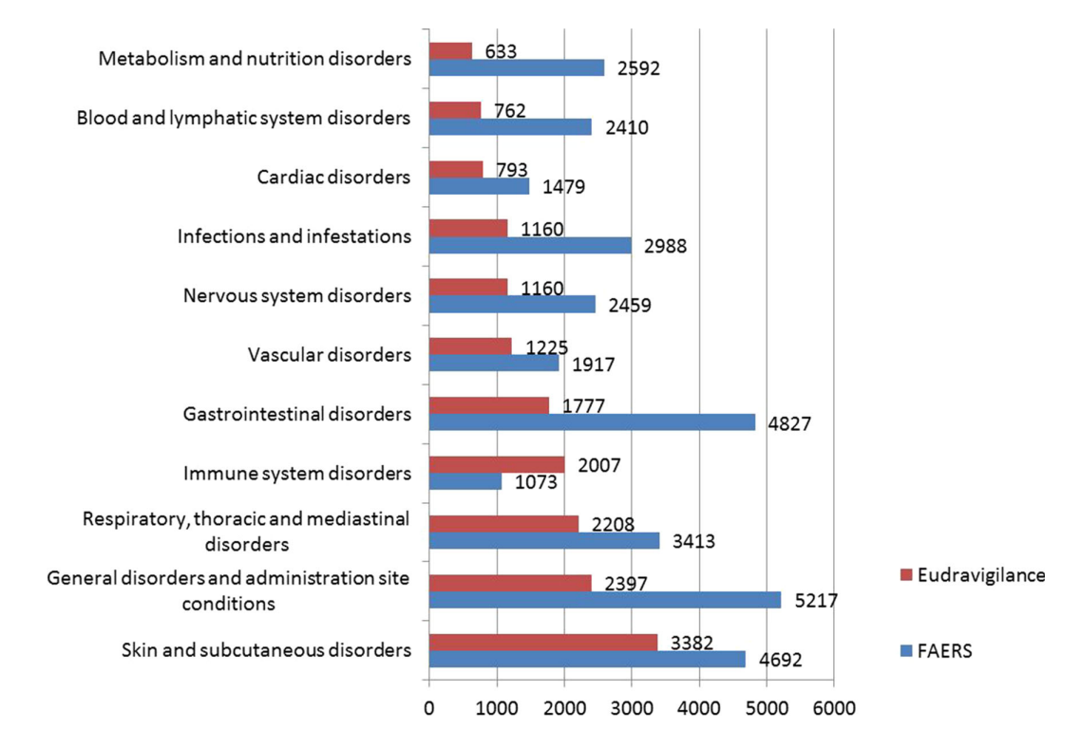

Fig. 1 Numbers of cases of ADRs reported in EudraVigilance and FEARS
（Cited from Fornasier, G）[12]

Adverse drug reactions(ADRs) of Cetuximab
Cetuximab is generally well tolerated. The most common ADRs are related to the inhibition of EGFR and the way of administration. The main ADRs include skin reaction, hypomagnesemia, mucositis and transfusion related reactions[2,13,14]. Although there are many GDs, they are mentioned after the above ADRs in all reports. It should be noted that GDs jump to the most important ADRs after the application of cetuximab combined with chemotherapy. It is reported by Eudra Vigilanc and FAERS database that GDs cause a high incidence of ADRs ,just next to skin reactions, infusion related reactions and mucositis.However, skin reactions in most cases are mild or just show as moderate rashes[15,16].We reviewed many clinical studies and find that severe rashes are scarce. The infusion related reactions are recurring but can be effectively controlled by conventional antihistamines and corticosteroids. Although digestive tract is not directly related to skin reaction and infusion reaction, its condition is closely related to the nutrition and immune state of patients, which is the basis of ADRs tolerance. As EGF regulates the activity and distribution of TRPM6 and mutation in the EGFR gene( Found by Thebault、Groenestege et al), cetuximab acts on the EGFR of kidney result in hypomagnesemia[17]. Controling GDs , especially diarrhea, is the first choice to alleviate hypomagnesemi[13]. Remarkably, in terms of mucositis, most of the reports focused on the lesions of oral mucosa. But facts we can't ignore are mucosa is widely distributed in the digestive tract and EGFR is widely expressed there[18], so GDs are symptoms of mucositis in the digestive tract. Several studies also confirmed that diarrhea and intestinal mucositis keep a direct causal relationship. To sum up, GDs play important roles in all major ADRs of cetuximab.

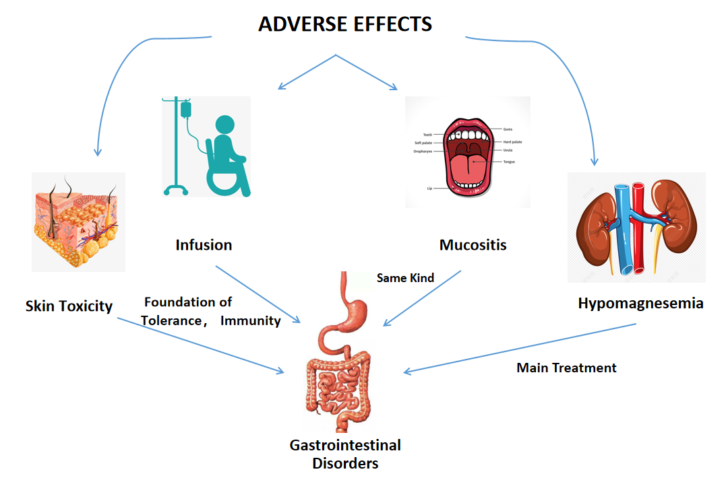
Fig. 2 The role of gastrointestinal disorders in major adverse drug reactions

In addition, many studies have found that GDs are not only closely related to the ADRs after the application of anti-tumor drugs, but also through multiple channels, affect the anti-tumor effect of drugs , the progress of tumor and the prognosis of colorectal patients. This review found that the impact is multifaceted mainly including intestinal mucosal barrier（IMB）、gut microbiota(GM)- host immune balance and microbial metabolites.To be noted, they interact with each other. Next, we will elaborate these three aspects.
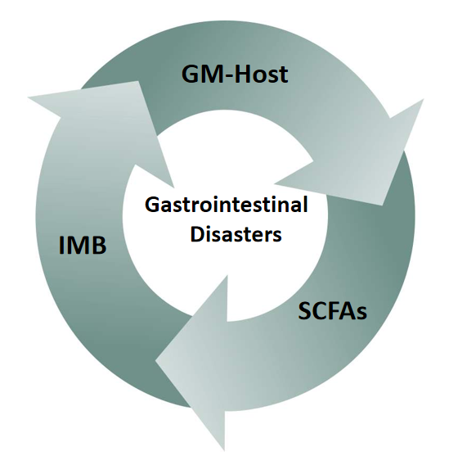
Fig. 3 IMB(intestinal mucosal barrier) , GM(gut microbiota)-host immune balance , Short Chain Fatty Acids(SCFAs) interact causing Gastrointestinal Disasters(GDs)

The destruction of intestinal mucosal barrier（IMB) induces GDs, and contributes to tumor growth microenvironment
The destruction of intestinal mucosal barrier（IMB）is a vital part to induce mucositis[17,19]. Mucositis in gastrointestinal tract is one of the major ADRs of cetuximab, which jump to the first place when combined with irinotecan and FOLFOX. The main mechanism is EGFR inhibition. EGFR is widely distributed in the digestive tract[18], 25% - 77% of colorectal cancer EGFR overexpress it[18]. We review and find EGFR inhibitors affect almost all of the major components of IMB.IMB can broadly be divided into physical barrier and chemical barrier.The physical barrier consists of four types of intestinal epithelial cells: absorptive intestinal cells, goblet cells producing mucin, paneth cells producing antimicrobial peptide (AMP) and endocrine cells produced by hormones.The chemical barrier mainly consists of mucus layer full of mucin, AMP and secretory IgA (sIgA). Mucin is the skeleton of mucus layer and work as isolation. IgA and AMP can kill GM directly and work with mucin to isolate bacteria from intestinal epithelial cells, including symbionts[20]. Yasuda-Onozawa et al. find that EGFR / Akt serine / threonine kinase 1 pathway can induce the expression of mucin 2, oligomeric mucus / gel forming (MUC2) mRNA and promote the production of mucin in goblet cells[21].Obviously, EGFR inhibitors will reduce the production of mucin. The integrity of IMB is difficult to maintain when mucin production reduce. GM and other components in the gut will directly break through the gap of IMB and contact with intestinal epithelial cells, result in mucosal inflammation.

This may be the initial mechanism of EGFR inhibitor leading to GDs, and then it also directly or indirectly induce multiple domino effects. Butyrate, a bacterial metabolite, has been shown to increase mucin secretion. It will significantly reduce as GM disordered by drug and Inflammatory environment. As a result , mucin production get further reduced[22]. ErbB 3 is a member of EGFR family which inhibit of Atoh 1 level,through PI3K mediated, to limit the number of paneth cells. AMP will reduce after that[23]. Dendritic cells(DCs) are activated in the inflammatory state and induce B cells to produce IgA. Although AMP and IgA increased by EGFR inhibitor can kill more Invasive GM, they can not act as a barrier physically. In addition, suitable reaction place for AMP and IgA decrease due to mucin deficiency. So increasing AMP and IgA can't completely prevent bacteria from contacting intestinal epithelial cells. On the contrary, killing GM extensively makes butyrate production reduce obviously . That aggravate the lack of mucin. More than that, it has been found that inflammation leads to the high permeability in and between epithelial cells, and diarrhea make effective components of IMB loss a lot which aggravates the damage of barrier[24].

Besides, the status of IMB is closely related to tumor growth environment and prognosis of mCRC. Since 1863, inflammation has been recognized as a high risk factor for cancer[25,26]. Less than 10% of cancers are caused by gene mutations, and more than 20% are related to microbial infection[27]. Chronic inflammation is a recognized risk factor for CRCs[28]. Most of the patients with mCRC have chronic inflammation. The inflammation caused by drugs and tumor rejection aggravate the original intestinal inflammation. After IMB destructed, the immune response and inflammatory response induce the proliferation and differentiation of a variety of immune cells which product a large number of cytokines, forming a microenvironment for tumor growth which is related to the occurrence, maintenance and development of tumor[29]. Therefore, destruction of IMB caused by EGFR inhibitor initiates the mucositis in gut , not only contributes to ADRs, but also antagonizes the curative effect of anti-tumor drugs resulting a profound impact on the prognosis.

The destruction of GM-Host immune balance impact the prognosis of mCRC
The immune balance between gut microbiota(GM) and host is the result of coevolution. The host provides a stable environment for GM, while GM have a wide range of functions, affecting the occurrence and development of various diseases. The gut immune system must maintain a delicate balance between tolerance and immunity[30]. It is found that this effect is realized by butyrate. Butyrate is a kind of short chain fatty acids (SCFAs), the main metabolite of intestinal bacteria. It can inhibit the differentiation of bone marrow stem cells into DCs, so as to make host keep immunoreactivity at a low-level. Drugs, especially antibiotics and anti-tumor drugs directly make the destruction of GT-Host immune balance ,more significantly than diet and inflammation[31,32]. Compared with intravenous administration, oral drugs impact the intestinal environment much more directly[33]. A study shows that cetuximab combined with XELOX can not significantly improve OS and PFS of patients with mCRC comparing with XELOX merely[34]. And a meta-analysis also show that FOLFOX plus cetuximab is better for intravenous administration[35].These suggest that the intestinal environment influence the drug efficacy.In the following, we will illustrate this effect from two aspects: host and GMs.

In terms of the host, a variety of immune cells in the host are activate by inflammation and immune response, among which the proliferation and differentiation of DCs up-regulate of the proportion of B cells and T (Th1, Th2, Th17, Treg) cells leading to chemotherapy-induced enteritis and other side effects[36,37]. On the other side, some growth factors, reactive oxygen species, nitrogen increase persisting damage DNAs under and even after the inflammatory state.As a result, genes are permanent changed and cancer may come and develop with it[29,38].

It should be noted that the proliferation and differentiation of DC induced by intestinal bacteria are achieved because bacterial translocate and contact with intestinal epithelial cells under pathological conditions, while under normal circumstances, DCs are inhibited by their metabolites: butyrate which can pass IMB easily but bacterials face many difficulties. Concetta Panebianco also confirmed that the immune effect from bacterial to host is not realized by its translocation but metabolite[37]. This fully explains why host immune system can be activated by GM, as well as inhibited by it.
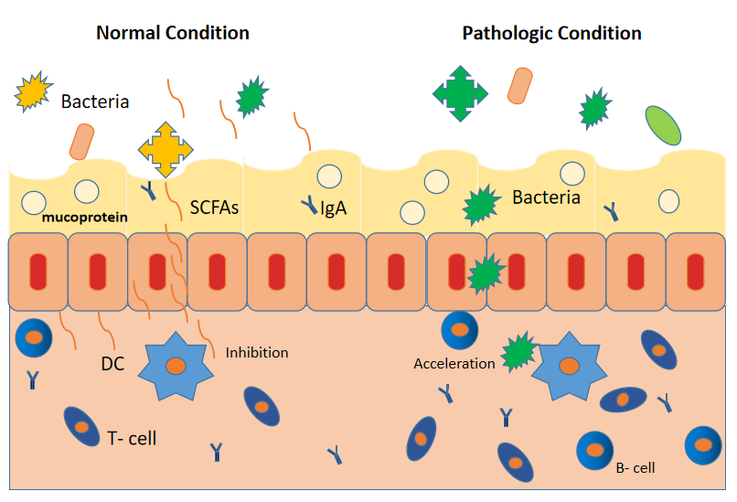
Fig. 4 The action mode of IBM, GT-Host , SCFAs working under normal condition versus pathologic condition

To be precise, GM include bacteria, viruses, fungi and so on. We're focused on bacteria because of their dominance. GMs disorder caused by drugs are mainly manifested in the decrease of quantity and type. Studies about patients treated with irinotecan and FOLFOX detecte that the number and species of intestinal bacteria indecreased in different degrees by 16S rRNA gene detection[33]. What's more, the decrease in GM is associated with the increase of CRCs morbidity already found by epidemiological investigation[37].Studies also found bacteria prefer to degrade mucin as its carbon source when lacking dietary fiber, which further aggravates the damage of IMB, makes more bacteria contact with intestinal epithelial cells and promotes the formation of tumor microenvironment in the host gut[39]. But whether this phenomenon exists under the application of drugs has not been studied.

Therefore, as an important chain reaction after the destruction of IMB caused by EGFR inhibitor, the destruction of GM-Host immune balance is an essential mechanism of GDs and affects the drug efficacy and prognosis of mCRC.

Short chain fatty acids have anti-inflammatory and anti-tumor effects.
It can be seen from the above that the integrity of IMB and the immune balance between GM and host are interdependent and interacted, short chain fatty acids(SCFAs) are running with them working as important media and signal. SCFAs, a metabolite of bacteria degraded from dietary fiber, include acetate, propionate and butyrate[40]. Many studies find that GM exert an anti-tumor effect mainly through their metabolites. Firstly, propionate and butyrate have the effect of histone deacetylase(HDAC) inhibitors, which have been widely used in cancer treatment. Propionate and butyrate will decrease because of bacteria damaged by antitumor drugs, as a result, the anti-tumor power of the host itself is clipped[41]. Secondly, Singh and Brown find SCFAs (such as acetate) play a protective signal molecule acting on GPR109A and GPR43 / 41 receptors in gastrointestinal tract[42-44]. In addition, we can also find the relationship between SCFAs and cetuximab in these studies. Tumor location is an important factor somewhat deciding the reactivity of cetuximab[45]. Colorectal cancer is usually classified as left and right by location. Tumors on the left come from the flexure of the spleen, the descending colon and the sigmoid colon; tumors on the right come from the cecum, the ascending colon, the flexure of the liver and the transverse colon. Multiple studies show that EGFR inhibitors are superior to left colon cancer with RAS wild-type comparing with the right. It is recommended that patients with left RAS wild type colon cancer should be given priority to use EGFR inhibitors[46-48]. Interestingly, SCFAs show a remarkable distribution and absorption gradient[40]. SCFAs are well absorbed in the distal colon, but not fully absorbed in the proximal colon. KOH et al think that the transport effect of Na coupled monocarboxylate transporter SLC5A8 and H coupled low af-Finity quality monocarboxylate transporter SLC16A, which makes the absorption efficiency of SCFAs greater in the distal colon than that in the proximal[30]. SCFAs will only play a biological role on the host after absorbed. As SCFAs have been proved to be effective intestinal mucosal protective agent and have antitumor function, we can find the absorption efficiency of SCFAs may be related to the tumor location sensitivity of cetuximab in colon. However, due to the reason why the difference in the positional sensitivity of cetuximab exist in colon is not clear, the specific mechanism of SCFAs related to the positional sensitivity of cetuximab is still lack of research.But we can find there is a correlation between the efficacy of cetuximab and SCFAs.

CONCLUSION
Most ADRs of cetuximab are related to the inhibition of EGFR and the way of administration. They are skin reaction, hypomagnesemia, mucositis and transfusion related reactions. The GDs such as diarrhea and nausea are recurring . After the application of cetuximab combined with chemotherapy, the ADRs of digestive tract become the main aspect. GDs are the manifestation of mucositis in digestive tract. The digestive tract condition is closely related to the nutritional status and immune status of the human body , which is the basis of the ADRs’ tolerance such as skin reaction and infusion reaction. Moreover, the management of the digestive tract is the necessary measure for the treatment of hypomagnesemia. The integrity of IMB, GT-Host immune balance and the biological effect of bacteria metabolite SCFAs are related to the intestinal mucositis after the application of cetuximab. GDs are not only closely related to the ADRs in the digestive tract, but also have effects on the drug reactivity and efficacy , and then influence the progress of mCRC and prognosis of colorectal patients.

Recently, more and more studies found that probiotics and prebiotics can restore the balance between GM and host immune system, reduce ADRs and improve the anti-tumor effect[49]. Probiotics have been proved to be a safe and beneficial choice, and there is no randomized clinical trial having reported that probiotics will increase the risk of adverse reactions compared with placebo[39,50]. Therefore, we suggest taking measures to maintain IMB, regulate GM-Host immune balance and control intestinal bacterial metabolism when applicating of cetuximab monotherapy or combined with chemotherapy. Probiotics and prebiotics will be promising measures to alleviate the ADRs of cetuximab, improve the cetuximab efficacy the prognosis of mCRC.

Declaration
Conflict of Interest: The authors declare that they have no conflict of interest.

References:
1. Lenz HJ: Anti-EGFR mechanism of action: antitumor effect and underlying cause of adverse events. Oncology (Williston Park) 2006;20:5-13.
2. Lenz HJ: Cetuximab in the management of colorectal cancer. Biologics 2007;1:77-91.
3. Vincenzi B, Schiavon G, Silletta M, et al.: The biological properties of cetuximab. Crit Rev Oncol Hematol 2008;68:93-106.
4. Fink K, Boratynski J: [The role of metalloproteinases in modification of extracellular matrix in invasive tumor growth, metastasis and angiogenesis]. Postepy Hig Med Dosw (Online) 2012;66:609-628.
5. Li X, Fan Z: The epidermal growth factor receptor antibody cetuximab induces autophagy in cancer cells by downregulating HIF-1alpha and Bcl-2 and activating the beclin 1/hVps34 complex. Cancer Res 2010;70:5942-5952.
6. Shuman ML, Jensen-Taubman S, Stetler-Stevenson WG: Matrix metalloproteinases: changing roles in tumor progression and metastasis. Am J Pathol 2012;181:1895-1899.
7. Cunningham D, Humblet Y, Siena S, et al.: Cetuximab monotherapy and cetuximab plus irinotecan in irinotecan-refractory metastatic colorectal cancer. N Engl J Med 2004;351:337-345.
8. Misale S, Di Nicolantonio F, Sartore-Bianchi A, et al.: Resistance to anti-EGFR therapy in colorectal cancer: from heterogeneity to convergent evolution. Cancer Discov 2014;4:1269-1280.
9. Van Cutsem E, Kohne CH, Lang I, et al.: Cetuximab plus irinotecan, fluorouracil, and leucovorin as first-line treatment for metastatic colorectal cancer: updated analysis of overall survival according to tumor KRAS and BRAF mutation status. J Clin Oncol 2011;29:2011-2019.
10. Laurent-Puig P, Cayre A, Manceau G, et al.: Analysis of PTEN, BRAF, and EGFR status in determining benefit from cetuximab therapy in wild-type KRAS metastatic colon cancer. J Clin Oncol 2009;27:5924-5930.
11. Nagata Y, Lan KH, Zhou X, et al.: PTEN activation contributes to tumor inhibition by trastuzumab, and loss of PTEN predicts trastuzumab resistance in patients. Cancer Cell 2004;6:117-127.
12. Fornasier G, Francescon S, Baldo P: An Update of Efficacy and Safety of Cetuximab in Metastatic Colorectal Cancer: A Narrative Review. Adv Ther 2018;35:1497-1509.
13. Hofheinz RD, Segaert S, Safont MJ, et al.: Management of adverse events during treatment of gastrointestinal cancers with epidermal growth factor inhibitors. Crit Rev Oncol Hematol 2017;114:102-113.
14. Lacouture ME, Anadkat MJ, Bensadoun RJ, et al.: Clinical practice guidelines for the prevention and treatment of EGFR inhibitor-associated dermatologic toxicities. Support Care Cancer 2011;19:1079-1095.
15. Pinto C, Barone CA, Girolomoni G, et al.: Management of skin toxicity associated with cetuximab treatment in combination with chemotherapy or radiotherapy. Oncologist 2011;16:228-238.
16. Van Cutsem E, Tejpar S, Vanbeckevoort D, et al.: Intrapatient cetuximab dose escalation in metastatic colorectal cancer according to the grade of early skin reactions: the randomized EVEREST study. J Clin Oncol 2012;30:2861-2868.
17. Roskoski RJ: The ErbB/HER family of protein-tyrosine kinases and cancer. Pharmacol Res 2014;79:34-74.
18. Bronte G, Cicero G, Cusenza S, et al.: Monoclonal antibodies in gastrointestinal cancers. Expert Opin Biol Ther 2013;13:889-900.
19. Marchesi JR, Adams DH, Fava F, et al.: The gut microbiota and host health: a new clinical frontier. Gut 2016;65:330-339.
20. Sanchez DMF, Romero-Calvo I, Mascaraque C, Martinez-Augustin O: Intestinal inflammation and mucosal barrier function. Inflamm Bowel Dis 2014;20:2394-2404.
21. Yasuda-Onozawa Y, Handa O, Naito Y, et al.: Rebamipide upregulates mucin secretion of intestinal goblet cells via Akt phosphorylation. Mol Med Rep 2017;16:8216-8222.
22. Gaudier E, Jarry A, Blottière HM, et al.: Butyrate specifically modulates MUC gene expression in intestinal epithelial goblet cells deprived of glucose. American Journal of Physiology - Gastrointestinal and Liver Physiology 2004;287:1168-1174.
23. Almohazey D, Lo Y, Vossler CV, et al.: The ErbB3 receptor tyrosine kinase negatively regulates Paneth cells by PI3K-dependent suppression of Atoh1. Cell death and differentiation 2017;24:855-865.
24. Anbazhagan AN, Priyamvada S, Alrefai WA, Dudeja PK: Pathophysiology of IBD associated diarrhea. Tissue Barriers 2018;6:e1463897.
25. Balkwill F, Mantovani A: Inflammation and cancer: back to Virchow? Lancet 2001;357:539-545.
26. Schmidt A, Weber OF: In memoriam of Rudolf virchow: a historical retrospective including aspects of inflammation, infection and neoplasia. Contrib Microbiol 2006;13:1-15.
27. de Martel C, Ferlay J, Franceschi S, et al.: Global burden of cancers attributable to infections in 2008: a review and synthetic analysis. Lancet Oncol 2012;13:607-615.
28. Medzhitov R: Origin and physiological roles of inflammation. Nature 2008;454:428-435.
29. Maeda H, Akaike T: Nitric oxide and oxygen radicals in infection, inflammation, and cancer. Biochemistry (Mosc) 1998;63:854-865.
30. Koh A, De Vadder F, Kovatcheva-Datchary P, et al.: From Dietary Fiber to Host Physiology: Short-Chain Fatty Acids as Key Bacterial Metabolites. Cell 2016;165:1332-1345.
31. Chang PV, Hao L, Offermanns S, Medzhitov R: The microbial metabolite butyrate regulates intestinal macrophage function via histone deacetylase inhibition. Proc Natl Acad Sci U S A 2014;111:2247-2252.
32. Singh N, Thangaraju M, Prasad PD, et al.: Blockade of dendritic cell development by bacterial fermentation products butyrate and propionate through a transporter (Slc5a8)-dependent inhibition of histone deacetylases. J Biol Chem 2010;285:27601-27608.
33. Panebianco C, Andriulli A, Pazienza V: Pharmacomicrobiomics: exploiting the drug-microbiota interactions in anticancer therapies. Microbiome 2018;6:92.
34. Sotelo MJ, Garcia-Paredes B, Aguado C, et al.: Role of cetuximab in first-line treatment of metastatic colorectal cancer. World J Gastroenterol 2014;20:4208-4219.
35. Chan DL, Pavlakis N, Shapiro J, et al.: Does the Chemotherapy Backbone Impact on the Efficacy of Targeted Agents in Metastatic Colorectal Cancer? A Systematic Review and Meta-Analysis of the Literature. PLoS One 2015;10:e135599.
36. Karin M, Clevers H: Reparative inflammation takes charge of tissue regeneration. Nature 2016;529:307-315.
37. Sivan A, Corrales L, Hubert N, et al.: Commensal Bifidobacterium promotes antitumor immunity and facilitates anti-PD-L1 efficacy. Science 2015;350:1084-1089.
38. Grivennikov SI, Greten FR, Karin M: Immunity, inflammation, and cancer. Cell 2010;140:883-899.
39. De Almeida CV, de Camargo MR, Russo E, Amedei A: Role of diet and gut microbiota on colorectal cancer immunomodulation. World J Gastroenterol 2019;25:151-162.
40. Cummings JH, Pomare EW, Branch WJ, et al.: Short chain fatty acids in human large intestine, portal, hepatic and venous blood. Gut 1987;28:1221-1227.
41. Johnstone RW: Histone-deacetylase inhibitors: novel drugs for the treatment of cancer. Nat Rev Drug Discov 2002;1:287-299.
42. Brown AJ, Goldsworthy SM, Barnes AA, et al.: The Orphan G protein-coupled receptors GPR41 and GPR43 are activated by propionate and other short chain carboxylic acids. J Biol Chem 2003;278:11312-11319.
43. Singh N, Gurav A, Sivaprakasam S, et al.: Activation of Gpr109a, receptor for niacin and the commensal metabolite butyrate, suppresses colonic inflammation and carcinogenesis. Immunity 2014;40:128-139.
44. Le Poul E, Loison C, Struyf S, et al.: Functional characterization of human receptors for short chain fatty acids and their role in polymorphonuclear cell activation. J Biol Chem 2003;278:25481-25489.
45. Modest DP, Stintzing S, von Weikersthal LF, et al.: Exploring the effect of primary tumor sidedness on therapeutic efficacy across treatment lines in patients with metastatic colorectal cancer: analysis of FIRE-3 (AIOKRK0306). Oncotarget 2017;8:105749-105760.
46. Cao DD, Xu HL, Xu XM, Ge W: The impact of primary tumor location on efficacy of cetuximab in metastatic colorectal cancer patients with different Kras status: a systematic review and meta-analysis. Oncotarget 2017;8:53631-53641.
47. Holch JW, Ricard I, Stintzing S, et al.: The relevance of primary tumour location in patients with metastatic colorectal cancer: A meta-analysis of first-line clinical trials. Eur J Cancer 2017;70:87-98.
48. Tejpar S, Stintzing S, Ciardiello F, et al.: Prognostic and Predictive Relevance of Primary Tumor Location in Patients With RAS Wild-Type Metastatic Colorectal Cancer: Retrospective Analyses of the CRYSTAL and FIRE-3 Trials. JAMA Oncol 2017;3:194-201.
49. Pandey KR, Naik SR, Vakil BV: Probiotics, prebiotics and synbiotics- a review. J Food Sci Technol 2015;52:7577-7587.
50. Mego M, Holec V, Drgona L, et al.: Probiotic bacteria in cancer patients undergoing chemotherapy and radiation therapy. Complement Ther Med 2013;21:712-723.

