Study on antitumor effect of pcDNA3.1(-)/rMETase-shUCA1 hyaluronic acid modified G5 PAMAM nanoparticles on gastric cancer
Running title: HA-G5 PAMAM-Au-METase-shUCA1 targets GC
Zhenxing Huang¹ , Chunying Xie^{1*} , Zhaohui Huang¹ , yanyan Guo¹ , Xue Zhang¹
¹ Department of Oncology, The Second Affiliated Hospital Of Nanchang University, Nanchang, China.
*Corresponding author: Chunying Xie
Mailing address: Department of Oncology The Second Affiliated Hospital Of Nanchang University, Nanchang, China. Address: No.1 Mind Road , donghu district city , Nanchang.
TEL: 13870688880
E-mail:516467669@qq.com

Abstract
Background: Recently, rMETase has been widely exploited as a chemotherapeutic option during gastric cancer (GC) treatment. The present experiment utilized the pcDNA3.1(-)/rMETase-shUCA1 complex, and hyaluronic acid (HA) modified G5 PAMAM nanoparticles, to evaluation antitumor function of the nanocarrier in gastric cells. Methods: The characteristic of nanoparticles was analyzed by TEM and DLS methods. The viability and invasion of GC cells were examined by CCK-8 assays. The levels of CD44, p-mTOR and c-caspase 3 were examined by western blot. In addition, nude mice xenograft models were established to evaluate the effect of HA-PAMAM-Au-METase-shUCA1 on GC cell lines. Results: The transfection of rMETase, alone and in combination with shUCA1 carried by HA-G5 PAMAM-Au visibly inhibited the viability, invasion and tumorsphere formation of GC cells, and obviously enhanced METase activity. Moreover, GC cells UCA1 siRNA significantly decreased the level of p-mTOR and increased c-caspase 3 expression, while this effect could be reversed by mTOR activator MHY 1485. Through in vivo study, CD44 positive cells number in nude mice caudal vein injected with HA-G5 PAMAM-Au-METase-shUCA1 was markly declined resulting in the inhibition of tumor growth. Conclusion: Nanoparticle HA-G5 PAMAM-Au-METase-shUCA1 significantly suppressed tumor growth and deterioration of GC through mTOR pathway.

Introduction
Gastric cancer remained one of the common causes of caner-related deaths [1] and presented a high incidence in China. During the past few decades, the development of chemotherapy, radiotherapy and surgical techniques for GC treatment [2] have made substanially improved, yet large numbers of GC patients were diagnosed as advanced or metastatic gastric carcinoma, and the prospect for GC patients was not optimistic [3]. Recombinant methioninase (rMETase) was widely used as a therapeutic strategy for GC in clinic [4], while rMETase resistance was still a major cause of therapeutic failure [5], which leading to cancer recurrence and cancer related death. Therefore, investigation into the molecular mechanism was urgently warranted.
Gene therapy can be an innovative therapeutic modality for advanced gastric carcinoma [6]. With the advance in gene therapies, more and more genes were found to be a key role in GC treatment. Urothelial carcinoma-associated 1 (UCA1) was a long non-coding RNA (lncRNA) with three exons that encode a 1.4 kb isoform and a 2.2 kb [7]. Several researchers have observed that UCA1 played an important role in tumorigenesis through DNA rearrangements or amplifications in non-small cell lung cancer [8] and hepatocellular carcinoma [9]. UCA1 was found to be up-regulated in GC cells and TGFβ1-induced UCA1 upregulation promoted GC cell invasion and migration [10]. Fang and his team indicated that UCA1 increased multi-drug resistance of GC via downregulating miR-27b [11]. Taken together, UCA1 could be used as a potential target and a therapeutic strategy for GC.
Nanoparticles, acted as a new material of nanometer particles, have been widely used to improve the limitations of the traditional administration because of its good biocompatibility and low toxicity in vivo, biodegradability and easy for solid tumor penetration and retention effect [12, 13]. Moreover, appropriate chemical modification of nanoparticles could directively targeted and effectively kill tumor cells to avoid systemic medication [14]. Polyamidoamine (PAMAM) dendrimers with the characters of low toxicity and non-immunogenicity were used to combine genes to format gene delivery systems. In addition, hyaluronic acid (HA) with good biocompatibility and aqueous solubility was reported to be a receptor of CD44 [15], which was closely associated with tumor invasion and metastasis [16], thus HA has been widely used as a modification of tumor cells. The resistance time of drug in blood was also elevated by nanocarriers with the decoration of HA via the decrease of opsonization. Therefore, in the current study, we established HA modified the fifth-generation polyamidoamine (G5 PAMAM) nanoparticles loaded with rMETase and UCA1 gene and explored the targeting and antitumor effects of PAMAM with HA decoration carrying Au-METase on GC cells, which providing theoretical basis for further treatment of GC.

Materials and methods
Nanoparticles preparation
HA modified G5 PAMAM nanoparticles was firstly prepared. HA (Lingbao Biological Technology Co., Ltd., Beijing, China) and G5 PAMAM (Sigma-Aldrich, USA) were dissolved in 0.1 M NaBH₄ buffer with PH = 8.5. Follwed by, the above mixture was developed into HA-G5 PAMAM polymer under the catalysis of NaBH₃CN at 40 °C for three days, in order to make the polymer possessing 5% grafting density. Then, the reaction solution was dialyzed in dialysis container, after dialysis and lyophilization, HA-G5 PAMAM was completed. The procedure of HA-G5 PAMAM-Au preparation was follows: the previous prepared HA-G5 PAMAM and chloroauric acid (HAuCl₄) was mixed at the mole ratio of 25:1, and NaBH₄ solution was added into the complex. The Au nanoparticles encapsulated in the interior cavities of HA-G5 PAMAM molecules were completed. Recombinant plasmid containing methioninase (rMETase) was synthesized by Company (Shionogi Co., Ltd., Osaka, Japan). HA-G5 PAMAM-Au complex was dissolved by PBS buffer at a concentration of 2 mg/mL, and the pcDNA-METase was added into the solution, and the mixture was incubated at room temperature for 15-30 min, then HA-G5 PAMAM-Au-pcDNA was completed. Agarose gel electrophoresis was used to estimate the efficiency of HA-G5 PAMAM-Au-pcDNA.

Characterization
Transmission electron microscopy (TEM) was used to examin nanoparticles morphology at 200 kV on JEOL-100CXII (Japan). Nanoparticle solutions were put on a copper grid coated with film to be determined. Average particle size and size distribution were determined through quasi elastic laser ight scattering with a Malvern Zetasizer (Malvern Instruments Limited, United Kingdom) at 25 °C. Zeta potentials of nanoparticles were recorded in deionized water solution.

Cell culture and transfection
Human gastric cancer cell line NCI-N87 cells used in the current study were obtained from American Type Culture Collection (ATCC, USA). NCI-N87 cells were maintained in Dulbecco's modified eagle medium (DMEM, Sigma, USA) cell culture media supplemented with 10% (v/v) heat-inactivated fetal bovine serum (FBS, Sigma, USA), 2 mM glutamine, 100 units/mL penicillin, 100 μg/mL streptomycin under a humidified atmosphere of 5% CO₂ at 37 °C.
NCI-N87 cells were also collected and cultured in serum free high glucose DMEM medium containing 20 ng/mL epidermal growth factor (EGF) and 10 ng/mL basic fibroblast growth factor (bFGF). NCI-N87 cells were cultured to be spheroids, CD44 positive cells were sorted by a magnetic-activated cell sorting (MACS) system (Miltenyi Biotech, San Diego, CA). After collecting spheroids, NCI-N87 gasric cancer stem cells (CD44⁺ NCI-N87) were obtained by magnetic beads method.
HA-PAMAM-Au, HA-PAMAM-Au-METase, HA-PAMAM-Au-shUCA1 and HA-PAMAM-Au-METase-shUCA1 nanoparticles were transfected into NCI-N87 or NCI-N87 CSC cells by Lipofectamine 2000 (Invitrogen, San Diego, CA, USA).

Cell viability assay
Cell viability was detected by CCK-8 assay in strictly accordance with the kit’s requirements. NCI-N87 or NCI-N87 CSC cells were dissociated with Accutase® cell dissociation buffer (Life Technologies Corporation, USA), resuspended and seeded in 96-well microplates at 1.0×10³ cells/well. Volume of 10 μL CCK-8 was added to each well at the time of harvest, according to the manufacturer’s instructions. The plate was incubated for 2 h at 37 °C and then cell survival and viability were recorded by measuring the absorbance of the converted dye at 450 nm on a Spectra Max M5 microplate reader (Molecular Devices, USA).

Cell invasion assay
NCI-N87 cells or NCI-N87 CSC cell were placed on the upper chamber (pore size of 8 μm, Corning) of each insert coated with 40 μL of 2 mg/mL Matrigel (growth factor reduced BD MatrigelTM matrix), and 600 μL of DMEM with 20% FBS was added to the lower part of the chamber. After incubating for 24 h, the chambers were disassembled, and the membranes were stained with a 2% crystal violet solution for 10 min and placed on a glass slide. Then, cells that had migrated across the membrane were counted in five random visual fields using a light microscope. All assays were performed three independent times in triplicate.

METase activity assay
The METase activity of cells were measured according to the method of previous study. Briefly, GC cells transfected with different vectors were collected and homogenized by sonication for 1 min with centrifugation at 14,000 rpm for 10 min. METase activity was measured in the supernatant by determining a-ketobutyrate production from 10 mM methionine by using 3-methyl-2-benzo-thiazoline hydrazone. The amount of reaction product was measured with a Hitachi model U-2000 spectrophotometer (Hitachi, Tokyo, Japan) at OD = 335 nm.

RNA isolation and qRT-PCR
Total RNA was extracted from cells with Trizol reagent (Invitrogen, USA) according to the manufacture’s instructions. cDNA was reverse-transcribled by a reverse-transcription kit (Takara, Dalian, China). Real-time PCR analysis was conducted on an Applied Bio-system 7500 instrument by using SYBR Green PCR Master Mix (Applied Biosystems, Foster City, CA, USA). The relative expression of UCA1 was calculated using the 2^{-△△CT} method. The CT values were normalized using GAPDH as internal control.

Western blot analysis
Total proteins were extracted from cells with RIPA buffer containing protease inhibitors (Beyotime Institute of Biotechnology, Shanghai, China) on ice, and samples were then subjected to SDS-PAGE and electrophoretically transferred to PVDF membranes. After non-specific binding was blocked with 5% nonfat milk at room terperature for 2 h, membranes were incubated with each primary antibody from Abcam (MA, USA), including CD44, c-caspase 3, p-mTOR, t-mTOR and β-actin overnight at 4 °C. Then, these membranes were washed and incubated with HRP-conjugated secondary antibody (Santa Cruz Biotechnology, USA) for 2 h. Immunoblots were visualized by enhanced chemiluminescence (ECL kit, Santa Cruz Biotechnology, USA) and recorded with ChemImager 5500 V2.03 software. The relative integrated density values were calculated with β-actin as an internal control.

Nude mice xenograft models
A total of 40 BALB/c nude mice (female, 6-8-weeks old) were purchased from the Experimental Animal Center of Shanghai Cancer Institute, and maintained in filter-topped cages with standard rodent chow and water made available ad libitum. Experiments were performed according to national regulations and approved by the The Second Affiliated Hospital Of Nanchang University ethical committee. Subcutaneous gastric cancer was induced via inoculation of 1 × 10⁷ mouse NCI-N87 cells in the flank. The mice were caudal vein injected with HA-G5 PAMAM-Au, HA-G5 PAMAM-Au-METase, HA-G5 PAMAM-Au-shUCA1 and HA-G5 PAMAM-Au-METase-shUCA1 on d 2, d 5, d 10 and d 15. The tumor-bearing mice were sacrificed on d 30 and the tumor volume was calculated by the equation: volume (mm³) = length × width ²/2.

Statistical analysis
Data were presented as the mean ± standard error mean (SEM). All experimental results were statistically analyzed with Student’s t-test or one-way analysis of variance (ANOVA). All statistical analysis were performed with SPSS 18.0 statistical software, with P<0.05 considered as statistically significant.

Results
The characteristic of nanoparticle
The morphological characteristic of HA-G5 PAMAM-Au was observed by TEM. Results showed that the particle size distribution of Au nanoparticles (AuNPs) was about 50 nm, also HA-G5 PAMAM-Au carrier presented irregular sphere and good dispersion (Figure 1A). The zeta potential of HA-G5 PAMAM-Au-METase-shUCA1 detected by dynamic light scattering (DLS) assay were around 10.7 mV (Figure 1B). The hydrated particle size of HA-G5 PAMAM-Au-METase-shUCA1 was about 206 nm(Figure 1C and 1D). In addition, the statistical results about hydrodynamic size (particle size in water) and zeta potential of various NPs was presented in Figure 1E.

Expression of nanoparticles in NCI-N87 and NCI-N87 CSC cells
NCI-N87 cells or NCI-N87 CSC cells were collected. The expression of CD44 at protein level and cell viability were detected by Western blot and CCK-8 method, respectively. We can see that CD44 showed higher protein expression in NCI-N87 CSC cells compared with that in NCI-N87 cells (Figure 2A). CCK-8 assay indicated that the carrier (HA-G5 PAMAM-Au) showed no obvious effect on cell viability with the concentrations below 200 μg/mL. Once the concentration reached or more than 200 μg/mL, the cell viability would be suppressed in two kinds of cells (Figure 2B). After gastric cancer cells NCI-N87 or NCI-N87 CSC were transfected with HA-G5 PAMAM-Au-METase or HA-G5 PAMAM-Au-METase-shUCA1 for 72 h, the METase activity in cellular supernatant were obvious increased (Figure 2C), while the expression of free MET was obviously decreased (Figure 2D) when compared with cells transfected HA-G5 PAMAM-Au. Moreover, relative UCA1 level was significantly reduced in NCI-N87 or NCI-N87 CSC cells transfected with HA-G5 PAMAM-Au-shUCA1 and HA-G5 PAMAM-Au-METase-shUCA1, as compared with that in cells treated with HA-G5 PAMAM-Au or HA-G5 PAMAM-Au-METase group (Figure 2E).

HA-G5 PAMAM-Au-METase-shUCA1 inhibited NCI-N87 cell viability and invasion
To determine the effect of nanoparticles on NCI-N87 cells, we divided cells into six groups, including HA-G5 PAMAM-Au group acted as control, HA-G5 PAMAM-Au-METase group, HA-G5 PAMAM-Au-shUCA1 group, HA-G5 PAMAM-Au-METase-shUCA1 group, HA-G5 PAMAM-Au-METase-shUCA1 + MHY 1485 (mTOR activator), HA-G5 PAMAM-Au-METase-shUCA1 + Rapamycin (mTOR inhibitor). Results presented that invasive cells were decreased in other five groups than that in the control group (Figure 3A). According to statistical analysis, we found that the best invasion of NCI-N87 cells suppression effect can be achieved in HA-G5 PAMAM-Au-METase-shUCA1 group. However, the number of invasive cells was significantly incresed in HA-G5 PAMAM-Au-METase-shUCA1 + MHY 1485 group as compared with HA-G5 PAMAM-Au-METase-shUCA1 group, and this effect could be reversed by Rapamycin supplymentation (Figure 3B). Meanwhile, the outcome of cell viability presented the similar trend as cell invasion (Figure 3C). Western blot analysis revealed that three vectors (HA-G5 PAMAM-Au-METase, HA-G5 PAMAM-Au-shUCA1, HA-G5 PAMAM-Au-METase-shUCA1) inhibited p-mTOR expression and promoted c-caspase3 level; Nevertheless, this effect was alleviated in cells tranfected with HA-G5 PAMAM-Au-METase-shUCA1 and MHY 1485, and opposite results were presented in HA-G5 PAMAM-Au-METase-shUCA1 + Rapamycin group (Figure 3D).

HA-G5 PAMAM-Au-METase-shUCA1 inhibited NCI-N87 CSC cell viability and invasion
Similarly, to determine the effect of nanoparticles on NCI-N87 CSC cells, the groups were the same as the above. Three vectors (HA-G5 PAMAM-Au combined with METase or shUCA1or METase-shUCA1) suppressed cell invasive, and HA-G5 PAMAM-Au-METase-shUCA1 showed the strongest effect. The same effect of cell invasion inhibition was also presented in HA-G5 PAMAM-Au-METase-shUCA1 + Rapamycin group, while this effect was mitigated by adding mTOR activator MHY 1485 (Figure 4A). Histogram of data statistics was shown in Figure 4B. Analogously, the results of cell viability were similar to those of cell invasion ability (Figure 4C). In addition, the level of p-mTOR was suppressed and the expression of c-caspase3 was increased in HA-G5 PAMAM-Au-METase, HA-G5 PAMAM-Au-shUCA1, HA-G5 PAMAM-Au-METase-shUCA1 group than those in control. However, this situation was reversed in HA-G5 PAMAM-Au-METase-shUCA1 + MHY 1485 group as compared with HA-G5 PAMAM-Au-METase-shUCA1 group. While HA-G5 PAMAM-Au-METase-shUCA1 + Rapamycin group showed the opposite result with HA-G5 PAMAM-Au-METase-shUCA1 + MHY 1485 group (Figure 4D).

HA-G5 PAMAM-Au-METase-shUCA1 inhibited tumor growth
Nanoparticles (HA-G5 PAMAM-Au, HA-G5 PAMAM-Au-METase, HA-G5 PAMAM-Au-shUCA1, HA-G5 PAMAM-Au-METase-shUCA1) were injected into tumor nude mice model. As demonstrated in Figure 5A, tumor volume was significantly reduced in other three groups than that of mice injected with HA-G5 PAMAM-Au. In addition, the result of immunohistochemistry (IHC) revealed that CD44 positive cells number in mice transfected with HA-G5 PAMAM-Au-METase, HA-G5 PAMAM-Au-shUCA1, HA-G5 PAMAM-Au-METase-shUCA1 was markly less than that in the control group (Figure 5B). Moreover, the level of p-mTOR was correspondingly decreased and the content of c-caspase3 was obviously enhanced in HA-G5 PAMAM-Au-METase, HA-G5 PAMAM-Au-shUCA1 and HA-G5 PAMAM-Au-METase-shUCA1 groups (Figure 5C).

Discussion
The mortality associated with GC was still a major problem worldwide [17]. However, conventional treatment strategies for GC were not yet adequate. The objective of the present study was to evaluate the effects of HA modified G5 PAMAM nanoparticles loaded with rMETase-shUCA1 on the growth and antitumor function for GC in NCI-N87 and NCI-N87 CSC cells.
GC was a major cause of cancer death in Asia and one of the most common cause of malignancy-related death [18]. In clinic, surgery and chemotherapy ect routine protocols were increasingly used for GC treatment, unfortunately, therapeutic effects of those methods were not optimistic and chemotherapeutic agents also had many side effects including drug resistance [19]. Moreover, previous studies showed that the chemotherapy resistance was associated with CSC with evidence that drug-resistant tumors displayed the enhanced expressions of CSC transcription factors [20]. The highly-expressed CD44 in the CSCs made the cells more highly tumorigenic and capable of originating heterogeneous tumors [21]. Similarly in our study, gastric CSCs showed high expression of CD44 and exhibited higher migration and the ability of tumorsphere formation.
In the treatment of diverse cancers, rMETase was widely utilized as a therapeutic option because of the strong ability to MET depletion [22]. Tan et al found that rMETase, alone and in combination with cisplatin (CDDP) had significant antitumor efficacy in colon cancer in vitro and in vivo [23]. In addition, through our previous research, results showed that rMETase-loaded stealth PLGA/liposomes modified with anti-CAGE scFV was effective for treatment of gastric garcinoma [24]. The present study indicated that over-expression of rMETase promoted METase activity and decreased free MET level, also suppressed the viability and invasion of GC cells that resulted in the elevated level of c-caspase 3 which was a protein associated with apoptosis.
Long non-coding RNAs (lncRNAs) were evolutionarily conserved non-protein coding RNAs with length more than 200 nucleotides [25]. UCA1 was an lncRNA involved in modulation of drug resistence in various cancer, for example, knockdown of UCA1 could increase the Tamoxifen sensitivity of breast cancer cells through inhibition of Wnt/β-catenin pathway [26]. UCA1 can also induce acquired resistance to EGFR-TKIs in EGFR-mutant non-small cell lung cancer by activating the AKT/mTOR pathway [27]. These findings suggest that UCA1 might be an important lncRNA modulating drug resistence. However, the underlying mechanisms remained largely unclear. In this study, we first compared the expression of UCA1 between NCI-N87 and NCI-N87 CSC GC cells. The results showed that silencing UCA1 cells had significantly lower expression of UCA1. Then, we further investigated the effect of UCA1 on anti-tumor effciency. Our data showed that both NCI-N87 and NCI-N87 CSC cells with UCA1 knockdown had significantly decreased cell viability and invasion, increased expression of c-caspase 3. Therefore, we decided to further investigate the underlying mechanism.
Previous studies reported that UCA1 upregulation can lead activation of mTOR pathway in multiple types of cancer cells [28]. For example, UCA1 conferred tamoxifen resistance to breast cancer cells partly via mTOR signaling pathway [7]. In non-small cell lung cancer, UCA1 may induce non-T790M acquired resistance to EGFR-TKIs by activating mTOR pathway and epithelial-mesenchymal transition (EMT) [29]. Therefore, we hypothesized that UCA1 might regulate GC progression via the mTOR signaling pathway. Our data showed that UCA1 siRNA significantly decreased the expression of p-mTOR in NCI-N87 and NCI-N87 CSC cells, and suppressed cell viability and invasion. These results suggest that UCA1 can activate mTOR signaling pathway in GC cells. The following functional study showed that MHY1485, an mTOR activator significantly abrogated the above effect of UCA1 on GC cells, suggesting that UCA1 modulated GC process at leaset partly via mTOR signaling pathway.
With the rapid development of nanotechnology in recent years, more and more nanoparticles and microparticle drug delivery systems generated from biodegradable polymers have been widely utilized for the treatment of various cancers [30, 31]. A major advantage of biodegradable synthetic microparticles was the ability to control the rate of drug release to obtain the desired local therapeutic concentrations by changing polymer structure and biodegradation rate [32]. Moreover, PAMAM dendrimers displayed great potential during the process of delivering drugs and genes owing to its high transfection efficiency and low toxicity [33]. HA modified PAMAM was beneficial to avoid macrophage phagocytosis through hydrophilic layer on nanoparticles [34]. In the current study, transfection of rMETase, alone and in combination with UCA1 gene carried by HA-G5 PAMAM visibly inhibited the proliferation, invasion and tumorsphere formation of GC, and promoted the expression of c-caspase 3 protein.

Conclusion
In conclusion, HA-G5 PAMAM-Au-METase-shUCA1 significantly suppressed tumor growth and deterioration of GC by targeting gastric cancer stem cells through mTOR pathway, suggesting that nanoparticles gene therapy can provide a safe and effective therapeutic option for gastric carcinoma.

Conflict of interest
None declared.

References
1. Shen, Y.H., et al., Expression level of microRNA-195 in the serum of patients with gastric cancer and its relationship with the clinicopathological staging of the cancer. European Review for Medical & Pharmacological Sciences, 2016. 20(7): p. 1283.
2. Peng, W., et al., Long non-coding RNA MEG3 functions as a competing endogenous RNA to regulate gastric cancer progression. Journal of Experimental & Clinical Cancer Research, 2015. 34(1): p. 79.
3. Shirong, C., et al., Survival of Proper Hepatic Artery Lymph Node Metastasis in Patients with Gastric Cancer: Implications for D2 Lymphadenectomy. Plos One, 2015. 10(3): p. e0118953.
4. Xin, L., et al., Stealth cationic liposomes modified with anti-CAGE single-chain fragment variable deliver recombinant methioninase for gastric carcinoma therapy. Journal of Nanoscience & Nanotechnology, 2013. 13(1): p. 178-83.
5. Yano, S., et al., Selective methioninase-induced trap of cancer cells in S/G2 phase visualized by FUCCI imaging confers chemosensitivity. Oncotarget, 2014. 5(18): p. 8729.
6. Zhu, X., et al., Gene therapy of gastric cancer using LIGHT-secreting human umbilical cord blood-derived mesenchymal stem cells. Gastric Cancer, 2013. 16(2): p. 155-166.
7. Wu, C. and L. Jing, Long Non-Coding RNA (lncRNA) Urothelial Carcinoma-Associated 1 (UCA1) Enhances Tamoxifen Resistance in Breast Cancer Cells via Inhibiting mTOR Signaling Pathway. Medical Science Monitor International Medical Journal of Experimental & Clinical Research, 2016. 22: p. 3860-3867.
8. Nie, W., et al., LncRNA-UCA1 exerts oncogenic functions in non-small cell lung cancer by targeting miR-193a-3p. Cancer Letters, 2016. 371(1): p. 99-106.
9. Xiao, J.N., et al., Long non-coding RNA UCA1 regulates the expression of Snail2 by miR-203 to promote hepatocellular carcinoma progression. Journal of Cancer Research & Clinical Oncology, 2017: p. 1-10.
10. Zuo, Z.K., et al., TGFβ1-Induced LncRNA UCA1 Upregulation Promotes Gastric Cancer Invasion and Migration. Dna & Cell Biology, 2017. 36(2): p. 159.
11. Fang, Q., X. Chen, and X. Zhi, Long Non-Coding RNA (LncRNA) Urothelial Carcinoma Associated 1 (UCA1) Increases Multi-Drug Resistance of Gastric Cancer via Downregulating miR-27b. Medical Science Monitor International Medical Journal of Experimental & Clinical Research, 2016. 22: p. 3506-3513.
12. Wang, X., et al., Increasing the cytotoxicity of doxorubicin in breast cancer MCF-7 cells with multidrug resistance using a mesoporous silica nanoparticle drug delivery system. International Journal of Clinical & Experimental Pathology, 2014. 7(4): p. 1337.
13. Abbasi, S., et al., Cationic albumin nanoparticles for enhanced drug delivery to treat breast cancer: preparation and in vitro assessment. Journal of Drug Delivery, 2012. 2012(2090-3014): p. 686108.
14. You, J., et al., Effective photothermal chemotherapy using doxorubicin-loaded gold nanospheres that target EphB4 receptors in tumors. Cancer Research, 2012. 72(18): p. 4777-86.
15. Ganesh, S., et al., In Vivo Biodistribution of siRNA and Cisplatin Administered using CD44-Targeted Hyaluronic Acid Nanoparticles. Journal of Controlled Release Official Journal of the Controlled Release Society, 2011. 172(3): p. 699-706.
16. Wang, Z., et al., Clinicopathologic correlation of cancer stem cell markers CD44, CD24, VEGF and HIF-1α in ductal carcinoma in situ and invasive ductal carcinoma of breast: An immunohistochemistry-based pilot study. Pathology Research & Practice, 2011. 207(8): p. 505-13.
17. Yin, P., et al., MiRNA-194 activates the Wnt/β-catenin signaling pathway in gastric cancer by targeting the negative Wnt regulator, SUFU. Cancer Letters, 2017. 385: p. 117-127.
18. Kim, Y.H., et al., AMPKα modulation in cancer progression: multilayer integrative analysis of the whole transcriptome in Asian gastric cancer. Cancer Research, 2012. 72(10): p. 2512-21.
19. Treasure, T., et al., Treasure T, Fallowfield L, Lees B, Farewell V. Pulmonary metastasectomy in colorectal cancer: the PulMiCC trial. Thorax, 2011. 67(2): p. 185-187.
20. L, W., et al., Cisplatin-enriching cancer stem cells confer multidrug resistance in non-small cell lung cancer via enhancing TRIB1/HDAC activity. Cell death & disease, 2017. 8(4): p. e2746.
21. Trapasso, S. and E. Allegra, Role of CD44 as a marker of cancer stem cells in head and neck cancer. Biologics Targets & Therapy, 2012. 6(default): p. 379-383.
22. Sun, X., et al., In vivo stabilization of polyethylene glycol (PEG)-modified recombinant methioninase (rMETase) activity by pyridoxal phosphate. Cancer Research, 2004. 64.
23. Tan, Y., et al., Efficacy of recombinant methioninase in combination with cisplatin on human colon tumors in nude mice. Clinical Cancer Research, 1999. 5(8): p. 2157-63.
24. Xin, L., et al., Evaluation of rMETase-Loaded Stealth PLGA/Liposomes Modified with Anti-CAGE scFV for Treatment of Gastric Carcinoma. Journal of Biomedical Nanotechnology, 2015. 11(7): p. 1153.
25. Aune, T.M. and S.C. Rd, Long non-coding RNAs in innate and adaptive immunity. Virus Research, 2016. 212: p. 146-160.
26. Liu, H., et al., Knockdown of Long Non-Coding RNA UCA1 Increases the Tamoxifen Sensitivity of Breast Cancer Cells through Inhibition of Wnt/β-Catenin Pathway. Plos One, 2016. 11(12): p. e0168406.
27. Sun, W., et al., Non-invasive approaches to monitor EGFR-TKI treatment in non-small-cell lung cancer. Journal of Hematology & Oncology, 2015. 8(1): p. 95.
28. Habib, S.L., et al., Novel mechanism of reducing tumourigenesis: upregulation of the DNA repair enzyme OGG1 by rapamycin-mediated AMPK activation and mTOR inhibition. European Journal of Cancer, 2010. 46(15): p. 2806-20.
29. Cheng, N., et al., Long non-coding RNAUCA1induces non-T790M acquired resistance to EGFR-TKIs by activating the AKT/mTOR pathway inEGFR-mutant non-small cell lung cancer. Oncotarget, 2011. 6(27): p. 23582-23593.
30. Ma, Y., et al., Nanoparticles of Poly(Lactide-Co-Glycolide)-d-a-Tocopheryl Polyethylene Glycol 1000 Succinate Random Copolymer for Cancer Treatment. Nanoscale Research Letters, 2010. 5(7): p. 1161.
31. Miladi, K., et al., Particles from preformed polymers as carriers for drug delivery. Excli Journal, 2014. 13: p. 28-57.
32. Xu, Q., et al., Preparation of Monodisperse Biodegradable Polymer Microparticles Using a Microfluidic Flow-focusing Device for Controlled Drug Delivery. Small, 2009. 5(13): p. 1575-81.
33. Ayatollahi, S., et al., Synthesis of efficient gene delivery systems by grafting pegylated alkylcarboxylate chains to PAMAM dendrimers: Evaluation of transfection efficiency and cytotoxicity in cancerous and mesenchymal stem cells. Journal of Biomaterials Applications, 2015. 30(5).
34. Sheardown, H., M. Van Beek, and J. Guo, Hyaluronic acid-retaining polymers. 2010, US.

Figure legends

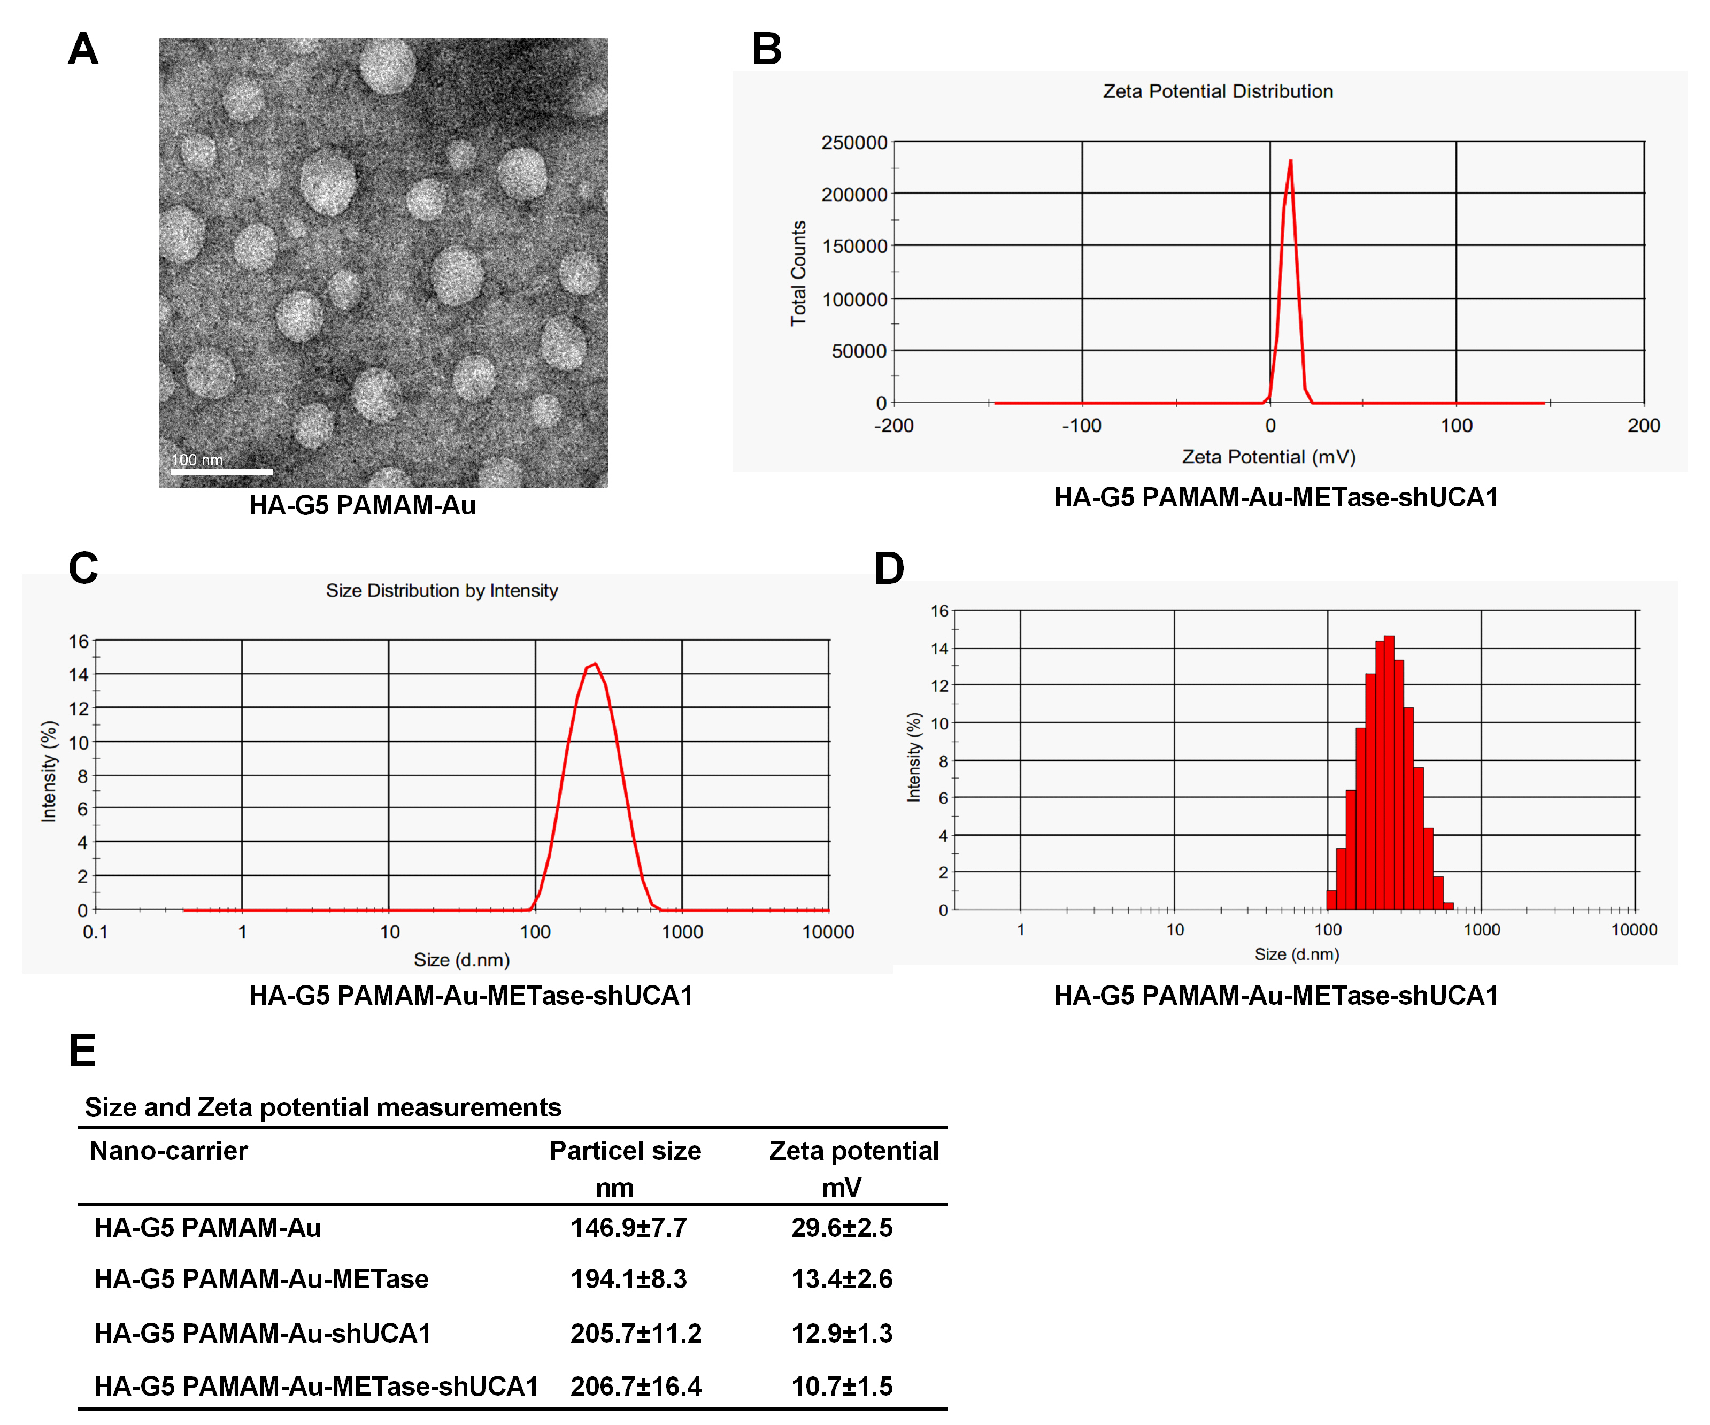

Figure 1 The characteristic of nanoparticle. (A) TEM image of HA-G5 PAMAM-Au. (B) Zeta potential distribution of HA-G5 PAMAM-Au-METase-shUCA1. (C, D) Size distribution based on intensity of HA-G5 PAMAM-Au-METase-shUCA1. (E) Statistical results of hydrated particle size (nM) and zeta potential (mV) of various nanoparticles.
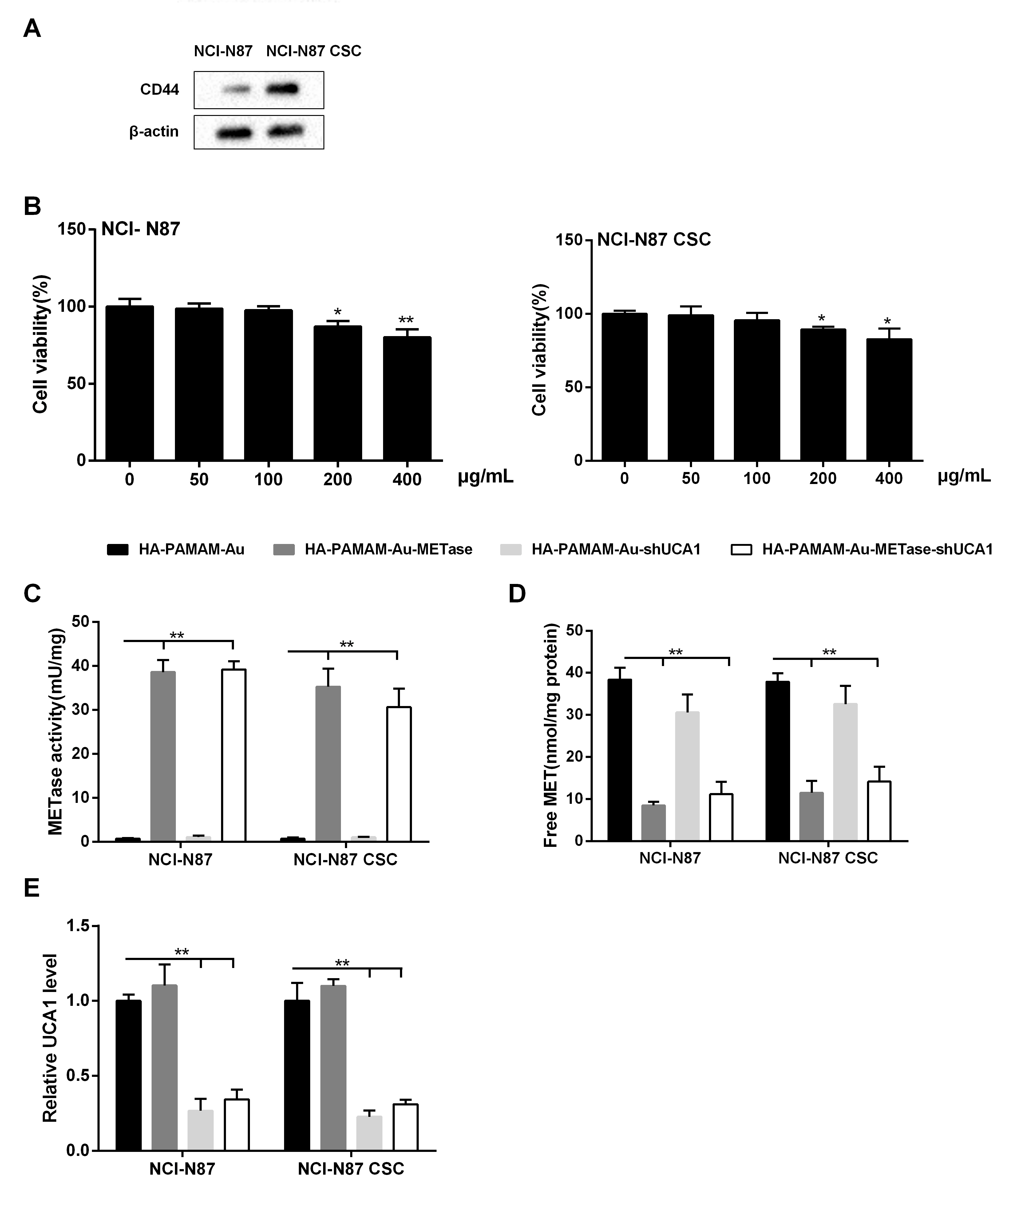

Figure 2 Expression of nanoparticles in NCI-N87 and NCI-N87 CSC GC cells. (A) The expression of CD44 in cells was detected by western blot analyis. β-actin acted as the internal control. (B) The effect of nanocarriers on cell viability was detected by CCK-8 assays. (C) METase activity transfected with different nanoparticles was assessed. (D) The effect of nanocarriers on free MET expression. (E) Relative UCA1 level in cells was detected by qRT-PCR. GAPDH was used as the internal control. *P<0.05, **P<0.01: comparison and analysis were conducted between groups.

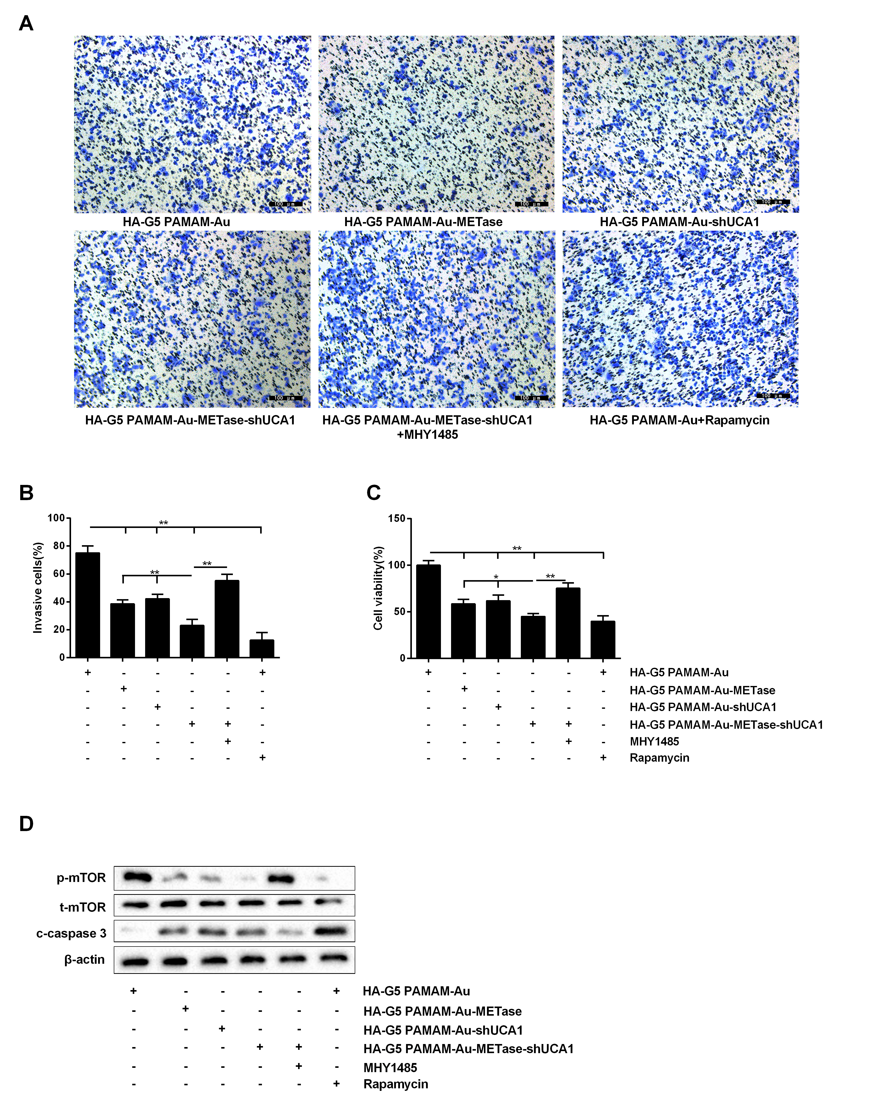

Figure 3 HA-G5 PAMAM-Au-METase-shUCA1 inhibited NCI-N87 cell viability and invasion. (A) Representative images and (B) accompanying statistical plots were presented about cell invasion. (C) HA-G5 PAMAM-Au-METase-shUCA1 suppressed NCI-N87 cell viability through CCK-8 assay. (D) The effect of different nanocarriers on the expression of p-mTOR and c-caspase3 through western blot analysis. β-actin was used as the internal control. *P<0.05, **P<0.01: comparison and analysis were conducted between groups.
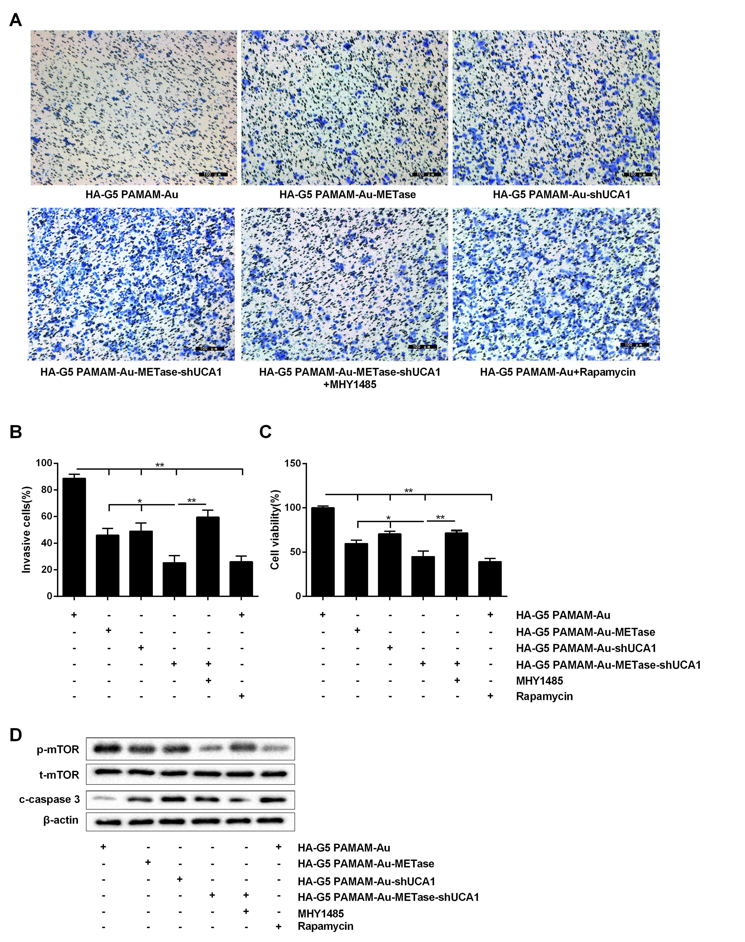

Figure 4 HA-G5 PAMAM-Au-METase-shUCA1 inhibited NCI-N87 CSC cell viability and invasion. Quantification of the invasion of NCI-N87 CSC cell in groups according to METase and UCA1 gene expression. (A) Representative images and (B) accompanying statistical plots were demonstrated. (C) A CCK-8 assay was used to determine the effect of various nanoparticles on NCI-N87 CSC cell viability. (D) Protein expression of p-mTOR and caspase-3 after transfection by western blot analysis. β-actin was used as the internal control. *P<0.05, **P<0.01: comparison and analysis were conducted between groups.
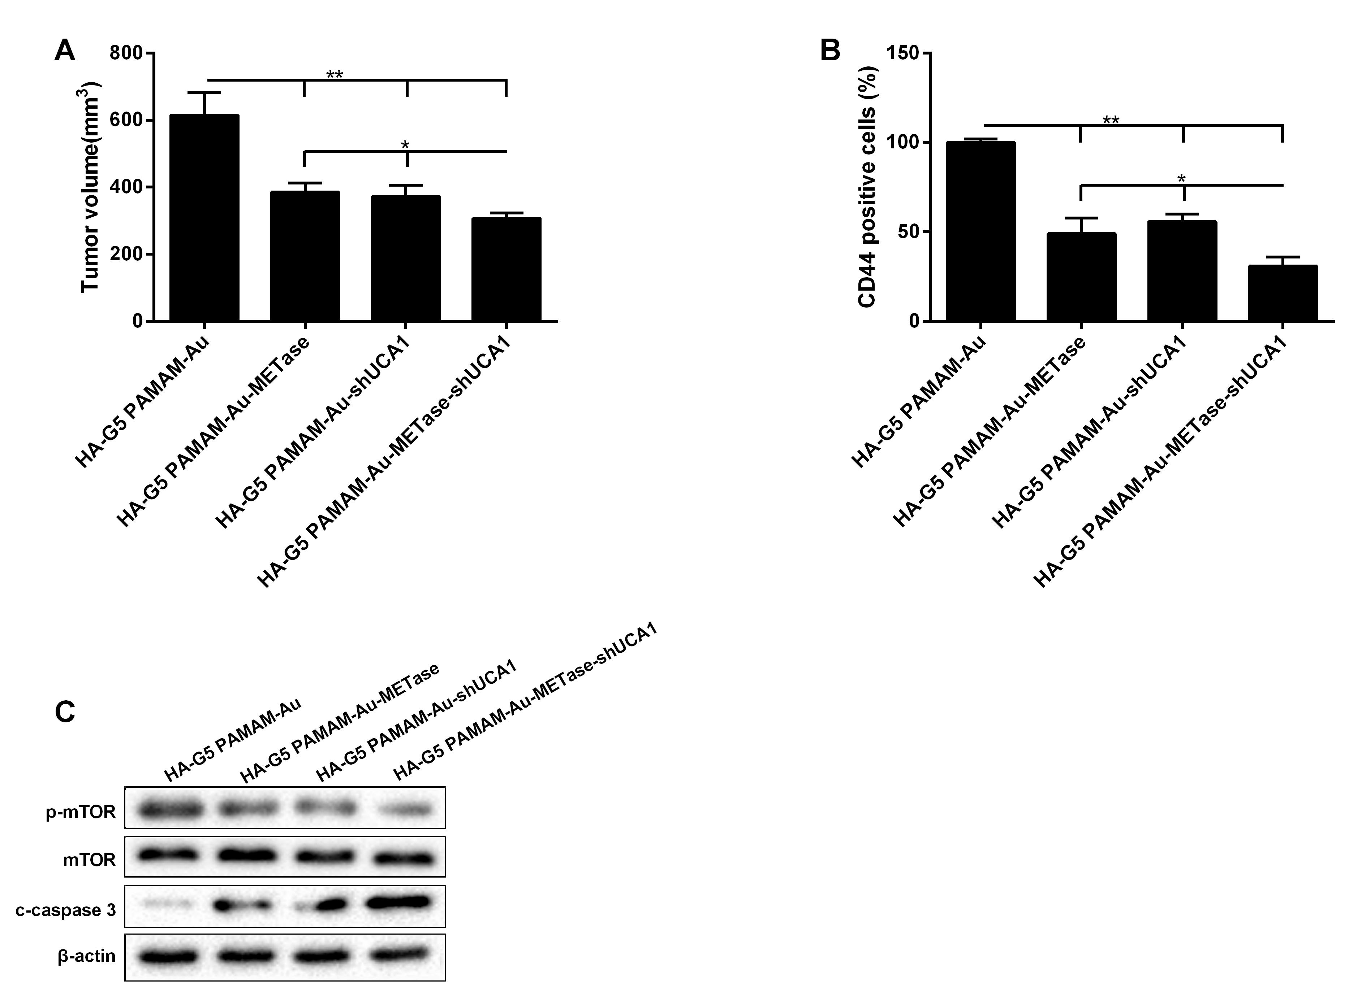

Figure 5 HA-G5 PAMAM-Au-METase-shUCA1 inhibited tumor growth. (A) Tumor volume of caudal vein implantation models of NCI-N87 cells were shown. (B) CD44 positive cells isolated from HA-G5 PAMAM-Au, HA-G5 PAMAM-Au-METase, HA-G5 PAMAM-Au-shUCA1 and HA-G5 PAMAM-Au-METase-shUCA1 groups. (C) Western blot of p-mTOR and caspase-3 in GC tumors, with β-actin as an endogenous control. *P<0.05, **P<0.01: comparison and analysis were conducted between groups.

