Study on the anti-tumor effect of pcDNA3.1(-)/rMETase-shUCA1 hyaluronic acid-modified G5 PAMAM nanoparticles on gastric cancer

Running title: HA-G5 PAMAM-Au-METase-shUCA1 targets GC

Zhenxing Huang, Chunying Xie*, Zhaohui Huang, Yanyan Guo, Xue Zhang

Department of Oncology, The Second Affiliated Hospital Of Nanchang University, Nanchang, China.

*Corresponding author: Chunying Xie
Mailing address: Department of Oncology The Second Affiliated Hospital Of Nanchang University, Nanchang, China.
Address: No. 1 Minde Road, Donghu District, Nanchang.
TEL: 13870688880
E-mail: 516467669@qq.com

Abstract
Background: Recently, rMETase has been widely exploited as a chemotherapeutic option during gastric cancer (GC) treatment. The present experiment utilized the pcDNA3.1(-)/rMETase-shUCA1 complex and hyaluronic acid-modified (HA-modified) G5 PAMAM nanoparticles to evaluate the anti-tumor function of the nanocarrier in GC cells.
Methods: The characteristics of nanoparticles were analyzed using a transmission electron microscopy. The viability and invasion of GC cells were examined by the CCK-8 assay and the Transwell assay. The levels of CD44, p-mTOR and c-caspase 3 were examined by western blot. In addition, nude mice xenograft models were established to evaluate the effect of HA-G5 PAMAM-Au-METase-shUCA1 on GC tumor growth.
Results: The transfection of rMETase, alone and in combination with shUCA1 carried by HA-G5 PAMAM-Au inhibited the viability, invasion, and tumor sphere formation of GC cells, and enhanced the METase activity. Moreover, HA-G5 PAMAM-Au-METase-shUCA1 decreased the level of p-mTOR and increased c-caspase 3 expression, while this effect could be reversed by mTOR activator MHY 1485. The CD44 positive cell number and the tumor volume in nude mice which were injected with HA-G5 PAMAM-Au-METase-shUCA1 were declined.
Conclusion: The HA-G5 PAMAM-Au-METase-shUCA1 nanoparticles significantly suppressed GC tumor growth, which was partly through the mTOR pathway.
Keywords: Nanoparticle, gastric cancer, UCA1, rMETase

Introduction
Gastric cancer (GC) remained one of the common causes of cancer-related deaths [1] and presented a high incidence in China. During the past few decades, the development of chemotherapy, radiotherapy, and surgical techniques for GC treatment [2] have made substantially improved, yet large numbers of GC patients were diagnosed as advanced or metastatic GC, and the prospect for GC patients was not optimistic [3]. Clinically, the recombinant methioninase (rMETase) was widely used as a therapeutic strategy for GC [4], while the rMETase resistance causes therapeutic failure [5], leading to the GC recurrence and cancer-related death. Therefore, investigating the molecular mechanism of GC growth was urgently warranted.
Gene therapy can be an innovative therapeutic modality for advanced GC [6]. With the advance in gene therapies, more and more genes were found to be a key role in GC treatment. Urothelial carcinoma-associated 1 (UCA1) is a long non-coding RNA (lncRNA) with three exons that encode a 1.4 kb and a 2.2 kb isoform [7]. Several researchers have observed that UCA1 played an important role in tumorigenesis through DNA rearrangements or amplifications in non-small cell lung cancer [8] and hepatocellular carcinoma [9]. UCA1 was found to be upregulated in GC cells, and TGF-β1-induced UCA1 upregulation promoted GC cell invasion and migration [10]. Fang et al. indicated that UCA1 increased multi-drug resistance of GC via downregulating miR-27b [11]. Taken together, UCA1 could be used as a potential target and a therapeutic strategy for GC.
Nanoparticles, acted as a new material of nanometer particles because of its good biocompatibility and low toxicity in vivo, biodegradability, and easy for solid tumor penetration and retention effects [12, 13]. Moreover, appropriate chemical modification of nanoparticles could directly and effectively kill tumor cells [14]. Polyamidoamine (PAMAM) dendrimers, with the characters of low toxicity and non-immunogenicity, were used to combine molecules to format gene delivery systems. In addition, hyaluronic acid (HA), with good biocompatibility and aqueous solubility, was reported to be a receptor of CD44 [15], which was closely associated with tumor invasion and metastasis [16]. Thus, HA has been widely used as a modification of tumor cells. The resistance time of drug in blood was also elevated by nanocarriers with the decoration of HA via the decrease of opsonization. Therefore, in the current study, we established HA-modified the fifth-generation PAMAM (HA-G5 PAMAM) nanoparticles loaded with UCA1 small hairpin RNA (shRNA)and Au-METase (HA-G5 PAMAM-Au-METase-shUCA1), and explored the anti-tumor effects of HA-G5 PAMAM-Au-METase-shUCA1 on GC cell viability and invasion, aiming to provide the theoretical basis for GC treatment.

Materials and methods
Nanoparticles preparation
HA (Lingbao Biological Technology Co., Ltd., Beijing, China) and G5 PAMAM (Sigma-Aldrich, USA) were dissolved in 0.1 M NaBH₄ buffer with PH = 8.5. Then, the mixture was developed into HA-G5 PAMAM polymer under the catalysis of NaBH₃CN at 40 °C for 3 days to make the polymer possessing 5% grafting density. Then, the reaction solution was dialyzed in dialysis container. After dialysis and lyophilization, HA-G5 PAMAM was completed. The procedure of HA-G5 PAMAM-Au preparation was shown as follows: the previous prepared HA-G5 PAMAM and chloroauric acid (HAuCl₄) was mixed at the mole ratio of 25:1, and NaBH₄ solution was added into the complex. The Au nanoparticles encapsulated in the interior cavities of HA-G5 PAMAM molecules were completed. Recombinant plasmid containing METase (pcDNA-METase) was synthesized by Shionogi Co., Ltd. (Osaka, Japan). HA-G5 PAMAM-Au complex was dissolved by PBS buffer at a concentration of 2 mg/mL, and the pcDNA-METase was added into the solution, and the mixture was incubated at room temperature for 15-30 min, then HA-G5 PAMAM-Au-METase was completed. Agarose gel electrophoresis was used to estimate the efficiency of HA-G5 PAMAM-Au-METase.

Characterization
Transmission electron microscopy (TEM) was used to examine nanoparticles morphology at 200 kV on JEOL-100CXII (Japan). Nanoparticle solutions were put on a copper grid coated with film to be determined. Average particle size and size distribution were determined through Quasi-elastic laser light scattering with a Malvern Zetasizer (Malvern Instruments Limited, United Kingdom) at 25 °C. Zeta potentials of nanoparticles were recorded in deionized water solution.

Cell culture
Human GC cell line NCI-N87 cells were obtained from American Type Culture Collection (ATCC, USA). NCI-N87 cells were maintained in Dulbecco's modified eagle medium (DMEM, Sigma, USA) supplemented with 10% (v/v) heat-inactivated fetal bovine serum (FBS, Sigma, USA), 2 mM glutamine, 100 units/mL penicillin, and 100 μg/mL streptomycin under a humidified atmosphere of 5% CO₂ at 37 °C.

Isolation of NCI-N87 cancer stem cells
NCI-N87 cells were also collected and cultured in serum free high glucose DMEM medium containing 20 ng/mL epidermal growth factor (EGF) and 10 ng/mL basic fibroblast growth factor (bFGF). NCI-N87 cells were cultured to be spheroids, CD44 positive cells were sorted by a magnetic-activated cell sorting (MACS) system (Miltenyi Biotech, San Diego, CA). After collecting spheroids, NCI-N87 cancer stem cells (NCI-N87 CSC) were obtained by magnetic beads method.

Cell transfection
HA-PAMAM-Au, HA-PAMAM-Au-METase, HA-PAMAM-Au-shUCA1 and HA-PAMAM-Au-METase-shUCA1 nanoparticles were transfected into NCI-N87 or NCI-N87 CSC cells by Lipofectamine 2000 (Invitrogen, San Diego, CA, USA).

Cell viability assay
Cell viability was detected by CCK-8 assay in strictly accordance with the kit’s requirements. NCI-N87 or NCI-N87 CSC cells were dissociated with Accutase® cell dissociation buffer (Life Technologies Corporation, USA), resuspended, and seeded in 96-well microplates at 1.0×10³ cells/well. Volume of 10 μL CCK-8 was added to each well at the time of harvest, according to the manufacturer’s instructions. The plate was incubated for 2 h at 37 °C and then cell survival and viability were recorded by measuring the absorbance of the converted dye at 450 nm on a Spectra Max M5 microplate reader (Molecular Devices, USA).

Cell invasion assay
NCI-N87 cells or NCI-N87 CSC cell were placed on the upper chamber (pore size of 8 μm, Corning) of each insert coated with 40 μL of 2 mg/mL Matrigel (growth factor reduced BD MatrigelTM matrix), and 600 μL of DMEM with 20% FBS was added to the lower chamber. After incubating for 24 h, the chambers were disassembled, and the membranes were stained with a 2% crystal violet solution for 10 min and placed on a glass slide. Then, cells that had migrated across the membrane were counted in 5 random visual fields using a light microscope. All assays were performed three independent times in triplicate.

METase activity assay
The METase activity of cells were measured according to the method of previous study. Briefly, GC cells transfected with different vectors were collected and homogenized by sonication for 1 min with centrifugation at 14,000 rpm for 10 min. METase activity was measured in the supernatant by determining a-ketobutyrate production from 10 mM methionine by using 3-methyl-2-benzo-thiazoline hydrazone. The amount of reaction product was measured with a Hitachi model U-2000 spectrophotometer (Hitachi, Tokyo, Japan) at OD = 335 nm.

RNA isolation and qRT-PCR
Total RNA was extracted from cells with Trizol reagent (Invitrogen, USA) according to the manufacturer’s instructions. cDNA was reverse-transcribed by a reverse-transcription kit (Takara, Dalian, China). Real-time PCR analysis was conducted on an Applied Bio-system 7500 instrument by using SYBR Green PCR Master Mix (Applied Biosystems, Foster City, CA, USA). The relative expression of UCA1 was calculated using the 2^{-△△CT} method. The CT values were normalized using GAPDH as internal control.

Western blot analysis
Total proteins were extracted from cells with RIPA buffer containing protease inhibitors (Beyotime Institute of Biotechnology, Shanghai, China) on ice, and samples were then subjected to SDS-PAGE and transferred to PVDF membranes. After non-specific binding was blocked with 5% nonfat milk at room temperature for 2 h, membranes were incubated with each primary antibody from Abcam (MA, USA), including CD44, c-caspase 3, p-mTOR, t-mTOR and β-actin overnight at 4 °C. Then, these membranes were washed and incubated with HRP-conjugated secondary antibody (Santa Cruz Biotechnology, USA) for 2 h. Immunoblots were visualized by enhanced chemiluminescence (ECL kit, Santa Cruz Biotechnology, USA) and recorded with ChemImager 5500 V2.03 software. The relative integrated density values were calculated with β-actin as an internal control.

Nude mice xenograft models
A total of 40 BALB/c nude mice (female, 6-8-weeks old) were purchased from the Experimental Animal Center of Shanghai Cancer Institute, and maintained in filter-topped cages with standard rodent chow and water made available ad libitum. Experiments were performed according to national regulations and approved by the The Second Affiliated Hospital Of Nanchang University ethical committee. Subcutaneous gastric cancer was induced via inoculation of 1 × 10⁷ mouse NCI-N87 CSC cells in the flank. The mice were caudal vein injected with HA-G5 PAMAM-Au, HA-G5 PAMAM-Au-METase, HA-G5 PAMAM-Au-shUCA1 and HA-G5 PAMAM-Au-METase-shUCA1 on d 2, d 5, d 10 and d 15 (n = 10 in each group). The tumor-bearing mice were sacrificed on d 30 and the tumor volume was calculated by the equation: volume (mm³) = length × width ²/2. The percentage of CD44 positive cells in tumor tissues were examined using immunohistochemistry.

Statistical analysis
Data were presented as the mean ± standard error mean (SEM). All experimental results were statistically analyzed with Student’s t-test or one-way analysis of variance (ANOVA). The statistical analysis was performed with SPSS 18.0 statistical software, with P<0.05 considered as statistically significant.

Results
The characteristic of nanoparticle
The morphological characteristic of HA-G5 PAMAM-Au was observed using TEM. Results showed that the particle size distribution of Au nanoparticles (AuNPs) was about 50 nm. The HA-G5 PAMAM-Au carrier presented irregular sphere and good dispersion (Fig. 1A). The zeta potential of HA-G5 PAMAM-Au-METase-shUCA1 was around 10.7 mV (Fig. 1B). The particle size of HA-G5 PAMAM-Au-METase-shUCA1 was about 206 nm (Fig. 1C and 1D). In addition, the statistical results about hydrodynamic size (particle size in water) and zeta potential of nano-carriers were presented in Fig. 1E.

HA-G5 PAMAM-Au-METase-shUCA1 inhibited METase activity and UCA1 expression in NCI-N87 and NCI-N87 CSC cells
NCI-N87 cells and NCI-N87 CSC cells were collected. The expression of CD44 and cell viability were detected in NCI-N87 cells and NCI-N87 CSC cells, respectively. The CD44 protein level was higher in NCI-N87 CSC cells than in NCI-N87 cells (Fig. 2A). CCK-8 assay indicated that the carrier (HA-G5 PAMAM-Au) showed no obvious effect on cell viability with the concentrations below 200 μg/mL. Once the concentration reached or exceeded 200 μg/mL, the cell viability would be suppressed in both NCI-N87 cells and NCI-N87 CSC cells (Fig. 2B). After the transfection of HA-G5 PAMAM-Au-METase or HA-G5 PAMAM-Au-METase-shUCA1 for 72 h in NCI-N87 or NCI-N87 CSC cells, the METase activity in cellular supernatant was obvious increased (Fig. 2C), while the level of free MET was obviously decreased (Fig. 2D). Moreover, relative UCA1 level was significantly reduced in NCI-N87 and NCI-N87 CSC cells transfected with HA-G5 PAMAM-Au-shUCA1 and HA-G5 PAMAM-Au-METase-shUCA1 (Fig. 2E).

HA-G5 PAMAM-Au-METase-shUCA1 inhibited NCI-N87 cell viability and invasion
To determine the effect of nanoparticles on NCI-N87 cells, we divided cells into six groups, including HA-G5 PAMAM-Au group acted as control, HA-G5 PAMAM-Au-METase group, HA-G5 PAMAM-Au-shUCA1 group, HA-G5 PAMAM-Au-METase-shUCA1 group, HA-G5 PAMAM-Au-METase-shUCA1 + MHY 1485 (mTOR activator), HA-G5 PAMAM-Au-METase-shUCA1 + Rapamycin (mTOR inhibitor). Results presented that invasive cells were decreased in other five groups than that in the control group (Fig. 3A). According to statistical analysis, we found that the best invasion of NCI-N87 cells suppression effect can be achieved in HA-G5 PAMAM-Au-METase-shUCA1 group. However, the number of invasive cells was significantly increased in HA-G5 PAMAM-Au-METase-shUCA1 + MHY 1485 group as compared with HA-G5 PAMAM-Au-METase-shUCA1 group, and this effect could be reversed by Rapamycin supplementation (Fig. 3B). Meanwhile, the outcome of cell viability presented the similar trend as cell invasion (Fig. 3C). Western blot analysis revealed that three vectors (HA-G5 PAMAM-Au-METase, HA-G5 PAMAM-Au-shUCA1, HA-G5 PAMAM-Au-METase-shUCA1) inhibited p-mTOR expression and promoted c-caspase 3 level; Nevertheless, this effect was alleviated in cells transfected with HA-G5 PAMAM-Au-METase-shUCA1 and MHY 1485, and opposite results were presented in HA-G5 PAMAM-Au-METase-shUCA1 + Rapamycin group (Fig. 3D).

HA-G5 PAMAM-Au-METase-shUCA1 inhibited NCI-N87 CSC cell viability and invasion
Similarly, to determine the effect of nanoparticles on NCI-N87 CSC cells, the groups were the same as the above. Three vectors (HA-G5 PAMAM-Au combined with METase or shUCA1or METase-shUCA1) suppressed cell invasion, and HA-G5 PAMAM-Au-METase-shUCA1 showed the strongest effect. The same effect of cell invasion inhibition was also presented in HA-G5 PAMAM-Au-METase-shUCA1 + Rapamycin group, while this effect was mitigated by adding mTOR activator MHY 1485 (Fig. 4A). Histogram of data statistics was shown in Fig. 4B. Analogously, the results of cell viability were similar to those of cell invasion ability (Fig. 4C). In addition, the level of p-mTOR was suppressed and the expression of c-caspase 3 was increased in HA-G5 PAMAM-Au-METase, HA-G5 PAMAM-Au-shUCA1, HA-G5 PAMAM-Au-METase-shUCA1 group than those in control. However, this situation was reversed in HA-G5 PAMAM-Au-METase-shUCA1 + MHY 1485 group as compared with HA-G5 PAMAM-Au-METase-shUCA1 group. While HA-G5 PAMAM-Au-METase-shUCA1 + Rapamycin group showed the opposite result with HA-G5 PAMAM-Au-METase-shUCA1 + MHY 1485 group (Fig. 4D).

HA-G5 PAMAM-Au-METase-shUCA1 inhibited tumor growth in vivo
Nanoparticles (HA-G5 PAMAM-Au, HA-G5 PAMAM-Au-METase, HA-G5 PAMAM-Au-shUCA1, HA-G5 PAMAM-Au-METase-shUCA1) were injected into NCI-N87 CSC cell xenograft mouse model. As demonstrated in Fig. 5A, tumor volume was significantly reduced in other three groups than that of mice injected with HA-G5 PAMAM-Au. In addition, the result of immunohistochemistry revealed that CD44 positive cell number in mice transfected with HA-G5 PAMAM-Au-METase, HA-G5 PAMAM-Au-shUCA1, and HA-G5 PAMAM-Au-METase-shUCA1 was lower than that in the control group (Fig. 5B). Moreover, the level of p-mTOR was correspondingly decreased and the expression of c-caspase 3 was obviously enhanced in HA-G5 PAMAM-Au-METase, HA-G5 PAMAM-Au-shUCA1 and HA-G5 PAMAM-Au-METase-shUCA1 groups (Fig. 5C).

Discussion
The mortality associated with GC is was still a major problem worldwide [17]. However, conventional treatment strategies for GC were not yet adequate. The objective of the present study was to evaluate the effects of HA-G5 PAMAM nanoparticles loaded with METase-shUCA1 on the growth and anti-tumor function for GC in NCI-N87 and NCI-N87 CSC cells.
GC was a major cause of cancer death in Asia and one of the most common cause of malignancy-related death [18]. Clinically, surgery and chemotherapy etc. routine protocols were increasingly used for GC treatment. Unfortunately, therapeutic effects of those methods were not optimistic and chemotherapeutic agents also had many side effects including drug resistance [19]. Moreover, previous studies showed that the chemotherapy resistance was associated with CSC with evidence that drug-resistant tumors displayed the enhanced expressions of CSC transcription factors [20]. The highly-expressed CD44 in the CSCs made the cells more highly tumorigenic and capable of originating heterogeneous tumors [21]. Similarly, in our study, gastric CSCs showed high expression of CD44 and exhibited higher migration and the ability of tumor sphere formation.
In the treatment of diverse cancers, rMETase was widely used as a therapeutic option because of the strong ability to MET depletion [22]. Tan et al. found that rMETase, alone and in combination with cisplatin (CDDP) had significant anti-tumor effect in colon cancer in vitro and in vivo [23]. In addition, a previous research showed that rMETase-loaded stealth PLGA/liposomes modified with anti-CAGE scFV was effective for treating GC [24]. The present study indicated that the overexpression of rMETase promoted METase activity, decreased the free MET level, and suppressed the viability and invasion of GC cells that resulted in the elevated level of c-caspase 3 which was a protein associated with apoptosis.
LncRNAs are evolutionarily conserved non-protein coding RNAs with a length of more than 200 nucleotides [25]. UCA1 is a lncRNA involved in the modulation of drug resistance in various cancers. For example, knockdown of UCA1 could increase the tamoxifen sensitivity of breast cancer cells through inhibition of Wnt/β-catenin pathway [26]. UCA1 can also induce acquired resistance to EGFR-TKIs in EGFR-mutant non-small cell lung cancer by activating the AKT/mTOR pathway [27]. These findings suggest that UCA1 might be an important lncRNA modulating drug resistance. However, the underlying mechanisms remained largely unclear. In this study, we compared the expression of UCA1 between NCI-N87 and NCI-N87 CSC GC cells. The results showed that silencing UCA1 significantly in NCI-N87 and NCI-N87 CSC cells lower the expression of UCA1. Then, we further investigated the effect of UCA1 on GC cell growth. Our data showed that both NCI-N87 and NCI-N87 CSC cells with UCA1 knockdown significantly decreased the cell viability and invasion, increased expression of c-caspase 3.
Previous studies reported that UCA1 upregulation can lead to the activation of mTOR pathway in multiple types of cancer cells [28]. For example, UCA1 conferred tamoxifen resistance to breast cancer cells partly via mTOR signaling pathway [7]. In non-small cell lung cancer, UCA1 may induce non-T790M acquired resistance to EGFR-TKIs by activating mTOR pathway and epithelial-mesenchymal transition (EMT) [29]. Therefore, we hypothesized that UCA1 might regulate GC progression via the mTOR signaling pathway. Our data showed that UCA1 siRNA significantly decreased the expression of p-mTOR in NCI-N87 and NCI-N87 CSC cells, and suppressed cell viability and invasion. These results suggest that UCA1 can activate mTOR signaling pathway in GC cells. The following functional study showed that MHY1485, an mTOR activator significantly abrogated the above effect of UCA1 on GC cells, suggesting that UCA1 modulated GC process at least partly via mTOR signaling pathway.
With the rapid development of nanotechnology in recent years, more and more nanoparticles and microparticle drug delivery systems generated from biodegradable polymers have been widely used for the treatment of various cancers [30, 31]. A major advantage of biodegradable synthetic microparticles was the ability to control the rate of drug release to obtain the desired local therapeutic concentrations by changing polymer structure and biodegradation rate [32]. Moreover, PAMAM dendrimers displayed great potential during the process of delivering drugs and genes owing to its high transfection efficiency and low toxicity [33]. HA-modified PAMAM was beneficial to avoid macrophage phagocytosis through hydrophilic layer on nanoparticles [34]. In the current study, transfection of rMETase, alone and in combination with UCA1 shRNA carried by HA-G5 PAMAM inhibited the proliferation and invasion of GC cells, and promoted the expression of c-caspase 3 protein.

Conclusion
In conclusion, HA-G5 PAMAM-Au-METase-shUCA1 significantly suppressed tumor growth of GC through mTOR pathway, suggesting that nanoparticle-mediated gene therapy can provide a safe and effective therapeutic option for GC, although more evidence is still needed.

Conflict of interest
None declared.

References
1. Shen, Y.H., et al., Expression level of microRNA-195 in the serum of patients with gastric cancer and its relationship with the clinicopathological staging of the cancer. European Review for Medical & Pharmacological Sciences, 2016. 20(7): p. 1283.
2. Peng, W., et al., Long non-coding RNA MEG3 functions as a competing endogenous RNA to regulate gastric cancer progression. Journal of Experimental & Clinical Cancer Research, 2015. 34(1): p. 79.
3. Shirong, C., et al., Survival of Proper Hepatic Artery Lymph Node Metastasis in Patients with Gastric Cancer: Implications for D2 Lymphadenectomy. Plos One, 2015. 10(3): p. e0118953.
4. Xin, L., et al., Stealth cationic liposomes modified with anti-CAGE single-chain fragment variable deliver recombinant methioninase for gastric carcinoma therapy. Journal of Nanoscience & Nanotechnology, 2013. 13(1): p. 178-83.
5. Yano, S., et al., Selective methioninase-induced trap of cancer cells in S/G2 phase visualized by FUCCI imaging confers chemosensitivity. Oncotarget, 2014. 5(18): p. 8729.
6. Zhu, X., et al., Gene therapy of gastric cancer using LIGHT-secreting human umbilical cord blood-derived mesenchymal stem cells. Gastric Cancer, 2013. 16(2): p. 155-166.
7. Wu, C. and L. Jing, Long Non-Coding RNA (lncRNA) Urothelial Carcinoma-Associated 1 (UCA1) Enhances Tamoxifen Resistance in Breast Cancer Cells via Inhibiting mTOR Signaling Pathway. Medical Science Monitor International Medical Journal of Experimental & Clinical Research, 2016. 22: p. 3860-3867.
8. Nie, W., et al., LncRNA-UCA1 exerts oncogenic functions in non-small cell lung cancer by targeting miR-193a-3p. Cancer Letters, 2016. 371(1): p. 99-106.
9. Xiao, J.N., et al., Long non-coding RNA UCA1 regulates the expression of Snail2 by miR-203 to promote hepatocellular carcinoma progression. Journal of Cancer Research & Clinical Oncology, 2017: p. 1-10.
10. Zuo, Z.K., et al., TGFβ1-Induced LncRNA UCA1 Upregulation Promotes Gastric Cancer Invasion and Migration. Dna & Cell Biology, 2017. 36(2): p. 159.
11. Fang, Q., X. Chen, and X. Zhi, Long Non-Coding RNA (LncRNA) Urothelial Carcinoma Associated 1 (UCA1) Increases Multi-Drug Resistance of Gastric Cancer via Downregulating miR-27b. Medical Science Monitor International Medical Journal of Experimental & Clinical Research, 2016. 22: p. 3506-3513.
12. Wang, X., et al., Increasing the cytotoxicity of doxorubicin in breast cancer MCF-7 cells with multidrug resistance using a mesoporous silica nanoparticle drug delivery system. International Journal of Clinical & Experimental Pathology, 2014. 7(4): p. 1337.
13. Abbasi, S., et al., Cationic albumin nanoparticles for enhanced drug delivery to treat breast cancer: preparation and in vitro assessment. Journal of Drug Delivery, 2012. 2012(2090-3014): p. 686108.
14. You, J., et al., Effective photothermal chemotherapy using doxorubicin-loaded gold nanospheres that target EphB4 receptors in tumors. Cancer Research, 2012. 72(18): p. 4777-86.
15. Ganesh, S., et al., In Vivo Biodistribution of siRNA and Cisplatin Administered using CD44-Targeted Hyaluronic Acid Nanoparticles. Journal of Controlled Release Official Journal of the Controlled Release Society, 2011. 172(3): p. 699-706.
16. Wang, Z., et al., Clinicopathologic correlation of cancer stem cell markers CD44, CD24, VEGF and HIF-1α in ductal carcinoma in situ and invasive ductal carcinoma of breast: An immunohistochemistry-based pilot study. Pathology Research & Practice, 2011. 207(8): p. 505-13.
17. Yin, P., et al., MiRNA-194 activates the Wnt/β-catenin signaling pathway in gastric cancer by targeting the negative Wnt regulator, SUFU. Cancer Letters, 2017. 385: p. 117-127.
18. Kim, Y.H., et al., AMPKα modulation in cancer progression: multilayer integrative analysis of the whole transcriptome in Asian gastric cancer. Cancer Research, 2012. 72(10): p. 2512-21.
19. Treasure, T., et al., Treasure T, Fallowfield L, Lees B, Farewell V. Pulmonary metastasectomy in colorectal cancer: the PulMiCC trial. Thorax, 2011. 67(2): p. 185-187.
20. L, W., et al., Cisplatin-enriching cancer stem cells confer multidrug resistance in non-small cell lung cancer via enhancing TRIB1/HDAC activity. Cell death & disease, 2017. 8(4): p. e2746.
21. Trapasso, S. and E. Allegra, Role of CD44 as a marker of cancer stem cells in head and neck cancer. Biologics Targets & Therapy, 2012. 6(default): p. 379-383.
22. Sun, X., et al., In vivo stabilization of polyethylene glycol (PEG)-modified recombinant methioninase (rMETase) activity by pyridoxal phosphate. Cancer Research, 2004. 64.
23. Tan, Y., et al., Efficacy of recombinant methioninase in combination with cisplatin on human colon tumors in nude mice. Clinical Cancer Research, 1999. 5(8): p. 2157-63.
24. Xin, L., et al., Evaluation of rMETase-Loaded Stealth PLGA/Liposomes Modified with Anti-CAGE scFV for Treatment of Gastric Carcinoma. Journal of Biomedical Nanotechnology, 2015. 11(7): p. 1153.
25. Aune, T.M. and S.C. Rd, Long non-coding RNAs in innate and adaptive immunity. Virus Research, 2016. 212: p. 146-160.
26. Liu, H., et al., Knockdown of Long Non-Coding RNA UCA1 Increases the Tamoxifen Sensitivity of Breast Cancer Cells through Inhibition of Wnt/β-Catenin Pathway. Plos One, 2016. 11(12): p. e0168406.
27. Sun, W., et al., Non-invasive approaches to monitor EGFR-TKI treatment in non-small-cell lung cancer. Journal of Hematology & Oncology, 2015. 8(1): p. 95.
28. Habib, S.L., et al., Novel mechanism of reducing tumourigenesis: upregulation of the DNA repair enzyme OGG1 by rapamycin-mediated AMPK activation and mTOR inhibition. European Journal of Cancer, 2010. 46(15): p. 2806-20.
29. Cheng, N., et al., Long non-coding RNAUCA1induces non-T790M acquired resistance to EGFR-TKIs by activating the AKT/mTOR pathway inEGFR-mutant non-small cell lung cancer. Oncotarget, 2011. 6(27): p. 23582-23593.
30. Ma, Y., et al., Nanoparticles of Poly(Lactide-Co-Glycolide)-d-a-Tocopheryl Polyethylene Glycol 1000 Succinate Random Copolymer for Cancer Treatment. Nanoscale Research Letters, 2010. 5(7): p. 1161.
31. Miladi, K., et al., Particles from preformed polymers as carriers for drug delivery. Excli Journal, 2014. 13: p. 28-57.
32. Xu, Q., et al., Preparation of Monodisperse Biodegradable Polymer Microparticles Using a Microfluidic Flow-focusing Device for Controlled Drug Delivery. Small, 2009. 5(13): p. 1575-81.
33. Ayatollahi, S., et al., Synthesis of efficient gene delivery systems by grafting pegylated alkylcarboxylate chains to PAMAM dendrimers: Evaluation of transfection efficiency and cytotoxicity in cancerous and mesenchymal stem cells. Journal of Biomaterials Applications, 2015. 30(5).
34. Sheardown, H., M. Van Beek, and J. Guo, Hyaluronic acid-retaining polymers. 2010, US.

Figure legends
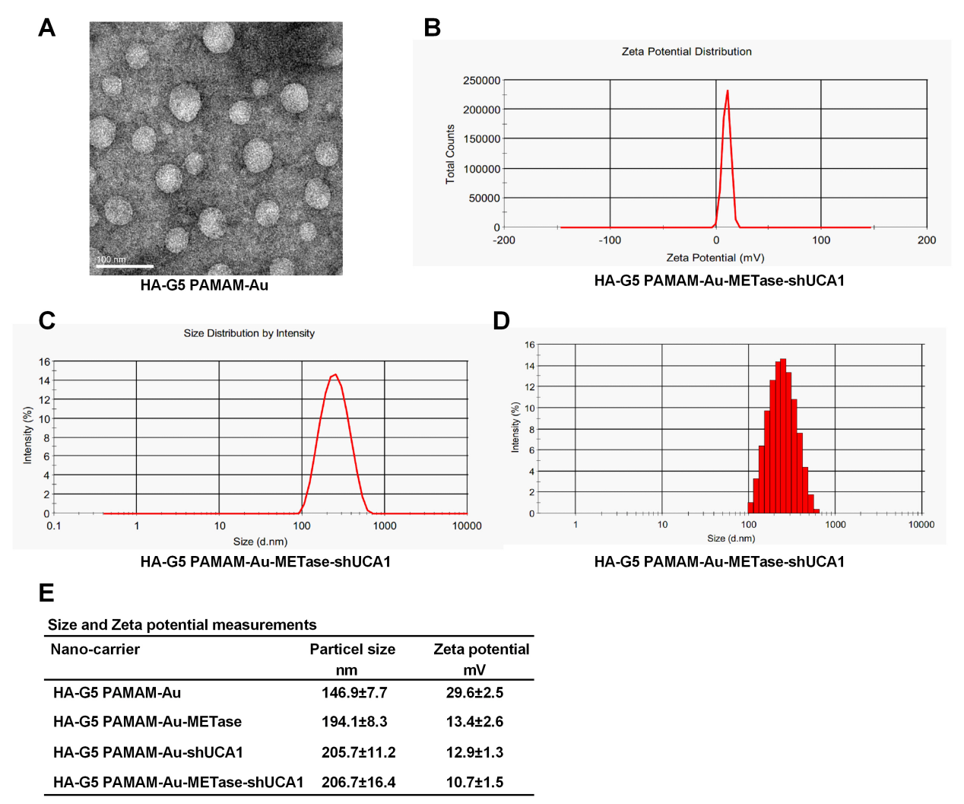

Figure 1 The characteristic of nanoparticles. (A) TEM image of HA-G5 PAMAM-Au. (B) Zeta potential distribution of HA-G5 PAMAM-Au-METase-shUCA1. (C, D) Size distribution based by intensity of HA-G5 PAMAM-Au-METase-shUCA1. (E) Statistical results of particle size (nM) and zeta potential (mV) of nano-carriers.
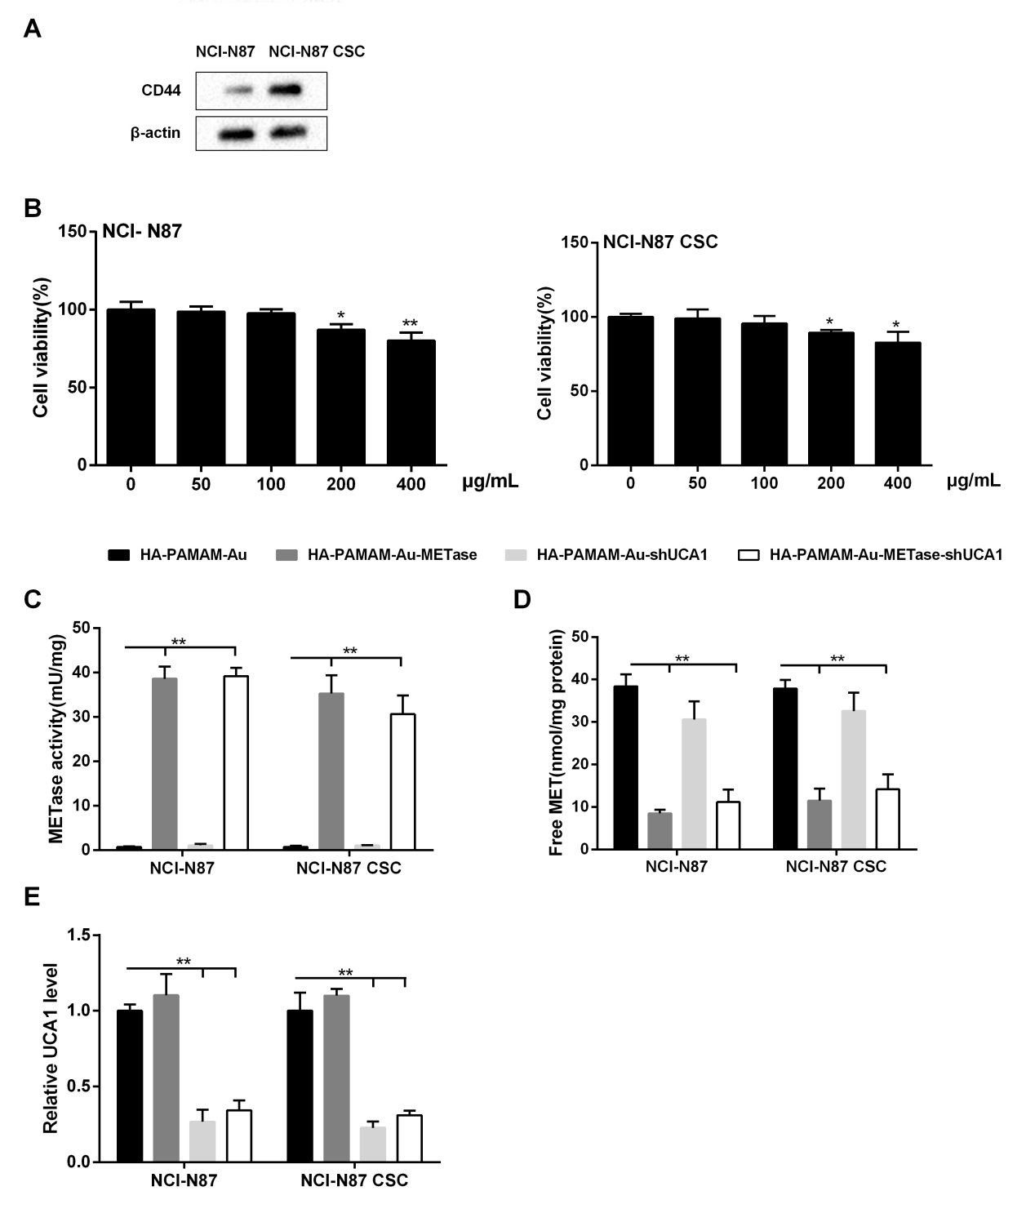
Figure 2 HA-G5 PAMAM-Au-METase-shUCA1 inhibited METase activity and UCA1 expression in NCI-N87 and NCI-N87 CSC cells. (A) The expression of CD44 in NCI-N87 and NCI-N87 CSC cells was detected by western blot analyis. β-actin acted as the internal control. (B) The effect of HA-G5 PAMAM-Au on cell viability was detected by CCK-8 assays. (C) METase activity transfected with different nanoparticles was assessed. (D) The effect of nanocarriers on free MET expression. (E) Relative UCA1 level in cells was detected by qRT-PCR. GAPDH was used as the internal control. *P<0.05, **P<0.01: comparison and analysis were conducted between groups.

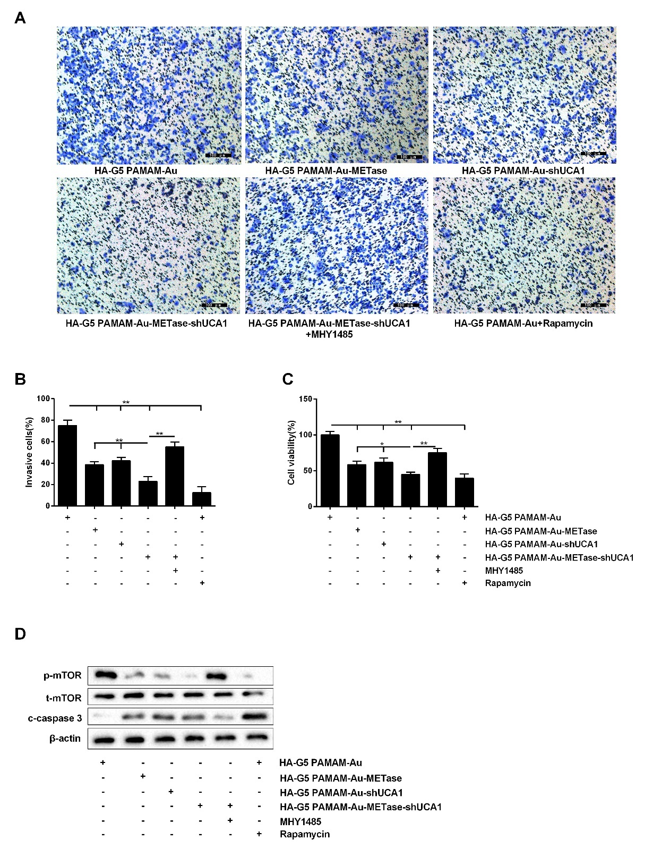
Figure 3 HA-G5 PAMAM-Au-METase-shUCA1 inhibited NCI-N87 cell viability and invasion. (A) Representative images and (B) accompanying statistical plots were presented about cell invasion. (C) HA-G5 PAMAM-Au-METase-shUCA1 suppressed NCI-N87 cell viability through CCK-8 assay. (D) The effect of different nanocarriers on the expression of p-mTOR and c-caspase3 through western blot analysis. β-actin was used as the internal control. *P<0.05, **P<0.01: comparison and analysis were conducted between groups.

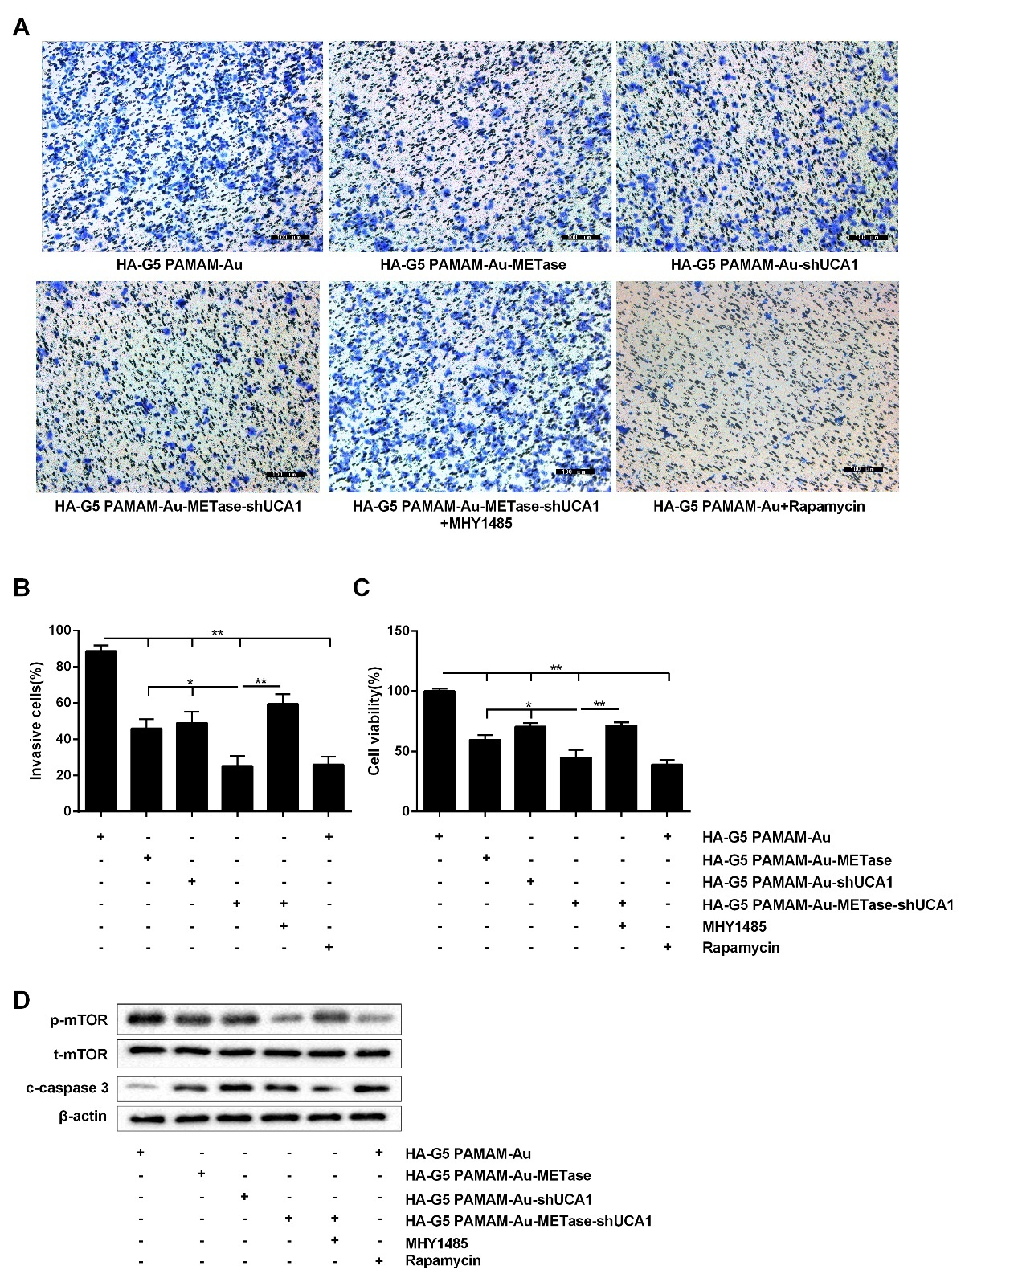
Figure 4 HA-G5 PAMAM-Au-METase-shUCA1 inhibited NCI-N87 CSC cell viability and invasion. Quantification of the invasion of NCI-N87 CSC cell in groups according to METase and UCA1 gene expression. (A) Representative images and (B) accompanying statistical plots were demonstrated. (C) A CCK-8 assay was used to determine the effect of various nanoparticles on NCI-N87 CSC cell viability. (D) Protein expression of p-mTOR and caspase-3 after transfection by western blot analysis. β-actin was used as the internal control. *P<0.05, **P<0.01: comparison and analysis were conducted between groups.
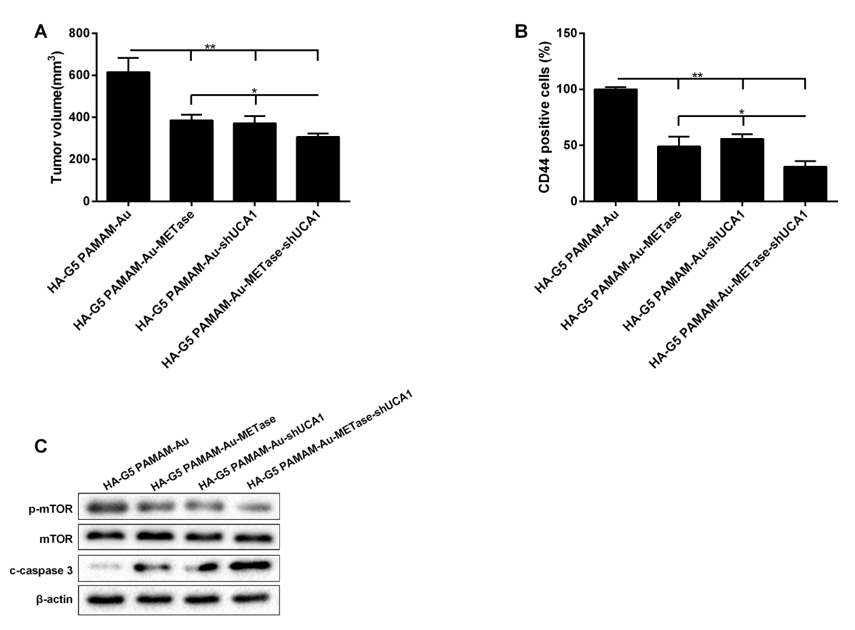
Figure 5 HA-G5 PAMAM-Au-METase-shUCA1 inhibited tumor growth in what type of mouse model?. (A) Tumor volume of caudal vein implantation models of NCI-N87 CSC cells were shown what tissue were the tumor cells collected from?. (B) The percentage of CD44 positive cells was determined using immunohistochemistry. (C) The expression of mTOR, p-mTOR, and c-caspase-3 was determined using western blot analysis. β-actin was used as an endogenous control. *P<0.05, **P<0.01: comparison and analysis were conducted between groups.

