Study on the anti-tumor effect of pcDNA3.1(-)/rMETase-shUCA1 hyaluronic acid-modified G5 Polyamidoamine nanoparticles on gastric cancer

Running title: HA-G5 Polyamidoamine-Au-METase-shUCA1 targets GC

Zhenxing Huang, Chunying Xie*, Zhaohui Huang, Yanyan Guo, Xue Zhang

Department of Oncology, The Second Affiliated Hospital Of Nanchang University, Nanchang, China.

*Corresponding author: Chunying Xie
Mailing address: Department of Oncology The Second Affiliated Hospital Of Nanchang University, Nanchang, China.
Address: No. 1 Minde Road, Donghu District, Nanchang.
TEL: 13870688880
E-mail: 516467669@qq.com

Abstract
Background: Recently, recombinant methioninase (rMETase) has been widely exploited as a chemotherapeutic option during gastric cancer [1] treatment. The present study utilized the pcDNA3.1(-)/rMETase-shUCA1 complex and hyaluronic acid-modified (HA-modified) G5 Polyamidoamine nanoparticles to evaluate the anti-tumor function of the nanocarrier in GC cells.
Methods: The characteristics of nanoparticles were analyzed using transmission electron microscopy. The GC cell viability and invasion were tested by the CCK-8 assay and the Transwell assay. The expressions of CD44, p-mTOR, and c-caspase 3 were measured by Western blot assay. Also, the model of nude mice xenograft was established to assess the function of HA-Polyamidoamine-Au-METase-shUCA1 in GC tumor growth.
Results: The transfection of rMETase, alone and in combination with shUCA1 carried by HA-Polyamidoamine-Au inhibited GC cell viability, invasion, and tumorsphere formation, and enhanced the METase activity. Moreover, HA-Polyamidoamine-Au-METase-shUCA1 decreased p-mTOR expression and raised c-caspase 3, while this effect could be reversed by mTOR activator MHY 1485. The CD44 positive cell number and the tumor volume in nude mice injected with HA-Polyamidoamine-Au-METase-shUCA1 were reduced.
Conclusion: The HA-Polyamidoamine-Au-METase-shUCA1 nanoparticles restrained GC tumor growth, which was partly via the mTOR pathway.
Keywords: Nanoparticle, gastric cancer, UCA1, rMETase

Introduction
Gastric cancer [1] remains one of the reasons for cancer-related deaths [2] and presents high morbidity in China. During the past few decades, several methods for GC cure have made progress [3],but the cure effect of GC patients is still poor due to the high metastasis of GC [4]. Clinically, the recombinant methioninase (rMETase) was has been widely used to cure GC [5], while resistance to the rMETase resistance causes therapeutic failure [6], leading to the GC recurrence of GC and cancer-related death. Therefore, investigating the molecular mechanism of GC growth was is urgently warranted.
Gene therapy can be an innovative therapeutic modality for advanced GC [7]. In the evolution of gene therapies, more and more genes have been proved that is be a pivotal role in GC cure. Urothelial carcinoma-associated 1 (abbreviated as UCA1) is a long non-coding RNA (lncRNA) with three exons that encode a 1.4 kb and a 2.2 kb isoform [8]. Several researchers have observed that UCA1 played a pivotal function in tumorigenesis through DNA rearrangements or amplifications in several cancers, mainly consist of non-small cell lung cancer [9] and hepatocellular carcinoma [10]. UCA1 was raised in GC cells, and TGF-β1-induced UCA1 raise promoted GC cell invasion and migration [11]. Fang et al. indicated that UCA1 raised GC multi-drug resistance via decreasing miR-27b [12]. Taken together, UCA1 could be used as a potential target and a therapeutic strategy for GC. Nanoparticles have gradually become a research hotspot due to their good biocompatibility, low toxicity in vivo, biodegradability, and easy penetration of solid tumors. [13, 14]. Moreover, appropriate chemical modification of nanoparticles could directly and effectively kill tumor cells [15]. Polyamidoamine (PAMAM) dendrimers, with the characteristic of low toxicity and non-immunogenicity, were used to combine molecules to format gene delivery systems. As reported, Hyaluronic acid (HA) is a receptor for CD44, which is mainly characterized by good biocompatibility and water solubility [16] and is bound up with tumor invasion and metastasis [17]. Thus, HA has been widely used as a modification of tumor cells. The half-life of the drug in blood was also elevated through nanocarriers and reduced HA modification. In the current study, we established HA-modified the fifth-generation Polyamidoamine (HA-G5 PAMAM) nanoparticles loaded with UCA1 small hairpin RNA (shRNA) and Au-METase (HA-Polyamidoamine-Au-METase-shUCA1), and we explored the functional role of HA-Polyamideamine-Au-METase-shUCA1 in GC cell viability and invasion, which might provide a research foundation for the cure of GC.
Materials and methods
Nanoparticles preparation
HA (Lingbao Biological Technology Co., Ltd., Beijing) and G5 PAMAM (Abbreviated as Polyamidoamine) (Sigma) were lysed in NaBH₄ buffer with the concentration of 0.1 M and with a pH of 8.5. Then, the mixture was developed into HA-Polyamidoamine polymer under the catalysis of NaBH₃CN at 40 °C for 3 days to make the polymer possessing 5% grafting density. Then, the reaction solution was dialyzed in a dialysis container. The HA-Polyamidoamine was finished when the dialysis and lyophilization procedures were finished. The procedure of HA-Polyamidoamine-Au preparation was shown as follows: the previously prepared HA-Polyamidoamine and chloroauric acid (HAuCl₄) was mixed at the mole ratio of 25:1, and we added NaBH₄ to this compound. The Au nanoparticles packed in interior cavities of HA-Polyamide amide was finished. A plasmid containing METase (which also be named as pcDNA-METase) was from Shionogi &Co., Ltd. HA-Polyamidoamine-Au complex was lysed via PBS buffer, and then we appended the above pcDNA-METase to this solution, and then was cultivated for about 0.5 h, then HA-Polyamidoamine-Au-METase was finished. Agarose gel electrophoresis (Abbreviated as AGE) was performed to estimate HA-Polyamidoamine-Au-METase efficiency.

Morphological observation of nanoparticles We used transmission electron microscopy (Abbreviated as TEM) to observe nanoparticle morphology. In brief, we determined the average particle size and size distribution using Particle size distribution tester (HMK-200).

Cell culture
We purchased Human GC cell line NCI-N87 from American Type Culture Collection (ATCC). NCI-N87 cells were put in the DMEM (Sigma) with the addition of 10% (v/v) heat-inactivated fetal bovine serum (Abbreviated as FBS, Sigma, USA), 2 mM glutamine, 100 units/mL penicillin, and 100 μg/mL streptomycin at a humidified surroundings of 37 °C, 5% CO₂.

Isolation of NCI-N87 cancer stem cells
We collected NCI-N87 cells and then cultured in serum-free high glucose DMEM medium (20 ng/mL epidermal growth factor, 10 ng/mL basic fibroblast growth factor). When the NCI-N87 cells were cultured in a spherical shape, we used the magnetically-activated cell sorting (Abbreviated as MACS) system to sort CD44 positive cells. Next, we gathered spheroids and gained NCI-N87 cancer stem cells (NCI-N87 CSC) by the magnetic beads.

Cell transfection
HA-Polyamidoamine-Au, HA-Polyamidoamine-Au-METase, HA-Polyamidoamine-Au-shUCA1, and HA-Polyamidoamine-Au-METase-shUCA1 nanoparticles were transfected into NCI-N87 or NCI-N87 CSC cells by Lipofectamine 2000 (Invitrogen, San Diego, CA, USA).

Cell viability assay
Accutase® cell dissociation buffer (Life Technologies Corporation) was used to dissociate NCI-N87 or NCI-N87 CSC cells, and then we inoculated these cells (1.0×10³ cells) to 96-well microplates. On the basis of the instructions of the manufacturer, a volume of 10 μL CCK-8 was put in each well. Next, the survival and viability of the above differently treated cells were recorded via determining the absorbance at 450 nm upon a Spectra Max M5 microplate reader.

Cell invasion experiment
We put NCI-N87 or NCI-N87 CSC cells in the upper chamber (pore size of 8 μm, Corning) with 40 μL Matrigel (2 mg/mL), and then we put 600 μL DMEM with 20% FBS in the lower chamber. After incubating for 1 d, we stained the membrane with 2% crystal violet solution for about 10 min. Ultimately, we used a microscope to count in 5 random fields. All determinations were performed three independent times in triplicate.

METase activity assay

On the basis of the method of the previous study, the METase activity of cells was measured. Briefly, GC cells transfected with different vectors were collected and sonicated for 1 min and centrifuged. Subsequently, the activity of METase in the supernatant after centrifugation was quantified via quantifying the a-ketobutyrate produced by 10 mM methionine by 3-methyl-2-benzothiazoline hydrazone. Ultimately, we used a Hitachi U-2000 spectrophotometer to quantify the product at an OD of 335 nm.

RNA isolation and qRT-PCR assay
Based on the standard procedure of the manufacturer, we separated total RNA from cells, and then we reverse-transcribed cDNA via a reverse-transcription kit. Next, we performed a real-time PCR experiment upon an Applied Bio-system 7500 instrument by the addition of SYBR Green PCR Master Mix (Applied Biosystems). 2^{-△△CT} method was performed to measure UCA1 expression.

Western blot analysis
RIPA buffer with protease inhibitors (Beyotime Institute of Biotechnology, Shanghai, China) was performed to separate the total proteins. Next, we subjected these samples to SDS-PAGE and then transferred them into PVDF membranes, and the membranes were then incubated with each primary antibody from Abcam (MA), including CD44, c-caspase 3, p-mTOR, t-mTOR and β-actin overnight at an environment of 4 °C. Next, these membranes were incubated with the secondary antibody from Abcam for 2 h. Next, we visualize the immunoblots via an ECL kit (Santa Cruz Biotechnology).

Nude mice xenograft models
A total of 40 aged 7 weeks old BALB/c nude mice (female) were purchased from the Experimental Animal Center of Shanghai Cancer Institute. Based on the national regulations, we performed these experiments, and these experiments were approved by The ethical committee of The Second Affiliated Hospital Of Nanchang University. We induced gastric cancer via inoculating mouse NCI-N87 CSC cells (1×10⁷ cells) in the flank. The mice were caudal vein injected with HA-Polyamidoamine-Au, HA-Polyamidoamine-Au-METase, HA-Polyamidoamine-Au-shUCA1 and HA-Polyamidoamine-Au-METase-shUCA1 on d 2, d 5, d 10 and d 15 (n = 10 per group). Ultimately, we killed the mice with the tumor on 30 th day and the equation (volume (mm³) = length × width ²/2) was performed to quantify the tumor volume. The percentage of CD44 positive cells in these tissue samples was examined using immunohistochemistry. Briefly, we counted the number of CD44 positive cells in 5 randomly chosen high power fields of each group, and the ratio of other groups to the HA-Polyamidoamine-Au group was calculated. The negative control was a section that used the phosphate buffer saline instead of the primary antibody.

Statistical analysis
Data were exhibited as the mean ± standard error mean (SEM), and all data were appraised with Student’s t-test or ANOVA. SPSS 18.0 software was performed to appraise these statistical analyses. P value was fewer than 0.05 indicates a prominent difference.

Results
The characteristic of nanoparticle
Transmission Electron Microscope (TEM) was performed to observe the morphological feature of HA-Polyamidoamine-Au. Results expounded that the particle size distribution of Au nanoparticles (AuNPs) was about 50 nm. The HA-Polyamidoamine-Au carrier presented irregular spheres and good dispersion (Fig. 1A), and HA-Polyamidoamine-Au-METase-shUCA1 zeta potential was around 10.7 mV (Fig. 1B). The particle size of HA-Polyamidoamine-Au-METase-shUCA1 was about 206 nm (Fig. 1C and 1D). Also, compared with the HA-Polyamidoamine-Au group, the particle size (nM) was raised in the HA-Polyamidoamine-Au-METase, HA-Polyamidoamine-Au-shUCA1, and HA-Polyamidoamine-Au-METase + shUCA1 groups, while zeta potential (mV) was reduced (Fig. 1E)..

HA-Polyamidoamine-Au-METase-shUCA1 restrained METase activity and UCA1 expression in NCI-N87 and NCI-N87 CSC cells
NCI-N87 cells and NCI-N87 CSC cells were collected, and then we measured the CD44 expression and cell viability, respectively. CD44 protein level was higher in NCI-N87 CSC cells (Fig. 2A). CCK-8 assay indicated that when the concentrations less than 200 μg/mL, the carrier (HA-Polyamidoamine-Au) showed no prominent influence on cell viability. Once the concentration reached or exceeded 200 μg/mL, the cell viability was restrained not only in NCI-N87, but also in NCI-N87 CSC cells (Fig. 2B). After the transfection of HA-Polyamidoamine-Au-METase or HA-Polyamidoamine-Au-METase-shUCA1 for 3 d in NCI-N87 or NCI-N87 CSC cells, the METase activity in the supernatant fluid was raised (Fig. 2C), while the level of free MET was decreased (Fig. 2D). Moreover, relative UCA1 level was significantly reduced in NCI-N87 and NCI-N87 CSC cells with the transfection of HA-Polyamidoamine-Au-shUCA1 and HA-Polyamidoamine-Au-METase-shUCA1 (Fig. 2E).

HA-Polyamidoamine-Au-METase-shUCA1 inhibited NCI-N87 cell viability and invasion
To expound the influence of nanoparticles on NCI-N87 cells, these cells were stochastically divided into six groups, including the HA-Polyamidoamine-Au group acted as a control, HA-Polyamidoamine-Au-METase group, HA-Polyamidoamine-Au-shUCA1 group, HA-Polyamidoamine-Au-METase-shUCA1 group, HA-Polyamidoamine-Au-METase-shUCA1 + MHY 1485 (mTOR activator), HA-Polyamidoamine-Au-METase-shUCA1 + Rapamycin (mTOR inhibitor). Results presented that the best invasion of NCI-N87 cells suppression effect can be achieved in the HA-Polyamidoamine-Au-METase-shUCA1 group. However, the quantity of invasive cells was markedly raised in HA-Polyamidoamine-Au-METase-shUCA1 + MHY 1485 group as compared with HA-Polyamidoamine-Au-METase-shUCA1 group, and this effect could be reversed by Rapamycin supplementation (Fig. 3A& Fig. 3B). Meanwhile, the outcome of cell viability presented a similar trend as cell invasion (Fig. 3C). Western blot analysis revealed that three vectors (HA-Polyamidoamine-Au-METase, HA-Polyamidoamine-Au-shUCA1, HA-Polyamidoamine-Au-METase-shUCA1) inhibited the p-mTOR expression and promoted c-caspase 3 levels; Nevertheless, this effect was alleviated in cells transfected with HA-Polyamidoamine-Au-METase-shUCA1 and MHY 1485, and opposite results were presented in HA-Polyamidoamine-Au-METase-shUCA1 + Rapamycin group (Fig. 3D).

HA-Polyamidoamine-Au-METase-shUCA1 inhibited NCI-N87 CSC cell viability and invasion
Similarly, to expound the influence of nanoparticles on NCI-N87 CSC cells, the groups were the same as the above. Three vectors (HA-Polyamidoamine-Au combined with METase or shUCA1or METase-shUCA1) suppressed cell invasion, and HA-Polyamidoamine-Au-METase-shUCA1 showed the strongest effect. The same effect of cell invasion inhibition was also presented in the HA-Polyamidoamine-Au-METase-shUCA1 + Rapamycin group, while this effect was mitigated by adding mTOR activator MHY 1485 (Fig. 4A). A histogram of data statistics is shown in Fig. 4B. Analogously, the results of cell viability were similar to those of cell invasion ability (Fig. 4C). Besides, the level of p-mTOR was suppressed and c-caspase 3 was raised in HA-Polyamidoamine-Au-METase, HA-Polyamidoamine-Au-shUCA1, HA-Polyamidoamine-Au-METase-shUCA1 group than those in control. However, this situation was reversed in HA-Polyamidoamine-Au-METase-shUCA1 + MHY 1485 group as compared with HA-Polyamidoamine-Au-METase-shUCA1 group. While HA-Polyamidoamine-Au-METase-shUCA1 + Rapamycin group showed the opposite result with HA-Polyamidoamine-Au-METase-shUCA1 + MHY 1485 group (Fig. 4D).

HA-Polyamidoamine-Au-METase-shUCA1 inhibited tumor growth in vivo
Nanoparticles (HA-G5 PAMAM-Au, HA Polyamidoamine-Au-METase, HA-Polyamidoamine-Au-shUCA1, HA-Polyamidoamine-Au-METase-shUCA1) were caudal vein injected into the NCI-N87 CSC cell xenograft mouse model. As demonstrated in Fig. 5A, the tumor volume of mice transfected with HA-Polyamidoamine-Au-METase, HA-Polyamidoamine-Au-shUCA1, and HA-Polyamidoamine-Au-METase-shUCA1 was reduced. . Furthermore, the result of immunohistochemistry revealed that compared with the control group, CD44 positive cell number in mice transfected with HA-Polyamidoamine-Au-METase, HA-Polyamidoamine-Au-shUCA1, and HA-Polyamidoamine-Au-METase-shUCA1 was decreased (Fig. 5B). Also, p-mTOR expression was accordingly reduced and c-caspase 3 expression was raised in HA-Polyamidoamine-Au-METase, HA-Polyamidoamine-Au-shUCA1, and HA-Polyamidoamine-Au-METase-shUCA1 groups (Fig. 5C).

Discussion
The mortality associated with GC is a major problem worldwide [19]. However, conventional cure strategies for GC are not yet adequate. The purpose of this research was to evaluate the effects of HA-Polyamidoamine nanoparticles loaded with METase-shUCA1 on the growth and anti-tumor function for GC in NCI-N87 and NCI-N87 CSC cells.
GC is a major cause of cancer death in Asia [20]. Clinically, routine procedures such as surgery and chemotherapy are used to relieve GC. Unfortunately, the therapeutic effects of those methods were not optimistic and chemotherapeutic agents also had many side effects including drug resistance [21]. Moreover, previous studies showed that the resistance of chemotherapy was bound up with CSC with evidence that drug-resistant cancers were accompanied by the raised CSC transcription factors expressions [22]. As reported, the overexpressed CD44 in the CSCs leads to a higher tumorigenicity of the cells and can develop heterogeneous cancers [23]. Homologous, in our study, gastric CSCs showed a raised CD44 level and were accompanied by higher migration and the capability of tumorsphere formation.
In the cure of diverse cancers, rMETase is widely used as a therapeutic option because of the strong ability to MET depletion [24]. Tan et al. found that rMETase, alone and combining with cisplatin (CDDP) had a prominent anti-tumor effect in colon cancer [25]. Besides, previous study showed that rMETase-loaded stealth PLGA/liposomes modified with anti-CAGE scFV were effective for treating GC [26]. Here, we discovered that the overexpression of rMETase boosted METase activity, restrained the free MET expression, and suppressed GC cell viability and invasion that resulted in the raised expression of the apoptosis-related protein c-caspase 3.
LncRNAs are evolutionarily conserved non-protein coding RNAs with a length of more than 200 nucleotides [27]. UCA1 is a lncRNA that bounds up with the concoction of drug resistance in various tumors. For example, knockout UCA1 raised the tamoxifen susceptiveness of breast cancer cell via the restraint of Wnt/β-catenin axis [28]. UCA1 also raises acquired resistance to EGFR-TKIs in EGFR-mutant non-small cell lung cancer through boosting the AKT/mTOR axis [29]. The above findings suggest that UCA1 might be a momentous lncRNA modulating drug resistance. However, the potential molecular mechanisms remained largely unknown. Here, we compared UCA1 expression between NCI-N87 and NCI-N87 CSC GC cells and expounded that silencing UCA1 in NCI-N87 and NCI-N87 CSC cells lower significantly lowered UCA1 expression. We paid further attention to probe into the influence of UCA1 on GC cell growth. Our data showed that the knockdown of UCA1 in both NCI-N87 and NCI-N87 CSC cells significantly decreased the cell viability and invasion, and raised expression of c-caspase 3.
Previous studies reported that UCA1 raise can lead to the activation of the mTOR axis in multiple types of cancer cells [30]. For example, UCA1 conferred breast cancer cells the resistance of tamoxifen partly through the mTOR signaling axis [8]. In the evolution of non-small cell lung cancer, UCA1 may induce non-T790M obtains the resistance of EGFR-TKIs by activating the mTOR axis and epithelial-mesenchymal transition (EMT) [1]. Therefore, we hypothesized that UCA1 might regulate GC progression via the mTOR axis. The experimental data in this study expounded that UCA1 siRNA significantly decreased p-mTOR in NCI-N87 and NCI-N87 CSC cells, and restrained cell viability and invasion. The above results hinted that UCA1 can activate the mTOR signaling pathway in GC cells. The following functional study showed that MHY1485, an mTOR activator significantly abrogated the above effect of UCA1 on GC cellssuggesting that UCA1 modulated GC process at least partly via mTOR signaling pathway.
With the rapid development of nanotechnology in recent years, more and more nanoparticles and microparticle drug delivery systems generated from biodegradable polymers have been used for the cure of several cancers [31, 32]. The advantage of biodegradable synthetic microparticles is mainly to regulate the drug release rate by altering the polymer structure and biodegradation rate to achieve the desired therapeutic concentrations [33]. Moreover, PAMAM dendrimers displayed great potential during the process of delivering drugs and genes owing to its high transfection efficiency and low toxicity [34]. HA-modified Polyamidoamine was beneficial to avoid macrophage phagocytosis through the hydrophilic layer on nanoparticles [35]. In the current study, transfection of rMETase, alone and in combination with UCA1 shRNA, carried by HA-Polyamidoamine restrained GC cell proliferation and invasion and boosted c-caspase 3 expressions.
In conclusion, HA-Polyamidoamine-Au-METase-shUCA1 restrained GC tumor growth through the mTOR pathway, suggesting that nanoparticle-mediated gene therapy can provide a safe and effective therapeutic option for GC, although more evidence is still needed.

Conflict of interest
None declared.

References
1. Cheng, N., et al., Long non-coding RNAUCA1induces non-T790M acquired resistance to EGFR-TKIs by activating the AKT/mTOR pathway inEGFR-mutant non-small cell lung cancer. Oncotarget, 2011. 6(27): p. 23582-23593.
2. Shen, Y.H., et al., Expression level of microRNA-195 in the serum of patients with gastric cancer and its relationship with the clinicopathological staging of the cancer. European Review for Medical & Pharmacological Sciences, 2016. 20(7): p. 1283.
3. Peng, W., et al., Long non-coding RNA MEG3 functions as a competing endogenous RNA to regulate gastric cancer progression. Journal of Experimental & Clinical Cancer Research, 2015. 34(1): p. 79.
4. Shirong, C., et al., Survival of Proper Hepatic Artery Lymph Node Metastasis in Patients with Gastric Cancer: Implications for D2 Lymphadenectomy. Plos One, 2015. 10(3): p. e0118953.
5. Xin, L., et al., Stealth cationic liposomes modified with anti-CAGE single-chain fragment variable deliver recombinant methioninase for gastric carcinoma therapy. Journal of Nanoscience & Nanotechnology, 2013. 13(1): p. 178-83.
6. Yano, S., et al., Selective methioninase-induced trap of cancer cells in S/G2 phase visualized by FUCCI imaging confers chemosensitivity. Oncotarget, 2014. 5(18): p. 8729.
7. Zhu, X., et al., Gene therapy of gastric cancer using LIGHT-secreting human umbilical cord blood-derived mesenchymal stem cells. Gastric Cancer, 2013. 16(2): p. 155-166.
8. Wu, C. and L. Jing, Long Non-Coding RNA (lncRNA) Urothelial Carcinoma-Associated 1 (UCA1) Enhances Tamoxifen Resistance in Breast Cancer Cells via Inhibiting mTOR Signaling Pathway. Medical Science Monitor International Medical Journal of Experimental & Clinical Research, 2016. 22: p. 3860-3867.
9. Nie, W., et al., LncRNA-UCA1 exerts oncogenic functions in non-small cell lung cancer by targeting miR-193a-3p. Cancer Letters, 2016. 371(1): p. 99-106.
10. Xiao, J.N., et al., Long non-coding RNA UCA1 regulates the expression of Snail2 by miR-203 to promote hepatocellular carcinoma progression. Journal of Cancer Research & Clinical Oncology, 2017: p. 1-10.
11. Zuo, Z.K., et al., TGFβ1-Induced LncRNA UCA1 Upregulation Promotes Gastric Cancer Invasion and Migration. Dna & Cell Biology, 2017. 36(2): p. 159.
12. Fang, Q., X. Chen, and X. Zhi, Long Non-Coding RNA (LncRNA) Urothelial Carcinoma Associated 1 (UCA1) Increases Multi-Drug Resistance of Gastric Cancer via Downregulating miR-27b. Medical Science Monitor International Medical Journal of Experimental & Clinical Research, 2016. 22: p. 3506-3513.
13. Wang, X., et al., Increasing the cytotoxicity of doxorubicin in breast cancer MCF-7 cells with multidrug resistance using a mesoporous silica nanoparticle drug delivery system. International Journal of Clinical & Experimental Pathology, 2014. 7(4): p. 1337.
14. Abbasi, S., et al., Cationic albumin nanoparticles for enhanced drug delivery to treat breast cancer: preparation and in vitro assessment. Journal of Drug Delivery, 2012. 2012(2090-3014): p. 686108.
15. You, J., et al., Effective photothermal chemotherapy using doxorubicin-loaded gold nanospheres that target EphB4 receptors in tumors. Cancer Research, 2012. 72(18): p. 4777-86.
16. Ganesh, S., et al., In Vivo Biodistribution of siRNA and Cisplatin Administered using CD44-Targeted Hyaluronic Acid Nanoparticles. Journal of Controlled Release Official Journal of the Controlled Release Society, 2011. 172(3): p. 699-706.
17. Wang, Z., et al., Clinicopathologic correlation of cancer stem cell markers CD44, CD24, VEGF and HIF-1α in ductal carcinoma in situ and invasive ductal carcinoma of breast: An immunohistochemistry-based pilot study. Pathology Research & Practice, 2011. 207(8): p. 505-13.
18. Lautem, A., et al., Expression and prognostic significance of insulinlike growth factor-2 receptor in human hepatocellular carcinoma and the influence of transarterial chemoembolization. Oncol Rep, 2019. 41(4): p. 2299-2310.
19. Yin, P., et al., MiRNA-194 activates the Wnt/β-catenin signaling pathway in gastric cancer by targeting the negative Wnt regulator, SUFU. Cancer Letters, 2017. 385: p. 117-127.
20. Kim, Y.H., et al., AMPKα modulation in cancer progression: multilayer integrative analysis of the whole transcriptome in Asian gastric cancer. Cancer Research, 2012. 72(10): p. 2512-21.
21. Treasure, T., et al., Treasure T, Fallowfield L, Lees B, Farewell V. Pulmonary metastasectomy in colorectal cancer: the PulMiCC trial. Thorax, 2011. 67(2): p. 185-187.
22. L, W., et al., Cisplatin-enriching cancer stem cells confer multidrug resistance in non-small cell lung cancer via enhancing TRIB1/HDAC activity. Cell death & disease, 2017. 8(4): p. e2746.
23. Trapasso, S. and E. Allegra, Role of CD44 as a marker of cancer stem cells in head and neck cancer. Biologics Targets & Therapy, 2012. 6(default): p. 379-383.
24. Sun, X., et al., In vivo stabilization of polyethylene glycol (PEG)-modified recombinant methioninase (rMETase) activity by pyridoxal phosphate. Cancer Research, 2004. 64.
25. Tan, Y., et al., Efficacy of recombinant methioninase in combination with cisplatin on human colon tumors in nude mice. Clinical Cancer Research, 1999. 5(8): p. 2157-63.
26. Xin, L., et al., Evaluation of rMETase-Loaded Stealth PLGA/Liposomes Modified with Anti-CAGE scFV for Treatment of Gastric Carcinoma. Journal of Biomedical Nanotechnology, 2015. 11(7): p. 1153.
27. Aune, T.M. and S.C. Rd, Long non-coding RNAs in innate and adaptive immunity. Virus Research, 2016. 212: p. 146-160.
28. Liu, H., et al., Knockdown of Long Non-Coding RNA UCA1 Increases the Tamoxifen Sensitivity of Breast Cancer Cells through Inhibition of Wnt/β-Catenin Pathway. Plos One, 2016. 11(12): p. e0168406.
29. Sun, W., et al., Non-invasive approaches to monitor EGFR-TKI treatment in non-small-cell lung cancer. Journal of Hematology & Oncology, 2015. 8(1): p. 95.
30. Habib, S.L., et al., Novel mechanism of reducing tumourigenesis: upregulation of the DNA repair enzyme OGG1 by rapamycin-mediated AMPK activation and mTOR inhibition. European Journal of Cancer, 2010. 46(15): p. 2806-20.
31. Ma, Y., et al., Nanoparticles of Poly(Lactide-Co-Glycolide)-d-a-Tocopheryl Polyethylene Glycol 1000 Succinate Random Copolymer for Cancer Treatment. Nanoscale Research Letters, 2010. 5(7): p. 1161.
32. Miladi, K., et al., Particles from preformed polymers as carriers for drug delivery. Excli Journal, 2014. 13: p. 28-57.
33. Xu, Q., et al., Preparation of Monodisperse Biodegradable Polymer Microparticles Using a Microfluidic Flow-focusing Device for Controlled Drug Delivery. Small, 2009. 5(13): p. 1575-81.
34. Ayatollahi, S., et al., Synthesis of efficient gene delivery systems by grafting pegylated alkylcarboxylate chains to PAMAM dendrimers: Evaluation of transfection efficiency and cytotoxicity in cancerous and mesenchymal stem cells. Journal of Biomaterials Applications, 2015. 30(5).
35. Sheardown, H., M. Van Beek, and J. Guo, Hyaluronic acid-retaining polymers. 2010, US.

Figure legends
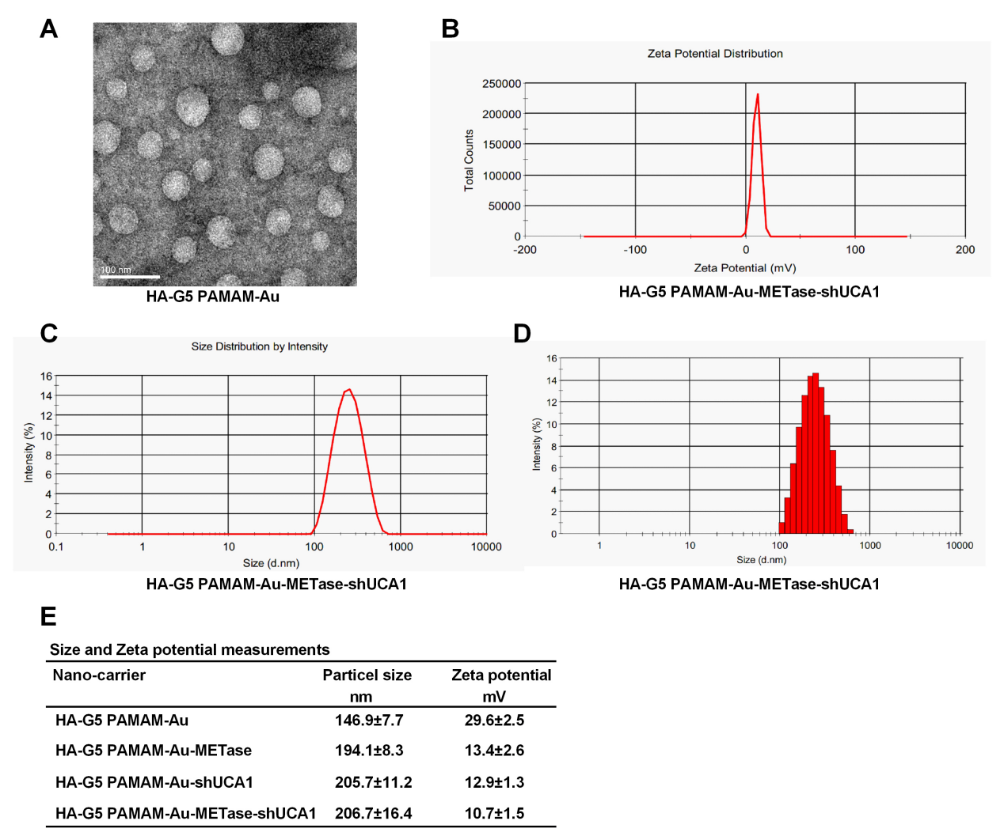

Figure 1 The characteristic of nanoparticles. (A) TEM image of HA-Polyamidoamine-Au. (B) Zeta potential distribution of HA-Polyamidoamine-Au-METase-shUCA1. (C, D) Size distribution based on intensity of HA-Polyamidoamine-Au-METase-shUCA1. (E) Statistical results of particle size (nM) and zeta potential (mV) of nano-carriers. G5 PAMAM, the 5th generation of Polyamidoamine. METase, methioninase. HA, hyaluronic acid.

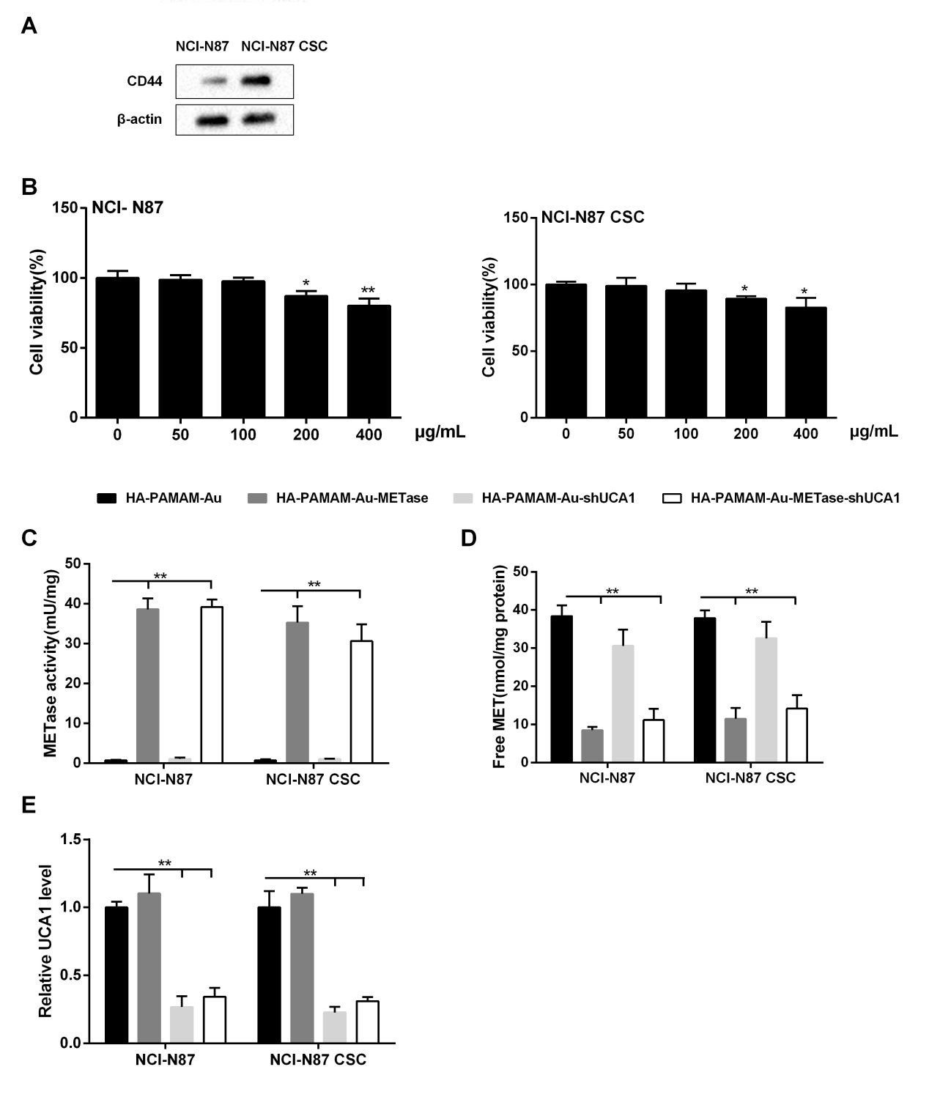
Figure 2 HA-Polyamidoamine-Au-METase-shUCA1 inhibited METase activity and UCA1 expression in NCI-N87 and NCI-N87 CSC cells. (A) The expression of CD44 in NCI-N87 and NCI-N87 CSC cells was detected by western blot analysis. β-actin acted as internal control. (B) The effect of HA-Polyamidoamine-Au on cell viability was detected by CCK-8 assays. (C) METase activity transfected with different nanoparticles was assessed. (D) The effect of nanocarriers on free MET expression. (E) The relative UCA1 level in cells was detected by qRT-PCR. GAPDH was used as internal control. *P<0.05, **P<0.01: comparison and analysis were conducted between groups. PAMAM, Polyamidoamine. METase, methioninase. HA, hyaluronic acid.

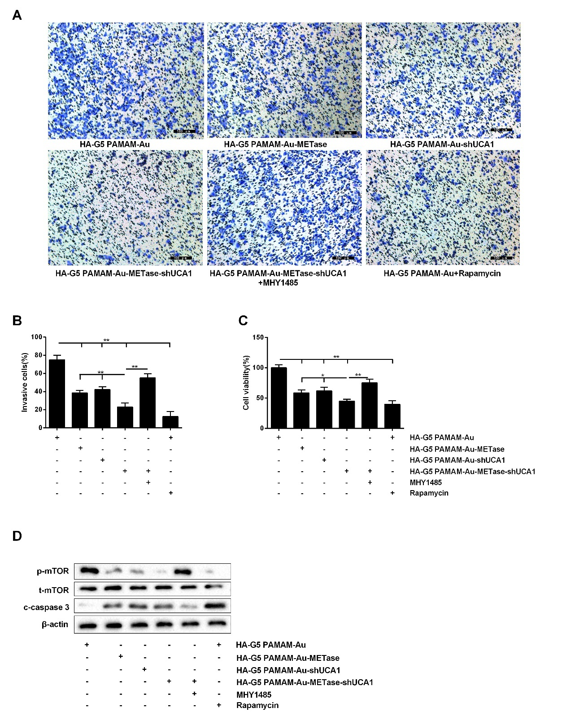
Figure 3 HA-Polyamidoamine-Au-METase-shUCA1 inhibited NCI-N87 cell viability and invasion. (A) Representative images and (B) accompanying statistical plots were presented about cell invasion. (C) HA-Polyamidoamine-Au-METase-shUCA1 suppressed NCI-N87 cell viability through CCK-8 assay. (D) The effect of different nanocarriers on the expression of p-mTOR and c-caspase 3 through western blot analysis. β-actin was used as internal control. *P<0.05, **P<0.01: comparison and analysis were conducted between groups. G5 PAMAM, the 5th generation of Polyamidoamine. METase, methioninase. HA, hyaluronic acid.

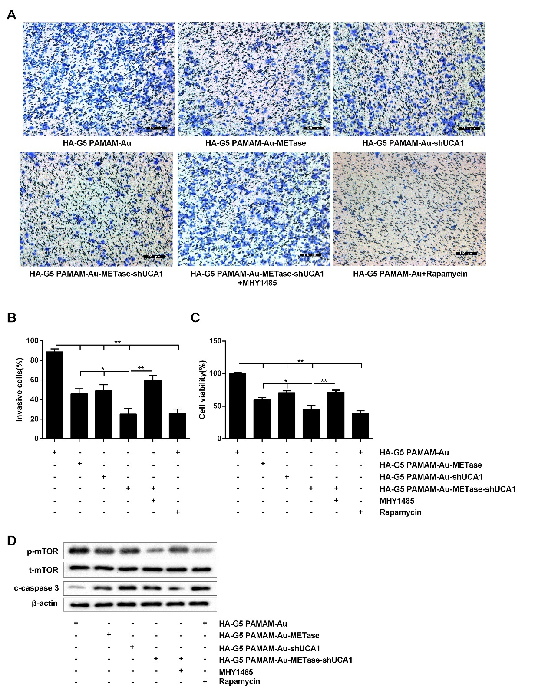
Figure 4 HA-Polyamidoamine-Au-METase-shUCA1 inhibited NCI-N87 CSC cell viability and invasion. Quantification of the invasion of NCI-N87 CSC cell in groups according to METase and UCA1 gene expression. (A) Representative images and (B) accompanying statistical plots were demonstrated. (C) A CCK-8 assay was used to determine the effect of various nanoparticles on NCI-N87 CSC cell viability. (D) Protein expression of p-mTOR and caspase-3 after transfection by western blot analysis. β-actin was used as internal control. *P<0.05, **P<0.01: comparison and analysis were conducted between groups. G5 PAMAM, the 5th generation of Polyamidoamine. METase, methioninase. HA, hyaluronic acid.

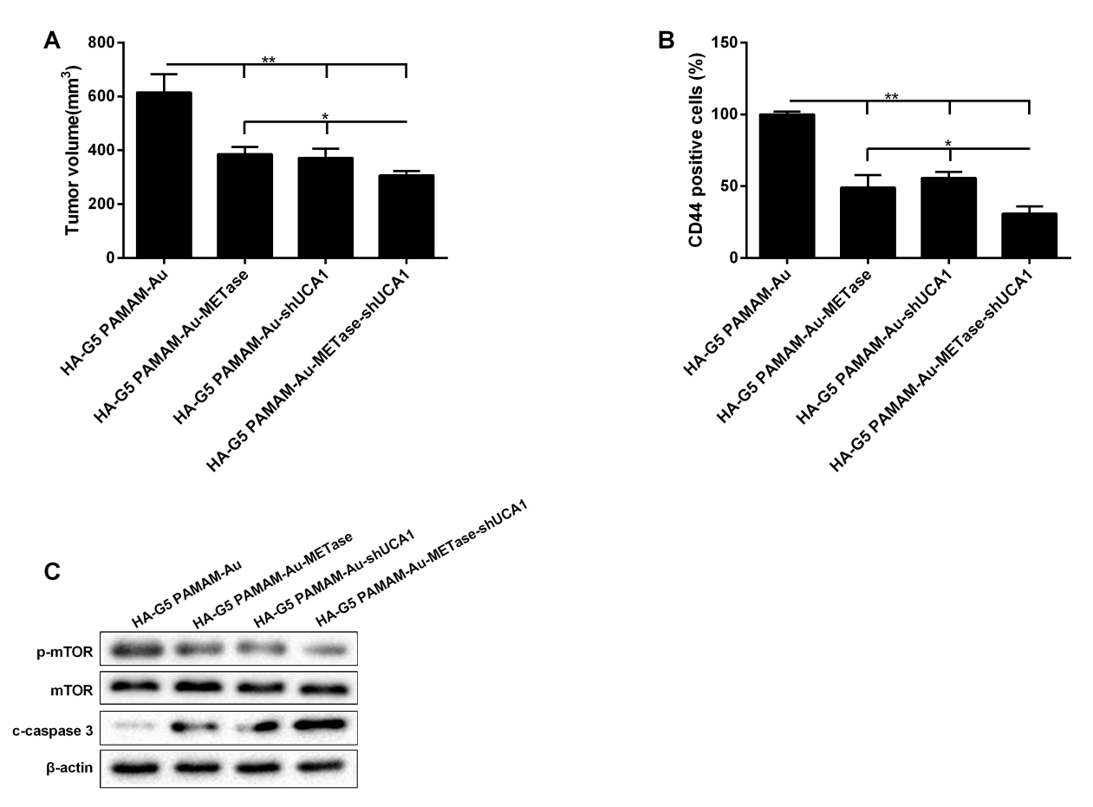
Figure 5 HA-Polyamidoamine-Au-METase-shUCA1 inhibited tumor growth in gastric cancer mice. Subcutaneous gastric cancer was induced via inoculation of 1 × 107 mouse NCI-N87 CSC cells in the flank. (A) Tumor volume of caudal vein implantation models of NCI-N87 CSC cells was shown. (B) The percentage of CD44 positive cells was determined using immunohistochemistry. (C) The expression of mTOR, p-mTOR, and c-caspase-3 was determined using Western blot analysis. β-actin was used as an endogenous control. *P<0.05, **P<0.01: comparison and analysis were conducted between groups. G5 PAMAM, the 5th generation of Polyamidoamine. METase, methioninase. HA, hyaluronic acid.

