Telomerase Therapy: To Treat All Age-Related Diseases

Steve Liebich¹
ORCID: 0000-0002-5379-4532

¹ Babu™ (BabuBio, LLC), Founder & CEO

Phone: +1 (315) 262 7005
Email: steven@babusolutions.com

Each eukaryotic cell division leads to a gradual sequence loss at the chromosomal termini known as telomeres [1]. This so-called end replication problem (ERP) forms the basis of cellular senescence, along with a few other well-established biochemical processes disrupting the cellular homeostasis [2].
Telomeres are composed of repeated oligonucleotide sequences supported by a six-protein complex (shelterin) and the quaternary structure they form in vivo [3-5]. Thus, telomeres are the specific genomic protection device, guarding the cell from inexpedient recombination events, degradation through the DNA repair system, and significant genetic material loss [6-9]. In some cell types, a reverse transcriptase known as telomerase, reconstitutes the original length of the shortening chromosomes, saving the chromosomal and genomic stability of the cell [10-14]. In such conditions, the cell undergoes almost an infinite number of mitotic cycles, breaking through the Hayflick phenomenon [15].
Cellular senescence is a complex, multilevel, precisely controlled mechanism of decline in effectiveness of physiological processes in the cell. Because of this complexity, more than three hundreds of different or slightly different theories of ageing have been proposed [16]. Many theories overlap, while the others leave gaps too broad to be omitted. New data are very often misleading and contradicting, thus not supporting either of the theories. Therefore, biogerontology needs to find a common denominator for all credible theories, so that one elegant unified theory could explain the entire life-long process of cellular ageing.
All proposed ageing theories are segregated into two main categories: programmed and non-programmed [17].The former category takes into account all ageing factors genetically inherited and gradually manifested over a span of lifetime. The latter group includes theories emerging from the customarily occurring errors in the genome and accumulated damage in the cell; Tear-and-wear is preferably chosen as the classic theory considering accumulating damage in the genomic DNA. However, it had been the free-radicals and mitochondrial theories that took much of the scientific community’s appraisal in the last century [18-21]. Three decades ago, the telomeric theory of cellular ageing stole the spotlight and since has grown into a well-developed and data-supported biogerontological doctrine, which aims to explain most of the observed hallmarks of cellular senescence [22-25]. These two models, the free-radical-mitochondrial and telomeric theories, have the potential to form a single comprehensive model of ageing explaining the entire complexity of the process. It is referred here as the Cellular Senescence Unification (CSU) model.
Is telomerase, the enzyme of capacity to restore the shortened telomeres and stabilize the genome, the definitive answer to the puzzling problem of ageing? Could we take an advantage of this finding and apply it to humans, hence aim to improve their health, fight the age-related diseases, and even reverse the ageing machinery in their cells? This work elaborates on the subject and answer these two questions with confidence: Yes, the telomerase may be the decisive tool in curing the age-related illnesses as well as the ageing itself.

Cellular Senescence and Ageing Unification Theory
As Bodnar et al. showed, each human cell which does not express an active hTERT transcript (human telomerase reverse transcriptase) loses its terminal chromosome repeats [11]. If cellular senescence was viewed as a dense system of all cellular and genomic changes occurring over an undefined span of time, relative loss of telomeres would be both one of the causes and effects of the total intracellular changes. However, the telomeric theory of ageing is well-established and strong enough to be thought of as one of most explanatory cellular senescence models in modern biogerontology.
Since the paper of L. Hayflick and P. Moorhead on the limited mitotic capacity of somatic cells, the link between restricted cell doublings and their mortality, telomeres shortening and the inevitable replicative senescence phenomenon has become obvious [15]. A large number of publications have been dedicated to the association of telomere shortening with numerous age-related disorders (see below).
A few notices must be highlighted when considering cellular senescence. Senescence is not equivalent to the quiescent state of the cell [26]; cell lines like hepatocytes and corneal endothelial cells remain replicative capability, but do not divide without external stimuli [27, 28]. All-or-nothing model of cellular senescence, popularized in the past century, has lost its merits over the more consistent and data-supported gradual changes within the cells [22]. Today, the cell senescence model of aging is acknowledged and the postulate that senescence and the non-programmed errors accumulated in genome result from changes in gene expression seems to work and unify other related theories [29]. As this will be elaborated in the next section of the article, there is a strong correlation between telomere shortening, chromatin destabilization, change in genome dynamics, and change in gene expression patterns.

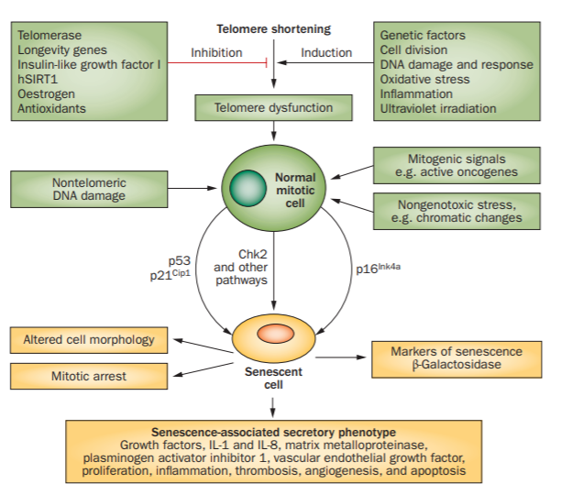

Figure 1. Cellular senescence external and internal factors. A plethora of mutagens, signaling pathways, cytokines, and oxidative agents influence the rate of telomere shortening in the cell. Environmental stressors (UV light, industrial toxins, carcinogens, and intercalating agents), expressed oncogenes, and chromatin alterations also affect the progression of cellular senescence. Tumor suppressors, including p53, are activated upon those deleterious signals and respond adequately by triggering mitotic arrest, altering cell morphology, secretion of growth factors, cytokines, and apoptotic factors. Telomeres are affected by all aforementioned senescence factors, but the same factors induce their effects through other genomic and non-telomeric pathways. Abbreviations: hSIRT1 (NAD-dependent protein deacetylase sirtuin-1); Chk2 (checkpoint signaling kinase 2). Figure adapted from [51].

After all, senescence is a gradual process occurring in every cell of a multicellular organism, including cells that are mitotically inactive. Senescence should be understood as a complex network of changes in genes expression, DNA damage, ineffective DNA repair mechanisms, misbalance between reactive oxidative species production and scavenging, cell morphology, toxins accumulations, proteomic changes, and finally loss of telomeres. Since only telomere shortening can be diagnostically well observed and therapeutic approaches in the aging research field have shown greatest efficiency in the telomere-based re-lengthening methodology, it is telomere length and cell population doublings (replicative potential) that are chosen as primary markers for senescence. Even though it is subjective and experimentally unapproachable to test whether a cell is already senescent or “not yet,” the CSU model is supported by our current knowledge, and although not perfect, it is still the best tool we can use to not only explain the cellular ageing processes, but also to manipulate them.
Fossel (2012) suggests the relative telomeres length measures as a reliable, clinically practical, and specific biomarker of age-related diseases [30]. Correlation between the telomere corrosion in a chronologically old individual and onset of various age-related diseases is well-known, thus telomeres and their shortening seem to be a reliable source of clinical information and a platform for proper intervention. It must be noted that it is the relative rate of telomeres shortening, not just a total loss of the termini sequences, which gives insight into telomere-dependent diseases onset and their symptoms [31]. This remark has been taken to clinics with commercial enterprises of key telomere researchers: Maria Blasco (Life Length) and Calvin Harley & Elizabeth Blackburn (Telome Health). These are first steps of the telomere research evolving to the clinical importance.
However, as long as the relative telomere loss is a strong biomarker in chronologically advanced patients and individuals in greater risk cohorts, the very common telomere length (TL) measures in the peripheral blood leukocytes (PBL) seem to be an undesirable method. First, false negative results might affect the diagnosis of a patient still affected by slowly evolving pathological process. The reason is that leukocytes’ telomeres might remain relatively stable if a disorder develops in the liver, for instance. Moreover, the “old” leukocytes are constantly being replaced by the white blood cells with long telomeres. Second, peripheral leukocytes can be exposed to toxic, stressful or immunological factors that would influence telomere loss in the PBL without any underlying age-related disorder [32]. Multiple studies showed a positive correlation between external factors such as smoking, obesity [33], oxidative damage [34, 35] and past infectious diseases [36-38]. Third, the genomic changes of white blood cells (WBC) are as much important as in other human cells: the age-dependent telomere shortening [39], polymorphisms in the hTERT promoter and its regulatory genes [40](although a Swedish cohort studies of the same single nucleotide polymorphism did not show any correlation [41]), and changes in the epigenetic landscape of the hTERT [42], they all matter. These findings indicate that the relative PBL telomere loss is a significant biomarker for a number of age-related diseases, but the PBL is not always the right source of telomere attrition information.
Coronary heart disease [43], osteoporosis [44], diabetes [45], and other age-related disorders are correlated with shortened telomeres; the telomere attrition leads to cell senescence as observed in multiple tissues and organs. The peripheral blood leukocytes (PBL) telomere length (TL) measurements have been applied to a plethora of various age-related disorders, diseases of affluence and immunological disorders, including longitudinal studies of cardiovascular health problems (46), chronic obstructive pulmonary disease [47], familial and sporadic pulmonary fibrosis (48), and hematopoietic malignancies [49]. These data underlie a strong correlation between telomere attrition and the diseases etiopathophysiology observed in clinical settings.
Human skin fibroblasts were the first telomere-associated senescence model cells, for which the telomerase transfection proved to be liable [11]. In two parallel studies, human keratinocytes and fibroblasts were grown on an immune-compromised mouse and the new skin morphology was assessed for early (20 population doublings) and late (85 population doublings) passage; the late passage cells were further transformed with an external hTERT and the relengthened telomeres led to skin reconstitution, optimal gene expression and normal filamentous connections observed in young skin [50].
Almost every issue type in the human body demonstrates histological and ultracellular changes associated with telomere shortening. For cardiovascular diseases, mice and human models show exceptional correlation between telomere dysfunction (also oxidative stress, proinflammatory molecules activation, etc.) and vascular endothelial cells senescence leading to development of cardiomyopathy and severe atherosclerosis [51]. The impairment of control mechanisms of stem cells reserve and their differentiation and division in the bone marrow, hugely associated with telomere attrition and immune system age-related changes, is responsible for its pathological decrease in activity in the elders. Similar deferment in physiology has been found in glial cells, the cells that divide and proliferate in the brain, whose ultracellular ageing transformation has been presented to be the leading cause of Alzheimer’s disease [52]. These examples indicate the necessity to reform the way how one interprets the pathophysiology of many age-related disorders. The non-division pattern of neural or myocardial cells is irrelevant; the scientific community must look at the cells that actually are mitotically active and then the telomeric theory of cellular ageing comes closer to the light than ever.
The telomeric theory of ageing is the most well-established and data-supported model of cellular ageing. In vitro studies of telomerase-deficient cells treated with external telomerase, immortal cell lines established after the telomerase treatment, infinitely doubling cancer cells expressing telomerase in constant rate, in vivo studies of the telomerase effects on somatic cells in mice models, and a gigantic data pool for diverse disorders correlated to telomere shortening showcase the causal relationship between telomere loss, telomerase activity and expression, and onset of age-dependent disorders.

Control Mechanisms of Telomeres Length and Telomerase Expression
Senescence is a gradual process that takes place in every living cell of human body, with cells varying in degrees of senescence. This is a complex and global process incorporating changes in epigenetic status, genomic mutations and breakages, slowed metabolic turnover of the cell, increased levels of oxidative species, failing mitochondria, accumulation of toxic chemical compounds (external and internal), deterioration of signaling pathways, increased turnover of proteins, and increasing area to volume ratio of the cell.
Not all changes lead to the cell’s death. Senescent cells rarely “die,” they rather move to a quiescent state where they become less mitotically active or completely inactive. Telomeres shortening advance the genomic defects, and this destabilization leads to more rapid cellular changes [23, 25]. On the other hand, stem cells are partially protected from the destabilizing consequences of telomeres attrition by expressing the telomerase, which extends the missing chromosomal termini. The difference between the somatic and stem cells is that the former have an accelerated rate of senescence, while the latter gradually become more senescent [53]. Thereby in the old age, stem cells are more senescent than they were in the young organism, but somatic cells are more senescent from the stem cell populations. Yet, the example of hematopoietic stem cells indicates their differential telomeres length with time and non-immortal molecular identity [54]. These changing proportions affect the organs’ capability to replace the ageing somatic cells by more vital stem cells located in the organs’ so-called stem cells niches [55]. These cells are transit cells (dividing and slightly differentiating stem cells) with the self-renewal capability [56]. These subtle differences between true stem cells, transit cells and functionally competent somatic cells bring confusion, but it must be remembered that only the competent somatic cells have their specific “lifespan.”
Telomerase plays an important part in keeping the cell’s homeostasis balanced. Therefore, the telomerase expression and activity regulation in the cell is as much significant. The 40-kb hTERT locus sits on chromosome 5, only 2 Mb away from the chromosomal end [57]. hTERT lacks both TATA and CAAT boxes, but is regulated with two canonical E-box sequences [12]. The E-box sequences and numerous CpG islands provide large methylation sites for the hTERT locus, which can be explained by the strict epigenetic regulation of the locus [58]. Most human cells do not produce telomerase [12]. The exceptions are stem cells, germ cells, and select white blood cells [59, 60]. Moreover, 85 – 90% cancer cells express active telomerase [61-63]. It is still unknown why most somatic cells are hypermethylated at the telomerase site and what exact mechanisms participate in the negative regulation [64]. However, various findings show that some cells are capable of producing telomerase in vivo, but these are inactively spliced variants that do not contribute to the telomerase activity [65].
The telomerase-telomere cellular “apparatus” is also controlled by a wide network of proteins. The trans-acting regulatory proteins are extremely active at the hTERT locus. The most abundant transcription factors (TFs) complexes are E-box-binding c-Myc/Max complex, which co-operates with the GC-box far-flung Sp1 TF acting as the activating element [66]; on the other hand, Mad1/Max complex, along with deacetylases, represses the hERT locus [67]. For review of divergent transcription factors involved in the telomerase expression regulatory mechanisms please refer to [68-70].

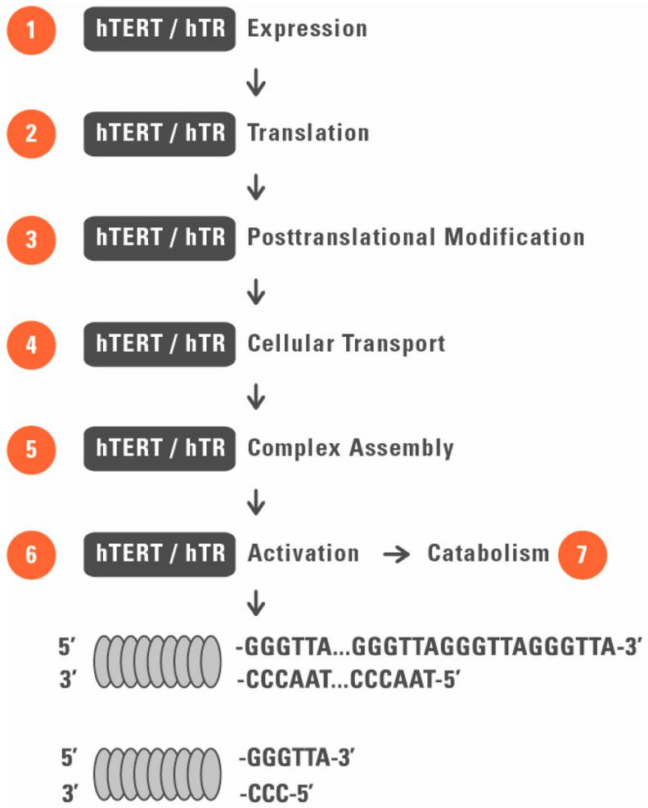

Figure 2. Telomerase expression mechanism in telomerase-positive cell line. Telomerase is a ribonucleoprotein complex composed of many subunits, of which telomerase reverse transcriptase (TERT) and telomerase RNA component (TERC) are essential in physiological activity of telomerase. The multicomponent enzymatic complex extends chromosomal termini by synthetizing de novo tandem telomeric repeats (5’TTAGGG-3’) at 3’ end of the chromosome. TERC binds the 5’ C-rich strand and its 11-nt sequence serves as the replication template for reverse transcription. Abbreviations: hTERT (human telomerase reverse transcriptas); hTR (human telomerase RNA component).

Telomeres are supported by another, but not exclusive, set of proteins. The already mentioned shelterin complex of six core proteins both protects telomeres from exonucleases degradation and provides an interaction matrix for other regulatory factors [71].The telomeres instability is reflected mainly through the double-strand break (DSB) events. The DSBs induce chromosomal translocations, error-prone recombination events and tumorigenic processes [72]. Two major DNA damage sensing pathways are related to ATM and ATR serine-threonine kinases, which are activated at cell cycle checkpoints, mostly at G₀, G₁ and S; the DSBs are repaired by two main processes: homologous recombination (HR) and non-homologous recombination end-joining (NHEJ) [73]. A plethora of proteins is used by the cell to protect the genomic stability and the truncated telomeres through the two recombination mechanisms [73, 74].
This complicated and heterogeneous network of signaling pathways and trans-acting regulatory elements serves to maintain the telomeres length and respond to occurring changes at telomeres. Recently, the telomere position effect (TPE), imposed by relative shortening of telomeres and the rate of loss, on nearby genes through telomeric chromatin looping has attracted much attention [75, 76]. This is because the TPE explains how physical changes of the truncated telomeres affect other genes expression through physical mechanisms, very often affecting genes placed more than 10 Mb from the telomeric region [75]. Additionally, short telomeres themselves may serve as another proximate senescence trigger through DNA repair mechanisms [77]. However, many researchers agree that, apart from the aforementioned mechanisms, the relative length of telomeres and the rate of telomere loss affect the genomic structure at most [30, 53, 78, 79]. The cell responds accordingly to all these changes, and depending on its current biochemical status, becomes more receptive to other deleterious processes inside of it.

The Role of Telomerase in Cellular Pathophysiology
The negative correlation between telomerase expression and onset of most cancers in the human body has been favored by the scientific community for years [61-63]. This replicative immortality stressed by Hanahan and Weinberg has been associated with hTERT activation, and thus the conclusion withdrawn was simple: telomerase expression promotes tumorigenesis in somatic cells [80].
Interestingly, the remaining cancer types that do not activate the hTERT locus still elongate their telomeres through the alternative lengthening of telomeres (ALT) mechanism [81, 82]. This route of telomere elongation takes an advantage of chromosomal instability and strands breaks, which is detrimental to the cell karyotype. A tumorigenic clone line will always sort the cells with longer telomeres compensating the higher proliferative rate [81]; furthermore, the telomere sister chromatic exchange (T-SCE), telomere-repeat arrays exchange resulting from the ALT pathways, yields the unequal sister telomere lengths in different cancerous cell lines [83].
The misconception is that long telomeres are a biomarker for high cancer risk; this is far from the truth. In fact, in most cancerous cells the telomeres are much shorter than those found in normal cells [84, 85].Most modern tumor studies find truncated telomeres in immortal cells, recombinogenic with dicentric chromosomes, reciprocal translocations and other deleterious karyotypes [86, 87]. Moreover, in most studies correlating the telomere length with concomitant cancer, the telomere length has either been found normal or reduced; in other studies the telomere length has been found increased with either active or quiescent telomerase [88-91]. In many papers studying the correlation between telomeres length, telomerase expression and cancer cell biology, cancer tissue histopathological changes are not reported, only the average length of the cell telomeres is measured instead of the shortest telomere length, and the telomere length measurements are taken from peripheral blood leukocytes (PBL) in malignant diseases not correlated with immune system cells [30]. These mistakes generate the false conclusions and consolidate the misconception.

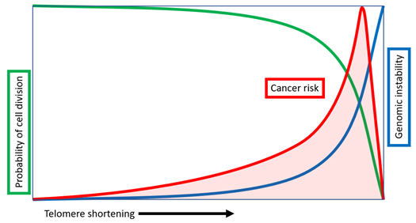

Figure 3. Relationship between telomere shortening, increasing genomic instability and varying cancer risk. With each replicative division the total telomere length decreases, which leads to miscellaneous genomic and intracellular alterations increasing the overall risk of hyperproliferation and tumorigenic mechanisms development. It must be noted that a cell in order to develop cancerous changes must rely on relatively long telomeres for proper genomic stability. If its telomeres are too short, the cell drifts into senescence and eventually dies.

There is no data on the relatedness between the telomere length maintenance (TLM) and cancer. Present studies with somatic cells expressing recombined telomerase gene or somatic cells treated with telomerase vectors, and studies on the embryonic pluripotent cells with constitutive telomerase expression, indicate no cancer remarks [26, 92-94]. This can be partially explained by the fact that only the average telomere shortening and its rate, not the total telomere loss, determine the senescence phenotype; thus telomerase expression increases the genomic stability by keeping the average telomere loss and re-lengthening constant [95]. This can be supported by showing that knocking down the telomerase gene coincides with tumor growth arrest, but only when the tumor had already grown, not before the tumorigenesis process, not even in a p53-null cell [79].
Recent findings present multiple non-canonical functions of telomerase affecting the genomic stability, very often resembling the ones found in the ALT mechanisms [96]; however, both the telomerase- and ALT-based telomere length maintenance pathways stabilize the already destabilized genome of the cancerous cell. Thereby, it is not about a maximum telomere length that can keep the cancer cell from apoptosis, but about keeping telomere length above the critical threshold, given for each organism. This also explains why the tumor cells in mice upregulate mTERT expression, even though the mural telomeres (approx. 50 kb) are much longer than in humans (approx. 15 kb in a young human cell) [78].The studies in mice corroborate the observations that, contrary to the general assumptions, telomerase does not increase the risk of tumor development, but also protects the cells from such [97, 98].

The Beginnings of Telomere-Targeted Therapies
The number of publications on telomerase and its different biological effects has immensely increased since the dawn of the 2000s [99]. Since the discovery of the telomeric RNP, the impact of it crossed into two separate ways. The first approach is “pro-TERT” favoring its regenerative function at the shortened telomeres, extending the cell’s population doubling, and restoring its mitotic capacity. The opposite approach is mainly “anti-TERT”, and different laboratories try to utilize our knowledge of telomerase to treat miscellaneous cancerous diseases.
Antitelomerase molecules have been chosen by selected biotechnological companies as potential drugs, mostly targeted against the cancerous tissues [100-102]. One of such pharmaceuticals, N3’-P5’ thio-phosphoramidate (NPS) oligonucleotide (GRN163) acting as telomerase antagonist, although primarily shown as a competitive and efficient cancer drug introduced by Geron Corporation, had turned out to become a complete failure. Interestingly, the anti-telomerase therapies seem to impair the findings of the opposite approach, i.e. upregulating telomerase levels in cell for therapeutic reasoning. This only showcases that the situation is far more complicated than it has seemed at first glance.
As already discussed, telomerase does not increase the risk of cancer development [103]. It is the optimal telomeres length that must be present in a cancerous cell in order to satisfy the unstoppable growth. If the telomeres were too long, they would provide the cell with incontestable genomic stability, thus precluding cancerogenesis [104]. On the other hand, if the average length of the cancerous cell’s telomeres was too small, the cell would fall into the senescence route and eventually die through apoptosis [105, 106]. Therefore, we should expect different clinical results depending on the dosage of anti-telomerase therapy, duration, and the activity of anti-telomerase agents. Perhaps, this sort of cancer treatment would yield positive clinical effects in a short run, but the long-term consequences seen in the patient are difficult to predict, especially if to consider the complexity of tumorigenesis and still uncertain role of telomeres and telomerase in its development.
Thereby, instead of focusing our sole attention on cancer in the light of telomerase, we should consider the telomerase therapeutic methods that could potentially help us confine age-related and other degenerative diseases. Some agree that telomeres extension through the reverse transcription of the telomerase complex outweighs the risk of cancer promotion [107].
Transient transfection of somatic cells with telomerase transcript, full or truncated, has shown that 1) a causation relationship exists between the length of telomeres and the expressed levels of telomerase, and 2) extrinsic delivery of telomerase to the cells restores their function, but does not change their phenotype [26, 108, 109]. The first proof was presented by Bodnar et al. in 1998, when human retinal pigment cells and foreskin fibroblasts were transfected with the hTERT-SV40 construct, and established the laboratory immortal cell lines [11]. Bodnar’s work initiated a cascade of future experiments using extrinsic telomerase catalytic subunit as the cells ‘transformer’, establishing immortalized and phenotypically regular transformed cells [110-112]. The groundbreaking experiment presented by DePinho’s lab using a special mural TERT transcript engineered with a knock-in TERT-estrogen receptor (mTERT-ER) allele controlled by an extrinsic estrogen receptor modulator, 4-hydroxytamoxifen (4-OHT) showed how reversing the systemic degenerative phenotypes and restoring telomeres length in mice with various telomere dysfunctions can be achieved by external, dosage-dependent telomerase expression regulation [92]. Other studies with somatic cells successfully transfected with TERT subunit are reviewed in [107].
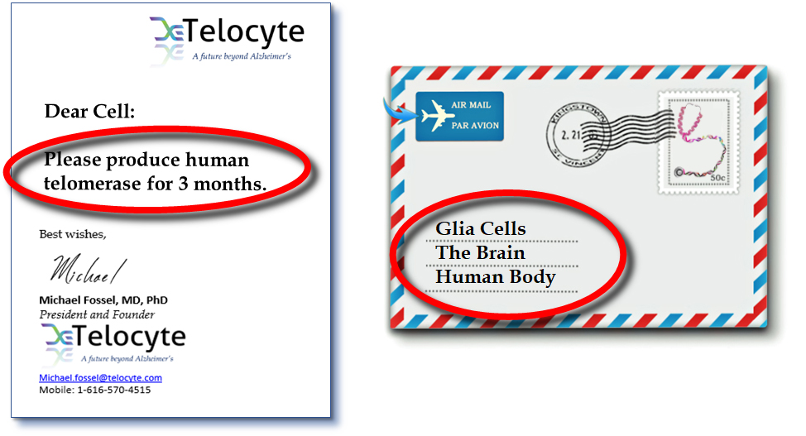

Figure 4. Delaware-based biotechnology company Telocyte will soon present the world’s first fully efficient telomerase therapy for Alzheimer’s disease (AD). TEL-01 is delivered through the AAV-9 vector to the spinal fluid and acts transiently on the glial cells of the brain – the mitotically active brain cells that underlie pathophysiology of Alzheimer’s disease and trigger all pathological changes in the neural tissue in the patients suffering from AD. This gene therapy builds a bigger therapeutic platform which will serve to eventually cure most of age-related disorders.

From time to time, different therapeutic variations concerning telomerase are reinforced by other biomolecules. In one such study, telomerase therapy was supported by the ectopic Bcl-2 transfection [113]. Telomerase as a biomolecule in tissue engineering and regenerative medicine (TERM) has already been strongly suggested [114, 115]. Moreover, it is commonly agreed that only transient, ectopic delivery of telomerase under constant physiological control is the only acceptable way of the therapeutic approach. This model, mostly with viral vectors, had been well-tested in the past [50, 116, 117]. The same model, but modified and extended, works perfectly fine with adeno-associated virus (AAV) as a viral vector for ectopic TERT, which does cause tumor transformation or any genomic instabilities within the transfected cells [93]. These findings show that we are ready to embrace all the experimental data coming from the telomeres research and apply our knowledge to clinics, where our patients could benefit from billions of dollars spent on the research on telomerase, cancer and TERM.

The Future of Ageing: Telomerase Therapy
Aims.
Telomerase therapy is rooted in the molecular foundations of cellular pathology. As such, it might target multiple potential diseases directly associated with genomic instability and/or TLM disruption. Every age-related disorder with an etiology correlated with telomere shortening, supported by experimental and clinical data, can become a potential target for the therapy. The therapy may not only be used to cure age-related diseases, but also it can be used to prevent their occurrence. The premise is clear: if we can suppress the genomic instability and strengthen cellular homeostasis, the risk of a disease onset and its progression might be reduced.
Previously in the text, reversing the cellular senescence was mentioned. This is an important aspect of every biogerontological therapy which must be addressed with high prudence. From biomedical standpoint, we are currently not able to reverse the molecular ageing in terms of the simple understanding: one cannot reverse the biological clock as this would stand against the second law of thermodynamics. However, one could help suppress the somatic damage to the genome and prevent further deleterious changes happening on the molecular level. These actions will reverse the molecular hallmarks of cellular senescence, giving an individual the better quality of living.
Moreover, as it has already been discussed here in depth, a strong correlation between cancerous transformation and the telomerase apparatus control exists. If the total loss of telomeric repeats in given set of chromosomes dictates further mechanisms being activated and deactivated during the rigorous checkpoints of the cell cycle, preventing the cell from the telomere truncation would yield broadly positive clinical outcomes for cancerous diseases. More experimental data is needed to draw proper conclusions, and it is still too early to declare any final statement on the correlation between cancer development and telomere length control, but based on the data we have at the moment we can conclude that there is a promising platform for telomerase therapy targeting the cancerous changes at the molecular level.

Evaluating Telomerase Therapy.
Human clinical studies must be completed until we can state that the therapy is successful and rational. Our predictions set a new course of developing the gene therapy for age-related diseases, where biopsychosocial model of disorder must be evaluated for the full understanding of potential telomerase therapy.
The biology of ageing is a crossroad for divergent fields of medicine and biology, where one must not speak about one cause, one effect or a simplified correlational model. Using novel proteomics of isolated chromatin segments (PICh) technique, it has been found that three cell lines manifesting two types of TLM, through telomerase and ALT, were associated with ~400 different proteins, sharing 98 proteins in common [118]. Many of those proteins could be associated with different genomic loci, cell cycle stages and chromatin looping effects, but this approximation showcases the great abundance of regulatory elements involved directly or indirectly in the processes of telomere length regulation (TRF1, POT1, Apollo), DNA damage mechanisms (Rad50, BLM, ERCC1, PARP1), chromosome end protection (Ku 70, Ku 80, ATM, ATR, WRN), and many others [119]. Many proteins on the cross-talk of different paths must be counted as well, which only adds on to the complexity of the biology of telomeres.
As already discussed in the text, there is much inconsistency in the TLM among stem cells which express telomerase, so is the situation complex for somatic and cancerous cells, which employ a variety of mechanisms to maintain the proper telomere length. These findings exclude telomerase from being the principal positive factor for telomere-based cellular ageing and bring some commotion to the scientific community. The turmoil between groups which incorporate the telomerase data to the cancer treatment research and the ones which take the exact opposite approach, introduces much of uncertainty. Should we trust a therapy making use of telomerase?

Conclusions
This question requires a definitive answer based only on data; no speculations have room here. However, we are certain that telomerase therapy can become a golden standard for all age-related diseases in the next 10 years. Recent findings (cited elsewhere in the text) showcase undoubtedly the positive role of telomerase in the “old” and senescent cells, which retrieve their biological functions and add to the pool of “young” and healthy cells of the tissue. The exact role of telomeres and their length control in cancer development is still debatable, but further steps in clinical research will finally resolve this dilemma.
There is yet much to say in the ageing research. New discoveries consistently broaden our understanding of the telomere biology and demonstrate its complexity, which is understandable in terms of its highly significant role in homeostasis. It must be noted that, even though many signaling pathways and metabolic processes are involved, the main role of telomeres is to protect the chromosomal ends form degradation and NHEJ, which destabilizes the genome and disrupts the cellular physiology. If we can stop this process, reverse it and stabilize the metabolic environment of the cell, we should do it. We must push the progress of our own findings and apply them in the real-world situations, where patients are the final recipients of what once has started in the laboratory.

References

- Blackburn EH, Gall JG. A tandemly repeated sequence at the termini of the extrachromosomal ribosomal RNA genes in Tetrahymena. J Mol Biol. 1978; 120: 33-53.
- Olovnikov, Alexeij M. "A theory of marginotomy: the incomplete copying of template margin in enzymic synthesis of polynucleotides and biological significance of the phenomenon." Journal of theoretical biology 41.1 (1973): 181-190.
- Meyne J, Ratliff RL, MoYzIs RK. Conservation of the human telomere sequence (TTAGGG) n among vertebrates. P Natl Acad Sci. 1989; 86: 7049-7053.
- Chong, Laura, et al. "A human telomeric protein." Science 270.5242 (1995): 1663-1667.
- De Lange, Titia. "Shelterin: the protein complex that shapes and safeguards human telomeres." Genes & development 19.18 (2005): 2100-2110.
- Harley CB, Futcher AB, Greider CW. Telomeres shorten during ageing of human fibroblasts. Nature. 1990; 345: 458.
- Lindsey J, McGill NI, Lindsey LA, Green DK, Cooke HJ. In vivo loss of telomeric repeats with age in humans. Mutat Res/DNAging. 1991; 256: 45-48.
- Allsopp, Richard C., et al. "Telomere length predicts replicative capacity of human fibroblasts." Proceedings of the National Academy of Sciences 89.21 (1992): 10114-10118.
- Lombard, David B., et al. "DNA repair, genome stability, and aging." Cell 120.4 (2005): 497-512.
- Greider CW, Blackburn EH. A telomeric sequence in the RNA of Tetrahymena telomerase required for telomere repeat synthesis. Nature. 1989; 337: 331.
- Bodnar, Andrea G., et al. "Extension of life-span by introduction of telomerase into normal human cells." science279.5349 (1998): 349-352.
- Cong YS, Wright WE, Shay JW. Human telomerase and its regulation. Microbiol Mol Biol Rev. 2002; 66: 407-425.
- Collins, Kathleen, and James R. Mitchell. "Telomerase in the human organism." Oncogene 21.4 (2002): 564.
- Shay, Jerry W., and Woodring E. Wright. "Telomeres and telomerase in normal and cancer stem cells." FEBS letters584.17 (2010): 3819-3825.
- Hayflick L, Moorhead PS. The serial cultivation of human diploid cell strains. Exp Cell Res. 1961; 25: 585-621.
- Medvedev, Zhores A. "An attempt at a rational classification of theories of ageing." Biological Reviews 65.3 (1990): 375-398.
- Jin, Kunlin. "Modern biological theories of aging." Aging and disease 1.2 (2010): 72.
- Harraan, Denham. "Aging: a theory based on free radical and radiation chemistry." (1955).
- Berlett, Barbara S., and Earl R. Stadtman. "Protein oxidation in aging, disease, and oxidative stress." Journal of Biological Chemistry 272.33 (1997): 20313-20316.
- Cadenas, Enrique, and Kelvin JA Davies. "Mitochondrial free radical generation, oxidative stress, and aging." Free Radical Biology and Medicine 29.3-4 (2000): 222-230.
- Pham-Huy, Lien Ai, Hua He, and Chuong Pham-Huy. "Free radicals, antioxidants in disease and health." International journal of biomedical science: IJBS 4.2 (2008): 89.
- Fossel, Michael. The Telomerase Revolution: The Enzyme That Holds the Key to Human Aging and Will Soon Lead to Longer, Healthier Lives. BenBella Books, Inc., 2015.
- Blasco, Maria A. "Telomere length, stem cells and aging." Nature chemical biology 3.10 (2007): 640.
- Blackburn, Elizabeth H., Elissa S. Epel, and Jue Lin. "Human telomere biology: a contributory and interactive factor in aging, disease risks, and protection." Science 350.6265 (2015): 1193-1198.
- Shay, Jerry W., and Woodring E. Wright. "Hallmarks of telomeres in ageing research." The Journal of Pathology: A Journal of the Pathological Society of Great Britain and Ireland 211.2 (2007): 114-123.
- Morales, Carmela P., et al. "Absence of cancer–associated changes in human fibroblasts immortalized with telomerase." Nature genetics 21.1 (1999): 115.
- Faragher, R. G. A., et al. "Aging and the cornea." British journal of ophthalmology 81.10 (1997): 814-817.
- Aikata, Hiroshi, et al. "Telomere reduction in human liver tissues with age and chronic inflammation." Experimental cell research 256.2 (2000): 578-582.
- Fossel, Michael. "Cell senescence in human aging: A review of the theory." In Vivo 14.1 (2000): 29-34.
- Fossel, Michael. "Use of telomere length as a biomarker for aging and age-related disease." Current Translational Geriatrics and Experimental Gerontology Reports 1.2 (2012): 121-127.
- Laberthonnière, Camille, Frédérique Magdinier, and Jérôme D. Robin. "Bring it to an end: does telomeres size matter?." Cells 8.1 (2019): 30.
- Calvert, Patrick A., et al. "Leukocyte telomere length is associated with high-risk plaques on virtual histology intravascular ultrasound and increased proinflammatory activity." Arteriosclerosis, thrombosis, and vascular biology 31.9 (2011): 2157-2164.
- Valdes, Ann M., et al. "Obesity, cigarette smoking, and telomere length in women." The lancet 366.9486 (2005): 662-664.
- Shen, Jing, et al. "Telomere length, oxidative damage, antioxidants and breast cancer risk." International journal of cancer 124.7 (2009): 1637-1643.
- Starr, John M., et al. "Oxidative stress, telomere length and biomarkers of physical aging in a cohort aged 79 years from the 1932 Scottish Mental Survey." Mechanisms of ageing and development 129.12 (2008): 745-751.
- Ilmonen, Petteri, Alexander Kotrschal, and Dustin J. Penn. "Telomere attrition due to infection." PloS one 3.5 (2008): e2143.
- Plunkett, Fiona J., et al. "The impact of telomere erosion on memory CD8+ T cells in patients with X-linked lymphoproliferative syndrome." Mechanisms of ageing and development 126.8 (2005): 855-865.
- Effros, Rita B., et al. "Shortened telomeres in the expanded CD28-CD8+ cell subset in HIV disease implicate replicative senescence in HIV pathogenesis." AIDS (London, England) 10.8 (1996): F17-22.
- Aviv, Abraham, et al. "Leukocyte telomere dynamics: longitudinal findings among young adults in the Bogalusa Heart Study." American journal of epidemiology 169.3 (2008): 323-329.
- Matsubara, Yumiko, et al. "Telomere length of normal leukocytes is affected by a functional polymorphism of hTERT." Biochemical and biophysical research communications 341.1 (2006): 128-131.
- Nordfjäll, Katarina, et al. "hTERT− 1327T/C polymorphism is not associated with age-related telomere attrition in peripheral blood." Biochemical and biophysical research communications 358.1 (2007): 215-218.
- Zhang, Dong-hong, et al. "DNA methylation of human telomerase reverse transcriptase associated with leukocyte telomere length shortening in hyperhomocysteinemia-type hypertension in humans and in a rat model." Circulation Journal (2014): CJ-14.
- Brouilette, Scott W., et al. "Telomere length, risk of coronary heart disease, and statin treatment in the West of Scotland Primary Prevention Study: a nested case-control study." The Lancet 369.9556 (2007): 107-114.
- Valdes, A. M., et al. "Telomere length in leukocytes correlates with bone mineral density and is shorter in women with osteoporosis." Osteoporosis International 18.9 (2007): 1203-1210.
- Sampson, Mike J., et al. "Monocyte telomere shortening and oxidative DNA damage in type 2 diabetes." Diabetes care 29.2 (2006): 283-289.
- Fitzpatrick, Annette L., et al. "Leukocyte telomere length and mortality in the Cardiovascular Health Study." Journals of Gerontology Series A: Biomedical Sciences and Medical Sciences 66.4 (2011): 421-429.
- Savale, Laurent, et al. "Shortened telomeres in circulating leukocytes of patients with chronic obstructive pulmonary disease." American journal of respiratory and critical care medicine 179.7 (2009): 566-571.
- Cronkhite, Jennifer T., et al. "Telomere shortening in familial and sporadic pulmonary fibrosis." American journal of respiratory and critical care medicine 178.7 (2008): 729-737.
- Scheinberg, Phillip, et al. "Association of telomere length of peripheral blood leukocytes with hematopoietic relapse, malignant transformation, and survival in severe aplastic anemia." Jama 304.12 (2010): 1358-1364.
- Funk, Walter D., et al. "Telomerase expression restores dermal integrity to in vitro-aged fibroblasts in a reconstituted skin model." Experimental cell research 258.2 (2000): 270-278.
- Fyhrquist, Frej, Outi Saijonmaa, and Timo Strandberg. "The roles of senescence and telomere shortening in cardiovascular disease." Nature Reviews Cardiology 10.5 (2013): 274.
- Fossel M. A Unified Model of Dementias and Age-Related Neurodegeneration. Alzheimer's & Dementia: The Journal of the Alzheimer's Association. January 2020. https://doi.org/10.1002/alz.12012
- Fossel, Michael. "Telomerase and the aging cell: implications for human health." JAMA 279.21 (1998): 1732-1735.
- Vaziri, Homayoun, et al. "Evidence for a mitotic clock in human hematopoietic stem cells: loss of telomeric DNA with age." Proceedings of the National Academy of Sciences 91.21 (1994): 9857-9860.
- Zhang, Jiwang, and Linheng Li. "Stem cell niche: microenvironment and beyond." Journal of Biological Chemistry 283.15 (2008): 9499-9503.
- Sharpless, Norman E., and Ronald A. DePinho. "How stem cells age and why this makes us grow old." Nature reviews Molecular cell biology 8.9 (2007): 703.
- Cong YS, Wen J, Bacchetti S. The human telomerase catalytic subunit hTERT: Organization of the gene and characterization of the promoter. Hum Mol Genet. 1999; 8: 137-142.
- Mine ()
- Wright, Woodring E., et al. "Telomerase activity in human germline and embryonic tissues and cells." Developmental genetics 18.2 (1996): 173-179.
- Liu, Kebin, et al. "Constitutive and regulated expression of telomerase reverse transcriptase (hTERT) in human lymphocytes." Proceedings of the National Academy of Sciences 96.9 (1999): 5147-5152.
- Shay, J. W., and S. Bacchetti. "A survey of telomerase activity in human cancer." European journal of cancer 33.5 (1997): 787-791.
- Kim, Nam W., et al. "Specific association of human telomerase activity with immortal cells and cancer." Science 266.5193 (1994): 2011-2015.
- Artandi, Steven E., and Ronald A. DePinho. "Telomeres and telomerase in cancer." Carcinogenesis 31.1 (2009): 9-18.
- Liebich S. hTERT Promoter Regulation by Differentiation Mechanisms vs Telomerase Activity in Somatic, Embryonic, and Cancerous Cells. OBM Geriatrics 2019;3(2):14; doi:10.21926/obm.geriatr.1902045.
- Ulaner, Gary A., et al. "Telomerase activity in human development is regulated by human telomerase reverse transcriptase (hTERT) transcription and by alternate splicing of hTERT transcripts." Cancer research 58.18 (1998): 4168-4172.
- Wang, Jing, et al. "Myc activates telomerase." Genes & development 12.12 (1998): 1769-1774.
- Xu, Dawei, et al. "Switch from Myc/Max to Mad1/Max binding and decrease in histone acetylation at the telomerase reverse transcriptase promoter during differentiation of HL60 cells." Proceedings of the National Academy of Sciences 98.7 (2001): 3826-3831.
- Ramlee, Muhammad Khairul, et al. "Transcription regulation of the human telomerase reverse transcriptase (hTERT) gene." Genes 7.8 (2016): 50.
- Cong, Yu-Sheng, Woodring E. Wright, and Jerry W. Shay. "Human telomerase and its regulation." Microbiol. Mol. Biol. Rev. 66.3 (2002): 407-425.
- Cairney, C. J., and W. N. Keith. "Telomerase redefined: integrated regulation of hTR and hTERT for telomere maintenance and telomerase activity." Biochimie 90.1 (2008): 13-23.
- Palm, Wilhelm, and Titia de Lange. "How shelterin protects mammalian telomeres." Annual review of genetics 42 (2008): 301-334.
- Khanna, Kum Kum, and Stephen P. Jackson. "DNA double-strand breaks: signaling, repair and the cancer connection." Nature genetics 27.3 (2001): 247.
- Abraham, Robert T. "Cell cycle checkpoint signaling through the ATM and ATR kinases." Genes & development 15.17 (2001): 2177-2196.
- Jackson, Stephen P. "Sensing and repairing DNA double-strand breaks." Carcinogenesis 23.5 (2002): 687-696.
- Kim, Wanil, et al. "Regulation of the human telomerase gene TERT by telomere position effect—over long distances (TPE-OLD): Implications for aging and cancer." PLoS biology 14.12 (2016): e2000016.
- Bouwman, Britta AM, and Wouter de Laat. "Getting the genome in shape: the formation of loops, domains and compartments." Genome biology 16.1 (2015): 154.
- Zou, Ying, et al. "Does a sentinel or a subset of short telomeres determine replicative senescence?." Molecular biology of the cell 15.8 (2004): 3709-3718.
- Vera, Elsa, et al. "The rate of increase of short telomeres predicts longevity in mammals." Cell reports 2.4 (2012): 732-737.
- Munoz-Lorente, Miguel A., et al. "AAV9-mediated telomerase activation does not accelerate tumorigenesis in the context of oncogenic K-Ras-induced lung cancer." PLoS genetics 14.8 (2018): e1007562.
- Hanahan, Douglas, and Robert A. Weinberg. "The hallmarks of cancer." cell 100.1 (2000): 57-70.
- Perrem, Kilian, et al. "Repression of an alternative mechanism for lengthening of telomeres in somatic cell hybrids." Oncogene 18.22 (1999): 3383.
- Cesare, Anthony J., and Roger R. Reddel. "Alternative lengthening of telomeres: models, mechanisms and implications." Nature reviews genetics 11.5 (2010): 319.
- Rudd, M. Katharine, et al. "Elevated rates of sister chromatid exchange at chromosome ends." PLoS genetics 3.2 (2007): e32.
- Feldser, David M., and Carol W. Greider. "Short telomeres limit tumor progression in vivo by inducing senescence." Cancer cell 11.5 (2007): 461-469.
- Blasco, Maria A. "Telomeres and human disease: ageing, cancer and beyond." Nature Reviews Genetics 6.8 (2005): 611.
- Bolzán, Alejandro D., and Martha S. Bianchi. "Telomeres, interstitial telomeric repeat sequences, and chromosomal aberrations." Mutation Research/Reviews in Mutation Research 612.3 (2006): 189-214.
- Blackburn, E. H., and J. W. Szostak. "The molecular structure of centromeres and telomeres." Annual review of biochemistry 53.1 (1984): 163-194.
- Zhan, Wen-Hua, et al. "Telomerase activity in gastric cancer and its clinical implications." World journal of gastroenterology 5.4 (1999): 316.
- Counter, Christopher M., et al. "Telomerase activity in human ovarian carcinoma." Proceedings of the National Academy of Sciences 91.8 (1994): 2900-2904.
- Martins, C. S., et al. "Telomere length and telomerase expression in pituitary tumors." Journal of endocrinological investigation 38.11 (2015): 1243-1246.
- Scheinberg, Phillip, et al. "Association of telomere length of peripheral blood leukocytes with hematopoietic relapse, malignant transformation, and survival in severe aplastic anemia." Jama 304.12 (2010): 1358-1364.
- Jaskelioff, Mariela, et al. "Telomerase reactivation reverses tissue degeneration in aged telomerase-deficient mice." Nature 469.7328 (2011): 102.
- de Jesus, Bruno Bernardes, et al. "Telomerase gene therapy in adult and old mice delays aging and increases longevity without increasing cancer." EMBO molecular medicine 4.8 (2012): 691-704.
- Jiang, Xu-Rong, et al. "Telomerase expression in human somatic cells does not induce changes associated with a transformed phenotype." Nature genetics 21.1 (1999): 111.
- Counter, Christopher M., et al. "Telomere shortening associated with chromosome instability is arrested in immortal cells which express telomerase activity." The EMBO journal 11.5 (1992): 1921-1929.
- Park, Jae-Il, et al. "Telomerase modulates Wnt signalling by association with target gene chromatin." Nature 460.7251 (2009): 66.
- Varela, Elisa, et al. "Generation of mice with longer and better preserved telomeres in the absence of genetic manipulations." Nature communications 7 (2016): 11739.
- Tomás-Loba, Antonia, et al. "Telomerase reverse transcriptase delays aging in cancer-resistant mice." Cell 135.4 (2008): 609-622.
- Corey, David R. "Telomeres and telomerase: from discovery to clinical trials." Chemistry & biology 16.12 (2009): 1219-1223.
- Shea-Herbert, Brittney, et al. "Oligonucleotide N3′→ P5′ phosphoramidates as efficient telomerase inhibitors." Oncogene 21.4 (2002): 638.
- Corey, David R. "Chemical modification: the key to clinical application of RNA interference?." The Journal of clinical investigation 117.12 (2007): 3615-3622.
- Asai, Akira, et al. "A novel telomerase template antagonist (GRN163) as a potential anticancer agent." Cancer research 63.14 (2003): 3931-3939.
- Harley, Calvin B. "Telomerase is not an oncogene." Oncogene 21.4 (2002): 494.
- Murnane, John P. "Telomere dysfunction and chromosome instability." Mutation research/Fundamental and molecular mechanisms of mutagenesis 730.1-2 (2012): 28-36.
- Bernadotte, Alexandra, Victor M. Mikhelson, and Irina M. Spivak. "Markers of cellular senescence. Telomere shortening as a marker of cellular senescence." Aging (Albany NY) 8.1 (2016): 3.
- Herbig, Utz, et al. "Telomere shortening triggers senescence of human cells through a pathway involving ATM, p53, and p21CIP1, but not p16INK4a." Molecular cell 14.4 (2004): 501-513.
- Harley, Calvin B. "Telomerase therapeutics for degenerative diseases." Current molecular medicine 5.2 (2005): 205-211.
- Poh, Melissa, et al. "Blood vessels engineered from human cells." The Lancet 365.9477 (2005): 2122-2124.
- Klinger, Rebecca Y., et al. "Relevance and safety of telomerase for human tissue engineering." Proceedings of the National Academy of Sciences 103.8 (2006): 2500-2505.
- Steinert, Susanne, Jerry W. Shay, and Woodring E. Wright. "Transient expression of human telomerase extends the life span of normal human fibroblasts." Biochemical and biophysical research communications 273.3 (2000): 1095-1098.
- Wyllie, Fiona S., et al. "Telomerase prevents the accelerated cell ageing of Werner syndrome fibroblasts." Nature genetics 24.1 (2000): 16.
- Condon, Jennifer, et al. "Telomerase immortalization of human myometrial cells." Biology of reproduction 67.2 (2002): 506-514.
- Petersen, Thomas, and Laura Niklason. "Cellular lifespan and regenerative medicine." Biomaterials 28.26 (2007): 3751-3756.
- Shay, Jerry W., and Woodring E. Wright. "Use of telomerase to create bioengineered tissues." Annals of the New York Academy of Sciences 1057.1 (2005): 479-491.
- Jäger, Kathrin, and Michael Walter. "Therapeutic targeting of telomerase." Genes 7.7 (2016): 39.
- Murasawa, Satoshi, et al. "Constitutive human telomerase reverse transcriptase expression enhances regenerative properties of endothelial progenitor cells." circulation 106.9 (2002): 1133-1139.
- Verra, Natascha CV, et al. "Human telomerase reverse transcriptase-transduced human cytotoxic T cells suppress the growth of human melanoma in immunodeficient mice." Cancer research 64.6 (2004): 2153-2161.
- Déjardin, Jérôme, and Robert E. Kingston. "Purification of proteins associated with specific genomic Loci." Cell 136.1 (2009): 175-186.
- De Boeck, Gitte, et al. "Telomere‐associated proteins: cross‐talk between telomere maintenance and telomere‐lengthening mechanisms." The Journal of Pathology: A Journal of the Pathological Society of Great Britain and Ireland 217.3 (2009): 327-344.

