Evaluation of sensory regulation of postural control in older women fallers and non-fallers

Abstract
Background: Aging generates changes in the visual, vestibular and proprioceptive systems that can increase the risk of falls in the elderly.
Method: To evaluate the performance of sensory regulation of static and dynamic balance of older women regular practitioners of physical exercise. Secondly, to verify the sensitivity and specificity levels of the Body Balance Test (TEC) in relation to its reference standard, determining the best cutoff point for identifying the risk of falling. 74 women (67.59 ± 5.26 years) participated in the study, and were divided into faller (n = 18) and non-faller (n = 56) groups. All participants were submitted to the Body Balance Test (TEC). The analyzes were processed according to static balance exteroceptive regulation (SBER), static balance interoceptive regulation (SBIR), dynamic balance exteroceptive regulation (DBER), dynamic balance interoceptive regulation (DBIR). The significance levels between the fafallers and non-fallers groups was determined by the Mann-Whitney U test. The Receiver Operating Characteristic (ROC) curve was used to examine the sensitivity and specificity levels of the TEC test.
Results: Comparatively, non-fallers indicated higher performance scores on the SBER, DBER, DBIR dimensions. The lowest score observed for both groups was in the SBIR dimension (p = 0.121). Significantly statistical differences were found in DBER (p = 0.000), DBIR (p = 0.031) regulation.The area verified under the ROC curve was 0.738 (95% CI: 0.589-0.886; p = 0.003) and sensitivity level of 42.3% and specificity of 84.8%. Conclusions: Deficits in sensory regulation of body balance are common to older women fallers and non-fallers.The findings suggest that the TEC is an appropriate tool to assess the risk of falling of older physically active women.

Keywords: older adults, aging, postural control, sensory regulation

Introduction
With advancing age, the human organism undergoes a set of biological, psychological and functional changes that make it difficult for the person to adapt to the environment [1]. Among these changes, there are the physiological ones, responsible for neuromuscular disorders, determining strength deficits, decreased gait speed and sensory system disorders (vision, hearing, somatosensory), important for the regulation of static and dynamic balance [2, 3]. For this reason, older adults with sensory function deficits exhibit a higher risk of falling [4, 5]. The fact highlights the importance of examining these systems, because falls, in the case of elderlies, cause injuries, fractures, hospitalization days and even death [6].
Approximately 28% to 35% of people aged 65 and over fall every year [7]. The proportion increases to 32-42% at the age of 70, especially among women. A recent study conducted in Brazil evaluated the rate of falls among older adults Brazilians living in urban areas [8]. A total of 4,174 participants with a mean age of 70.2 years (56.6% of women) were included. There was a prevalence of falls in 25.1%, of which 1.8% resulted in hip or femur fractures and 31.8% required surgical treatment with prosthesis placement. According to the Department of Informatics of the Brazilian Unified Health System [9], between 2018 and 2019, 115,905 hospitalizations were recorded due to falls among older adults (60 to 79 years), costing approximately US $ 700,000 for inpatient services. Among the hospitalizations recorded, 56.77% were female.

Regulation of body balance
Falls are multifactor events arising from extrinsic and intrinsic causes [2]. The extrinsic group concerns lighting, paving and scattered obstacles on the way. While intrinsic causes are associated with physiological changes in the body, such as musculoskeletal system performance, attention and cognition levels, and the sensory condition itself [3, 10].
The regulation of body balance is responsibility of the sensorial system, composed of the visual, vestibular and somatosensory apparatus. Its function is the apprehension of information regarding body movement in relation to the environment [11]. Once captured, postural stimuli are sent to the central nervous system (CNS), which analyzes the information and then decides the type of motor adjustment most compatible and effective for the situation [12, 13].
Postural data is constantly processed according to a value scale, which considers the type of movement and environment. Thus, in unbalanced situations, the CNS immediately creates a particular strategy for adjusting the center of gravity on the body's support base [14, 15, 16]. For this reason, disturbances in the functioning of sensory receptors make it difficult to transport postural information to the CNS. As a result, there is a delay or inability to send corrective commands to the extremities of the body to compensate for imbalance and prevent the fall [17, 18]. Each sensory system has a definite function. The visual system acts on the perception of space, regulating posture based on the relationship established between body movement and objects placed in the environment [19, 20]. Data processing occurs in the retina, where stimuli are seized and sent by the extraocular muscles to the CNS. Deficits in this sensory system may be related to refraction, myopia, astigmatism and hyperopia problems [21], common in older adults population. Thus, early identification of disorders and factors associated with the risk of falling is a strategy to prevent falls [20, 21].
The vestibular system is responsible for sending information to the CNS about the positions assumed by the head in space, as well as their relationship with the forces of gravity and inertia [22]. The analysis of the stimuli occurs through linear acceleration measurements, which are created by the affinity of the head position with the gravitational angular axis [23]. This system has sensory and motor characteristics because it is involved in the control of eye movements.
The somatosensory system has the role of sending to the CNS information on the position and speed of movement of body segments in space [11]. Information is captured by receptors located on joints, tendons, and muscles [3, 17]. Sensory receptors are also located in the plantar region, where they continuously capture postural information through the pressure exerted by the body on shoes [23, 24].

Methods for the Evaluation of Human Body Balance
The tests differ according to the complexity of their methods, technology components, purpose, application time and cost. The tests can be divided into two categories, the first includes clinical and field tests and the other laboratory tests [25]. Clinical tests are further classified into subjective, observational, functional, timed and static [26].
Clinical tests have the advantage of being of simple application, not requiring sophisticated materials, performed in a short time and at a low cost. However, they allow evaluating only one body segment. While laboratory tests such as force platforms, electromyograms and photo film systems have the advantage of examining different variables simultaneously, offering greater accuracy. This is because these are composed of inertial sensors, which allow you to measure the center of pressure (COP) [25]. Considering that studies on the risk of falls in older adults seek to explain a specific problem, the methods and parameters offered by laboratory tests allow a broader analysis of the data and consequent better interpretation and explanation of the person's behavioral balance model. However, these tests require applicators to have advanced training and adequate equipment space. This makes laboratory testing more expensive than clinical testing.
Among the most widely used clinical tests to assess body balance in older adults are the Berg Balance Scale (BSE) [27], the Performance Oriented Mobility Assessment (POMA) Tinetti Balance Test [28], the Dynamic Gait Index (DGI) [29], Sensory Interaction and Balance (CTSIB) [30](Shumway-Cook, Horak, 1986) and Timed Up and Go (TUG)[31], applied in the gait pattern evaluation (auxiliary data to estimate the risk of falling). Each test is able to evaluate one or another facet of body balance, which implies the joint application of two or more tests. For this reason, they are considered complementary.
The specialized literature highlights some problems inherent in these clinical tests to examine the body balance of regular physical exercise practitioners elderlies. Among them is the low sensitivity of the tests, not being sensitive enough to detect changes. For this reason, their results may generate the ceiling effect [25]. This is because their validation studies were conducted with dependent older adults or residents in geriatric homes. This increases the chances that physically trained seniors will achieve maximum test scores more easily [32, 33].
A functional test that allows the general examination of static and dynamic balance and that is also able to specifically analyze the performance of its three regulation systems is the GGT (Gleichgewichtstest). This test is comprised of success rules for each gender, according to age groups ranging from 30 to 79 years. The test was designed and validated in Germany by Wydra [34], receiving good test-retest reliability levels (0.78). The GGT was later introduced to the Portuguese-speaking community by Nascimento, Coriolano and Appel [35], named as Teste de Equilíbrio Corporal (TEC), which means ‘body balance test’.
The present study aimed to: 1) evaluate the performance of sensory regulation (visual, vestibular and somatosensory system) of the static and dynamic balance of a group of older adults regular exercise practitioners, with and without history of falls, and 2) check the levels of sensitivity and specificity of the Body Balance Test (TEC) in relation to its reference standard, determining the best cutoff point for identifying the risk of falling.

Methodology
This is an observational exploratory study with a cross-sectional design.

Participants
The study included women who practiced 60 minutes of Pilates twice a week. The activities were offered by the University of the Third Age of the University of XXXXXXXXXXXXXXXXXXXXXXXXXXXXX, located in the city of XXXXXXXX. The sample size calculation was performed considering 105 people, the margin of error adopted was 5%, prevalence of outcome of 20% and confidence level of 95%. The study included 74 participants (67.59 ± 5.26 years), later divided into two groups: faller (n = 18) and non-faller (n = 56). Inclusion criteria were: age 60-79 years old, minimum time of six months of Pilates practice; 75% of frequency in the activities; no muscle, joint or bone injury during the evaluation period, as well as neurological diseases such as Parkinson's or a stroke. Those who did not complete all stages of the investigation or signed the Free and Informed Participation Term of the study were excluded from the investigation.

Procedures
Data were collected by two properly trained researchers between May and July 2019. The study was conducted in three phases:
Phase I: Survey through a questionnaire of sociodemographic data and comorbidities.
Phase II: Anthropometric data were collected by assessing body mass and height from a mechanical scale up to 300 kg (Welmy, Brazil), with an anthropometric ruler up to 2 meters. Body Mass Index (BMI) was calculated with the formula: mass (Kg)/height (m²).
Phase III: Body balance was assessed using the Gleichgewichtstest (GGT) developed in Germany [34] and presented to the Portuguese-speaking community [35] as the Body Balance Test (TEC). The test was validated with 306 subjects of both genders (20-79 years), with test-retest reliability of 0.78, alpha Cronbach consistency of 0.92 and correlation of r= 0.60 (<001) on postural radiographs. The TEC has some advantages over other clinical tests, offering more possibilities for evaluation, interpretation and a subsequent intervention on postural deficit in older adults population: i) Its validation included independent and healthy individuals; ii) The fourteen test tasks are distributed by an increasing order of difficulty. Thus, it is possible to identify more accurately and easily the type of postural problem. For safety reasons is advised to interrupt the test if the subject is unable to solve two tasks in a row [34]; iii) The scoring system is dichotomous, assigning zero (0) for the missed task and one (1) for the correctly performed task. This avoids errors in scoring results and makes the performance of postural control more accurate; iv) Interpretation of the results is based on norms, which allow categorizing performance by gender and age group (Table 1):

Table 1. TEC - Test Performance Standards
Classification | Sex | 30-39  years | 40-49  years | 50-59  years | 60-69  years | 70-79  years
Good  Very Good | Men | >11 | >10 | > 8 | > 7 | > 6
 | Women | >10 | >10 | > 8 | > 6 | > 5
Regular | Men | 10-11 | 9-10 | 8 | 7 | 6
 | Women | 9-10 | 9-10 | 7-8 | 5-6 | 4-5
Weak | Men | 8-9 | 7-8 | 6-7 | 5-6 | 4-5
 | Women | 7-8 | 7-8 | 5-6 | 3-4 | 2-3
 | Men | 6-7 | 5-6 | 4-5 | 3-4 | 2-3
 | Women | 5-6 | 5-6 | 3-4 | < 3 | < 2
Very Weak | Men | < 6 | < 5 | < 4 | < 3 | < 2
 | Women | < 5 | < 5 | < 3 | < 2 | <1
Note: Adapted from Nascimento, Coriolano Appel, & Appell Coriolano (2012).

Among the advantages presented by the TEC test is the evaluation of static and dynamic balance with emphasis on exteroceptive (visual system) and interceptive (vestibular and somatosensory) sensory regulation. Another particularity of the test is the interpretation of the results in two ways: a) General assessment: here the examination of body balance is determined from a scale of 1-14 points; b) Specific assessment: the body balance examination is established according to the performance of sensory functions. Figure 1 illustrates the model used in this study to assess the sensory regulation of postural control. It is possible to observe that the 14 TEC tasks are divided into four sensory dimensions: i) static balance, exteroceptive regulation (SBER), ii) static balance, interoceptive regulation (SBIR), iii) dynamic balance, exteroceptive regulation (DBER) and (iv) dynamic balance, interoceptive regulation (DBIR):

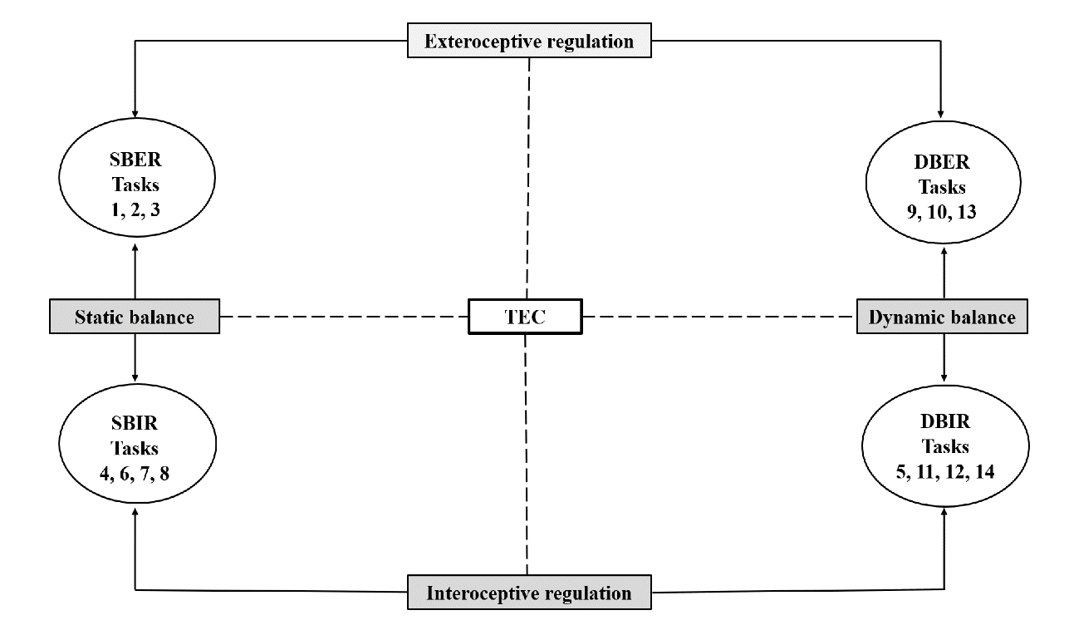
Figure 1. Conceptual model for balance regulation evaluation, Balance Test (TEC).
Note: SBER: Static Balance Exteroceptive regulation; SBIR: Static Balance Interoceptive Regulation; DBER: Dynamic Balance Exteroceptive Regulation; DBIR: Dynamic Balance Interoceptive Regulation.

Description of TEC tasks

SBER (Static Balance Exteroceptive Regulation)
Task 1: The person is asked to lean on one lower limb of their free choice.
Judgment: Stay in position for at least 15 seconds.
Task 2: The person is required to lean on one lower limb (free choice) and must swing the other leg back and forth without moving the support foot. Judgment: Stay in position for at least 15 seconds.
Task 3: The person is asked to perform a 360° turn and then lean on one lower limb of their own choice. Judgment: Stay in position for at least 15 seconds.

SBIR (Static Balance Interoceptive Regulation)
Task 9: The person is asked to walk on the wooden beam (4-meter long, 10-cm wide and 3-cm high). Judgment: Walk and maintain balance until the end of the course.
Task 10: The person is asked to walk on the wooden beam up to the 2-meter mark, rotate 180° and return to the beginning of the beam. Judgment: Walk and maintain balance until the end of the course.
Task 13: The person is asked to walk on the wooden beam and simultaneously bounce a volleyball on the floor beside them. Judgment: Walk and maintain balance until the end of the course.
*Note: If an imbalance exists and a foot touches the ground while walking over the beam, a score of 0 (0) is given.

DBER (Dynamic Balance Exteroceptive Regulation)
Task 4: The person is asked to lean on a lower limb of their own choice and move the other foot/leg in the air around two plastic bottles, drawing number 8. The task is performed twice in a row: first with their eyes open, then with their eyes closed. The objects should be positioned laterally to the body, spaced from each other to the same extent as their heights. Judgment: During the execution, the foot cannot touch the ground or objects.
Task 6: The person is asked to close their eyes and lean on a lower limb of their free choice. Judgment: Stay in position for at least 15 seconds.
Task 7: The person is asked to make a 360° rotation, close their eyes, and rest on a lower limb of their own choice. Judgment: Stay in position for at least 15 seconds without moving the support foot.
Task 8: The person is asked to close their eyes and rest on a lower limb of their own choice and swing the other leg (forwards and backwards) without moving the support foot. Judgment: Stay in position for at least 15 seconds.

DBIR (Dynamic Balance Interoceptive Regulation)
Task 5: The person is asked to close their eyes and perform 5 jumping jacks on a marked line on the ground, moving their arms and legs simultaneously. At the end of each run, a foot should always be in contact with the line. Judgment: If a foot does not remain in contact with the line during execution, the score received will be zero (0).
Task 11: The person is asked to walk for 2 meters over the wooden beam, rotate 180°, keep walking forward for another 2 meters until the end of the beam. Judgment: Maintain balance until the end of the course without touching the ground.
Task 12: The person is asked to walk for 2 meters over the wooden beam, rotate 360​​° and continue walking for another 2 meters, returning to the original position.
Judgment: Maintain balance until the end of the course without touching the ground.
Task 14: The person is asked to walk the wooden beam to the end (4 meters) with eyes closed. Judgment: Maintain balance until the end of the course without touching the ground.

Statistical analysis
Data normality was obtained by the Shapiro Wilk test. Descriptive statistics (mean, frequency and standard deviation) were used to present the results. The comparison of nominal variables was determined by the Chi-square test. In the presence of values ​​lower than five, Fisher's exactness test was applied. The significance levels between the fallers and non-fallers was determined by the Mann-Whitney U test. The Receiver Operating Characteristic (ROC) curve was used to examine the sensitivity and specificity levels of the TEC test [34, 35] and to determine the cutoff point for fall risk. The area below the curve was considered as a reference for the quantification of the predictor factor, which allowed the discrimination between individuals with and without postural control disorder [36]. Data were processed using the statistical program SPSS version 24.0. The confidence level adopted was 5%.

Results
Table 2 presents the main characteristics of the evaluated population, classified as fallers (n = 18; 64.61 ± 2.85 years) and non-fallers (n = 56; 68.41 ± 5.49 years). Considering the BMI cutoff points (Lipschitz, 1994), both groups had a relative degree of obesity (p = 0.078). The evaluation of the Mini-Mental Health Status Examination (MMSE) did not indicate possible cases of dementia (p = 0.321). No significant results were observed for daily medication use and comorbidities (p = 0.561). The average Pilates practice time of the evaluated population was 19.95 ± 5.3 months (p = 0.432). Regarding the total balance test score (TEC), according to the success normative system (Table 1), participants from the faller group showed poor performance and risk of falling (p = 0.000). Meanwhile, participants with no history of falls attested good performance without risk of falling (p = 0.000).

Table 2. Main characteristics of the study participants.
Variable | Fallers (n=18) | Non-fallers (n=56) | p
Age (years)  60-69 (f)  70-79 (f) | 63.22±1,88  11 (61.2%)  7 (38.8%) | 65.21±2.22  44 (78,5%)  12 (215%) | 0.177
Mass (Kg) | 71.79±9.90 | 68.66±11.24 | 0.468
Height (cm) | 153.00±0.88 | 162.00±0.60 | 0.469
BMI (kg/m²) | 30.70±7,10 | 28.40±6.90 | 0.292
MMSE | 27.28±2.12 | 27.40±3.74 | 0.388
Medicines (day) | 3,60±1.50 | 2.40±1.20 | 0.058
Exercise time (months) | 19.70±4.20 | 20.30±4.50 | 0.068
Falls | 1.8±0.90 | ------ | ------
Comorbidities
Visual (f)  Yes  No | 16 (88.8%)  2 (11.2%) | 44 (78.5%)  12 (21.5%) | 0.764
Hearing (f)  Yes  No | 6 (33.3%)  12 (66.4%) | 2 (3.6%)  54 (96.4%) | 0.456
Labyrinthitis (f)  Yes  No | 8 (44.4%)  10 (55.6%) | 12 (21,4%)  44 (78.6%) | 0.732
Hypertension (f)  Yes  No | 12 (66.6%)  6 (33.4%) | 11 (19.6%)  45 (80.4%) | 0.358
Diabetes mellitus (f)  Yes  No | 1 (5.5%)  17 (94.5%) | 2 (3.6%)  54 (96.4%) | 0.154
Body balance
TEC | 3.33±3,72 | 5.74±2.85 | <0.001
Note: Kg = kilogram; m2 = square meters; cm = centimeters, f= frequency; BMI = Body Mass Index; MMSE = Mini-Mental State Examination; TEC = Body Balance Test; * Mann-Whitney U test (p≤0.05).

Table 3 presents the average results of the static and dynamic balance performance of both groups in the four dimensions considered for the examination of sensory regulation of body balance. Comparatively, non-fallers indicated higher performance scores on the SBER, DBER, DBIR dimensions. The lowest score observed for both groups was in the SBIR dimension (p = 0.121). Significantly statistical differences were found in dynamic balance in DBER (p = 0.000), DBIR (p = 0.031) regulation.

Table 3. Average results of balance regulation performance, according to the dimensions of the TEC test.
Sensory balance regulation system | Fallers (n=18) | Non-fallers (n=56) | p
SBER | 138±1.41 | 1.98±1.09 | 0.096
SBIR | 0.44±0.85 | 0.43±0.65 | 0.803
DBER | 0.88±1.02 | 2.00±0.93 | <0.001
DBIR | 0.61±1.14 | 1.37±1.20 | 0.028
Note: SBER: Static Balance Exteroceptive regulation; SBIR: Static Balance Interoceptive Regulation; DBER: Dynamic Balance Exteroceptive Regulation; DBIR: Dynamic Balance Interoceptive Regulation; *p≤0,05 (U Mann-Whitney).

Figure 2 comparatively illustrates the performance of the sensory condition of static and dynamic balance between fallers and non-fallers. Image "A" shows the results of the evaluation of static balance exteroceptive regulation (SBER). Zero (0) scores were reported by 44.4% (8/18) participants in the fallers group and 10.7% (6/56) in the non-fallers group. Image "B" shows the performance of interoceptive static balance regulation (SBIR). In this sensory condition, the largest deficit of the present study was verified, which was attested by 72.2% (13/18) of fallers and 66.1% (37/56) of non-fallers. Image "C" illustrates the results of dynamic balance performance in its exteroceptive regulation (DBER). Impairments were verified in 44.4% (8/18) of the fallers group and 8.9% (5/56) of non-fallers. Image "D" shows the dynamic balance functioning in its interoceptive regulation (DBIR) (p = 0,000). Disturbances were observed in 66.7% (12/18) of participants from the fallers group and in 28.6% (16/56) of the non-fallers group (p = 0,029).

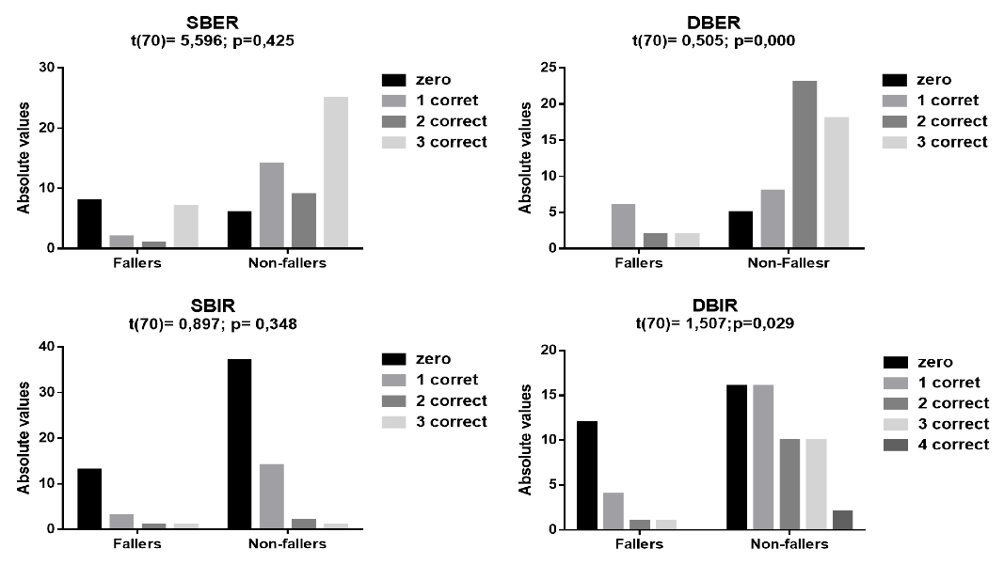
Figure 2. Score of the results of the static and dynamic balance performance evaluation, according to their exteroceptive and interoceptive regulation.
Note: SBER: Static Balance Exteroceptive regulation; SBIR: Static Balance Interoceptive Regulation; DBER: Dynamic Balance Exteroceptive Regulation; DBIR: Dynamic Balance Interoceptive Regulation; *p≤0,05 (U Mann-Whitney).

Figure 3 shows the results of the ROC curve used to determine the levels of sensitivity and specificity of the identification criteria for the risk of falling of the evaluated population. Statistical analysis showed an area of 0.738 below the curve (95% CI: 0.589-0.886; p = 0.003), followed by a sensitivity level of 42.3%. Based on these coefficients, the test can be assumed to detect falls in older women considered fallers. The specificity level obtained was 84.8%, this result attributed the TEC a high capacity to discriminate older women who do not fall, among those considered as such.

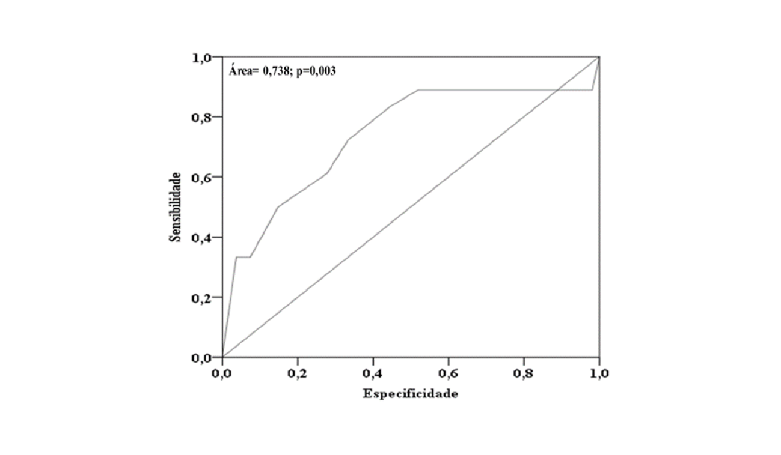
Figure 3. ROC curve, sensitivity and specificity values for determining the cutoff point for the risk of falling (95% CI).

Discussion
The aim of this study was to analyze the performance of the static and dynamic balance sensory strategies of 74 older women regular practitioners of physical exercises with and without history of falls. Secondly, to examine the sensitivity and specificity levels of the TEC test and determine its cutoff point for fall risk. Maintaining the upright position requires constant anticipatory adjustments to compensate body oscillations and to keep body segments aligned [18]. Disturbances in the visual, vestibular and somatosensory systems make it difficult for the CNS to construct effective representations of the relationship between body segments and the environment [38]. For this reason, older adults with changes in the functioning of these three systems are more susceptible to falls [17, 39].
Previous studies have highlighted the benefits of exercise for sensory organ function and postural control maintenance, especially in older adults population [40,41]. The present study provided an important finding: although the fallers group had an average time of 19 months of Pilates practice, their total TEC score indicated a risk of falling. This result does not mean that exercise is not a protective factor against falls [42, 43], but it serves as a warning to the need for a detailed examination of the sensory regulation condition of body balance in older adults fallers, since changes in postural control are directly linked to the aging process. Another interesting finding was that members of the non-fallers group also indicated weak to moderate sensory dysfunction in the regulation of static and dynamic balance, although they did not show a risk of falling in the total TEC test score.
The detailed diagnosis of the sensory condition of the SBER dimension of the TEC test alerted to a possible impairment of the optical flux of the evaluated population. The function of the exteroceptive sensory system is to provide the CNS with information about changes in body movement relative to objects placed in space. Campelo et al. [19] and Souza et al. [20] highlighted that the regulation of the visual-foot axis contributes considerably to the recovery of body balance, preventing fall events.
In the present study, limitations of optical flow performance were examined by TEC tasks 1, 2 and 3, performed in the unipodal support position, with eyes open. Oddsson et al. [40] and Zhao and Knwongehung [42] highlighted the importance of static balance evaluation, because their results attest to the competence of independent functional ambulation. In a meta-analysis study, Bohannon et al. [44] suggested cutoff points for determining the risk of fall in single-leg support assessment: permanence of less than 8.6 seconds for sexagenarians and 9.3 seconds for septuagenarians. Considering that the TEC test protocol required participants to remain in the unipodal position for at least 15 seconds, it can be said that the criteria adopted in the present study were strict, especially for septuagenarian women.
Among the four dimensions of the TEC test, the highest prevalence of sensory deficit found in both groups was set of tasks 4, 6, 7 and 8, responsible for the static balance interoceptive regulation (SBIR). The finding serves as an indication that the sensory deficit is inherent in advancing age and is also present in non-faller elderlies. The result confirms the need to include exercises in older women's programs that develop body balance in the static position, with emphasis on interoceptive sensory regulation (vestibular and somatosensory system). Regarding the criteria adopted for the SBIR dimension examination, these were also rigid (permanence of 15 seconds). Bohannon et al. [44] suggested as a cutoff point the minimum time of 10.2 seconds for sexagenarians and 4.3 seconds for septuagenarians.
The high prevalence of the zero score (0) in the SBIR category can be assumed as a warning for vestibular system dysfunctions in the evaluated population. Caixeta, Doná & Gazola [45] conducted a study with 86 elderlies (60 to 81 years) with vestibular dysfunction. The authors found low functional balance capacity and observed a relationship between vestibular system disorders with body balance performance and cognitive processing capacity. This attests to the fact that falls are multifactorial events [19, 22] and highlights the need for a multifactorial assessment to identify the risk of falls in older adults population [3, 11].
The performance deficit in the SBIR dimension may also be an indication of impairments in sensory receptors located in the plantar region of the foot and ankle joints (changes in the somatosensory system). In the older adults, these problems limit the perception of plantar pressure and emission of the postural information flow to the CNS [11]. In a study conducted with individuals aged 65 to 76 years, Toledo and Barela [46] observed a relative increase in the level of anteroposterior postural oscillations resulting from reduced sensitivity of the plantar region. The authors observed in the participants’ limitations to perform dorsiflexion and plantar ankle flexion movements. For this reason, the examination of body balance should include procedures that analyze the motor and sensory performance of the body support base joints [28, 47, 48].
The evaluation of DT is important because, with aging, the performance of executive functions is affected, as well as the combined performance of different motor tasks [49]. For this reason, older adults with cognitive impairment indicate slow walking pattern [50] and difficulty associating gait with mathematical calculation or verbal tasks [51]. All of these increase the risk of falling [40].
Among the four dimensions of sensory regulation of body balance examined, statistically significant differences were observed for the dimensions of dynamic body balance (DBER, DBIR). In comparison, 44.4% of the participants fallers indicated a zero (0) score in the DBER (exteroceptive dynamic balance regulation) task set, while in the non-fallers group the rate was 8.9%. Performance on task 13 attested that both groups presented a deficit for postural adjustments for DT task resolution. Literature review studies Ghai, Gahai and Effenberg [49] and meta-analysis (Plummer et al., 2015) highlighted that the concomitant accomplishment of two or more tasks causes interference and conflict in sending postural information to the CNS, mainly in older adults.
The second highest prevalence of zero (0) score observed in both groups occurred in the DBIR dimension (interoceptive dynamic balance regulation). 66.67% of fallers and 28.6% non-fallers presented deficits for postural adjustments. Toledo and Barela [46] warned that examining proprioceptive balance regulation is not just a sensory task. This evaluation requires the investigation of motor responses that originated in the articular perception of the movements. Deficits in these functions are indicative of changes in the CNS afferent or efferent pathway.
Previous systematic review [53], experimental [43, 54] and correlational [55] highlighted the efficiency and practicality of the TEC test for postural examination of older women regular physical exercise practitioners. Therefore, in a second moment, this study compared the agreement between the total mean score achieved by the faller and non-faller group with the cutoff point suggested by the TEC normative for the diagnosis of fall risk. The procedure was performed by the ROC curve.
The estimated probability model was statistically significant and high. The finding can be considered excellent, because the predictive value was able to discriminate 73% of the fall events among the evaluated population [36]. According to the statistical analysis, the best sensitivity and specificity value found was 3.5 tasks solved. This result can be assumed as the gold standard, capable of indicating the risk of falling in the evaluated population. Considering that the average performance in the TEC test of the non-fallers group was 5.74 ± 2.95 and of the fallers group was 3.33 ± 3.72 tasks (p = 0.000), the results corroborated the value suggested by the ROC curve to identify the risk of falling, as well as confirming the value of the TEC test normative (Table 1). The specificity coefficient found was high, 84.8%, it is assumed that the sensitivity level of 42.3% is moderate, however, it should be considered that falls are multifactorial events [19, 22, 39].
It is noteworthy that the results offered by the TEC test revealed only one facet of the risk of falling for older women who practice regular exercise. It is known that a model capable of predicting falls more broadly should consider other factors, such as gait pattern [31,40], polypharmacy events [56], executive functions [45, 49], coefficients of strength and flexibility [22] and related aspects, such as confidence in balance and fear of falling [6].

Limitations
The present study is not without limitations. It highlights the disproportionate size among the number of falling and non-falling group members. Another point to consider is that among the groups there were sexagenarian and septuagenarian subjects, and this mixture may have influenced the results. The application of the TEC test is suggested in studies that include sedentary male elderlies and also in investigations with experimental design.

Conclusion
It was concluded that among regular physical exercise practitioners elderlies, regardless of whether or not there is a history of falls, there were weak to severe impairment in the systems responsible for sensory regulation of static and dynamic balance. Statistical analysis confirmed that the TEC test has good reliability values and can be applied to assess the sensory condition of the body balance of older women who practice regular exercise. Parallel to the fact, the test has advantages for use in the clinical area. It is accepted that the evaluation offered by the TEC test cannot replace sophisticated laboratory tests such as force platforms, electromyograms and photo film systems. However, the TEC allowed the evaluation of postural control parameters that are not generally considered by conventional functional tests of the geriatric area.

What does this article add?
This study provided specific information about the postural control deficit of older women who regularly practice physical exercises. The findings showed that even older adults with adequate levels of physical fitness have problems with the sensory balance regulation systems (vision, hearing, proprioception). This means that the physiological changes caused by the human aging process are present in older adults, especially among individuals with a history of falls. This study also showed that the body balance test used (TEC) has good levels of sensitivity and specificity, it is an adequate instrument for examining the postural control of healthy older adults who exercise. The test presents guidelines for age groups, according to sex. Its examination differentiates the performance of the static and dynamic balance, according to the interoceptive and exteroceptive sensory regulation systems. Our results offer useful practical information for future procedures in the area of ​​clinical evaluation and the development of effective interventions with physical exercises.

Acknowledgments
The authors would like to thank the participants.

Acknowledgments: The procedures were approved by the Human Research Ethics Committee of the XXXXXXXXXXXXXXXXXXXX (0000000000000000000). This study did not have funders, the costs of all procedures were the responsibility of the authors.

References

1. Amarya S, Singh K, Sabharwal M. Ageing Process and Physiological Changes. In Gerontology; InTech, 2018; pp. 3–24.
2. Lord SR, Sturnieks DL. The physiology of falling: Assessment and prevention strategies for older people. J. Sci. Med. Sport 2005, 8, 35–42.
3. Illing S, Choy NL, Nitz J, Nohan M. Sensory system function and postural stability in men aged 30-80 years. Agin Male 2010, 13, 202–210.
4. Sharif SI, Al-Harbi AB, Al-Shihabi AM, Al-Daour DS, Sharif RS. Falls in the elderly: Assessment of prevalence and risk factors. Pharm. Pract. (Granada). 2018, 16, 1206.
5. Coppin AK, et al. Association of executive function and performance of dual-task physical tests among older adults: Analyses from the InChianti study. Age Ageing 2006, 35, 619–624.
6. Ambrose AF, Paul G, Hausdorff JM. Risk factors for falls among older adults: A review of the literature. Maturitas 2013, 75, 51–61.
7. World Health Organization-WHO Global Report on Falls Prevention in Older Age. Community Health (Bristol). 2007, 53.
8. Pimentel WRT et al. Quedas entre idosos brasileiros residentes em áreas urbanas: ELSI-Brasil. Rev. Saude Publica 2018, 52 Sup 2:1, 1–9.
9. Ministry of Health-SUS Department of Informatics. Brasilia DF Available online: http://tabnet.datasus.gov.br/cgi/tabcgi.exe?sih/cnv/fiuf.def.
10. Nascimento MM. Queda em adultos idosos: considerações sobre a regulação do equilíbrio, estratégias posturais e exercício físico. Geriatr. Gerontol. Aging 2019, 13, 103–110.
11. Kleiner AFR, De Camargo DX, Schlitter, S.-A.M. O papel dos sistemas visual, vestibular, somatosensorial e auditivo para o controle postural. Rev. Neurociencias 2011, 19, 349–357.
12. de Almeida ST, Chaves Soldera CL, de Carli GA, Gomes I, Lima Resende T. de Analysis of extrinsic and intrinsic factors that predispose elderly individuals to fall. Rev. da Assoc. Médica Bras. (English Ed. 2012, 58, 427–433.
13. Li IF et al. Elderly Taiwanese’s Intrinsic Risk Factors for Fall-related Injuries. Int. J. Gerontol. 2016, 10, 137–141.
14. Melzer I, Benjuya N, Kaplanski J. Postural stability in the elderly: A comparison between fallers and non-fallers. Age Ageing 2004, 33, 602–607.
15. Stins, J.F, Schneider IK, Koole SL, Beek PJ. The influence of motor imagery on postural sway: Differential effects of type of body movement and person perspective. Adv. Cogn. Psychol. 2015, 11, 77–83.
16. Blenkinsop GM, Pain MTG, Hiley MJ. Balance control strategies during perturbed and unperturbed balance in standing and handstand. R. Soc. Open Sci. 2017, 4, 161018.
17. Horak FB. Postural orientation and equilibrium: what do we need to know about neural control of balance to prevent falls? Age Ageing 2006, 35, ii7–ii11.
18. Santos MJ, Kanekar N, Aruin AS. The role of anticipatory postural adjustments in compensatory control of posture. J Electromyogr Kinesiol 2011, 18, 1492–1501.
19. Campelo TS, Bankoff ADP, Schmidt A, Ciol P, Zamai CA. Postura e equilibrio corporal: um estudo das relações existentes. Mov. Percepção 2006, 6, 55–70.
20. Souza NS et al. A influência do eixo visuo-podal na regulação do equilíbrio morfoestático em idosos. Rev. Neurociencias 2012, 20, 320–327.
21. Bigelow RT et al. Association between visuospatial ability and vestibular function in the baltimore longitudinal study of aging. J. Am. Geriatr. Soc. 2015, 63, 1837–1844.
22. Shumway-Cook A, Woollacott H. Controle motor: teoria e aplicações praticas. 2ª ed. Barueri: Manole, p. 179-208; 2003;
23. Ricci NA, Gazzola JM, Coimbra IB. Sistemas sensoriais no equilíbrio corporal de idosos. Arq Bras Ciên Saúde 2009, 34, 94–100.
24. Rebelatto JR, De Castro AP, Sako FK, A.T. Equilíbrio estático e dinâmico em indivíduos. Fisioter. em Mov. Mov. 2008, 21, 69–75.
25. Panjan A, Sarabon N. Review of Methods for the Evaluation of Human Body Balance. Sport Sci. Rev. 2010, 19.
26. Cowley A, Kerr K. A review of clinical balance tools for use with elderly populations. Crit Rev Phys Rehabil Med 2003, 16, 114–26.
27. Miyamoto ST, Lombardi I, Berg KO, Ramos LR, Natour,J. Brazilian version of the Berg balance scale. Brazilian J. Med. Biol. Res. 2004, 37, 1411–1421.
28. Tinetti ME. Performance-oriented assessment of mobility problems in elderly patients. J Am Geriatr Soc 1986, 119–126.
29. De Castro SM, Perracini MR, Ganança FF. Dynamic gait index - Brazilian version. Braz. J. Otorhinolaryngol. 2006, 72, 817–825.
30. Shumway-Cook A, Horak F. Assessing the influence of sensory interaction of balance. Phys. Ther. 1986, 66, 1548–1550.
31. Podsiadlo D, Richardson S. The time “Up & Go”: a teste of basic functional mobility for frail elderly pearsons. J. Am. Geriatr. Soc. 1991, 39, 142–148.
32. Santos GM, Souza ACS, Virtuoso JF, Tavares GMS, Mazo GZ. Valores preditivos para o risco de queda em idosos praticantes e não praticantes de atividade física por meio do uso da escala de equilíbrio de berg. Rev. Bras. Fisioter. 2011, 15, 95–101.
33. Nascimento MN, Maia NS, Ramos LS, Appell HJ Concordância entre instrumentos para avaliação do equilíbrio corporal, em idosos ativos. J. Phys. Educ. 2017, 28, 1–10.
34. Wydra G. Bedeutung, Diagnose und Therapie von Gleichgewichtstörung. Motorik 1993, 16, 100–107.
35. Nascimento MM, Coriolano I, Appell HJ. Teste de equilíbrio corporal (TEC) para idosos independentes. Rev. Port. Cienc. Desp. 2012, 12, 72–82.
36. Prati RC, Batista G, Monard MC. Curvas ROC para avaliação de classificadores. Rev IEE Am. Lat. 2008, 6, 215–222.
37. Lipschitz DA. Screening for nutritional status in the elderly. Prim Care 1994, 21, 55–67.
38. Teixeira, C. Equilibrio e Controle Postural. Rev. Bras. Biomecânica 2010, 11, 30–40.
39. Ambrose AF, Paul, G, Hausdorff JM. Risk factors for falls among older adults: A review of the literature. Maturitas 2013, 75, 51–61.
40. Oddsson LIE, Boissy P, Melzer I. How to improve gait and balance function in elderly individuals-compliance with principles of training. Eur. Rev. Aging Phys. Act. 2007, 4, 15–23.
41. Plummer P, Zukowski LA, Giuliani C, Hall AM, Zurakowski D. Effects of Physical Exercise Interventions on Gait-Related Dual-Task Interference in Older Adults: A Systematic Review and Meta-Analysis. Gerontology 2015, 62, 94–117.
42. Zhao Y, Kwongehung P. A preliminary design for a community-based exercise program for balance improvement and fall prevention. Int. J. Sport. Phys. Educ. 2015, 1, 5–14.
43. Nascimento MDM, Castro HD, Ramos MA. Evaluation of systems of sensory regulation of body balance and risk of fall of adult and elderly physically active. Pan Am. J. Aging Res. 2019, 7, e32683.
44. Bohannon RW, Larkin PA, Cook AC. Gear J, Singer J. Decrease in timed balance test scores with aging. Phys. Ther. 1984, 64, 1067–1070.
45. Cristina G, Caixeta S. Cognitive processing and body balance in elderly subjects with vestibular dysfunction. Braz. J. Otorhinolaryngol. 2012, 78.
46. Toledo DR, Barela JA. Sensory and motor differences between young and older adults: somatosensory contribution to postural control. Rev. Bras. Fisioter. 2010, 14, 267–75.
47. Duarte M, Freitas SM. Revision of posturography based on force plate for balance evaluation. Rev. Bras. Fisioter. 2010, 14, 183–192.
48. Sabchuk RAC, Bento PCB, Rodacki ALF. Comparison between field balance tests and force platform. Rev. Bras. Med. do Esporte 2012, 18, 404–408.
49. Ghai S, Ghai I, Effenberg AO. Effects of dual tasks and dual-task training on postural stability: a systematic review and meta-analysis. Clin. Interv. Aging 2017, Volume 12, 557–577.
50. Muir-Hunter SW, Wittwer JE. Dual-task testing to predict falls in community-dwelling older adults: A systematic review. Physiother. (United Kingdom) 2016, 102, 29–40.
51. Smith-Ray RL et al. Impact of cognitive training on balance and gait in older adults. J. Gerontol. B. Psychol. Sci. Soc. Sci. 2015, 70, 357–66.
52. Plummer P, Zukowski LA, Guiliani C, Hall AM, Zurakowski D. Effects of physical exercise interventions on gait-related dual-Task interference in older adults: A systematic review and meta-analysis. Gerontology 2015, 62, 94–117.
53. Cancela JM, de Oliveira IM, Rodriguez-Fuentes G. Effects of Pilates method in physical fitness on older adults. A systematic review. Eur. Rev. Aging Phys. Act. 2014, 11, 81–94.
54. Coriolano IPA, Pérez VR, Nascimento MDM, Appell HJ. The Pilates Method to Improve Body Balance in the Elderly. Arch. Exerc. Heal. Dis. 2012, 3, 188–193.
55. Nascimento MM, Maia NJS, Ramos LS, Appell HJ. Agreement Between Instruments for Assessment of Body Balance in Active Elderly Individuals. J. Phys. Educ. 2017, 28, 1–10.
56. Alecrin JDS et al. Avaliação da farmacoterapia empregada em residentes de uma Instituição de Longa Permanência para Idosos. Rev. Kairós Gerontol. Gerontol. 2016, 19, 113–133.

