* **Case Report: Fornix Infarction Causing Anterograde Amnesia Post-Operatively**
* Abstract:

A 65-year-old woman underwent elective hip replacement surgery and post-operatively was found to have significant anterograde amnesia without other significant neurological deficits. MRI imaging demonstrated an area of infarction in the anterior fornix and genu of the corpus callosum. On neuropsychological testing, she had “extremely low performance in learning, immediate memory and delayed memory consistent with anterograde amnesia. This case illustrates the relationship between the anterior fornix and memory function and the role of hypoperfusion brain injury in ischaemic stroke.

Keywords:

* anterograde amnesia; brain fornix; ischaemic stroke; postoperative period
* **Case Details:**
* Ms O was a 65-year-old was admitted for an elective right total hip replacement with a background of hypertension and hyperlipidaemia on alpha-blocker, beta-blocker and statin therapy. During the intra-operative and immediate post-operative period, she became hypotensive with systolic blood pressure in the 80s despite withholding her antihypertensives, requiring fluid resuscitation. During the first 24 hours, she appeared confused and disoriented without any focal neurological deficits identified. She repetitively asked where she was and why she was in hospital, even after she was reorientated by nursing staff. A CT brain (Figure 1A) 48 hours after surgery showed a hypodensity in the medial aspect of the frontal lobe, appearing to involve the anterior corpus callosum. An MRI brain (Figure 1B) demonstrated an area of increased signal in FLAIR and DWI sequences in the beginning of the corpus callosum, suggesting acutely impaired diffusion in the genu of the corpus callosum, extending into the fornix and septum pellucidum. The diagnosis an acute fornix infarction was made.
* Neuropsychological assessment includes the Repeatable Battery of the Assessment of Neuropsychological Status (RBANS), which revealed “Extremely Low” performance in two areas: learning & immediate memory, and delayed memory. These results were incongruent with the remainder of her testing scoring “Average” or higher in premorbid ability, attention, processing speed, visuospatial and constructional ability, fluency and insight. She was later transferred to an inpatient Brain Injury Rehabilitation Service, requiring three months of multidisciplinary brain rehabilitation before discharge to the community.

Figure 1: Brain imaging demonstrating the fornix infarct (A: CT; B: MRI FLAIR)

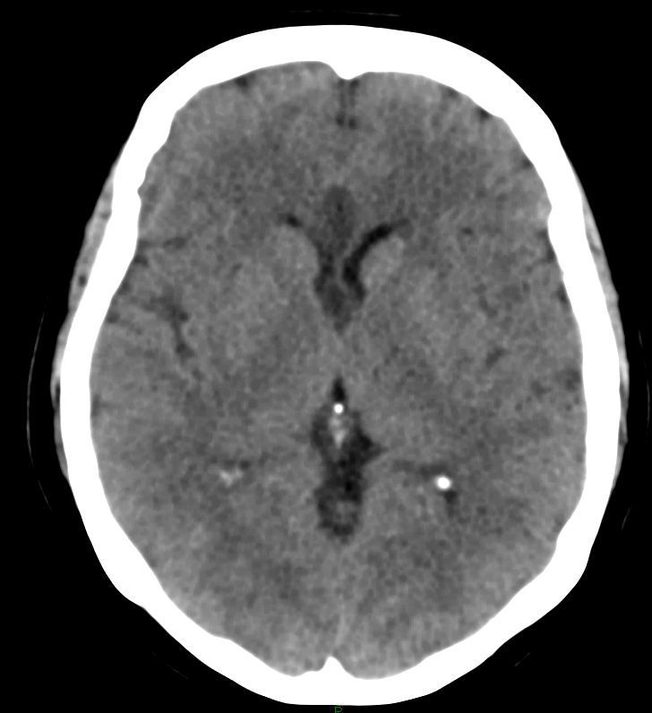

**A**

**B**

**Discussion:**

Stoke following total joint arthroplasty is a rare occurrence, occurring in around 0.2% of patients [1]. The first two weeks after arthroplasty are high risk for developing ischaemic stroke, with almost a five times greater risk compared to an age-adjusted population. The risk remains high for about six weeks, with the highest risk being the immediate post-operative period. [2] Cerebral hypoperfusion, marrow embolization, and anaesthetic effects on the cardiovascular system were cited as possible mechanisms for this ischaemic risk. [1,2]

Ischaemic strokes affecting the anterior fornix is also an infrequent occurrence, with case reports published regarding this entity [3-8]. All of the cases demonstrate a link between acute amnesia and fornix infarct. Two of the cases were due to an isolated fornix infarction, while the remainder (including the case described above) were associated with ischaemia of nearby structures, including the corpus callosum and the cingulate gyrus. Interestingly, the case of the isolated left anterior fornix injury was not clinically different to the one with isolated bilateral fornix infarction; suggesting that isolated fornix lesions can cause amnesia and a lack of laterality to fornix function [4,6]. This may be due to its co-existing role as a projection tract from the thalamus to the basal forebrain, and a commissure between the left and right hemispheres [9].

The role of the anterior fornix in memory function is related to its anatomical placement within the Circuit of Papez; comprising of the fornix, hippocampus, mammillary bodies, anterior thalamus and cingulate gyrus [10]. The anterior fornix acts as an output tract from the hippocampus, primarily to the mammillary bodies. The primary function of this classic circuit was first described in 1937 by James Papez and involves encoding and recall of new, episodic information. However, the function of memory is more reliant on the structural integrity of the circuit as a whole rather than the integrity of each of the individual components [9, 10].

The anterior fornix can be damaged from multiple pathologies, either in exclusivity or as part of a diffuse process. These include congenital absences, neoplastic disease, infection, autoimmune disease, metabolic disease, infarction and trauma. Isolated fornix infarcts almost exclusively occur in the anterior columns. This is likely due to the proximity of the remaining fornix to the choroidal arterial supply, providing collateral perfusion and relative protection against infarction [9]. The anterior fornix blood is supplied by branches of the anterior communicating artery (ACoA) [9], which accounts for the high rate of post-operative amnesia in ACoA aneurysm surgery [11,12]. Other variations to the vascular supply include anterior fornix infarction due to occlusion of the subcallosal artery [8] or anterior cerebral artery via short medial central arteries [3].

Approximately 20-50% post-stroke patients have subjective complaints of memory difficulties, which may be accounted for non-anatomical aetiology such as depression, fatigue, medication side-effects or sleep disorders. However, lesions within memory-associated structures, or amnesic lesions and lesions impairing the processing of memory (process lesions) should be a consideration [10]. The involvement of hippocampal and diencephalic connections is consistently more likely to impair memory function compared to fornix lesions [10,13]. Interestingly, a case study of 142 epileptic patients who underwent bilateral anterior fornix transection, no patients were identified as having ongoing memory impairment [14]

For this case, the fornix infarct occurred during the peri-operative period. A contributor to her infarct was hypoperfusion of the fornix during the period of hypotension. The combination of systemic hypotension and pre-existing extracranial arterial occlusive disease causing marginal blood supply led to a haemodynamic stroke [15]. It is currently known that hypotension is a cause for ischaemic strokes, with high risk for those with symptomatic orthostatic hypotension and cardiac failure [15]. Intraoperative blood pressure has also been shown to be directly related to neurological outcome following cardiac surgery. Almost half of the patients undergoing cardiac surgery have MRI evidence of bilateral ischaemic lesions in ‘border zone’ areas between the main brain vascular supplies, which are vulnerable areas to ischaemic injury. The risk of watershed infarcts was higher in patients with an intra-operative fall in systolic blood pressure of 10mmHg or more [16]. Another study found that there was radiological evidence of strokes in 7.2% of patients with intraoperative mean arterial pressure (MAP) of 50-60mmHg, compared to 2.4% when MAPs were maintained between 80-100mmHg [17]. Thus, maintaining blood pressure and brain perfusion during the intraoperative and post-operative period is important to reduce the risk of ischaemic stroke.

The patient required intensive multi-disciplinary assessment and treatment at an inpatient specialised acute brain injury rehabilitation service. Early initiation of post-acute rehabilitation treatment in brain injury is beneficial and increases the likelihood of functional improvement [18]. The mechanism behind such recovery is likely multimodal, ranging from controllable factors (motivation, family support systems and the quality of rehabilitation services) and uncontrollable factors (age, sex, severity and site of the injury, and pre-morbid cognitive reserve) [19].

The long term cognitive outcome from acute fornix infarcts is uncertain. A paper described a patient, who developed amnesia and confabulation following astrocytoma removal which disrupted the right anterior fornix. The patient made a good recovery over the 17-month follow-up period, suggesting that recovery is possible over a longer term period. This is likely accounted by compensatory measures by the left fornix [13]. However, a remaining functional fornix is not a pre-requisite for memory recovery, as observed in patients who improve after bilateral fornix transection [20]

**Conclusion:**

A case of a fornix infarct resulting in anterograde amnesia was described. This was likely due to a haemodynamic stroke from peri-operative hypotension and hypoperfusion. The patient required rehabilitation for recovery, but long term outcomes remain unclear.

**Author Contributions:**

The author contributed solely to the article.

**Conflicts of Interest:**

All authors declared that there are no conflicts of interest.

**Consent for Publication:**

Written informed consent for publication was obtained.

**References:**

1. Mortazavi S, Kakli H, Bican O, et al. Perioperative stoke after total joint arthroplasty: prevalence, predictors, and outcome. J Bone Joint Surg Am 2010;92:2095-2101.
2. Lalmohamed A, Vestergaard P, Cooper C, et al. Timing of stroke in patients undergoing total hip replacement and matched controls: a nationwide cohort study. Stroke 2012;43:3225-3229.
3. Moudgil S, Azzouz M, Abdulkader A, Haut M, Gutmann L. Amnesia due to fornix infarction. Stroke 2000;31:1418-1419.
4. Korematsu K, Hori T, Morioka M, Kuratsu J. Memory impairment due to small unilateral infarction of the fornix. Clin Neurol Neurosurg 2010;112:164-166.
5. Renou P, Ducreux D, Batouche F, Denier C. Pure and acute Korsakoff syndrome due to bilateral anterior fornix infarction: a diffusion tensor tractography study. Arch Neurol 2008;65(9):1252-1253.
6. Rizek P, Pasternak S, Leung A, Jenkins M. Acute-onset anterograde amnesia caused by isolated bilateral fornix infarction. Can J Neurol Sci 2013;40:738-739.
7. Saito Y, Matsumura K, Shimizu T. Anterograde amnesia associated with infarction of the anterior fornix and genu of the corpus callosum. J Stroke Cerebrovasc Dis 2006;15:176-177.
8. Moussouttas M, Giacino J, Papamitsakis N. Amnesic syndrome of the subcallosal artery: a novel infarction syndrome. Cerebrovas Dis 2005;19:410-414.
9. Thomas A, Koumellis P, Duneen R. The fornix in health and disease: an imaging review. Radiographics 2011;31:1107-1121.
10. Lim C, Alexander M. Stroke and episodic memory disorders. Neuropsychologia 2009;47:3045-3058.
11. Gade A. Amnesia after operations on aneurysms of the anterior communicating artery. Surg Neurol 1982;18(1):46–49.
12. Hattingen E, Rathert J, Raabe A, Anjorin A, Lanfermann H, Weidauer S. Diffusion tensor tracking of fornix infarction. J Neurol Neurosurg Psychiatry 2007;78(6):655–656.
13. Massimiliano R, Sabatini U. Recovery from amnesic confabulatory syndrome after right fornix lesion. Neurorehabil Neural Repair 2008;22:404-409.
14. Garcia-Bengochea F, Friedman W. Persistent memory loss following section of the anterior fornix in humans: a historical review. Surg Neurol 1987;27:361-364.
15. Klijn C, Kappelle L. Haemodynamic stroke: clinical features, prognosis and management. Lancet Neurol 2010;9:1008-17.
16. Gottesman RF, Sherman PM, Grega MA, et al. Watershed strokes after cardiac surgery: diagnosis, etiology, and outcome. Stroke 2006;37:2306–2311.
17. Gold JP, Charlson ME, Williams-Russo P, et al. Improvement of outcomes after coronary artery bypass: a randomized trial comparing intraoperative high vs low mean arterial pressure. J Thorac Cardiovasc Surg 1995;110:1302–1314.
18. Hayden M, Plenger P, Bison K, et al. Treatment effect versus pretreatment recovery in persons with traumatic brain injury: a study regarding the effectiveness of postacute rehabilitation. PMR 2013;5(4):319-327.
19. Wilson B. Brain injury: recovery and rehabilitation. WIREs Cogn Sci 2010;1:108-118.
20. Mazarakis N, Summers F, Murray A, et al. Partial Recovery from amnesia following bilateral surgical fornix transection is correlated with cortical plasticity. Br J Neurosurg 2011;25(5):658-661.