Therapeutic Brief

The antidiabetic drug acarbose suppresses age-related lesions in C57BL/6 mice in an organ dependent manner

Sneh Gupta, Zhou Ziang, Warren Ladiges

Department of Comparative Medicine, School of Medicine, University of Washington, Seattle, WA 98195

Abstract
Acarbose (Acb) is an antidiabetic drug used to reduce blood glucose by inhibiting conversion of complex carbohydrates into simple sugars. It has also shown promise as an anti-aging drug by increasing lifespan in mice but studies have not been reported on effects of short term treatment in aging mice. To address this question, 20 month old C57BL/6 male and female mice were given a standard diet, or a diet supplemented with 1000 ppm Acb for 3 months. After this period, mice were assessed for age-related lesions as readouts for delay in the progression of aging. Results showed there was a significant decrease in lesions of the heart and kidney in mice treated with Acb suggesting that Acb can suppress cardiac and renal pathology associated with increasing age.

Aging is a complex process and affects many organs in the body, so multiple pathways need to be targeted to combat or slow the effects of aging. Acarbose (Acb) is a well-known anti-diabetic drug for type 2 diabetic patients. It has been shown to decrease plasma glucose levels and cholesterol levels by the reversible inhibition of membrane-bound intestinal alpha-glucosidase and pancreatic alpha-amylase, two enzymes needed to digest complex carbohydrates [1]. Recently acarbose has been shown to increase median and maximum life-span in mice, when treated starting at 4 months of age [2] or starting at 8 months of age [3], with more pronounced effect in males than females. Aging increases the risk factor for cardiovascular diseases [4], kidney impairment [5], lung diseases [6] and liver diseases [7]. It was therefore of interest to see if Acb might reduce age related damage to organs in aging mice.

Male and female C57BL/6 mice were used, 12 in each cohort. The experimental group was fed Acb (Cayman Chemical Co., Ann Arbor, MI) at 1000 ppm in their diet (prepared by TestDiet, Inc, a division of Purina Mills, Richmond, IN), while the control group was fed an identical diet without medication for 3 months starting at 20 months of age. After this period, mice were euthanized and tissues collected and slides of heart, lungs, liver and kidney were read and scored for age related lesions using the geropathology grading platform (GGP) [8]. The results indicate that age-related lesions in the heart (Fig 1a) and kidney (Fig 1b) were significantly less in the Acb treated group than the control group for both males and females. There was no significant difference in lesion severity in the liver (Fig 1c) or lungs (Fig 1d) between treated and control mice.

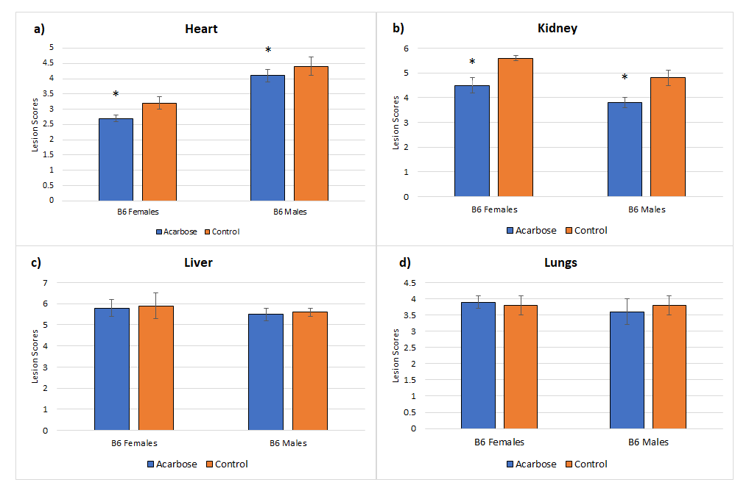
Figure 1. Male and female 57BL/6 mice, 20 months of age, were fed a diet containing 1000 PPM acarbose or a control diet without acarbose for three months.Tissues were collected and scored for age-related lesions. Mice fed the acarbose diet had decreased lesion scores in the heart and kidney compared to mice fed the control diet (a and b), but no differences were seen in the lungs or liver (c and d). *p≤0.05

These observations suggest that Acb can potentially be used to decrease the risk of cardiac and renal lesions associated with aging. Type 2 diabetes is associated with kidney and heart failure [9] due to increased plasma sugar. Decreasing risk of heart and kidney disease by Acb is consistent with this observation. Hence, Acb could potentially be used to decrease the risk of renal and cardiac diseases for people with a family history of these conditons. Further studies would be of interest to see the effects of acarbose in combination with other drugs like Rapamycin, which has been shown to decrease pathological lesions in the lungs [10], and liver [11].

References
1. Balfour JA, McTavish D. Acarbose. An update of its pharmacology and therapeutic use in diabetes mellitus. Drugs. 1993 Dec;46(6):1025-54. doi: 10.2165/00003495-199346060-00007. Erratum in: Drugs 1994 Dec;48(6):929. PMID: 7510610.
2. Harrison D E, Strong R, Allison D B, et al. Acarbose, 17‐α‐ estradiol, and nordihydroguaiaretic acid extend mouse lifespan preferentially in males. Aging cell, 2014, 13(2): 273-282.
3. Harrison, D. E., Strong, R., Alavez, S., Astle, C. M., DiGiovanni, J., Fernandez, E., ... & Miller, R. A. (2019). Acarbose improves health and lifespan in aging HET3 mice. Aging Cell, 18(2), e12898.
4. Steenman, Marja, & Lande, Gilles. (2017). Cardiac aging and heart disease in humans. Biophysical Reviews, 9(2), 131-137.
5. O'Sullivan, Eoin D, Hughes, Jeremy, & Ferenbach, David A. (2017). Renal Aging: Causes and Consequences. Journal of the American Society of Nephrology, 28(2), 407-420.
6. Rojas, Mauricio, Mora, Ana L, Kapetanaki, Maria, Weathington, Nathaniel, Gladwin, Mark, & Eickelberg, Oliver. (2015). Aging and Lung Disease Clinical Impact and Cellular and Molecular Pathways. ANNALS OF THE AMERICAN THORACIC SOCIETY, 12(12), S222-S227.
7. Kim, In Hee, Kisseleva, Tatiana, & Brenner, David A. (2015). Aging and liver disease. Current Opinion in Gastroenterology, 31(3), 184-191.
8. Snyder, J. M., Snider, T. A., Ciol, M. A., Wilkinson, J. E., Imai, D. M., Casey, K. M., ... & Ladiges, W. (2019). Validation of a geropathology grading system for aging mouse studies. GeroScience, 41(4), 455-465
9. Selvarani, R., Mohammed, S., & Richardson, A. (2020). Effect of rapamycin on aging and age-related diseases-past and future. GeroScience, GeroScience, 2020-10-10.
10. Karunadharma, Pabalu P, Basisty, Nathan, Dai, Dao‐Fu, Chiao, Ying A, Quarles, Ellen K, Hsieh, Edward J, . . . Rabinovitch, Peter S. (2015). Subacute calorie restriction and rapamycin discordantly alter mouse liver proteome homeostasis and reverse aging effects. Aging Cell, 14(4), 547-557.
11. Koomen, Jeroen V, Stevens, Jasper, Bakris, George, Correa-Rotter, Ricardo, Hou, Fan Fan, Kitzman, Dalane W, . . . Heerspink, Hiddo J L. (2020). Individual Atrasentan Exposure is Associated With Long-term Kidney and Heart Failure Outcomes in Patients With Type 2 Diabetes and Chronic Kidney Disease. Clinical Pharmacology and Therapeutics, Clinical pharmacology and therapeutics, 2020-12-18.

Extra stuff: (Not part of Note)
Acarbose has an antihyperglycemic effect resulting from competitive, reversible inhibition of membrane-bound intestinal alpha-glucosidase and pancreatic alpha-amylase, two enzymes needed to digest complex carbohydrates [Balfour and Mctivish, 1993]. In diabetic patients, inhibiting these enzymes results in delayed glucose absorption and a lowering of postprandial hyperglycemia. In the NIA Intervention Testing Program, acarbose increased medium and maximal lifespan in four-way cross mice when treatment started at 4 months of age [Harrison et al., 2014]. When acarbose was started at 16 months of age, lifespan extension was achieved but was reduced [Strong et al., 2016].
The four way cross mice used in the above studies consisted of four inbred strains- C57BL/6, Balb/c, C3H and DBA 1. Short term acarbose treatment in any of these individual strains at old age would be of interest to see if there was any anti-aging effects. Both genders of the C57BL/6 strain at 20 months of age were assessed for age-related lesion scores as readouts (Snyner et al., 2020) for delay in aging after three months on a diet containing 1000 ppm acarbose.

Strain/Gender | Drug | Heart | Lungs | Liver | Kidney
B6 Females | Acarbose | 2.7±0.1* | 3.9±0.2* | 5.8±0.4 | 4.5±0.3*
 | Control | 3.2±0.2 | 3.8±0.3 | 5.9±0.6 | 5.6±0.1
B6 Males | Acarbose | 4.1±0.2 | 3.6±0.4 | 5.5±0.3 | 3.8±0.2*
 | Control | 4.4±0.3 | 3.8±0.3 | 5.6±0.2 | 4.2±0.3

Strain/Gender | Drug | Heart | Lungs | Liver | Kidney
B6 Females | Acarbose | 2.7±0.1* | 3.9±0.2* | 5.8±0.4 | 4.5±0.3*
 | Control | 3.2±0.2 | 3.8±0.3 | 5.9±0.6 | 5.6±0.1
 | t-value | -7.746 | 0.961 | -0.480 | -12.050
B6 Males | Acarbose | 4.1±0.2 | 3.6±0.4 | 5.5±0.3 | 3.8±0.2*
 | Control | 4.4±0.3 | 3.8±0.3 | 5.6±0.2 | 4.8±0.3
 | t-value | -2.882 | -1.386 | -0.961 | -9.608

Critical value = 2.201 for alpha = 0.05
cohort size = 12

Heart - significant decrease in males and females acarbose
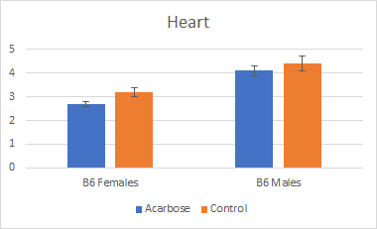
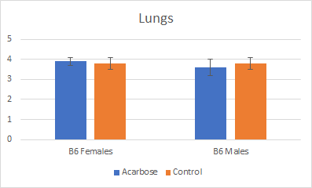
Lungs - no significant change

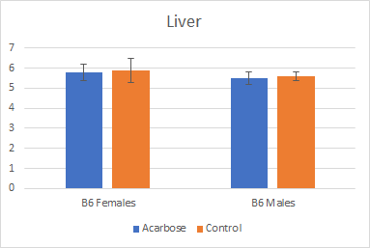
Liver - no significant change in treatment group

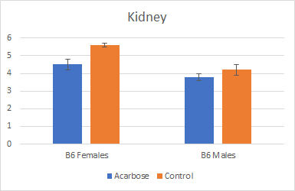
kidney - significant decrease in kidney lesions in male and female acarbose treated mice

