Faradarmani Consciousness Field Suppresses Alzheimer’s Disease Development in both in vitro and in vivo Models of the Disease

Mohammad Ali Taheri¹, Sara Torabi², Noushin Nabavi³, Farid Semsarha^{4*}

- Sciencefact R&D Department, Cosmointel Inc. Research Center, Ontario, Canada
- Department of Plant Biology, School of Biology, College of Sciences, University of Tehran, Tehran, Iran
- Research Services at University of Victoria, BC, Canada
- Institute of Biochemistry and Biophysics (IBB), University of Tehran, Tehran, Iran

* Corresponding Author: Farid Semsarha Ph.D., Institute of Biochemistry and Biophysics (IBB), University of Tehran, P.O. Box: 13145-1384, Tehran, Iran
Email: Semsarha@alumni.ut.ac.ir

Abstract
Background: Alzheimer’s Disease (AD) is one of the most common causes of dementia, imposing large financial and psychological burdens on nations worldwide. Thus, we are in dire need for new treatment strategies or drugs for this disease. The aim of this study is to investigate the effects of a novel non-pharmacological method in the treatment of Alzheimer’s disease, based on Taheri's Consciousness Field approach. This approach works at the level of cellular and molecular processes and is tested in neuronal cells of AD mouse models.
Methods: In this study, we established a neuron cell culture from an AD mouse model as well as a traumatic brain injury mouse model. We then measured changes in amyloidopathy, tau protein content, microtubule assembly, neuronal cell survival, and finally behavior of TBI mice in elevated Plus Maze under treatment of the Faradarmani Consciousness Field (FCF).
Results: According to the results of this study, treatment of neural cell and mouse model of Alzheimer's disease by the FCF, leads to about complete survival of neural cell models and elimination of amyloidopathy and tau protein and remarkable behavioral improvement of the treated TBI mice model in the elevated plus maze.
Conclusions: Based on the results, the FCF treatment suppresses AD development in the laboratory models. In this regard, conducting a human clinical study with the aim of introducing a new global complementary and alternative medicine in AD treatment is highly recommended.

Keywords: Alzheimer’s Disease; Faradarmani Consciousness Field; TBI; mice model; neural cell model

Introduction
Alzheimer’s disease (AD)-related dementia is a critical public health issue in industrialized and non-industrialized nations [1]. According to the World Health Organization, AD and other forms of dementia ranked as 7th leading causes of death in 2019 and globally 65% of deaths are women [2]. There are many diseases that leads to dementia, but AD is the most common dementing illness in elderly, and it has been estimated that AD contributes to approximately 60-77% of cases [3]. It takes many years before symptoms of AD emerge from its onset. Therefore, preclinical studies of AD would provide a critical opportunity for developing therapeutic interventions [4]. Impaired recent memory is an initial symptom of AD and sometimes associated with other cognitive deficits like changes in attention and problem-solving abilities. As dementia progresses, other cognitive deficits, such as language dysfunction, visuospatial difficulty, loss of insight are frequently apparent [5]. In individuals, these cognitive impairments are usually accompanied by changes in personality, behavior, uncharacteristic mood fluctuations such as agitation, impaired motivation, initiative, apathy, social withdrawal etc. [6]. In order to manage the behavioral symptoms, psychological interventions, alternative therapies as well as antidepressant treatments are employed [7].
Pathologically, AD is defined by the progressive accumulation of β-amyloid (Aβ) plaques and neurofibrillary tangles composed of hyper phosphorylated tau protein [8, 9, 10]. Accumulation of Aβ in the brain is the primary factor driving AD pathogenesis [11]. Therefore, mechanistic clearance of Aβ peptides becomes a potential target for drug development for AD [12]. Multiple enzymes are capable of degrading Aβ like neprilysin and insulin-degrading enzymes. Conversely, reductions in the activity of Aβ-degrading enzymes could contribute to AD itself [13-14]. The cysteine protease cathepsin B (Cat B) reduces levels of Aβ peptides, especially Aβ 1-42, through proteolytic cleavage [15]. In addition, it has been reported that the peripheral system is potent in clearing brain Aβ and preventing AD pathogenesis [16]. As it was mentioned before, tau accumulation in senile plaques is another hallmark for AD. In healthy subjects, tau proteins are an abundant microtubule-associated protein that have roles in maintaining the stability of microtubules in axons [17]. Microtubules maintain the architectural support for the elongated shape of growing axons and development of neurons [18-19]. However, tau hyper phosphorylation could lead to the detachment of tau from microtubules and lead to the formation of Neurofibrillary tangles (NFTs) [20-21]
The risk of dementia is highest in people with a history of Traumatic brain injury (TBI) [22]. A study found that TBI history is associated with an earlier onset of AD-related cognitive decline [23-24]. They reported that before tauopathy, cis p-tau increase in sport- and military-related TBI in humans, also reflected in mice and stressed neurons. In that study, treating TBI mice with cis antibody prevented the development of widespread taupathy. Thus, cis p-tau could be an early biomarker for diagnosis and therapy. In addition, the cis pT231-tau isoform was introduced as a central mediator in TBI and neurodegeneration. Therefore, targeting cis pT231-tau could be a good candidate for immunotherapy for several tauopathy disorders including AD [25].
The loss of cholinergic function in the central nervous system contributes to cognitive decline and dementia [26], which has been the target of anti-AD drugs [27]. Pharmacologic treatments temporarily improve symptoms but can’t slow or stop the degeneration of neurons [28].
In a novel approach presented by Mohammad Ali Taheri, consciousness is one of the three elements of the universe that is neither matter, nor energy, but that has direct effect on both matter and energy through specific and distinct non-material, non-energetic fields called the Consciousness Fields (CFs) which are the subcategories of a richly networked universal internet called the Cosmic Consciousness Network (CCN). The mentioned CFs are one of the achievements of using the CCN, in which people as a user receive troubleshooting and repair programs, by “Etesal” (virtual connecting) to the CCN followed by correction and treatment.
The CFs based on its position of influence and the special type of function, has several types, one of which is the Faradarmani that is applicable to all living (and non-living) creature including plants, animals, microorganisms, molecules etc. Faradarmani, establishes a consciousness bond between the whole consciousness and the parts where all constituents will be scanned and corrected.
The applied CFs according to Taheri, is mediated by Faradarmangar’s mind (a person who makes a virtual connection). In this type of affection, mind-matter interaction occurred through connecting to the CCN by a Faradarmangar. In other words, according to the theory of the consciousness field, the human mind, has an intermediary role in this affection and the main achievement obtained as a result of the operation of the CFs. However, in cognitive science and neuroscience, mind is considered with an active role which has an interaction with the world of matter and energy.
By defining consciousness as neither matter nor energy we cannot associate a quantity to it. Since Consciousness isn’t measurable its existing can only be known through experience. Although, the mechanism of this linkage is not yet definable by science, its consequences can be measured and studied scientifically[29].
Accordingly, Sciencefact has been defined by Mohammad Ali Taheri in 2020. Sciencefact discovers evidence of influence on the world of matter and energy through the consciousness fields (CFs) but conventional science studies matter and energy. The common point between science and Sciencefact is that both of them can be experienced at the level of matter and energy through reproducible laboratory experiments. On the other hand, investigation, usage and application of consciousness in Sciencefact distinguishes it from conventional science. In fact, the world of science is seen as a tool for the emergence of Sciencefact evidence. In previous investigations, we screened the effects of FCF on the spatial memory and avoidance behavior of a rat model of AD [30]. The results showed that FCF improved the learning and memory impairment induced by scopolamine in rats. In addition, remarkable restorative- enhancing effects were observed in their passive avoidance behavior. Changes in cancer cell growth [31], investigations on electrical activity of the brain during FCF connection in Faradarmangar [32], and alleviative effects of FCF on wheat plant under salt stress [33] are other observations that have used this method in research. The aim of the present study was to investigate the influence of the FCF on AD cells and animal models.

Materials and Methods
FCF Application: The use of FCF (and other CFs) is possible by registering a request through the announcement section on the website for research center of Consciousness Fields (www.consmointel.com). For this purpose, each researcher, based on desired time and place and by introducing the generalities of the experiments, can allocate CFs interventions for the subject of his/her study. The Research and Development Department of the Science-fact research center is staffed to allocate the CFs treatments for studies under the direct supervision of Mr. Taheri, 24 hours a day, free of charge.
In this study, the FCF treatment was assigned to cellular and animal models of AD on a daily basis and for the entire duration of the experiment from the time the model was created to the ends of related assays. All executive processes and primary analyses of this study have been done by double-blind experts unfamiliar with the theory of how to use the FCF.

Antibodies. The primary antibodies were cis pT231-tau mAbs (gift from KPL, Harvard), β-actin mAb (Sigma, St Louis, MO), Caspase-3 (Abcam, Cambridge, MA), Tau5 (Biosource Camarillo, CA), and oligomeric tau T22 polyclonal antibodies (EMD Millipore, Billerica, MA).

Generating human embryonic neural progenitor cells (hESC-NPCs)
Induced Pluripotent Stem Cells (iPSCs) from two late onset AD patients and two healthy control age-matched subjects were donated from Royan Cell Bank; which were in turn generated from fibroblasts employing Yamanaka factors. The iPSCs were then differentiated to NPCs. The neuro-induction medium composed of DMEM/F12 medium (Gibco, 21331020) supplemented with 5% knockout serum (Gibco, 10828028), Glutamax (Gibco, 25030081), MEM-NEAA (Gibco, 11140050), 1% N2 (Gibco, 17502048), 3 µM SB431242 (Cyman, 13031), 5 µM Dorsomorphin (Stemgent, 04-0024), 3 µM CHIR99021 (Stemgent, 04-0004-10), and 0.5 µM SAG (Cayman, 912545-86-9). The rosette form structures were manually picked up after 7 days of the induction. The NPCs were then re-plated on 1mg/mL laminin and 15mg/mL poly-l-ornithine–coated tissue culture dishes (Sigma-Aldrich) in the neural expansion medium included DMEM-F12 medium supplemented with 5% knockout serum replacement (KOSR), 1% non-essential amino acid, 2 mM L-glutamine, 2% N2 (all from Invitrogen), 0.1 mM β-mercaptoethanol, 20 ng/ml basic fibroblast growth factor (bFGF, Royan Institute), 20 ng/ml additional epidermal growth factor (EGF, Sigma-Aldrich) and 0.2 mM ascorbic acid (Sigma-Aldrich). Medium was changed every other day for 7 days. After differentiation of neurons, the expansion medium was replaced with differentiation medium by eliminating growth factors (bFGF) and adding hBDNF (PR-1113), hGDNF (pr-1107) and cAMP (Sigma, D0627) for 35 days. The differentiation process was tracked and confirmed with SOX2, PAX6, NESTIN, NCAM, GFAP, MAP2, GAD65, GABA and S100 staining.

Nutritional starvation stress. We normally changed the culture medium every 4 days according to our differentiation protocol. However, in order to starve the cells, we didn’t change the medium for additional 96 hours. We initially confirmed tauopathy process time line in our cell culture model and found prominent tauopathy upon 96 hours starvation; consistent with previous findings [24].

Live and dead cell assay. Fluorescein diacetate (FDA) and Propidium Iodide (PI) double staining was used for cell viability assessment. Aliquots of 20 µl of FDA stock solution and 50 µl of PI stock solution were diluted in 10 ml PBS [34]. The cells were initially washed with cold PBS and then the FDA/PI solution was added to the cells and was inspected by a fluorescent microscope after 5 min incubation in room temperature with the solution.

Cell staining. Cells were harvested at different time points and fixed with 4% paraformaldehyde (PFA) for 20 minutes in dark. They were either directly subjected to microscopic observations or stained with antibodies. In case of further processing, they were permeabilized with 0.2 % TritonX 100 for 20 minutes and stained with primary antibodies overnight at 4 ºC. They were then incubated with Alexa Fluor 488 or 568 conjugated secondary antibodies for 1 hour at room temperature. The samples were visualized with a Zeiss confocal microscope (LSM 800).

Traumatic brain injury. The mouse TBI model was used as previously described [24]. Briefly, 18 male C57BL/6 mice (2–3 months old), obtained from Royan Animal Facility, were randomized to undergo injury or sham-injury. The mice were anaesthetized for 45 seconds using 4% isoflurane in a 70:30 mixture of air: oxygen. Anaesthetized mice were placed on a delicate task wiper (Kimwipe, Kimberly-Clark, Irving, TX) and positioned such that the head was placed directly under a hollow guide tube. The mouse’s tail was grasped. A 54-gram metal bolt was used to deliver an impact to the dorsal aspect of the skull, resulting in a rotational acceleration of the head through the Kimwipe. Mice underwent single severe injury (ssTBI, 60-inch height). Sham-injured mice underwent anesthesia but not concussive injury. All mice were recovered in room air. Anesthesia exposure for each mouse was strictly controlled to 45 seconds. Subsequent behavioral and histopathological testing was conducted in a blinded manner.

Immunohistochemistry. Mice were perfused with 4% PFA at various time points after injury and brains were harvested for further analysis. Serial 8 µm coronal sections from sham and injured brains were cut on a cryostat (Leica) and were collected on slides.

Immunoblotting analysis. Immunoblotting analysis was carried out as described [24]. Briefly, brain tissues or cultured cells were lysed in RIPA buffer (50 mM Tris-HCl, pH 7.4, 150 mM NaCl, 2 mM EDTA, 1% NP 40, 0.1% SDS, 0.5% Na-deoxycholate, 50 mM NaF) containing proteinase and phosphatase inhibitors and then mixed with the SDS sample buffer and loaded onto a gel after boiling. The proteins were resolved by polyacrylamide gel electrophoresis and transferred to PVDF membrane and block stained with 5% milk in TBST (10 mM Tris-HCl pH 7.6, 150 mM NaCl, 0.1% Tween 20) for 1 hour. The membrane was then incubated with primary antibodies in 5% milk in TBST overnight at 4 ºC. Then, the membranes were incubated with HRP-conjugated secondary antibody in 5% milk in TBST. The signals were detected using chemiluminescence reagent (Perkin Elmer, San Jose, CA). The membranes were washed 6 times with TBST after each step. Immunoblotting results were quantified using Quantity One from BioRad.

Immunostaining analysis. Immunofluorescence staining of mice brains was done essentially as described [24]. After treatment with 0.3% hydrogen peroxide, slides were briefly boiled in 10 mM sodium citrate, pH 6.0, for antigen retrieval. The sections were incubated with primary antibodies overnight at 4 ºC. Then, the sections were incubated with an Alexa Fluor 488 or 568 conjugated secondary antibodies (Jackson ImmunoResearch, West Grove, PA) for 1 hour at room temperature. The sections were washed 3 times with TBS after each step. The sections were visualized with a Zeiss confocal microscope (LSM 800). The gain of the confocal laser was set at the level where there are no fluorescence signals including autofluorescence in sections without primary antibody but with secondary antibody.

Elevated plus maze. The elevated plus maze was used to assess anxiety two months after injury and carried out as described. In brief, the maze consists of two closed and open arms (30 x 5 cm) extended out opposite from each other from a central platform (decision zone). The entire apparatus is raised 100 cm above the floor. Mice were placed on the center platform of the maze, facing a closed arm, and allowed to explore the apparatus for 5 min. The maze was thoroughly cleaned between subjects with a weak ethanol solution. We track-recorded the total time spent in the open center (decision zone), and the two closed arms and the two open arms. The percent time spent in the open arms is presented as a surrogate measure of risk-taking behavior.

Statistical analysis
Experiments were repeated at least three times. We didn’t exclude any animals or samples from the analysis. For all behavioral tests, experimenters were blinded to injury and treatment status. The hitmap data was collected with Python & OpenCV. All data are presented as mean ± standard deviation (SD) followed by two-way analysis of variance and multiple comparisons with a 95% confidence interval, and significant p-values less than 0.05. All other analyses were carried out with GraphPad Prism version 8.

Results
A
In vitro assessments:
At this stage, the effect of the FCF on taupathy and amyloidopathy, as well as survival and accumulation of microtubules structure of neurons under the aging stress has been investigated. This part of the study was conducted in three groups: A, B and C. Group A is the control group (without any treatments), group B is sham group (or positive) control group in which neuron cells are under aging stress without affecting the FCF and group C, is the sample group in which the effect of the FCF on the parameters related to the Alzheimer's cellular model investigated in comparison with other groups.
Immunoflourescent intensity of cis p-tau protein in three samples of the present study shown in the Figure 1. As can be seen in the Figure 1, while there was a profound neurotoxic cis p-tau increase in the stressed-out culture neurons, the FCF treatment eliminated p-tau from the cells. Moreover, as can be seen in the Figure 2, aging stress induced significant amyloidopathy in cultured neurons and FCF treatment blocked the pathogenic process.
On the other hand, changes in the survival of neurons and structural strength of the microtubules under aging stress in different cell groups of this study are shown in Figure 3. As can be seen in this figure, FCF treatment prominently suppressed neurodegeneration in cultured neurons upon aging stress. Also, there was a profound microtubule disruption in the stressed-out neurons but the FCF treatment healed the phenomena confirmed by immunofluorescence staining of the cells.

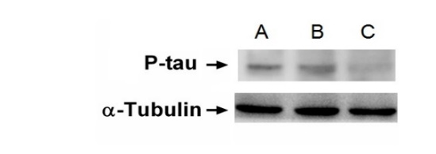
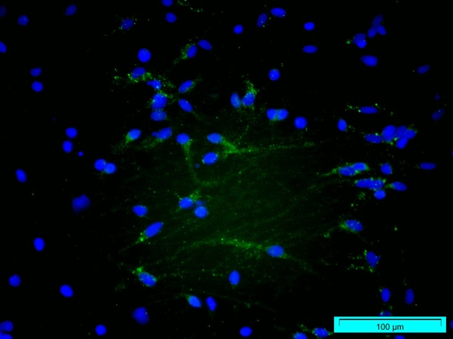
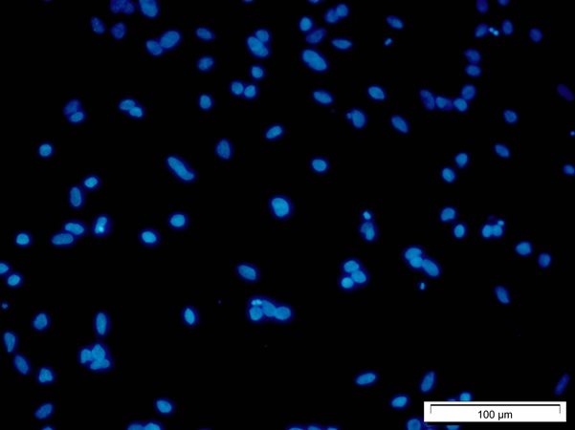
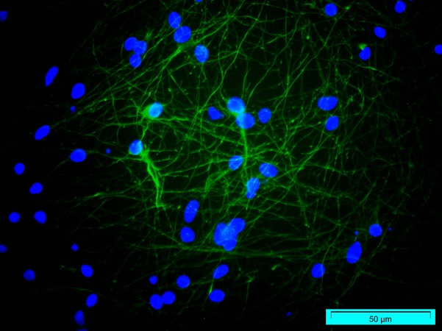
**
*
D
A
B
C

C

Figure 1: Immunostained cultured neurons with pathogenic p-tau under (A) Control, (B) Nutritional starved and (C) Stressed out neurons treated with FCF. (D) Quantification representation of Immunoflourescent intensity of A, B, and C (*: p-value < 0.001, **: p-value<0.01; difference between A and C is not significant).

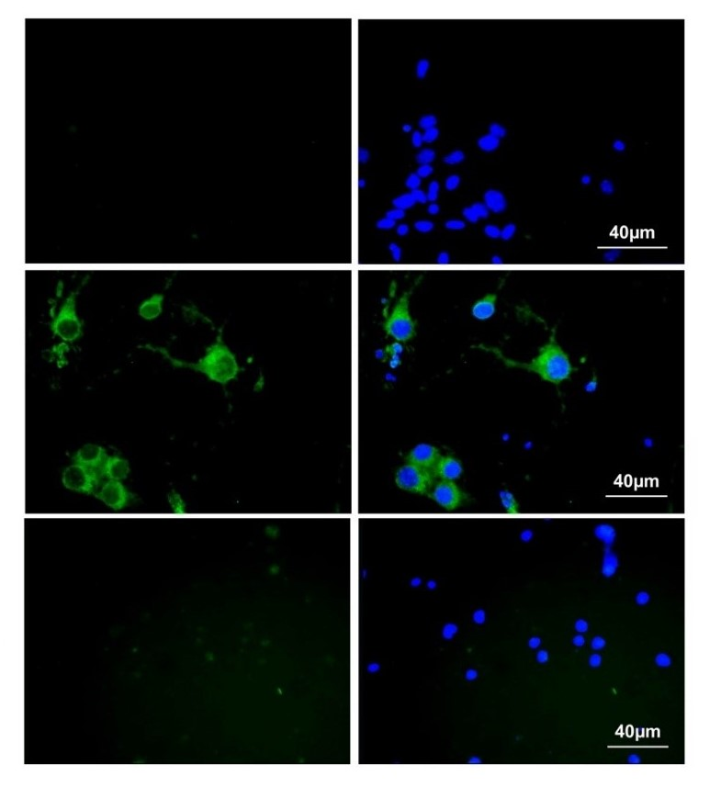
Amyloid Merge

A

B

C

D
**
**

Figure 2. Immunostained cultured neurons with antiamyloid antibody in (A) Control, (B) nutritional starved and, (C) FCF treated sample. (D) Quantification representation of A, B, and C (**: p-value<0.001; difference between A and C is not significant).

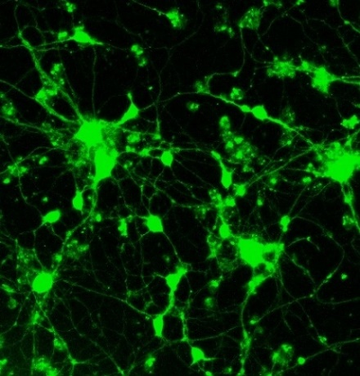
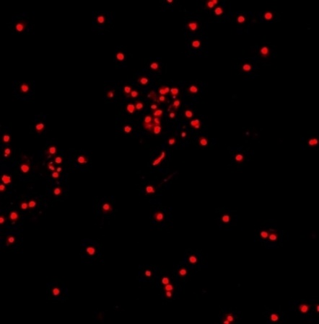
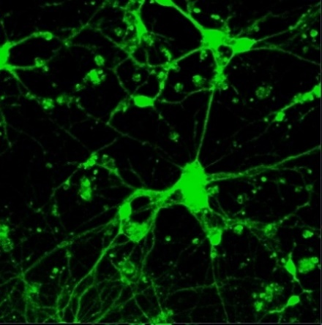
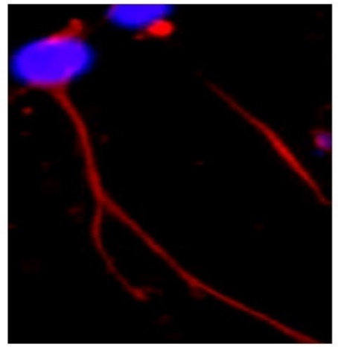
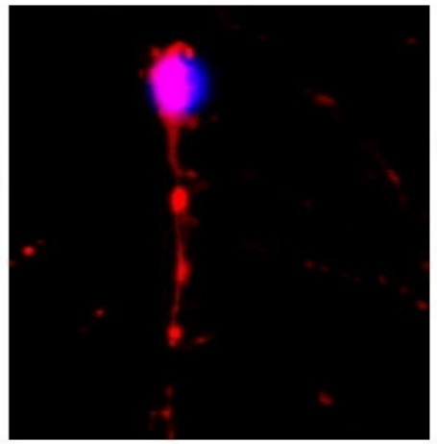
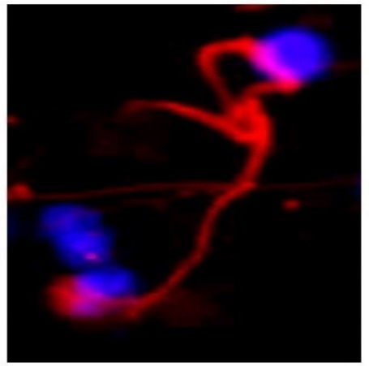

A

B

C

Figure 3. Live and dead cell assay and immunoblotting assay (Left) and Immunofluorescence staining of microtubules (Right) of stressed out cultured neurons. (A) Control, (B) Sham and (C) FCF treated samples.

In vivo assessments:
In the in vivo assessment of mice AD models, the p-tau protein production (taupathy) is evaluated in different samples of this study and is shown in the Figures 4 and 5. As can be seen in these figures, while Traumatic Brain Injury induced prominent neurotoxic p-tau in the brain, the FCF treatment suppressed pathogenic p-tau accumulation. Moreover, use of elevated plus maze, the cognitive decline in TBI mice models has been investigated. As can be seen in the Figure 6, the complete behavioral improvement in the FCF treated mice is such that even compared to the control group, they exhibit behaviors based on optimal brain function in relation to the memory, especially in the decision- arm
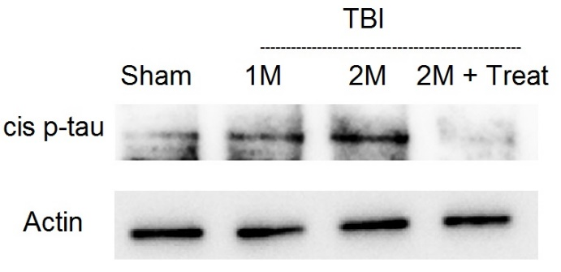
a

b

*
*

Figure 4. Immunoblotting (A) and Immunoflourescent (B) analysis of mouse brains stained with p-tau antibody upon various conditions. (C) Quantification representation of A and B (*: p-value<0.01).
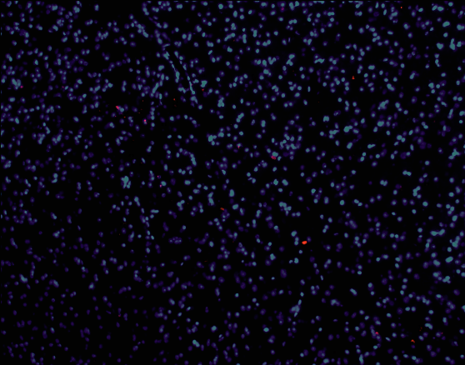
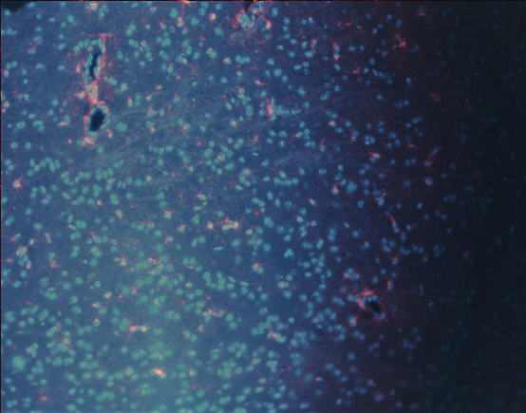
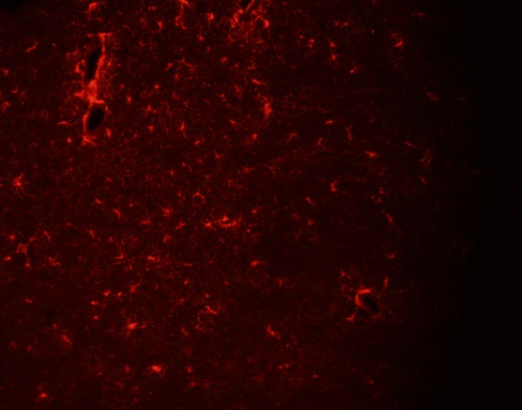
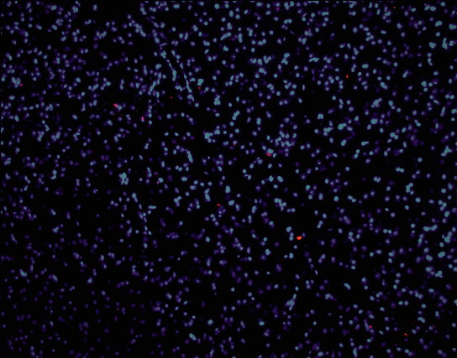
Cis p-tau Merge

A

B

C

*
*

D

Figure 5. Immunoflourescent stained TBI mouse brains with p-tau antibody (A) Sham, (B) TBI, (C) FCF treated TBI mouse. (D) Quantification representation of A, B, and C (*: p-value<0.01).

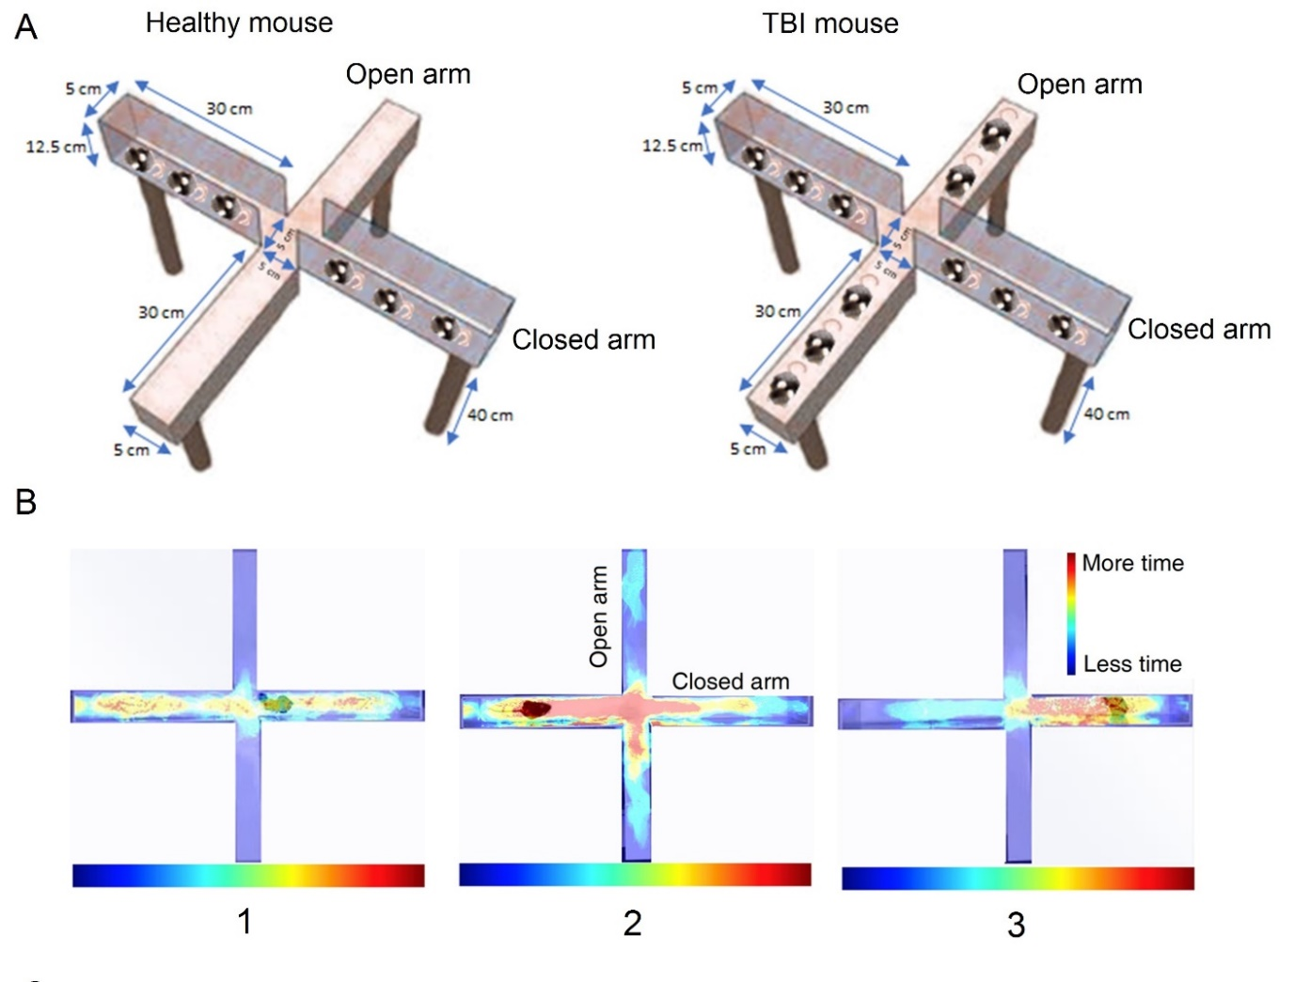
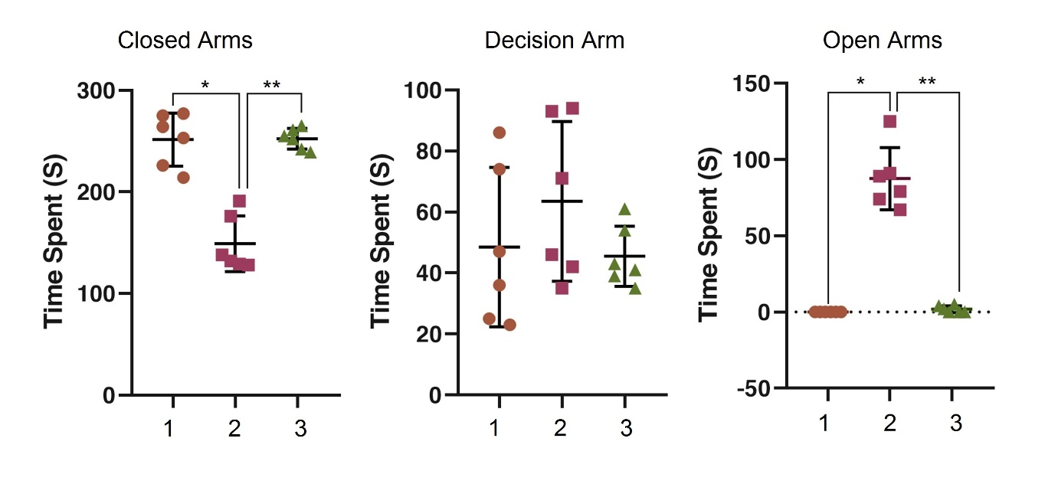
c
a
b

Figure 6. Behavioral analysis of TBI mouse models with elevated plus maze. (A) Schematic representation of healthy and TBI mice. (b) The hit map road of the mice in the different arms of the plus maze. (c) Quantification of mice behavior based on the time spent in the different regions of the plus maze. (1) Healthy mice (Control), (2) Mice after 2-month TBI initiation, (3) Mice after 2-month TBI initiation with the FCF treatment (*: p-value <0.05, **: p-value <0.001).

Discussion
This study is a continuation of assessments of FCF on behavioral changes in AD mouse models in addition to investigations on cell and molecular mechanisms involved in AD. The reduction in the Tau protein concentration in AD neuronal cells under stress, their survival, stabilization of microtubules, and reduction in the amyloidopathy are distinct differences when compared with the un-treated sham groups. AD is considered one of the most expensive diseases of old age and so development of therapeutic interventions to ameliorate or prevent the symptoms are of great interest. A therapeutic remedy still remains far-fetched, encouraging us to test the effects of the FCF on AD animals and cell models. The use of FCF as proposed by Taheri has been considered in a variety of contexts in the past decade. As the CFs are not matter nor energy, we cannot measure them with scientific means. However, we can measure their effects on other objects or living organisms. Under the FCF, objects are presumably scanned and healed as described in the methodology section. The resultant connection between the whole consciousness with the part consciousness (objects or living beings) leads to scanning of the part consciousness which is always towards a healing direction. We observe that the FCF does affect the objects under the study at the cellular and molecular levels in addition to the whole organisms in a reproducible fashion. An appealing advantage of using FCF is its non-pharmacological and interventional approach in producing results. This is particularly helpful in illnesses that have no pharmacological or other therapeutic forms of treatment in living systems. Since access to the FCF is free and accessible to any researcher, we recommend its use for assessment of CFs’ efficacy and specificity in similar or different systems. For instance, the efficacy of FCF in treatment of other neurological disorders such as Parkinson disease, multiple sclerosis, or amyotrophic lateral sclerosis can be of particular interest.
Conclusion
Overall, in this study by investigating the effects of a novel non-pharmacological method in the treatment of AD, disease development suppresses in the laboratory models. The results indicate that Faradarmani Consciousness Field is an effective factor on biological systems, especially at the level of the nervous system, and can be used as a powerful tool in the treatment of diseases and disorders.

Authors’ contributions
MA.T. contributed to study concept and design. F.S contributed to data acquisition and analysis. F.S, S.T and N.N contributed to drafting the text and figures. All authors critically evaluated and approved the manuscript.

Availability of data and materials
The data used in this study are not publicly available, but may be provided upon reasonable request.

Ethics approval and consent to participate
All these and following animal
experiments were approved by the …. and complied with the NIH Guide for the Care and Use of
Laboratory Animals
All animal experiments were approved by the by the Institutional Animal Care and Use Committee of Royan Institute (Tehran, Iran) and complied with the NIH Guide for the Care and Use of Laboratory Animals.

Consent for publication
Not applicable.

Competing interests
The authors declare that they have no competing interests.

References
- Yiannopoulou KG, Papageorgiou SG. Current and future treatments for Alzheimer’s disease. Therapeutic Advances in Neurological Disorders. 2013:19-33. doi:10.1177/1756285612461679
- World Health Organization (WHO), The top 10 causes of death, 2020. https://www.who.int/news-room/fact-sheets/detail/the-top-10-causes-of-death
- Barker WW, Luis CA, Kashuba A, Luis M, Harwood DG, Loewenstein D, Waters C, Jimison P, Shepherd E, Sevush S, Graff-Radford N, Newland D, Todd M, Miller B, Gold M, Heilman K, Doty L, Goodman I, Robinson B, Pearl G, Dickson D, Duara R. Relative frequencies of Alzheimer disease, Lewy body, vascular and frontotemporal dementia, and hippocampal sclerosis in the State of Florida Brain Bank. Alzheimer Dis Assoc Disord. 2002; Oct-Dec;16(4):203-12. doi: 10.1097/00002093-200210000-00001. PMID: 12468894.
- Sperling, R. A., Aisen, P. S., Beckett, L. A., Bennett, D. A., Craft, S., Fagan, A. M., Iwatsubo, T., Jack, C. R., Jr, Kaye, J., Montine, T. J., Park, D. C., Reiman, E. M., Rowe, C. C., Siemers, E., Stern, Y., Yaffe, K., Carrillo, M. C., Thies, B., Morrison-Bogorad, M., Wagster, M. V., … Phelps, C. H. Toward defining the preclinical stages of Alzheimer's disease: recommendations from the National Institute on Aging-Alzheimer's Association workgroups on diagnostic guidelines for Alzheimer's disease. Alzheimer's & dementia: the journal of the Alzheimer's Association. 2011; 7(3), 280–292. https://doi.org/10.1016/j.jalz.2011.03.003
- Holtzman DM, Morris JC, Goate AM. Alzheimer's disease: the challenge of the second century. Sci Transl Med. 2011; 3(77):77sr1. doi: 10.1126/scitranslmed.3002369. PMID: 21471435; PMCID: PMC3130546
- McKhann GM, Knopman DS, Chertkow H, et al. The diagnosis of dementia due to Alzheimer's disease: recommendations from the National Institute on Aging-Alzheimer's Association workgroups on diagnostic guidelines for Alzheimer's disease. Alzheimers Dement. 2011;7(3):263-269. doi:10.1016/j.jalz.2011.03.005
- Ballard, C., Gauthier, S., Cummings, J. et al. Management of agitation and aggression associated with Alzheimer disease. Nat Rev Neurol. 2009; 5, 245–255. https://doi.org/10.1038/nrneurol.2009.39
- Crews L, Masliah E. Molecular mechanisms of neurodegeneration in Alzheimer's disease. Hum Mol Genet. 2010; Apr 15;19(R1):R12-20. doi: 10.1093/hmg/ddq160. Epub 2010 Apr 22. PMID: 20413653; PMCID: PMC2875049.
- Trojanowski, J. Q., & Lee, V. M. "Fatal attractions" of proteins. A comprehensive hypothetical mechanism underlying Alzheimer's disease and other neurodegenerative disorders. Annals of the New York Academy of Sciences. 2000; 924, 62–67. https://doi.org/10.1111/j.1749-6632.2000.tb05561.x
- Guénette SY. Mechanisms of Abeta clearance and catabolism. Neuromolecular Med. 2003;4(3):147-60. doi: 10.1385/NMM:4:3:147. PMID: 14716023.
- Hardy J, Selkoe DJ. The amyloid hypothesis of Alzheimer's disease: progress and problems on the road to therapeutics. Science. 2002 Jul 19;297(5580):353-6. doi: 10.1126/science.1072994. Erratum in: Science. 2002;297(5590):2209. PMID: 12130773.
- Wang, Y. J., Zhou, H. D., & Zhou, X. F. Clearance of amyloid-beta in Alzheimer's disease: progress, problems and perspectives. Drug discovery today. 2006; 11 (19-20), 931–938. https://doi.org/10.1016/j.drudis.2006.08.004
- Miners JS, Baig S, Palmer J, Palmer LE, Kehoe PG, Love S. Abeta-degrading enzymes in Alzheimer's disease. Brain Pathol. 2008; 18(2):240-52. doi: 10.1111/j.1750-3639.2008.00132.x. PMID: 18363935.
- Eckman EA, Eckman CB. Abeta-degrading enzymes: modulators of Alzheimer's disease pathogenesis and targets for therapeutic intervention. Biochem Soc Trans. 2005; Nov;33 (Pt 5):1101-5. doi: 10.1042/BST20051101. PMID: 16246055.
- Mueller-Steiner, S., Zhou, Y., Arai, H., Roberson, E. D., Sun, B., Chen, J., Wang, X., Yu, G., Esposito, L., Mucke, L., & Gan, L. Antiamyloidogenic and neuroprotective functions of cathepsin B: implications for Alzheimer's disease. Neuron. 2006; 51(6), 703–714. https://doi.org/10.1016/j.neuron.2006.07.027
- Xiang, Y., Bu, XL., Liu, YH. et al. Physiological amyloid-beta clearance in the periphery and its therapeutic potential for Alzheimer’s disease. Acta Neuropathol. 2015; 130, 487–499. https://doi.org/10.1007/s00401-015-1477-1
- Dotti C.G., Banker G.A., Binder L.I. The expression and distribution of the microtubule-associated proteins tau and microtubule-associated protein 2 in hippocampal neurons in the rat in situ and in cell culture, Neuroscience. 1987; Volume 23, Issue 1, Pages 121-130, ISSN 0306-4522, https://doi.org/10.1016/0306-4522(87) 90276-4.
- Slaughter T, Wang J, Black MM. Microtubule transport from the cell body into the axons of growing neurons. 1997; J Neurosci. 1997;17(15):5807-5819. doi:10.1523/JNEUROSCI.17-15-05807.
- Griffin, W. Inflammation and neurodegenerative diseases. Am J Clin Nutr 3. 2006; (Suppl.): 470–474.
- Citron, M. Alzheimer's disease: strategies for disease modification. Nat Rev Drug Discov. 2010; 9, 387–398. https://doi.org/10.1038/nrd2896
- Serrano-Pozo A, Frosch MP, Masliah E, Hyman BT. Neuropathological alterations in Alzheimer disease. Cold Spring Harb Perspect Med. 2011; 1(1): a006189. doi: 10.1101/cshperspect.a 006189. PMID: 22229116; PMCID: PMC3234452.
- Fann JR, Ribe AR, Pedersen HS, Fenger-Grøn M, Christensen J, Benros ME, Vestergaard M. Long-term risk of dementia among people with traumatic brain injury in Denmark: a population-based observational cohort study. Lancet Psychiatry. 2018; May;5(5):424-431. doi: 10.1016/S2215-0366(18)30065-8. Epub 2018 Apr 10. PMID: 29653873.
- LoBue C, Wadsworth H, Wilmoth K, Clem M, Hart J Jr, Womack KB, Didehbani N, Lacritz LH, Rossetti HC, Cullum CM. Traumatic brain injury history is associated with earlier age of onset of Alzheimer disease. Clin Neuropsychol. 2017; Jan;31(1):85-98. doi: 10.1080/13854046.2016.1257069. Epub 2016 Nov 18. PMID: 27855547; PMCID: PMC5224912
- Kondo, A., Shahpasand, K., Mannix, R., Qiu, J., Moncaster, J., Chen, C. H., Yao, Y., Lin, Y. M., Driver, J. A., Sun, Y., Wei, S., Luo, M. L., Albayram, O., Huang, P., Rotenberg, A., Ryo, A., Goldstein, L. E., Pascual-Leone, A., McKee, A. C., Meehan, W., … Lu, K. P. Antibody against early driver of neurodegeneration cis P-tau blocks brain injury and tauopathy. Nature. 2015; 523(7561), 431–436. https://doi.org/10.1038/nature14658
- Shahpasand K, Sepehri Shamloo A, Nabavi SM, Ping Lu K, Zhen Zhou X. "Tau immunotherapy: Hopes and hindrances". Hum Vaccin Immunother. 2018; 14(2):277-284. doi: 10.1080/21645515.2017.1393594. Epub 2017 Dec 1. PMID: 29049003; PMCID: PMC5806642.
- Lunardi, P., Nardin, P., Guerra, M. C., Abib, R., Leite, M. C., & Gonçalves, C. A. Huperzine A, but not tacrine, stimulates S100B secretion in astrocyte cultures. Life sciences. 2013; 92(12), 701–707. https://doi.org/10.1016/j.lfs.2013.01.029
- Anand, P., Singh, B. A review on cholinesterase inhibitors for Alzheimer’s disease. Arch. Pharm. Res. 2013. 36, 375–399. https://doi.org/10.1007/s12272-013-0036-3
- Dos Santos Picanco, L. C., Ozela, P. F., de Fatima de Brito Brito, M., Pinheiro, A. A., Padilha, E. C., Braga, F. S., de Paula da Silva, C., Dos Santos, C., Rosa, J., & da Silva Hage-Melim, L. I. Alzheimer's Disease: A Review from the Pathophysiology to Diagnosis, New Perspectives for Pharmacological Treatment. Current medicinal chemistry. 2018; 25(26), 3141–3159. https://doi.org/10.2174/0929867323666161213101126
- Taheri MA: “Human from another outlook” Interuniversal Press; 2nd Edition (September 26, 2013). ISBN-13: 978-1939507006, ISBN-10: 1939507006 2013.
- Taheri, Mohammad Ali and Torabi, Sara and Nabavi, Noushin and Semsarha, Farid, Influence of Faradarmani Consciousness Field (FCF) on Spatial Memory and Passive Avoidance Behavior of Scopolamine Model of Alzheimer Disease in Male Wistar Rats (January 6, 2021). Available at SSRN: https://ssrn.com/abstract=
- Taheri, MA, Semsarha, F, Mahdavi, M, Afsartala, Z and Amani, Laleh, The Influence of the Faradarmani Consciousness Field on the Survival and Death of MCF-7 Breast Cancer Cells: An Optimization Perspective (October 5, 2020). Available at SSRN: https://ssrn.com/abstract=
- Taheri, M.A.; Semsarha, F.; Modarresi-Asem, F. An Investigation on the Electrical Activity of the Brain during Faradarmani Connection in the Fara-Therapist Population. Preprints. 2020; 2020090679 (doi: 10.20944/preprints202009.0679.v1).
- Torabi S, Taheri MA and Semsarha F. Alleviative effects of Faradarmani Consciousness Field on Triticum aestivum L. under salinity stress [version 1; peer review: awaiting peer review]. F1000Research 2020, 9:1089 (https://doi.org/10.12688/f1000research.25247.1)
- Jiajia L, Shinghung M, Jiacheng Z, Jialing W, Dilin X, Shengquan H, et al. Assessment of Neuronal Viability Using Fluorescein Diacetate-Propidium Iodide Double Staining in Cerebellar Granule Neuron Culture. J Vis Exp. 2017(123).

