How autophagy and mitophagy affect plaque stability in atherosclerosis
Bo-Bo Fan ^{a,b} Gao-Po Cai ª, Ke Ma ª, Zhen Li ^{a*}
ªDepartment of Endovascular Surgery, The First Affiliated Hospital, Zhengzhou University, Zhengzhou, Henan 450000, China
^{b}Academy of Medical Sciences, Zhengzhou University, Zhengzhou, Henan 450000, China
*Correspondence to: Department of Endovascular Surgery, The First Affifiliated Hospital, Zhengzhou University, No.1, Jianshe East Road, Erqi District, Zhengzhou, Henan 450000, PR China. Tel./fax:+86 0371 66862153.
E-mail address: lizhen1029@hotmail.com (Z.Li).

Abstract:
Atherosclerosis is a complex chronic inflammatory disease and a leading cause of death worldwide, and unstable plaque is one of the main features of advanced atherosclerosis. Plaque rupture and thrombus formation are the most fatal complications of atherosclerosis. Therefore, it is important to elucidate the mechanism underlying the formation of unstable plaques in order to prevent atherosclerosis-related complications. Autophagy is an important self-renewal process that degrades harmful cellular components and dysfunctional organelles via lysosomes to maintain cellular homeostasis and normal function. Previous studies have shown that autophagy plays a pivotal role in reducing inflammatory responses, oxidative stress, and the number of apoptotic cells, thereby improving cholesterol efflux from macrophages in atherosclerosis. Activating autophagy can significantly inhibit the development of atherosclerotic plaque and maintain plaque stability, as shown in various experimental models, including animal studies. Autophagy exerts a protective effect during early atherosclerosis but becomes dysregulated during advanced atherosclerosis. Therefore, appropriate activation of autophagy can inhibit atherosclerosis progression and prevent its complications. In this review article, we summarize the mechanisms of autophagy in -, as well as the effect of mitophagy on atherosclerotic plaque stability.
Keywords: atherosclerosis; plaque stability; autophagy; mitophagy; macrophage; vascular smooth muscle cell

1. Introduction
As an inflammatory disease, atherosclerosis can occur in almost all arteries and is characterized by plaque formation [1,2]. Through the course of disease development, plaque stability plays a paramount role in the occurrence of atherosclerotic complications: stable atherosclerotic plaques contain a thick fibrous cap covering the necrotic core, a small necrotic core, and a few macrophages; during advanced atherosclerosis, where a violent inflammatory response causes cell death, stable plaques can turn into unstable plaques that contain a thin fibrous cap, a large necrotic core, few vascular smooth muscle cells (VSMCs), and a large number of macrophages, and the rupture of unstable plaques can cause several fatal complications, such as stroke, acute myocardial infarction, or sudden death [3]. To prevent these fatal complications, new therapeutic options must be identified by elucidating the mechanisms underlying plaque instability and rupture.
Autophagy is a highly conserved biological process that degrades harmful components and organelles, such as dysfunctional mitochondria and misfolded proteins [4]. Based on the binding mode of harmful cell components and lysosomes, autophagy can be classified as macroautophagy, microautophagy, and molecular chaperone-mediated autophagy [5]. In this study, we focused on autophagy (also known as macroautophagy). Autophagy begins with the formation of the phagosome, an isolation membrane enclosing toxic cellular components and dysfunctional organelles (see figure 1). These phagosomes gradually elongate to form a cup-shaped structure, finally forming double lipid membrane vesicles called autophagosomes [6]. Subsequently, autophagosomes and lysosomes fuse to form autophagosomal lysosomes, and lysosomal hydrolases decompose the toxic substances within [7]. To date, two crucial signaling pathways of autophagy have been identified: the PI3K-mTOR-related signaling pathway and the PI3K-Beclin1-related signaling pathway [8,9]. Basic autophagy can maintain cell homeostasis and function [10]. Autophagy can be activated by environmental stress-related signals, such as dysfunctional organelles, inflammation, and oxidative stress, and it facilitates nutrient recycling, energy generation, and maintenance of cellular viability [11].

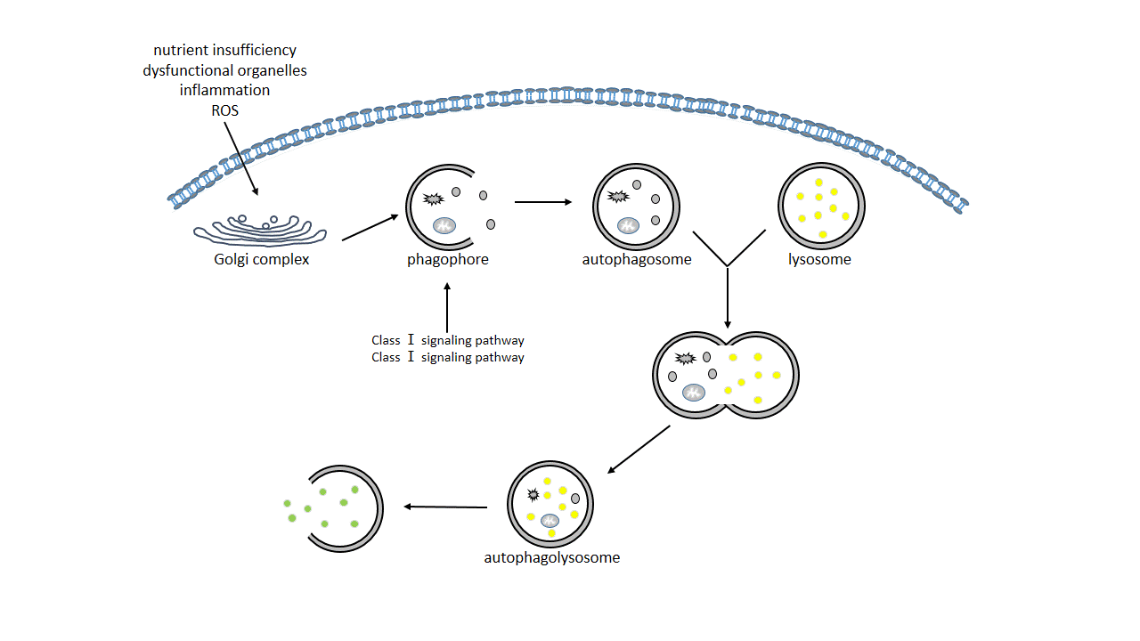

Figure 1: Schematic diagram of the autophagy process. Induced by nutrient insufficiency, inflammation, or oxidative stress, bilayer lipid membranes from the endoplasmic reticulum or Golgi complex form cup-shaped phagophores. The phagophore digests damaged organelles and harmful components to form the autophagosome. The autophagolysosome is formed by the integration of the autophagosome and lysosome. Two crucial signaling pathways of autophagy have been found: the PI3K-mTOR-related signaling pathway and the PI3K-Beclin1-related signaling pathway.
Endothelial cells (EC), VSMCs, and macrophages are the three most important cell types involved in the development of atherosclerosis, and all of them can express autophagy markers [12]. In addition, autophagy has been observed in the main cells in human atherosclerotic plaque using transmission electron microscopy [13,14]. Recent studies have shown that autophagy plays a critical role in attenuating atherosclerosis and maintaining plaque stability, suggesting that autophagy may be a useful target for the treatment of atherosclerosis [15,16]. In atherosclerosis, autophagy exerts similar effects in endothelial cells, macrophages, and VSMCs, although using different mechanisms. Next, we will focus on the mechanism of dysfunctional autophagy in these three cell types and the effect of mitophagy on plaque stability.

2. Mechanism of autophagy effect on plaque stability in endothelial cells
Endothelial cells, located in the innermost layer of the atherosclerotic plaque, are in direct contact with blood and control material exchange and communication between blood and vessel walls [17,18]. Endothelial cells regulate vascular tension, anticoagulation, and inflammation [19]. In atherosclerosis, defective autophagy in endothelial cells affects plaque stability by affecting thrombus formation, endothelial function, and apoptosis; for example, tissue factor (TF), expressed in the necrotic core of atherosclerotic plaques, is the main promoter of the extrinsic pathway that causes thrombus formation when the plaque ruptures. TF activates the coagulation cascade when it comes in contact with the activating factor VIIa, finally producing thrombin, which plays a pivotal role in platelet activation and fibrin formation [20]. Yau et al. [21] provided evidence that the deletion of ATG7, a key autophagy-specific mediator in endothelial cells, attenuates the expression of TF in human umbilical vein endothelial cells induced by tumor necrosis factor-α. Moreover, deletion of the key autophagy-related gene ATG7 in mouse endothelial cells resulted in dysfunctional thrombosis. In addition, stents coated with rapamycin (an autophagy activator) are more likely to cause in-stent thrombosis in patients receiving percutaneous coronary stent interventional therapy [22,23]. However, there is no clear clinical evidence that reducing endothelial autophagy can inhibit thrombosis in atherosclerosis.
Blood flow exerts frictional and shear stress on the vascular walls, which influence atherosclerosis development and plaque stability via dynamic interactions with endothelial cells. In addition, atherosclerotic plaque can change blood flow patterns by causing abnormal flow and turbulence, which affect endothelial repair, vasodilation, and endothelial nitric oxide synthase (eNOS) production [24,25]. Guo et al. [26] demonstrated that when endothelial autophagy is upregulated, eNOS expression is increased, and endothelin-1 expression is inhibited, thereby maintaining normal vascular wall tension and plaque stability. Endothelin-1 is a natural counterpart of the vasodilator nitric oxide (NO) and a specific protein marker of endothelial dysfunction.
Moreover, defective autophagy in endothelial cells can accelerate apoptosis, promote plaque instability and platelet aggregation, and promote thrombus formation and plaque rupture [17,27,28]. Furthermore, apoptotic stimuli, such as tumor necrosis factor-α, oxidized low-density lipoprotein (oxLDL), and ceramide, are more likely to lead to the death of autophagic defective endothelial cells, possibly due to decreased NO levels and increased reactive oxygen species (ROS)-induced damage [29–31]. Evidence suggests that these effects are regulated by the overexpression of lectin-like oxidized LDL (LOX-1), a scavenger receptor that selectively internalizes oxLDL in endothelial cells [32]. LOX-1 expression can be directly regulated by mechanical force, oxLDL, oxidative stress, and angiotensin II, which play a pivotal role in the progression of atherosclerosis [33–35]. Recently, Mollace et al. [36] showed that oxLDL reduces NO production and increases cell death in bovine aortic endothelial cells through overexpression of LOX-1 and attenuation of autophagy.

Macrophage autophagy modulates plaque stability
Macrophages play both harmful and beneficial roles in atherosclerosis. During the initial phase of atherosclerosis, the harmful plaque components, such as cytotoxic lipoproteins and apoptotic cells, can be scavenged by macrophages. In addition, macrophages promote tissue repair and plaque stability by increasing extracellular matrix synthesis and VSMC proliferation [37]. In advanced atherosclerosis with disordered homeostasis and gradual autophagy damage, a large number of dysfunctional and apoptotic macrophages, which secrete matrix-degrading enzymes and release ROS (reactive oxygen species)and pro-inflammatory factors, lead to extracellular matrix degradation and necrosis of surrounding cells, resulting in plaque destabilization, plaque rupture, and thrombotic events [38]. Accumulating evidence demonstrates that autophagy can alleviate atherosclerosis and maintain plaque stability by promoting macrophage cholesterol efflux and apoptotic macrophage clearance and reducing macrophage apoptosis (see figure 2) [39].
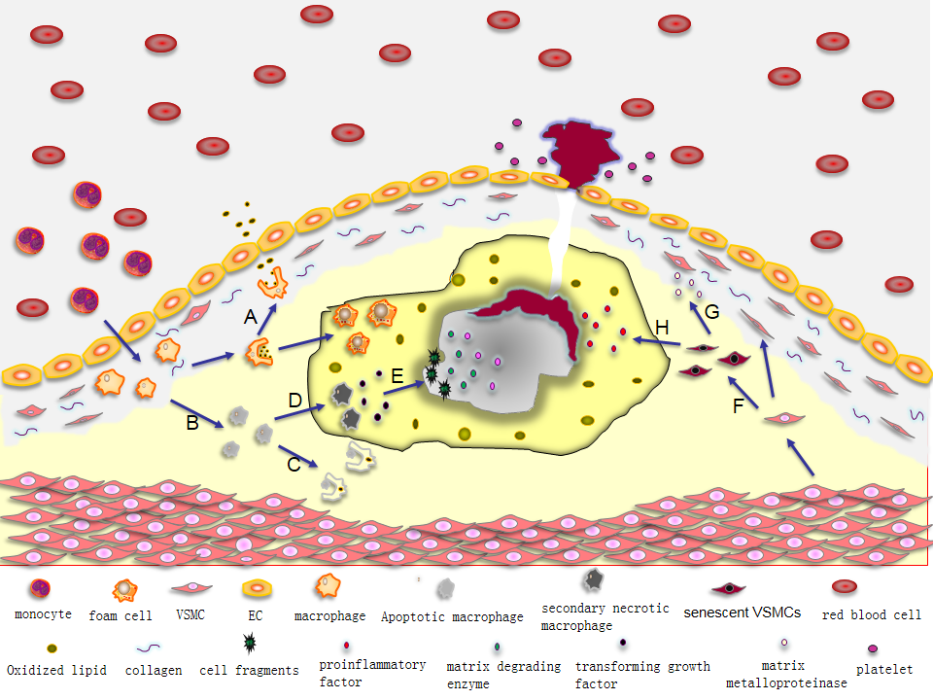
Figure 2: Macrophages and vascular smooth muscle cells (VSMCs) influence plaque stability in several ways. (A) Cholesterol efflux from macrophages reduces the accumulation of foam cells; (B) Macrophage apoptosis; (C) Apoptotic macrophages are eliminated; (D) Apoptotic macrophages transform into secondary necrosis cells; (E) Secondary necrotic macrophages secrete pro-inflammatory factors and matrix-degrading enzymes, which promote plaque necrosis and rupture; (F) VSMC senescence; (G) Senescent VSMCs secrete matrix metalloproteinases, which degrade collagen tissues and reduce fibrous cap formation; (H) Senescent VSMCs secrete various pro-inflammatory factors to promote the formation of the necrotic core.

3. Autophagy increases cholesterol efflux in macrophages
During the initial stage of atherosclerosis, monocytes in the blood enter the intima of the vessels and differentiate into macrophages. Macrophages form foam cells by internalizing large amounts of modified lipoproteins (such as oxLDL) and lipoproteins [40]. The continuous accumulation and death of foam cells, along with chronic inflammation, promote the formation of atherosclerotic plaques [41,42]. Research has shown that during the initial phase of atherosclerosis, autophagy can promote cholesterol efflux in macrophages and reduce foam cell accumulation, thereby inhibiting plaque formation. This particular type of autophagy is termed “lipophagy [43]”. As atherosclerosis progresses, autophagy in macrophage cells is gradually impaired, characterized by increased number of autophagosomes and decreased number of autophagolysosomes in intermediate and advanced atherosclerosis [44,45]. Liu et al. [44] demonstrated that autophagy in macrophages was impaired gradually as macrophages were incubated with oxLDL for longer periods of time, leading to cell death and decreased cell viability. Recently, Zhai et al. [39] showed that, in the vulnerable plaques induced in New Zealand white rabbits, the level of autophagy in macrophages was upregulated by selectively inhibiting the Akt/mTOR signaling pathway, and plaque rupture incidence, plaque burden, and vulnerability index were also decreased.

4. Autophagy reduces macrophage apoptosis
Macrophage apoptosis and necrosis are significant features of advanced atherosclerosis that influence necrosis core formation and unstable plaque formation [37]. There is evidence that dysfunctional autophagy in macrophages can accelerate apoptosis and promote plaque instability in advanced atherosclerosis [46]. For example, Liao et al. [47] demonstrated that deletion of macrophage autophagy-specific mediator ATG5 increases macrophage apoptosis and necrosis in LDLR^{−/−} mice, leading to the development and rupture of atherosclerotic plaque after 12–16 weeks of consuming a high-fat diet. In addition, in vitro experiments showed that activating autophagy can reduce macrophage apoptosis, suggesting that autophagy could alleviate atherosclerosis and promote plaque stability [44]. Evidence supports the notion that deficient autophagy in macrophages promotes apoptosis by enhancing nicotinamide adenine dinucleotide phosphate oxidase-mediated oxidative stress, leading to lower recognition of apoptotic cells by efferocytosis [47]. Furthermore, apoptotic macrophages may reduce collagen synthesis in VSMCs due to reduced transforming growth factor-β secretion, resulting in unstable plaque [48].

5. Autophagy promotes clearance of apoptotic macrophages and prevents secondary necrosis
Apoptotic macrophages can be effectively cleared during the early stage of atherosclerosis; however, during the late stage of atherosclerosis, several factors lead to insufficient phagocytic clearance of apoptotic macrophages, resulting in secondary necrosis and pro-inflammatory responses [37]. Schrijvers et al. [49] showed that a large number of apoptotic macrophages are found in human carotid atherosclerosis without being cleared via phagocytosis. Liao X et al. [47] provided evidence that silencing macrophage autophagy mediator ATG5 in fat-fed LDLR^{-/-} mice could reduce the recognition and clearance of apoptotic macrophages, which may lead to secondary necrosis, thereby promoting atherosclerotic plaque development and necrosis in advanced atherosclerosis. Apoptotic macrophages that have not been cleared develop into secondary necrotic cells, which can promote the occurrence of unstable plaque by inducing inflammation and expanding the necrotic core [50]. These macrophages are also important sources of TFs that promote intraplaque thrombosis [51]. In addition, secondary necrosis of apoptotic macrophages promotes plaque development and necrosis and directly induces the secretion of pro-inflammatory cytokines and the formation of damage-related molecular patterns (DAMPs) [52]. DAMPs can enhance the inflammatory response in the necrotic core, leading to its enlargement and plaque rupture. In addition, in advanced atherosclerosis, macrophages with secretory phenotypes secrete matrix-degrading enzymes that cause thinning of the fibrous cap, plaque rupture, and thrombus formation. Abnormal macrophages also release nitrogen radicals and toxic oxygen, causing the death of surrounding cells [38,53].

6. Autophagy affects plaque stability in VSMCs
VSMCs can regulate blood pressure, distribute nutrients and oxygen to the surrounding tissues, and exhibit significant plasticity [54]. On one hand, VSMCs can transform from a contractile phenotype to a macrophage-like phenotype, phagocytose lipoproteins or apoptotic cells, and form smooth muscle cell-derived foam cells, thus promoting the progression of atherosclerosis; in contrast, in advanced atherosclerosis, VSMCs transform into a synthetic phenotype, which shows high proliferative and migratory abilities and enhances extracellular matrix production, thereby maintaining plaque stability [55,56]. Therefore, VSMCs are considered to play a pivotal role in increasing plaque stability and preventing plaque rupture and thrombus formation [3,57–59]. Many studies have shown that activation of autophagy in VSMCs can attenuate atherosclerosis by reducing oxidative stress, inhibiting the VSMC phenotypic shift, and inhibiting senescence (see figure 2) [10,60,61].
Evidence suggests that the proliferative and self-repairing abilities are impaired in senescent VSMCs, leading to reduced fibrous cap formation [62]. Many senescent VSMCs are found in unstable atherosclerotic plaques, with a marked decrease in proliferative capacity and increased expression of senescence markers, such as senescence-associated β-galactosidase [63]. Recently, Grootaert et al. [64] have shown that the deletion of the smooth muscle cell-specific autophagy-related mediator ATG7 promotes senescence and ligation-induced neointima formation in a mouse model of atherosclerosis, suggesting that autophagy affects VSMC phenotype and proliferation. Masuyama et al. [65] established a model of carotid tandem stenosis and showed that autophagy-deficient VSMCs increased the risk of atherosclerotic plaque rupture; moreover, ApoE^{-/-} mice with autophagy-deficient VSMCs showed increased intraplaque bleeding, plaque rupture, and thrombosis. Studies have shown that autophagy can inhibit oxidative stress and protein toxic stress by scavenging impaired mitochondria and protein aggregates, thereby negatively regulating cell senescence [66]. Maatinet et al. [67] demonstrated that the autophagy inducer 7-ketocholesterol could effectively reduce senescence in VSMCs, which, in turn, improved plaque stability. The altered secretory activity of senescent VSMCs is referred to as a proinflammatory senescence-associated secretory phenotype, where these cells secrete proinflammatory cytokines, chemokines, growth factors, and proteases, but not anti-inflammatory factors [68]. These findings suggest that senescent VSMCs can aggravate the inflammatory response and matrix degradation in atherosclerotic plaques [69].
Although autophagy is generally considered a protective mechanism against atherosclerosis, excessive activation of autophagy can induce autophagic death of VSMCs, leading to plaque instability [70]. An in vitro study showed that a moderate dose of ox-LDL (10–40 μg/mL) induced VSMC proliferation, while higher levels of ox-LDL (more than 60 μg/mL) were more likely to cause cell apoptosis [71]. Luo et al. [72] demonstrated that low doses of rapamycin in an ApoE^{−/−} mouse atherosclerosis model could moderately upregulate autophagy, thereby mitigating the progression of atherosclerosis and maintaining plaque stability, which are associated with the regulation of autophagy and senescence in VSMCs via the mTORC1/ULK1/Atg13 signaling pathway; however, high doses of rapamycin had no additional beneficial effects on atherosclerosis and plaque stability. Furthermore, other cell types, such as macrophages, pancreatic cells, and neurons, are also more vulnerable to damage-mediated cell death in the case of defective or excessive autophagy [47,73].

7. Effect of mitophagy on plaque stability
In addition to the non-selective process, by which autophagosomes phagocytose the cytoplasm, they also selectively degrade damaged organelles (e.g., mitochondria and ribosomes). This selective autophagy is referred to as organ-specific autophagy [74,75]. Mitophagy, the selective degradation of damaged mitochondria to inhibit cell death, can occur during specific developmental processes, such as red blood cell maturation, or after pathological mitochondrial damage (see figure 3) [76–78]. Selective elimination of dysfunctional mitochondria can reduce the production of pro-apoptotic factors, such as cytochrome C, which can activate cell death pathways [79]. There is evidence that mitophagy can resist oxidative stress, reduce ROS production, and inhibit the apoptosis of VSMCs, thereby alleviating atherosclerosis and maintaining plaque stability [80].

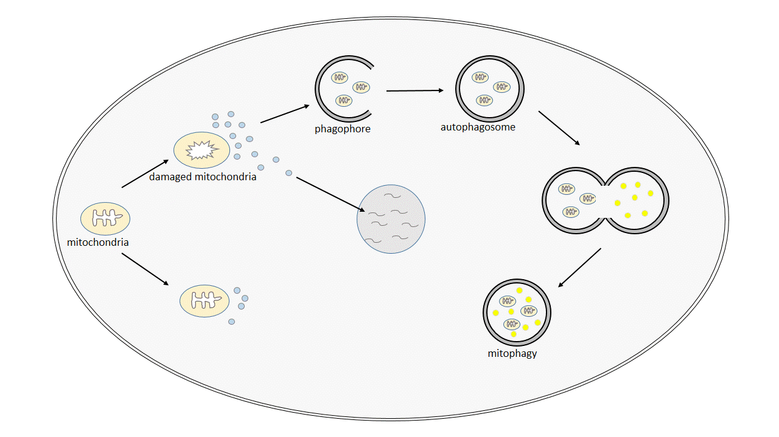
Figure 3: Schematic illustration of mitophagy. The excessive accumulation of reactive oxygen species (ROS) during cellular stress can damage mitochondrial components, including mitochondrial DNA, proteins, and lipids, thus aggravating the production of ROS and mitochondrial dysfunction. ROS, especially hydrogen peroxide, hydroxyl radicals, and superoxide anions, can cause a series of DNA changes, such as DNA strand breaks and DNA base changes, which accelerate replicative senescence. Phagophores specifically phagocytose dysfunctional mitochondria and combine with lysosomes to form autophagolysosomes to eliminate harmful mitochondria.

Of all organelles, mitochondria have the most direct effect on cellular energy metabolism and disease phenotypes [81]. The main role of mitochondria is to produce adenosine triphosphate via oxidative respiratory phosphorylation, and they can regulate innate immunity, necrosis, apoptosis, and autophagy [82–84]. The production of ATP through the respiratory chain is accompanied by the formation of ROS as a byproduct. Low levels of ROS can be directly removed by antioxidants or actively stimulate the signal/transcription pathway to maintain an appropriate redox balance; however, excessive accumulation of ROS during stress can damage mitochondrial components, including mitochondrial DNA, proteins, and lipids, thus aggravating ROS production and mitochondrial dysfunction [85]. ROS, especially hydrogen peroxide, hydroxyl radicals, and superoxide anions, can cause a series of DNA changes, such as DNA strand breaks and DNA base changes, thereby triggering DNA damage response pathways. In some types of cells, ROS can cause telomere loss during replication and lead to premature senescence that does not depend on telomere shortening [86,87]. ROS levels are significantly elevated in all types of cells in atherosclerotic lesions, especially in the plaque itself [88]. Matthews et al. [89] have demonstrated that VSMC senescence in plaques is attributed to oxidative DNA damage that accelerates replicative senescence. Replicative senescence and sustained apoptosis of VSMCs lead to reduced fibrous cap formation, commonly observed in advanced atherosclerosis in humans, which may also contribute to plaque rupture through overexpression of adhesion molecules, hemostatic regulatory factors, matrix metalloproteinases, and other proteins [90–92]. Swiader A et al. [80] showed that human VSMCs exposed to oxLDL selectively scavenge damaged mitochondria through autophagy, which can inhibit VSMC apoptosis caused by atherosclerotic stressors. In addition, this process depends on the PTEN-mediated putative kinase 1 (PINK1)/parkin pathway. In addition, oxidative stress is significantly enhanced, and the number of apoptotic cells is significantly increased in the cardiomyocytes of PINK1-deficient mice. Kubli et al. [93,94] demonstrated that parkin-deficient mice were more prone to myocardial infarction, which was primarily due to the dysfunctional mitophagy in cardiomyocytes. Although mitophagy plays a pivotal role in alleviating atherosclerosis and maintaining plaque stability, its related pathways and mechanisms require further study.

8. Conclusion
In conclusion, here, we have summarized the progress in research focused on the mechanism of autophagy in three different types of cells and the effects of mitophagy on plaque stability in atherosclerosis. The effect of autophagy on atherosclerosis and plaque stability is similar in different types of cells, but it is executed via different mechanisms. Therefore, revealing the underlying autophagy mechanism of alleviating atherosclerosis and maintaining plaque stability in different types of cells could provide a new basis for treating and preventing atherosclerosis. A growing body of evidence has shown that activating autophagy is an effective method to inhibit plaque growth and maintain plaque stability, but clinical data are still limited. Atherosclerosis is a dynamic pathological process. It is important to identify the critical time points of autophagy activation, as well as the mode and degree of its activation in pathological conditions. Any autophagy regulatory approach targeting only advanced atherosclerosis will not inhibit the development of atherosclerosis, and may aggravate its pathological changes instead. In recent years, several stable and effective animal models of unstable plaques have been established, providing a new basis for elucidating the therapeutic effect of autophagy on unstable plaques.

Abbreviations: vascular smooth muscle cells (VSMCs); endothelial cells (EC); tissue factor (TF); endothelial nitric oxide synthase (eNOS); nitric oxide (NO); oxidized low-density lipoprotein (oxLDL); reactive oxygen species (ROS); lectin-like oxidized LDL (LOX-1); damage-related molecular patterns (DAMPs); PTEN-mediated putative kinase 1 (PINK1)

Declarations
Acknowledgements:
Funding: This work was supported by grants from the National Natural Science Foundation of China (grants no. 8187020205).
Availability of data and materials: The datasets used and/or analyzed during the current study are available from the corresponding author on reasonable request.
Authors' contributions: Not applicable
Ethics approval and consent to participate: Not applicable
Patient consent for publication: Not applicable
Competing interests: The authors declare that there is no conflict of interest regarding the publication of this paper.
References
[1] Lusis AJ. Atherosclerosis. Nature 2000;407, no. 6801:233–41. DOI: 10.1038/35025203.
[2] Libby P. Inflammation in atherosclerosis. Nature 2002;420, no. 6917:868–74. DOI: 10.1038/nature01323.
[3] Virmani R, Kolodgie FD, Burke AP, Farb A, Schwartz SM. Lessons from sudden coronary death: a comprehensive morphological classification scheme for atherosclerotic lesions. Arterioscler Thromb Vasc Biol 2000;20, no. 5:1262–75. DOI: 10.1161/01.atv.20.5.1262.
[4] Ryter SW, Bhatia D, Choi ME. Autophagy: A lysosome-dependent process with implications in cellular redox homeostasis and human disease. Antioxid Redox Signal 2019;30, no. 1:138–59. DOI: 10.1089/ars.2018.7518.
[5] Stolz A, Ernst A, Dikic I. Cargo recognition and trafficking in selective autophagy. Nat Cell Biol 2014;16, no. 6:495–501. DOI: 10.1038/ncb2979.
[6] Sciarretta S, Maejima Y, Zablocki D, Sadoshima J. The role of autophagy in the heart. Annu Rev Physiol 2018;80, no. 1:1–26. DOI: 10.1146/annurev-physiol-021317-121427.
[7] Feng Y, He D, Yao Z, Klionsky DJ. The machinery of macroautophagy. Cell Res 2014;24, no. 1:24–41. DOI: 10.1038/cr.2013.168.
[8] Salabei JK, Conklin DJ. Cardiovascular autophagy: crossroads of pathology, pharmacology and toxicology. Cardiovasc Toxicol 2013;13, no. 3:220–9. DOI: 10.1007/s12012-013-9200-8.
[9] Ryter SW, Lee SJ, Smith A, Choi AM. Autophagy in vascular disease. Proc Am Thorac Soc 2010;7, no. 1:40–7. DOI: 10.1513/pats.200909-100JS.
[10] Levine B, Kroemer G. Autophagy in the pathogenesis of disease. Cell 2008;132, no. 1:27–42. DOI: 10.1016/j.cell.2007.12.018.
[11] Mizushima N, Komatsu M. Autophagy: renovation of cells and tissues. Cell 2011;147, no. 4:728–41. DOI: 10.1016/j.cell.2011.10.026.
[12] Zhang T, Tian F, Wang J, Jing J, Zhou SS, Chen YD. Endothelial cell autophagy in atherosclerosis is regulated by miR-30-Mediated translational control of ATG6. Cell Physiol Biochem 2015;37, no. 4:1369–78. DOI: 10.1159/000430402.
[13] Perrotta I. The use of electron microscopy for the detection of autophagy in human atherosclerosis. Micron 2013;50:7–13. DOI: 10.1016/j.micron.2013.03.007.
[14] Liu H, Cao Y, Tong T et al. Autophagy in atherosclerosis: a phenomenon found in human carotid atherosclerotic plaques. Chin Med J (Engl) 2015;128, no. 1:69–74. DOI: 10.4103/0366-6999.147815.
[15] Schrijvers DM, De Meyer GR, Martinet W. Autophagy in atherosclerosis: a potential drug target for plaque stabilization. Arterioscler Thromb Vasc Biol 2011;31, no. 12:2787–91. DOI: 10.1161/ATVBAHA.111.224899.
[16] Martinet W, De Meyer I, Verheye S, Schrijvers DM, Timmermans JP, De Meyer GR. Drug-induced macrophage autophagy in atherosclerosis: for better or worse? Basic Res Cardiol 2013;108, no. 1:321. DOI: 10.1007/s00395-012-0321-1.
[17] Paone S, Baxter AA, Hulett MD, Poon IKH. Endothelial cell apoptosis and the role of endothelial cell-derived extracellular vesicles in the progression of atherosclerosis. Cell Mol Life Sci 2019;76, no. 6:1093–106. DOI: 10.1007/s00018-018-2983-9.
[18] Daiber A, Steven S, Weber A et al. Targeting vascular (endothelial) dysfunction. Br J Pharmacol 2017;174, no. 12:1591–619. DOI: 10.1111/bph.13517.
[19] Krüger-Genge A, Blocki A, Franke RP, Jung F. Vascular endothelial cell biology: an update. Int J Mol Sci 2019;20, no. 18:4411. DOI: 10.3390/ijms20184411.
[20] Yau JW, Teoh H, Verma S. Endothelial cell control of thrombosis. B.M.C. Cardiovasc Disord 2015;15, no. 1:130. DOI: 10.1186/s12872-015-0124-z.
[21] Yau JW, Singh KK, Hou Y et al. Endothelial-specific deletion of autophagy-related 7 (ATG7) attenuates arterial thrombosis in mice. J Thorac Cardiovasc Surg 2017;154, no. 3:978–988.e1. DOI: 10.1016/j.jtcvs.2017.02.058.
[22] Lüscher TF, Steffel J, Eberli FR et al. Drug-eluting stent and coronary thrombosis: biological mechanisms and clinical implications. Circulation 2007;115, no. 8:1051–8. DOI: 10.1161/CIRCULATIONAHA.106.675934.
[23] Barilli A, Visigalli R, Sala R et al. In human endothelial cells rapamycin causes mTORC2 inhibition and impairs cell viability and function. Cardiovasc Res 2008;78, no. 3:563–71. DOI: 10.1093/cvr/cvn024.
[24] Guo F, Li X, Peng J et al. Autophagy regulates vascular endothelial cell eNOS and ET-1 expression induced by laminar shear stress in an ex vivo perfused system. Ann Biomed Eng 2014;42, no. 9:1978–88. DOI: 10.1007/s10439-014-1033-5.
[25] Heo KS, Fujiwara K, Abe J. Disturbed-flow-mediated vascular reactive oxygen species induce endothelial dysfunction. Circ J 2011;75, no. 12:2722–30. DOI: 10.1253/circj.cj-11-1124.
[26] Herranz B, Marquez S, Guijarro B et al. Integrin-linked kinase regulates vasomotor function by preventing endothelial nitric oxide synthase uncoupling: role in atherosclerosis. Circ Res 2012;110, no. 3:439–49. DOI: 10.1161/CIRCRESAHA.111.253948.
[27] Grootaert MOJ, Roth L, Schrijvers DM, De Meyer GRY, Martinet W. Defective autophagy in atherosclerosis: to die or to senesce? Oxid Med Cell Longev 2018;2018:1–12. DOI: 10.1155/2018/7687083.
[28] Mallat Z, Tedgui A. Apoptosis in the vasculature: mechanisms and functional importance. Br J Pharmacol 2000;130, no. 5:947–62. DOI: 10.1038/sj.bjp.0703407.
[29] Hampel B, Malisan F, Niederegger H, Testi R, Jansen-Dürr P. Differential regulation of apoptotic cell death in senescent human cells. Exp Gerontol 2004;39, no. 11–12:1713–21. DOI: 10.1016/j.exger.2004.05.010.
[30] Erusalimsky JD. Vascular endothelial senescence: from mechanisms to pathophysiology. J Appl Physiol (1985) 2009;106, no. 1:326–32. DOI: 10.1152/japplphysiol.91353.2008.
[31] Childs BG, Baker DJ, Kirkland JL, Campisi J, van Deursen JM. Senescence and apoptosis: dueling or complementary cell fates? E.M.B.O. Rep 2014;15, no. 11:1139–53. DOI: 10.15252/embr.201439245.
[32] Sawamura T, Kume N, Aoyama T et al. An endothelial receptor for oxidized low-density lipoprotein. Nature 1997;386, no. 6620:73–7. DOI: 10.1038/386073a0.
[33] Kume N, Kita T. Lectin-like oxidized low-density lipoprotein receptor-1 (LOX-1) in atherogenesis. Trends Cardiovasc Med 2001;11, no. 1:22–5. DOI: 10.1016/s1050-1738(01)00079-2.
[34] Mehta JL, Li D. Identification, regulation and function of a novel lectin-like oxidized low-density lipoprotein receptor. J Am Coll Cardiol 2002;39, no. 9:1429–35. DOI: 10.1016/s0735-1097(02)01803-x.
[35] Mollace V, Ragusa S, Sacco I et al. The protective effect of bergamot oil extract on lecitine-like oxyLDL receptor-1 expression in balloon injury-related neointima formation. J Cardiovasc Pharmacol Ther 2008;13, no. 2:120–9. DOI: 10.1177/1074248407313821.
[36] Mollace V, Gliozzi M, Musolino V et al. Oxidized LDL attenuates protective autophagy and induces apoptotic cell death of endothelial cells: role of oxidative stress and LOX-1 receptor expression. Int J Cardiol 2015;184:152–8. DOI: 10.1016/j.ijcard.2015.02.007.
[37] Martinet W, Coornaert I, Puylaert P, De Meyer GRY. Macrophage death as a pharmacological target in atherosclerosis. Front Pharmacol 2019;10:306. DOI: 10.3389/fphar.2019.00306.
[38] Martinet W, Kockx MM. Apoptosis in atherosclerosis: focus on oxidized lipids and inflammation. Curr Opin Lipidol 2001;12, no. 5:535–41. DOI: 10.1097/00041433-200110000-00009.
[39] Zhai C, Cheng J, Mujahid H et al. Selective inhibition of PI3K/Akt/mTOR signaling pathway regulates autophagy of macrophage and vulnerability of atherosclerotic plaque. PLOS ONE 2014;9, no. 3:e90563. DOI: 10.1371/journal.pone.0090563.
[40] Chen SG, Xiao J, Liu XH et al. Ibrolipim increases ABCA1/G1 expression by the LXRalpha signaling pathway in THP-1 macrophage-derived foam cells. ACTA PHARMACOL SIN 2010;31, no. 10:1343–9. DOI: 10.1038/aps.2010.166.
[41] Gu HF, Tang CK, Yang YZ. Psychological stress, immune response, and atherosclerosis. Atherosclerosis 2012;223, no. 1:69–77. DOI: 10.1016/j.atherosclerosis.2012.01.021.
[42] Sarjan HN, Yajurvedi HN. Chronic stress induced duration dependent alterations in immune system and their reversibility in rats. Immunol Lett 2018;197:31–43. DOI: 10.1016/j.imlet.2018.02.008.
[43] Narabayashi K, Ito Y, Eid N et al. Indomethacin suppresses LAMP-2 expression and induces lipophagy and lipoapoptosis in rat enterocytes via the ER stress pathway. J Gastroenterol 2015;50, no. 5:541–54. DOI: 10.1007/s00535-014-0995-2.
[44] Liu X, Tang Y, Cui Y, Zhang H, Zhang D. Autophagy is associated with cell fate in the process of macrophage-derived foam cells formation and progress. J Biomed Sci 2016;23, no. 1:57. DOI: 10.1186/s12929-016-0274-z.
[45] Zhou M, Ren P, Zhang Y et al. Shen-yuan-dan capsule attenuates atherosclerosis and foam cell formation by enhancing autophagy and inhibiting the PI3K/Akt/mTORC1 signaling pathway. Front Pharmacol 2019;10:603. DOI: 10.3389/fphar.2019.00603.
[46] De Meyer GR, Grootaert MO, Michiels CF, Kurdi A, Schrijvers DM, Martinet W. Autophagy in vascular disease. Circ Res 2015;116, no. 3:468–79. DOI: 10.1161/CIRCRESAHA.116.303804.
[47] Liao X, Sluimer JC, Wang Y et al. Macrophage autophagy plays a protective role in advanced atherosclerosis. Cell Metab 2012;15, no. 4:545–53. DOI: 10.1016/j.cmet.2012.01.022.
[48] Fadok VA, Bratton DL, Konowal A, Freed PW, Westcott JY, Henson PM. Macrophages that have ingested apoptotic cells in vitro inhibit proinflammatory cytokine production through autocrine/paracrine mechanisms involving TGF-beta, PGE2, and PAF. J Clin Invest 1998;101, no. 4:890–8. DOI: 10.1172/JCI1112.
[49] Schrijvers DM, De Meyer GR, Kockx MM, Herman AG, Martinet W. Phagocytosis of apoptotic cells by macrophages is impaired in atherosclerosis. Arterioscler Thromb Vasc Biol 2005;25, no. 6:1256–61. DOI: 10.1161/01.ATV.0000166517.18801.a7.
[50] Martinet W, Schrijvers DM, De Meyer GR. Necrotic cell death in atherosclerosis. Basic Res Cardiol 2011;106, no. 5:749–60. DOI: 10.1007/s00395-011-0192-x.
[51] Mallat Z, Hugel B, Ohan J, Lesèche G, Freyssinet JM, Tedgui A. Shed membrane microparticles with procoagulant potential in human atherosclerotic plaques: a role for apoptosis in plaque thrombogenicity. Circulation 1999;99, no. 3:348–53. DOI: 10.1161/01.cir.99.3.348.
[52] Seimon T, Tabas I. Mechanisms and consequences of macrophage apoptosis in atherosclerosis. J Lipid Res 2009;50 (Suppl.):S382–7. DOI: 10.1194/jlr.R800032-JLR200.
[53] Kockx MM, Herman AG. Apoptosis in atherosclerosis: beneficial or detrimental? Cardiovasc Res 2000;45, no. 3:736–46. DOI: 10.1016/s0008-6363(99)00235-7.
[54] Salabei JK, Hill BG. Implications of autophagy for vascular smooth muscle cell function and plasticity. Free Radic Biol Med 2013;65:693–703. DOI: 10.1016/j.freeradbiomed.2013.08.003.
[55] Lacolley P, Regnault V, Nicoletti A, Li Z, Michel JB. The vascular smooth muscle cell in arterial pathology: a cell that can take on multiple roles. Cardiovasc Res 2012;95, no. 2:194–204. DOI: 10.1093/cvr/cvs135.
[56] Gomez D, Owens GK. Smooth muscle cell phenotypic switching in atherosclerosis. Cardiovasc Res 2012;95, no. 2:156–64. DOI: 10.1093/cvr/cvs115.
[57] Lee RT, Libby P. The unstable atheroma. Arterioscler Thromb Vasc Biol 1997;17, no. 10:1859–67. DOI: 10.1161/01.atv.17.10.1859.
[58] Ross R. Atherosclerosis--an inflammatory disease. N Engl J Med 1999;340, no. 2:115–26. DOI: 10.1056/NEJM199901143400207.
[59] Watanabe M, Sangawa A, Sasaki Y et al. Distribution of inflammatory cells in adventitia changed with advancing atherosclerosis of human coronary artery. J Atheroscler Thromb 2007;14, no. 6:325–31. DOI: 10.5551/jat.e489.
[60] Yao Y, Li H, Da X et al. SUMOylation of Vps34 by SUMO1 promotes phenotypic switching of vascular smooth muscle cells by activating autophagy in pulmonary arterial hypertension. Pulm Pharmacol Ther 2019;55:38–49. DOI: 10.1016/j.pupt.2019.01.007.
[61] Meng YY, Wu CW, Yu B, Li H, Chen M, Qi GX. PARP-1 involvement in autophagy and their roles in apoptosis of vascular smooth muscle cells under oxidative stress. Folia Biol (Praha) 2018;64, no. 3:103–11.
[62] Xiong Y, Yu Y, Montani JP, Yang Z, Ming XF. Arginase-II induces vascular smooth muscle cell senescence and apoptosis through p66Shc and p53 independently of its l-arginine ureahydrolase activity: implications for atherosclerotic plaque vulnerability. J Am Heart Assoc 2013;2, no. 4:e000096. DOI: 10.1161/JAHA.113.000096.
[63] Gardner SE, Humphry M, Bennett MR, Clarke MC. Senescent vascular smooth muscle cells drive inflammation through an interleukin-1alpha-dependent senescence-associated secretory phenotype. Arterioscler Thromb Vasc Biol 2015;35, no. 9:1963–74. DOI: 10.1161/ATVBAHA.115.305896.
[64] Grootaert MO, Da Costa Martins PA, Bitsch N et al. Defective autophagy in vascular smooth muscle cells accelerates senescence and promotes neointima formation and atherogenesis. Autophagy 2015;11, no. 11:2014–32. DOI: 10.1080/15548627.2015.1096485.
[65] Masuyama A, Mita T, Azuma K et al. Defective autophagy in vascular smooth muscle cells enhances atherosclerotic plaque instability. Biochem Biophys Res Commun 2018;505, no. 4:1141–7. DOI: 10.1016/j.bbrc.2018.09.192.
[66] Rubinsztein DC, Mariño G, Kroemer G. Autophagy and aging. Cell 2011;146, no. 5:682–95. DOI: 10.1016/j.cell.2011.07.030.
[67] Martinet W, Schrijvers DM, Timmermans JP, Bult H. Interactions between cell death induced by statins and 7-ketocholesterol in rabbit aorta smooth muscle cells. Br J Pharmacol 2008;154, no. 6:1236–46. DOI: 10.1038/bjp.2008.181.
[68] Coppé JP, Patil CK, Rodier F et al. Senescence-associated secretory phenotypes reveal cell-nonautonomous functions of oncogenic RAS and the p53 tumor suppressor. PLOS Biol 2008;6, no. 12:2853–68. DOI: 10.1371/journal.pbio.0060301.
[69] Minamino T, Yoshida T, Tateno K et al. Ras induces vascular smooth muscle cell senescence and inflammation in human atherosclerosis. Circulation 2003;108, no. 18:2264–9. DOI: 10.1161/01.CIR.0000093274.82929.22.
[70] Levine B, Yuan J. Autophagy in cell death: an innocent convict? J Clin Invest 2005;115, no. 10:2679–88. DOI: 10.1172/JCI26390.
[71] Li BH, Yin YW, Liu Y et al. TRPV1 activation impedes foam cell formation by inducing autophagy in oxLDL-treated vascular smooth muscle cells. Cell Death Dis 2014;5, no. 4:e1182. DOI: 10.1038/cddis.2014.146.
[72] Luo Z, Xu W, Ma S et al. Moderate autophagy inhibits vascular smooth muscle cell senescence to stabilize progressed atherosclerotic plaque via the mTORC1/ULK1/ATG13 signal pathway. Oxid Med Cell Longev 2017;2017:3018190. DOI: 10.1155/2017/3018190.
[73] Jung HS, Chung KW, Won Kim JW et al. Loss of autophagy diminishes pancreatic β cell mass and function with resultant hyperglycemia. Cell Metab 2008;8, no. 4:318–24. DOI: 10.1016/j.cmet.2008.08.013.
[74] Johansen T, Lamark T. Selective autophagy mediated by autophagic adapter proteins. Autophagy 2011;7, no. 3:279–96. DOI: 10.4161/auto.7.3.14487.
[75] Bolender RP, Weibel ER. A morphometric study of the removal of phenobarbital-induced membranes from hepatocytes after cessation of treatment. J Cell Biol 1973;56, no. 3:746–61. DOI: 10.1083/jcb.56.3.746.
[76] Lemasters JJ. Selective mitochondrial autophagy, or mitophagy, as a targeted defense against oxidative stress, mitochondrial dysfunction, and aging. Rejuvenation Res 2005;8, no. 1:3–5. DOI: 10.1089/rej.2005.8.3.
[77] Mortensen M, Ferguson DJP, Simon AK. Mitochondrial clearance by autophagy in developing erythrocytes: clearly important, but just how much So? Cell Cycle 2010;9, no. 10:1901–6. DOI: 10.4161/cc.9.10.11603.
[78] Kubli DA, Gustafsson ÅB. Mitochondria and mitophagy: the yin and yang of cell death control. Circ Res 2012;111, no. 9:1208–21. DOI: 10.1161/CIRCRESAHA.112.265819.
[79] Galluzzi L, Kepp O, Trojel-Hansen C, Kroemer G. Mitochondrial control of cellular life, stress, and death. Circ Res 2012;111, no. 9:1198–207. DOI: 10.1161/CIRCRESAHA.112.268946.
[80] Swiader A, Nahapetyan H, Faccini J et al. Mitophagy acts as a safeguard mechanism against human vascular smooth muscle cell apoptosis induced by atherogenic lipids. Oncotarget 2016;7, no. 20:28821–35. DOI: 10.18632/oncotarget.8936.
[81] Evans TD, Sergin I, Zhang X, Razani B. Target acquired: selective autophagy in cardiometabolic disease. Sci Signal 2017;10, no. 468. DOI: 10.1126/scisignal.aag2298.
[82] Wang Z, Jiang H, Chen S, Du F, Wang X. The mitochondrial phosphatase PGAM5 functions at the convergence point of multiple necrotic death pathways. Cell 2012;148, no. 1–2:228–43. DOI: 10.1016/j.cell.2011.11.030.
[83] Subramanian N, Natarajan K, Clatworthy MR, Wang Z, Germain RN. The adaptor MAVS promotes NLRP3 mitochondrial localization and inflammasome activation. Cell 2013;153, no. 2:348–61. DOI: 10.1016/j.cell.2013.02.054.
[84] Mukhopadhyay S, Panda PK, Sinha N, Das DN, Bhutia SK. Autophagy and apoptosis: where do they meet? Apoptosis 2014;19, no. 4:555–66. DOI: 10.1007/s10495-014-0967-2.
[85] Dai DF, Rabinovitch PS, Ungvari Z. Mitochondria and cardiovascular aging. Circ Res 2012;110, no. 8:1109–24. DOI: 10.1161/CIRCRESAHA.111.246140.
[86] von Zglinicki T, Saretzki G, Döcke W, Lotze C. Mild hyperoxia shortens telomeres and inhibits proliferation of fibroblasts: a model for senescence? Exp Cell Res 1995;220, no. 1:186–93. DOI: 10.1006/excr.1995.1305.
[87] Chen QM, Prowse KR, Tu VC, Purdom S, Linskens MH. Uncoupling the senescent phenotype from telomere shortening in hydrogen peroxide-treated fibroblasts. Exp Cell Res 2001;265, no. 2:294–303. DOI: 10.1006/excr.2001.5182.
[88] Hathaway CA, Heistad DD, Piegors DJ, Miller FJ. Regression of atherosclerosis in monkeys reduces vascular superoxide levels. Circ Res 2002;90, no. 3:277–83. DOI: 10.1161/hh0302.104724.
[89] Matthews C, Gorenne I, Scott S et al. Vascular smooth muscle cells undergo telomere-based senescence in human atherosclerosis: effects of telomerase and oxidative stress. Circ Res 2006;99, no. 2:156–64. DOI: 10.1161/01.RES.0000233315.38086.bc.
[90] Saito H, Papaconstantinou J. Age-associated differences in cardiovascular inflammatory gene induction during endotoxic stress. J Biol Chem 2001;276, no. 31:29307–12. DOI: 10.1074/jbc.M103740200.
[91] Yamamoto K, Takeshita K, Shimokawa T et al. Plasminogen activator inhibitor-1 is a major stress-regulated gene: implications for stress-induced thrombosis in aged individuals. Proc Natl. Acad Sci U S A 2002;99, no. 2:890–5. DOI: 10.1073/pnas.022608799.
[92] Zeng G, Mccue HM, Mastrangelo L, Millis AJ. Endogenous TGF-beta activity is modified during cellular aging: effects on metalloproteinase and TIMP-1 expression. Exp Cell Res 1996;228, no. 2:271–6. DOI: 10.1006/excr.1996.0326.
[93] Billia F, Hauck L, Konecny F, Rao V, Shen J, Mak TW. PTEN-inducible kinase 1 (PINK1)/Park6 is indispensable for normal heart function. Proc Natl. Acad Sci U S A 2011;108, no. 23:9572–7. DOI: 10.1073/pnas.1106291108.
[94] Kubli DA, Zhang X, Lee Y et al. Parkin Protein Deficiency Exacerbates Cardiac Injury and Reduces Survival following myocardial infarction. J Biol Chem 2013;288, no. 2:915–26. DOI: 10.1074/jbc.M112.411363.

