A reappraisal of the measured concentration of voriconazole based on plasma albumin concentration during its therapeutic drug monitoring
Fang-Min Xu^{1,3}, Ye-Xuan Wang^{1,3}, Xiao-Shan Zhang^{1,3}, Jun-Hui Yu³, Li-Wen Zhang³, Xu-ben Yu^{1,2*}, Hai-Na Zhang^{1*}

¹ Department of Pharmacy, the First Affiliated Hospital of Wenzhou Medical University, Wenzhou, China.
² School of Pharmacy, Chonnam National University, Gwangju, South Korea.
³ School of Pharmacy, Wenzhou Medical University, Wenzhou, China.

F.X. and Y.W. contributed equally to this work.
Corresponding author: Xu-Ben Yu* and Hai-Na Zhang*
Tel: +86-577-55578706, Fax: +86-557-55578706
E-mail: yuxuben@126.com to X.Y.; 443945147@qq.com to H.Z.

Abstract
Objectives: Unbound fractions of voriconazole might be elevated due to decreased plasma albumin concentrations given its nonlinear pharmacokinetic profile, which might further cause adverse effects even though the total concentration was within the therapeutic window. This study aims to investigate the factors on the protein plasma binding (PPB) of voriconazole and proposed a reappraisal of the measured concentration of voriconazole based on plasma albumin concentration.
Methods: An observational retrospective study was performed in adult patients received voriconazole and therapeutic drug monitoring (TDM) from January 2019 to December 2020 in the First Affiliated Hospital of Wenzhou Medical University. Unbound voriconazole was separated using high-throughput equilibrium dialysis. The total voriconazole concentration and unbound voriconazole concentration were determined by liquid chromatography-tandem mass spectrometry (LC-MS/MS). Pearson correlation analysis was used to analyze the correlation between the plasma albumin concentration, liver function, concomitant medication, and voriconazole PPB.
Results: 193 cases with 470 voriconazole plasma samples were included. The plasma concentration of voriconazole was 2.78 [1.56, 4.40] mg/L, the concentration of unbound voriconazole was 1.34 [0.61, 2.18] mg/L, and the voriconazole PPB was 51.45% [45.53%, 57.89%]. Pearson correlation analysis showed that voriconazole PPB was positively correlated with plasma albumin concentration (R=0.664, P<0.001). The current drug therapeutic monitoring (TDM) of voriconazole was defined as the total trough concentration within 1.5 to 5.5 mg/L, assuming the voriconazole PPB of 50%. However, the fluctuation of plasma albumin levels did affect the unbound fraction of voriconazole and further resulted in different responses or toxicity despite that the measured voriconazole concentration was within the therapeutic window. Therefore, we developed a formula to amend the measured concentration of voriconazole, which could reflect the influence of fluctuation of plasma albumin levels.
Conclusion: Plasma albumin levels could affect the voriconazole PPB, which further changed the unbound fraction of voriconazole. Adjusting the measured total voriconazole concentration based on the plasma albumin concentration was needed during its TDM.

Keywords: plasma albumin, voriconazole, therapeutic drug monitoring

Introduction
Plasma protein binding (PPB) was investigated as a crucial factor affecting the pharmacokinetics (PK) of antimicrobial agents [1-4]. As the plasma protein level decreased, the binding rate between the drug and protein was decreased, leading to an increase in the unbound fraction. Since only the unbound drugs have pharmacological activity, the change of PPB will cause the fluctuation of concentration of unbound form, which subsequently influences the efficacy and safety of the drug. However, the increase in the unbound form could be reversed by rapid distribution and elimination via the liver or kidney, and this phenomenon is expected to be of clinical significance only for highly protein-bound drugs [2].
Because of broad-spectrum antibiotic use and immunosuppression, elderly individuals are prone to fungal infection. Voriconazole is a triazole antifungal agent with a broad-spectrum against invasive aspergillosis and Candida albicans infections. It is widely used in clinical as the first-line option in the treatment of invasive fungal infections. For the pharmacokinetics of voriconazole, it is rapidly absorbed after oral administration, reaching the peak plasma concentration within 1 to 2 hours, and the oral bioavailability is over 90%. The PPB of voriconazole is approximately 50% in healthy people [5]. In addition, it is mainly metabolized in the liver but shows a nonlinear pharmacokinetic profile [6]. Thus, in patients with low plasma protein levels, the increase of unbound form of voriconazole cannot be rapidly eliminated.
The high inter-patient variability of pharmacokinetics and narrow therapeutic window triggered the need for therapeutic drug monitoring (TDM) of voriconazole. The voriconazole concentration in elderly patients may be higher than that in younger patients due to relatively insufficient liver function. The current guideline for the TDM of voriconazole suggests the trough concentration (both bounded and unbound form) maintained within 1 - 4.5 mg/L [7], which does not consider the effect of PPB fluctuation. Given the complexity of the determination of unbound drugs, the current therapeutic window for voriconazole was recommended based on the total form of voriconazole, assuming the PPB fixed at 50%. However, in patients with low plasma protein levels, especially in patients with hypoalbuminemia, even though the total form of the trough concentration is within the therapeutic range [7], the risk of developing voriconazole-related adverse reactions is increased as the unbound form of voriconazole is much higher in those patients.
The main objective of this study was to investigate the impact factors on the PPB of voriconazole and proposed an emendation for the measured concentration of voriconazole based on plasma albumin concentration, which was more suitable for patients with lower plasma albumin levels during the TDM process of voriconazole.

Materials and Methods
Patients and ethics
This retrospective, observational study was designed in accordance with the Declaration of Helsinki and was approved by the Ethical Committees of the First Affiliated Hospital of Wenzhou Medical University, China ([2021]069). Adult patients receiving voriconazole and its TDM from January 2019 to December 2020 at the First Affiliated Hospital of Wenzhou Medical University. The inclusion criteria were as follows: a) receiving voriconazole for at least 3 days; b) at least one plasma concentration of voriconazole was collected. The exclusion criteria were as follows: a) the total voriconazole concentration <0.5 mg/L; b) the unbound voriconazole concentration < 0.1 mg/L.
Clinical Data Collection
Clinical data, including basic demographic characteristics (age, sex, weight), medication information of voriconazole, laboratory measurements (alanine aminotransferase (ALT), aspartate aminotransferase (AST), total bilirubin (TBiL), albumin (ALB), and co-medications, especially the drug with high PPB values (>70%), such as aspirin, phenytoin sodium, sodium valproate, amitriptyline, warfarin, and methotrexate, were collected from the medical records.
Unbound voriconazole separation
The unbound voriconazole of plasma samples was separated using the rapid equilibrium dialysis (RED, Thermo Fisher Scientific, USA) [8]. Briefly, the plasma sample was added into a 96-well plate with a semipermeable membrane through which only the unbound voriconazole can permeate. Cover the plate with sealing tape and incubate it at room temperature in a vortex mixer at 800 rpm for 4 hours to reach equilibrium.
Determination of voriconazole concentration
A validated LC-MS/MS was used to determine voriconazole concentrations both in the plasma and buffer compartment [9]. ﻿Plasma samples and the buffer compartment were prepared using a protein precipitation method. The concentration of voriconazole was quantified using a 4×3.0 mm Zorbax SB-C18 column with the Xevo TQ-S mass spectrometer (Waters, USA). The column temperature was 50°C, and the flow rate was set at 0.6 ml/min. The mobile phase consisted of water (A) and Methanol-0.1% formic acid (B). The column was eluted with a gradient elution program and first ramped with a constant slope from 30% mobile phase B to 100% at 0.4 minutes, then return to 30% mobile phase B at 0.8 minutes. The injection volume was 10 μL. Electrospray ion source (ESI) interface parameters were as follows: positive-ion detection, the drying gas (N2) flow rate is set to 550L/h, the drying gas temperature is set to 400°C. Compounds were detected by multiple reaction-monitoring mode (voriconazole m/z 350.1–281.1). The calibration range for voriconazole was 0.1 to 10 μg/mL. The method validations including calibration curve, selectivity, accuracy, precision, matrix effect, recovery, and stability met the requirement of FDA principles.
Calculation of PPB of Voriconazole
The protein plasma binding of voriconazole was calculated using the following formula:
$$PPB\%=\frac{C_{serum}-C_{buffer}}{C_{serum}}×100\%$$where $C_{serum}$is the total voriconazole plasma concentration, $C_{buffer}$is the voriconazole concentration in the buffer compartment, which means unbound voriconazole concentration.
Statistical analysis
Statistical analyses were performed using SPSS version 21.0 (IBM Corp). All study variables were summarized by descriptive statistics. ﻿Accordingly, normally distributed variables were expressed as mean ± standard deviation (SD), while nonnormally distributed variables were expressed as the median and interquartile range (IQR). Pearson correlation analysis was used to analyze the correlation between the variables and the PPB of voriconazole. P-value of < 0.05 was considered statistically significant.

Results
Demographic information was shown in Table 1. In total, 193 adult patients with a mean ± SD age of 61.83 ± 12.8 years were included in the study. 470 plasma samples of voriconazole were included with a median [IQR] concentration of 2.78 [1.56–4.40] mg/L. In addition, the unbound voriconazole concentration was 1.34 [0.61–2.18] mg/L. The protein binding rate of voriconazole was 51.45 [45.53-57.89] %.

Table 1. Clinical characteristics of patients
Characteristic | Valueª
Number of patients | 193
Age (years) | 61.83 ± 12.80
Sex
male | 116 (60.10%)
female | 77 (39.90%)
Body height (cm) | 163.11 ± 8.70
Laboratory data at baseline
Serum albumin (g/L) | 34.50 ± 5.87
Alanine aminotransferase (U/L) | 18 [12, 30]
Aspartate aminotransferase (U/L) | 25 [18, 39]
Total bilirubin (μmol/L) | 8 [6, 12]
ª Values are No. (%) or median [min, max] or mean±SD

Pearson correlation analysis showed that the PPB of voriconazole was positively correlated with plasma albumin concentration (R=0.664, P<0.001). A scatter plot of the correlation between the PPB of voriconazole with plasma albumin concentration was shown in Figure 1. However, no significant correlations were found in the ALT (R=0.03, P>0.05), AST (R=0.059, P>0.05), and TBil (R=-0.051, P>0.05) with the PPB of voriconazole.

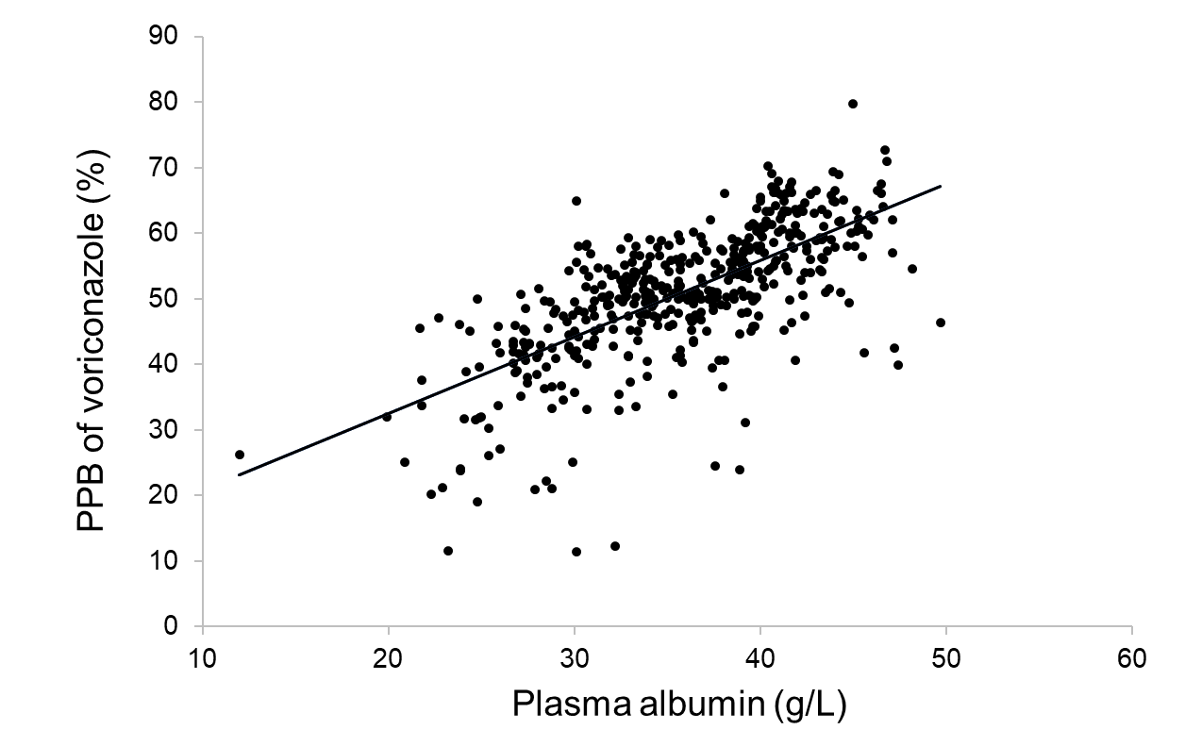
Figure 1. Correlation between the voriconazole plasma protein binding rate (PPB) and plasma albumin concentrations. (R=0.664, P<0.001)

In addition, we divided the included patients into two groups according to hepatic function. There was no significant difference in the voriconazole PPB between patients with normal ALT/AST/TBil levels and those with abnormal ALT/AST/TBil (P>0.05).
Based on these results, an equation describing the relationship between voriconazole PPB and plasma albumin concentration was established by using a general linear model as below:
$PPB (\%)=1.1672×ALB+9.1204$ (1)
Where PPB is the protein plasma binding, ALB is plasma albumin concentration (g/L),
Moreover, the modification of the measured voriconazole concentration was needed for the TDM of voriconazole, which could be adjusted according to equation 2.
$C_{t,adjusted}=\frac{(100-PPB)}{100}×C_{t}×2$ (2)
Where C_{t} is the measured total voriconazole plasma concentration, C_{t,adjusted} is the adjusted voriconazole concentration. The PPB of voriconazole is approximately 50% in most patients [6], and the current therapeutic target of voriconazole is defined as 1-4.5 mg/L [7]. Thus, the range of unbound voriconazole concentration is 0.5-2.25 mg/L. However, patients with different albumin levels should have different unbound voriconazole concentrations even if the measured total concentration is the same. By converting the measured total concentration into the adjusted concentration according to equation 2 which is more suitable when judging whether the adjusted concentration is within the therapeutic target (1-4.5 mg/L) or not. Together with the above-mentioned equations, the data presented in Figure 2 showed the result of a variety of adjusted voriconazole concentrations under different plasma albumin concentrations.
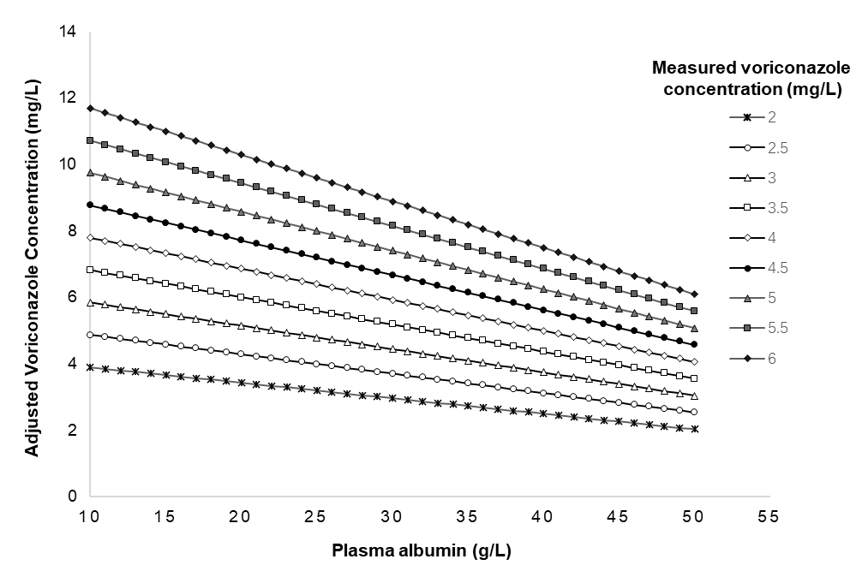
Figure 2. Adjusted voriconazole concentrations based on plasma albumin concentrations.

Discussion
This study investigated the impact of plasma albumin levels on the PPB of voriconazole, which showed that the voriconazole PPB was positively correlated with plasma albumin levels. In patients with hypoproteinemia, the change of plasma protein level has a great influence on the concentration of unbound form if the drug is of high PPB. For drugs not with a high PPB, the increased unbound form caused by the decreased plasma protein has little effect on its clinical efficacy and safety [10,11], because for those drugs with linear pharmacokinetics, the increase in its unbound form is limited, and the increased unbound form could be rapidly eliminated [12]. However, though voriconazole is a drug with a moderate protein binding rate [5], the increase in its unbound form caused by decreased plasma albumin level cannot be fast eliminated because it has nonlinear pharmacokinetics profile. In addition, voriconazole has a narrow therapeutic window, its saturated metabolism profile is hypothesized to result in an increased risk for toxic adverse events in patients with hypoproteinemia. Because even if these patients could access TDM, it potentially misinterpreted the result by directly comparing the measured total concentration of voriconazole with the therapeutic target. Therefore, the impact of fluctuation of plasma albumin level on voriconazole PPB should be considered when interpreting the TDM result of voriconazole, especially in patients with hypoproteinemia.
We constructed a formula to describe the correlation between voriconazole PPB and plasma albumin concentration by a general linear model, through which the adjusted voriconazole concentration under different plasma albumin levels could be attained, which could be directly used to judge whether the C_{t,adjusted} is within the therapeutic target or not. Previous studies have reported the formulas for correcting the measured plasma concentration of two ﻿antiepileptics (phenytoin sodium and valproate sodium) with a high protein binding rate (PPB > 70%) and saturated metabolism [13,14], which is of great significance to accurately evaluate PKPD attainment of drugs.
Though we can get the unbound form of a drug through equilibrium dialysis or other separation technology, then measure the concentration of the unbound form, this process takes a long time. in this study, we recommended using the equation 2 to correct the measured concentration of voriconazole, which can interpret the influence of plasma albumin levels on the PPB of voriconazole.
What’s more, we also investigated the effect of ALT, AST, and TBil on voriconazole PPB, which showed no significant correlation between those and voriconazole PPB. Patients with decompensated cirrhosis often show a decrease in plasma albumin, which further decreases the unbound fraction of voriconazole. In the current study, the proportion of patients with hepatic insufficiency is low, which might be related to the fact that the clinicians chose an alternative drug for patients with hepatic insufficiency as they worried that the voriconazole might aggravate liver function damage. Meanwhile, we investigated the impact of concomitant medication on voriconazole PPB. Drugs with high protein binding rates can excrete other drugs from albumin, resulting in an increase in an unbound fraction [15]. In this study, we did not find a significant impact of concomitant medication of high PPB drugs on voriconazole PPB, it might be because that only 11 of the 470 samples were concomitantly used with aspirin (PPB>99%), sodium valproate (PPB>80%) and warfarin (PPB>98%) in this study.
There are great individual differences in the pharmacokinetics of voriconazole, and factors such as age, weight, liver function, and gastrointestinal status affect the metabolism of voriconazole [16-21]. Voriconazole is prone to suffering adverse reactions such as hepatotoxicity and neurotoxicity as it has a narrow therapeutic window. Therefore, therapeutic drug monitoring is a crucial tool to avoid the adverse effects of voriconazole while ensuring its efficacy, especially for elderly patients who had higher voriconazole concentrations due to relatively insufficient liver function. This study found that it is insufficient to evaluate the efficacy and safety just according to measured voriconazole concentration as voriconazole PPB was significantly affected by plasma albumin levels. Estimating the adjusted voriconazole plasma concentrations based on plasma protein concentrations helps reduce the risk of voriconazole-related adverse reactions.

Acknowledgments
This work was supported by grants from the Wenzhou Science and Technology Project of Public Welfare and Social Development (Medical Health) (Y20190654) and the General Scientific Research Project of Zhejiang Provincial Education Department (Y202045533).

Conflict of Interest Statement
There are no financial relationships with any organizations that might have an interest in the submitted work, and no other relationships or activities that could appear to have influenced the submitted work. All authors have no conflicts of interest to disclose.

Contributors
X.B.Y., and H.N.Z. conceptualized and planned the work that led to the manuscript. Y.X.W., F.M.X., X.S.Z., J.H.Y, L.W.Z., X.B.Y. and H.N.Z. collected and analyzed the data, Y.X.W., F.M.X., and X.B.Y. drafted the manuscript. The final submitted version of manuscript was reviewed and approved by all the authors.

Data availability statement
The data that support the findings of study are available from the corresponding author upon reasonable request.

References
- Ulldemolins M, Roberts JA, Wallis SC, Rello J, Lipman J. Flucloxacillin dosing in critically ill patients with hypoalbuminaemia: special emphasis on unbound pharmacokinetics. J Antimicrob Chemother. 2010, 65:1771–1778.
- Ulldemolins M, Roberts JA, Rello J, Paterson DL, Lipman J. The effects of hypoalbuminaemia on optimizing antibacterial dosing in critically ill patients. Clin Pharmacokinet. 2011, 50:99–110.
- Yamasaki K, Chuang VT, Maruyama T, Otagiri M. Albumin-drug interaction and its clinical implication. Biochim Biophys Acta. 2013, 1830:5435–5443.
- Wong G, Briscoe S, Adnan S, McWhinney B, Ungerer J, Lipman J, Roberts JA. Protein binding of beta-lactam antibiotics in critically ill patients: can we successfully predict unbound concentrations? Antimicrob.Agents Chemother. 2013, 57:6165–6170.
- Vanstraelen K, Wauters J, De Loor H, Vercammen I, Annaert P, Lagrou K, Spriet I. Protein-binding characteristics of voriconazole determined by high-throughput equilibrium dialysis. J Pharm Sci. 2014, 103:2565-2570.
- Theuretzbacher U, Ihle F, Derendorf H. Pharmacokinetic/pharmacodynamic profile of voriconazole. Clin Pharmacokinet. 2006, 45:649-663.
- Ashbee HR, Barnes RA, Johnson EM, Richardson MD, Gorton R, Hope WW. Therapeutic drug monitoring (TDM) of antifungal agents: guidelines from the British Society for Medical Mycology. J Antimicrob Chemother. 2014, 69:1162-1176.
- Vanstraelen K, Wauters J, Vercammen I, De Loor H, Maertens J, Lagrou K, Annaert P, Spriet I. Impact of hypoalbuminemia on voriconazole pharmacokinetics in critically ill adult patients. Antimicrob Agents Chemother. 2014, 58:6782-6789.
- Pauwels S, Vermeersch P, Van Eldere J, Desmet K. Fast and simple LC-MS/MS method for quantifying plasma voriconazole. Clin Chim Acta. 2012, 413:740-743.
- Musteata FM. Calculation of normalized drug concentrations in the presence of altered plasma protein binding. Clin Pharmacokinet. 2012, 51:55-68.
- D'Arcy PF, McElnay JC. Drug interactions involving the displacement of drugs from plasma protein and tissue binding sites. Pharmacol Ther. 1982, 17:211-220.
- Ulldemolins M, Roberts JA, Rello J, Paterson DL, Lipman J. The effects of hypoalbuminaemia on optimizing antibacterial dosing in critically ill patients. Clin Pharmacokinet. 2011, 50:99-110.
- Hermida J, Tutor JC. A theoretical method for normalizing total serum valproic acid concentration in hypoalbuminemic patients. J Pharmacol Sci. 2005, 97:489-493.
- Dager WE, Inciardi JF, Howe TL. Estimating phenytoin concentrations by the Sheiner-Tozer method in adults with pronounced hypoalbuminemia. Ann Pharmacother. 1995, 29:667-670.
- Johnson GJ, Kilpatrick CJ, Bury RW, Fullinfaw RO, Moulds RF. Unbound phenytoin plasma concentrations in patients comedicated with sodium valproate--the predictive value of plasma albumin concentration. Br J Clin Pharmacol. 1989, 27:843-849.
- Han K, Bies R, Johnson H, Capitano B, Venkataramanan R. Population pharmacokinetic evaluation with external validation and Bayesian estimator of voriconazole in liver transplant recipients. Clin Pharmacokine. 2011, 50:201-14.
- Han K, Capitano B, Bies R, A Potoski B, Gilbert S, L Paterson D, McCurry K, Venkatarmanan. Bioavailability and population pharmacokinetics of voriconazole in lung transplant recipients. Antimicrob Agents Chemother. 2010, 54:4424-31.
- Liu P, Mould DR. Population pharmacokinetic analysis of voriconazole and anidulafungin in adult patients with invasive aspergillosis. Antimicrob Agents Chemother. 2014, 58:4718-26.
- Muto C, Shoji S, Tomono Y, Liu P. Population pharmacokinetic analysis of voriconazole from a pharmacokinetic study with immunocompromised Japanese pediatric subjects. Antimicro Agents Chemother. 2015, 59:3216-23.
- Pascual A, Csajka C, Buclin T, Bolay S, Bille J, Calandra T, Marchetti O. Challenging recommended oral and intravenous voriconazole doses for improved efficacy and safety: population pharmacokinetics-based analysis of adult patients with invasive fungal infections. Clin Infect Dis. 2012, 55:381-90.
- Wang T, Chen S, Sun J, Cai J, Cheng X, Dong H, Wang X, Xing J, Dong W, Yao H, Dong Y. Identification of factors influencing the pharmacokinetics of voriconazole and the optimization of dosage regimens based on Monte Carlo simulation in patients with invasive fungal infections. J Antimicrob Chemother. 2014, 69:463-70.

