Model Profile

A mouse model of naturally occurring age-related cognitive impairment

Sara Daneshjoo¹, Juliana Moreno¹, Manuela Rosenfeld¹, Joo Young Park¹, Martin Darvas², Warren Ladiges^{1*}

¹Department of Comparative Medicine, School of Medicine, University of Washington, Seattle, WA
²Department of Laboratory Medicine and Pathology, School of Medicine, University of Washington, Seattle, WA

Abstract

Age-related cognitive impairment (ARCI) is a neurological condition that affects millions of older people, but little is known about increased risk for developing more severe neurodegeneration and dementia. Preclinical research is needed to understand mechanisms of the impairment and the neuropathology associated with it. We have characterized a model of naturally occurring ARCI in the C57BL/6J mouse strain that shows an age-dependent development of cognitive impairment. As in people, some mice have little cognitive impairment while others have more severe cognitive impairment. Therefore, mice can be categorized as resistant or susceptible and the two groups can be studied for behavioral and neuropathology differences. Preliminary observations show no difference in strength and agility test scores between ARCI resistant and susceptible mice of either sex suggesting the cognitive impairment in ARCI susceptible mice is not accompanied by impairment in daily living activities, similar to ARCI in humans. The hippocampal area of the brain from ARCI susceptible mice shows evidence of an increase in the inflammatory cytokine MCP-1 compared to ARCI resistant mice, suggesting inflammation may be associated with ARCI. These preliminary observations suggest that ARCI in C57BL/6J mice could be a high impact model to study how resilience to brain aging may predict resilience to dementia associated with Alzheimer’s disease and other age-related neurological conditions.

Key words. Age-related cognitive impairment, C57BL/6J mouse, Brain aging, Cognitive resilience

*Correspondence. Warren Ladiges, wladiges@uw.edu

Cognitive decline with increasing age is a common aspect of growing old [1]. It is a generic umbrella for all aspects of cognitive dysfunction ranging from memory lapses associated with typical aging to prodromal stages of neurodegenerative diseases such as Alzheimer’s disease (AD). Dementia is the term used for more severe cognitive impairment where patients experience memory loss as well as difficulties in maintaining independence in normal living activities [2]. Mild cognitive impairment is often used to describe a prodromal stage between cognitive impairment related to aging and dementia [3]. Age-related cognitive impairment (ARCI), which falls under the umbrella of cognitive decline, is an extremely common condition that affects millions of older people, but little is known about how these people may be at increased risk for developing more severe neurodegeneration and dementia.

We have characterized a mouse model of naturally occurring ARCI that will provide the opportunity to investigate cellular, molecular and transcriptomic aspects of cognitive impairment without the presence of disease factors such as AD. Mice do not get AD naturally, so the mouse brain is not cluttered with amyloid plaques or tau fibrillary tangles. The purpose of this short note is to describe the model.

C57BL/6 mice are used extensively in aging research. In order to determine if cognitive impairment was age-dependent in this strain, mice were obtained from the NIA Aged Rodent Colony (Charles River) at ages 4, 12, 20, and 28 months. They were acclimated for three weeks and subsequently tested for cognition using the radial water tread maze [4]. Figure 1 clearly shows 28-month-old mice performed poorly, whereas 4-month-old mice showed superior performance and were not cognitively impaired. The 12- and 20-month-old mice were in the middle with 20-month-old mice trending toward more cognitive impairment than 12-month-old mice.

Figure 1. Cognitive impairment in C57BL/6 mice develops in an age-dependent manner as determined by the radial water tread maze.

We next obtained 20-month-old C57BL6 mice, 20 males and 20 females, from the NIA Aged Rodent Colony to assess the variability of ARCI using a spatial navigation learning task [5].
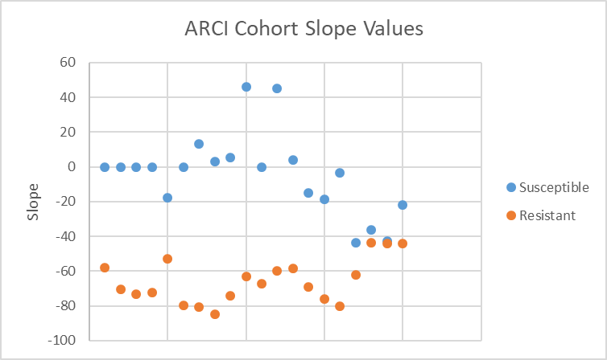
This is a one-day assessment procedure that measures escape times from an isolated box-like bin into an open hole among 7 closed holes. After finding the median slope value across the number of mice in each cohort, a threshold value was set so that mice that escaped more quickly after 4 trials could be distinguished from mice that were slow to escape. This was done by plotting the raw data of each mouse (Figure 2) on a logarithmic scale and determining the R² value and slope using a trendline thus allowing placement into an ARCI susceptible group and an ARCI resistant group. The R² value was used to further separate fast learners.

Figure 2. Regression analysis of escape times by 20-month-old C57BL/6 mice in a spatial navigation learning task. It can be seen that mice at this age can be stratified into a slow escape group and a fast escape group providing the rationale to designate these groups as susceptible and resistant, respectively, to ARCI.

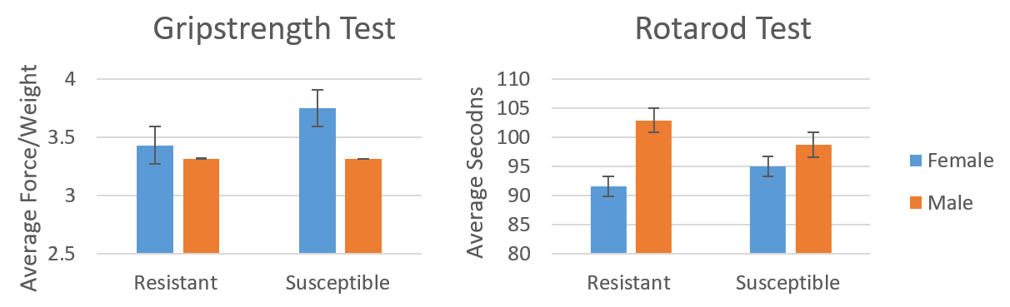
In order to determine if ARCI susceptible mice at this age had any age-related physical challenges, agility and strength tests were performed. As can be seen in Figure 3, there were no differences in performance in strength or agility between the two groups of males or females suggesting ARCI susceptible mice were fully capable of performing basic living tasks requiring mobility for eating, drinking and grooming. Interestingly, susceptible females performed better than susceptible males in the grip strength test but not the rotarod test, while resistant males performed better than resistant females in the rotarod test but not the grip strength test.
Figure 3. Grip strength and rotarod tests showed no significant difference in performance between ARCI resistant and ARCI susceptible mice in either males or females.

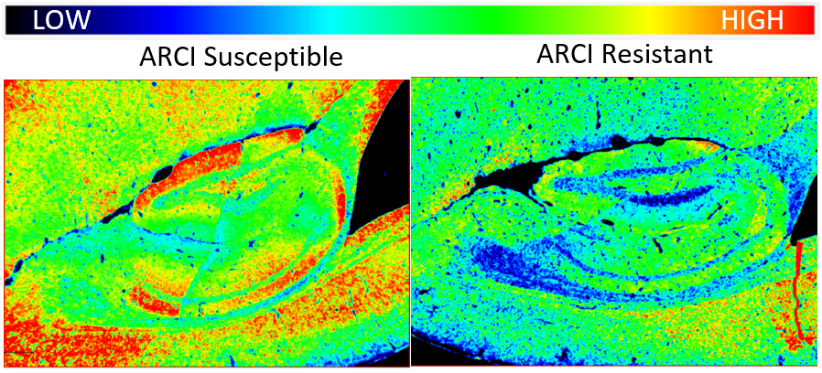
It was then of interest to see if there were any molecular differences in the brains of ARCI resistant and ARCI susceptible mice. MCP-1 is a prototype inflammatory cytokine associated with aging [6]. We used immunohistochemistry and Qu-Path digital imaging [7] to show that staining intensity for MCP-1 was less in the hippocampus of ARCI-resistant mice compared to ARCI susceptible mice (Figure 4) suggesting that inflammation may be associated with cognitive impairment in these mice.

Figure 4. Staining intensities for MCP-1 were determined by immunohistochemistry and Qu-Path digital imaging. The heat map shows more intense staining in the brain of an ARCI susceptible mouse compared to the brain from an ARCI resistant mouse.

In conclusion, we have presented preliminary observations in aging C57BL/6 mice of both sexes that describe a naturally occurring model of ARCI. This is a potentially high impact translational model to study brain aging and how mice resistant to ARCI might be more resistant to developing AD, or other neurodegenerative diseases. There is also the opportunity to explore, in exquisite detail not possible in people, mechanistic aspects involved in determining resistance or susceptibility, thus providing insight into possible therapeutic targets for preventing or slowing the development of ARCI and decreasing the risk of developing more severe neurodegenerative diseases. We already have preliminary evidence that inflammation, a process of aging, may be associated with impairment of cognition in this model, and that mice that are resistant to ARCI have less inflammation based on less MCP-1 expression. Therefore, the C57BL/6 ARCI mouse model would be ideal to study strategies for targeting inflammation in a therapeutic precision manner. ARCI resistant mice could also be used to determine resistance factors to AD by challenge with an AAV vector system linked with Aβ 42 and mutant tau in a model we have previously described [8].

Acknowledgments
Supported by NIH grants R01 AG067193, Ladiges and Darvas (co-PI’s) and R01 AG057381, Ladiges (PI),

References
- Jeste, Savla, G. N., Thompson, W. K., Vahia, I. V., Glorioso, D. K., Martin, A. S., Palmer, B. W., Rock, D., Golshan, S., Kraemer, H. C., & Depp, C. A. (2013). Association Between Older Age and More Successful Aging: Critical Role of Resilience and Depression. The American Journal of Psychiatry, 170(2), 188–196. https://doi.org/10.1176/appi.ajp.2012.12030386
- Kolanowski, Boltz, M., Galik, E., Gitlin, L. N., Kales, H. C., Resnick, B., Van Haitsma, K. S., Knehans, A., Sutterlin, J. E., Sefcik, J. S., Liu, W., Petrovsky, D. V., Massimo, L., Gilmore-Bykovskyi, A., MacAndrew, M., Brewster, G., Nalls, V., Jao, Y.-L., Duffort, N., & Scerpella, D. (2017). Determinants of behavioral and psychological symptoms of dementia: A scoping review of the evidence. Nursing Outlook, 65(5), 515–529.
- Petersen. (2011). Mild Cognitive Impairment. The New England Journal of Medicine, 364(23), 2227–2234. https://doi.org/10.1056/NEJMcp0910237
- Pettan-Brewer C, Touch DV, Wiley JC, Hopkins HC, Rabinovitch PS, Ladiges WC. A novel radial water tread maze tracks age-related cognitive decline in mice. Pathobiol Aging Age Relat Dis. 2013 Oct 4;3.
- Darvas M, Mukherjee K, Lee A, Ladiges W. A Novel One-Day Learning Procedure for Mice. Curr Protoc Mouse Biol. 2020 Mar;10(1):e68. doi: 10.1002/cpmo.68.PMID: 32096920
- Yousefzadeh MJ, Schafer MJ, Noren Hooten N, Atkinson EJ, Evans MK, Baker DJ, Quarles EK, Robbins PD, Ladiges WC, LeBrasseur NK, Niedernhofer LJ. Circulating levels of monocyte chemoattractant protein-1 as a potential measure of biological age in mice and frailty in humans. Aging Cell. 2018 Apr;17(2):e12706. doi: 10.1111/acel.12706. Epub 2017 Dec 31.PMID: 29290100
- Lee A, Jiang Z, Zhu L, Ladiges W. QuPath. A new digital imaging tool for geropathology. Aging Pathobiol Ther. 2020 Jun 29;2(2):114-116. doi: 10.31491/apt.2020.06.024.PMID: 35083445
- Darvas M, Keene D, Ladiges W. A geroscience mouse model for Alzheimer's disease. Pathobiol Aging Age Relat Dis. 2019 May 14;9(1):1616994. doi: 10.1080/20010001.2019.1616994. eCollection 2019.

