Elderly onset male MELAS: A case report and mini-review
Sheng-Peng Diaoª, Song-Fa Chenª, Ai-Qun Liuª, Zhi-Hua Zhouª, Zhong-Xing Pengª, Ming-Fan Hongª
ª Department of Neurology, College of Clinical Medicine, the First Affiliated Hospital, Guangdong Pharmaceutical University, Guangzhou, Guangdong, China.
Address correspondence to Ming-Fan Hong, PhD, Department of Neurology, School of Clinical Medicine, the First Affiliated Hospital of Guangdong Pharmaceutical University, 19 NonglinxiaRoad, 510080, Guangzhou, China. E-mail: hongmingfan9001@163.com. Tel: +86 020 61337324.
Abstract
Background: Mitochondrial encephalomyopathy with lactic acidosis and stroke-like episodes (MELAS) is the most common mitochondrial disease. MELAS in the elderly onset is rarely seen.
Case presentation: We herein describe the case of a 61-year-old male MELAS patient. He had experienced acute migraine-like headaches as the first symptoms. Laboratory data showed elevated lactate and creatine kinase levels. Brain Magnetic Resonance Imaging (MRI) showed a high signal intensity lesion in the left occipital-temporal-parietal lobe on diffusion-weighted imaging (DWI). Magnetic Resonance angiography (MRA) revealed reversible vasoconstriction of the middle cerebral arteries and bilateral superficial temporal arteries. Muscle biopsy suggests minor muscle damage. A genetic study revealed a mitochondrial DNA A3243G point mutation.
Conclusions: MELAS should be considered in elderly stroke-like attack patients with multi-lobe DWI high signal without corresponding responsible cerebrovascular disease. Elderly MELAS patients may show less severe muscle damage.
Keywords: MELAS, Stroke-like Episodes, Magnetic resonance angiography (MRA), Migraine
1. Background
Mitochondrial encephalomyopathy with lactic acidosis and stroke-like episodes (MELAS) is the most common mitochondrial disease. Most of the patients are affected due to matrilineal inheritance, and a few are sporadic [1]. MELAS is typically characterized by stroke-like episodes and hyperelastic acidemia. Still, only about half of the patients show typical clinical manifestations, with significant heterogeneity in genetics and clinical manifestations [2-3], which leads to difficulty in the diagnosis and even misdiagnosis.
Only 1% to 6% of patients develop the disease after 40 years of age [4]. It is even rarely seen in patients after 60 years of age. Only a few cases have been reported, all female cases [5-7]. We herein describe the case of a 61-year-old male, MELAS. His particular clinical and imaging features help us understand the clinical manifestations of MELAS in the elderly and make an accurate diagnosis.
2. Case Presentation
2.1 First attack
A previously healthy 61-year-old male patient presented with sudden onset left-sided migraine-like headache and developed right-sided migraine-like headache two days later. He was admitted to a local hospital for treatment soon. The results of the brain CT scan (no image obtained) showed acute cerebral infarction of the left occipital-parietal lobe, and he was diagnosed with acute ischemic cerebral infarction. He was then treated with aspirin, statins, and other drugs. However, he had weakness in his right limb and could not walk seven days after onset. He subsequently showed emotional irritability and hallucinations eight days after onset.
The patient was admitted to our hospital 11 days after onset. On physical examination, his blood pressure was 112/69mmHg, had lethargy, lag in response, with slow speaking, and had right homonymous hemianopia, with a slight wrinkle on the right frontal, a slight nasolabial groove on the right, and his mouth was skewed to the left with a tongue extending into the middle. The patient was given grade 1 for right upper extremity strength, a grade 3 for right lower extremity strength, and a grade 5 for left extremity strength, with reduced tendon reflex of the limbs. The pathological sign was negative. He scored 10 points according to the United States National Institutes of Health stroke scale (NIHSS) [8].
Clinical chemistry analysis showed 6.6 mmol/L for fasting blood glucose, 6.1% for glycated hemoglobin, 448 U/L for creatine kinase, 42.1 mg/L for high sensitivity C-reactive protein, and 3.3mmol/L for arterial blood lactic acid 12 days after onset. The results of routine hematological tests, homocysteine, blood lipids, four coagulation tests, erythrocyte sedimentation rate, antinuclear antibodies, anti-cardiolipin antibodies, anti-neutrophil antibodies, protein C, and protein S were all within the normal range. Cerebrospinal fluid (CSF) assay results showed a value of 4.13 mmol/L for lactic acid, and no visible abnormal signs were observed by routine biochemistry.
The first Magnetic Resonance Imaging (MRI) examination was performed 12 days after onset (Fig.1 A), diffusion-weighted imaging (DWI) showed a high signal intensity (Fig.1 A-3). Magnetic Resonance angiography (MRA) showed dilation of the left middle cerebral artery, posterior cerebral artery, and bilateral superficial temporal arteries (Fig.2 A). Arterial spin labeling (ASL) showed hyperperfusion in the left occipital-temporal-parietal focal areas (Fig.2 D). Magnetic resonance spectroscopy (MRS) showed a double inverted lactate peak at 1.33ppm (Fig.2 F).
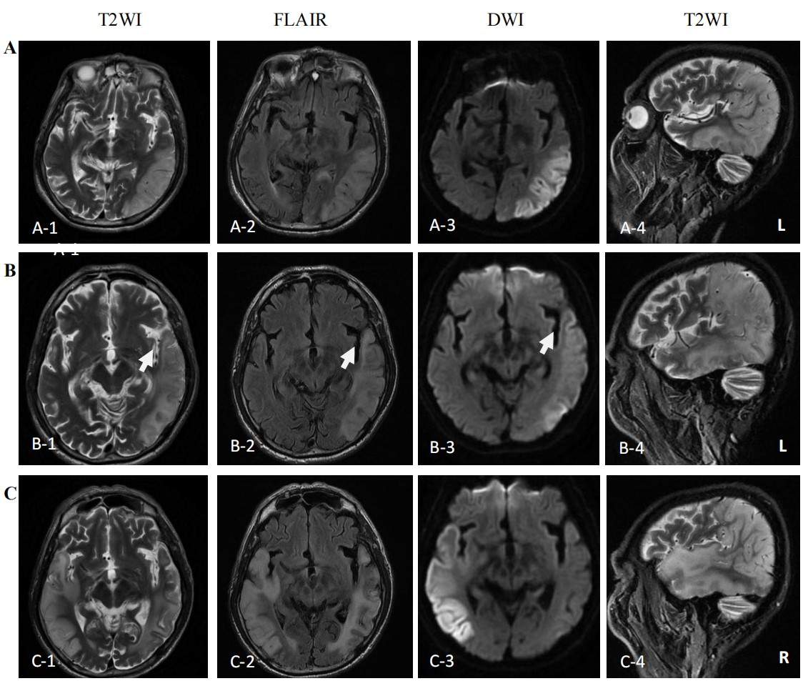
- MRI images performed on the First attack (12 days after onset) showed high signal intensity in occipital-temporal-parietal lobe hyperextension on T2-weighted, FLAIR, and DWI. (B) MRI images performed on the remission (27 days after the first onset) showed that the high signal intensity of DWI, FLAIR and T2WI of the left occipital-temporal-parietal lobe was reduced. Still, the focus of the temporal lobe is enlarged (arrow). (C) MRI images performed on the recurrence (68 days from the first onset) showed new high signal intensity in the right occipital-temporal-parietal lobe hyperextension on T2-weighted, FLAIR, and DWI.
Figure 1. MRI images of the patient.
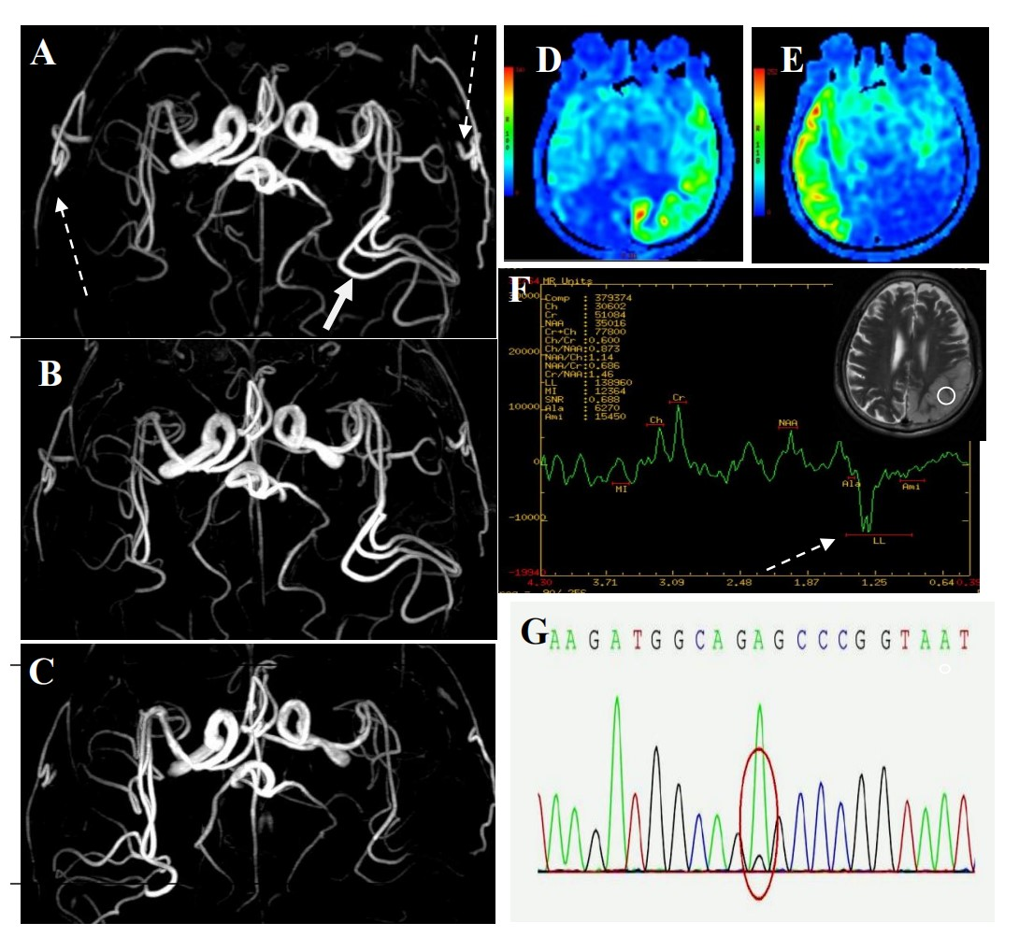
(A, D, F) MRA, ASL, and MRS images of the first onset, 12 days after onset; (B) MRA image of remission period, 27 days after onset; (C, E) MRA and ASL images of recurrence period, 68 days after onset; (G) Gene detection . (A) MRA showed dilation of the left middle cerebral artery (long-tail arrow), with apparent dilation of bilateral superficial temporal arteries (long dotted arrow). (B) MRA showed that the bilateral superficial temporal arteries were retracted. (C) MRA showed that the left middle cerebral artery was appeared normal, and the right middle cerebral artery was dilated. (D) ASL showed hyperperfusion in the left occipital-temporal-parietal focal areas. (E) ASL showed hyperperfusion in the right occipital-temporal-parietal focal regions. (F) MRS showed a double inverted lactate peak at 1.33ppm (short dotted arrow). (G) Genotypic detection analysis showed mitochondrial mutation (m.3243A >G).
Figure 2. MRI images of the patient.
Electroencephalogram (EEG) monitoring showed several high amplitudes and sharp slow wave activities in the left and right hemispheres, alternating during waking and sleeping. Muscle biopsy of this patient (Fig.3): Modified gomori trichrome（MGT） staining was negative, succinate dehydrogenase（SDH）/ c oxidase（COX） double staining showed a blue fiber, no positive result of blood vessel wall strength, no obvious abnormality of muscle fiber under the electron microscope [9]. Next, 3ml of peripheral venous blood of the patients was drawn for genotypic detection analysis, and the results suggested mitochondrial 3243A＞G mutation (Fig.2 G), which was a pathogenic mutation².
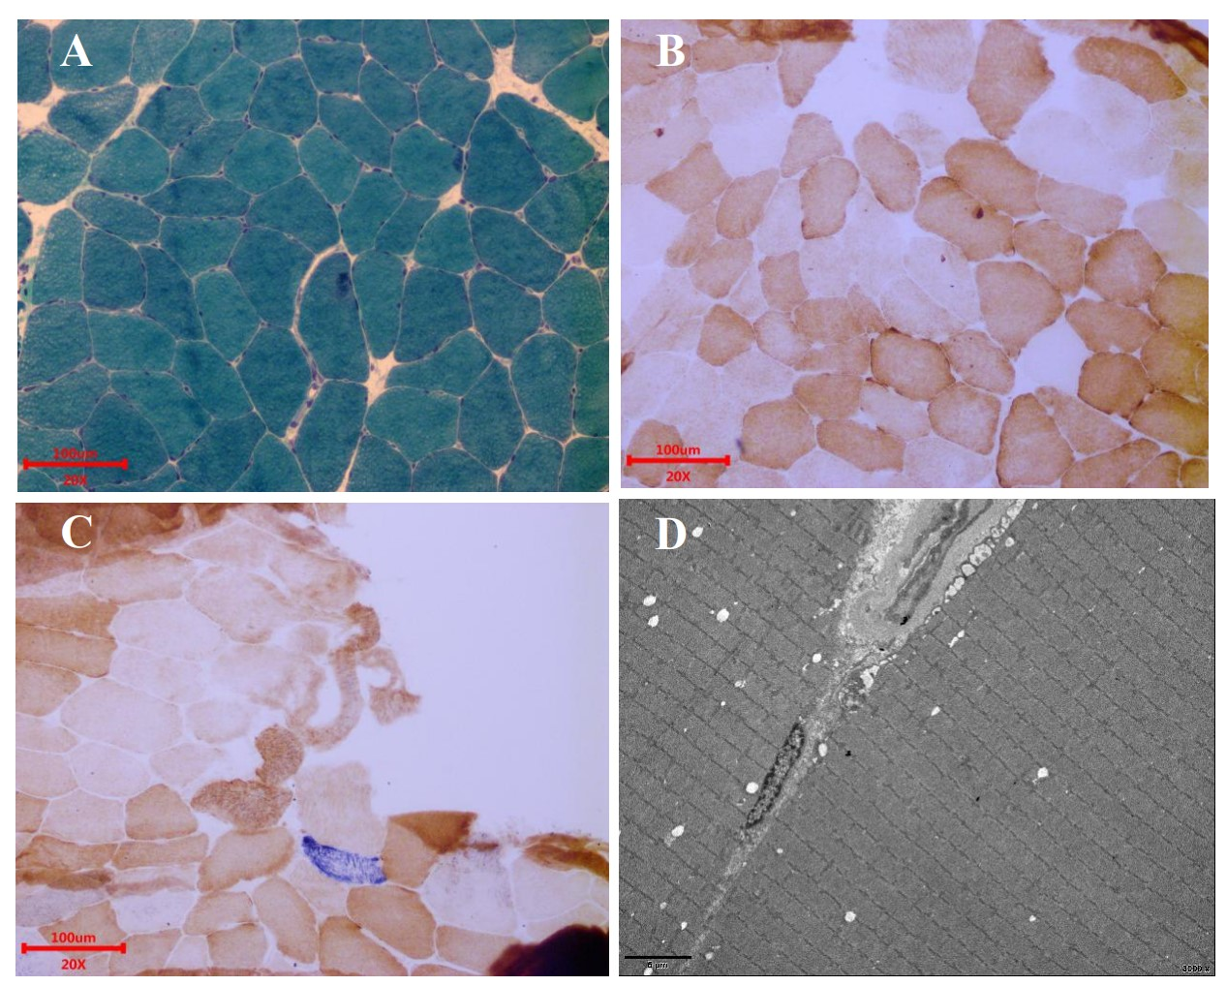
(A) MGT staining showed no broken red fiber; (B) COX staining showed no significant decrease in myofibrillase activity; (C) SDH / COX double staining: see 1 blue fiber; (D) Under the electron microscope, the basic arrangement of myofibrils was regular, the sarcolemma was shrunk, and no special ultrastructural and pathological changes were found. Scale bars: 100μm (A),(B)and(C); 5μm(D).
Figure 3. Muscle biopsy.
2.2 Remission
The patient was diagnosed with MELAS by gene testing. After an initial treatment (Adenosine triphosphate disodium 60mg/day, coenzyme Q10 30mg/day, and L-arginine 20mg/day), the patient's condition showed significant improvement and he could live independently. The second MRI examination was performed 27 days after the first onset; DWI showed the high signal intensity of the left occipital-temporal-parietal lobe was reduced (Fig.1 B); The MRA showed the bilateral superficial temporal arteries were retracted (Fig.2 B).
2.3 Recurrence
However, the patient relapsed 68 days from the first onset. The patient’s left limb demonstrated twitch, his limbs were weak, and he was soon unable to walk. The third MRI examination was performed 68 days from the first onset. DWI showed a high signal intensity (Fig.1 C), and ASL showed hyperperfusion in the right occipital-temporal-parietal focus areas (Fig.2 E). MRA showed that the left middle cerebral artery appeared normal, and the right middle cerebral artery was dilated (Fig.2 C). After treatment with lamotrigine(50mg/day), coenzyme Q10(30mg/day), and L-arginine(20mg/day), his limb convulsion did not recur; limb muscle strength weakness was improved, but he developed dementia, and his life needs family care.
3. Discussion and Conclusions
MELAS is the most common clinical form of mitochondrial encephalomyopathy, with stroke-like episodes and hyperelastic acidemia as the primary clinical features, first reported by Pavlakis et al. in 1984 [10]. MELAS is common in adolescents and rarely seen in the elderly. Some scholars believe that MELAS with onset in over 50-year-old patients is seldom seen and has atypical clinical manifestations [11], making it difficult to be diagnosed. We have inadequate knowledge of this disease in the elderly. Only a few cases of older women were reported [5-7]. No cases of MELAS male patients over 60 years old have been reported. We herein describe the case of a 61-year-old male, MELAS.
This older man had experienced acute migraine-like headaches as the first symptoms. The CT scan of the local hospital showed low-density lesions of the left occipital-parietal lobe. This patient is easily misdiagnosed as ischemic cerebrovascular disease. Brain MRI showed a hyperintense lesion in the left occipital-temporal-parietal lobe on diffusion-weighted imaging (DWI) in our hospital. However, MRA did not suggest stenosis or occlusion of the corresponding cerebral responsible vessels. At this time, we need to suspect the diagnosis of ischemic cerebral infarction, and other diseases such as MELAS need to be considered. Then, laboratory data showed elevated lactate and creatine kinase levels. A genetic study revealed a mitochondrial DNA A3243G point mutation. The patient got the clinically diagnostic criteria and was confirmed MELAS [12].
This case has some essential and specific MRA imaging features. MRA revealed reversible vasoconstriction of the middle cerebral arteries and bilateral superficial temporal arteries. In patients presenting with the acute stage of MELAS, the accumulation of lactate in the lesion results in local arterial dilatation. With disease progression, some blood vessels suffer from chronic damage of the vessel wall, episodic spasm, and hyperplasia of the intima. The angiogram showed the normalization progression and blood vasculature reduction [13]. The focus area's cerebral blood vessels were dilated during the first attack and recurrence stages and retracted at remission. There was no such vascular change during acute ischemic stroke. MRA can detect cerebrovascular imaging characteristics of MELAS and help diagnose and evaluate the MELAS.
The patient had experienced acute migraine-like headaches as the first symptoms. MRA indicated apparent dilation of bilateral superficial temporal arteries in the acute phase. After treatment, the headache has been gradually disappeared. Subsequent MRA showed that the bilateral superficial temporal arteries were slowly retracted and appeared normal. According to the theory of the vascular origin of migraine [14], it is thought that the superficial temporal artery could dilate in the acute stage of migraine and that the flow of blood could increase, progressing to a migraine attack [15]. In recent years, mitochondrial dysfunction has proven to play an essential role in the pathogenesis of migraine [16]. The patient was revealed a mitochondrial DNA A3243G point mutation. The findings of this case support mitochondrial dysfunction as the pathogenesis of migraine.
Myopathic symptoms are also the manifestations of MELAS, mainly including myasthenia, myalgia, exercise intolerance [17]. The patient underwent a muscle biopsy. MGT staining was negative; SDH / COX double staining showed a blue fiber. There was no positive result of blood vessel wall strength, no obvious abnormality of muscle fiber under the electron microscope. Muscle biopsy suggests minor muscle damage. It is easy to result in missed diagnosis and delayed treatment. But there was a limited correlation between muscle biopsies and MELAS diagnosis [18]. If the muscle biopsy is normal, this does not rule out the mitochondrial disease [19]. Gene detection plays a vital role in diagnosing MELAS when muscle biopsy fails to diagnose it, and it is the gold standard for diagnosing MELAS [20].
In conclusion, this paper is the first report on elderly male MELAS patients. Elderly MELAS patients may show less severe muscle damage. The close relationship between superficial temporal artery dilation and migraine-like attacks supports mitochondrial dysfunction caused by mitochondrial gene mutations as one of the pathogenesis of migraine attacks.

Declarations:
Ethics approval and consent to participate
This study was approved by the Ethics Committee of the First Affiliated Hospital, Guangdong Pharmaceutical University. This enrolled patient provided written, informed consent to be included in the study. All methods were performed in accordance with the relevant guidelines and regulations.
Consent for publication
The authors have obtained the patient’s written informed consent for print and electronic publication of this case report.
Availability of Data and Materials
The datasets generated and/or analysed during the current study are not publicly available due to privacy or ethical restrictions. But are available from the corresponding author on reasonable request.
Competing interests
The authors declare that they have no competing interests.
Funding
Not applicable.
Author’s contributions
MF H and ZX P contributed to the conception of the study. ZH Z, AQ L and SF C contributed significantly to analysis and manuscript preparation. SP D performed the data analyses and wrote the manuscript.
Acknowledgements
We would like to acknowledge the subject who participated in this study.

References
1. Chinnery PF, Turnbull DM. Epidemiology and treatment of mitochondrial disorders. Am J Med
Genet. 2001 Spring;106(1):94-101.
2. Kaufmann P, Engelstad K, Wei Y, et al. Protean phenotypic features of the A3243G mitochondrial DNA mutation. Arch Neurol. 2009 Jan;66(1):85-91.
3. Mancuso M, Orsucci D, Angelini C, et al. The m.3243A>G mitochondrial DNA mutation and
related phenotypes. A matter of gender? J Neurol. 2014 Mar;261(3):504-10.
4. El-Hattab AW, Adesina AM, Jones J, et al. MELAS syndrome: Clinical manifestations,
pathogenesis, and treatment options. Mol Genet Metab. 2015 Sep-Oct;116(1-2):4-12.
5. Sinnecker T, Andelova M, Mayr M, et al. Diagnosis of adult-onset MELAS syndrome in a
63-year-old patient with suspected recurrent strokes - a case report. BMC Neurol. 2019 May
8;19(1):91.
6. Aurangzeb S, Vale T, Tofaris G, et al. Mitochondrial encephalomyopathy with lactic acidosis and stroke-like episodes (MELAS) in the older adult. Pract Neurol. 2014 Dec;14(6):432-6.
7. Mukai M, Nagata E, Mizuma A, et al. Adult-onset Mitochondrial Myopathy, Encephalopathy, Lactic Acidosis, and Stroke (MELAS)-like Encephalopathy Diagnosed Based on the Complete Sequencing of Mitochondrial DNA Extracted from Biopsied Muscle without any Myopathic Changes. Intern Med. 2017;56(1):95-99.
8. Kwah LK, Diong J. National Institutes of Health Stroke Scale (NIHSS)[J]. Journal of Physiotherapy. 2014; 60:61.
9. Van Adel BA, Tarnopolsky MA. Metabolic Myopathies: Update 2009[J]. Journal of Clinical Neuromuscular Disease. 2009; 10:97-121.
10. Pavlakis SG, Phillips PC, DiMauro S, et al. Mitochondrial myopathy, encephalopathy, lactic acidosis, and strokelike episodes: a distinctive clinical syndrome. Ann Neurol. 1984 Oct;16(4): 481-8.
11. Hirano M, Pavlakis SG. Mitochondrial myopathy, encephalopathy, lactic acidosis, and stroke-like episodes (MELAS): current concepts. J Child Neurol. 1994 Jan;9(1):4-13.
12. Iizuka T, Sakai F, Suzuki N, et al. Neuronal hyperexcitability in stroke-like episodes of
MELAS syndrome. Neurology. 2002 Sep 24;59(6):816-24.
13. Ikawa M, Yoneda M, Muramatsu T, et al. Detection of preclinically latent hyperperfusion due to stroke-like episodes by arterial spin-labeling perfusion MRI in MELAS patients. Mitochondrion. 2013 Nov;13(6):676-80.
14. Ho TW, Edvinsson L, Goadsby PJ. CGRP and its receptors provide new insights into migraine pathophysiology. Nat. Rev. Neurol. 2010; 6: 573-582
15. Cutrer FM. Pathophysiology of migraine. Seminars in neurology. 2010; 30:120-130.
16. Dong X, Guan X, Chen K, et al. Abnormal mitochondrial dynamics and impaired mitochondrial biogenesis in trigeminal ganglion neurons in a rat model of migraine. Neuroscience letters. 2017; 636:127-133.
17. Adel BV, Tarnopolsky MA. Metabolic Myopathies: Update 2009[J]. Journal of Clinical Neuromuscular Disease, 2009,10(3):97-121.
18. Baek MS, Kim SH, Lee YM. The Usefulness of Muscle Biopsy in Initial Diagnostic
Evaluation of Mitochondrial Encephalomyopathy, Lactic Acidosis, and Stroke-Like
Episodes. Yonsei Med J. 2019 Jan;60(1):98-105.
19. Lorenzoni PJ, Werneck LC, Kay CS, et al. When should MELAS (Mitochondrial myopathy,
Encephalopathy, Lactic Acidosis, and Stroke-like episodes) be the diagnosis? Arq
Neuropsiquiatr. 2015 Nov;73(11):959-67.
20. Finsterer J. Genetic Data Are a Prerequisite for Interpreting Clinical and Muscle Biopsy
Findings in MELAS. Yonsei Med J. 2019 Apr;60(4):399-400.

