Molecular mechanisms underpinning neuroprotective effects of nutritional polyphenols
Johnson O. Oladele¹, Isaac O. Babatunde², Oluwaseun T. Oladele²
¹Department of Chemical Sciences, Faculty of Science, Kings University, Ode-Omu, Osun State, Nigeria.
²Phytomedicine and Toxicology Laboratories, Department of Biochemistry, Faculty of Basic and Applied Sciences, Osun State University, Osogbo, Nigeria.

*Correspondence to Author:
Johnson O. Oladele, MDS, MSOT, FCS, FIMS
Phytomedicine and Toxicology Unit, Chemical Sciences Department, Faculty of Science, Kings University, Odeomu, Osun State, Nigeria.
Email: Oladelejohn2007@gmail.com

Abstract
Polyphenols are one of the most notable phytochemicals present abundantly in fruit, vegetables, and other nutritional sources. A number of therapeutic significances have been attributed to this phytochemical which include antioxidant, anti-inflammatory, antiapoptotic, modulatory effects and so on. This therapeutic importance has also been reported in polyphenols neuroprotective actions such as enhancement of memory, learning, and cognitive performances, neuronal detoxification and repairment, downstream modulation of signaling pathways of neuronal oxidative stress, neuro-inflammation and necrosis which are all implicated in neurodegenerative diseases as well as transcription, translation, amyloid congestion, neuronal disruption pathways within the nerve cells. This article presents the molecular mechanisms underpinning neuroprotective action of polyphenols via Nrf-2, neurotropic pathways, NF-kB/MAPK, c-JUN, c-FOS, p53 pathway, anti-apoptotic, and anti-neuro-inflammatory signaling pathways. Considering the deteriorating effects of apoptosis, protein misfolding, neuroinflammation, and oxidative stress in the pathogenesis of neurodegenerative diseases, modification of these key neurodegenerative pathological mediators at the molecular level may offer promising treatment approaches to slow down neurodegeneration and mitigate associated symptoms. Polyphenols pose to be promising therapeutic candidate to halt/mitigate/slow down the pathogenesis of these neuronal degenerative diseases via signaling pathways discussed in this article.

Keywords: Polyphenols; Phytochemicals; Neurodegenerative diseases; Parkinson disease, Alzheimer’s disease; oxidative stress; neuro-inflammation.
1.0 Introduction
The role of phytochemicals in maintenance of structural components integrity of nerve cell and tissues, neuronal homeostasis and disease prevention presently cannot be undervalued. Most notable among the phytochemicals are polyphenols, which are larger polymeric hydroxyl containing substances which acts as secondary metabolites. Plant sources like fruit and vegetables are richly in polyphenols. They are majorly classified as flavonoid and non-flavonoids-based polyphenols which selective cross through the blood brain barrier to exact their therapeutic roles in neuronal detoxification and repairment in order to enhance memory, learning, and cognitive performances [1,2].
Polyphenols have many therapeutic roles in combating many cellular and neuronal oxidative damages and inflammation which are all stack development of neurodegenerative diseases. Review on these groups of compound shows that they possessed antioxidant via free radicals scavenging and metal chelating potentials. Dietary polyphenols are either natural bioactive or considered to be xenobiotics within but upon biotransformation by gut microbiota they tend to be made biologically therapeutically and pharmacological active [1-3].
Polyphenols currently are of major discussion among the populace of researchers due to their identify neuroprotective therapeutic role in prevention of neurological and cognitive decline disorders, age- related cognitive malignancies [1,4]. Molecular mechanism of neuroprotective action of polyphenols in neuronal damage and disorders occurs via downstream modulation of signaling pathways of oxidative stress, inflammation and necrosis which are all implicated in neurodegenerative diseases as well as transcription, translation, amyloid congestion, neuronal disruption pathways within the nerve cells [1-2,4-5].
Inhibition of expression pro-oxidant biological catalyst and some molecules associated with and susceptible to oxidative attack such as nuclear factor -kB, direct ROS scavenging, down regulation of Bcl-2 and other molecules associated with apoptotic pathways are all involved in the molecular mechanism associated with polyphenols. Modulation of MAPK (Mitogen-activated protein kinase) activity, dissociation of nuclear factor erythroid 2–related factor 2 (Nrf2) associated complexes and other signaling pathway involved in developmental protective mechanism against neuronal damages processes [6,7].
Neuronal damages, amyloid congestion, and impairment of nerves cell are major causes of developmental neuronal losses of functions and structure which leads to degenerative diseases such Parkinson disease, Alzheimer’s, Huntington and other degenerative diseases. The prevalence of these diseases has been increasingly yearly, presently over 50 million people worldwide are suffering from these pathological conditions and statistical prediction shown that numerical values might increase to 115 million by 2025 [8].
Although the used of polyphenols in neurodegenerative research are limited by it reduced bioavailability due to its ability to pass through the blood brain barriers but the advent of nanotechnology in drug delivery and structural modification strategy have help in delivering the polyphenols containing compound in the brain. Exploiting the role of these phyto-polyphenols is paramount in prevention and treatment of these neurodegenerative diseases. Therefore, in exploiting their therapeutic and pharmacological functions, the molecular mechanism underpinning their neuroprotective mechanisms must be understood clearly for it effective used and in their drug design. Hence in this paper, the discussion on the polyphenol’s neuroprotective mechanism down to the molecular level will be done explicitly.
2.0 Neurodegenerative diseases
Continuing loss of neuronal structure and functions collectively are clinically referred to as neuronal degenerative diseases [4,9]. These progressive degenerative disorders are still incurable, they effectually result in complete loss of nerve cell’s biological functions and death at final stage. These diseases affect the brain at both molecular, cellular and systemic levels. Apoptosis, neuro-inflammation and oxidative destruction of nerve cells are majorly known contributory factors which have implicated in the development and progression of the degenerative diseases [9, 10].
Alzheimer, Multiple atrophy and sclerosis, Parkinson, Huntington and Amyotrophic lateral sclerosis diseases are all most notable known neurodegenerative disorders. These pathological conditions result in formation of protein assembly, misfolding and aggregation which eventually leads to total cell death [9,11]. Research in this field is growing but still need more focus as longevity is ultimate desire of everyone.
2.1 Parkinson disease
Parkinson disease is the most popular degenerative diseases after Alzheimer’s disease. This disease was early called shaking palsy disease. Parkinson disease is a slow onset degenerative condition which affect nerves cell at the substantial nigra compacta of the mid brain region. Continuous loss of function and death of the dopaminergic neurons at this region of the brain occurred in Parkinson [4,12]. Bradykinesia, instability of posture, involuntary slow motor of hands (tremor), and rigidity of body parts are major cardinal motor symptoms of Parkinson while language speaking and memory defaults, inability to recall and recapture, slow speed in thinking and action are part of neurological psychology symptoms [4,12,13].
Oxidative destruction of neuronal cells and its components, mitochondria cellular malfunctioning, neuronal inflammation, default in protein clearance which result in Lewis bodies build up (due continuous accumulation of misfolded alpha synucleins proteins) within and outside the brain interacting with other cellular and extracellular components are all involved in the pathogenesis of the Parkinson disease [4,12]. Although its etiology is multifactorial, genetic or environmental, exposure to agrochemicals and heavy metals, caffeine and cigarettes smoking are all environmental factors that have been implicated in the development of the disease while changes in nucleotides of DNA coding for alpha synucleins, Tau proteins and many others which have been identified encompassed the genetic factors (figure 1). These genes are collectively called PARK genes [4,14,15].
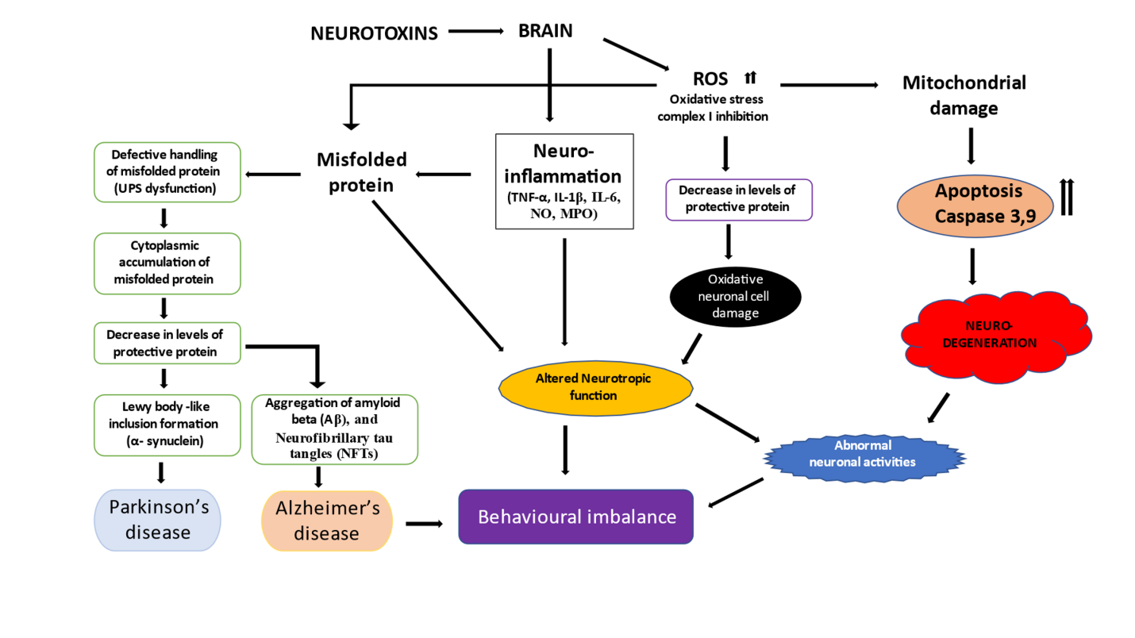
Figure 1: Molecular mechanisms underlying pathogenesis of Parkinson’s disease and Alzheimer’s disease [9]
The prevalence of this degenerative disease is about less than 1% in age range of 65-69years and 4% in those at 80 years and above [4,16]. The prevalence has been suggested to raise statistically to more than 30% by year 2030 [17]. This shown a need to arrest this slows killing deadly disorder.
Several molecular mechanisms have been reported to implicate in the disease pathogenesis [4,9]. Building of misfolded alpha synucleins proteins is part of these molecular mechanisms [9]. In native form, alpha synucleins exhibit alpha helical structure or unfolded form but in diseased state (Parkinson) it exhibits beta sheet helical amyloid structure due to conformation changes through the processes of ubiquitination, phosphorylation of its serine 129 or terminal carbon distortion [18,19]. Accumulation of these over a long time combined with reduce efficiency or default in protein clearance system of the cell bring about formation of insoluble oligomeric protein call Lewis bodies which is the cause of loss and death of dopaminergic neurons [20].
These oligomeric proteins block and suppressed the activities of mitochondria complex 1 activity, reduction in activities of the complex results mitochondria dysfunction which eventually exposure the brain and nerve cells to oxidative attack and depletion in ATP generation. In addition to this, exposure of cell to neurotoxins like pesticide and heavy metals combined with depletion in antioxidant capacity of cell due to oxidative attack results in imbalance in free radicals/reactive oxygen species generation and antioxidants levels [21,22].
Presently there is no true cure for Parkinson disease, the disorder is being managed based on symptoms presented by the patients. Levodopa is still the current precious method of treatment of Parkinson disease and has been used over decades [4,23]. Aside this, there are other method used currently in addition to or following the used of Levodopa, some these Include Monoamine oxygenase-B inhibitor, dopamine antagonist, and dopa decarboxylase inhibitor [24]. The advent and choice of use of these other drugs preference to, after and in combination with levodopa is due to its clinical complications like dyskinesias, nauseas, vomiting, and low blood pressure [23]. Fluctuations in its effectiveness due to on-off effect of the drug and low bioavailability due to blood brain barrier and many more are notable factors that limited it usage. Others drug used in combination still shown side effects like hallucination and insomnia to mention but few. Stem cell transplants, surgery, and gene therapy are alternative means but these are very expensive [25].
Alzheimer’s disease
Alzheimer’s disease is another neurodegenerative disease that people mistakenly seem confused to be aging symptomatically, due to some similar features and process shared with aging and about 20% are diagnosis wrongly [26]. Loss of functional neurons and nerves synapses within brain cerebral cortex and extending to some part of the subcortical are major characteristic features of this disease [27]. Alzheimer’s disease is most common and rampant degenerative diseases in term of number of sufferers in the world. The disease was named after the science which first gives public description about this clinical condition back then in 1906 [28]. The disease is basically referred to as memory loss disorder. The disease is also slow onset and continue worsen progressively over years. Infact, this disease accounted for over 60% of medical cases reported and linked to dementia worldwide [29]. The disease primary affects the part of the brain that function to memory which is known as hippocampus and defect or altered the physio-anatomical function of this region resulting to loss memory attributed to brain impairment.
Although memory loss is the most paramount and most identifiable symptoms in Alzheimer’s, but language problem, apraxia, difficulties in perception, writing, dressing and other fine motor activities as well as movement coordination are clinically identified early-stage symptoms [30]. Detrimental damages long time memory which is affected in early stage, difficulties in patient speech most notable paraphasia, failure to recognize relatives, untailored aggressiveness, loss of courtesy in urination and other neuropsychiatric- behavioral alteration have been identified diagnostically as middle stage symptoms while at severe stage, complete reliance of care giver and absolute loss of speech exist [31].
The prevalence of Alzheimer’s disease is about 6% in adults of age 65 and above [4,32], this is disease affect woman more in terms of number and over 50 million of people were affected globally. The pathogenesis of this disease has been attributed protein misfolding due to larger gathering together in place of folded amyloid beta proteins in neurons and brain tissues. In homeostatic state, the amyloid beta proteins are sub part of transmembrane protein called amyloid beta precursor which function upon transport via neuron’s membrane is to promote growth and repair of nerve cell, but when largely gather thus ravel them to folded randomly so as to associate together leading to abnormal folding within the cell as neurofibrillary tangles and outside the cell as amyloid plaques and Tau proteins [33].
These plaques are insoluble deposit which it named proteopathy. Also, the Tau proteins aids transport of nutrients and other vital nutrients are further subjected to phosphorylation leading to formation of paired thread like structure called neurofibrillary tangles [34]. All these results in neuronal toxicity, then coupled with oxidative stress, decreased protein clearances of the system and neuro-inflammation response in eliminating these plagues results in neuronal functions loss and death, disruption of calcium homeostasis, induction of apoptosis, mitochondria malfunctioning and energy depletion [35].
The etiology of this disease is also multifactorial like Parkinson disease, as this is linked to genetic and environmental factors. In term of genetic, Alzheimer’s disease can inherit when any of these autosomal dominant gene’s APP, PSEN1/2 which codes for amyloid precursor proteins and presenilins are inherited [36] or when there is mutation of gene APOE£4 which codes for apolipoproteins E [37]. Environmental factors include exposure to traffic exhaust and burning, excessive consumption of alcohol, poor sleeping lifestyle, high cholesterol intake were channels of being prone to development of Alzheimer’s disease.
Like Parkinson disease, the Alzheimer’s disease is being managed based on symptoms presented by the sufferers. There is no true cure for Alzheimer’s diseases; medicinal intervention made so far on it was on way of reducing the onset and the disease progression. The used of drug that could enhance memory and cognitive function such as tacrine (an acetylcholinesterase inhibitor) and Memantine which function as the N-Methyl-D-aspartate receptor antagonist [38], as well as other drug which could lower depression, inflammation, hypertension and cholesterol level are usually employed depending on the pronounce symptom in individuals [39,40]. Also, physical exercise, educational engagement, abstinent from smoking, adequate sleep and living less stressful are life style changes that could help in management this disease condition.
Huntington diseases
The disease pathogenesis has been linked to inclusion bodies neuronal toxicity which present itself similar to amyloid plaque protein deposit which exist in other neurodegenerative diseases. The inclusion bodies exist due to cellular cleavage of polyglutamine chains into smaller fragments, which misfolded and build up to form beta strand amyloid deposit with the help of hydrogen bonds interaction between the amino acids of the short polypeptide chains [41].
The inclusion bodies are not useful to the cell and present neuronal toxicity. They further interact and impaired activities of other proteins like chaperone and caspases, thereby exacerbating the neuronal toxicity level. Mitochondria malfunctioning present after due interaction with the nerve cell membrane metabolic processes. This has led to oxidative stress, ROS release and energy depletion which finally caused cell death [42].
Like other types of neurodegenerative diseases, there is no true cure for Huntington disease. Medications available so far for treatment are all for the symptoms associated with these diseases in order to improve the healthy living in such patient. Psychotic combating drug like benzodiazepines is used to treating Huntington related psychology symptoms, tetrabenazine is used for treatment of chorea related symptoms while the used of eicosapentanoic acid for improvement in the motor and cognitive problems [43,44]. Physical and speech therapies are also part of the multidisciplinary care giving in the disease management.
Other kinds of neurodegenerative diseases
Other neuronal function degenerative disorders include multiple sclerosis, a disease that its pathogenesis has been attributed to inflammation response due to autoimmune attack leading to migration on nerve cell signaling molecules such as myelin proteins and glycoprotein, proteolipids and other antigen related responses, moving to the blood brain barrier of the myelin layer of the neuronal cell [45]. Other forms of neuronal function degenerative disorders like Amyotrophic lateral sclerosis, progressive nuclear palsy, ataxia and others diseases have their pathogenic mechanisms from either amyloid protein formation or fibrillary aggregates in case of synucleino-or TDP-43 proteino- pathy or prion proteins build up or shared any of its combination [46].
Chemistry and biological significance of polyphenols
The relevance of polyphenols in biomedical research cannot be underestimated due to their ability to combat diseases whose origin of molecular pathology can be traced to oxidative stress and free radicals’ attacks, inflammation, protein misfolding and amyloid aggregation, unregulated growth and mitochondria malfunctioning, these include diseases like cancer, cardiovascular and neurodegenerative diseases to mention but few [1,47,48].
In term of structural overview, Polyphenols belongs to compound having more than one phenol moiety in their structure, many thousands of them have been analytical identified and classified. Some of these compounds are edible while the rest are not.
Polyphenols exist abundantly and largely derived from plant and this is the major reason they were classified as phytochemicals. They exist naturally as the nutritional component of plants like fruits, vegetables, cereal and red wine etc [1,49]. Polyphenols have minimum of fifteen carbon skeletons in its structure which are surrounded by hydroxyl moieties, the phenol moiety are linked together by ester or through carbon-to-carbon bonds. This ester connection is hydrolysable tannins whereas the carbon-to-carbon connection is non hydrolysable but condensed tannins like linked.
Because of their structural diversification and wide distribution in natural products, polyphenols are classified in different ways based on the chemical structure, biological roles and sources. Of all the chemical structural classification, the most common and widely used are discussed in this article.
Polyphenols can be grouped two categories, flavonoids and non-flavonoids polyphenols. The non-flavonoid polyphenols include the simple and free phenol such as gallic acid which are benzoic acid derivatives having C1 to C6 backbone and coumaric acids which are cinnamic derivatives having C3 to C6 backbone. Others non flavonoids polyphenols include hydrolysable tannins, lignans, phenylacetic acids etc [50].
The flavonoids polyphenols group are the most abundant categories and most commonly studied due to the antioxidant and counter inflammatory potentials. In term of structural skeleton, they have two benzyl moeities tagged ring A & B linked together by three carbon C3 skeleton tagged ring C in their structure. These comprises of the following:
- Those having their ring B attached to Carbon-3 position of ring C in open or closed ring form as found in isoflavones (genistein), neoflavonoids (dalbergin), and chalcones [51].
- Those having their three carbon skeletons forming a ring chain with ring A and the last carbon of the three carbon skeletons attached to the ring C as found inflavanones (furanoflavanones), flavones (nobiletin), flavonols (quercetin) and flavanonols (taxifolin) [52].
- Flavanols and proanthocyanidins which are structurally similar to the group of flavonols except that there is no double bond between the carbon 2 & 3 of the ring C. Flavanols includes catechin and epicatechin while proanthocyanidins includes tannins.
- Polyphenolic amides are polyphenols having N-containing functional substituent. This includes capsaicinoids in chili peppers.
Other polyphenols include resveratrol, curcumin, rosmarinic acid and other which are complex polyphenols but have been reported to have crucial antioxidative, anti-inflammatory and neuroprotective roles [1,51].
The physiological roles of polyphenols to healthy living are diverse ranging from chemopreventive, treatment and management of diseases like cancer, diabetes, cardiovascular diseases and degenerative diseases [1,53]. They play their health beneficial roles either directly or indirectly by modulation the signal pathways and its components which have been implicated to play role in disease development. Research on physiology of polyphenols is increasing nowadays because of its multifunctional therapeutic and pharmacological importance. In promoting healthy brain, polyphenols have been reported to help scavenging reactive chemical species generated in the brain due to metabolic processes or due to exposure to xenobiotics, thus exhibiting antioxidant role which help in lowering the risk of developing neurodegenerative disorder [1,54].
Polyphenol such as curcumin of turmeric, flavonoids and carotenoids has reported to be useful cytoprotective and chemoprotective agent which promote in tissue generation and repair of the lining of the digestive tracts as well as suppressing of inflammation. In preventing stress on cardiovascular vessel, polyphenols have been reported to help inhibiting the oxidation of low-density lipoprotein cholesterol in the blood and blood vessels and also promote blood conveying process by increasing the vasodilation of the blood channels [55,56]. In ensuring healthy bone function and structure, polyphenols show protective effects against deterioration of bone, which occurs via oxidative attack on the bone components, thus help prevention and management of bones conditions like osteoporosis and arthritis [57].
Another most distinct physiological function of polyphenols is therapeutic role in combating cancer via anti-oxidative and anti-inflammatory effects. Antioxidant potential of curcumin and flavonoids against DNA damages by free radicals’ attacks has been reported via direct free radical scavenging action, as this act triggers and promote cancer cell development [58]. Polyphenols also acts indirectly via the signaling pathway of some transcriptional factors whose alteration have implicated in oxidative stress, inflammation and cancer. Such factor includes p53, c-Jun, Nrf-2, COX-2 and MAPK [59].
The dietary polyphenols also help in promoting healthy digestion of food and in control of the metabolic activities of gut microbiota, by favoring the growth of beneficial bacteria and fending off the system of the harmful pathogens. Evidence of these was reported for green tea polyphenols in an in vitro study using bifidobacteria. The available research evidences support the nutritional and microbial regulatory roles of dietary polyphenols by promoting the survival of probiotics and improving the symptomatic features of inflammatory bowel diseases and peptic ulcer [60,61]. Furthermore, compositional modulation of the gut microbiota and function, quorum bacterial sensing interfering, sensitizing of the gut bacteria to xenobiotics and membrane permeability were also reported as the beneficial roles of polyphenols [61,62].

Mechanisms of neuroprotective effect of nutritional polyphenols
Among the most notable ways by which polyphenols demonstrated neuronal protection against neurological damages and brain ageing is via modulation of signaling pathway which are directly or indirectly involved in the molecular and pathological events of these diseases such as oxidative stress, inflammation, protein misfolding, mitochondria malfunctioning and many more. Some of these signaling pathways are Nrf-2, neurotropic pathways, NF-kB/MAPK, c-JUN, c-FOS, p53 pathway, anti-apoptotic, anti-neuro-inflammatory pathways, and others [1,4,63]. Studies have elucidated the physiological role of polyphenols in modulating these pathways; some of which will be of discussion here.
Neuroprotective mechanism of polyphenols via NF-kB signaling pathway
Nuclear factor kappa-light-chain-enhancer of activated B cells (NF-κB) is an ubiquitous transcriptional factor hosted in nearly all types of animal cell. NF-κB major roles involve modulating the genetic expression of cytokines and chemokines which includes interferons, interleukins, lymphokines and tumor necrosis factors [64] (figure 2). These factors play wide roles in inflammatory and immune responses, survival of cells as well as promoting integrity of signaling pathway in nervous system involve in learning, plasticity and memory [65]. Likewise, its role in management of cancerous cell has been linked with down line suppression of tumor necrosis factors cellular cytosol toxicity via apoptotic route and suppression of c-Jun pathway via the N-terminal enzymatic kinase activities [66].
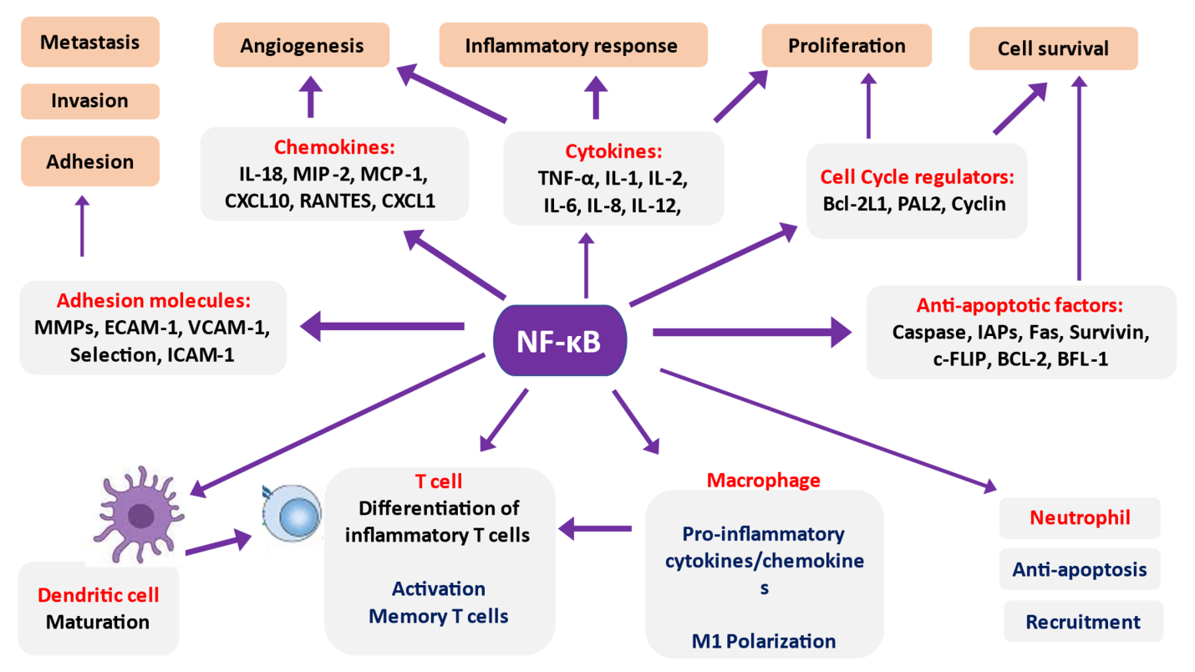
Figure 2: NF-κB is an inducible transcription factor that target genes which are linked to inflammation development and progression.
NF-kB undergoes either canonical or non-canonical route which are both dependent on the structural oligomeric dimerized components. The p50 and p65 (RelA) subunits play role in the canonical route while RelB and p52 play role in non-canonical route.
In homeostatic state, the NF-kB exist as an inactive hetero-dimer forms composing of p50 and p65 (RelA) subunits, complexing with an inhibitory proteins IkB-α or IkB-β and mask with the cytoplasm, but upon stimulation by microglia, expression of the membranes receptor like toll-like receptors (TLRs) and their associate which recognized the pathogen-associated molecules like and damage-associated molecules of bacteria, virus, fungal and other parasites as pro-inflammatory ligands are initiated [67,68]. The signaling response results in activation of the IκB protein kinases which phosphorylate the inhibitory protein for its dissociation from the complexes to free NF-kB for nuclear transport in order to bind with its nuclear receptor for expression and recruitment of expression of chemokines, inflammatory enzymes: COX-2 and iNOS, pro-inflammatory cytokines and tissues adhesion cytokine molecules [69,70] (figure 3). These molecules are collectively markers for cellular or tissues or neuronal inflammatory responses.
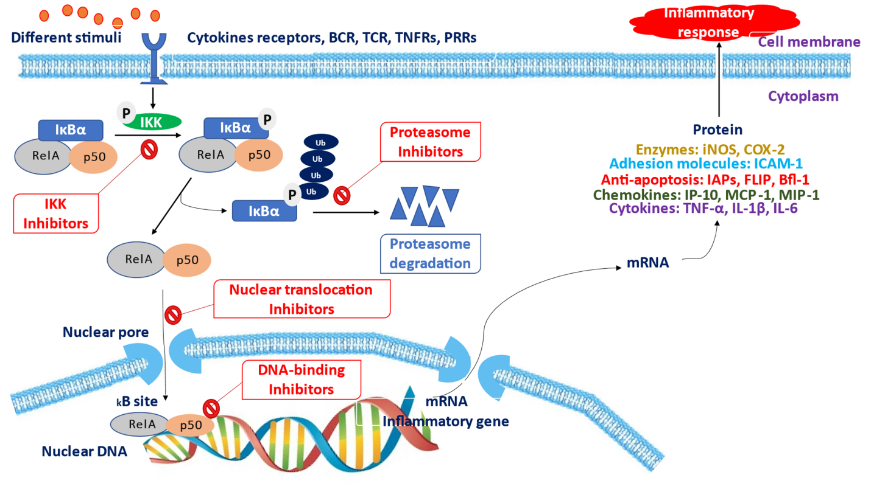
Figure 3: Mechanistic approaches in NF-κB mediated intervention in inflammatory diseases
Suppression of the active level of NF-KB could be therapeutic tool in prevention of cancer, cardiovascular and degenerative diseases. Research have shown that polyphenols exhibit anti-inflammatory potential in neuronal cells via these mechanism: (i) by inhibiting the activity of the enzyme IκB protein kinases, thereby halting the phosphorylation and ubiquitination processes which are essential for liberation of IkB moiety from the NF-kB complexes [71]; (ii) by inhibiting the productive interaction of the NF-κB subunits even after translocation into the nucleus with the targeted DNA [71]; (iii) polyphenols also interfere directly with arachidonic acid (AA) dependent pathways by inhibiting the expression of the enzyme which promote progression of inflammatory process (cyclooxygenase-2) and AA independent pathways indirectly as this depends on it counterpart pathway [72].
Among the reported polyphenols which have been shown to exhibit these neuronal anti-inflammatory mechanisms are curcumin, quercetin, epigallocate catechin and resveratrol [73-75].
Neuroprotective mechanism of polyphenols via Nrf2 signaling pathway
Many dietary polyphenols have been identified to play significant role in activation of the heterodimer’s transcription factor: Nuclear factor-erythroid factor 2-related factor 2 (Nrf2) in mediating neuronal protection against oxidative destruction/stress and inflammation [76,77].
Nrf2 is a transcription factor which belongs to Cap “n” Collar family of basic leucine zipper (bZip) which are located in the cytoplasm to regulates the main genes for antioxidant and cellular protection [78]. It interacts under physiological conditions with Kelch-like ECH-associated protein 1(Keap 1) to enhance proteasomal degradation via interaction with ubiquitin ligase. This complex, Nrf2-Keap1 is essential for passage of Nrf2 in to the nuclear for associative interaction with other leucine zipper (bZip) transcription factors and to the non-coding region of DNA which plays role in pleiotropy of many neighboring genes called Cis-acting element, specifically the Antioxidant response element (ARE) (figure 4 and 5).
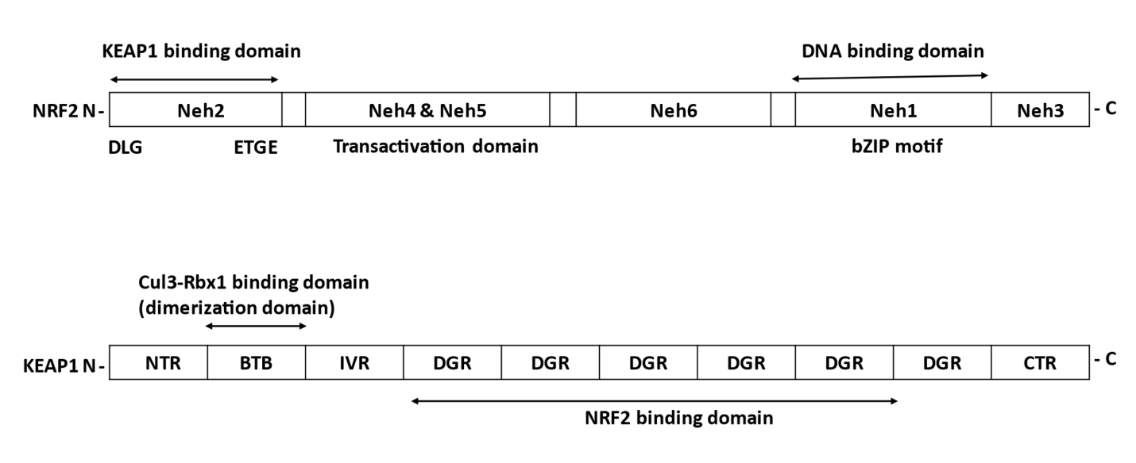
Figure 4: Domain structure of NRF2 and KEAP1 proteins.
bZIP: basic leucine zipper, NTR: N-terminal region, BTB: Broad Complex, Tramtrack, and Bric-a-Brac, IVR: intervening region, DGR: double glycine repeat (=Kelch), and CTR: carboxyl terminal region.

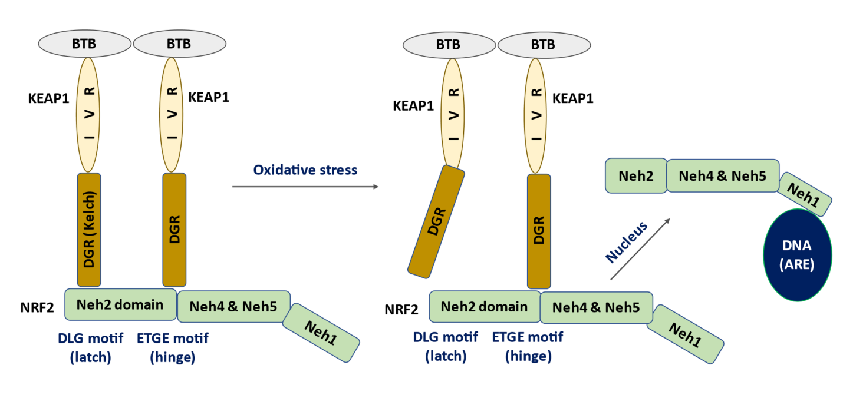
Figure 5: Interaction of NRF2 and KEAP1: hinge and latch model.
KEAP1 proteins dimerize via BTB domains. The KEAP1 homodimer identifies the DLG (weak interaction) and ETGE (strong interaction) motifs in the NRF2. NRF2 tightly binds to KEAP1 homodimer in basal state. After stress, weaker DLG motif is detached, blocking ubiquitination of NRF2 and facilitating nuclear import and binding to ARE. BTB: Broad Complex, Tramtrack, and Bric-a-Brac, IVR: intervening region, DGR: double glycine repeat (=Kelch), and ARE: antioxidant response element.

Under cellular oxidative stress, the condition serves as signal for the Nrf2 to dissociate from the Nrf2-Keap1 complex and for its activation, which further translocate into nuclear through E3 ubiquitin ligase catalytic action. ARE responses give rise to induction of inducible cytoprotective biological proteins like hemeoxygenase-1(HO-1), glutathione-s-transferase and other associated enzymes complexes which all play roles in detoxification of xenobiotics and removal of endogenously generated toxic molecules [79] (figure 6). The Nrf2-ARE interaction is the major target for polyphenols enhanced neuroprotective signaling. Polyphenols promote NrF2 and ARE interaction as this interaction activates HO-1 (regulatory enzymes) and activate of xenobiotics/drug detoxifying enzymes complexes. Likewise, the end products of HO-1 catalyzed reaction results in generation of carbon monoxide and bilirubin [80]. These end products enable HO-1 to demonstrate its immuno-modulatory and neuronal anti-inflammation role via end products regulatory actions which includes regulation of neuronal vessel tone, platelets aggregation prevention, neuronal tissue injury prevention, neuronal tissue congestion and neuro-inflammation prevention [80,81].
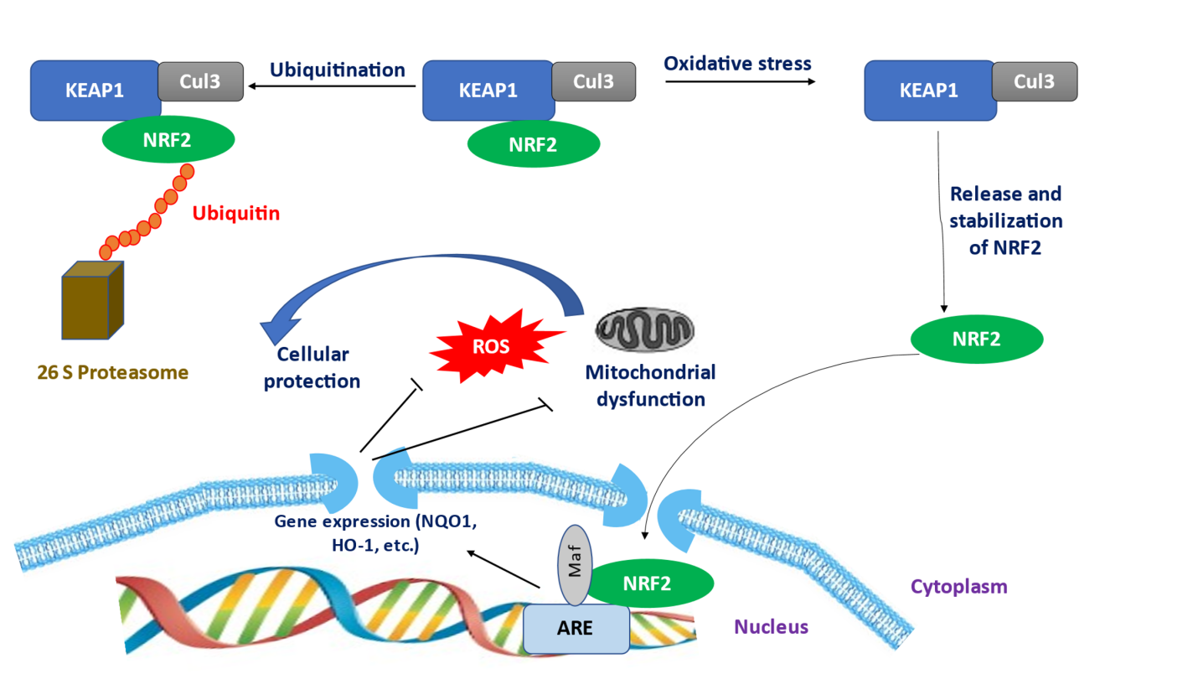
Figure 6: Regulation of NRF2 stability by KEAP1.
NRF2 is constantly degraded by KEAP1-mediated ubiquitination in the cytoplasm. Oxidative stress will halt degradation of NRF2 and lead it to bind to ARE to activate transcription of oxidant and detoxifying enzymes

Asides from the direct free radicals and lipid peroxides quenching potentials, polyphenols via Nrf2 pathways exhibited neuroprotection through phase II detoxifying enzymes system, HO-1 expression and Nrf2-ARE signaling complex activation. Curcumin, caffeic acid phenethylester, and the green tea catechins have been shown to exhibit this neuroprotective role via HO-1 expression and Nrf2-ARE signaling routes [82,83]. Curcumin rich diet have been reported to enhance memory, learning and cognitive functions through decreased amyloid protein aggregation, suppression of inflammation responses, reversing of brain lipid peroxidation and lipid modifications, and increased glutathione levels in Alzheimer and Parkinson patient. Likewise, the green tea catechins had been shown to possess anti-inflammation in addition to its neuroprotective actions, its daily intake has been reported to help in delaying the occurrence of ageing and age-related diseases. Furthermore, neuronal vessel formation and inhibition of the spread of cancerous are other beneficial roles accounted for its intake [84].
The health benefits of polyphenols have been linked to its direct antioxidant and anti-inflammatory role due to their ability to scavenge free radicals through their hydroxyl functional group present in its structure, but an underlined indirect neuroprotective mechanism not well study is their role in modulation of signaling pathway within the cells. Curcumin, green tea catechins, cinnamic acid of ferulic acid source and caffeic acid phenethyl ester are all polyphenols which modulate Nrf2 signaling pathway, specifically by enhancing Nrf2-ARE interaction which activates and promotes the expression of the phase II detoxifying enzymes and expression of HO-1 gene which accounted for their powerful antioxidant, neuroprotective and anti-inflammatory capacities [83]. Additionally, the Nrf2 pathway also helps in moderating the levels and effect principal neurotransmitters including norepinephrine, dopamine, and glutamate. This underlined mechanism of action could be another significant therapeutic tool for treatment of cancer and neurodegenerative diseases.
Neuroprotective mechanism of polyphenols via MAPK pathway
Among the important pathway which helps in signal transduction from the extracellular components of the cell to the intracellular or target region is mitogen-activated protein kinase (MAPK) pathway. MAPK pathway comprises of cascade of events which plays role in modulating signaling event which is vital for mammalian cells proliferation, development and differentiation, inflammatory responses and apoptosis [85]. The pathway comprises of many proteins which transfer signal via phosphorylation of their tyrosine, serine or threonine amino acids containing moiety in their structure of the neighboring proteins in order to send signal to the DNA for transcription purposes.
The phosphorylation process caused conformational changes in their protein structure enabling them to activate neighboring proteins. Mutation is gene expression of any of these proteins results in development of cancer. C-Jun N-terminal kinases (JNK), extracellular signal-regulated kinases (ERKs) and p38 mitogen-activated protein kinases are major MAPK subfamilies of popular discussions, although other subfamilies like Nemo-like kinase exist [86]. In general, each cascade event is activated by binding of ligand to the extracellular receptor sites which pronounce three sequential kinases event where MAPK kinase kinase (MAPKKK) stimulates MAPK kinase (MAPKK) which finally turn on MAP kinase (MAPK).
Although the ligand type determines which cascade among the subfamilies that will be activate within the enzymatic complexes. The canonical ERKs is activated by growth factor and cytokines while oxidative stress, cytokines, lipopolysaccharide and infections turn on the p38 and JNK signaling routes [85].
MAPK pathway play crucial role in response to oxidative stress and oxidative damages which occurs as a result of destructive effect of free radicals and reactive nitric oxides species. This occurs via activation and expression of transcriptional factor for regulation of apoptosis and inflammatory processes. When the cell is under oxidative stress irrespective of the causative agent either ROS or iNOS, this serves as effector ligand that binds the extracellular receptor components causing activation of the MAPK upstream regulatory proteins thioredoxin which is a classical component of apoptosis signal-regulating kinase 1 (ASK1) [87]. The ROS caused dissociation of the thioredoxin from the complexes converting it to active form, where its kinases activity catalyzed phosphorylation of the MEKs component i.e MAPKs and proceed further to the phosphorylate JNK and p38 of MAPK. Likewise, the causative agent, ROS can also directly activate MAPK via inhibition of its phosphatase’s components. This cascade event caused expression of transcriptional factor the regulates apoptosis and inflammation [85.87]. With respect to inflammation, MAPK pathway play roles in turning on of transcriptional factor gene NF-κB which is crucial for induction of pro-inflammatory cytokines, cyclooxygenase-2 and the inducible nitric oxide synthase, which are all promoters of inflammation response [85].
From this point of view, inhibition of the signal transduction of MAPK vis ERKs, JNK and p38 pathway either at transcriptional level should be the major target of therapeutic drug for promoting neuroprotection against oxidative and inflammation. Many reports have shown that polyphenols exhibit neuroprotective role via this mechanism. They regulate the MAPK pathway by inhibiting the activation processes at each step. For example, report from research conducted using activated human THP1 monocyte cell line showed that the polyphenol catechins regulates MAPK pathway by inhibiting activity the p38 and JNK of MAPK and their phosphorylated form, while quercetin demonstrated its inhibition on ERK, JNK, and their phosphorylated forms, thereby preventing further signaling transduction via phosphorylation process catalyzed by kinases [88]. Likewise, research conducted using lipopolysaccharide activated macrophages in mouse showed that polyphenol (quercetin) displayed its regulatory role against expression of TNF-α by inhibiting the prevention production of TNF-α protein synthesis via inhibiting the phosphorylation ERK1/2 and activity of p38 MAPK as well as TNF-α expression by halting the phosphorylation [89].
Furthermore, the green tea catechins displayed its neuroprotective mechanism by inhibiting the expression of the gene for cyclooxygenase-2, an enzyme that promote inflammatory response by inhibiting the activation via phosphorylation of the p38 MAPK pathway and it binding to DNA of NF-κB [75].
Neuroprotective mechanism of Polyphenols via P⁵³ Pathway.
P⁵³ pathway is another signaling pathway of great significant to the cell. This pathway and its transcriptional products participate in stress response signaling processes like cell cycle arrest, senescence and apoptosis and most importantly the pathway helps in expression and synthesis of p53 protein which act as tumor suppressor protein preventing development of cancer [90]. Additionally, the p53 helps in process of inhibition of angiogenesis, metastasis and IGF-1/mTOR pathway, facilitate exosomes secretion and in DNA damage repair.
Damaged DNA via ROS and radiation, activated oncogenes, nitric oxide, cold and heat shock, hypoxia, damage spindle are stress signals that activate p53 genes which result in expression of p53, in same way the Murine double minute 2 (MDM-2) are degraded in response to these stress signals via MDM-2 ubiquitin ligase [91,92]. P⁵³ response genes upstream mediating follows a ND, the activated p53 proteins caused transcription of many genes, among which are GADD-45, MDM-2, cycling G and p21 which play role in cell cycle arrest; secreted protein fas, and killer/DR5 which works in conjunction with PIDD to activate caspases 8 and Bid to release cytochrome c in extrinsic apoptotic pathway; Bax, p53AIP and PIGs in intrinsic apoptotic pathway; p48, GADD-45 and p53R2 which play role in DNA damage repair mechanism; BAI-1, KAI, Maspin which play role as inhibitors of protease which degrades extracellular matrix and surface and PTEN/IGF-BP3 genes which gene products IGF-1R, IGF 1 and others inhibit the activation of growth response signal transduction routes thereby regulating cell growth negatively after stress signals are triggered with cell [93,94].
Available evidence proved that the p53 cross the nucleus and acting directly on mitochondria and its protein components BCL-2 to enhance the liberation of cytochrome c and apoptotic p53 also play role in communication between neighboring cell by inducing the TSAP-6 gene which enhances production of exosome for cell-cell communication. However, the p53 protein level is regulated by MDM-2 via ubiquitin ligase enzyme like COP1 (constitutively photomorphogenic 1) and Pirh2 (p53-induced RING-H2 domain protein) and catalytic turn over [90].
Polyphenols help in activation of p53 transcriptional activity in order to mediated increase synthesis of p53 protein which suppresses neuronal tumors and neurological cancer via initiation of apoptosis, cell arrest, ROS generation and cell senescence with the neurological tumor [95,96]. Furthermore, polyphenols caused up-regulation of p53 dependent target like p21, Bax and DR5 [95].
Conclusion
Neurodegenerative diseases affect the brain at both molecular, cellular and systemic levels. Apoptosis, neuro-inflammation and oxidative destruction of nerve cells are majorly known contributory factors which have implicated in the development and progression of the degenerative diseases. Polyphenols are one of the most notable phytochemicals present abundantly in fruit, vegetables, and other nutritional sources. A number of therapeutic significances have been attributed to this phytochemical which include antioxidant, anti-inflammatory, antiapoptotic, modulatory effects and so on. This therapeutic importance has also been reported in polyphenols neuroprotective actions such as enhancement of memory, learning, and cognitive performances, neuronal detoxification and repairment, downstream modulation of signaling pathways of neuronal oxidative stress, neuro-inflammation and necrosis which are all implicated in neurodegenerative diseases as well as transcription, translation, amyloid congestion, neuronal disruption pathways within the nerve cells. The molecular mechanisms underpinning neuroprotective actions of polyphenols involved signaling pathways such as Nrf-2, neurotropic pathways, NF-kB/MAPK, c-JUN, c-FOS, p53 pathway, anti-apoptotic, and anti-neuro-inflammatory. Polyphenols pose to be promising therapeutic candidate to halt/mitigate/slow down the pathogenesis of these neuronal degenerative diseases due to its multi-signaling modulatory properties.

Reference
- Oladele JO., Oladele OT. Oyeleke OM. (2021). Possible health benefits of polyphenols in neurological complications associated with COVID-19. Acta facultatis medicae Naissensis. 38: 294-309
- Oladele J.O., Oladele OT. Oyeleke OM., Oladiji AT. (2021). Neurological Complications in COVID-19: Implications on International Health Security and Possible Interventions of Phytochemicals. Contemporary Developments and Perspectives in International Health Security - Volume 2. DOI: http://dx.doi.org/10.5772/intechopen.96039
- Deprez, S.; Mila, I.; Huneau, J.F.; Tome, D.; Scalbert, A. Transport of proanthocyanidin dimer, trimer, and polymer across monolayers of human intestinal epithelial Caco-2 cells. Antioxid. Redox. Signal. 2001, 3, 957–967.
- Oladele JO., Oyeleke OM., Oladele OT. Olaniyan MD. (2020). Neuroprotective mechanism of Vernonia amygdalina in a rat model of neurodegenerative diseases. Toxicology report. 7: 1223 - 1232.
- Smolensky, D.; Rhodes, D.; McVey, D.S.; Fawver, Z.; Perumal, R.; Herald, T.; Noronha, L. High-polyphenol sorghum bran extract inhibits cancer cell growth through ROS induction, cell cycle arrest, and apoptosis. J. Med. Food 2018, 21, 990–998.
- Gupta, S.; Hastak, K.; Afaq, F.; Ahmad, N.; Mukhtar, H. Essential role of caspases in epigallocatechin-3-gallate-mediated inhibition of nuclear factor kappa B and induction of apoptosis. Oncogene 2004, 23, 2507–2522.
- Bhakkiyalakshmi, E.; Dineshkumar, K.; Karthik, S.; Sireesh, D.; Hopper,W.; Paulmurugan, R.; Ramkumar, K.M. Pterostilbene-mediated Nrf2 activation: Mechanistic insights on Keap1: Nrf2 interface. Bioorg. Med. Chem. 2016, 24, 3378–3386.
- Livingston, G; Huntley, J; Sommerlad, A (8 August 2020). "Dementia prevention, intervention, and care: 2020 report of the Lancet Commission". Lancet. 396 (10248): 413–446.
- Oladele J.O., Oladiji AT, Oladele OT, Oyeleke OM. (2021). Reactive Oxygen Species in Neurodegenerative Diseases: Implications in Pathogenesis and Treatment Strategies [Online First], IntechOpen, DOI: 10.5772/intechopen.99976.
- Singh, A; Kukreti, R; Saso, L; Kukreti, S (22 April 2019). "Oxidative Stress: A Key Modulator in Neurodegenerative Diseases". Molecules (Basel, Switzerland). 24 (8).
- Bredesen DE, Rao RV, Mehlen P (October 2006). "Cell death in the nervous system" (https://www.ncbi.nl m.nih.gov/pmc/articles/PMC3970704) . Nature. 443 (7113): 796–802.
- Kouli A, Torsney KM, Kuan WL. Parkinson’s Disease: Etiology, Neuropathology, and Pathogenesis. In: Stoker TB, Greenland JC, editors. Parkinson’s Disease: Pathogenesis and Clinical Aspects [Internet]. Brisbane (AU): Codon Publications; 2018 Dec 21. Chapter 1. doi: 10.15586/codonpublications.parkinsonsdisease.2018.ch1
- Jankovic J (2008). "Parkinson's disease: clinical features and diagnosis" (http://jnnp.bmj.com/content/79/4/368.full) . Journal of Neurology, Neurosurgery, and Psychiatry. 79 (4): 368–76.
- Deng H, Wang P, Jankovic J (March 2018). "The genetics of Parkinson disease" (https://pubmed.ncbi.nl m.nih.gov/29288112) . Ageing Research Reviews. 42: 72–85.
- Schulte C, Gasser T. Genetic basis of Parkinson’s disease: Inheritance, penetrance, and expression. Appl Clin Genet. 2011 Jun 1;4:67–80.
- De-Lau, L.M.; Breteler, M.M. Epidemiology of Parkinson’s disease. Lancet Neurol. 2006, 5, 525–535.
- Chen RC, Chang SF, Su CL, Chen TH, Yen MF, Wu HM, et al. Prevalence, incidence, and mortality of PD: A door-to-door survey in Ilan county, Taiwan. Neurology. 2001 Nov 13;57(9):1679–86. https://doi .org/10.1212/WNL.57.9.1679.
- Eliezer D, Kutluay E, Bussell R, Browne G. Conformational properties of α-synuclein in its free and lipid-associated states11Edited by P. E. Wright. J Mol Biol. 2001 Apr 6;307(4):1061–73.
- Fujiwara H, Hasegawa M, Dohmae N, Kawashima A, Masliah E, Goldberg MS, et al. alpha-Synuclein is phosphorylated in synucleinopathy lesions. Nat Cell Biol. 2002 Feb;4(2):160–4. https://doi .org/10.1038/ncb748.
- Winner B, Jappelli R, Maji SK, Desplats PA, Boyer L, Aigner S, et al. In vivo demonstration that -synuclein oligomers are toxic. Proc Natl Acad Sci. 2011 Mar 8;108(10):4194–9. https://doi .org/10.1073/pnas.1100976108.
- Devi, L.; Raghavendran, V.; Prabhu, B.M.; Avadhani, N.G.; Anandatheerthavarada, H.K. Mitochondrial import and accumulation of _-synuclein impair complex I in human dopaminergic neuronal cultures and Parkinson disease brain. J. Biol. Chem. 2008, 283, 9089–9100.
- Liu, G.; Zhang, C.; Yin, J.; Li, X.; Cheng, F.; Li, Y.; Yang, H.; Uéda, K.; Chan, P.; Yu, S. _-Synuclein is di_erentially expressed in mitochondria from di_erent rat brain regions and dose-dependently down-regulates complex I activity. Neurosci. Lett. 2009, 454, 187–192.
- The National Collaborating Centre for Chronic Conditions, ed. (2006).(NCCCC) "Symptomatic pharmacological therapy in Parkinson's disease". Parkinson's Disease. London: Royal College of Physicians. pp. 59–100. ISBN 978-1-86016-283-1.
- Connolly BS, Lang AE (30 April 2014). "Pharmacological treatment of Parkinson disease: a review" (http s://semanticscholar.org/paper/282b19727fa648f2fdc92597a40713d3708ae092) . JAMA. 311 (16): 1670–83.
- Poewe W, Seppi K, Tanner CM, et al. (23 March 2017). "Parkinson disease". Nature Reviews Disease. Primers. 3 (1): 17013. doi:10.1038/nrdp.2017.13
- Hamilton RL. Lewy bodies in Alzheimer's disease: a neuropathological review of 145 cases using alpha-synuclein immunohistochemistry. Brain Pathol. 2000;10(3):378–384.
- Wenk GL (2003). "Neuropathologic changes in Alzheimer's disease". The Journal of Clinical Psychiatry. 64 (Suppl 9): 7–10. PMID 12934968 (https://pubmed.ncbi.nlm.nih.gov/12934968).
- Berchtold NC, Cotman CW (1998). "Evolution in the conceptualization of dementia and Alzheimer's disease: Greco-Roman period to the 1960s". Neurobiology of Aging. 19 (3): 173–189.
- Simon RP, Greenberg DA, Aminoff MJ (2018). Clinical neurology (Tenth ed.). [New York]: McGraw Hill. p. 111. ISBN 978-1-259-86173-4. OCLC 1012400314
- Bäckman L, Jones S, Berger AK, Laukka EJ, Small BJ (September 2004). "Multiple cognitive deficits during the transition to Alzheimer's disease" (https://doi.org/10.1111%2Fj.1365-2796.2004.01386.x). Journal of Internal Medicine. 256 (3): 195–204.
- Taler V, Phillips NA (July 2008). "Language performance in Alzheimer's disease and mild cognitive impairment: a comparative review". Journal of Clinical and Experimental Neuropsychology. 30 (5): 501– 556. doi:10.1080/13803390701550128
- Burns A, Iliffe S (2009). "Alzheimer's disease". BMJ. 338: b158. doi:10.1136/bmj.b158.
- Tackenberg C, Kulic L, Nitsch RM (2020). "Familial Alzheimer's disease mutations at position 22 of the amyloid β-peptide sequence differentially affect synaptic loss, tau phosphorylation and neuronal cell death in an ex vivo system" (https://doi.org/10.1371%2F. journal.pone.0239584) . PLOS ONE. 15 (9):
- Sun W, Samimi H, Gamez M, Zare H, Frost B (2018). "Pathogenic tau-induced piRNA depletion promotes neuronal death through transposable element dysregulation in neurodegenerative tauopathies" (https://www.ncbi.nlm.nih.gov/pmc/articles/PMC6095477) . Nature Neuroscience. 21 (8): 1038–1048.
- Sinyor B, Mineo J, Ochner C (June 2020). "Alzheimer's Disease, Inflammation, and the Role of Antioxidants" (https://www.ncbi.nlm.nih.gov/pmc/articles/PMC7369138) . Journal of Alzheimer's Disease Reports. 4 (1): 175–183. doi:10.3233/ADR-200171 (https://doi.org/10.3233%2FADR-200171). PMC 7369138 (https://www.ncbi.nlm.nih.gov/pmc/articles/PMC7369138)
- Atri A (March 2019). "The Alzheimer's Disease Clinical Spectrum: Diagnosis and Management". The Medical Clinics of North America (Review). 103 (2): 263–293. doi:10.1016/j.mcna.2018.10.009
- Mahley RW, Weisgraber KH, Huang Y (April 2006). "Apolipoprotein E4: a causative factor and therapeutictarget in neuropathology, including Alzheimer's disease". Proceedings of the National Academy of Sciences of the United States of America. 103 (15): 5644– 5651.
- Weller J, Budson A (2018). "Current understanding of Alzheimer's disease diagnosis and treatment" (https://www.ncbi.nlm.nih.gov/pmc/articles/PMC6073093) . F1000 Research (Review). 7: 1161. doi:10.12688/f1000research.14506.1
- Chu CS, Tseng PT, Stubbs B, et al. (April 2018). "Use of statins and the risk of dementia and mild cognitive impairment: A systematic review and meta-analysis" (https://www.ncbi.nlm.nih.gov/pmc/articles/PMC5895617) . Scientific Reports. 8 (1): 5804.
- Yu JT, Xu W, Tan CC, et al. (November 2020). "Evidence-based prevention of Alzheimer's disease: systematic review and meta-analysis of 243 observational prospective studies and 153 randomised controlled trials" (https://www.ncbi.nlm.nih.gov/pmc/articles/PMC7569385) . J Neurol Neurosurg Psychiatry. 91 (11): 1201–1209. doi:10.1136/jnnp-2019-321913
- Rubinsztein DC, Carmichael J (August 2003). “Huntington’s disease: molecular basis of neurodegeneration”. Expert Reviews in Molecular Medicine. 5 (20): 1–21. Doi:10.1017/S1462399403006549.
- Liu Z, Zhou T, Ziegler AC, Dimitrion P, Zuo L (2017). “Oxidative Stress in Neurodegenerative Diseases: From Molecular Mechanisms to Clinical Applications”. Oxidative Medicine and Cellular Longevity. 2017: 2525967.
- Coppen, Emma M.; Roos, Raymund A. C. (1 January 2017). “Current Pharmacological Approaches to Reduce Chorea in Huntington’s Disease”. Drugs. 77 (1): 29–46.
- Morsy S, Khalil SM, Doheim MF, Kamel MG, El-Basiony DS, Ahmed Hassan HI, et al. (August 2019). "Efficacy of ethyl-EPA as a treatment for Huntington disease: a systematic review and meta-analysis". ActaNeuropsychiatrica. 31 (4): 175–185.
- Stys, Peter K.; Tsutsui, Shigeki (2019-12-13). “Recent advances in understanding multiple sclerosis”. F1000Research. 8: 2100
- Dugger BN, Dickson DW. Pathology of neurodegenerative diseases. Cold Spring Harbor perspectives in biology.2017-Jul-1;9(7):a028035.Available from: https://www.ncbi.nlm.nih.gov/pmc/articles/PMC5495060
- Milner, J.A. Reducing the risk of cancer. In Functional Foods: Designer Foods, Pharmafoods, Nutraceuticals; Goldberg, I., Ed.; Chapman & Hall: New York, NY, USA, 1994; pp. 39-70.
- Duthie, G.G.; Brown, K.M. Reducing the risk of cardiovascular disease. In Functional Foods: Designer Foods, Pharmafoods, Nutraceuticals; Goldberg, I., Ed.; Chapman & Hall: New York, NY, USA, 1994; pp. 19-38
- Ajayi E.I.O., Molehin O.R., Adefegha S.A., Fakayode A.E., Oladele J.O., Adewumi SO. (2021). Nutritional Regulation of Metabesity. In. Nutrition, Food and Diet in Ageing and Longevity. Healthy Ageing and Longevity. 14. https://doi.org/10.1007/978-3-030-83017-
- Adom K.K., Liu R.H. Antioxidant activity of grains. J. Agric. Food Chem. 2002;50:6182–6187.
- Bravo L. Polyphenols: Chemistry, Dietary Sources, Metabolism, and Nutritional Significance. Nutr. Rev. 1998;56:317–333. Doi: 10.1111/j.1753-4887.1998.tb01670.x.
- Valant-Vetschera K.M., Wallenweber E. Flavones and Flavonols. In: Anderson O.M., Markham K.R., editors. Flavonoids: Chemistry, Biochemistry and Applications. CRC Press/Taylor & Francis Group; Boca Raton, FL, USA: 2006. Pp. 618–748.
- Philip hunter (2012).The inflammation theory of disease. EMBO Rep. 2012 Nov; 13(11): 968–970.Published online 2012 Oct 9. Doi: 10.1038/embor.2012.142
- Vauzour D. Dietary polyphenols as modulators of brain functions: biological actions and molecular mechanisms underpinning their beneficial effects. Oxid Med Cell Longev. 2012;2012:914273. Doi: 10.1155/2012/914273.
- Tangney CC, Rasmussen HE. Polyphenols, inflammation, and cardiovascular disease. CurrAtheroscler Rep. 2013 May;15(5):324. Doi: 10.1007/s11883-013-0324-x.
- Potì F, Santi D, Spaggiari G, Zimetti F, Zanotti I. Polyphenol Health Effects on Cardiovascular and Neurodegenerative Disorders: A Review and Meta-Analysis. Int J Mol Sci. 2019 Jan 16;20(2):351. Doi: 10.3390/ijms20020351.
- Hubert PA, Lee SG, Lee SK, Chun OK. Dietary polyphenols, berries, and age-related bone loss: a review based on human, animal, and cell studies. Antioxidants. (2014) 3:144–58. 10.3390/antiox3010144
- Panel Hua Zhang and RongTsao(2016). Dietary polyphenols, oxidative stress and antioxidant and anti-inflammatory effects.Current Opinion in Food Science, Volume 8, 2016, Pages 33-42, ISSN 2214-7993.
- Graef JL, Rendina-Ruedy E, Crockett EK, Ouyang P, Wu L, King JB, et al.. Osteoclast differentiation is downregulated by select polyphenolic fractions from dried plum via suppression of MAPKs and Nfatc1 in mouse C57BL/6 primary bone marrow cells. Curr Dev Nutr. (2017) 1:e000406. 10.3945/cdn.117.000406
- Oladele JO., Anyim JC., Oyeleke OM., Olowookere BD., Bamigboye MO., Oladele OO., Oladiji AT. (2021) Telfairia occidentalis mitigates dextran sodium sulphate-induced ulcerative colitis in rats via suppression of oxidative stress, lipid peroxidation and inflammation. Journal of food biochemistry. DOI: 10.1111/jfbc.13873.
- Pacheco-Ordaz R, Wall-Medrano A, Goñi MG, Ramos-Clamont-Montfort G, Ayala-Zavala JF, González-Aguilar GA. Effect of phenolic compounds on the growth of selected probiotic and pathogenic bacteria. Lett ApplMicrobiol. 2018 Jan;66(1):25-31. Doi: 10.1111/lam.12814.
- Lee HC, Jenner AM, Low CS, Lee YK. Effect of tea phenolics and their aromatic fecal bacterial metabolites on intestinal microbiota. Res Microbiol. 2006 Nov;157(9):876-84. Doi: 10.1016/j.resmic.2006.07.004. Epub 2006 Aug 18. PMID: 16962743
- Kim J, Lee HJ, Lee KW (2010) Naturally occurring phytochemicals for the prevention of Alzheimer’s disease. J Neurochem 112 (6):1415–30
- NilooKarunaweera, Ritesh Raju,Erika Gyengesi, and Gerald Münch (2015). Plant polyphenols as inhibitors of NF-κB induced cytokine production—a potential anti-inflammatory treatment for Alzheimer’s disease?MolNeurosci. 2015; 8: 24.
- Mattson MP, Meffert MK (2006). “Roles for NF-kappaB in nerve cell survival, plasticity, and disease”. Cell Death & Differentiation. 13 (5): 852–860. Doi:10.1038/sj.cdd.4401837. PMID 16397579.
- Papa S, Bubici C, Knabb JR, Dean K, Franzoso G (2006). “The NF-kappaB-mediated control of the JNK cascade in the antagonism of programmed cell death in health and disease”. Cell Death & Differentiation. 13 (5): 712–729. Doi:10.1038/sj.cdd.4401865. PMID 16456579.
- Figuera-Losada M., Rojas C., Slusher B. S. (2014). Inhibition of microglia activation as a phenotypic assay in early drug discovery. J. Biomol. Screen. 19, 17–31. 10.1177/1087057113499406
- Mogensen T. H. (2009). Pathogen recognition and inflammatory signaling in innate immune defenses. Clin. Microbiol. Rev. 22, 240–273. 10.1128/CMR.00046-08
- Ghosh S., Karin M. (2002). Missing pieces in the NF-kappaB puzzle. Cell 109(Suppl.), S81–S96. 10.1016/S0092-8674(02)00703-1
- Perkins N. D. (2007). Integrating cell-signalling pathways with NF-kappaB and IKK function. Nat. Rev. Mol. Cell Biol. 8, 49–62. 10.1038/nrm2083.
- Ruiz P. A., Haller D. (2006). Functional diversity of flavonoids in the inhibition of the proinflammatory NF-kappaB, IRF, and Akt signaling pathways in murine intestinal epithelial cells. J. Nutr. 136, 664–671.
- Yoon J. H., Baek S. J. (2005). Molecular targets of dietary polyphenols with anti-inflammatory properties. Yonsei Med. J. 46, 585–596. 10.3349/ymj.2005.46.5.585
- Endale M., Park S. C., Kim S., Kim S. H., Yang Y., Cho J. Y., et al.. (2013). Quercetin disrupts tyrosine-phosphorylated phosphatidylinositol 3-kinase and myeloid differentiation factor-88 association, and inhibits MAPK/AP-1 and IKK/NF-kappaB-induced inflammatory mediators production in RAW 264.7 cells. Immunobiology 218, 1452–1467. 10.1016/j.imbio.2013.04.019
- Jobin C., Bradham C. A., Russo M. P., Juma B., Narula A. S., Brenner D. A., et al.. (1999). Curcumin blocks cytokine-mediated NF-kappa B activation and proinflammatory gene expression by inhibiting inhibitory factor I-kappa B kinase activity. J. Immunol. 163, 3474–3483
- J.K. Kundu, Y.J. Surh, Epigallocatechingallate inhibits phorbol ester-induced Activation of NF-kappa B and CREB in mouse skin: role of p38 MAPK, Ann. N. Y Acad. Sci. 1095 (2007) 504 12.
- Nakatani N (2000). Phenolic antioxidants from herbs and spices. Biofactors 13:141–146
- Van Dyk K, Sano M (2007) The impact of nutrition on cognition In the elderly. Neurochem Res 32:893–904
- Sun Z, Zhang S, Chan JY, Zhang DD. Keap1 controls postinduction repression of the Nrf2-mediated antioxidant response by escorting nuclear export of Nrf2. Mol Cell Biol. 2007 Sep;27(18):6334-49. Doi: 10.1128/MCB.00630-07.
- Ma Q. Xenobiotic-activated receptors: from transcription to drug metabolism to disease. Chem. Res. Toxicol. 2008;21:1651–71.
- Pamplona A et al (2007) Heme oxygenase-1 and carbon Monoxide suppress the pathogenesis of experimental cerebral Malaria. Nat Med 13(6):703–710
- Scapagnini G, Vasto S, Abraham NG, Caruso C, Zella D, Fabio G. Modulation of Nrf2/ARE pathway by food polyphenols: a nutritional neuroprotective strategy for cognitive and neurodegenerative disorders. MolNeurobiol. 2011 Oct;44(2):192-201. Doi: 10.1007/s12035-011-8181-5.
- Yang C, Zhang X, Fan H, Liu Y (2009) Curcumin upregulates transcription factor Nrf2, HO-1 expression and protects rat brains against focal ischemia. Brain Res 1282:133–41
- Scapagnini G, Foresti R, Calabrese V, Giuffrida Stella AM, Green CJ, Motterlini R. Caffeic acid phenethyl ester and curcumin: a novel class of heme oxygenase-1 inducers. MolPharmacol. 2002 Mar;61(3):554-61. Doi: 10.1124/mol.61.3.554.
- Khan N, Mukhtar H (2007) Tea polyphenols for health Promotion. Life Sci 81:519–53
- Behl T, Rana T, Alotaibi GH, Shamsuzzaman M, Naqvi M, Sehgal A, Singh S, Sharma N, Almoshari Y, Abdellatif AAH, Iqbal MS, Bhatia S, Al-Harrasi A, Bungau S. Polyphenols inhibiting MAPK signalling pathway mediated oxidative stress and inflammation in depression. Biomed Pharmacother. 2022 Feb;146:112545. Doi: 10.1016/j.biopha.2021.112545.
- Yu J, Sun X, Goie J, Zhang Y (2020). “Regulation of Host Immune Responses against Influenza A Virus Infection by Mitogen-Activated Protein Kinases (MAPKs)”. Microorganisms. 8 (7): 1067. Doi:10.3390/microorganisms8071067.
- A. Matsuzawa, K. Saegusa, T. Noguchi, C. Sadamitsu, H. Nishitoh, S. Nagai, S. Koyasu, K. Matsumoto, K. Takeda, H. Ichijo, ROS-dependent activation of the TRAF6-ASK1-p38 pathway is selectively required for TLR4-mediated innate Immunity, Nat. Immunol. 6 (2005) 587–592.
- S.M. Huang, C.H. Wu, G.C. Yen, Effects of flavonoids on the expression of the pro-Inflammatory response in human monocytes induced by ligation of the receptor .For AGEs, Mol. Nutr. Food Res. 50 (2006) 1129–1139.
- T.L. Wadsworth, T.L. McDonald, D.R. Koop, Effects of Ginkgo biloba extract (EGb 761) and quercetin on lipopolysaccharide- induced signaling pathways involved In the release of tumor necrosis factor-alpha, Biochem. Pharm. 62 (2001) 963–974.
- AJ Levin, W Hu and Z Feng (2006).The P53 pathway: what questions remain to be explored? Cell Death and Differentiation (2006) 13, 1027–1036. doi:10.1038/sj.cdd.4401910; published online 24 March 2006
- Vogelstein B, Lane D and Levine AJ (2000). Surfing the p53 network. Nature 408: 307–310.
- Zhao R, Gish K, Murphy M, Yin Y, Notterman D, Hoffman WH, Tom E, Mack DH and Levine AJ (2000) The transcriptional program following p53 activation. Cold Spring Harb. Symp. Quant. Biol. 65: 475–482.
- Moll UM, Wolff S, Speidel D and Deppert W (2005) Transcription-independent pro-apoptotic functions of p53. Curr. Opin. Cell Biol. 17: 631–636.
- Chipuk JE, Kuwana T, Bouchier-Hayes L, Droin NM, Newmeyer DD, Schuler M and Green DR (2004) Direct activation of Bax by p53 mediates mitochondrial membrane permeabilization and apoptosis. Sciencem 303: 1010–1014.
- Khan H., Reale M., Ullah H., Sureda A., Tejada S., Wang Y., Zhang Z.J., Xiao J. Anti-cancer effects of polyphenols via targeting p53 signaling pathway: Updates and future directions. Biotechnol. Adv. 2020;38:107385. Doi: 10.1016/j.biotechadv.2019.04.007.
- Sheikh M.S., Fornace A.J., Jr. Death and decoy receptors and p53-mediated apoptosis. Leukemia. 2000;14:1509–1513. Doi: 10.1038/sj.leu.2401865.

