Review Article Creative Commons 4.0
Title: Application and research progress of BCL2 inhibitors in elderly patients with hematologic malignancies
[Suggestions: No more than 20 words. No abbreviations except for standardized ones e.g., DNA, RNA, gene or protein names, etc.]
Forename Surname¹, Forename Surname^{1,2}, Forename Surname³
¹Department, Institution, City Postcode, Country.
²Department, Institution, City, State Postcode, Country.
³Department, Institution, City Postcode, Province, Country.
Correspondence to: Prof./Dr. Forename Surname, Department, Institution, Detailed Address, City Postcode, Country.
E-mail: xxxx@xxxx.xxx
How to Use This Template
This template shows the manuscript structure that can be used in an original article: Abstract, Keywords, Introduction, Methods, Results, Discussion, Declarations and References. Please note that each part has a corresponding style, which authors should follow. Please note that the fonts in gray show writing requirements. For any questions, you may contact the editorial office.
Abstract
[Suggestions: No more than 250 words. No citations. Define abbreviations at their first mention.]
Abstract is a brief summary of an article, which helps the readers quickly ascertain the paper's main content. In this part, authors may mention writing purpose, experimental methods, results and their significance in this research field, etc.
Keywords: Aging, older patients, chronic heart failure, drug therapy
[Please suggest 3-6 keywords which can be used for describing the content of the manuscript and will enable the full text of the manuscript to be searchable online.]
INTRODUCTION
The introduction is a beginning section of a manuscript which states the purpose of the study, overviews or summarizes previous findings and progress related to this study, and indicates its significance in this research field. It is generally followed by the body and discussion.
LEVEL 1 HEADING
[e.g., MAIN TEXT]
In this section, authors should describe the main text of the review in detail. It may contain a summary of representative studies in a specific field, the methods, results in previous studies, their advantages and disadvantages, authors’ opinions on the topic, etc. We suggest that authors may set headings (level 1 heading, level 2 heading, level 3 heading, etc.) to separate different cases or situations.
Level 2 heading
[e.g., Statistical analyses]
Level 3 heading
[e.g., Data distributions, outliers and linear regression]
Tips:
- All drugs and chemicals used, including generic name(s), dose(s), and route(s) of administration, should be identified precisely;
- When reporting studies on human beings or animals, authors should strictly follow the Helsinki Declaration (available at http://www.wma.net/en/30publications/10policies/b3/) and other related publishing ethical standards.

Table 1 (other forms: Tables 1 and 2; Tables 1-3), Equation (1) [other forms: Equations (2) and (3); Equations (4-6)] and Figure 1 (other forms: Figure 1A and B; Figure 2A-C; Figures 1 and 2A; Figures 1, 2A and 3-5) show the examples of diagrams. All the tables, equations and figures should be cited in sequence in the main content near to the first time they appear. For supplementary material, authors may cite table, equation and figure like Supplementary Table 1, Supplementary Equation (1) and Supplementary Figure 1.
Tips:
- Results should be presented in a logical sequence;
- Avoid redundant explanations to all the data from the tables or illustrations.
Table 1. This is a table caption. A summary description of this table should be written here
Authors | Regimen | n | Age (year) | CR (%) | 2-year (3-year) EFS/PFS (%) | 2-year (3-year) OS (%)
Our current study | CHOP  CVP | 251  67 | 17-82  45-87 | 69.8  29.9* | 55.3 (46.0)  18.0 (12.0)* | 58.0 (52.0)  25.0 (19.0)*
Khaled et al.^{[1]} | CHOP | 40 | 19-75 | 67 | 54 (54) | 82 (71)
Burton et al.^{[2]} | CHOP  CIOP | 105  106 | 22-66  25-67 | 70  52 | 4-year PFS: 56  4-year PFS: 40* | 4-year OS: 65  4-year OS: 56#
This part is footer. *P < 0.05, #P ≥ 0.05. EFS: event-free survival; PFS: progression-free survival; OS: overall survival; CHOP: cyclophosphamide, doxorubicin, vincristine, and prednisone; CVP: cyclophosphamide, vincristine, and prednisone; CIOP: cyclophosphamide, idarubicin, vincristine, and prednisone; CR: complete response. This table is cited with permission from Li et al.^{[1]} published in xxx
Table notes:
- Tables should be cited in numeric order and placed after the paragraph where it is first cited;
- The table caption should be placed above the table and labeled sequentially (e.g., Table 1, Table 2);
- Tables should be provided in editable form like DOC or DOCX format (picture is not allowed);
- Abbreviations and symbols used in table should be explained in footnote;
- Explanatory matter should also be placed in footnotes;
- Non-English words should be avoided;
- Permission for use of copyrighted materials from other sources, including re-published, adapted, modified, or partial tables from the internet, must be obtained. It is authors’ responsibility to acquire the licenses, to follow any citation instruction requested by third-party rights holders, and cover any supplementary
(1)
Equation note:
- Equations should be provided in editable form (image file format is not allowed).
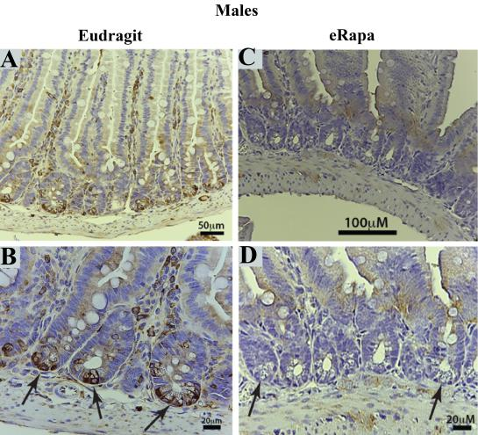  A | 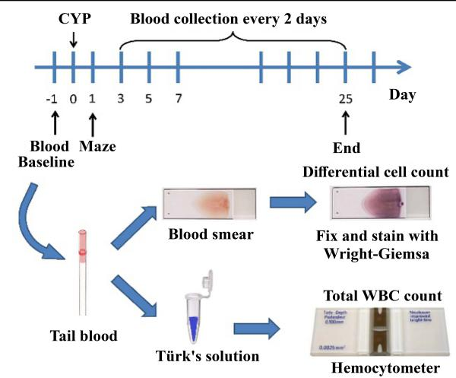  B
C
Figure 1. We present examples of electron micrograph, non-editable and editable images in Figure 1A-C. A: description of what the Figure 1A is; B: description of what the Figure 1B is; C: description of what the Figure 1C is.
Figure notes:
- Figures should be cited in numeric order (e.g., Figure 1, Figure 2) and placed after the paragraph where it is first cited;
- Figures can be submitted in format of tiff, psd, AI or jpeg, with resolution of 300-600 dpi;
- Diagrams with describing words (including, flow chart, coordinate diagram, bar chart, line chart, and scatter diagram, etc.) should be editable in word, excel or powerpoint format. Non-English information should be avoided;
- Please use the font in “Times New Roman” format for the text in the chart
- Labels, numbers, letters, arrows, and symbols in figure should be clear, of uniform size, and contrast with the background;
- Symbols, arrows, numbers, or letters used to identify parts of the illustrations must be identified and explained in the legend;
- Internal scale (magnification) should be explained and the staining method in photomicrographs should be identified;
- All non-standard abbreviations should be explained in the legend;
- Authors should pay attention to the protection of patients’ rights, such as privacy and portrait, and obtain signed patient consent from authors before using any personal information of patients. The patient’s portrait with full characters and his/her real name is not allowed for use;
- Permission for use of copyrighted materials from other sources, including re-published, adapted, modified, or partial figures and images from the internet, must be obtained. It is authors’ responsibility to acquire the licenses, to follow any citation instruction requested by third-party rights holders, and cover any supplementary charges.
CONCLUSION
In this part, authors should summarize the principle conclusions of the study. In details, it may contain a summary of key findings, a statement about strengths and limitations of the studies, or the implications of the work for future research, etc. An attractive and interesting conclusion is always welcome.
Tips:
- Avoid redundant explanations to data or other materials given in the Introduction or the Results section;
- Contributors should avoid making statements on economic benefits and costs except for economic data and analyses that serve as an integral part of the manuscript.
DECLARATIONS
Acknowledgments
Anyone who contributed towards the article but does not meet the criteria for authorship, including those who provided professional writing services or materials, should be acknowledged. Authors should obtain permission to acknowledge from all those mentioned in the Acknowledgments section. This section is not added if the author does not have anyone to acknowledge.
Authors’ contributions
Single author:
The author contributed solely to the article.
Two or more authors:
Made substantial contributions to conception and design of the study and performed data analysis and interpretation: Salas H, Castaneda WV;
Performed data acquisition, as well as provided administrative, technical, and material support: Castillo N, Young V
…
Availability of data and materials
Authors should declare where the data supporting their findings can be found. Data can be deposited into data repositories or published as supplementary information in the journal. Authors who cannot share their data should state that the data will not be shared and explain it.
If a manuscript does not involve such issue, please state “Not applicable.” in this section.
Financial support and sponsorship
If there are sources of funding for the study reported, any relevant grant numbers and the link of funder’s website should be provided if any. The role of the funding body in the experiment design, collection, analysis and interpretation of data, and writing of the manuscript should be declared:
This work was supported by Grant name XX (No. XXXX; No. XXX)...
If there is no grant:
None.
Conflicts of interest
If there are any potential conflicts of interest that may be perceived as inappropriately influencing the representation or interpretation of reported research results, please declare here.
If not, please write as “All authors declared that there are no conflicts of interest.”.
Some authors may be bound by confidentiality agreements. In such cases, in place of itemized disclosures, we will require authors to state “All authors declare that they are bound by confidentiality agreements that prevent them from disclosing their conflicts of interest in this work.”.
If authors are unsure whether conflicts of interest exist, please refer to the “Conflicts of Interest” of ANT Editorial Policies for a full explanation.
Ethical approval and consent to participate
Research involving human subjects, human material or human data must be performed in accordance with the Declaration of Helsinki and approved by an appropriate ethics committee. An informed consent to participate in the study should also be obtained from participants, or their parents or legal guardians for children under 16. A statement detailing the name of the ethics committee (including the reference number where appropriate) and the informed consent obtained must appear in the manuscripts reporting such research.
Studies involving animals and cell lines must include a statement on ethical approval. More information is available at Editorial Policies.
If the manuscript does not involve such issue, please state “Not applicable.” in this section.
Consent for publication
Manuscripts containing individual details, images or videos, must obtain consent for publication from that person, or in the case of children, their parents or legal guardians. If the person has died, consent for publication must be obtained from the next of kin of the participant. Manuscripts must include a statement that a written informed consent for publication was obtained. Authors do not have to submit such content accompanying the manuscript. However, these documents must be available if requested.
If the manuscript does not involve this issue, state “Not applicable.” in this section.
Copyright
Authors retain copyright of their works through a Creative Commons Attribution 4.0 International License that clearly states how readers can copy, distribute, and use their attributed research, free of charge. Authors are required to sign License to Publish before formal publication.
REFERENCES
Identify references in the text by alphabetic numerals e. g. [1-3] or [1, 2]. The reference list should be separated from the text; references must be numbered consecutively in the order in which they are mentioned in the text. Use the style of the examples below, which are based on the formats used by the NLM in Index Medicus. The titles of journals should be abbreviated according to the style used in Index Medicus. Use complete name of the journal for non-indexed journals. Avoid using abstracts as references. Information from manuscripts submitted but not accepted should be cited in the text as "unpublished observations" with written permission from the source. Avoid citing a "personal communication" unless it provides essential information not available from a public source, in which case the name of the person and date of communication should be cited in parentheses in the text.
Reference to a journal publication:
King VM, Armstrong DM, Apps R, et al. Numerical aspects of pontine, lateral reticular, and inferior olivary projections to two paravermal cortical zones of the cat cerebellum. J Comp Neurol 1998: 390:537-551.
Reference to a book
Voet D, Voet JG. Biochemistry. New York: John Wiley & Sons 1990. 1223 p.
Reference to a website
Cancer Research UK, 1975. Cancer statistics reports for the UK. http://www.cancerresearchuk.org/aboutcancer/statistics/cancerstatsreport/ (accessed 13.03.03).
For other types of references, please refer to U.S. National Library of Medicine.
The journal also recommends that authors prepare references with a bibliography software package, such as EndNote to avoid typing mistakes and duplicated references.
Supplementary Materials
Additional data and information can be uploaded as Supplementary Materials to accompany the manuscripts. The supplementary materials will also be available to the referees as part of the peer-review process. Any file format is acceptable, such as data sheet (word, excel, csv, cdx, fasta, pdf or zip files), presentation (powerpoint, pdf or zip files), image (cdx, eps, jpeg, pdf, png or tiff), table (word, excel, csv or pdf). All information should be clearly presented. Supplementary materials should be cited in the main text in numeric order (e.g., Supplementary Figure 1, Supplementary Figure 2, Supplementary Table 1, Supplementary Table 2, etc.). The style of supplementary figures or tables complies with the same requirements on figures or tables in main text.

