**Review**

Medication-related osteonecrosis of the jaw-A case report and literature review

Da-ming Liao1, Meng-yu Xie2, Chieh Chen3

1 Department of Dental, Puli Christian Hospital, Taiwan.

2 Department of Dental, Hualien Armed Forces General Hospital, Taiwan.

3 Division of family medicine, Hualien Armed Forces General Hospital, Taiwan.

Corresponding Author: Chieh Chen

No. 36, Lane 100, Section 2, Zhongshan Road, Taiping District, Taichung City, Taiwan

(+886)0928-698950

Email: [guppy5230@yahoo.com.tw](mailto:guppy5230@yahoo.com.tw)

Running title: Osteonecrosis of the jaw

**Abstract**

Osteoporosis is a skeletal disease caused by changes in the structure of the human skeleton, resulting in fragile and easily fractured bones. Because it is more common in postmenopausal women or the elderly, fractures may cause disability in the elderly, resulting in reduced quality of life, bedridden or increased mortality. Therefore, the treatment of osteoporosis is one of the important issues in today's aging society. In addition, diseases such as bone metastasis of cancer and multiple myeloma also need to be paid attention to. Drugs for the treatment of osteoporosis have been widely used in the prevention and treatment of osteoporosis because of their inhibitory effect on osteoclast activity, and even become the first-choice drug for bone metastases of some malignant tumors. Drugs for the treatment or prevention of osteoporosis can inhibit osteoclasts, and can also be used to treat hypercalcemia complications of malignant tumors or bone-related systemic diseases. For example, bisphosphonates or monoclonal antibody preparations (eg: Denosumab, Romosozumab, etc.) can resist bone resorption. However, in recent years, the literature pointed out that patients using anti-bone resorption drugs may have adverse reactions of maxillofacial osteonecrosis. Medication-related osteonecrosis of the jaw (MRONJ) may occur in patients with osteoporosis and tumors. Bisphosphonates or synthetic human monoclonal antibodies can inhibit bone resorption, and are currently the most commonly used drugs for the treatment of osteoporosis in the world. The literature for nearly 20 years has shown that long-term use of such antiresorptive drugs increases the risk of osteonecrosis of the jaw in the oral cavity. Therefore, MRONJ is still a complication that we must pay attention to. Once MRONJ occurs, it is recommended to refer to an oral surgeon immediately; the current clinical treatment methods include the use of antibacterial mouthwash and drugs to control pain in mild cases, and antibiotics for infection control in moderate cases.

**Keywords:** fracture prevention; osteoporosis; medication-related osteonecrosis of jaw; bone anti-resorptive agent; osteonecrosis of the jaw.

**Introduction**

There are more and more older people in Taiwan's. Presently, nearly one-fifth of the elderly population (the elderly are defined as those over 65 years old), so the future public health policy will focus on the care of the elderly and for the prevention of diseases of older age. Among many senile diseases, osteoporosis has been concerned. Osteoporosis is skeletal diseases in which bones are fragile and prone to fractures due to changes in the structure of human body. Osteoporosis tends to occur in menopausal women and the elderly population; then resulting fractures most commonly occur in the spine, hip, and distal radius of wrist. Fractures can be disabling and lead to poor quality of life, such as bedridden or increased mortality in the elderly. Therefore, the treatment of osteoporosis is one of the important issues in today's aged society. Osteoporosis is a common skeletal metabolic disease in the older people. It can cause persistent bone density loss, bone fragility, and low bone mineral density (BMD), so it is easy to cause non-traumatic fractures [1].

**Case**

A 42-year-old woman, five months after receiving regular chemotherapy for stage IV breast cancer, found bone metastases due to nuclear medicine scans, and used Denosumab (Prolia) subcutaneous injection to relieve the discomfort of the bone pain. When she went to the dental clinic for her gum inflammation, the Dr. Liao found that there was osteonecrosis of the mandible (Figure 1, Figure 2).

**Discussion**

**Definition of MRONJ**:

The latest definition of medication-related osteonecrosis of the jaw [2] is a consensus issue by the American Academy of Oral and Maxillofacial Surgery in 2022. The diagnosis of this type of disease must meet the following three items:

1.Current or previous treatment with antiresorptive therapy alone or in combination with immune modulators or anti-angiogenesis drugs.

2.Exposed bone or bone that can be probed through an intraoral or extraoral fistulae in the maxillofacial region that has persisted for more than 8 weeks. Internal and external fistulas protrude to the surface of the bone and persist for more than eight weeks.

3.No history of radiation therapy to the jaws or metastatic disease to the jaws. (No history of radiation therapy to the jaws or metastatic disease to the jaws).

**Incidence rate**:

The proportion of MRONJ due to the use of drugs in the world is relatively small, but it is still listed as a common adverse reaction of antiresorptive drugs [3]. Among patients with osteonecrosis of the jaw, its pathogenic mechanism has not been fully elucidated; however, since Marx et al. published 36 cases in 2003, osteonecrosis of the jaw occurred mainly due to long-term use of bisphosphonates [4]. According to the data of the American Society of Oral and Maxillofacial Surgery in 2022, the risk of osteoporosis patients getting MRONJ is less than 0.05%; the risk of malignant tumors is higher, less than 5%. In patients with osteoporosis, the incidence of osteonecrosis of the jaw after injection of denosumab will increase (0.04-0.3%), while those using bisphosphonates will have a lower risk (0.02-0.05%). Many articles that report in the world pointed out that, the incidence of MRONJ was 0.283% per year in patients treated with osteoporosis using oral BPs (bisphosphonate such as alendronate), but the incidence of MRONJ increased to 0.92% in the tenth year [5,6]. Taiwan's data shows that MRONJ the average age is 73 years old, and 3/4 were women. Therefore, it is necessary to educate patients to monitor themselves before using drugs, and ask patients to inform the dentist before tooth extraction.

**Pathophysiological mechanism**

The process of bone metabolism starts with osteoclasts contacting the bone surface and decomposing the bone matrix. During the process of bone matrix being decomposed, growth factors are released at the same time to stimulate the formation of osteoblasts, which then form mature bones. Rizzoli [4] put forward a theory in 2008, stating that the pathological causes of delayed jawbone healing caused by bisphosphonates include: 1.Affecting angiogenesis. 2.Affect bone metabolism, 3.Inflammation, trauma and oral surgery. When bisphosphonates are attached to the bone tissue and then absorbed by osteophagocytic cells, they inhibit the development of osteophagic cells by stimulating the release of osteophagic inhibitory molecules, indirectly causing the self-apoptosis of osteophagic cells and inhibiting bone regeneration and re-absorbtion. Once bisphosphonates are combined with bones, they are difficult to be metabolized by the human body, and will be attached to bones for a long time. Taking alendronate as an example, the half-life in bones exceeds ten years. Both denosumab and romosozumab are human monoclonal antibodies that can be used in patients with osteoporosis, but their mechanism of action is different. Denosumab is a receptor activator of nuclear factor kappa-B ligand (RANK-L) inhibitor, which can inhibit osteoclasts. It has a short half-life and its efficacy will disappear six months after injection. Romosozumab regulates the Wnt pathway and combines with sclerostin to increase bone formation and reduce bone resorption [7]. The treatment of osteoporosis relies on inhibiting the activity of osteoclasts, but over-inhibition of the activity of osteoclasts may lead to excessive accumulation of inactive bone cells, causing continuous micro-trauma to the bones and increasing the probability of osteonecrosis of the jaw [8,9]. Bone resorption drugs enter the human body and hinder the progress of osteoclasts [2], when the dead bone cells cannot be decomposed and release the growth factors contained in the cells, the osteogenesis cannot proceed, and the dead bone cannot be replaced by new bone cells. Drugs that inhibit bone resorption can also cause jaw bone ischemia, immune dysfunction, and poor oral hygiene, following by secondary infections, which become the type of osteomyelitis MRONJ. Clinical symptoms include pain, infection, and poor oral hygiene (Figure 3) [10-12]. Because the jawbone has a faster rate of bone turnover than other bones, the jawbone will be affected more [13, 14]. If bone necrosis occurs in the jawbone, the gum soft tissue attached to the necrotic jawbone will also be necrotic. Especially in elderly patients, carrion will be found in the oral cavity, and the exposed area will also be due to traumatic fractures of the jawbone, tooth extraction, and inappropriate activities. Factors such as dentures, severe periodontal diseases, or oral infections caused by deep caries, become more serious. Other non-specific symptoms are mostly gingival inflammation, swelling, suppuration, bleeding, loose teeth, unhealed wounds, numbness of the jawbone, exposed alveolar, bone resorption, bone sclerosis, moth-eaten and Rotten bones spawn.

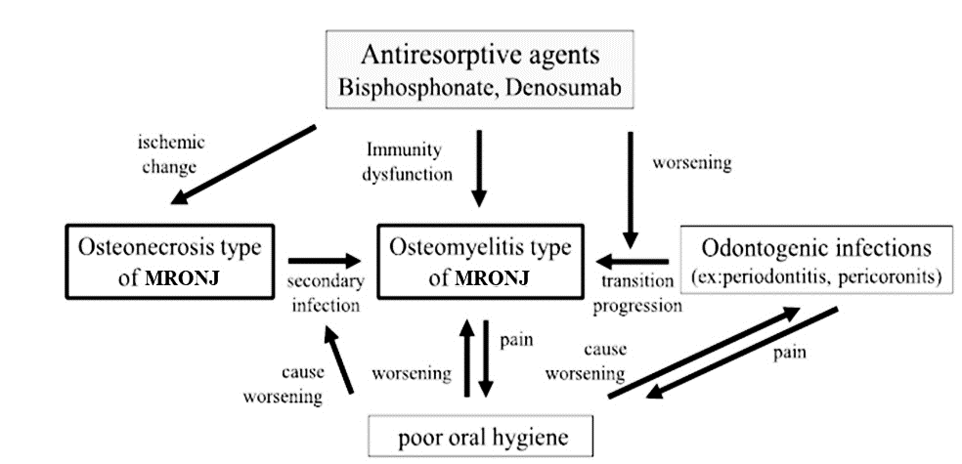

Figure 3. The relationship between the type of osteonecrosis of the jaw and the type of osteomyelitis. Predisposing causes for MRONJ include drug use, infection, individual immunity, skeletal ischemia, and periodontal disease, taken from references [10-12].

**Risk factor** **of MRONJ**

The risk factors for medication-related osteonecrosis of the jaw are drugs that inhibit bone resorption; in addition, other causes that make MRONJ more likely to occur are considered to be called initiating factors [15], such as the patient's own chronic systemic diseases, inflammatory conditions of the jaw itself, etc. Discussion of risk factors is mainly divided into three categories for discussion [16], 1.Drug-related factors and their indications; 2.Local factors; 3.Systemic factors.

1. Drug-related factors:

Drug-related factors include: dose, dosage form, potency, or duration of use. Among osteoporosis patients, the incidence rate of patients who use oral bisphosphonates is about 0.05%; the incidence rate of patients who use Denosumab (DMB) is about 0.3% in ten years; but cancer patients will use more doses than osteoporosis patients. The probability of producing MRONJ will increase to 0.03%-5%. Osteonecrosis occurred in 0% - 0.15% of patients with osteoporosis and 1% in DMB patients who received bisphosphonates for jawbone-related surgery. In cancer patients, the rate ranged from 1.6%-14.8%; while the proportion of cancer patients with MRONJ is higher, obviously the influence of drug dose is huge. In addition, the duration of drug use will also affect. Generally using bisphosphonate or DMB in patients with malignant tumors increases, and the incidence of MRONJ is higher. Among osteoporosis patients, bisphosphonate for four years or more is even a 0.21% chance that users will have MRONJ.

2. Local factors:

Since the bone turnover rate of the jawbone is several times that of the long bones [14,16], MRONJ mainly presents oral-related symptoms, and patients often suffer from oral alveolar bone disease, surgery or trauma. For example, Osteonecrosis of the jaw occurs only from local infections, tooth extractions, implants, wounds or pressure sores caused by improperly fitted dentures. Therefore, dental treatments such as tooth extractions will be considered as the most important risk factors in the study. However, the cause-and-effect relationship is also because the alveolar bone wounds in the oral cavity are easily affected by anti-resorptive drugs, resulting in slower healing, infection and even osteonecrosis. Alveolar bone surgery is still listed as a relevant local factor in the current literature, and the mandibular bone accounts for 75% of the jawbone, which is the most prone location for MRONJ. If there are exostoses in the jawbone or the alveolar ridge behind the mandible, there are more chances of ulceration due to the pressure of the dentures or the thinner mucosa, which in turn increases the chance of osteonecrosis [17]. The original inflammation in the oral cavity can also cause MRONJ. Before taking anti-resorptive drugs or such drugs, the inflammation in the teeth, including periodontitis or periapical inflammation, etc., or the bone caused by abnormal occlusion. Injuries can also increase the probability of osteonecrosis. Studies have also found that dental examination and treatment before treatment can significantly reduce the occurrence of MRONJ [16].

3. Systemic factors:

Many systemic or demographic risk factors, including age, postmenopausal women, patients on long-term systemic steroid therapy, cancer, anemia, diabetes mellitus, hyperparathyroidism, rheumatoid arthritis, low serum calcium level, etc. and even smokers etc. Since anti-resorptive agents are often used by female cancer patients and osteoporosis patients, chronic diseases and bad living habits, such as diabetes and smoking, will affect peripheral blood supply and affect wound healing, but whether it is a direct risk factors are still inconclusive [2,16].

**Timing of referral for medication-related osteonecrosis of the jaw**

After long-term use of anti-resorptive drugs, various symptoms of MRONJ may appear, including gingival or oral mucosa rupture, redness, swelling and pain of the gums, increased shaking of the teeth around the affected area; in addition to the exposure of the alveolar bone, sometimes the surrounding soft tissues inflammation and swelling, suppuration and infection may occur. If the mandibular bone lesion affects the inferior alveolar nerve, there will be numbness of the lips; the maxillary bone lesion may cause the mouth, nose and sinuses to communicate and sinusitis. If you have the above symptoms, you should immediately refer to an oral surgeon. If you need dental surgery, you must arrange a return visit every six to eight weeks to ensure the successful healing of the gingival mucosa [12,14,16,18,19]. In 1994, the World Health Organization evaluated osteoporosis and recommended that the bone density value be used as the diagnostic standard. The bone density value of any bone in the body is lower than -2.5 standard deviations of the average value of 20-year-old young women (T-score is less than -2.5) can be diagnosed as osteoporosis. If combined with fractures, it is called severe osteoporosis; the bone density value is between -1 and -2.5 standard deviations (T-score is between -1 and -2.5), then called osteopenia, bone density value higher than -1 standard deviation (T-score greater than -1) is normal. Drugs for the treatment or prevention of osteoporosis can inhibit osteoclasts, and can also be used to treat hypercalcemia complications of malignant tumors or bone-related systemic diseases, such as bisphosphonates (BPs) (Table 1) or monoclonal antibody preparations such as Denosumab (DMB), Romosozumab etc., can resist bone resorption; however, recent literature has pointed out that patients who use anti-resorptive drugs may have adverse reactions of maxillofacial osteonecrosis [1], and this adverse reaction is currently often known as medication-related osteonecrosis of the jaw (MRONJ), or it used to be called bisphosphonate-related osteonecrosis of the jaw (BRONJ). Since the American Association of Oral and Maxillofacial Surgeons (AAOMS) published a consensus document in 2007, it was updated in 2009, 2014, and 2022 in order to spread the knowledge and experience development of MRONJ. The American Academy of Oral and Maxillofacial Surgeons believes that physicians should be familiar with the adverse side effects of MRONJ associated with anti-resorptive or anti-angiogenic drugs; dentists treat patients with risky drugs such as osteoporosis, multiple sclerosis, rheumatoid arthritis , multiple myeloma, or patients with bone metastases of cancer, special caution should be exercised.

**Clinical Treatment and Prevention Strategies**

The best way to reduce MRONJ is to prevent it. The public should go to the dentist every six months to reduce the occurrence of tooth decay and periodontal disease [12,18]. During the period of medication, good oral hygiene should be maintained. Discomfort symptoms and oral health you should take the initiative to inform the dentist about the history of osteoporosis, cancer or tumor-related medication, such as bisphosphonates, steroids, etc. When doing invasive dental treatment, and fully communicate with the dentist to understand the incidence of osteonecrosis of the jaw and preventive methods; physicians need to be more cautious before prescribing anti-resorptive drugs. It is recommended to consult an oral surgeon or dentist to evaluate the oral condition. Complete caries filling, root canal treatment, and periodontal disease treatment to reduce the chance of osteonecrosis of the jaw. Table 2 shows the prevention strategies recommended by the American Academy of Oral and Maxillofacial Surgeons in 2022. Once MRONJ occurs, referral to an oral surgeon is recommended (Table 2). The current clinical treatment methods are to use antibacterial mouthwash and drugs to control pain in mild cases, and antibiotics to control infection in moderate cases [19], supplemented by conservative bone decay surgery. If severe osteonecrosis occurs, large-scale surgery will be performed. Extensive bone debridement surgery, even jawbone resection and reconstruction; the use of hyperbaric oxygen therapy(HBO) is still controversial. There are reports that hyperbaric oxygen combined with drug withdrawal can significantly and continuously relieve the effect. In addition, after using hyperbaric oxygen, most patients have short-term remission Phenomenon, but easy to relapse.

Table 1. Bisphosphonates frequently used on the market and their route of use.

|  |  |  |  |
| --- | --- | --- | --- |
| Agent components | | Product name | FDA approval |
| Pamidronate | | Aredia, IV | 1991 |
| Tiludronate | | Skelid, PO | 1997 |
| Alendronate sodium | | Fosamax, PO | 1995 |
| Etidronate | | Didronel, PO | 1997 |
| Risedronate | | Actonel, PO | 1998 |
| Zoledronic acid | | Aclasta, Zometa, IV | 2007, 2001 |
| Ibandronate | | Bonviva, IV | 2003 |
| Table 2. MRONJ PREVENTION STRATEGIES [12] | | | | |
| Pretherapy (Nonmalignant  Disease) | •Educate patient about the potential risks associated with long-term ART.*  •Optimization of dental health can occur concurrent with ART. | | | |
| Pretherapy (malignant disease) | •Educate patients about the higher risk of MRONJ and the importance of regimented dental care.  •Optimization of the dental health *prior* to the initiation of ART if systemic conditions permit (extraction of nonrestorable teeth or teeth with a poor prognosis). | | | |
| During antiresorptive therapy  (nonmalignant disease) | •No alteration of operative plan for most patients.  •Considerations include drug schedule, duration of therapy, comorbidities, other medications (especially chemotherapy, steroids, or antiangiogenics), degree of underlying infection/inflammation, and extent of surgery to be  performed. Drug holidays are controversial.  •BTM† are not a useful tool to assess MRONI risk | | | |
| During antiresorptive therapy/  targeted therapies (malignant  disease) | •Educate patients about the higher MRONJ risk in the setting of malignant disease.  •Educate the patient about the importance of regimented dental care and prevention.  •Avoid dentoalveolar surgery if possible.  •Consider root retention techniques to avoid extractions.  •Dental implants are contraindicated.  •Drugs holiday are controversial. | | | |
| * Antiresorptive therapies.  †Bone turnover markers (CTX).  *Ruggiero et al. AAOM’ Position Paper on MRONJ-2022 Update. J Oral Maxillofac Surg 2022.* | | | | |

**Conclusion**

Drugs for the treatment or prevention of osteoporosis can inhibit osteoclasts, and can also be used to treat hypercalcemia complications of malignant tumors or bone-related systemic diseases, such as bisphosphonates or monoclonal antibody preparations (such as Denosumab, Romosozumab, etc.) can resist bone resorption; however, recent literature has pointed out that patients who use anti-resorptive drugs may have adverse reactions of maxillofacial osteonecrosis; bisphosphonates can inhibit bone resorption. At present, which it is one of the most commonly used drugs for the treatment of osteoporosis in the world, but many case reports have presented more and more evidence that long-term use of bisphosphonates increases the risk of adverse reactions of oral severe osteonecrosis of the jaw. In addition, osteoporosis drugs that may cause osteonecrosis of the jaw include 1.The incidence of bisphosphonates such as oral Alendronate is about 0.004-0.1%, and intravenous Zoledronate is about 0.017%. Generally, oral drugs have a lower incidence of jaw osteonecrosis than injection drugs; 2.The incidence rate of Denosumab synthetic human monoclonal antibody (Prolia™) was 0.04%. Anti-resorptive drugs can reduce the incidence of fractures caused by osteoporosis, and can also treat cancer bone metastases and multiple myeloma, etc. [20]. But before using these agents, patients and their families must be informed of the risk of osteonecrosis of the jaw, and patients should be advised not to treat osteoporosis. In addition to caring for cancer and tumors, the health of the oral cavity and jawbone must also be taken care of. In addition, all specialists need to work together to formulate an appropriate treatment plan based on each patient's different diseases and medication methods, in order to effectively reduce the occurrence of MRONJ.

**Reference**

1. Aguirre JI, Castillo EJ, Kimmel DB. Biologic and pathologic aspects of osteocytes in the setting of medication-related osteonecrosis of the jaw (MRONJ). Bone 2021; 153: 116168.
2. Ruggiero SL, Dodson TB, Aghaloo T, et al: American Association of Oral and Maxillofacial Surgeons’ Position Paper on Medication-Related Osteonecrosis of the Jaw–2022 Update. J Oral Maxillofac Surg. 2022; 80: 920-43.
3. Marx RE: Pamidronate (Aredia) and zoledronate (Zometa) induced avascular necrosis of the jaws: a growing epidemic. Journal of oral and maxillofacial surgery 2003; 61: 1115-7.
4. Rizzoli R, Burlet N, Cahall D, et al: Osteonecrosis of the jaw and bisphosphonate treatment for osteoporosis. Bone 2008; 42: 841-7.
5. Chiu WY, Chien JY, Yang WS, et al: The risk of osteonecrosis of the jaws in Taiwanese osteoporotic patients treated with oral alendronate or raloxifene. The Journal of Clinical Endocrinology & Metabolism 2014; 99: 2729-35.
6. Aguirre JI, Castillo EJ, Kimmel DB: Preclinical models of medication-related osteonecrosis of the jaw (MRONJ). Bone 2021; 153: 116184.
7. Marx RE: Understanding Drug-Induced Osteonecrosis of the Jaws. In: Drug-Induced Osteonecrosis of the Jaws: How to Diagnose, Prevent, and Treat It. 1st ed. Quintessence Publishing, 2022: 3–8.
8. Dunphy L, Salzano G, Gerber B, Graystone J: Medication-related osteonecrosis (MRONJ) of the mandible and maxilla. BMJ Case Reports CP 2020; 13: e224455.
9. Allen MR, Burr DB: The pathogenesis of bisphosphonate-related osteonecrosis of the jaw: so many hypotheses, so few data. Journal of Oral and Maxillofacial Surgery 2009; 67: 61-70.
10. AlDhalaan NA, BaQais A, Al-Omar A: Medication-related osteonecrosis of the jaw: a review. Cureus 2020; 12: 1-8.
11. Kishimoto H, Noguchi K, Takaoka K: Novel insight into the management of bisphosphonate-related osteonecrosis of the jaw (BRONJ). Japanese Dental Science Review 2019; 55: 95-102.
12. Ruggiero SL, Dodson TB, Fantasia J, et al: American Association of Oral and Maxillofacial Surgeons position paper on medication-related osteonecrosis of the jaw—2014 update. Journal of oral and maxillofacial surgery 2014; 72:1938-56.
13. Soutome S, Otsuru M, Hayashida S, Murata M, Yanamoto S, Sawada S, et al: Relationship between tooth extraction and development of medication-related osteonecrosis of the jaw in cancer patients. Scientific Reports 2021; 11(1): 1-8.
14. Dixon RB, Tricker ND, Geretto LP: Bone turnover in early canine mandible and tibia. J Dent Res 1997; 76: 336.
15. Kwon TG: Risk Factors for Medication-Related Osteonecrosis of the Jaw. In: Medication-related osteonecrosis of the jaws. Bisphosphonates, Denosumab, and New Agents Springer Publishing, 2015: 32-3.
16. Nicolatou-Galitis O, Schiødt M, Mendes RA, et al: Medication-related osteonecrosis of the jaw: definition and best practice for prevention, diagnosis, and treatment. Oral surgery, oral medicine, oral pathology and oral radiology 2019; 127: 117-35.
17. Fliefel R, Tröltzsch, M, Kühnisch J, et al: Treatment strategies and outcomes of bisphosphonate-related osteonecrosis of the jaw (BRONJ) with characterization of patients: a systematic review. International journal of oral and maxillofacial surgery 2015; 44: 568-85.
18. Kuroshima S, Sasaki M, Sawase T: Medication-related osteonecrosis of the jaw: A literature review. Journal of oral biosciences 2019; 61: 99-104.
19. Querrer R, Ferrare N, Melo N, et al: Differences between bisphosphonate-related and denosumab-related osteonecrosis of the jaws: a systematic review. Supportive Care in Cancer 2021; 29: 2811-20.
20. Yao S, Ding X, Rong G, et al: Association Between Malignant Diseases and Medication-Related Osteonecrosis of the Jaw (MRONJ): A Systematic Review and Meta-Analysis. Journal of Craniofacial Surgery 2022; 1090-97.

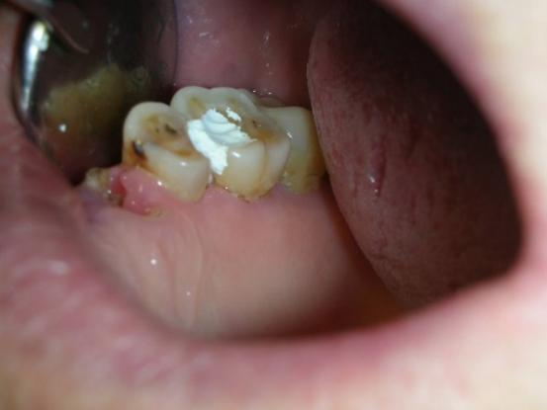

Figure 1. MRONJ in cancer patients taking anti-resorptive agents.

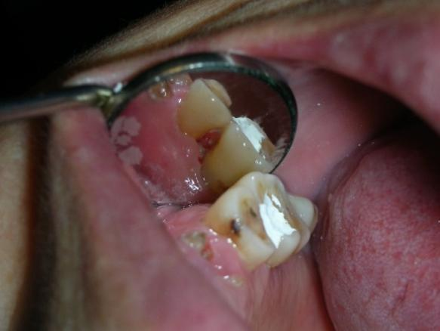

Figure 2. MRONJ in cancer patients taking anti-resorptive agents.



Figure 3. The relationship between the type of osteonecrosis of the jaw and the type of osteomyelitis. The reasons for prone BRONJ include the use of drugs, infection, individual immunity, bone ischemia, periodontal disease, etc. Drugs that inhibit bone resorption, such as BPs or Denosumab, will cause jaw bone ischemia, immune dysfunction, and oral conditions. Poor, then may develop into BRONJ of osteomyelitis type, or secondary infection into BRONJ of osteomyelitis type, clinical symptoms include pain, infection, and poor oral hygiene are mutually causal [10-12].