Review

Senescence of mesenchymal stem cells: implications in extracellular vesicles, miRNAs and their functional and therapeutic potentials

Liangge He^{a, b}, Mingzhu Liª, Zhen Liu^{b}, Arshad Ahmed Padhiar^{c}, Guangqian Zhou^{b}*

ª Guangdong Key Laboratory of Genomic Stability and Disease Prevention, Shenzhen Key Laboratory of Anti-Aging and Regenerative Medicine, Shenzhen Engineering Laboratory of Regenerative Technologies for Orthopedic Diseases, Department of Medical Cell Biology and Genetics, Shenzhen University Medical School, Shenzhen, 518060, China.
^{b} Guangdong Key Laboratory for Biomedical Measurements and Ultrasound Imaging, National-Regional Key Technology Engineering Laboratory for Medical Ultrasound, School of Biomedical Engineering, Shenzhen University Medical School, Shenzhen 518060, China.
^{c} Lungene Biotech Ltd., Longhua District, Shenzhen,518107, China.

*Corresponding author: Guangqian Zhou
Mailing address: Department of Medical Cell Biology and Genetics, Shenzhen University, 1066 Xueyuan Avenue, Shenzhen 518060, China.
E-mail: gqzhou@szu.edu.cn.

Abstract
Senescence is seen as the cellular counterpart of tissue and biological aging, with irreversible stagnation of cell growth, and changes in function and behavior. Mesenchymal stem cells (MSCs) are one of the key therapeutic tools in regenerative medicine, and their regenerative and therapeutic potential declines significantly with the increasing age of cell donors and prolonged continuous culture in vitro. MicroRNAs (miRNAs) are regarded as important players in regulating the expression and function of multiple genes and pathways. Emerging evidence suggests that extracellular vesicles (EVs) participate in a complex cell senescence network, at least partially by providing certain miRNAs. Therefore, MSC EVs and miRNAs are implicated in not only contributing to but also influenced by MSC senescence. Here, we will provide an overview of the recent results on roles and mechanisms of miRNAs, particularly EV-miRNAs, involved in MSC senescence, and discuss their implications in functional properties and therapeutic efficacy of MSCs and their EVs.
Keywords: Extracellular vesicles, microRNAs, mesenchymal stem cells, senescence

Introduction
Stem cells offer the foundation of regenerative medicine. Based on the plasticity of stem cells, in vitro and in vivo induction or gene modification methods can make them transdifferentiate into therapeutic cells to achieve therapeutic purposes. Mesenchymal stem cells (MSCs) are one of the most accepted therapeutic cells in regenerative medicine and tissue engineering [1]. MSCs can be obtained from a rather wide range of adult tissues (e.g., muscles, bone marrow (BM), and adipose tissue) and neonatal tissues (e.g., umbilical cord (UC), placenta, and amnion), and amplified by in vitro expansion [2], easily reaching the manufacturing levels. MSCs have the potential for self-renewal and multi-lineage differentiation and exert pro-angiogenesis, pro-proliferation, anti-apoptotic, anti-fibrosis, and anti-inflammatory functions through the interaction between cells and the secretion of many soluble factors [3].
Cellular senescence refers to the irreversible stagnation of cell growth under the action of various stress factors and may be important to prevent the proliferation of damaged cells and acts as a barrier to tumor lesions [4]. However, cells that undergo permanent proliferation arrest may be detrimental to the entire individual, and senescent cells are present in aging tissues and accumulate in an age-dependent manner that accelerates the decline of tissue function and contributes to the development of age-related diseases [5]. The regenerative and therapeutic potential of MSCs decreased significantly with the increasing age of the cell donor. In cell-based therapy and tissue engineering, MSCs require prolonged and large-scale in vitro manufacture, in which continuous expansion may lead to replicative senescence [1], likely constraining the manufacturing quantity in return. Senescent MSCs usually show decreased regenerative ability, reduced differentiation ability, and weakened immune-regulatory functions, and thus possibly fail to achieve optimal therapeutic outcomes. In order to manufacture the highest quantity of MSCs with optimal functional properties, there is an urgency to develop technologies to easily assess and delay the replicative senescence of MSCs.
MicroRNAs (miRNAs) are a class of special small RNAs composed of about 22 nucleotides that selectively bind to the 3’-untranslated region (3’-UTR) of the mRNA sequence and regulating the translation and stability of the targeted mRNA, thus altering gene expression without changing the genetic code [6, 7]. MiRNAs are important regulators of senescence-related gene expression. Most miRNAs that regulate stem cell senescence have been shown in MSCs and hematopoietic stem cells (HSCs) by targeting genes associated with metabolism, epigenetics, and DNA damage [8, 9]. Extracellular vesicles (EVs) are heterogeneous vesicles induced by stimuli such as cell differentiation, activation, senescence, and transformation. They are formed by lipid bilayer membranes and contain proteins, nucleic acids, lipids, and their derivatives. EVs are an important participant in cell-to-cell communication and can precisely regulate receptor cell senescence and inflammation under various physiological and pathological conditions [10, 11]. It has been reported that miRNAs released in the extracellular environment by cell-secreted EVs can influence the senescence of surrounding cells. In this review, we will focus on the latest advances in the regulatory role of miRNAs, especially those in EVs, in MSC senescence, and their application potentials.

MSC senescence
Although MSCs originate from the mesoderm, they can differentiate into mesodermal tissues (e.g., adipose, bone, cartilage, and hematopoietic tissues) and non-mesodermal tissues (e.g., neurons and glial cells) [12, 13]. Due to their self-renewal, multipotent differentiation, and immunomodulatory properties, MSCs are considered ideal candidates to replace damaged or lost cells and tissues in vivo. Thus far, MSCs are widely used for regenerative medicine and tissue engineering and are currently the focus of over thousands of clinical trials, showing significant therapeutic capacity in a broad range of diseases, such as pulmonary fibrosis [14], myocardial infarction [15], and diabetes mellitus [16].
Senescence is a physiological process of organisms and is associated with a decline in MSC activity, which slows tissue repair and maintenance [17]. In vitro, proliferation arrest is the major characteristic of cell senescence. With the accumulation of undegraded macromolecules, senescent cells show morphological enlargement, flattening, and extensive vacuolization [18], accompanied by increased senescence-associated β-galactosidase (SA-β-gal) activity, DNA damage, telomere shortening, and genomic instability.
In tissues or organisms, senescent cells can transmit signals to surrounding tissues through senescence-associated secretory phenotype (SASP), which consists of basic fibroblast growth factor (FGF), cytokines (interleukin-6 (IL-6), IL-1β), chemokines (IL-8, and monocyte chemoattractant protein-1 (MCP-1)), extracellular proteases (matrix metalloproteinases (MMPs)), growth factors (transforming growth factor-beta (TGF-β), hepatocyte growth factor (HGF)), and vascular endothelial growth factor (VEGF) [19]. SASP can in a way help eliminate senescent cells and/or tissue remodeling by promoting phagocytic immune cells and promote the occurrence and development of tumors and age-related diseases by creating a pro-inflammatory microenvironment.
The aging of adult resident MSCs is directly proportional to the old donor, and the functional properties of MSCs deteriorate severely with the increase of donor age. Compared with MSCs from adult tissues, some MSCs from neonatal tissues have a stronger proliferative capacity in vitro, especially under hypoxic conditions [20]. The differentiation efficacy of adult MSCs into certain lineage-specific cells is also influenced by the donor age, while their ex vivo proliferative potential depends on population doubling (PD) and cell passage [21]. The senescence of MSCs influences their replicative potential and properties (e.g., morphology, function, and biomarker), which may affect their therapeutic efficacy. The functional degradation and potentially harmful effects of senescence have limited the application of MSCs in regenerative medicine and tissue engineering. Therefore, it is important to understand the senescence features of MSCs and identify common methods for assessing the MSC status.
During the long-term culture of MSCs in vitro, their proliferative capacity and colony-forming units (CFU) decreased. The proliferation of MSCs slows down at 30-40 PD, stops proliferation, and enters the senescence state when PD reaches a certain level [22]. The number of colonies indicates the clonogenic potential and proliferation ability, and the level of CFU decreased in senescent cells. The CFU of MSCs decreased continuously with the increase of passage and could hardly be detected after the 20th passage [23]. Therefore, detecting PD and CFU indicators of MSCs is a shared method for detecting senescence in vitro.
The size and morphology of MSCs changed significantly during senescence. With long-term culture in vitro, the early MSCs, similar to spindle-forming fibroblasts form, became larger in size, flattened in shape, and increased in cytoplasmic granules [24]. The in vitro imaging system analysis showed that the cell volume of MSCs began to expand at the 5th passage, and the area of ​​the 9th passage cells increased by 4.8 times compared with the 1st passage [25]. The cell size was strongly associated with the increase of SA-β-gal expression and actin stress fibers [26]. Therefore, assessing the morphology and size of MSCs is also a shared method for detecting senescence in vitro. Especially based on the unique morphology of senescent cells, the development of image recognition-related detection technology has excellent application prospects.
MSCs continuously lose their adipogenic and osteogenic differentiation potential during prolonged culture [27]. It has been reported that senescence can transform the osteogenic differentiation potential of MSCs into adipogenic [28]. Rapamycin, an autophagy activator, can restore the biological characteristics of senescent MSCs by increasing proliferation and osteogenic and decreasing adipogenic differentiation [29].
MSCs are involved in regulating the activation and phenotype of innate and adaptive immune cells, including dendritic cells, macrophages, monocytes, natural killer cells, and lymphocytes. When co-cultured with young mice MSCs, mice macrophages retained their original phagocytosis and M2 polarization and showed higher migration rates [30]. With senescence, the protective immunomodulatory functions of MSCs may be altered, such as their reduced ability to inhibit lymphocyte proliferation. With the increase of passages, the ability of MSCs co-cultured with peripheral blood mononuclear cells to inhibit the proliferation of CD4⁺ and CD8⁺ T cells were continuously weakened [31]. In addition to proliferation, senescent MSCs attenuated the inhibitory effects of phytohemagglutinin-stimulated T-cell cytokine and activation-antigen production [32].
The secretory properties of MSCs also change with senescence. The expression of growth factors (TGF-β and HGF), inflammatory cytokines (IL-1, IL-6, and IL-8), and extracellular proteases (MMP1, MMP3, and MMP9) increased in SASP secreted by senescent MSCs [33]. SASP-related factors were increased in the conditioned medium of late passages compared with that of early passages. SASP-related factors drive the senescence of their own or neighboring cells in a cell-autonomous manner or paracrine manner, resulting in negative effects on cellular functions (such as cell adhesion, differentiation, proliferation, and migration) [34].
Specific molecules associated with MSCs--CD markers show different expression patterns at early and late stages. The expression of CD264 is up-regulated during the intermediate stage of cell senescence and continues to be up-regulated during cell senescence, which can be used to evaluate therapeutic potential. When the CD264⁺ proportion is 75%, the regenerative potential of MSCs is severely impaired [35]. On the other hand, the CD146⁺ proportion decreases with the increase in donor age and generation [36]. The expression of CD90⁺ and CD106⁺ is also decreased in senescent MSCs [26]. Leptin receptor (CD295) can be used to mark apoptotic cells and its expression increased with MSCs of advancing biological aging [37].
Telomere shortening and DNA damage are the major mechanisms of senescence. Telomere length is closely related to the replicative potential of cells and tissues. Telomerase prevents telomere shortening and induces elongation by bringing repeated TTAGGG to chromosome ends [38]. However, telomerase almost does not express itself throughout the life cycle of MSCs. Due to the lack of telomerase activity, adult MSCs showed irreversibly shortened telomeres during continuous passages [39]. Oxidative stress is the major cause of DNA damage. Increased oxidative stress-related molecules can induce senescence and growth arrest in MSCs, which are highly sensitive to the accumulation of DNA damage [40]. Elevated intracellular reactive oxygen species (ROS) levels can reduce MSCs proliferation and DNA synthesis [41]. The activity of the antioxidant enzyme (superoxide dismutase (SOD)) decreased in late-generation MSCs, while the levels of nitrogen monoxide (NO), ROS, and gluconate oxidizing enzyme increased [42].
Phosphatidylinositol 3-kinase (PI3K)/v-akt murine thymoma viral oncogene homolog (Akt)/mechanistic target of rapamycin (mTOR) pathways are activated by the high concentration of ROS and are key regulators of the oxidative stress response [43]. Nuclear factor erythrocyte 2-related factor 2 (NRF2) plays an important role as a transcription and regulator factor in oxidative stress response by regulating a variety of antioxidant response element-dependent antioxidant genes [44]. NRF2 activity decreased with the senescence of MSCs. Activation of NRF2 may be an effective method for preventing the deterioration of the MSC growth state under oxidative stress and maintaining stemness [45].
In addition, mitochondrial membrane potential changes in senescent cells, are accompanied by increased cellular oxygen consumption and ROS production [46]. Mitochondrial dysfunction has been shown to contribute to senescence. When mitochondrial function is impaired, oxidative stress increases, leading to apoptosis [47]. Mitochondrial fusion increased and mitochondrial fission decreased in senescence MSCs. The efficiency and function of autophagy gradually decline with age, and enhanced autophagy may prolong the life span of organisms [48]. In vitro MSC senescence induced by the high glucose concentration showed increased autophagy levels, while down-regulation of autophagy alleviated the senescence, suggesting autophagy is involved in MSCs senescence [49].

MiRNAs in MSC senescence
MiRNAs are important contributors to epigenetic regulation, affecting the translation and stability of targeted mRNAs to regulate post-transcriptional gene expression [50]. Mounting evidence indicates that individual miRNAs participate in the regulation of target mRNAs and mediate numerous cellular processes by influencing different signaling networks [51], including senescence-related multiple signaling molecules and pathways (Figure 1 and Table 1).
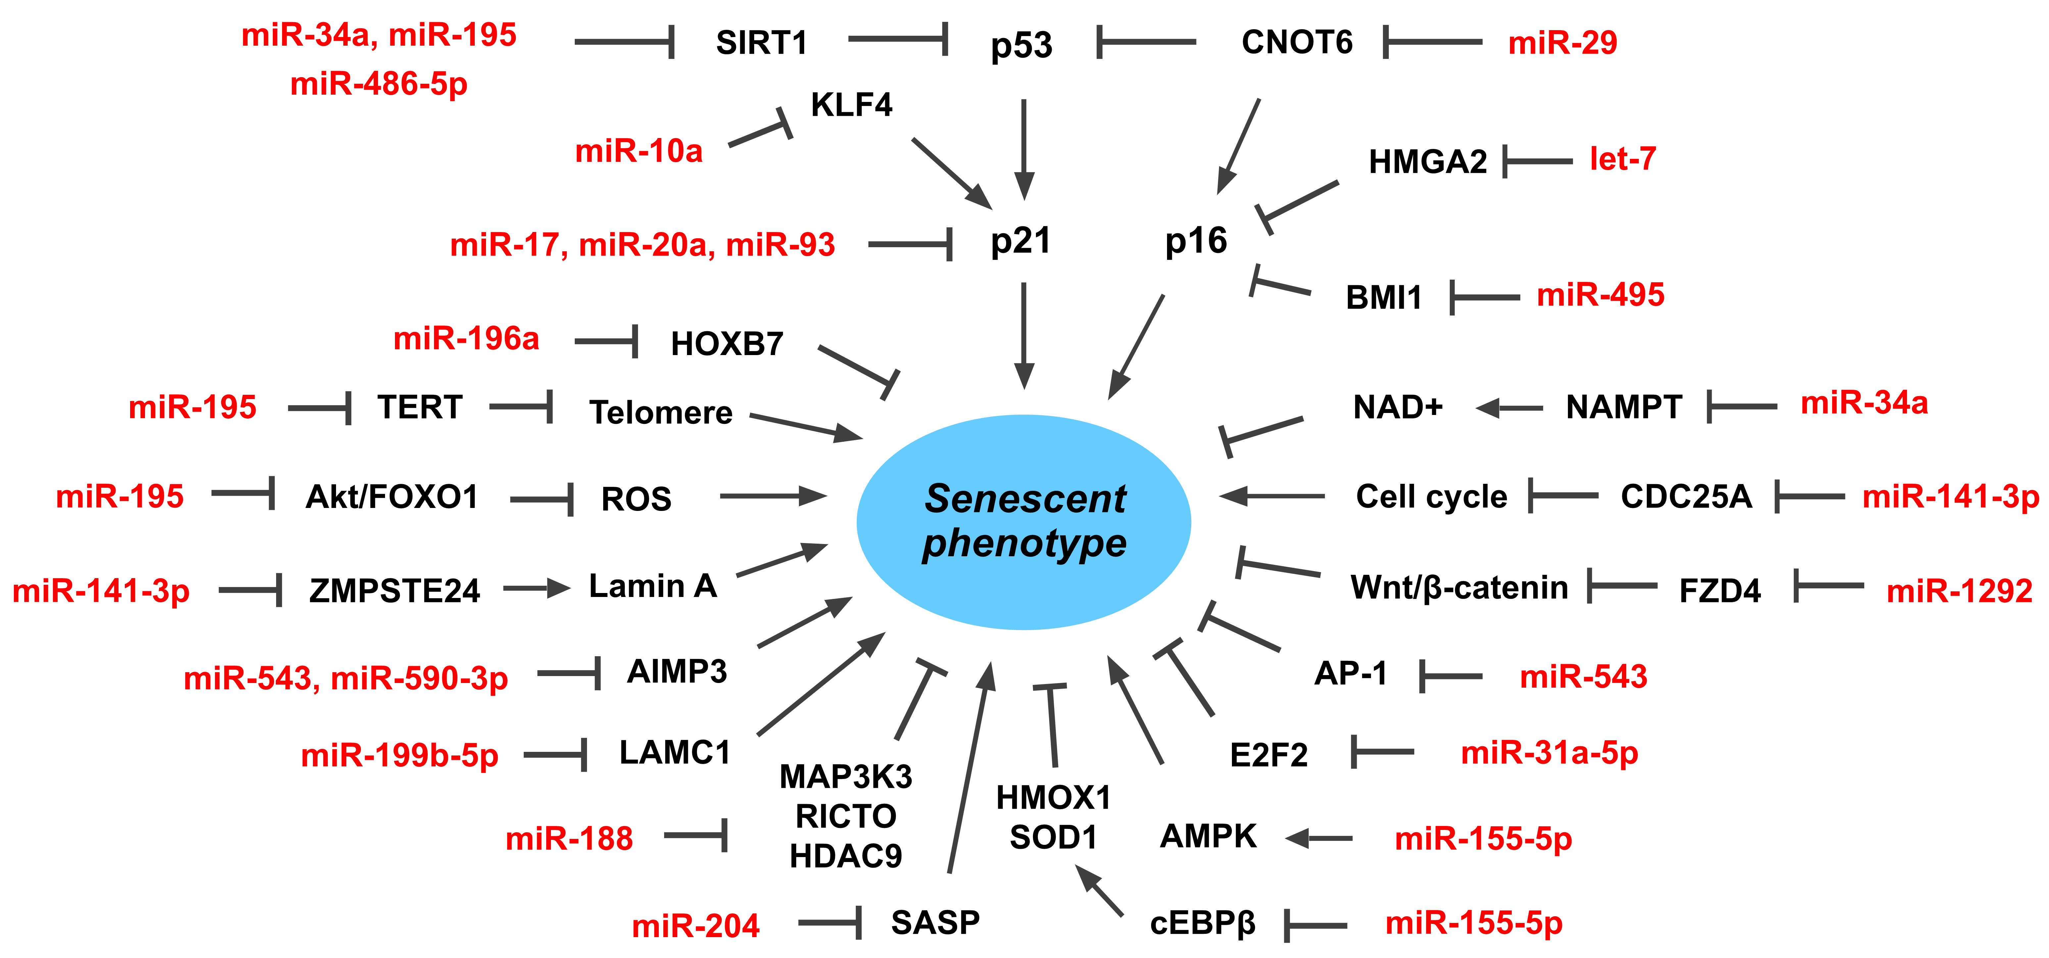
Figure 1. MiRNAs are involved in MSC senescence.
AIMP3, Aminoacyl-tRNA synthetase-interacting multifunctional protein 3; AMPK, AMP-activated protein kinase; AP-1, activating protein 1; BMI1, B-cell-specific moloney murine leukemia virus insertion site 1; CDC25A, cell division cycle 25A; cEBPβ, CCAAT/enhancer binding protein β; CNOT6, CCR4-NOT transcription complex subunit 6; E2F2, early 2 factor 2; FOXO1, forkhead box O1; FZD4, frizzled-4; HDAC9, histone deacetylase 9; HMGA2, high mobility group A2; HMOX1, heme oxygenase-1; HOXB7, homeobox B7; KLF4, krüpple-like factor 4; LAMC1, laminin gamma 1; MAP3K3, mitogen-activated protein kinase kinase kinase 3; NAMPT, nicotinamide phosphoribosyl-transferase; RICTOR, RPTOR-independent companion of MTOR complex 2; SASP, senescence-associated secretory phenotype; SIRT1, sirtuin 1; SOD1, superoxide dismutase 1; TERT, telomerase reverse transcriptase; ZMPSTE24, zinc metallopeptidase STE24.

Specific miRNA function and expression profiles may reflect unique developmental stage-specific, tissue-specific, or disease-specific patterns. Several miRNAs are expressed differently between young and senescent MSCs (Figure 2). The miScript miRNA assay was used to identify 43 miRNAs in senescent MSCs, of which 23 miRNAs were analyzed. Fourteen miRNAs (miR-10, miR-27b, miR-30b, miR-30d, miR-103a, miR-103a-2, miR-136, miR-140-5p, miR-323-3p, miR-330-5p, miR-361-5p, miR-409-3p, miR-424, and miR-455-3p) were up-regulated in response to senescence, and five miRNAs (miR-16-2, miR-29b, miR-199b-5p, miR-454, and miR-618) were down-regulated [52]. MiRNA expressed on MSCs from old donors (39-78 years) and young (3-13 years old) donors were also shown different, and 7 miRNAs (miR-99a, miR-100, miR-196, miR-337-5p, miR-376b, miR-431, and miR-543) were particularly identified, with miR-196 rarely detected in the old-donors [53]. By analyzing the replicative senescence-induced miRNAs expression changes of MSCs derived from young and old donors, twelve miRNAs were shown to be differentially expressed jointly in young and old donor MSCs. Among them, ten miRNAs (miR-150-3p, miR-371a-5p, miR-762, miR-1207-5p, miR-1225-5p, miR-1915-3p, miR-2861, miR-3665, miR-4281, and miR-4327) were found to be up-regulated and two miRNAs (miR-25-3p and miR-93-5p) were down-regulated [54].
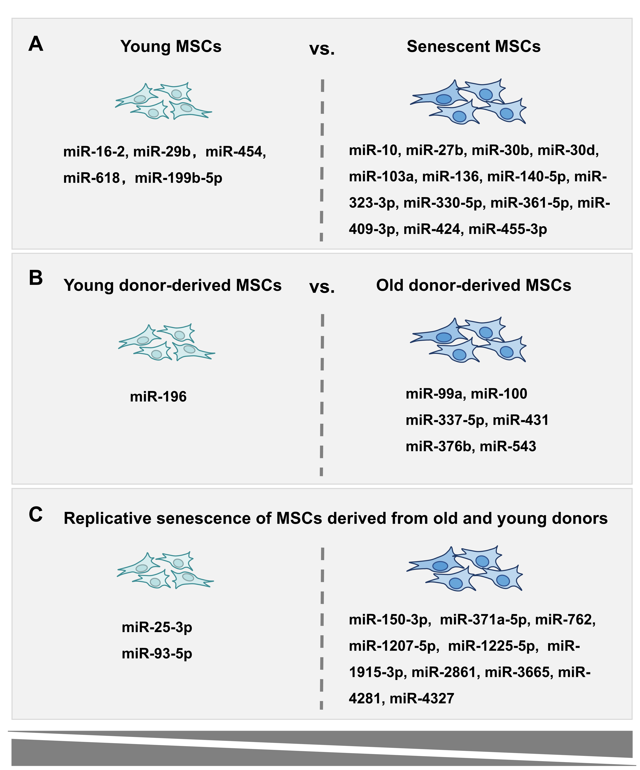
Figure 2. Characteristics of miRNAs profile of young and senescent MSCs.

Functionally, overexpression or downregulation of particular miRNAs has been proven to mediate senescence by targeting candidate genes on the p16^{INK4a}/pRB and p53/p21 pathways, which primarily control cell senescence.
Histone deacetylase inhibitors induce senescence in MSCs. The up-regulation of miRNAs in the let-7 family can reduce high mobility group A2 (HMGA2) expression during cell senescence [55]. Decreased HMGA2 leads to the activation of the p16INK4a gene, which in turn induces MSCs senescence [56] through the regulation of the p16^{INK4a}/pRB pathway by let-7. In senescent MSCs, the expression of miR-20a and miR-93 (members of the miR-17 family) decreased [57]. The decreased expression of miR-20a was critical for the upregulation of p21, and overexpression of miR-20a significantly attenuated senescence [58].
The expression of miR-10a in MSCs also affected by donor age. MiR-10a attenuated cell senescence by inhibiting Krüpple-like factor 4 (KLF4) and increased the differentiation capacity of aged BM-MSCs [59]. KLF4, a zinc finger transcription factor, is involved in the regulation of important processes such as cell cycle, cell growth, and apoptosis. Overexpression of KLF4 can induce cell senescence, which is mainly caused by inducing p21 expression [60].
MiR-17 partially rescues the osteogenic differentiation of senescent MSCs in vitro and in vivo. Smad ubiquitin regulatory factor 1 (SMURF1), as a direct target gene, is an important contributor to the cascade of p53/miR-17 in osteogenesis [61]. The miR-17 family participates in senescence regulation by directly targeting p21 [62].
The expression of miR-29 showed an increasing trend during the aging of human MSCs. MiR-29c-3p may regulate MSCs senescence depending on the p53 pathway. Overexpression of miR-29c-3p resulted in enhanced SA-β-gal staining and SASP expression, delayed osteogenic differentiation, and reduced proliferation, whereas that of silencing had the opposite results. MiR-29c-3p was shown to target CCR4-NOT transcription complex subunit 6 (CNOT6) and activated the p16 ^{INK4a} /pRB and p53/p21 pathways in MSCs [63].
The expression of miR-31a-5p was significantly elevated in old rat BMSCs, which exhibited increased adipogenesis and senescence phenotypes. MiR-31a-5p affects osteoblastic and osteoclastic differentiation and mediates the age-related bone marrow microenvironment. MiR-31a-5p induces DNA damage, cell senescence, and senescence-associated heterochromatin foci by targeting E2F2, which is involved in senescence-related changes of heterochromatin [64].
The expression of miR-34a increased in senescent MSCs with continuous passage. MiR-34a promotes apoptosis by regulating mitochondrial dysfunction and activating sirtuin 1(SIRT1)/forkhead box O3a (FOXO3a) and intrinsic apoptosis pathways. In replicative and naturally senescent MSCs, inhibition of miR-34a contributes to the alleviation of senescence-related phenotypic features [65]. MiR-34a is up-regulated by p53 and then down-regulates SIRT1 expression (a p53 inhibitor), thus forming a positive feedback loop [66]. Exception of p53/p21, overexpression of miR-34a reduces cycle-dependent kinases and cyclins. In addition, overexpression of miR-34a in young MSCs induces long-term proliferation, increased SA-β-gal activity, and decreased osteogenic differentiation capacity. MiR-34a significantly reduced SIRT1 activity, nicotinamide adenine dinucleotide (NAD)⁺ content, and NAD⁺/nicotinamide adenine dinucleotide (NADH) ratio by targeting nicotinamide phosphoribosyl-transferase (NAMPT) [67].
In MSCs, miR-141 target genes include B-cell-specific moloney murine leukemia virus insertion site 1 (BMI1), stromal cell-derived factor 1 (SDF1), sodium-dependent from vitamin C-2 (SVCT2), and distal-less homeobox 5 (DLX5), which are involved in the regulation of differentiation, migration, and proliferation. The expression of miR-141-3p depends on histone acetylation at the promoter and increases in senescent MSCs [68, 69]. MiR-141-3p directly inhibited zinc metallopeptidase STE24 (ZMPSTE24) (enzyme for processing pre-lamin A into lamin A) [70]. In the subculture of aged MSCs, the cells have abnormal nuclear morphology due to the increase of pre-Lamin A. MiR-141-3p targeted cell division cycle 25A (CDC25A) leads to inhibiting MSC proliferation by arresting cell cycle at the G1 phase [71].
The expression of miR-155-5p in MSCs from old donors was significantly higher than that from young donors. In young donor-derived MSCs, high expression of miR-155-5p resulted in increased cell senescence. MiR-155-5p increases mitochondrial fusion and inhibits mitochondrial fission in MSCs through the AMP-activated protein kinase (AMPK) pathway, thereby leading to cell senescence by inhibiting Cab39 expression [72]. In addition, miR-155-5p promotes ROS production. MiR-155-5p suppressed the expression of antioxidant genes (heme oxygenase-1 (HMOX1) and superoxide dismutase 1 (SOD1)) by repressing CCAAT/enhancer binding protein β (cEBPβ, a common transcription factor regulating these genes) [73].
MiR-188 regulates the senescence-associated transition of BMSCs from osteogenesis to adipogenesis and has additional significance in senescence. The expression of miR-188 increased in BMSCs of elderly mice and humans. In lineage-negative myeloid cells, overexpression of miR-188 promotes senescence. MiR-188 targeted genes including RPTOR-independent companion of MTOR complex 2 (RICTOR), mitogen-activated protein kinase kinase kinase 3 (MAP3K3), and histone deacetylase 9 (HDAC9) [74, 75].
The expression of miR-195 increased in senescent and old donor MSCs, and the miRNA directly targeted SIRT1 and telomerase reverse transcriptase (TERT) [76]. SIRT1 is a regulator of p53 deacetylation and exerts an inhibitory role in aging [77]. TERT encodes telomerase, which prevents telomere shortening [78]. MiR-195 affects telomere length changes by targeting TERT. Increased miR-195 expression shortens telomere length in MSCs from old donors. Inhibition of miR-195 significantly reduced SA-β-gal expression in senescent MSCs. MiR-195 also affects the phosphorylation of Akt and FOXO1 [76]. FOXO is a downstream target of the PI3K-Akt signaling pathway, which regulates the ROS pathway during cell senescence [79]. Among them, FOXO1 is a transcription factor involved in the expression of antioxidant enzymes (SOD and catalase) and acts on SIRT1-mediated ROS increase and maintenance during senescence[80, 81].
Expression of miR-196a increased with senescence. Compared with the children group, the expression level of miR-196a increased and Ki-67 decreased in adult MSCs. MiR-196a is negatively correlated with MSC proliferation by directly targeting homeobox B7 (HOXB7). Overexpression of HOXB7 can reduce senescence and improve cell growth, which is related to the increase of basic fibroblast growth factor secretion. HoxB7 acts in cell differentiation, proliferation, and signal transduction, and is a major factor driving the behavioral longevity of progenitor cells to optimize MSC performance [53].
Compared to young (average 21 years) and old (average 65 years) donor MSCs, miR-199b-5p is dysregulated in senescent MSCs. MiR-199b-5p directly represses the expression of laminin gamma 1 (LAMC1) to regulate the LAMC network, thereby indirectly affecting the senescence of MSCs [52]. LAMC1 promotes tumor cell migration and proliferation through the Akt-NF-κB signaling pathway.
The expression of miR-204 is upregulated in senescent human umbilical vein endothelial cells (HUVECs) and stress-induced senescent chondrocytes [82, 83]. In mice, ectopic expression of miR-204 is sufficient to promote osteoarthritis development, while knockdown improved surgically-induced osteoarthritis and repressed SASP expression [83]. SIRT1 is considered to be a key regulator of inflammation and aging. miRNAs post-transcriptionally downregulated SIRT1 during the differentiation of mouse embryonic stem cells, and maintain low levels of SIRT1 expression in differentiated tissues, where MiR-204 was found to be involved in inhibiting SIRT1 protein expression [82].
The expression of miR-335 was increased in BMSCs from old donors and senescent MSCs. Forced expression of miR-335 in MSCs induces a senescent phenotype and disrupts immunomodulatory properties and chondrogenic differentiation ability by repressing activating protein 1 (AP-1), which regulates cell proliferation, differentiation, and migration [84, 85].
MiR-486-5p plays a role in senescence by targeting the SIRT1. In adipose-derived MSCs (AMSCs), miR-486-5p is increased during aging and replicative senescence. Overexpression of miR-486-5p represses cell proliferation and adipogenic and osteogenic differentiation and induces senescence phenotype. MiR-486-5p directly regulates SIRT1 expression and deacetylase activity, and downregulation of SIRT1 can induce senescence [86].
In MSCs, miR-495 increased p16^{INK4a}, p21, and p53 expression and SA-β-gal activity by targeting BMI1 [87]. BMI1 is an inhibitor of cell senescence and a regulator of p16^{INK4a} [88]. Conditioned medium collected from MSCs overexpressing miR-495 suppressed the cell migration, which is consistent with the paracrine effect of SASP to trigger cell senescence into healthy adjacent cells [87].
Aminoacyl-tRNA synthetase-interacting multifunctional protein 3 (AIMP3) affects the senescence and differentiation potential of MSCs, and its protein expression level increases with senescence, while miR-543 and miR-590-3p can significantly reduce the expression of AIMP3. Overexpression of miR-543 or miR-590-3p alleviated the late passage MSCs, whereas inhibition of miR-543 or miR-590-3p aggravated senescence by increasing AIMP3 [89, 90].
MiR-1292 acts to accelerate senescence in adipose-derived MSCs and is negatively correlated with osteogenic markers alkaline phosphatase (ALP) and runt-related transcription factor 2 (RUNX2) in bone. MiR-1292 mediates its influence through the Wnt/β-catenin pathway by targeting frizzled-4 (FZD4) [91]. The Wnt/β-catenin signaling pathway is an important contributor to the self-renewal and differentiation of MSCs by promoting the intracellular production of ROS [92].
Table 1. MiRNAs are involved in MSC senescence.
miRNA | miRNA Target | Mechanism | Reference
let-7 | HMGA2 | Regulate the p16^{INK4a}/pRB pathway | [55]
miR-10a | KLF4 | Reduce p21 expression | [59]
miR-17 | SMURF1 | Regulate p53 pathway | [61,62]
miR-20a/93 | p21 | Regulate p53 pathway | [56-58]
miR-29 | CNOT6 | Activate the p16^{INK4a}/pRB and p21/p53 pathways | [63]
miR-31a | E2F2 | DNA damage and heterochromatin | [64]
miR-34a | NAMPT | Regulate mitochondrial dysfunction and SIRT1/ FOXO3a activation | [65-67]
miR-141 | BMI1, SDF1, SVCT2, DLX5, ZMPSTE24 | Regulate differentiation, migration, proliferation, and cell cycle | [68-71]
miR-155 | Cab39, cEBPβ | Regulate AMPK pathway and ROS production | [72,73]
miR-188 | RICTOR, MAP3K3, HDAC9 | Regulates differentiation | [74,75]
miR-195 | SIRT1, TERT,  Akt/FOXO1 | Shorten telomere length and ROS production | [76]
miR-196a | HOXB7 | Repress proliferation | [53]
miR-199b | LAMC1 | Regulate LAMC network | [52]
miR-204 | SIRT1 | SASP expression | [82,83]
miR-335 | AP1 | Disrupts immunomodulatory properties and chondrogenic differentiation | [84,85]
miR-486 | SIRT1 | Repress cell proliferation and differentiation | [86]
miR-495 | BMI1 | Increased p16, p21 and p53 expression,  SA-β-gal activity, and suppress cell migration | [87,88]
miR-543/590 | AIMP3 | Affect differentiation potential | [89,90]
miR-1292 | ALP, RUNX2, FZD4 | Regulate Wnt/β-catenin pathway | [91,92]

EV, EV-miRNA in MSC senescence
Based on their differences in size and secretion pathway, EVs are classified into three subtypes: exosomes, microvesicles, and apoptotic bodies [93]. Exosomes (less than 120 nm) originate from the endoplasmic reservoir, producing multivesicular bodies that fuse with the plasma membrane to secrete their contents. Microvesicles (100 to 500 nm) are budding vesicles that may arise from the plasma membrane under various conditions of stress. Apoptotic bodies (500 nm to 5 μm) are released from the plasma membrane of apoptotic cells [94].
EVs are composed of nucleic acids (mRNA, DNA, miRNAs, and long noncoding RNAs), lipids, and proteins [95]. The contents reflect the origin of the cell and convey specific molecules for specific cell types. EV-miRNA exchange between cells may be a key for intercellular communication and the miRNAs encapsulated into EVs are strictly regulated by various microenvironmental conditions and stress stimuli. The miRNA content of EVs may reflect the pathological state of released cells and serve as promising biomarkers for multiple pathologies. EVs are highly enriched for ALG-2 interacting protein X (ALIX), CD63, CD81, and tumor susceptibility gene 101 (TSG-101). Various techniques have been used to characterize EVs, including atomic force microscopy, dynamic light scattering, enzyme-linked immunosorbent assay, electrochemical biosensors, flow cytometry, fluorescence-activated cell sorting, microfluidics, nanoparticle tracking analysis, resistance pulse sensing, scanning electron microscopy, and transmission electron microscopy [96, 97].
Senescence-related EVs can transfer regulatory factors such as miRNAs and proteins to promote the senescence process in autocrine, endocrine, and paracrine ways. Senescent cells secrete high levels of EVs and regulate the microenvironment. P53 regulates the transcription of other endosomal genes associated with vesicle biosynthesis. DNA damage-induced senescence induces an increase in p53-dependent EV biogenesis. Senescent cell-derived EVs are partially dependent on p53 and its downstream target tumor suppressor-activated pathway 6 (TSAP6) [98].
Senescent cell-derived EVs enable neighboring cells to respond particularly rapidly and efficiently to stress by regulating the surrounding environment. On the hand, these EVs may play a role in promoting SASP by transmitting pro-senescence signals, which facilitate the regenerative potential of surrounding cells and the elimination of senescent cells and also enhance local inflammation levels by recruiting immune cells and spreading senescence throughout tissues. A recent study has just shown that senescence-associated exosomes influence the genetic information and immunomodulatory potential of the microenvironment [99].
At present, a variety of inflammation-related miRNAs have been identified in EVs, such as miR-19b, miR-20a, miR-21, miR-126, miR-146a, and miR-155 [100]. The expression pattern of different miRNAs in MSC-EVs changes with senescence [101]. Compared with young rats, the expression levels of miRNA-294 and miRNA-872-3p in MSC-EVs decreased with age [102]. The expression of miRNA-146a was elevated in late passage MSC-EVs compared with the early passage [103]. Mouse senescent MSC-EVs contain miRNA-183-5p, which promotes senescence in young MSCs [104].
Old bone marrow-derived EVs were absorbed by young MSCs and repressed osteogenic differentiation. Overexpression of miR-183-5p reduced Hmox1 protein level and cell proliferation and promoted senescence in MSCs [104]. MiR-34a increases with age in muscle-derived EVs and induces senescence of BMSCs. That is, EVs may induce MSC senescence through miR-34a-5p targeting SIRT1 [105].
MiR-17-3p and miR-199b-5p were decreased in senescent fibroblast-derived EVs. In particular, miR-199b-5p is decreased in senescent MSCs and elderly donor-derived MSCs [52]. MiR-17-3p is also decreased in senescent MSCs and skin fibroblasts as a cellular model. MiR-23a-5p has been proven to regulate the osteogenic differentiation of BMSCs, and its expression was increased in senescent fibroblast-derived EVs [106]. MiR-23a-5p promotes osteogenic differentiation by targeting transmembrane protein 64 (TMEM64), whereas inhibition of miR-23a-5p expression promotes adipogenic differentiation in MSCs [107].
MSC-EVs containing let-7a, miR-21, miR-191, and miR-222 are known to regulate cell proliferation and cycle progression [108]. The expression of miR-21 was decreased in EVs of senescent MSCs and adult MSCs, and this miRNA was also decreased in MSCs from ovariectomized mice and postmenopausal osteoporotic patients [109]. In breast cancer cells, this miR-21 targets E2F2, a downstream effector of p21 and p16^{INK4a} [110].
MiR-31 is a circulating miRNA that is differentially expressed with senescence and increased in the blood of osteoporosis patients. The expression of miR-31 is also elevated in senescent endothelial cell MVs. These MVs repress the osteogenic differentiation of MSCs by targeting FZD3 [111]. MiR-31a-5p was found in senescent MSC-derived exosomes, which trigged osteogenesis of co-cultured bone marrow cells [112]. Compared with young mice, exosomes secreted from older mice-isolated muscle cells are enriched with miR-34a. MiR-34a is related to senescence and inflammation. Myoblast exosomes overexpressing miR-34a can reduce MSCs proliferation and induce senescence by promoting SA-β-gal activity [105].
Induced pluripotent stem cell-derived MSC-EVs (iMSC-EV) enriched with miR-105-5p could rejuvenate senescent nucleus pulposus cells by activating the SIRT6 pathway in vitro. miR-105-5p plays a pivotal role in the iMSC-EV-mediated therapeutic effect by decreasing the level of the cAMP-specific hydrolase phosphodiesterase 4D (PDE4D) [113]. It has been reported that suppression of PDE4D expression can promote the migration, invasion, colony formation, and proliferation of colorectal cancer cells [114].
MiR-146a-5p is increased in senescent MSC-derived EVs. This miRNA is known to regulate the NF-κB signaling activation and SASP production of senescent cells [103]. In a mouse model of allergic airway inflammation, MSC-EV suppresses the function of group 2 innate lymphoid cells, reducing inflammatory infiltration and T helper 2 cytokines production by transporting miR-146a-5p [115]. MSC-EV effectively represses the inflammatory response of cardiomyocytes by delivering miR-146a-5p to reduce v-myb myeloblastosis viral oncogene homolog-like 1 (MYBL1) expression [116].
Exosomes enriched with miR-188-3p ameliorate senescence by regulating the mTOR complex. Incubation of old MSCs with this exosome decreased senescence markers and mTOR pathway proteins, and up-regulate the pluripotency markers. Inhibition of miR-188-3p in MSC-EVs significantly increased the expression of RICTOR, decreased the expression and phosphorylation of Akt, and downregulated the proportion of SA-β-gal staining cells [117].
Interestingly, EVs from MSCs of young donors or early passages have been shown to reverse the senescent phenotypes of late passages MSCs or that from pre-mature aged patients. In our study, we found that adding early passage iMSC-EV to the senescent iMSC culture promoted cell growth, downregulated the expression of age-related genes, reduced mitochondrial density, and improved mitochondrial membrane potential (Figure 3). This, even still at the preliminary stage, may suggest that the addition of exogenous exosomes, ideally engineered with elevated expression of specific miRNAs, to the MSC culture, may be feasible for promoting MSC proliferation in culture or scaling-up the manufacture of MSCs to a significant extent.
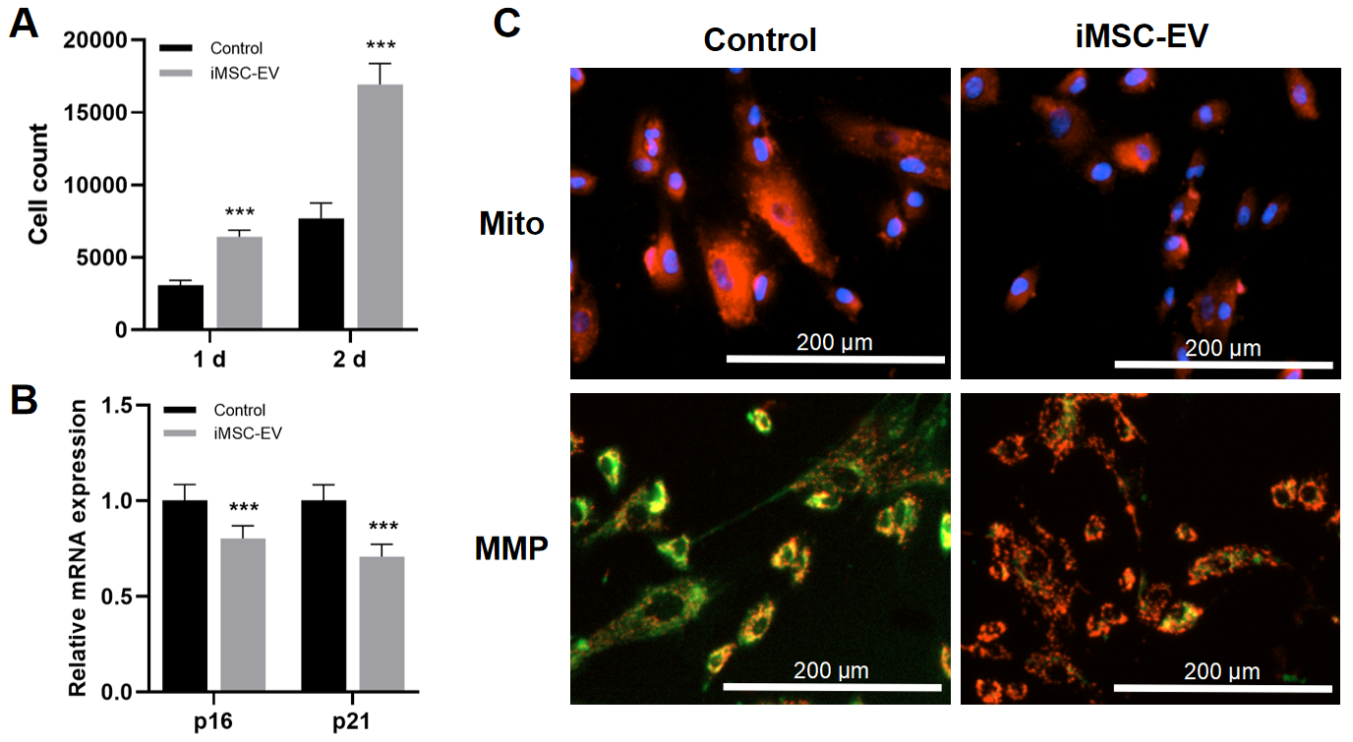
Figure 3 Effect of early passage iMSC-EV on senescence characteristics of late passage iMSCs.
A. Changes in cell count of senescent iMSCs after early passage iMSC-EV incubation. B. Expression of cell cycle genes of senescent iMSCs. C. Mitochondrial density and mitochondrial membrane potential (MMP) of senescent iMSCs. n=3, *** p < 0.001.

Prospects of MSC-EV therapy
In initial studies in most animals, MSCs have shown encouraging positive results in various types of cell therapy, but the concerns of human MSC therapy remain unneglectable, including immune rejection and various cancer promotion. Due to the clinical outcomes of MSC-based therapy remaining nonoptimal, so far, a large proportion of the majority of registered clinical trials applying MSC therapy for human diseases have indeed fallen short of expectations.
Emerging evidence suggests that MSC-EV therapy has equal or better efficacy than MSCs in many diseases, and the risk of MSC-based therapy is significantly reduced. The advantages of cell-free therapies based on MSC-EVs are considerable. The incapability of MSC-EVs to self-replicate greatly reduces the risk of expansion and tumor and increases safety. The small size also provides faster tissue penetration [118]. The potential to stimulate the immune system is limited, reducing the risk during allogeneic transplantation. EVs are easier to handle in transportation and storage, which makes EV therapeutic potential optimal.
The effects of MSC-EVs, including anti-senescence, anti-inflammatory, and wound healing, play a positive role in various diseases. In pilocarpine-induced status epilepticus mice treated with MSC-EVs, EVs reach the hippocampus within 6 h and exert anti-inflammatory and neuroprotective effects, which are coupled with normal hippocampal neurogenesis and cognitive and memory functions [119]. Melatonin-pretreated MSC-EVs affect the ratio of macrophage M2 polarization to M1 polarization by regulating the activation of phosphatase and tensin homolog (PTEN)/Akt signaling pathway, thus suppressing inflammatory response and promoting diabetic wound healing [120]. In the rat model of skin burn treated with human MSC-EVs, EVs accelerate the re-epithelialization of the wound, promote the nuclear transfer of β-catenin, and enhance skin cell migration and proliferation, thus facilitating wound healing [121].
Although preclinical data have demonstrated the scalability of EV isolation methods and the safety of therapy, the clinical use of MSC-EVs is still limited. Currently, there is a lack of well-defined and standardized optimal culture conditions of parental cells and optimal protocols for EV isolation and storage, optimal therapeutic doses and dosing schedules, as well as reliable potency and safety profiles. Currently, studies have investigated the effectiveness of MSC-EVs in the clinical setting, and most clinical trials are still recruiting and active (Table 2). The delivery routes oral, intranasal administration, intravenous and intraperitoneal injection.
Table 2. List of clinical trials using MSC-EVs.
No. | Condition or disease | Treatment | Trial Phase | Trial ID
1 | Cerebrovascular Disorders | Allogenic MSC-EVs enriched by miR-124 | Phase I  Phase II  (Recruiting) | NCT03384433
2 | Metastatic Pancreas Cancer With KrasG12D Mutation | MSC-EVs with KRAS G12D siRNA | Phase I  (Recruiting) | NCT03608631
3 | Chronic Graft Versus Host Diseases | Artificial tears for 14 days of UMSC-EVs 10ug/drop | Phase I  Phase II  (Recruiting) | NCT04213248
4 | Alzheimer Disease | Twice a week for 12 weeks nasal drip of MSC-EVs  (5, 10, 20μg) | Phase I  Phase II  (Recruiting) | NCT04388982
5 | Hospital-acquired pneumonia | 7 times aerosol inhalation of MPC-EVs (8×10⁸ or 16×10⁸ particles) | Phase I  Phase II  (Recruiting) | NCT04544215
6 | Acute Respiratory Distress Syndrome | Basic treatment and 7 times aerosol inhalation of MSC-EVs (2×10⁸, 8×10⁸, or 16×10⁸ particles) | Phase I  Phase II  (Recruiting) | NCT04602104
7 | Moderate SARS-CoV2 Infection | Intravenous injection of MSC-EVs | Phase II  Phase III  (Recruiting) | NCT05216562
8 | Degenerative Meniscal Injury | Intra-articular administration of synovial fluid-derived MSC-EVs | Phase II  (Recruiting) | NCT05261360
9 | Perianal Fistula | Placenta-MSC-EVs | Phase I  Phase II  (Recruiting) | NCT05402748
10 | Retinitis Pigmentosa | Subtenon injection of Wharton jelly-derived MSC-EVs | Phase II  Phase III  (Recruiting) | NCT05413148
11 | Chronic Ulcer | MSC conditioned media | Phase I  (Completed) | NCT04134676
12 | Novel Coronavirus Pneumonia | 5 times aerosol inhalation of MSC-EVs (2×10⁸ nanovesicles/3 ml) | Phase I  (Completed) | NCT04276987
13 | Healthy | Once aerosol inhalation of MSC-EVs (2×10⁸, 4×10⁸, 8×10⁸, 12×10⁸, or 16×10⁸nanovesicles/3 ml) | Phase I  (Completed) | NCT04313647
14 | SARS-CoV-2 Associated Pneumonia | Twice a day for 10 days inhalation of MSC-EVs (0.5-2×10⁸ nanovesicles/3 ml) | Phase I  Phase II  (Completed) | NCT04491240
15 | COVID-19 Associated Acute Respiratory Distress Syndrome | Intravenous administration of  BM-MSC-EVs | Phase II  (Completed) | NCT04493242
*Information obtained from https://clinicaltrials.gov/ on 30 November 2022.

The heterogeneity of MSC-EVs is probably one of the key factors affecting their therapeutic properties. EV variability lies in the contents of RNA and proteins, particularly non-coding RNAs with properties such as inflammation resolution, potency, and tissue regeneration. The development of technology for detecting EV contents is helpful to promote the study of maintaining EV characteristics. Currently, contents are analyzed using chemical, physical, biological, and nanotechnological methods, usually involving the use of multiple antibodies, nucleic acid fitting, or molecular markers as recognition components, coupled with various chemical labels (e.g., redox probes and optical dyes), nanoparticle tags or DNA oligonucleotide [122]. For example, Raman spectroscopy is used to distinguish the overall chemical bond characteristics of EVs based on the spectral patterns generated by vibration and rotation. EV particles are captured on a specially modified plane or spherical interface and fluorescent dye labeling is added to detect and quantify the membrane proteins and internal miRNAs [122-124]. The analysis and identification of specific contents can be achieved by using surface-sensitive label-free physical analysis methods (e.g., electrical impedance spectroscopy, quartz crystal microbalance, and surface plasmon resonance) or external chemical tags to monitor the binding of EV contents to receptors on the array [125-127]. Although the diversity of EV detection methods has been achieved, the standardization of identification and analysis is still very important. The above detection methods are more or less affected by the difference in the quality of reagents provided by different suppliers. The control of high-quality biologics and the evaluation of binding parameters helps to improve the reproducibility of detection.
Promoting or inhibiting expression levels of specific miRNAs in EVs can improve therapeutic efficiency for specific diseases or specific repair tissues. The culture conditions and external stimuli of stem cells can alter their EV yield and content composition. While the EV components cannot be fully controlled in gene-manipulated cells, currently, breakthroughs have been made in the use of EVs as a carrier for the better delivery of specified molecules, including passive loading (e.g., incubation stimulation) or active loading (e.g., extrusion, electroporation, hypotonic dialysis, sonication, saponin permeabilization, and transfection) [128]. The miRNA enrichment techniques can be achieved by constructing overexpressed cell lines or direct loading miRNAs into EVs by physical or chemical methods. Due to the complex EV loading mechanisms involving the endosomal sorting complex required for transport (ESCRT)/Rab protein family, multivesicular bodies, intracellular tubules, and actin networks, the generated EVs loaded with specific miRNA molecules by transfection of parental stem cells are unreliable and unpredictable. In addition to cell transfection, direct delivery of desired miRNAs into EVs is an efficient and feasible method for enriching miRNAs, which can enhance the interaction of miRNAs with the surface of EVs by using calcium chloride (CaCl₂) buffered medium and promote the incubation of selected miRNAs into EVs [129]. The heat shock method can alter the fluidity of EV membranes, and promote miRNA entry into EVs [130]. Electroporation is another technology to promote miRNA entry, but electroporation may trigger EV aggregation and change its morphological characteristics, thus affecting the effect. The existing limitations still need to be improved.

Conclusion
Cell senescence is a dynamic process evolving with time, and its specific regulation remains unknown. Analyzing the senescence properties of MSCs is very important for developing methods to assess MSC senescence, as well as for understanding how senescence affects the quality and efficacy of MSCs. A comprehensive analysis of miRNAs provides a more detailed and in-depth insight into how senescence influences MSCs. Advances in understanding the role of miRNAs in aging may provide new ways to alleviate MSC senescence. Undoubtedly, continued in-depth studies of miRNAs within MSC senescence will shed light on their mechanisms of action during senescence and may reveal clues for the potential roles in the extracellular environment.
Senescence may influence the production rate and cargo type of MSCs and their EVs. Systematic analysis and comparison of miRNAs related to MSC senescence and those contained in MSC-EVs will help to discover universal senescence markers to identify senescent cells. Translating preclinical results into the clinic faces different challenges related to EV dynamics and biology. Effective MSC-EV therapy may depend on the physiological function and state of the parental cells, as senescent may deprive cells of reverse/reduce disease efficacy. A correct understanding of the detailed mechanisms involved in miRNAs and EV-miRNAs during senescence may contribute to the regulation of MSC efficacy, as well as the development of MSC-EVs to improve tissue regeneration and aging-related diseases.

Author contributions
Conceptualization, Liangge He and Guangqian Zhou; Investigation, Arshad Ahmed Padhiar, and Zhen Liu; Writing-Original Draft Preparation, Liangge He and Mingzhu Li; Writing-Review & Editing, Liangge He and Guangqian Zhou; Supervision, Guangqian Zhou; Project Administration, Guangqian Zhou; Funding Acquisition, Guangqian Zhou. All authors were involved in approving the final manuscript.

Availability of data and materials
Not applicable.

Financial support and sponsorship
This work is supported, in part, by the National Natural Science Foundation of China (2072480 and 32100603), and Shenzhen Commission of Development Reform (Funding for Shenzhen Engineering Laboratory for Orthopedic Diseases and Regenerative Technologies).

Conflicts of interest
The authors declare no conflict of interest.

Ethical approval and informed Consent Statement
Not applicable.

Consent for publication
Not applicable.

References

