Research Article
Additional polg^{D257A} mutation (mutator) does not influence dopaminergic neurodegeneration in aged parkin-deficient mice
David Mrohs^{a,c}, Max Rybarski^{a,b,c}, Michael Andriskeª, Pauline Bohne^{b}, Melanie D. Mark^{b}, Hermann Lübbertª, Xin-Ran Zhu^{a,b}

ª Department of Animal Physiology, Ruhr-University Bochum, Universitätsstrasse 150, 44801 Bochum, Germany.
^{b} Department of Behavioral Neuroscience, Ruhr-University Bochum, Universitätsstrasse 150, 44801 Bochum, Germany.
^{c} These two authors contributed equally.
*Corresponding author: Xin-Ran Zhu, Department of Behavioral Neuroscience, Ruhr-University Bochum, Universitätsstrasse 150, 44801 Bochum, Germany.
E-mail: xinran.zhu@ruhr-uni-bochum.de

Abstract
Background: Parkinson's disease is a neurodegenerative disease caused by the loss of dopaminergic neurons in the substantia nigra pars compacta. Among the first identified causes of autosomal recessive Parkinson's disease were mutations in the parkin gene. Independently, we and other groups have developed various parkin knockout mice, and none displayed dopaminergic degeneration in the substantia nigra. Interestingly, dopaminergic degeneration in the substantia nigra has been reported in a parkin knockout line (exon 3 deletion) carrying an additional mutation (D257A) in the mitochondrial DNA polymerase γ (polg) gene (mutator). The mutator mice show accelerated mutation rates in mitochondrial DNA resulting in a premature-aging phenotype.
Methods: To verify this finding, we crossed our parkin-deficient mice with the mutator mice, and characterized phenotypic changes of the parkin/mutator double mutant mice up to one year of age. We examined their locomotion and motor coordination behaviors by using the open field, the rotarod, and the pole test, subsequently investigating their nigrostriatal axis by counting TH-positive cells in every tenth section throughout the entire substantia nigra pas compacta and their termini in the striatum.
Results: The double mutants did not display additional deficiencies in locomotion in our behavior tests. We could also not detect dopaminergic neurodegeneration in the substantia nigra pars compacta of aged double mutants measured by levels of tyrosine hydroxylase positive neurons in the substantia nigra pars compacta as well as in striatal terminals.
Conclusion: Our results do not support the hypothesis that the polg^{D257A} mutation contributes to the age-related vulnerability of dopaminergic neurons in parkin-deficient mice.
Keywords: Parkin, neurodegeneration, polg^{D257A}, mutator, substantia nigra

Introduction
Parkinson´s disease (PD) is characterized by a progressive loss of dopaminergic (DA) neurons in the substantia nigra pars compacta (SNc), leading to basal ganglia dysfunction and subsequent impairment of movement control. To date 26 PD risk loci have been identified [1], providing substantial PD research advances via the generation of transgenic mouse models. One of the first genetic variations found in PD patients was the exon 3 deletion in the parkin gene, coding for an E3 ubiquitin ligase [2]. However, all parkin knockout mouse strains did not show a hint of loss of DA neurons in the SNc [3, 4]. The reason for the missing neurodegeneration in those mouse models is not understood. One could assume that the mouse DA neurons in SNc are exposed to less aging since mice have a shorter lifespan. This explanation is supported by findings that the age-dependent mutation rate of mitochondrial DNA (mtDNA) increases much more in human SNc compared to murine tissue [5]. Such age-dependent accumulation of mtDNA mutations, as well as a broad spectrum of aging-like phenotypes, have been observed in the polg^{D257A} mice (mutator; MT) by a knock-in proofreading-deficient version of the mtDNA polymerase γ [6]. Utilizing this mouse model, Pickrell et al. 2015 reported age-dependent degeneration of DA neurons in the SNc in aged MT/Parkin KO double mutants [7].
In this study, we intended to verify this finding by crossing MT mice with our parkin-deficient Padel mice [8]. We followed possible phenotypic changes of MT/Padel double mutant mice up to one year of age, but could not find any additional deficiency in locomotion, nor dopaminergic neurodegeneration in the SNc compared to MT and wild-type mice. Our results do not support the hypothesis that the polg^{D257A} mutation contributes to the age-related vulnerability of dopaminergic neurons in parkin-deficient mice.

Materials and methods
Animals
All animal experiments were conducted and approved using the German guidelines and by the animal care and use committee of the state of North-Rhine Westphalia. Mice were kept under standard conditions with free access to water and food and a 12:12 hrs a day/night cycle.
The parkin knockout Padel carries a deletion for the exon 3 in the parkin gene, and the neo gene was removed by crossing with the Deleter followed by backcrossing with C57BL/6N mice for over 20 generations [8]. The Bl6 congenic Mutator mice (MT) were acquired from the Jackson Laboratory (B6.129S7(Cg)-Polgtm1Prol/J, Strain #:017341). Animals of both sexes were used for all behavior and histological studies.

Behavior tests
The rotarod test was conducted on a rod starting with 4 rpm and accelerating to 40 rpm within 240 s and the latency to fall was measured (RotaRod, TSE, Germany).
For the pole test mice (12 months old) were placed on top of a metal pole (height: 55 cm; diameter: 8 mm), and the time until the animals reached the ground was measured. Further, it was noted when the animals fell or slipped off the pole.
For the open field tests, the mice were placed in a plastic box (40 x 40 x 40 cm) for 30 min. Their traveled distance, number of stops, time of rest, and the time spent in the center of the box (20 x 20 cm) were recorded by the Videomot2 software (TSE, Germany).

Immunohistochemistry
Mice were perfused transcardially with 4% formaldehyde. Brains were removed and dehydrated with ethanol and isopropanol followed by embedding in paraffin. Coronal brain sections (10 µm) of the SN and striatum were made (RM2145, Leica, Germany). These sections were deparaffinized and rehydrated followed by incubation with the primary antibody (anti-TH; 1:1000; Merk Millipore; ab152). Subsequently, sections were incubated with the secondary antibody (biotinylated anti-rabbit IgG; 1:300; Vector Laboratories; BA-1000) followed by incubation with an avidin/biotin complex solution (vectastain® elite ABC-HRP kit; Vector Laboratories) and stained with diaminobenzidine.

Quantifications and statistical analysis
Every tenth consecutive section containing TH positive cells within the entire SN was counted using the software ImageJ. The staining intensity units of TH positive axonal terminals in the striatum were analyzed with CellProfilerTM (Module: MeasureImageIntensity). All statistical analyses with H- and u-tests were performed with the software SigmaPlot 14.0 (Systat Software).

Results
Four homozygous genotypes (wild type (WT) littermates (LM): WT/WT; MT: polg^{-/-}; Padel: Padel^{-/-}; MT/Padel: polg^{-/-}/ Padel^{-/-}) were used to examine phenotypic changes up to an age of 12 months since the median lifespan of homozygous MT is 416 days [6]. We note that MT and MT/Padel mice started to lose body weight when the animals approached 8 months of age (Figure 1A), consistent with published results [7]. In addition, we also observed spleen enlargement (Figure 1B) and shorter lifespan (Figure 1C) of MT/Padel mice, which was not different from that of MT mice. Based on those parameters we confirmed the premature aging phenotype of the MT/Padel mice.
Next, we investigated whether the combination of the polg^{D257A} mutation with the parkin deletion may contribute to additional motor impairments that could indicate loss of DA neurons in SNc. Six-month-old mice were tested monthly, up to 12 months of age in the rotarod task. Consistent with our previous results [4], the Padel and WT mice showed similar rotarod performance (Figure 1D). While the MT mice showed low performance constantly, the MT/Padel mice showed an age-dependent, continuous decline in latency to fall (Figure 1D). However, there was no difference in the rotarod performance between MT and MT/Padel mice at the age of 7 to 12 months, indicating that the motor impairment of the aged MT/Padel mice was dependent only on the polg^{D257A} mutation.
Analogs to the rotarod task, mice were tested in the open field starting at the age of six months to examine locomotor activity and habituation behavior. Young WT mice exhibited locomotion habituation in the open field over time, showing reduced levels of activity on the second day compared to the first day, while our Padel mice displayed delayed habituation which was visible on the third day (Figure 2A, left). The same-aged MT and MT/Padel mice exhibited reduced locomotor activity on the first day. However, the delayed habituation behavior could be observed only in MT/Padel mice, but not in MT mice (Figure 2A, left). This result indicates that the delayed habituation was caused by the parkin deletion alone, while the polg^{D257A} mutation was responsible for the reduced locomotor activity of the MT/Padel mice. A similar phenomenon was also observed in the second parameter of the open field: The time in the center. Interestingly, the MT/Padel mice seem to spend more time in the center region of the open field compared with the WT mice. However, this effect was dependent on the polg^{D257A} mutation only (Figure 2A, right). While the WT and Padel mice exhibited relatively constant locomotor activity when they were re-exposed to the open field, two groups of these mice with the polg^{D257A} mutation showed an age-dependent decline in the total traveled distance and increased resting time, regardless of the parkin deletion (Fig. 2B). This polg^{D257A}-dependent effect could also be observed in stops, a parameter reflecting the initiation of movement (Fig. 2A+B).
So far, our behavior tests showed severe impairment of MT/Padel double mutant mice in motor coordination and locomotor activity. However, this impairment seems to be caused by the polg^{D257A} mutation alone, since there was no difference between animals with or without the parkin deletion. These results contradict the finding reported by Pickrell et al., 2015 [7] using the pole test, an alternative behavior test for dopamine-dependent motor coordination. To examine this discrepancy, we performed the pole test using a similar protocol described by Pickrell et al., 2015 [7] and found significantly higher latency time descending the pole for MT/Padel double mutants compared with WT or Padel mice (Figure 1E). However, MT mice displayed a similar higher latency time that was statistically not different from those of MT/Padel double mutants (Figure 1E). This polg^{D257A}-dependent impairment was also detected in the number of mice that fell off or slid down the pole (Figure 1F). This result is consistent with those observed in our rotarod and the open field test and demonstrates impairment of aged MT/Padel double mutant mice in locomotor activity and motor coordination, which is dependent on the polg^{D257A} mutation only.
After the last behavioral test at the age of 12 months, mice were sacrificed to determine the integrity of their nigrostriatal axis by counting TH-positive cells in every tenth section throughout the entire SNc. Mice with all four genotypes displayed similar counts of TH-positive neurons in their SNc (Figure 3A+C). To determine if there was any change regarding the nigrostriatal axis in the MT/Padel mice, we also counted the intensities of the TH-staining in the striatum and compared them with Padel, MT, and wild-type mice. We were not able to find any significant difference in striatal TH staining intensity between all four groups (Figure 3B+D). Our results demonstrate that those behavioral impairments of the MT and MT/Padel mice in locomotor activity and motor coordination were likely not due to dopamine deficiency in their nigrostriatal axis.

Discussion
Pickrell et al., 2015 reported that the MT/Parkin KO mice exhibited age-dependent degeneration of DA neurons in the SNc and motor deficit in the pole test [7]. By crossing MT mice with our Padel mice we intended to verify this finding with an independent mouse strain carrying the same exon 3 deletions of the parkin gene. Some characteristic features for premature aging, e.g. lost body weight, spleen enlargement, and short lifespan could also be confirmed in the MT/Padel mice, which were indistinguishable from those of MT mice (Figure 1A–C). However, there are several discrepancies in motor behaviors between the results of the pole test in both studies. We observed similar impairment of MT mice in latency time descending the pole with or without the parkin deletion (Figure 1E), while the MT mice did not exhibit such motor impairment in the study of Pickrell et al. [7]. Because of their severe aging phenotypes, it seems less likely that the aged MT mice are still able to perform such complex motor tasks on a wild-type level. Indeed, a study by Hauser et al., 2015 demonstrated that the old MT mice tend to slide down or fall off instead of climb down the pole [9], which could be confirmed in our study (Figure 1F). Additionally, we found that the slide-down rates of MT (mean ± SEM: 28.33 ± 10.70 %) and MT/Padel (mean ± SEM: 35.91 ± 5.39 %) mice were significantly higher than those of wild type (mean ± SEM: 10.65 ± 4.22 %) and Padel (mean ± SEM: 5.26 ± 2.23 %) mice (H- and u-test, p < 0.05). This higher slide-down rate was not dependent on the parkin deletion (H- and u-test, p > 0.05), but on the MT mutation. Furthermore, impairment in locomotion and motor coordination has also been observed in two previous studies, when aged MT mice were tested in the open field and on the rotarod [10, 11]. By their results, we observed similar motor impairments for the aged MT/Padel mice in both tests, most likely independent of the parkin mutation.
Consistent with our behavior results, no significant difference was found in the number of the TH positive cell bodies in the SNc and their terminals in the striatum between wild-type, Padel, MT, and MT/Padel mice in our study (Figure 3). Those observed motor deficits in the aged MT mice seem not to be related to functions of the nigrostriatal axis. This result is also supported by the fact that L-dopa could not restore the normal motor behavior of the MT mice [9]. Altogether, we were not able to confirm the protective function of parkin against the degeneration of DA neurons in the SNc of the MT mice described by Pickrell et al., 2015. Although the Parkin KO strains used in both studies share a similar deletion of the exon 3 in the parkin gene, there are few differences in their genomic region surrounding the deletion site. While a 34 base pair loxP remains in this region in our Padel mouse, the Parkin KO strain used in the study of Pickrell et al. carried the neo-resistant gene with an additional GFP coding sequence [3]. We speculate that the additional big DNA fragment coding for two functional proteins under a strong promoter may cause DA neurons more susceptible to degeneration during aging in the MT background with deficient parkin function. It is also known that the neo-resistant gene can result in altered expression of other genes as much as 100-kilo bases distant in the locus downstream of the pGK NEO insertion since its excision from the locus results in dramatically different phenotypes [12].
Our results are similar to other studies that have crossed MT mice with other mouse models for PD. The double mutant of MT with DJ-1 KO did not affect the numbers of TH-positive cells in the SNc up to 12 months of age [9]. Likewise, treatment of MT mice with the 1-methyl-4-phenyl-1,2,3,6-tetrahydropyridine (MPTP), a toxin mouse model for PD, did not result in an additional degeneration of DA neurons in the nigrostriatal axis [13] (Dai et al., 2014). With the same MT/Parkin KO, parkin deficiency does not affect the cardiac hypertrophy observed in aged MT mice [14]. Several studies have shown that aged MT mice carry mtDNA deletions in the SNc to a similar extent as that found in humans, but with no difference between PD patients and controls [15]. Altogether, this suggests that the absence of parkin was unlikely to have a strong effect on the survival of SNc DA neurons in aged MT mice and contradicts results found by Pickrell et al., 2015. A difference in genetic background around the exon 3 deletion site in both parkin KO strains seems to be the most likely explanation for these conflicting results. Therefore, at least two independent strains should be included in such investigations in the future.

Conclusion
Our results do not support the hypothesis that the polgD257A mutation contributes to the age-related vulnerability of dopaminergic neurons in parkin-deficient mice.
Declarations
Availability of data and materials: The data that support the findings of this study are available from the corresponding author, Zhu XR., upon request.
Financial support and sponsorship: Mark DM. is supported by the German Research Foundation, MA 5806/2-1.
Conflicts of interest: The author declares that there are no conflicts.
Ethical approval and consent to participate: Not applicable.
Consent for publication: Not applicable.

References
1. Lill CM. Genetics of Parkinson's disease. Mol Cell Probes, 2016, 30(6): 386-396. https://doi.org/10.1016/j.mcp.2016.11.001
2. Shimura H, Hattori N, Kubo S, Mizuno Y, Asakawa S, Minoshima S, et al. Familial Parkinson disease gene product, parkin, is a ubiquitin-protein ligase. Nat Genet, 2000, 25(3): 302-305. https://doi.org/10.1038/77060
3. Goldberg MS, Fleming SM, Palacino JJ, Cepeda C, Lam HA, Bhatnagar A, et al. Parkin-deficient mice exhibit nigrostriatal deficits but not loss of dopaminergic neurons. J Biol Chem, 2003, 278(44): 43628-43635. https://doi.org/10.1074/jbc.M308947200
4. Zhu XR, Maskri L, Herold C, Bader V, Stichel CC, Güntürkün O, et al. Non-motor behavioural impairments in parkin-deficient mice. Eur J Neurosci, 2007, 26(7): 1902-1911. https://doi.org/10.1111/j.1460-9568.2007.05812.x
5. Guo X, Kudryavtseva E, Bodyak N, Nicholas A, Dombrovsky I, Yang D, et al. Mitochondrial DNA deletions in mice in men: substantia nigra is much less affected in the mouse. Biochim Biophys Acta, 2010, 1797(6-7): 1159-1162. https://doi.org/10.1016/j.bbabio.2010.04.005
6. Kujoth GC, Hiona A, Pugh TD, Someya S, Panzer K, Wohlgemuth SE, et al. Mitochondrial DNA mutations, oxidative stress, and apoptosis in mammalian aging. Science, 2005, 309(5733): 481-484. https://doi.org/10.1126/science.1112125
7. Pickrell AM, Huang CH, Kennedy SR, Ordureau A, Sideris DP, Hoekstra JG, et al. Endogenous Parkin Preserves Dopaminergic Substantia Nigral Neurons following Mitochondrial DNA Mutagenic Stress. Neuron, 2015, 87(2): 371-381. https://doi.org/10.1016/j.neuron.2015.06.034
8. Rybarski M, Mrohs D, Osenberg K, Hemmersbach M, Pfeffel K, Steinkamp J, et al. Loss of parkin causes endoplasmic reticulum calcium dyshomeostasis by upregulation of reticulocalbin 1. Eur J Neurosci, 2023, https://doi.org/10.1111/ejn.15917
9. Hauser DN, Primiani CT, Langston RG, Kumaran R, & Cookson MR. The Polg Mutator Phenotype Does Not Cause Dopaminergic Neurodegeneration in DJ-1-Deficient Mice. eNeuro, 2015, 2(1)https://doi.org/10.1523/eneuro.0075-14.2015
10. Dai Y, Kiselak T, Clark J, Clore E, Zheng K, Cheng A, et al. Behavioral and metabolic characterization of heterozygous and homozygous POLG mutator mice. Mitochondrion, 2013, 13(4): 282-291. https://doi.org/10.1016/j.mito.2013.03.006
11. Ross JM, Coppotelli G, Branca RM, Kim KM, Lehtiö J, Sinclair DA, et al. Voluntary exercise normalizes the proteomic landscape in muscle and brain and improves the phenotype of progeroid mice. Aging Cell, 2019, 18(6): e13029. https://doi.org/10.1111/acel.13029
12. Gingrich JA, & Hen R. The broken mouse: the role of development, plasticity and environment in the interpretation of phenotypic changes in knockout mice. Curr Opin Neurobiol, 2000, 10(1): 146-152. https://doi.org/10.1016/s0959-4388(99)00061-6
13. Dai Y, Clark J, Zheng K, Kujoth GC, Prolla TA, & Simon DK. Somatic mitochondrial DNA mutations do not increase neuronal vulnerability to MPTP in young POLG mutator mice. Neurotoxicol Teratol, 2014, 46: 62-67. https://doi.org/10.1016/j.ntt.2014.10.004
14. Woodall BP, Orogo AM, Najor RH, Cortez MQ, Moreno ER, Wang H, et al. Parkin does not prevent accelerated cardiac aging in mitochondrial DNA mutator mice. JCI Insight, 2019, 5(10)https://doi.org/10.1172/jci.insight.127713
15. Perier C, Bender A, García-Arumí E, Melià MJ, Bové J, Laub C, et al. Accumulation of mitochondrial DNA deletions within dopaminergic neurons triggers neuroprotective mechanisms. Brain, 2013, 136(Pt 8): 2369-2378. https://doi.org/10.1093/brain/awt196

Legends

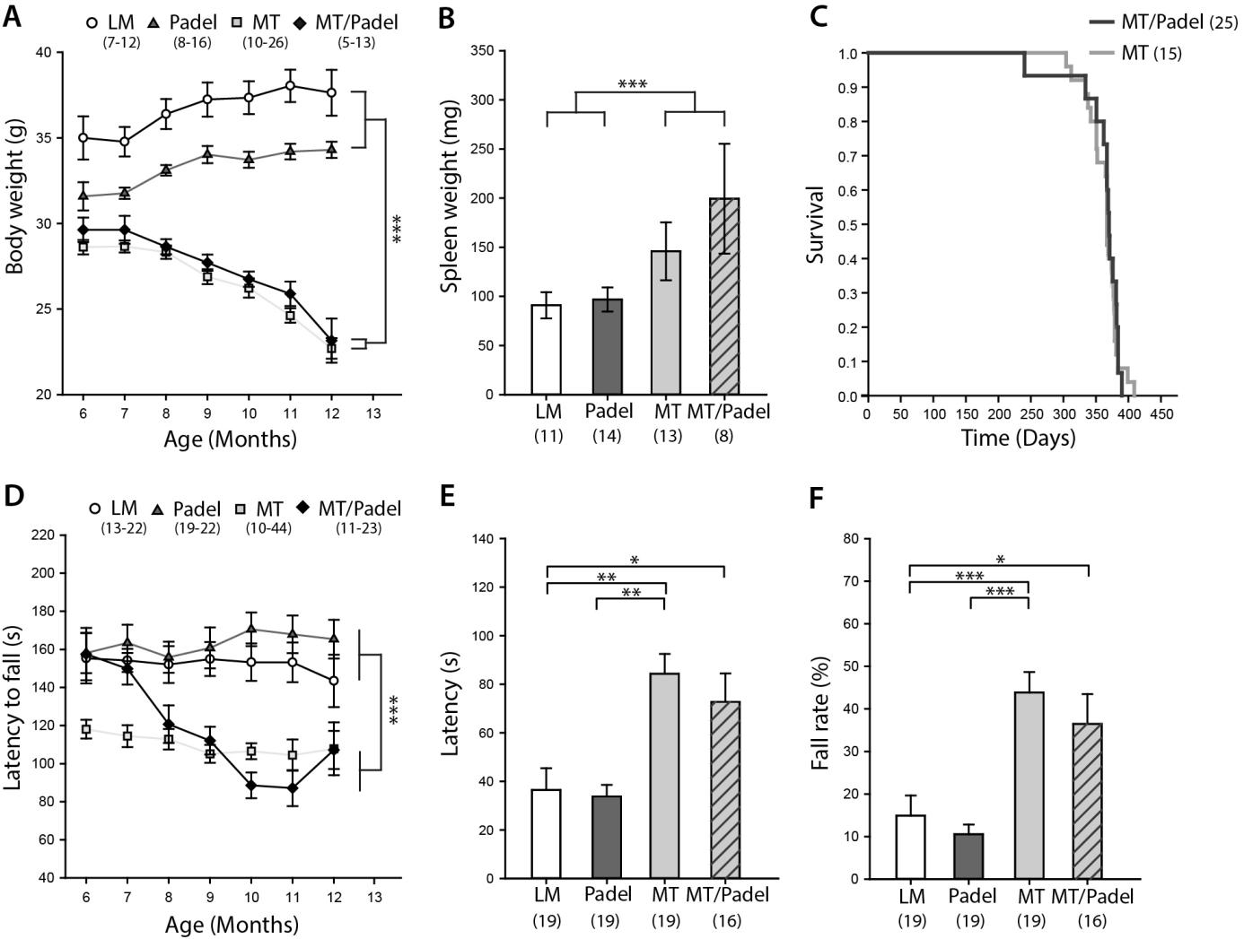
Figure 1. MT and MT/Padel mice displayed similar phenotypical effects. (A) Body weight (mean ± SEM) of Padel mice at the age of 6 months was lower than wildtype littermates (LM) (u-test: p < 0.05), increased after 8. Month of age (H-test: p < 0.05), which was then not different from that of LM (u-tests: p > 0.05). MT and MT/Padel mice started to lose body weight when the animals approached 8 months of age (H-tests: p < 0.001), which was different from LM and Padel (u-tests: p < 0.05). There were no differences between MT and MT/Padel mice (u-tests: p > 0.05). (B) MT and MT/Padel mice (12 months old) showed similar enlargement of spleen compared to LM and Padel (mean ± SEM; u-test: p > 0.05 for MT vs MT/Padel). (C) MT and MT/Padel mice exhibited similar survival rates in Kaplan-Meier analysis (log-rank test: p > 0.05). (D) LM and Padel mice exhibited similar constant performance (mean ± SEM) on the rotarod (u-tests: p > 0.05). MT mice showed low performance, compared to LM and Padel (u-tests: p < 0.05). MT/Padel mice showed an age dependent, continuous decline in performances (H-test: p < 0.001). No difference was found between MT and MT/Padel for 8 - 12 months. (u-tests; p > 0.05). (E) LM and Padel mice displayed similar latencies (mean ± SEM) in the pole test (u-test: p > 0.05). MT and MT/Padel mice showed reduced performance compared to LM and Padel (u-tests: p < 0.05). No differences were found between MT and MT/Padel (u-test: p > 0.05). (F) MT and MT/Padel mice exhibited a higher percentage of trials in which they fell off or slid down the pole during the pole test (mean ± SEM). No difference was found between MT and MT/Padel mice (u-test; p > 0.05). (A-F) Numbers in parentheses indicate numbers of analysed animals. H- or u-test: *p < 0.05; **p < 0.01; ***p < 0.001.
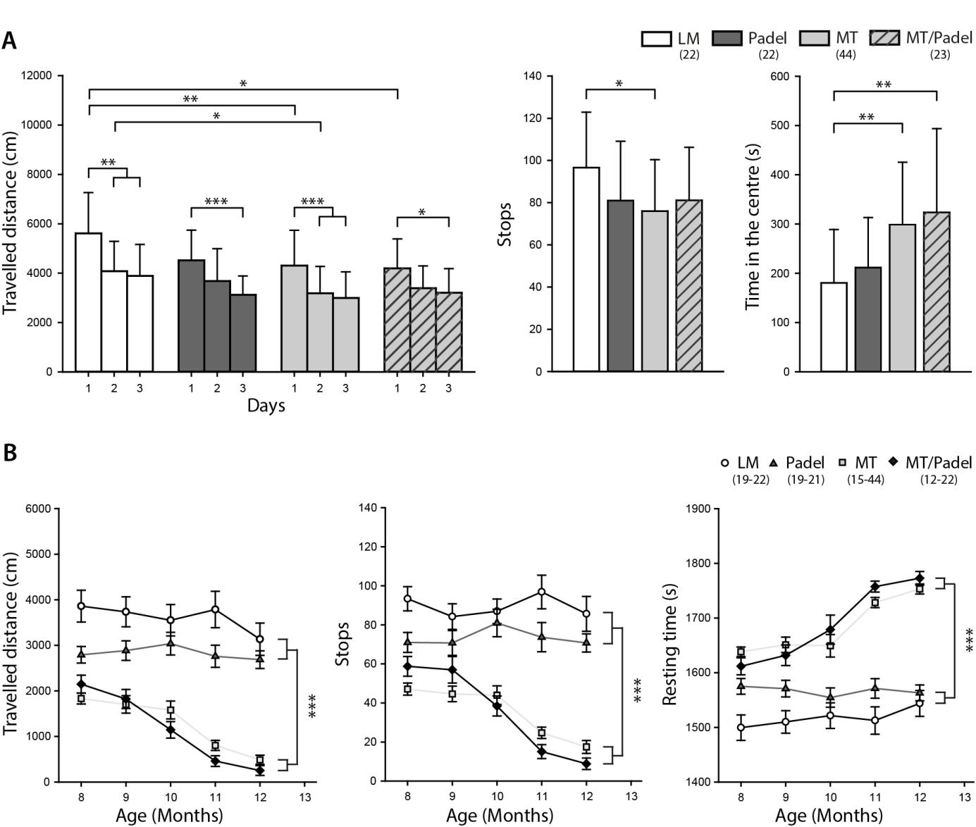
Figure 2. MT and MT /Padel mice exhibited similar phenotypical changes in the open field test. (A) Naïve mice (6 – 7 months old) were exposed to the open field for 30 min on three consecutive days. (Left) The MT and MT/Padel mice showed reduction of the travelled distance on the day 1, while no difference was found between LM and Padel mice (u-test: p > 0.05). LM and MT mice displayed similar habituation behaviour by showing reduced travelled distance on the day 2 and 3, while a delayed habituation on the day 3 of the test was found for Padel and MT/Padel animals. (Middle) Averaged number of stops within 30 min was lower with MT mice compared to LM. No difference was found between MT and MT/Padel (u-test: p > 0.05). (Right) MT and MT/Padel mice showed similarly increased amounts of time spend in the center compared to LM and Padel. No differences found between MT and MT/Padel (u-test: p > 0.05). (B) MT and MT/Padel mice showed similar successive shortening of travelled distances (left), similarly less initiative movements (as stops) (middle), and similar increased resting time (right), when the animals were re-tested monthly in the open field up to 12 months of age. (A-B) All data: mean ± SEM, Numbers in parentheses indicate numbers of analysed animals. H- or u-test: * p < 0.05; **; p < 0.01 *** p < 0.001.
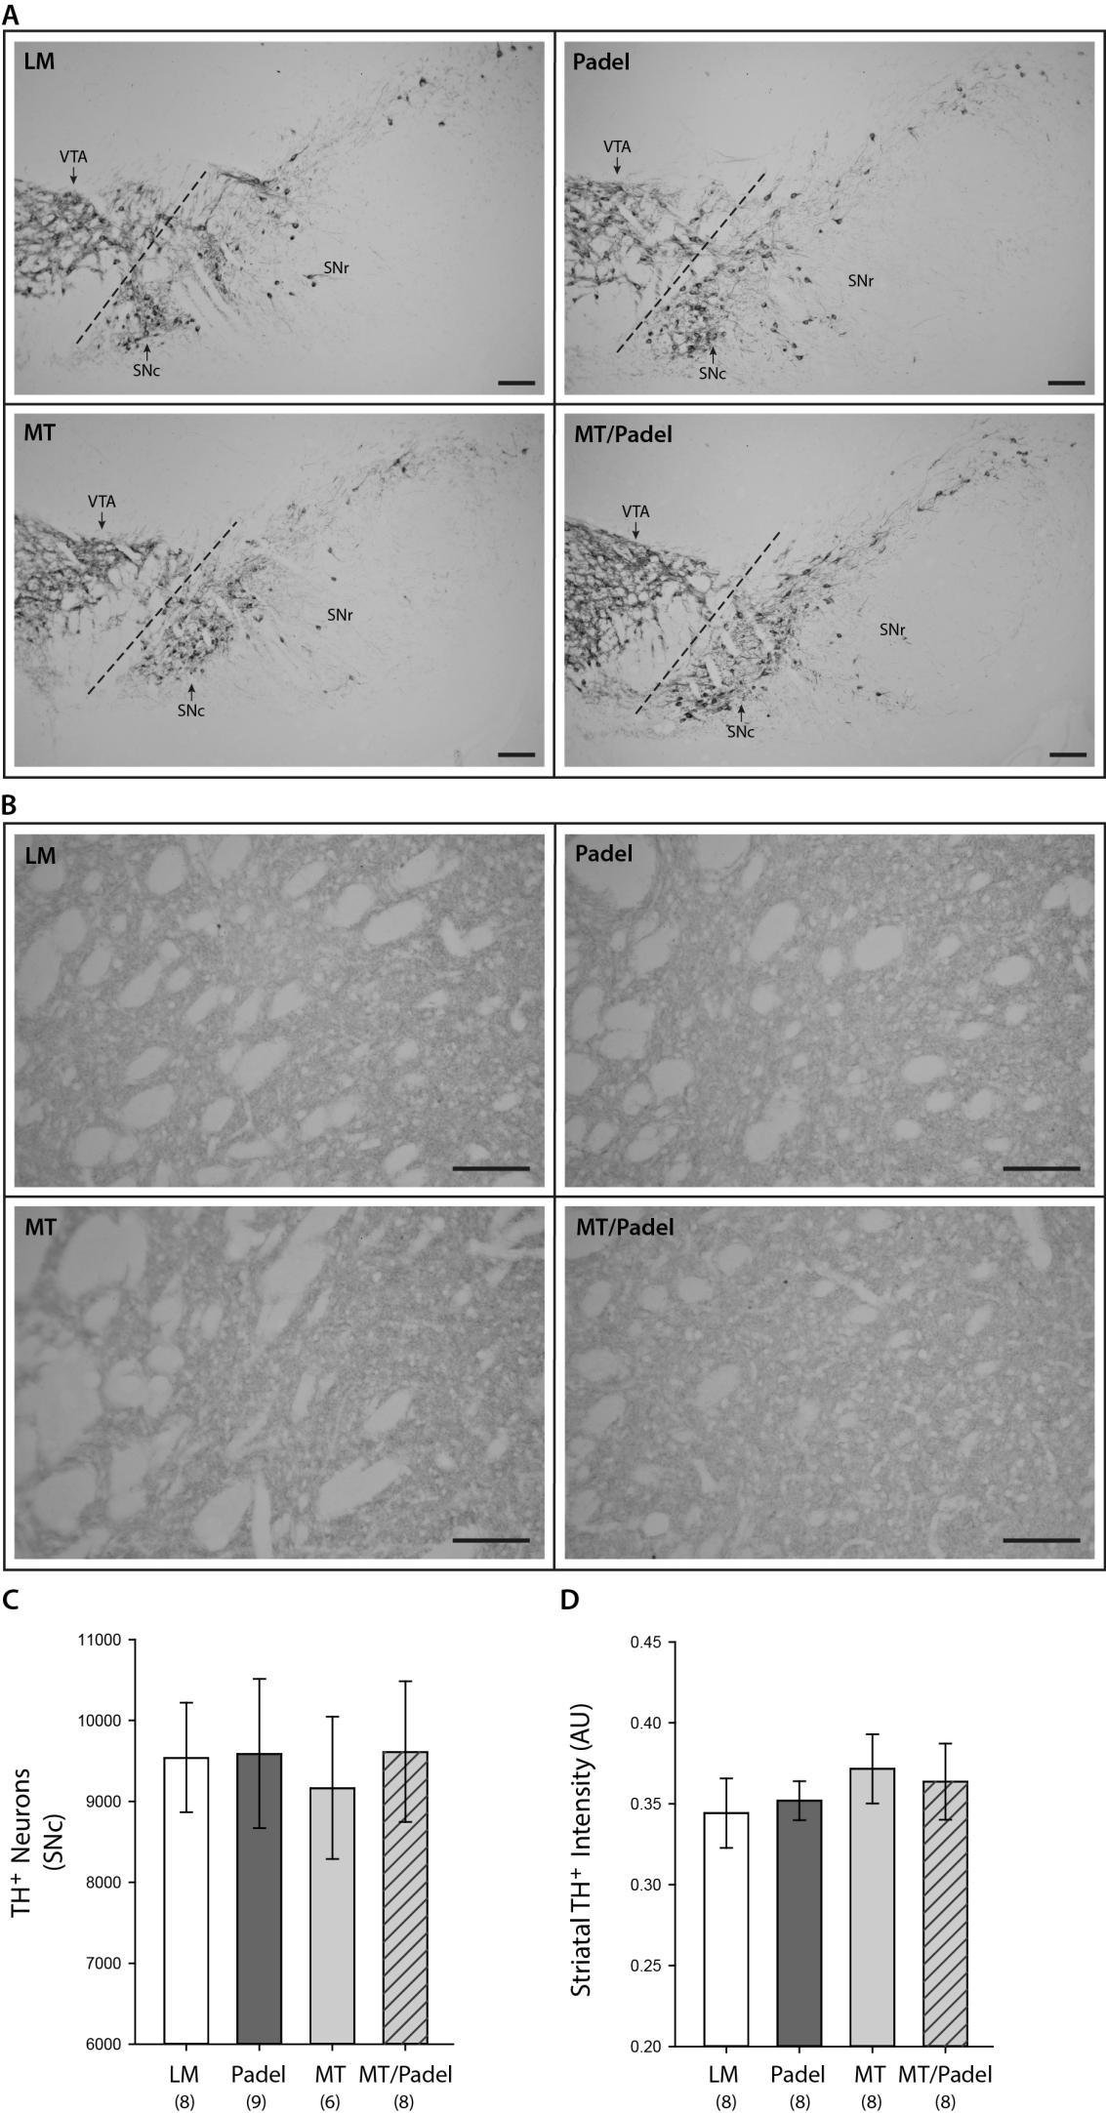
Figure 3. No significant morphological difference in nigrostriatal axis between wildtype (LM), Padel, MT and MT/Padel mice. (A) Representative images of TH-stained coronal brain sections containing the substantia nigra pars compacta (SNc), substantia nigra pars reticulata, (SNr) and ventral tegmental area (VTA) at the age of 12-months. (B) Representative images of TH-stained coronal brain sections containing the striatum for each of those four genotypes at the age of 12 months. (C) Similar TH positive cell counts (mean ± SD) in the SNc (H-test; p > 0.05) (D) Similar TH-staining intensity units (mean ± SD) in the striatum between four genetypes (H-Test; p > 0.05). (A-B) scale bars: 100 µm. (C-D): Numbers in parentheses indicate numbers of analysed animals.

